Lab05 : Python Strings
Name | Ben Stobie
Date | 26/02/21

Exercise 1:
Try the following example Python statements from the IDLE shell and note the Unicode values displayed.
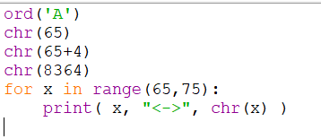
Write a program lab5ex1.py that displays the 10 numeric characters 0 to 9 with their Unicode value.

Copy your Python code here. Make sure that your code contains your name and date.
def main():
x = 0
for x in range (48,58):
print(x, "<->", chr(x))

main()

Paste screen capture here showing the program being run
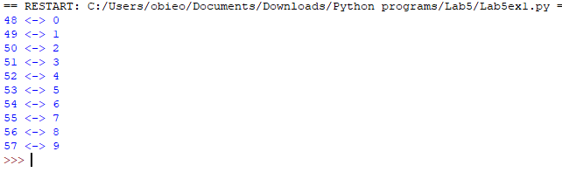

Answer the following questions:

Q1 Briefly explain what the term “immutable” means.
Immutable means that the thing in question can’t change.

Exercise 2: String Indexing
Write a program lab5ex2.py that asks the user to input a string and then using a for loop displays the characters of the string in reverse order. For example:

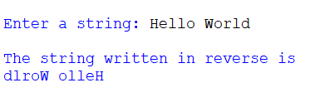

Hint – you can use for i in range(start, stop, step) format to count down from (length of string-1) by having a negative step value and ensuring that you count all the way down to include the index 0 or you could use the negative indices.

Copy your Python code here. Make sure that your code contains your name and date.
def main():
i = 0
x = input(str("Enter a string: "))
print("The string written in reverse is: ")
f = len(x)-1

for i in range(len(x), 0, -1):
print(x[f])
f = f-1
main()

Paste screen capture here showing the program being run
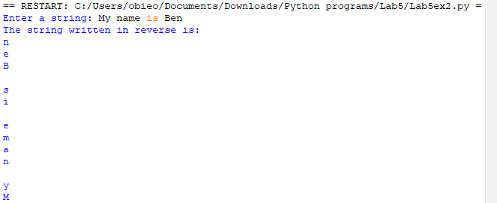

Answer the following questions:

Q2 - Give two examples of how you might display the last character in a string using indices

Exercise 3: String Slicing
Write a program lab5ex3.py that asks the user to input a string and then uses slicing to create a substring from the first 5 characters and display this substring. Then check if the substring contains the string “spam”.

Copy your Python code here. Make sure that your code contains your name and date.
def main():
x = input(str("Enter a string: "))
sliceVar = str(x[:5])
print(sliceVar)
if sliceVar == "spam":
print("This slice is spam")
main()

Paste screen capture here showing the program being run
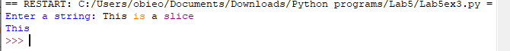
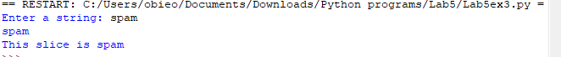

Answer the following questions:

Q3 - What would be displayed when the following Python statements are executed?
my_string = "Python is easy to learn!"
s1 = my_string[7:-1]
print(s1)
s2 = my_string[::-1] # 3rd parameter is the step
print(s2)

s1 will display every portion of the string after the 7th variable
s2 will display the text in reverse.

Exercise 4 – String Methods
Write a program lab5ex4.py that asks the user to input a string. The program should call a string method to converts the string to lowercase and then displays the lowercase string.

Copy your Python code here. Make sure that your code contains your name and date.
def main():
x = input(str("Enter a string: "))
print(str.lower(x))

main()

Paste screen capture here showing the program being run
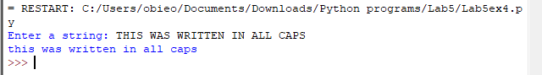

Answer the following questions:

Q4 – What is meant by the term “method” and how is a method called in Python?

They are a way to return variables from a string without changing the original string and they are called with a “.METHOD” following the “str()” variable type declaration.

Additional Practice Exercises
Log your work on the additional practice exercises here.

Exercise 5 – String Methods
Write a program that asks the user to enter a string and then counts how many times the letter ‘T’ appears in the string.

Copy your Python code here. Make sure that your code contains your name and date.
def main():
x = input(str("Enter a string: "))
y = x.count("t")
print(str.lower(x))
print("T occurs", y )
print("times")

main()

Paste screen capture here showing the program being run
