Week06 - Lab: Lists and Tuples
Name | Ben Stobie
Date | 12/03/21

Exercise 1: Iterating over a list

Write a modular program that creates a list with the five integer values 10, 11, 12,13 and 11 in a main function and then calls a function that when passed the list, displays all the elements of the list.

Copy your Python code here. Make sure that your code contains your name and date.
def main():
list1 = [10,11,12,13,11]
iterateList(list1)

def iterateList(x):
i = 0
for i in x:
print(i)

main()

Paste screen capture here showing the program being run
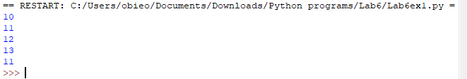

Differentiate between two methods of iterating over a list?
While similar, using the for in to iterate a variable through the list is cleaner to code where previously you would have to increment a variable and use that variable to point at list elements.

Exercise 2: Demonstrate that a list is mutable

Write a modular program that prompts the user for a ten floating point numbers and stores these in a list. The program should include an input function that populates the list from user input, returning the list to the main function. The program should then overwrite each element of the list with the cube of each of the numbers. The program should include a display function that when called displays all the elements of the list.

Use the id() function to obtain for display the object reference for the list from your main function and your cube function.

Copy your Python code here. Make sure that your code contains your name and date.
def main():
i = 0
list1 = []
list1 = getInput()
for i in list1:
print(i, end = " ")

print("\n", id(list1))
cubeList(list1)

def getInput():
i = 0
x = []
for i in range(10):
y = float(input("Please enter a Variable: "))
x.append(y)
return x

def cubeList(x):
i = 0
for i in range(len(x)):
x[i] = x[i]**3
for i in x:
print(i, end = " ")

print("\n", id(x))

main()

Paste screen capture here showing the program being run
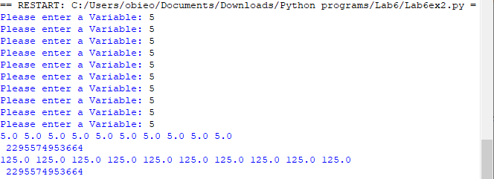

State what the object ID for your list was in main and in cube. Were the values the same and if so what was the significance of this?

The object IDs were the same, this means that you can use this unique ID number to identify lists across functions.

Exercise 3: List and some useful functions

Write a modular program that creates a list containing the 30 random numbers and then call some functions to compute the min, max and sum.
- Create an empty list and then call the randint() function in a loop, using the append() method to add each random number generated to the list.
- Find the maximum and minimum value in the new list using the built-in max() and min() functions
- Compute the sum of the new list using the built-in sum() function

Copy your Python code here. Make sure that your code contains your name and date.
from random import randint

def main():
list1 = []
i = 0
for i in range(30):
list1.append(randint(0,100))
print(list1[i - 1], end = " ")
if i == 9 or i == 19 or i == 29:
print("\n")
minAndMax(list1)
totalValue(list1)

def minAndMax(x):
print("The max value of the list is: ", max(x))
print("The minimum value of the list is: ", min(x))

def totalValue(x):
print("The total of the list is: ", sum(x))
main()

Paste screen capture here showing the program being run
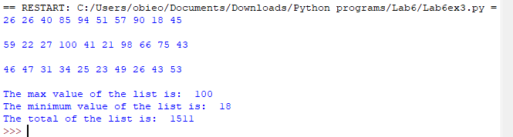
List two observations you made about this exercise?

I observed that you can import individual functions from libraries and I also observed that some inbuilt functions can read entire lists without needing defined elements of said list.

Exercise 4: List Methods

Create a program that asks the user to input a string of text containing at least six words.

Use the split() method on the string to convert the text to a list of words.

- Check if any of the words start with “IP”.
- Sort the list by calling the sort() method on the list and display the sorted list.
- Using slicing, create a new list containing the first three words in the sorted list and display this new list

Copy your Python code here. Make sure that your code contains your name and date.
def main():
list1 = getList()
sortList(list1)
sliceList(list1)

def getList():
i = 0
y = []
x = input("Please enter a sentence (min 6 words): ")
y = x.split()

while (len(y)) < 6:
print("Invalid Input \n")
x = input("Please enter a sentence (min 6 words): ")
y = x.split()
if "ip" or "IP" in y:
print("IP detected in list \n")
return y

def sortList(x):
i = 0
x.sort()
for i in x:
print(i, end = " ")
print("\n")

def sliceList(x):
y = x[0:2]
for i in y:
print(i, end = " ")
main()

Paste screen capture here showing the program being run
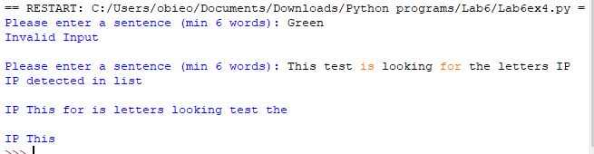

List two observations you made about this exercise?
Splitting and slicing are very finicky in lists and the sort function doesn’t sort as expected

Tuples

Exercise 5:
Write a program using tuples to stores the days of the week.
Write a display function that when called displays all the elements of the tuple.

Exercise 6:
Write a program that demonstrates that a tuple is immutable.

Copy your Python code here. Make sure that your code contains your name and date.
def main():
i = 0
days = ("Monday", "Tuesday", "Wednesday", "Thursday", "Friday", "Saturday", "Sunday")
for i in days:
print(i, end = " ")
tupleProof(days)

def tupleProof(x):
i = 0
x.append("St. Paddies Day")
for i in x:
print(i, end = " ")
main()

Paste screen capture here showing the program being run
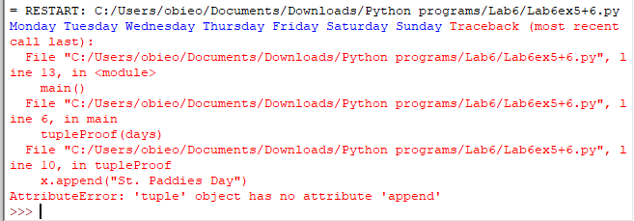

Explain the difference between a tuple and a list?

A list is a potentially predefined group of elements that can be added to, extracted from or be removed using functions while a tuple is a predefined set of values that cannot change.

