Lab07: Exception Handling and File IO
Name | Ben Stobie
Date | 19/03/21

Exercise 1:
Copy your Python code here. Make sure that your code contains your name and date.
def main():
x = 1
whole = input("Enter a whole Number: ")
try:
z = x + int(whole)
except:
print("False")
z = "NaN"
else:
z = int(whole)

print("The value is: ", z)

main()

Paste screen capture here showing the program being run
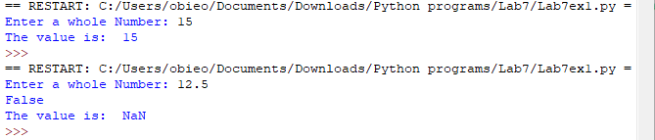

State what exception is thrown if the user inputs a value which is not an Integer?

If my code were not formatted in the way it is the compiler would return “Unsupported operand type”

Exercise 2 and 3
Copy your Python code here for both exercise 2 and 3. Make sure that your code contains your name and date.
def main():
writeToFile()
appendToFile()

def writeToFile():
i = 0
file_object = open("names.txt", "w")
while i != 9:
file_object.write(input("Enter a name: "))
file_object.write("\n")
i = i + 1
file_object.close()

def appendToFile():
file_object = open("names.txt", "a")
file_object.write("John Doe")
file_object.write("\n")
file_object.close()

main()

Paste screen capture here showing the program being run
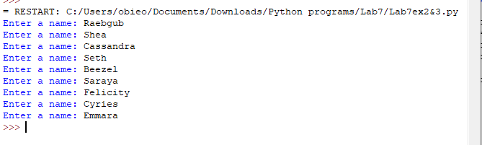
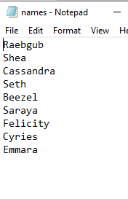
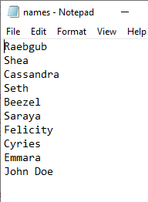
What is the purpose of the mode parameter in the open() function

To define how the program is able to handle the file, this prevents files from accidentally writing to a file instead of reading it’s contents

Exercise 4:
Copy your Python code here. Make sure that your code contains your name and date.
def main():
i = 0
names = open("names.txt", "r")
while i != 10:
read = names.readline()
print(read)
i = i + 1

names.close()

main()

Paste screen capture here showing the program being run
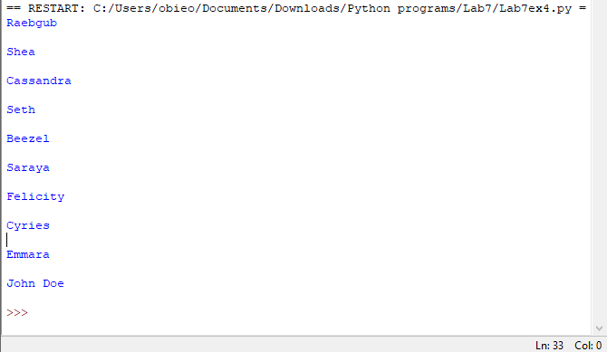

State what would happen if you replace the read() method in your code with readline()
(Not sure if this is incorrect however the exercise says to use the readline() function)
When read is used it returns the entire file so using just read() would return the entire file in one print statement whereas without a loop readline() would only return the first line.

Exercise 5:
Copy your Python code here. Make sure that your code contains your name and date.
def main():
marks = open("marks.txt", "r")
count = marks.readline()
z = 0
while count:
if int(count) > int(z):
z = count
count = marks.readline()
print("The highest mark was: ", z)
marks.close()

main()

Paste screen capture here showing the program being run
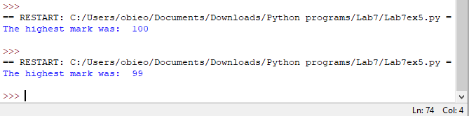
Give an example of a Python statement you would use to write the number 33.5 out to a file.

filename.write(“33.5”)

Exercise 6:
Copy your Python code here. Make sure that your code contains your name and date.
def main():
student = open("students.txt", "r")
readData = student.readline()
readData = student.readline()
y = 0
while readData:
splitData = readData.split(",")
x = splitData[2]
if int(x) > int(y):
a = splitData[0]
b = splitData[1]
y = splitData[2]
readData = student.readline()
print("Student Name: ", a)
print("Subject: ", b)
print("Mark: ", y)

main()

Paste screen capture here showing the program being run
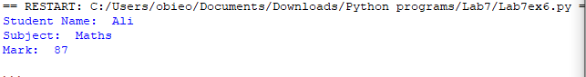

Explain the purpose of the parameter passed to the split() method.

The Parameter defines which portions of the str is to be ignored by the compiler

Exercise 7:
Copy your Python code here. Make sure that your code contains your name and date.
import urllib.request
def main():
url = input("Please enter a valid URL: ")

try:
response = urllib.request.urlopen(url)
alldata = response.read().decode('utf-8')
print (alldata)
except:
print ("Something went wrong!")

main()

Paste screen capture here showing the program being run
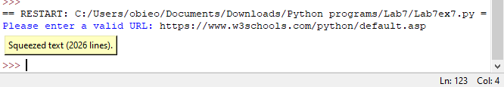
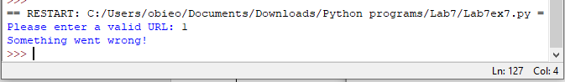

Explain what happened when the user enters an invalid URL to your program.

From my understanding the program attempts to contact the provided address, when an invalid address is entered the program is unable to make a connection and therefore returns false jumping out of the try function and into the except function.

