Lab08: Dictionaries and Sets
Name | Ben Stobie
Date | 26/03/21

Exercise 1 Sets
Copy your Python code here for exercise 1 . Make sure that your code contains your name and date.
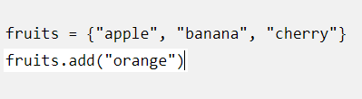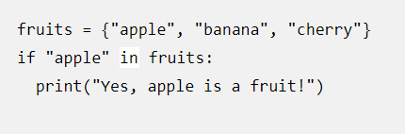
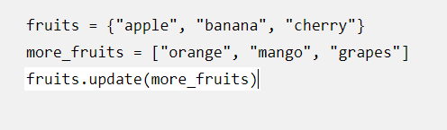
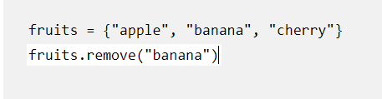
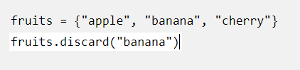

Paste screen capture here showing the program being run
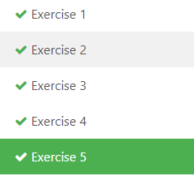
Answer the following questions>>

- What is the difference between the add and update methods
- What is the difference between the remove, discard and pop methods
- What is the difference between the clear and del methods

- The add method requires the item be specified while the update method uses an iterable variable.
- The remove method removes a specified variable but will cause errors, the discard method does the same without raising errors and the pop method removes the last variable regardless of name.
- Clear empties the set of all items while del gets rid of the whole variable.

Exercise 2 - Sets
Copy your Python code here for exercise 2. Make sure that your code contains your name and date.
#Ben Stobie
#26 March 2021

def main():
ipList = []
inList = open("ipaddresses.txt", "r")
readLine = inList.readline()
while readLine:
ipList.append(readLine.strip())
readLine = inList.readline()
print(ipList)
ipSet = set(ipList)
print(ipSet)
inList.close()
main()

Paste screen capture here showing the program being run
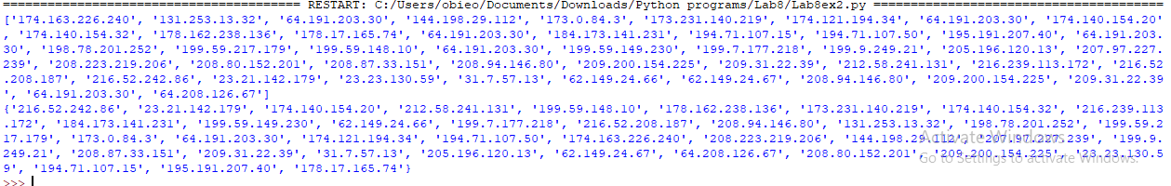

Answer the following questions>

- What are the main differences between a list and a set
- What is the difference between a set and a dictionary

- A list is an array of items/values which can be sorted, a set on the other hand is an array of unique items/values that are in an unsorted order.
- A dictionary is collection of pairs of items in a key:value relationship while a set contains independent variables.

Exercise 3 - Dictionaries

Copy your Python code here for exercise 3. Make sure that your code contains your name and date.
#Ben Stobie
#26 March 2021

def main():
users = {"student1" : "networking101", "student2" : "networking102", "student3" : "networking103"}
i = 0
while i != 1:
x = input("Please enter your username: ")
y = input("Please enter your password: ")
if x in users:
if users[x] != y:
print("Invalid username or password")
else:
print("Logged In")
i = 1
else:
print("Please create an account")

main()

Paste screen capture here showing the program being run
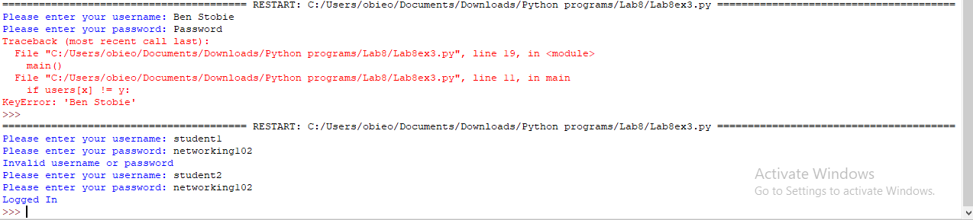
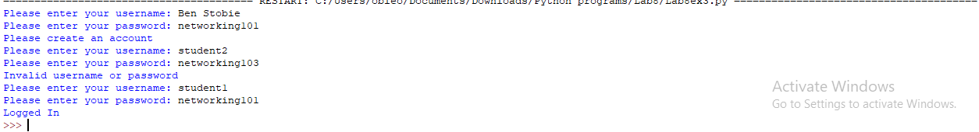

Comment on how the approach you took to this exercise differed from your Lab3 exercise 5 password program.

The main difference in my approach was avoiding the key errors associated with using dictionaries, while in lab3 we were just dealing with 2 arrays other than that the procedure was pretty much the same.

Exercise 4 - Dictionaries

Copy your Python code here for exercise 4. Make sure that your code contains your name and date.
#Ben Stobie
#26 March 2021

def main():
students = {}
i = 0
while i != 5:
stdInfo = []
stdID = input("Please enter the student's ID number: ")
while stdID in students:
print("Input failed")
stdID = input("Please enter another student's ID number: ")
stdInfo.append(input("Please enter the student's name: "))
stdInfo.append(input("Please enter the Course name: "))
stdInfo.append(int(input("Please enter the Student's Mark: ")))
students[stdID] = stdInfo
i = i+1
for x in students:
print("Name: ", students[x][0])
print("Course: ", students[x][1])
print("Mark: ", students[x][2])
print(" ")

main()

Paste screen capture here showing the program being run
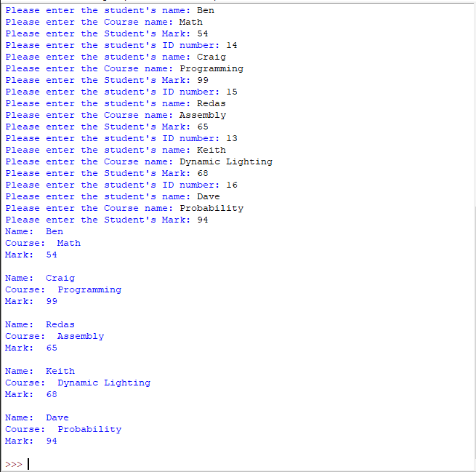

Comment on the approach you took to converting user input to a dictionary data structure.

By using a newly created list every iteration while the list stored in the dictionary bears the same name it’s key differentiates it from the other ones thus cutting down on clutter and extra needless code.

Exercise 5 - Dictionaries

Copy your Python code here for exercise 5. Make sure that your code contains your name and date.
#Ben Stobie
#26 March 2021

def main():
ipInfo = makeDict()
for i in ipInfo:
print(i)
print("Eth 1 - Ip address:", ipInfo[i]["Eth1"])
print("Eth 2 - Ip address:", ipInfo[i]["Eth2"])

def makeDict():
ipInfo = {"R1":{"Eth1":"", "Eth2":""},"R2":{"Eth1":"", "Eth2":""},"R3":{"Eth1":"", "Eth2":""}}
i = 0
x = 0
for i in ipInfo:
ipIn1 = input("Please enter an IP address for Eth1: ")
y = 0
while y != 1:
for x in ipInfo:
if ipIn1 in ipInfo[x]["Eth1"]:
print("***ERROR Duplicate IP***")
ipIn1 = input("Please enter another IP address for Eth1: ")
elif ipIn1 in ipInfo[x]["Eth2"]:
print("***ERROR Duplicate IP***")
ipIn1 = input("Please enter another IP address for Eth1: ")
else:
y = 1
ipIn2 = input("Please enter an IP address for Eth2: ")
ipInfo[i]["Eth1"] = ipIn1
y = 0
while y != 1:
for x in ipInfo:
if ipIn2 in ipInfo[x]["Eth1"]:
print("***ERROR Duplicate IP***")
ipIn2 = input("Please enter another IP address for Eth2: ")
elif ipIn2 in ipInfo[x]["Eth2"]:
print("***ERROR Duplicate IP***")
ipIn2 = input("Please enter another IP address for Eth2: ")
else:
y = 1
ipInfo[i]["Eth2"] = ipIn2

return ipInfo

main()

Paste screen capture here showing the program being run
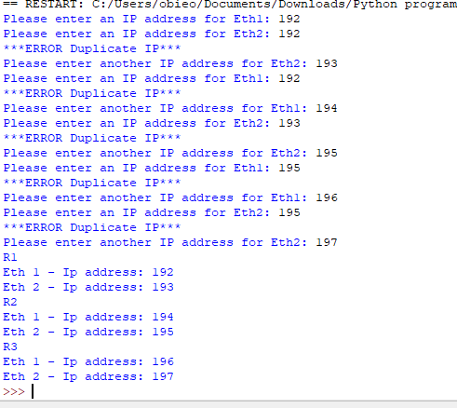

Comment on how the approach you took to this exercise to ensuring that the IP address assigned to a router’s interface was not already assigned to another interface.

I went through, without exaggeration over 6 or 7 different methods all of which were failures, until I finally got this revision to work as intended.

Exercise 6 - Dictionaries

Copy your Python code here for exercise 6. Make sure that your code contains your name and date.
#Ben Stobie
#26 March 2021

def main():
emptDic = {}
split2 = []
i = 0
x = 0
inStr = open("ifacedata.json", "r")
readLine = inStr.read()
readLine = readLine.strip('{')
strip1 = readLine.strip('} \n')
split1 = strip1.split(',')
for i in range(len(split1)):
split2.append(split1[i].split(':'))
i = 0
for x in range(3):
emptDic[split2[x][i]] = split2[x][i+1]

print(emptDic)

main()

Paste screen capture here showing the program being run

Comment on what you notice about the format of the ifacedata.json file.

The structure of the .json is similar to that of a dictionary.

