Lab : Introduction to Python
Name | Ben Stobie
Date | 29/01/21

Part 1 – Interactive Mode –Using Python as a Calculator!!

Exercise 1- 1:
In Interactive mode type in the following commands and note the results obtained. Explain the operation that has been executed for each case in the table below
:
Command | Output? | Explain what operation
1 + 2 | 3 | Calls an addition function
2 + 4 * 3 | 14 | Calls a multiplication function then calls an addition function
(2 + 4) * 3 | 18 | Calls an addition function then calls a multiplication function
2 + 4 / 3 | 3.333333333333333 | Calls a division function then calls an addition function
2 + 4 // 3 | 3
(2 + 4) / 3 | 2.0 | Calls an addition function then calls a division function
a = 2  b = 3  c = a / b  print(c) | 0.6666666666666666 | Sets up the variable a,b and c as variables and then calls a division function and prints the result.
a = input("Enter number: ")  b = int(a)**3  print(b) | 216 | Prompts the user to input a variable which is then stored in a then it puts a to the power of 3 and stores the result in b then it prints b.

Exercise 1-2:
In Interactive mode enter the appropriate command to execute the following maths equation correctly:
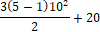

Command | Output? | Comment on result
(3*(5-1)*(10**2))/2 +20 | 620.0 | Considering the complexity of the calculation it is surprising that the interpreter was so quick at interpreting and execution the formula

Exercise 2-1:
Write a new program called lab1ex1.py that displays the following details:
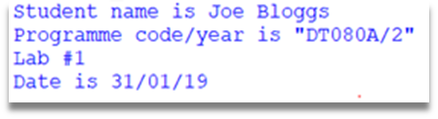
Student Name
Programme code/year
Lab Number
Date

Copy your Python code here. Make sure that your code contains your name and date.
# Student: Ben Stobie
# Date: 29/01/21
print("Student_name: Ben Stobie")
print("Programme code/year: DT080A/2")
print("Lab 1")
print("Date: 29/01/21")

Paste screen capture here showing the program being run

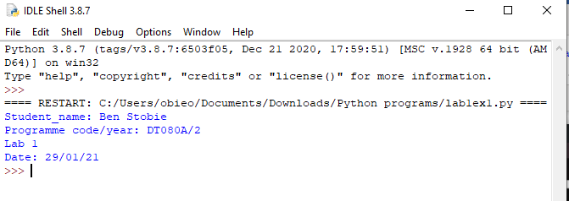

Answer the following questions in it:

- What are the steps involved in getting a Python program to run?
You either open the file in a command line window or open the file with IDLE.

Exercise 2-2
Write a Python program lab1ex2.py that computes and displays the average value of three variables x, y and z that reference the values 10, 12, 13:

Copy your Python code here. Make sure that your code contains your name and date.
# Student: Ben Stobie
# Date: 29/01/21
x = 10
y = 12
z = 13
avg = (x+y+z)/3
print(avg)

Paste screen capture here showing the program being run

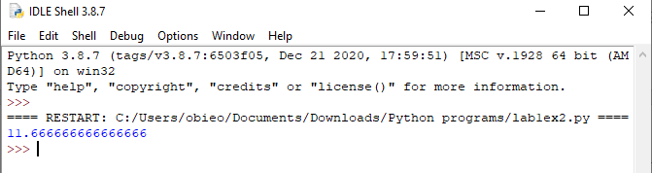

Comment on the Results
- List one key thing you learned from exercise

I learned how simple and easy to comprehend the python syntax is in terms of declaring simple variables.

Exercise 2-3

Write a Python program lab1ex3.py that inputs three integers from the user and displays the sum, average, product of the numbers.

Copy your Python code here. Make sure that your code contains your name and date.
# Student: Ben Stobie
# Date: 29/01/21
x = input("Enter value 1: ")
y = input("Enter value 2: ")
z = input("Enter value 3: ")
total = int(x)+int(y)+int(z)
print("The total is:" + str(total))
avg = total/3
print("The average is:" + str(avg))
Prod = int(x) * int(y) * int(z)
print("The product is:" + str(Prod))

Paste screen capture here showing the program being run
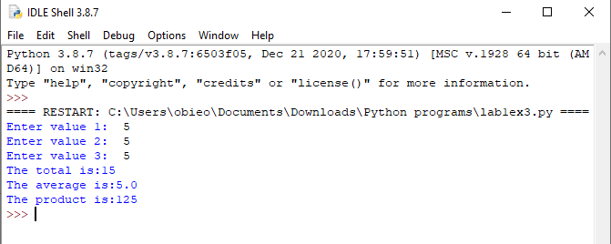

Comment on the Results
- List one key thing you learned from this exercise
Python is very awkward when it comes to defining your variable types and will be highly improved by functions to reduce redundance.

