**Hospital Administrator Database Design Document**

**Version 1.0 Revision 10**

**Submittal Date: 09/05/2021**

**Version History**

|  |  |
| --- | --- |
| **Version** | **Description** |
| 1.0 rev 10 | First released draft |

**Table of Contents**

**Topic Page**

**Purpose ….……………………………………………………………..………... 4**

**Narrative ...………………………………………………………...……………. 4**

**Requirements (Actors/Roles) …..……………………………………………… 6**

**Entities …………………….………...…………………………….……………. 7**

**Entities (w/ Nested Attributes) …………………………………..……………. 7**

**Business Rules ……………………………………………………….……...…. 9**

**ERD …………………………………….………………………………………. 10**

**EERD ……………………………………….………………………………….. 11**

**Relational Schema ……………………………………….……………………. 12**

**Purpose**

The purpose of this Database Design Documentation (DBDD) is to record the administrative tasks that happen in a hospital and generate reports regarding the nurses, nurse assignments to the wards, patients’ admissions, bed assignments, doctors, treatments, patient care, etc. To track all such processes of the hospital, it is important to document this entire process within an organized database.

**Narrative**

The hospital administrator wants to create a database to track nurse assignments to their wards and nurse interactions with their patients, patient admissions by their doctors and treatments administered by doctors to their patients, bed assignments for each patient and items charged to patients during their stay. Administrator wants to record each nurse’s name and address, phone and alternate phone, email and the medical specialties he or she is certified. Some nurses supervise one or more other nurses. No nurse is supervised by more than one nurse, and some nurses are unsupervised.

Each ward at the hospital has a designated number, descriptive name, physical location and phone number. Each ward has at least one nurse assigned to it. A nurse is assigned to at least one ward and rotates assignments among other wards. The assignment is tracked by the specific date and the hours worked in the assigned ward by each nurse on that date.

In addition to nurse assignments, each ward also has a charge nurse. The charge nurse is the custodian of the medical records for the ward. Not all nurses act in this capacity, but those that do are in charge of only one ward, and a ward only has one charge nurse.

A ward consists of hospital beds. The beds are inventoried to a specific ward. Information on beds including their size (small, large, extra-large) and their type (elevated electrically or manually) and if they are available to be assigned to a patient. Most of the beds are large and manual (this is the default setting). The data entry (checks) for beds is limited to S, L, XL for size; E or M for type; O for occupied and A for available. Availability defaults to occupied to avoid double booking by mistake. All of these value formats are set by rule or check.

When a patient is admitted to the hospital they are assigned to a specific bed. Not all beds are available for use all the time, and a bed may not be assigned to more than one patient. In this database we are only tracking bed assignment history and not bed occupancy or availability.

The admitting official conducts a review of all beds to determine which beds are available to assign to a patient.

Information on patients is recorded: name, gender, dob, address, phone, alternate phone, email. The patient’s calculated age is also tracked.

The date the patient is admitted to the hospital, the admitting doctor, the date the patient is discharged, and discharging doctor are also tracked.

Some doctors admit patients while others do not. Doctor information tracked: name, address, phone, alternate phone, email and their medical specialties.

The hospital tracks the treatments administered to patients and the treating doctor. Treat­ments are tracked by name, description, and charge. The hospital also tracks the date and time of each treatment administered and the results. Some doctors treat patients while others do not.

A given patient may receive no treatments or may receive many, and some patients may receive their treatments from more than one doctor. Some treatments have yet to be used while others have been used often.

In addition to treatments, patients incur other charges for items used during their stay. The hospital tracks these charges as “items” and stores information on what items have been charged to which patients, based on date and quantity. Information that is to be stored for each item includes the item name and charge. All patients incur at least one charge for consumable items used during their stay. Some items are used often while items may be new or unusual in nature and might rarely or never be charged to any patients.

Lastly, the hospital tracks nurse patient care. Each nurse-patient care interaction is an event. There are several types of events: wellness check, medication, food service, assistance, treatment admin, and “other.” Given the number of shifts and ward rotations, a patient will typically be seen by more than one nurse during their stay, and a nurse most likely will interact with the same patient over several events during a single shift.

**Requirements (Actors and Roles)**

Nurses: Nurses are assigned to the wards and interacts with the patients. Some nurses supervise one or more other nurses. No nurse is supervised by more than one nurse and some nurses are unsupervised. A nurse is assigned to at least one ward and rotates assignments among other wards.

Wards: Wards consists of hospital beds. Each ward has at least one nurse assigned to it. Each ward also has one charge nurse.

Patients: Patients may or may not be admitted to the hospital by the doctors. A patient may or may not receive treatments from one or many doctors. Patients incur charges for items used during their stay.

Beds: Beds are inventoried to a specific ward. A bed may not be used for more than one patient.

Doctors: Doctors administer treatments to the patients. Some doctors admit patients while others do not. More than one doctor may treat some patients.

Treatments: Treatments are administered to patients. A patient may receive no treatment or may receive many. Some patients receive treatments from more than one doctor.

Items: Items are used for the patients and they are charged for the items. Some items are used often, some are never charged to any patients.

**Entities**

* Nurse
* Ward
* Patient
* Bed
* Doctor
* Treatment
* Item

**Entities w/ Nested Attributes**

* Nurse
  + Nurse ID
  + Name
  + Address
  + Phone
  + Alt Phone
  + Email
  + Specialty
* Ward
  + Ward ID
  + Ward Name
  + Location
  + Phone Number
* Patient
  + PID
  + PName
  + Gender
  + DOB
  + Age
  + PAddress
  + PPhone
  + PAlt Phone
  + PEmail
  + Admit Date
  + Admitting Doc
  + Discharge Date
  + Discharging Doc
* Bed
  + Bed ID
  + Size
  + Type
  + Availability
* Doctor
  + Doctor ID
  + Doc Name
  + Doc Address
  + Doc Phone
  + Doc Alt Phone
  + Doc Email
  + Doc Specialty
* Treatment
  + TID
  + TName
  + TDesc
  + TCharge
* Items
  + Item ID
  + Item Name
  + Item Charge

**Business Rules**

Nurses: No nurse is supervised by more than one nurse and some nurses are unsupervised. A nurse is assigned to one or more than one ward. Only one charge nurse maybe assigned to each ward.

Wards: Each ward has one nurse assigned to it. Each ward also has one charge nurse assigned to it.

Patients: An admitted patient is assigned only to a specific bed. A patient may receive zero, one or more than one treatment from one or many doctors. Patients incur charges for one or more than one item.

Beds: Beds are inventoried to a specific ward. A bed may not be used for more than one patient.

Doctors: Doctors may admit zero, one or more than one patient. One or more than one doctor may treat zero, one or more than one patient. Doctors may provide zero, one or more treatments.

Treatments: Treatments are administered to zero, one or more than one patient. Treatments may be prescribed by zero, one or more than one doctor.

Items: Items are charged to zero, one or more patients.

**ERD**

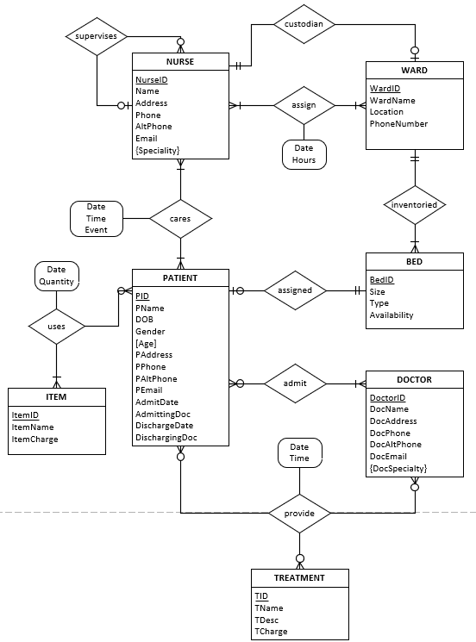

**EERD**

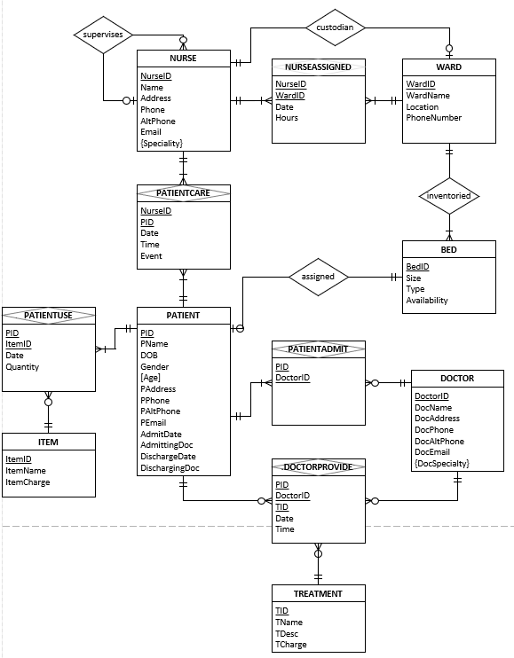

**Relational Schema**

