

Lab 4

[Click here to Register Attendance](https://goo.gl/forms/J9WP2kj83JC1mKYU2)

|  |  |
| --- | --- |
| Name |  |
| Date |  |
| Student No |  |
| Student Email |  |

### **Arduino Wifi**

1. Open the [Arduino IDE](https://www.arduino.cc/en/software) or [Arduino Create](https://create.arduino.cc/editor) website
2. Go to File -> Example -> Bridge - and open the WifiStatus sketch
3. Look at the code and describe what you think it is doing here:

|  |
| --- |
|  |

1. Upload the sketch and open the Serial Monitor at the top-right of the IDE window
2. Wait after you see the Starting Bridge message and this screen should appear:

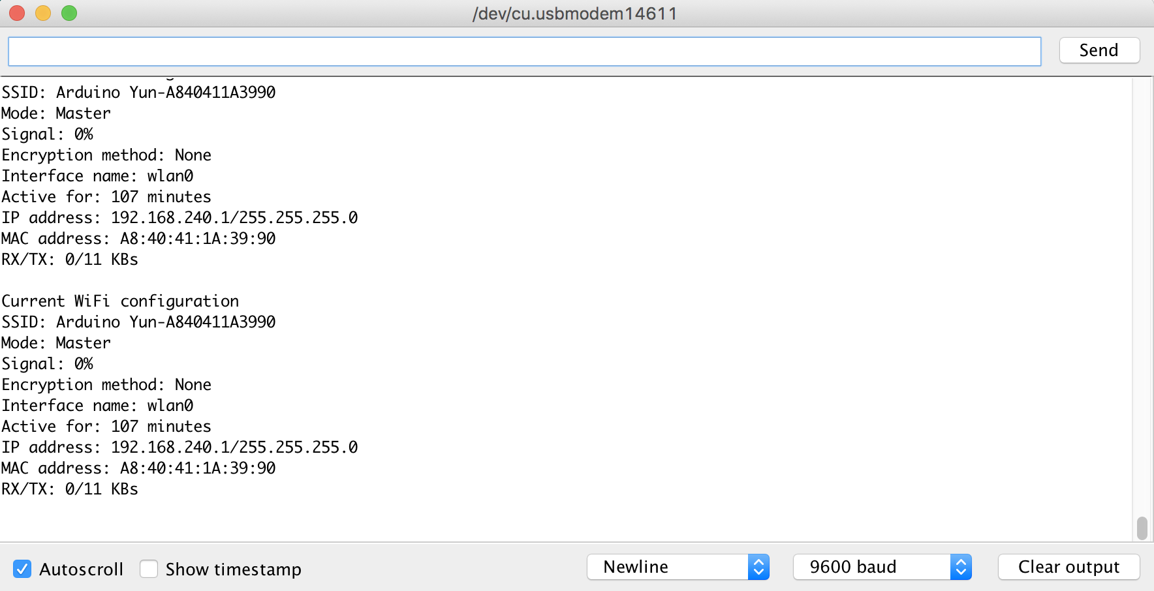

1. Can you see the IP address of your Arduino?
2. Type it here:

|  |
| --- |
|  |

### **Arduino Sketch Exploration**

1. Have a browse through the sketches in the Arduino Examples menu
2. Pick a sketch and see if you can figure out what it does and how it works
3. Paste a screenshot of the code and if you have an Arduino, upload the sketch and include a picture of the it running:

|  |
| --- |
|  |

1. Explain briefly what the sketch is doing:

|  |
| --- |
|  |

### **Web Research**

1. Continue your research and find 3 articles relevant to your project on [Google Scholar](https://scholar.google.com/) or from the I[T Sligo Library](https://library.itsligo.ie/)

|  |
| --- |
|  |
|  |
|  |

1. How do you think they might be relevant to your project idea?

|  |
| --- |
|  |

1. Check the bibliography of these articles - do they include any papers that look interesting that you might follow up on? Insert details here:

|  |
| --- |
|  |

### **Arduino Project Research**

You will find many Arduino projects online. Do some research to find any Arduino projects that have similarities to yours. Check out these sources (bear in mind many use more equipment than you have - but you may still get ideas from browsing these):

<https://create.arduino.cc/projecthub>

<https://howtomechatronics.com/arduino-projects/>

<https://www.electronicshub.org/arduino-project-ideas/>

<https://www.hackster.io/arduino/projects>

<https://www.instructables.com/Arduino-Projects/>

<https://itsfoss.com/cool-arduino-projects/>

<https://www.sparkfun.com/news/tags/sustainability>

Which projects were of most interest to you?

|  |
| --- |
|  |

Also remember if you use work from any of these sites in your project to cite it and say what you added to the original work ;)

### **Primary Research**

1. Have you identified any people you know who would be interested in your project idea and could provide ideas, feedback, etc?

|  |
| --- |
|  |

1. If you don’t know of anyone you could speak to, what sort of person do you think would be useful to talk to e.g. if your idea relates to sport it might be a coach or player, if it relates to music it might be a composer or performer, if it’s healthcare related it might be a doctor or patient - make a list of the types of people it would be useful to talk to:

|  |
| --- |
|  |

1. Can you update your Project Plan to include contacting finding or contacting these people?

|  |
| --- |
|  |

**Network Commands**

Explain what each of the following network commands do and screenshot them in use:

1. Ping 192.168.1.1 requests a response from IP address

|  |
| --- |
|  |

1. Traceroute / Tracert shows path request is taking

|  |
| --- |
|  |

1. Ipconfig / Ifconfig shows your IP details

|  |
| --- |
|  |

1. Nslookup translates IP address to Name or vice versa

|  |
| --- |
|  |

1. Netstat

|  |
| --- |
|  |