P1)

a)

1. Adiabatic Process: A thermodynamic process in which the system is thermally isolated from its surrounding so that no heat is exchanged during the process
2. Isothermal Process: A thermodynamic process in which the system is in thermal equilibrium with its surrounding so that heat can be exchanged
3. Thermal Resistivity: Heat property and a measurement of a temperature difference by which an object can resist heat flow
4. Emissivity: The ability of a surface to radiate EM waves

b)

1. Zeroth law of thermodynamics states that if two thermodynamic systems are each in thermal equilibrium with a third one, then they are in thermal equilibrium with each other.
2. The first law of thermodynamics states that the change in the internal energy of a closed system is equal to the amount of heat supplied minus the amount of work done by the system on its surroundings.

3. Thermal equilibrium: an object at a higher temperature in contact with a lower temperature object will transfer its heat to the lower temperature object. They will approach the same temperature and in the absence of loss to other objects, they will maintain a constant temperature.

Thermodynamic Process: A passage of a thermodynamic system from an initial state to a final state of thermodynamic equilibrium.

4.Heat capacity: measurable quantity equal to the ratio of heat added to or removed from an object to the resulting temperature change.

Specific heat is the amount of heat per unit mass required to raise the temperature by on degree Celsius.

Specific heat constant volume and pressure: represents the dimensionless heat capacity

5. The main difference in heat pump and a fridge is in the transfer of heat. A fridge absorbs heat from the system which is at a low temperature and throws it to the atmosphere which is at a high temperature so that the fridge stays cold inside. Heat pump absorbs heat from atmosphere which is at a low temperature and throws it to the room which is at high temperature. Both situations the heat is being transferred from low temperature reservoir to high, but the fridge is meant to continue to cool the low temp reservoir, and the heat is meant to heat the high temp reservoir.

6. Free expansion: The unrestrained expansion of a gas into a volume.

Constant-volume: a thermodynamic process during which the volume of the closed system undergoing such a process remains constant

Cyclic process: a thermodynamic process in which the the system starts and returns to the same thermodynamic state

7. Ideal Gas: Theoretical gas composed of many randomly moving point particles whose only interactions are perfectly elastic collisions.

8. When we measure temperature, we can determine: E

9. Yes

P2) Ttea = 90oC, ksteel = 43W/moC, Tfinger = 33oC, kwood = 43W/moC, d = 5mm, L = 60mm

1. qsteel = - π * (5*10-3m/2)2 * 43W/moC * (33oC-90oC)/(60*10-3)

qsteel = 0.802W

qwood = - π * (5*10-3m/2)2 * 0.17W/moC * (33oC-90oC)/(60*10-3)

qwood = 0.00317W

1. Cskin = 3.47J/g*oC, Vskin = 60mm3, densityskin = 1mg/mm3, ΔT = 5oC

Q = CmΔT, m = 60mm3*1mg/mm3 = 60mg

Q = 1.041J

P=E/t = q

tsteel= (1.041J/0.802W) = 1.298s

twood= (1.041J/0.00317W) = 328.39s

1. dcup = 80mm, Troom = 21oC, h = 10W/m2 oC

q = 10W/m2 oC * π * (80*10-3m/2)2(90oC-21oC)

q = 3.468W

1. ε= 0.995, σ = 5.67*10-8

Jcup = 0.995*5.67*10-8(273+ 90)4(W/m2)

Jcup = 979.56W/m2

Heat flux = 979.56W/m2* π * (80*10-3m/2)2

Heat flux = 4.92W

P3)

1. kjunction = 130, kelastamor = 0.5, khs = 202

Rjunction = tjunction/(kjunctionAjunction) = 0.0128

Thermal resistance of silicon = 12.8 m°C/W

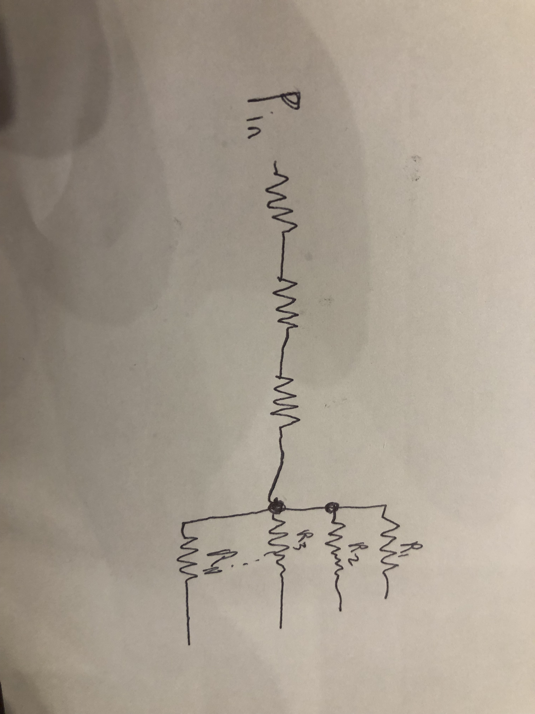Relestomer = telestamor/(kelesatmorAelestamor) = 0.5

Thermal resistance of elastomer = 0.5 °C/W

Rbase = tbase/(khsAhs) = 0.0152

Thermal resistance of base of heat sink = 15.2 m°C/W

1. q=2hNfinAfin3/4(Ts-Ta) = Pin

Ta = 21

Ts= Tj –Pin(Rj+Rel+Rbase)

h=Pin/(Nfin*lfin*(Ahs)1/2* (3/2)*(Ts-Ta)) = 49.47W/m2 .C

Forced air cooling is required

P4)

1. Volume:

γ = 5/3

VA = (ThVDϒ-1/T1)1/(ϒ-1)

VB = V2

Vc = (T1VBϒ-1/Th)1/(ϒ-1)

VD = V1

Pressure:

PA  = PDVDϒ / VAϒ

PB  = PAVA / VB

PC  = PDVD / VC

PD = 100kPa

Temperature:

TA = T1

TB = T1

TC = Th

TD = Th

n = PDVD/RTD

QAB = nRT1Log(VB/VA)

QCD = nRThLog(VD/VC)

QBC=QDA=0

Work:

WAB = QAB

WBC = 1/(1-ϒ) * (PCVC-PBVB)

WCD = QCD

WDA = 1/(1-ϒ) * (PAVA-PDVD)

Entropy change:

ΔSAB = QAB/T1

ΔSCD = QCD/Th

ΔSBC = ΔSDA = 0

|  |  |  |  |  |  |  |  |
| --- | --- | --- | --- | --- | --- | --- | --- |
| Point | Volume (L) | Pressure (kPa) | Temperature (K) | Transition | Heat flux | Work (J) | Entropy Change (J/K) |
| A | 0.559 | 83.09 | 273 | A-B | 27.02 | 27.02 | 0.099 |
| B | 1 | 46.43 | 273 | B-C | 0 | -5.36 | 0 |
| C | 0.895 | 55.88 | 294 | C-D | -29.1 | -29.1 | -0.099 |
| D | 0.5 | 100 | 294 | D-A | 0 | 5.36 | 0 |

1. m = 250g, T1=284K, T2 273K, C = 4.18

E = 250 * (21oK) * 4.18 = J

Cycles = E / QAB = 812.154 => number of cycles required is 813

1. Vm = 18

nm = m/Vm

Cp = c * Vm

**ΔT = QAB/(m*C)**

ΔSw,1 cycle =nmcplog((T1- ΔT)/T1) = -0.091J/K is the entropy change per cycle

1. ΔSw,t= nmcplog(T2/T1)= -77.44J/K is the total entropy
2. Since heat was removed from the water and moved to gas and dumped into the environment therefore it decreases.
3. KR = (TL/(TH-TH)) = 13