
HOW WE WORK TOGETHER
Operating & Communication Playbook — Consolidated Edition
Field | Detail
Document Number | EA-COMM-PLAY-01
Version | 3.2 (Verna/Tareq designated Branch Admin)
Effective Date | 13-Sep-2026
Document Owner | Operations Manager

Document Approval
Prepared By — Designation  Operations Manager | Approved By — Designation  Chief Executive Officer
Name | Name
Signature | Signature
Date | Date

Version 3.0 aligns the playbook with everything settled since v2.0: Roaa's reporting line is confirmed, upward reporting moves to the monthly + email rhythm defined in the Communication Procedure, and the organization chart is now included as Appendix B. Remaining open items are trimmed to what's still genuinely undecided — two additional items (Roaa's cc mechanism and Saud's reporting cadence) are tracked separately in the Communication Procedure Open Items document (EA-COMM-OPEN-01).

1. What We Stand For
We build better humans.
Elite Academy contributes to a better society through martial arts — building character, discipline, and responsibility for ourselves and others.

Our Five Principles
- Safety First — If it's not safe, we don't do it. Safe training, safe places, safe treatment of children.
- Discipline — Show up. Repeat. Improve. Do it over and over to achieve speed and perfect technique.
- Accountability — Own your choices. Get back up. Learn from mistakes. Take responsibility for what comes next.
- Tough Love — Be the example. Hold the standard. Firm, fair, and caring. Earn respect through actions.
- Team First — Respect the individual. Protect the group. Don't be afraid to remove a member when needed.
Safety supports everything: people, character, opportunity, and a better society.

2. Who Does What — Organization Structure
Dakhil holds direction and alignment for Elite Academy as a whole. Four functions report directly, per the Management Meeting notes (10-Sep-2026):
Function | Lead | Mandate
1. Teaching Martial Arts (Training) | Abdullah | Training programs and instructor development. Carlos leads grappling; Ahmed leads striking. All Elite instructors report to Abdullah.
2. Operations (COO) | Nasser | Delivers on the academy's promises: leads, sales, conversion, registration, retention, and inventory across both branches.
3. Public Relations & Marketing | Maryam | Communicates the academy's value through value-based marketing. Ayaa implements the marketing strategy day to day.
4. Systems & IT (New) | Saud | Owns Elite Academy's systems and IT infrastructure (Mindbody, SAQR, and related tools). Scope of responsibility to be fully defined — see Section 9.

Branch Structure (under Operations)
Branch | Branch Admin | Responsibilities
Promenade, Hawalli | Verna | Registrations and correct bookings for both branches.
Bedaya | Tareq | Welcome and attendance, class photography, inventory and local purchasing for both branches.

Roaa reports to Nasser in Operations, sitting above Verna and Tareq, and also coaches under Abdullah in Training — a confirmed dual role. See Appendix B for the full organization chart, including this reporting line.

3. How We Work Together — Cross-Team Handoffs
"Different skills. Same purpose. Stronger together."
Marketing, Training, and Operations all orbit one center: Our Members — one Elite experience, built on trust, communication, support, growth, and belonging.

Handoffs Between Teams
From → To | What Moves
Training → Marketing | Program knowledge and real progress stories.
Marketing → Training | Align the marketing message with what is actually taught.
Marketing → Operations | Campaigns → leads.
Operations → Marketing | Conversion results → better campaigns; Tareq's class photos → Ayaa.
Training → Operations | Attendance, progress, and concerns.
Operations → Training | Bookings and member processes.

Shared Rule: the next person accepts the handoff before we let go.
- (New) Unify how we look — Marketing keeps a consistent visual identity (branding, tone, imagery) across every channel and location.

Reporting Upward to Dakhil
- Operations (Nasser) → Dakhil: monthly summary of leads, conversion, and retention.
- Training (Abdullah) → Dakhil: monthly summary of attendance trends and any unresolved concerns.
- Marketing (Maryam) → Dakhil: monthly summary of campaign results and community growth.
- Systems & IT (Saud) → Dakhil: cadence to be confirmed once the function's scope is defined (tracked in the Communication Procedure Open Items document).
Between monthly reports, any lead can reach Dakhil by email with updates, issues, or urgent matters, and by phone if a message isn't being answered or acted on. Full detail on channels and confirmation steps, at every level, lives in the Communication Procedure (EA-COMM-PROC-01).

Group Sales Handoff
The sales process ends with Marketing (Maryam/Ayaa) securing a paid group registration, then handing delivery to Operations and Training.
TO CONFIRM — recommend naming a single receiving owner for group-sales handoffs (e.g., Nasser or Roaa) who confirms receipt of the signed agreement before Training is scheduled to deliver.

4. What We Expect From Everyone — Daily Standards
Our values, in daily actions:
Expectation | In Practice
Stop Unsafe Activity | Safety comes before sales, speed, or performance.
Arrive Prepared | Be on time, ready, and consistent (uniform, notes, positive attitude).
Practise What You Teach | Model the discipline and respect you expect.
Follow Agreed Processes | Use the right bookings, attendance, and member handoffs.
Own Mistakes | Speak up, help put things right, and follow through.
Close the Loop | Every lead, request, and concern needs an owner.
Be Firm, Fair & Respectful | Challenge with care. Never humiliate or intimidate.
Protect the Group | Address harmful behaviour early. Support both sides.

Before you take the next step, ask: Is it safe? Is it respectful? Does it serve the group? Who owns the next step?

5. Membership & Sales Process

5.1 Every Lead Starts in SAQR
Recorded fields: name and contact, source, branch/interest, one named owner, stage, and next action.

5.2 Individual Membership Journey
Stage | Team Pool | Action
1. Inquiry | Walk-in: Roaa / Verna / Tareq. Digital: AI → Roaa. | Log the inquiry in SAQR.
2. Contacted + Trial Booked | Roaa / Verna / Tareq | Follow up, book, brief the instructor.
3. Trial Delivery | Class instructor / Abdullah | Deliver safe, welcoming training and feedback.
4. Paid Membership | Verna / Tareq / Roaa | Close sale, process payment and registration.
5. Renewal | Training + Front office | Earned through training, completed through follow-up.

TO CONFIRM — a tie-breaker rule (e.g. "whoever first contacts the lead becomes its named owner in SAQR") is still needed so each stage has one accountable owner in practice, not a team pool.

5.3 Member Evaluation & Tiers (New)
- Every member is evaluated on a 4–6 week cadence to track progress against the training program.
- Elite Member tier: members who compete regularly and attend daily qualify for a reduced membership rate. Eligibility criteria and the exact rate are to be confirmed.
- Freeze fee: members may freeze their membership for a fee. The amount and process (who approves, how it's logged) are to be confirmed.

5.4 Group Sales
Step | Owner
Contact | Maryam / Ayaa
Meeting | Maryam / Ayaa
Proposal | Maryam / Ayaa
Agreement | Maryam / Ayaa
Paid Registrations | Maryam / Ayaa
Coordinate Delivery | Operations + Training — receiving owner TO CONFIRM

Renewal is earned through training and completed through follow-up. Every lead: one named owner and a next action.

6. Escalation Path for Safety & Conduct Concerns
Routine information (attendance, standard progress notes, booking changes) flows on the cadence in Section 3. Safety or conduct concerns follow a separate, faster path:
- Any staff member who observes a safety issue or harmful behaviour raises it the same day to their function lead (Abdullah for training-floor issues, Nasser for front-office/member issues).
- The function lead names an owner for the concern immediately and logs it, per the "close the loop" standard.
- Any concern involving member safety or a potential removal decision is escalated to Dakhil within 24 hours.
These timings are confirmed. For any other message that stalls because a lead isn't answering or acting on it, staff can call Dakhil directly by phone (Communication Procedure, Section 6.3).

7. Member Photo & Video Consent (New)
Per the Management Meeting notes, written parental/guardian consent is required before any member's photo or video is used — including the internal handoff "Tareq's class photos → Ayaa" described in Section 3.
- Consent is collected in writing at enrollment using the Media Consent Form (Appendix A).
- The Branch Receiver collecting registration (Verna or Tareq, per branch) is responsible for obtaining and filing the signed form alongside the member's registration record.
- Ayaa (Marketing) only uses photos or videos of members whose signed consent form is on file and covers the intended use (internal records, social media, or website/marketing materials, as selected on the form).
- A member's consent can be withdrawn at any time in writing; once withdrawn, existing posted material involving that member should be reviewed for removal.
TO CONFIRM — where signed consent forms are filed/stored (physical file vs. shared drive) and who audits that Marketing only uses consented images, should be assigned as part of finalizing this section.

8. Campaign Performance Tracking (New)
Per the Management Meeting notes, a mechanism is needed to measure campaign performance. This extends the existing "Conversion results → better campaigns" handoff (Section 3) into a concrete, trackable process.

8.1 Campaign Tracker
Proposed fields, logged by Ayaa for every campaign:
Field | Description
Campaign Name | Short identifying name for the campaign.
Channel | Where it ran (Instagram, Google, in-branch, etc.).
Start / End Date | Campaign flight dates.
Spend | Amount spent on the campaign.
Leads Generated | Count of SAQR leads tagged with this campaign as source.
Conversions | Count of those leads that became Paid Memberships in SAQR.
Cost per Lead | Spend ÷ Leads Generated.
Cost per Conversion | Spend ÷ Conversions.

8.2 Process
- Every SAQR lead is tagged with its source campaign at intake (Section 5.1), so leads can be traced back to the campaign that generated them.
- Ayaa updates the Campaign Tracker at the end of each campaign, or monthly for ongoing campaigns.
- Cost per lead and cost per conversion feed directly into the "Conversion results → better campaigns" handoff to Operations (Section 3), closing the loop between spend and results.
TO CONFIRM — where the Campaign Tracker itself lives (spreadsheet, SAQR add-on, or another tool) is a Systems & IT (Saud) decision once that function's scope is defined.

9. Open Items Requiring a Decision
These items are flagged, not resolved, in this edition. Two additional items — Roaa's cc-visibility mechanism between Nasser and Abdullah, and Saud's upward-reporting cadence — are tracked separately in the Communication Procedure Open Items document (EA-COMM-OPEN-01), not repeated here.
1. Name a single receiving owner for the Group Sales → Operations/Training handoff (Section 3).
2. Adopt a tie-breaker rule so every funnel stage has one named owner in practice (Section 5.2).
3. Confirm Elite Member tier eligibility and rate, and the freeze fee amount and approval process (Section 5.3).
4. Confirm where signed media consent forms are filed and who audits Marketing's use of them (Section 7).
5. Confirm which tool will host the Campaign Tracker — likely a Systems & IT decision (Section 8).

Appendix A — Member Photo & Video Consent Form
Form Code: EA-MKT-FRM-01

Member / Child Details
Member / Child Full Name
Date of Birth
Branch (Promenade / Bedaya)
Parent / Guardian Full Name
Parent / Guardian Contact Number

Consent
I, the parent/guardian named above, consent to Elite Academy photographing and/or filming my child during classes, events, and competitions, and to the use of that photo/video material for the purposes I have selected below (tick all that apply):
- Internal training and progress records only
- Elite Academy social media (Instagram, Facebook, etc.)
- Elite Academy website and marketing materials (flyers, ads, etc.)
I understand that I may withdraw this consent at any time by notifying my branch in writing, and that Elite Academy will review existing posted material involving my child for removal upon request.

Signature
Parent/Guardian Signature |  | Date
Received By (Staff Name) |  | Branch

Note: File this form with the member's registration record. Photos/videos of this member should only be used for the purpose(s) ticked above.

Appendix B — Organization Chart
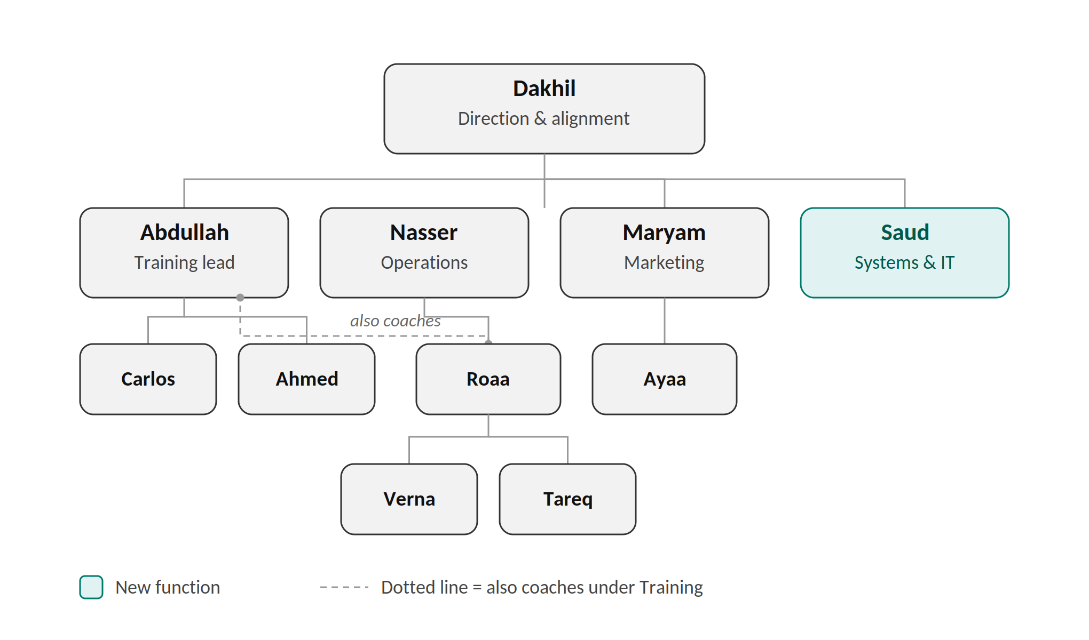
Carlos leads grappling and Ahmed leads striking under Abdullah, with all instructors reporting to him. Roaa reports to Nasser in Operations, sitting above Verna (Promenade, Hawalli) and Tareq (Bedaya), and also coaches under Abdullah in Training — shown by the dotted line. Ayaa implements marketing strategy under Maryam. Saud (highlighted) is the newly added Systems & IT function; his team, if any, is not yet defined.

