
INVENTORY MANAGEMENT PROCEDURE
Purchase Request & Approval, Receipt of Items, and Inter-Branch Transfer of Ownership
Procedure Number | EA-INV-PROC-01
Procedure Title | Inventory Management Procedure
Version | 3.1
Effective Date | 13-Sep-2026

Document Approval
Prepared By — Designation  Operations Manager | Approved By — Designation  Chief Executive Officer
Name | Name
Signature | Signature
Date | Date

This procedure is binding on all staff involved in inventory management across Elite Academy branches. Signature by the Chief Executive Officer above authorizes this version for implementation and confirms visibility into how inventory is received, approved, and transferred between branches.
Inventory Management Procedure
Receipt of Items & Inter-Branch Transfer of Ownership

1. Purpose
This procedure describes how inventory items are received from vendors and how ownership of items is transferred between branches. It is a simple, paper-based supplement to the Inventory tab/function in Mindbody — the steps below are followed in addition to, not instead of, recording items in Mindbody.

2. Scope
This procedure covers three activities:
- Requesting and approving a purchase before any order is placed with a vendor (Procedure A).
- Receiving a vendor order — local or international — at Promenade (Procedure B).
- Transferring items between branches, including delivering Bedaya's share of a freshly received order (Procedure C).

3. Roles & Responsibilities
Role | Branch | Responsibility
Operations Manager | All branches | Reviews and approves, rejects, or amends every Purchase Request Form before an order is placed with any vendor, local or international.
Purchasing / Receiving Coordinator | Promenade | Places approved orders with vendors. Receives and checks all vendor orders — local and international — against the invoice and the approved Purchase Request Form, signs the Initial Receipt Form, and enters the received items into the Mindbody Inventory system for Promenade.
Branch Receiver | Bedaya | Identifies stock needs and submits Purchase Request Forms for approval (local vendor requests limited to once per calendar month). Confirms and signs for items transferred in from Promenade, and enters those items into the Mindbody Inventory system for Bedaya.
Branch Receiver | Promenade | Identifies stock needs and submits Purchase Request Forms for approval. Confirms and signs for any items transferred into Promenade, and enters those items into the Mindbody Inventory system for Promenade.

4. Procedure A – Purchase Request & Approval
Used whenever a branch identifies a need to purchase items, from a local or international vendor. No order is placed with any vendor until the request has been approved.
- The branch admin (the Bedaya or Promenade Branch Receiver) identifies the items needed and fills in the Purchase Request Form.
- The branch admin submits the form to the Operations Manager for approval.
- The Operations Manager reviews the request and approves, rejects, or amends it, signing the form accordingly.
- The Operations Manager or Coordinator informs the requesting branch admin of the decision (approved, rejected, or amended) — including the reason for any rejection or amendment — before the request is closed or the order is placed. [Notification channel to be confirmed.]
- If approved, the Purchasing / Receiving Coordinator places the order with the vendor, referencing the approved Purchase Request Form.
- Local vendor purchase requests are limited to one per calendar month per branch; the Operations Manager enforces this limit at the approval step.
- The Operations Manager reviews and decides on each Purchase Request Form within 2 business days of submission.
- A copy of the approved Purchase Request Form is kept by the requesting branch and by the Coordinator, to be matched against the Initial Receipt Form when the order arrives.
- No purchase is placed with any vendor without an approved Purchase Request Form.

5. Procedure B – Receiving the Vendor Order (Local or International)
Performed by the Purchasing / Receiving Coordinator at Promenade. This procedure applies the same way whether the order is from the main international vendor or a local vendor — all deliveries arrive at Promenade, never directly at Bedaya.
- Receive the order and the vendor invoice at Promenade.
- Check the quantities received against the invoice and the approved Purchase Request Form, per item and per size.
- If the received quantities match, proceed to fill in the Initial Receipt Form.
- If any items are missing or the received quantities do not match, fill in the Missing / Discrepancy Report for the affected items and notify the vendor.
- Fill in the Initial Receipt Form for the items actually received and sign it.
- Once signed, the Coordinator is responsible for the items received.
- The Coordinator enters the received items into the Mindbody Inventory system for Promenade.
- The vendor invoice and the approved Purchase Request Form are attached to the Initial Receipt Form.
- If a Missing / Discrepancy Report was raised, attach a copy of it to the Initial Receipt Form as well.
- The Coordinator also notifies the Operations Manager of any discrepancy raised, so budget and payment can be reconciled against what was actually received.
- The form(s) are filed into the inventory file.

6. Procedure C – Internal Transfer Between Branches
Used any time stock moves from one branch to another — most commonly to send Bedaya its share of an order just received at Promenade (Procedure B), but also for any other rebalancing of existing stock between branches.
- The sending branch identifies the items to transfer, per item and per size.
- The sending branch fills in and signs the Internal Transfer Form.
- The receiving branch signs the Internal Transfer Form to confirm receipt; ownership of the items transfers at this point.
- The receiving branch enters the transferred items into the Mindbody Inventory system for their own branch.
- Both branches file their own signed copy of the form.

7. Process Flow Diagrams
The diagrams below summarise Procedures A–C visually.
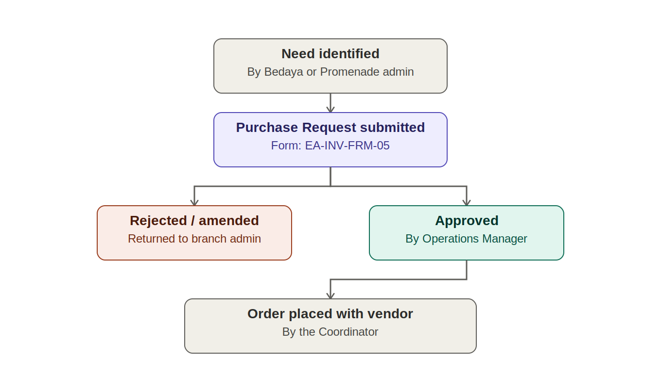
Figure 1 — Purchase request and approval, before any order is placed (Procedure A)
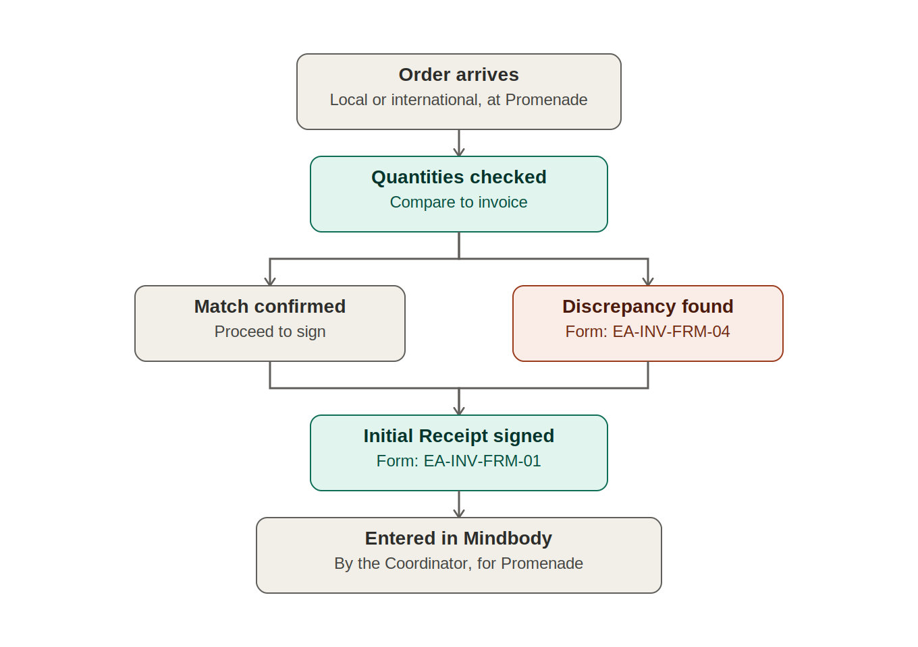
Figure 2 — Receiving a vendor order at Promenade, local or international (Procedure B)
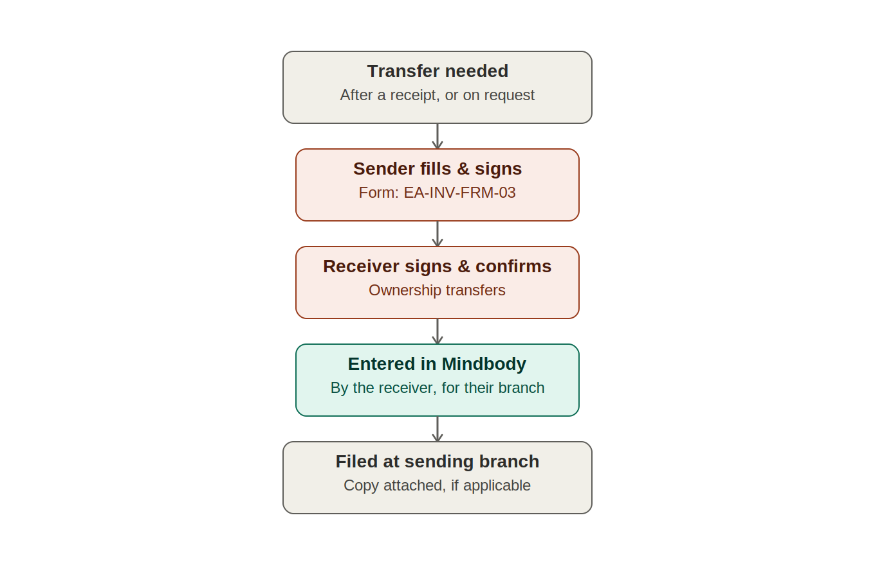
Figure 3 — Internal transfer between branches, including delivering Bedaya's share (Procedure C)

8. Forms
Four active forms support this procedure; a fifth (the former Purchase Breakdown Form, EA-INV-FRM-02) has been retired and superseded by the Internal Transfer Form. Full fillable copies of each active form are attached at the end of this document (Appendix A–D).

8.1 Purchase Request Form (Form Code: EA-INV-FRM-05)
Completed by a branch admin whenever a purchase is needed, and approved by the Operations Manager before any order is placed (Procedure A). See Appendix A.
Field | Description
Reference No. | Unique sequential number assigned to this specific form, for filing and traceability.
Requesting Branch | Branch identifying the need (Bedaya or Promenade).
Requested By | Name of the branch admin submitting the request.
Date of Request | Date the request was submitted.
Vendor Type | Local or international.
Items Table | Items needed, per item and per size, with quantities and reason.
Approval Decision | Approved, Rejected, or Amended, decided by the Operations Manager.
Operations Manager Signature | Signature confirming the approval decision.

8.2 Initial Receipt Form (Form Code: EA-INV-FRM-01)
Completed at the point of receiving any vendor order, local or international (Procedure B). See Appendix B.
Field | Description
Reference No. | Unique sequential number assigned to this specific form, for filing and traceability.
Vendor's Name | Name of the supplier the order was received from.
Invoice Number | The vendor's invoice number for the order.
Date | Date the order was received.
Items Table | List of items received, per item and per size, with quantities.
Received Date | Date the receipt was confirmed / signed.
Location | Branch where the items were received (Promenade).
Signature (Receiver) | Signature of the person confirming receipt.

8.3 Internal Transfer Form (Form Code: EA-INV-FRM-03)
Completed whenever stock moves from one branch to another, including sending Bedaya its share of a freshly received order (Procedure C). See Appendix C.
Field | Description
Reference No. | Unique sequential number assigned to this specific form, for filing and traceability.
Sender's Name & Signature | Person releasing the items from the sending branch.
Receiver's Name & Signature | Person accepting the items at the receiving branch.
Items Table | Items and quantities transferred, per item and per size.

8.4 Missing / Discrepancy Report (Form Code: EA-INV-FRM-04)
Completed at the confirmation stage of Procedure B when the vendor invoice quantities do not match the quantities actually received. See Appendix D.
Field | Description
Reference No. | Unique sequential number assigned to this specific form, for filing and traceability.
Related Initial Receipt Ref. No. | Reference number of the Initial Receipt Form this report relates to.
Vendor's Name | Name of the supplier the order was received from.
Invoice Number | The vendor's invoice number for the order.
Date | Date the discrepancy was identified.
Items Table | Item, size, invoiced quantity, received quantity, and shortfall for each affected item.
Reported By | Name and signature of the person who identified the discrepancy.
Vendor Notified | Date the vendor was notified of the shortfall.

9. Record Keeping
All signed forms (and any attached invoices, discrepancy reports, or transfer records) are filed by the person who signed for receipt at their branch. Each branch's admin — the Promenade Coordinator for items received there, and the Bedaya Branch Receiver for items transferred in — is responsible for entering their own branch's received items into the Mindbody Inventory system. The Operations Manager's approval on the Purchase Request Form is the control point for the once-per-month local vendor limit, and approved requests are matched against Initial Receipt Forms as they arrive. Signed forms should also be scanned and saved to the shared drive within 3 business days of filing, so records are not lost if a physical copy is misplaced.
Appendix A — Purchase Request Form
Completed by a branch admin whenever a purchase is needed, and approved by the Operations Manager before any order is placed (Procedure A).
Reference No. | PRF-______

Request Details
Requesting Branch |  | Requested By
Date of Request |  | Vendor Type (Local / Int'l)
Items Requested
Item | Size | Quantity | Reason / Notes

Approval — Operations Manager
Decision (Approved / Rejected / Amended) |  | Comments
Operations Manager Name |  | Signature & Date
Note: No order may be placed with any vendor until this form is approved. Local vendor requests are limited to one per branch per calendar month. Keep a copy at the requesting branch and with the Coordinator, to be matched against the Initial Receipt Form on delivery.
Appendix B — Initial Receipt Form
Completed by the Purchasing / Receiving Coordinator when any vendor order — local or international — is received (Procedure B).
Reference No. | IRF-______

Order Details
Vendor's Name |  | Invoice Number
Date Received |  | Location
Items Received
Item | Size | Quantity | Notes

Confirmation
Received By (Name) |  | Signature
Note: Once signed, the Coordinator is responsible for the items received and for entering them into the Mindbody Inventory system. Attach a copy of the vendor invoice and the approved Purchase Request Form to this form and file together in the inventory file.
Appendix C — Internal Transfer Form
Completed whenever stock moves from one branch to another, including sending Bedaya its share of a freshly received order (Procedure C).
Reference No. | ITF-______

Transfer Details
From Branch |  | To Branch
Date Requested |  | Date Transferred
Items Transferred
Item | Size | Quantity | Notes

Confirmation
Sender's Name |  | Sender's Signature
Receiver's Name |  | Receiver's Signature
Note: Once signed, the receiving branch is responsible for entering these items into the Mindbody Inventory system for their branch. If this transfer follows a fresh vendor receipt, attach a copy of the Initial Receipt Form; otherwise attach the original request email. File at the sending branch.
Appendix D — Missing / Discrepancy Report
Completed at the confirmation stage of Procedure B when invoice quantities do not match quantities received.
Reference No. | MDR-______

Order Reference
Related Initial Receipt Ref. No. |  | Vendor's Name
Invoice Number |  | Date
Items Affected
Item | Size | Invoiced Qty | Received Qty | Shortfall | Notes

Reported By
Name |  | Signature
Vendor Notified (Date) |  | Resolution / Follow-up
Note: Attach a copy of this report to the related Initial Receipt Form and file together in the inventory file.

