武汉家教网

目录

1. **引言**........................................................................................1

1.1目的...............................................................................1

1.2背景以及功能概述.......................................................1

1. **运行环境**................................................................................1

2.1软件环境.......................................................................1

2.2硬件环境.......................................................................1

1. **网站设计内容**........................................................................1

3.1 网站首页........................................................................2

3.2家长注册.........................................................................3

3.3家长登录.........................................................................6

3.4家长个人中心.................................................................7

3.5家教注册........................................................................15

3.6家教登录........................................................................21

3.7家教个人中心................................................................23

1. **引言**

**1.1目的**

这个用户手册的编写是为了详细的说明武汉家教网从设计到使用的整体过程是如何实现的。

**1.2背景，功能描述**

网站名称：武汉家教网一

背景：随着社会的发展，时代的进步，社会竞争力也越来越大。父母对自己孩子的学习教育问题也越来越看重，为了满足家长或学生自己对不论是基础学科的学习还是特长爱好的培养，开发了一个家教网。虽然现在市面上有很多五花八门的家教网站，但是我们还是想根据自己对家教类型网站的理解亲手设计一个区域只限于武汉市的家教网。

主要功能：

1. 家长或者学生可以根据自己对家教的要求预约家教。
2. 家教也可以发布自己的信息，方便家长查看预约。
3. **运行环境：**

**2.1软件环境**

Visual Studio 2015

**2.2硬件环境**

Windows系统

**3网站设计内容：**

**3.1网站首页：**

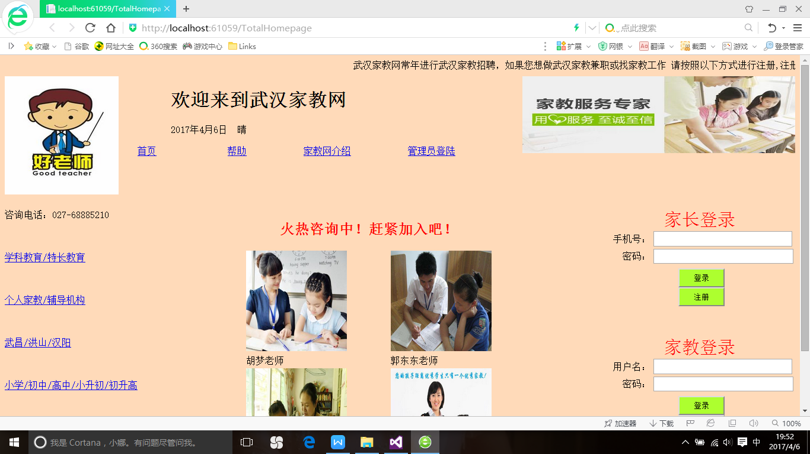

**3.2家长注册：**

（1）运行结果显示

家长开始注册

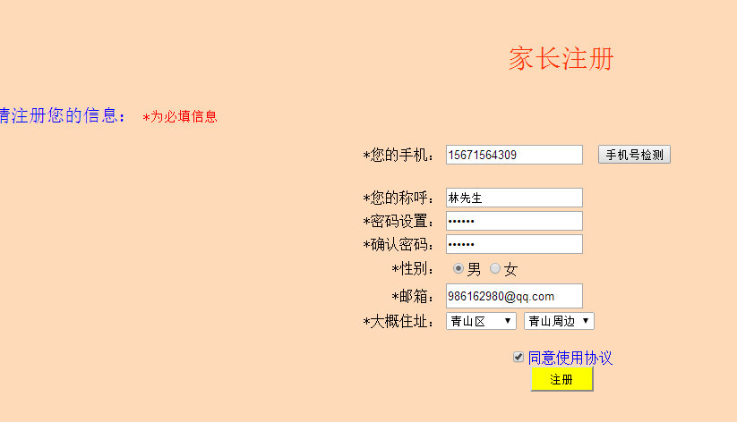

成功注册.......

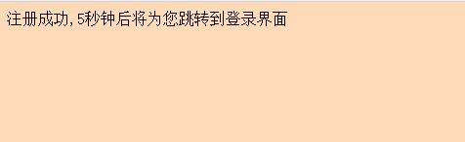

注册成功后进入登录页面

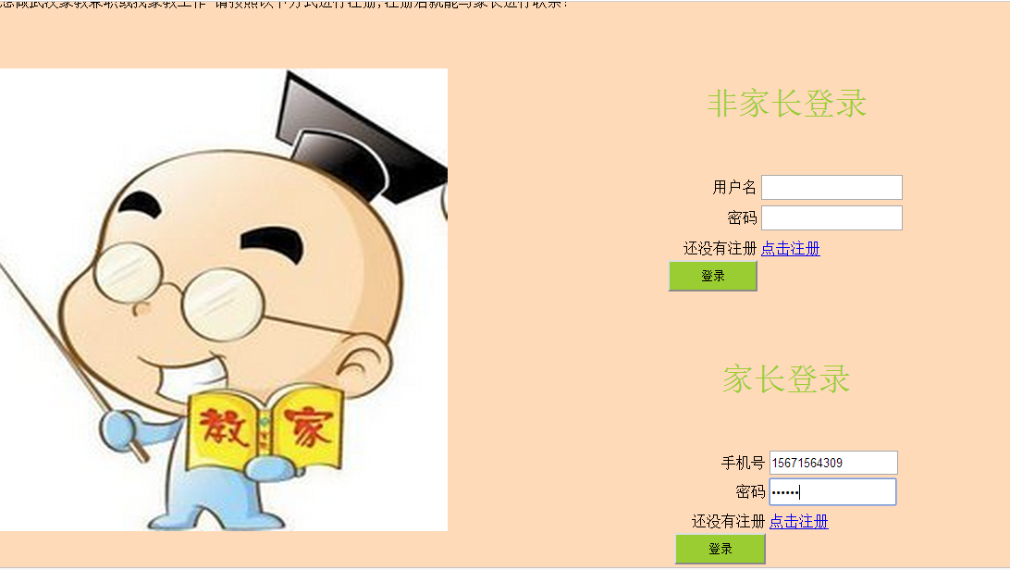

1. 主要代码：

//注册按钮，保存注册的信息

protected void zhuce_Click(object sender, EventArgs e)

{

Session["phonenums"] = nindeshouji.Text;

Session["calls"] = nindechenghu.Text;

Session["psws"] = psw1.Text;

Session["sexs"] = xingbie.SelectedValue;

Session["emails"] = youxiang.Text;

Session["addresss"] = dagaizhuzhi1.SelectedItem.Text + dagaizhuzhi2.SelectedItem.Text;

Response.Redirect("ShowParentInfor.aspx");

}

//将注册的信息写入数据库中

protected void CustomValidator1_ServerValidate(object source, ServerValidateEventArgs args)

{

psw1.Attributes["value"] = psw1.Text;

psw2.Attributes["value"] = psw2.Text;

string connStr = @"Data Source=(LocalDB)\MSSQLLocalDB;AttachDbFilename=D:\VS项目\导师制-家教网\WebApplication2\App_Data\ParentInfm.mdf;Integrated Security=True";

SqlConnection conn = new SqlConnection(connStr);

try

{

conn.Open();

SqlCommand cmd = new SqlCommand("select count(*) from ParTab where PHONENUM=@phonenums ", conn);

cmd.Parameters.Add("@phonenums", SqlDbType.NChar);

cmd.Parameters[0].Value = nindeshouji.Text;

int count = (int)cmd.ExecuteScalar();

conn.Close();

if (count > 0)

args.IsValid = false;

else

args.IsValid = true;

}

catch

{

args.IsValid = false;

Response.Write("连接失败");

}

}

1. 数据库信息

数据库中家长信息表的定义

表名：ParTab 主键是PHONENUM手机号

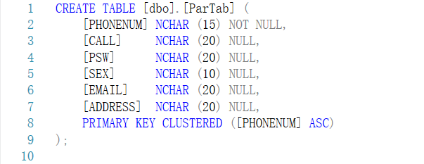

表中的详细信息

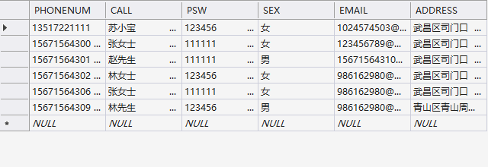

**3.3家长登录**

（1）运行结果显示

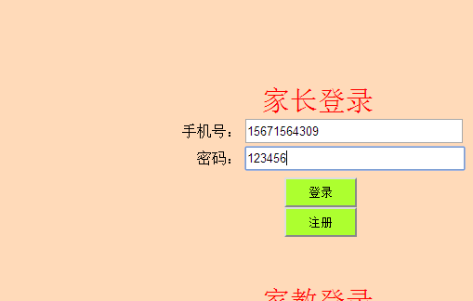

1. 关键代码：

//家长登录按钮连接数据库.....

protected void ParLog_Click(object sender, EventArgs e)

{

Session["phone"] = ParPhone.Text;

string connStr = @"Data Source=(LocalDB)\MSSQLLocalDB;AttachDbFilename=D:\VS项目\导师制-家教网\WebApplication2\App_Data\ParentInfm.mdf;Integrated Security=True";

SqlConnection conn = new SqlConnection(connStr);

try

{

conn.Open();

SqlCommand cmd = new SqlCommand("select count(*) from ParTab where phonenum=@phonenum ", conn);

cmd.Parameters.Add("@phonenum", SqlDbType.NChar);

cmd.Parameters.Add("pas", SqlDbType.NChar);

cmd.Parameters[0].Value = ParPhone.Text;

cmd.Parameters[1].Value = ParPsw.Text;

int count = (int)cmd.ExecuteScalar();

conn.Close();

if (count == 1)

{

Response.Redirect("ParentCenter.aspx");

}

else

{

ParLabel.Text = "用户名或密码不对";

}

}

catch

{

Response.Write("连接失败！");

}

}

**3.4家长个人中心：**

1. 运行界面

**家长个人中心页面**

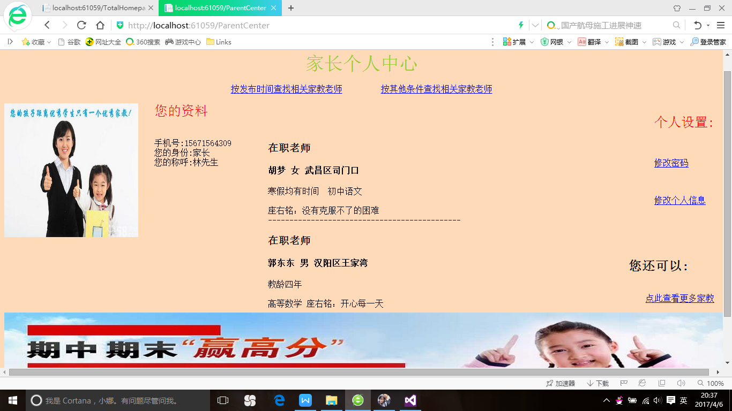

**按发布时间查找相关家教老师页面：**

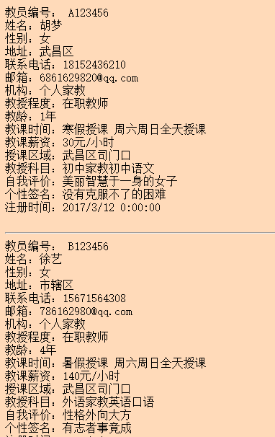

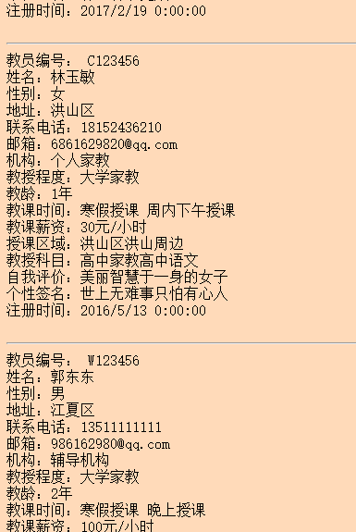

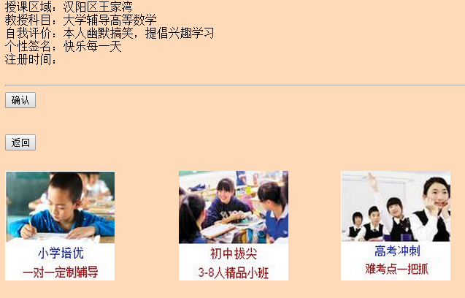

**按其他条件查找相关家教老师页面：**

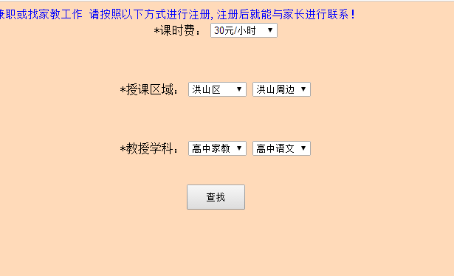

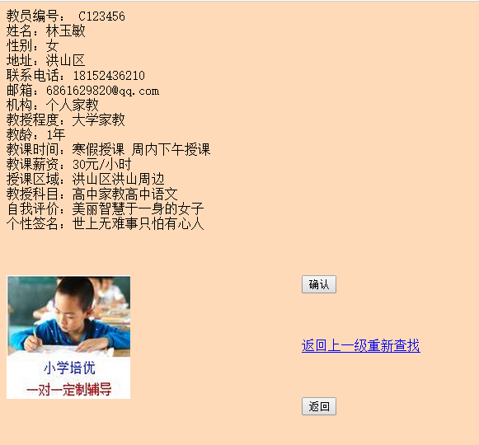

1. **主要代码**：

**//连接数据库，显示家长信息**

protected void Page_Load(object sender, EventArgs e)

{

String user = "", status = "", call = "";

string ans = "";

string connStr = @"Data Source=(LocalDB)\MSSQLLocalDB;AttachDbFilename=D:\VS项目\导师制-家教网\WebApplication2\App_Data\ParentInfm.mdf;Integrated Security=True";

SqlConnection conn = new SqlConnection(connStr);

SqlDataReader dr = null;

try

{

conn.Open();

SqlCommand cmd = new SqlCommand("select * from ParTab where PHONENUM=@phonenums ", conn);

cmd.Parameters.Add("@phonenums", SqlDbType.NChar);

cmd.Parameters[0].Value = Session["phone"];

dr = cmd.ExecuteReader();

if (dr.Read())

{

user = "手机号:" + dr[0].ToString();

status = "您的身份:" + "家长";

call = "您的称呼:" + dr[1].ToString();

ParInf.Text = dr[0].ToString();

}

ans = user + "<br/>" + status + "<br/>" + call + "<br/>";

ParInf.Text = ans;

}

catch

{

ParInf.Text = "操作失败";

}

finally

{

if (dr != null)

dr.Close();

conn.Close();

}

}

**//按发布时间查找相关家教老师：**

protected void checktime_Click(object sender, EventArgs e)

{

string regidate =DateTime.Now.ToLongDateString();

Session["家教信息时间"] = "";

string connStr = @"Data Source=(LocalDB)\MSSQLLocalDB;AttachDbFilename=D:\VS项目\导师制-家教网\WebApplication2\App_Data\TutorInf.mdf;Integrated Security=True";

SqlConnection conn = new SqlConnection(connStr);

try

{

conn.Open();

SqlCommand cmd = new SqlCommand("select * from TutorTable order by time DESC ", conn);

cmd.Parameters.Add("@time", SqlDbType.NChar);

cmd.Parameters[0].Value =regidate.ToString();

SqlDataReader dr = cmd.ExecuteReader();

while (dr.Read())

{

Session["家教信息时间"]+= "教员编号： " + dr[0].ToString() + "<br/>" + "姓名：" + dr[6].ToString() + "<br/>" + "性别：" + dr[8].ToString() + "<br/>" + "地址：" + dr[16].ToString() + "<br/>" + "联系电话：" + dr[3].ToString() + "<br/>" + "邮箱：" + dr[2].ToString() + "<br/>" + "机构：" + dr[4].ToString() + "<br/>" + "教授程度：" + dr[7].ToString() + "<br/>" + "教龄：" + dr[11].ToString() + "<br/>" + "教课时间：" + dr[12].ToString() + " " + dr[13].ToString() + "<br/>" + "教课薪资：" + dr[14].ToString() + "<br/>" + "授课区域：" + dr[15].ToString() + "<br/>" + "教授科目：" + dr[17].ToString() + "<br/>" + "自我评价：" + dr[18].ToString() + "<br/>" + "个性签名：" + dr[9].ToString() + "<br/>" +"注册时间："+dr[19].ToString()+"<br/>" + "<br/>"+"<hr/>";

}

Response.Redirect("ShowTimeCheck.aspx");

conn.Close();

}

catch (Exception ee)

{

Response.Write(ee.Message);

Response.Write("连接失败！");

}

}

**按其他条件查找家教信息**

protected void Unnamed1_Click(object sender, EventArgs e)

{

Session["1"] = DropDownList_keshifei.SelectedItem.ToString();

Session["2"] = shukequyu1.SelectedItem.ToString() + shukequyu2.SelectedItem.ToString();

Session["3"] = jiaoshouxueke1.SelectedItem.ToString() + jiaoshouxueke2.SelectedItem.ToString();

string connStr = @"Data Source=(LocalDB)\MSSQLLocalDB;AttachDbFilename=D:\VS项目\导师制-家教网\WebApplication2\App_Data\TutorInf.mdf;Integrated Security=True";

SqlConnection conn = new SqlConnection(connStr);

try

{

conn.Open();

SqlCommand cmd = new SqlCommand("select * from TutorTable where TeachCost=@TeachCost and TeachArea=@TeachArea and TeachSubject=@TeachSubject ", conn);

cmd.Parameters.Add("@TeachCost", SqlDbType.NChar);

cmd.Parameters.Add("@TeachArea", SqlDbType.NChar);

cmd.Parameters.Add("@TeachSubject", SqlDbType.NChar);

cmd.Parameters[0].Value = Session["1"].ToString();

cmd.Parameters[1].Value = Session["2"].ToString();

cmd.Parameters[2].Value = Session["3"].ToString();

SqlDataReader dr = cmd.ExecuteReader();

while (dr.Read())

{

Session["家教信息"] = "教员编号： " +dr[0].ToString() +"<br/>"+"姓名："+ dr[6].ToString() + "<br/>" + "性别：" + dr[8].ToString() + "<br/>" + "地址：" + dr[16].ToString() + "<br/>" + "联系电话：" + dr[3].ToString() + "<br/>" + "邮箱：" + dr[2].ToString() + "<br/>" + "机构：" + dr[4].ToString() + "<br/>" + "教授程度：" + dr[7].ToString() + "<br/>" + "教龄：" + dr[11].ToString() + "<br/>" + "教课时间：" + dr[12].ToString() +" "+ dr[13].ToString() + "<br/>" + "教课薪资：" + dr[14].ToString() + "<br/>" + "授课区域：" + dr[15].ToString() + "<br/>" + "教授科目：" + dr[17].ToString() + "<br/>" + "自我评价：" + dr[18].ToString() + "<br/>" + "个性签名：" + dr[9].ToString() + "<br/>" + "<br/>" + "<br/>" + "<br/>";

Response.Redirect("ShowCheck.aspx");

}

conn.Close();

}

catch(Exception ee)

{

Response.Write(ee.Message);

Response.Write("连接失败！");

}

**3.5家教注册**

1. 运行页面

家教注册信息页面1

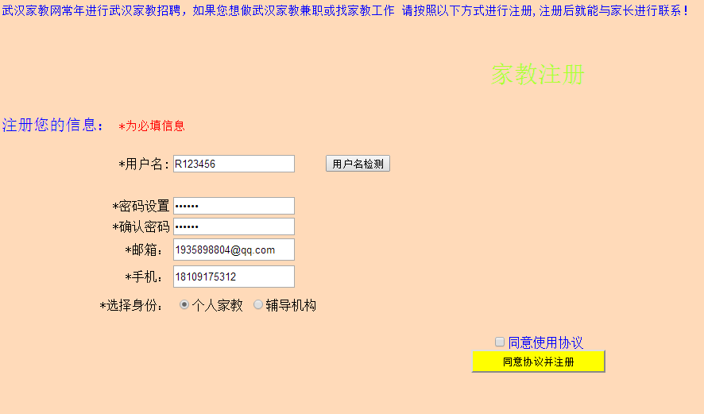

家教注册信息页面2

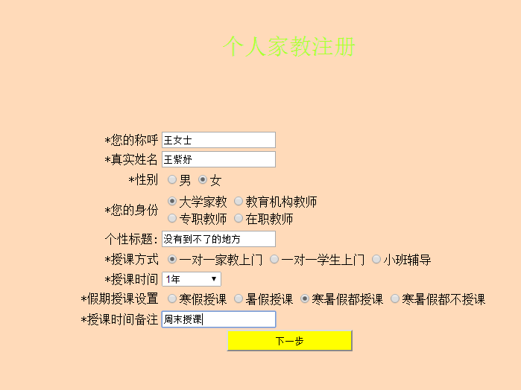

家教注册信息页面3

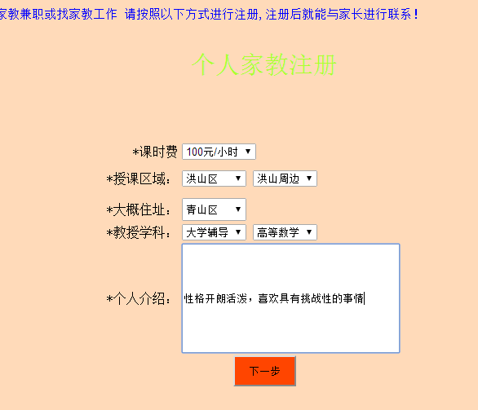

注册成功....

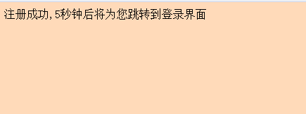

注册成功后登录.....

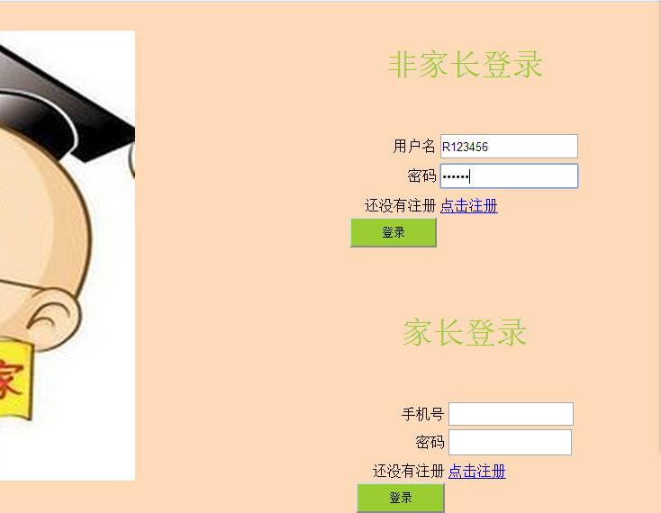

1. 关键代码：

**//连接数据库..**

protected void CustomValidator1_ServerValidate(object source, ServerValidateEventArgs args)

{

psw1.Attributes["value"] = psw1.Text;

psw2.Attributes["value"] = psw2.Text;

string connStr = @"Data Source=(LocalDB)\MSSQLLocalDB;AttachDbFilename=Data Source=(LocalDB)\MSSQLLocalDB;AttachDbFilename=D:\VS项目\导师制-家教网\WebApplication2\App_Data\TutorInf.mdf;Integrated Security=True";

SqlConnection conn = new SqlConnection(connStr);

try

{

conn.Open();

SqlCommand cmd = new SqlCommand("select count(*) from TutorTable where USERN=@use ", conn);

cmd.Parameters.Add("@use", SqlDbType.NChar);

cmd.Parameters[0].Value = username.Text;

int count = (int)cmd.ExecuteScalar();

conn.Close();

if (count > 0)

args.IsValid = false;

else

args.IsValid = true;

}

catch

{

args.IsValid = false;

Response.Write("连接失败");

}

}

**//注册按钮，保存家教注册的信息**

protected void button1_Click(object sender, EventArgs e)

{

Session["use"] = username.Text;

Session["psw"] = psw1.Text;

Session["EMail"] = email.Text;

Session["phone"] = phonenum.Text;

Session["shenfen"] = xuanzeshenfen.SelectedValue;

Response.Redirect("FirstTutorInformation.aspx");

}

**//第二个页面保存家教注册信息**

protected void xiayibu_Click(object sender, EventArgs e)

{

Session["calls"] = nindechenghu.Text;//您的称呼

Session["names"] = zhenshixingming.Text;//真实姓名

Session["degrees"] = nindeshenfen.SelectedValue;//您的身份

Session["sex"] = sexs.SelectedValue;//性别

Session["titles"] = gexingbiaoti.Text;//个性标题

Session["TeachMeths"] = RadioButtonList_shoukefangshi.SelectedValue;//授课方式

Session["TeachTimes"] = DropDownList_shoukeshijian.SelectedItem.Text;//授课时间

Session["TeachSets"] = RadioButtonList_jiaqishukeshezhi.SelectedValue;//假期授课设置

Session["TeachTimeBZs"] = shukeshijianbeizhu.Text;//授课时间备注

Response.Redirect("SecondTutor");

}

**//第三个页面保存家教注册信息**

protected void xiayibu_Click(object sender, EventArgs e)

{

Session["TeachCosts"] = DropDownList_keshifei.SelectedItem.Text;//课时费

Session["TeachAreas"] = shukequyu1.SelectedItem.Text + shukequyu2.SelectedItem.Text;//授课区域

Session["Addresss"] = DropDownList_dagaizhuzhi.SelectedItem.Text;///大概住址

Session["TeachSubjects"] = jiaoshouxueke1.SelectedItem.Text + jiaoshouxueke2.SelectedItem.Text;//教授学科

Session["PersonInfors"] = gerenjieshao.Text;//个人介绍

Response.Redirect("ShowTutor.aspx");

}

1. 数据库：

数据库中表的定义 表名：TutorTable主键用户名USERN

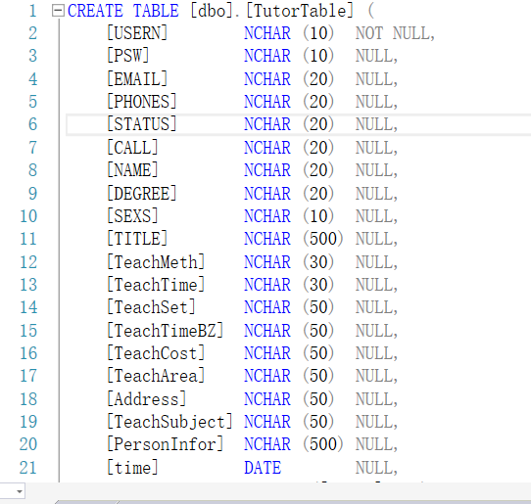

表中的数据：

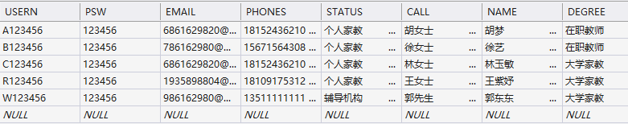

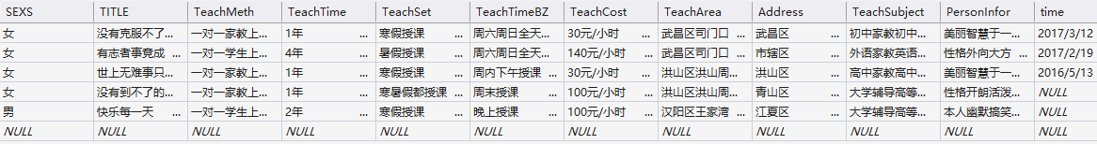

**3.6家教登录**

1. 运行界面



1. 关键代码

**//连接数据库**

protected void TutLog_Click(object sender, EventArgs e)

{

Session["user"] = TutUser.Text;

string connStr = @"Data Source=(LocalDB)\MSSQLLocalDB;AttachDbFilename=Data Source=(LocalDB)\MSSQLLocalDB;AttachDbFilename=D:\VS项目\导师制-家教网\WebApplication2\App_Data\TutorInf.mdf;Integrated Security=True";

SqlConnection conn = new SqlConnection(connStr);

try

{

conn.Open();

SqlCommand cmd = new SqlCommand("select count(*) from TutorTable where USERN=@use ", conn);

cmd.Parameters.Add("use", SqlDbType.NChar);

cmd.Parameters.Add("psw", SqlDbType.NChar);

cmd.Parameters[0].Value = TutUser.Text;

cmd.Parameters[1].Value = TutPsw.Text;

int count = (int)cmd.ExecuteScalar();

conn.Close();

if (count == 1)

{

Response.Redirect("TutorCenter.aspx");

}

else

{

TutLabel.Text = "用户名或密码不对";

}

}

catch

{

Response.Write("连接失败！");

}

}

**3.7家教个人中心**

1. 运行界面

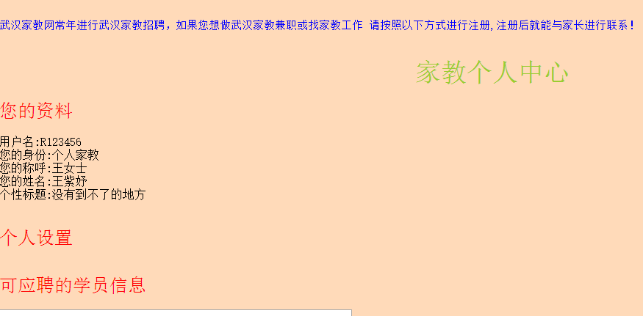

1. 关键代码

**//连接数据库，显示家教的个人信息**

protected void Page_Load(object sender, EventArgs e)

{

String user = "", status = "",call="",name="",title="";

string ans = "";

string connStr = @"Data Source=(LocalDB)\MSSQLLocalDB;AttachDbFilename=Data Source=(LocalDB)\MSSQLLocalDB;AttachDbFilename=D:\VS项目\导师制-家教网\WebApplication2\App_Data\TutorInf.mdf;Integrated Security=True";

SqlConnection conn = new SqlConnection(connStr);

SqlDataReader dr = null;

try

{

conn.Open();

SqlCommand cmd = new SqlCommand("select * from TutorTable where USERN=@use ", conn);

cmd.Parameters.Add("use", SqlDbType.NChar);

cmd.Parameters[0].Value = Session["user"];

dr = cmd.ExecuteReader();

if (dr.Read())

{

user = "用户名:" + dr[0].ToString();

status = "您的身份:" + dr[4].ToString();

call = "您的称呼:" + dr[5].ToString();

name = "您的姓名:" + dr[6].ToString();

title = "个性标题:" + dr[9].ToString();

TutInf.Text = dr[0].ToString();

}

ans = user+"<br/>" + status + "<br/>" + call + "<br/>" + name + "<br/>" + title + "<br/>";

TutInf.Text = ans;

}

catch

{

TutInf.Text = "操作失败";

}

finally

{

if (dr != null)

dr.Close();

conn.Close();

}

}

}

}