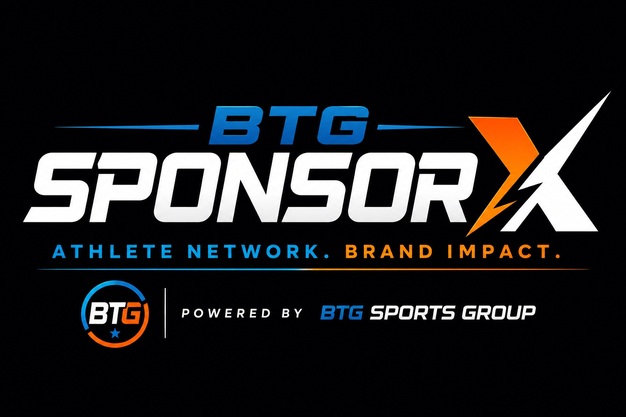
CREATE. COMMUNICATE. REPRESENT. BUILD.
Presented by BTG Sports Group / SponsorX
Participant | Information
Name | ____________________________
School / Team | ____________________________
Sport / Position | ____________________________
Grade / Age | ____________________________
Cohort / Dates | ____________________________

Welcome
CREATE • COMMUNICATE • REPRESENT • BUILD
Across six workshops you will build your personal brand, create content, practice sponsor campaigns, strengthen interview skills, produce sports media, explore careers and build a starter portfolio.
Workshop | Focus | Participant Output
1 | Your Story Is Your Brand | Personal Brand Blueprint
2 | Content Creation Lab | 30-second athlete Reel
3 | SponsorX Brand Campaign Lab | Sponsor-ready campaign Reel
4 | Media Readiness & Career Preparation | Mock interview + elevator pitch
5 | Sports Media Production Lab | 60-90 second athlete feature
6 | SponsorX Media Day | Portfolio + showcase

Portfolio Checklist
☐ Personal Brand Blueprint
☐ Professional headshot
☐ Youth resume
☐ Elevator pitch
☐ Lifestyle Reel
☐ SponsorX campaign Reel
☐ Recorded mock interview
☐ Mock Interview Scorecard
☐ Sports-media athlete feature
☐ 90-Day Development Plan
☐ Completion certificate

WORKSHOP 1
YOUR STORY IS YOUR BRAND

Learning Objective
Understand how your story, behavior, interests, content and digital footprint combine to create your personal brand.
Agenda | Minutes
Welcome + pre-check | 10
Instruction + discussion | 25
Applied exercise | 25
Scenario / practice | 15
Post-check, assignment + close | 10

Lesson
Your personal brand is the reputation people build about you from what you do, how you communicate, what you post, and what you consistently represent.

My Three Brand Words
________________________________________________________________________________
________________________________________________________________________________
________________________________________________________________________________
My sport and role:
________________________________________________________________________________
________________________________________________________________________________
Three things I care about outside sports:
________________________________________________________________________________
________________________________________________________________________________
A community issue I care about:
________________________________________________________________________________
________________________________________________________________________________
Skills people count on me for:
________________________________________________________________________________
________________________________________________________________________________
Career areas I want to explore:
________________________________________________________________________________
________________________________________________________________________________
Content I enjoy creating:
________________________________________________________________________________
________________________________________________________________________________
Brands/categories that naturally fit me:
________________________________________________________________________________
________________________________________________________________________________

Digital Footprint Check
☐ My profile photo is appropriate.
☐ My bio clearly says who I am.
☐ My public posts represent me well.
☐ My username is professional enough to share.
☐ I would be comfortable with a sponsor reviewing my profile.

Personal Brand Blueprint
Brand Element | My Answer
Three Brand Words
My Story in One Sentence
My Audience
My Interests
My Community
My Career Interest
Best Content Topics

One thing I will change this week:
________________________________________________________________________________
________________________________________________________________________________
________________________________________________________________________________

WORKSHOP 2
CONTENT CREATION LAB

Learning Objective
Create professional-looking short-form sports content using a smartphone and a simple storytelling structure.
Agenda | Minutes
Welcome + pre-check | 10
Instruction + discussion | 25
Applied exercise | 25
Scenario / practice | 15
Post-check, assignment + close | 10

SponsorX Formula | Question
HOOK | Why should someone stop scrolling?
STORY | What is happening?
PERSONALITY | What makes it sound like you?
CTA | What should the viewer do next?

☐ Clean the lens.
☐ Use vertical 9:16.
☐ Face your light source.
☐ Avoid noisy backgrounds.
☐ Frame intentionally.
☐ Record B-roll.
☐ Start quickly.
☐ Use captions when appropriate.

30-Second Reel Planner
Topic:
________________________________________________________________________________
________________________________________________________________________________
Hook:
________________________________________________________________________________
________________________________________________________________________________
Main message:
________________________________________________________________________________
________________________________________________________________________________
B-roll shots:
________________________________________________________________________________
________________________________________________________________________________
Closing CTA:
________________________________________________________________________________
________________________________________________________________________________
Role | What I Learned
On-Camera Athlete
Camera Operator
Director
Audio / Content Assistant

Self-Review | 1 | 2 | 3 | 4 | 5
Lighting | ☐ | ☐ | ☐ | ☐ | ☐
Audio | ☐ | ☐ | ☐ | ☐ | ☐
Framing | ☐ | ☐ | ☐ | ☐ | ☐
Hook | ☐ | ☐ | ☐ | ☐ | ☐
Clarity | ☐ | ☐ | ☐ | ☐ | ☐
Personality | ☐ | ☐ | ☐ | ☐ | ☐
CTA | ☐ | ☐ | ☐ | ☐ | ☐

One improvement for my next video:
________________________________________________________________________________
________________________________________________________________________________
________________________________________________________________________________

WORKSHOP 3
SPONSORX BRAND CAMPAIGN LAB

Learning Objective
Understand how athlete content becomes a professional sponsor campaign and practice executing a real creative brief.
Agenda | Minutes
Welcome + pre-check | 10
Instruction + discussion | 25
Applied exercise | 25
Scenario / practice | 15
Post-check, assignment + close | 10

SPONSOR → CAMPAIGN BRIEF → ATHLETE MATCH → CAMPAIGN ORDER → CONTENT → APPROVAL → PUBLISH → TRACK → REPORT
Term | Meaning
Campaign Brief | What the sponsor wants and why.
Deliverable | The exact work you agreed to provide.
Campaign Order | Pay, dates, rights and requirements.
Disclosure | Clear notice content is sponsored when required.
Usage Rights | Where/how long content may be used.
Tracking Code / QR | Helps measure response.

Practice: WHAT’S YOUR PREGAME MEAL?
Prompt: “Before a game, I gotta have _____.” Close with: “What’s yours?”
My pregame meal/routine:
________________________________________________________________________________
________________________________________________________________________________
Why I choose it:
________________________________________________________________________________
________________________________________________________________________________
What I will show:
________________________________________________________________________________
________________________________________________________________________________
My opening line:
________________________________________________________________________________
________________________________________________________________________________
Practice sponsor integration:
________________________________________________________________________________
________________________________________________________________________________
My CTA:
________________________________________________________________________________
________________________________________________________________________________
Campaign Order Field | Practice Entry
Sponsor
Deliverable | 15-30 sec vertical Reel
Due Date
Compensation | $
Usage Period
Exclusivity
Tracking Code
Disclosure

☐ I followed the brief.
☐ I used the correct sponsor name/tag.
☐ I included disclosure.
☐ I avoided restricted competitors.
☐ I submitted for approval if required.
☐ I avoided unapproved claims.

WORKSHOP 4
MEDIA READINESS & CAREER PREPARATION

Learning Objective
Communicate confidently in interviews and connect sports experience to future careers.
Agenda | Minutes
Welcome + pre-check | 10
Instruction + discussion | 25
Applied exercise | 25
Scenario / practice | 15
Post-check, assignment + close | 10

Interview Structure
ANSWER → MESSAGE → EXAMPLE → CLOSE
My three messages I want an interviewer to remember:
________________________________________________________________________________
________________________________________________________________________________
________________________________________________________________________________

Difficult Questions
ACKNOWLEDGE → ANSWER → BRIDGE → MESSAGE
Question | My Response
You didn’t play well tonight. What happened?
Why should a college/employer choose you?
What is your biggest weakness?
What happens if sports doesn’t work out?

☐ Eye contact
☐ Posture
☐ Clear voice
☐ Controlled pace
☐ Limited filler words
☐ Listen completely
☐ Pause when needed
☐ Concise answers
☐ Professional under pressure

Professional Communication
Rewrite professionally: “Yo coach u called?”
________________________________________________________________________________
________________________________________________________________________________
________________________________________________________________________________
________________________________________________________________________________
Write a professional follow-up after meeting someone:
________________________________________________________________________________
________________________________________________________________________________
________________________________________________________________________________
________________________________________________________________________________
________________________________________________________________________________

My 30-Second Elevator Pitch
WHO I AM → WHAT I DO → WHAT I’VE LEARNED → WHERE I’M GOING
________________________________________________________________________________
________________________________________________________________________________
________________________________________________________________________________
________________________________________________________________________________
________________________________________________________________________________
________________________________________________________________________________
________________________________________________________________________________
Sports Experience | Career Translation | My Example
Film study | Analysis
Practice schedule | Time management
Team role | Leadership/teamwork
Game pressure | Decision-making
Coach feedback | Coachability
Setback/loss | Resilience
Recruiting/networking | Professional communication

Youth Resume Builder
Education:
________________________________________________________________________________
________________________________________________________________________________
Athletics:
________________________________________________________________________________
________________________________________________________________________________
Leadership:
________________________________________________________________________________
________________________________________________________________________________
Community Service:
________________________________________________________________________________
________________________________________________________________________________
Work / Volunteer Experience:
________________________________________________________________________________
________________________________________________________________________________
Media / Content Skills:
________________________________________________________________________________
________________________________________________________________________________
Awards:
________________________________________________________________________________
________________________________________________________________________________
Career Interests:
________________________________________________________________________________
________________________________________________________________________________
Mock Interview Category | Score 1-5 | Feedback
Eye contact
Voice / clarity
Confidence
Answer structure
Message discipline
Body language
Professionalism
Authenticity
Difficult-question response
Overall media readiness

TOTAL: ______ / 50
Strength:
________________________________________________________________________________
________________________________________________________________________________
Improvement:
________________________________________________________________________________
________________________________________________________________________________

WORKSHOP 5
SPORTS MEDIA PRODUCTION LAB

Learning Objective
Learn the roles and workflow required to produce a short athlete interview/story.
Agenda | Minutes
Welcome + pre-check | 10
Instruction + discussion | 25
Applied exercise | 25
Scenario / practice | 15
Post-check, assignment + close | 10

Role | Responsibility
Host / Reporter | Research, questions, listening, follow-ups.
Producer | Story, schedule, shots.
Camera Operator | Framing, focus, stable shots.
Audio | Microphone and clean sound.
Editor | Select moments, B-roll, captions, pacing.
Social Producer | Headline, caption, thumbnail, format.

Athlete/Guest:
________________________________________________________________________________
________________________________________________________________________________
What I already know:
________________________________________________________________________________
________________________________________________________________________________
What I need to research:
________________________________________________________________________________
________________________________________________________________________________
Main story angle:
________________________________________________________________________________
________________________________________________________________________________
Opening question:
________________________________________________________________________________
________________________________________________________________________________
Three follow-up questions:
________________________________________________________________________________
________________________________________________________________________________
Closing question:
________________________________________________________________________________
________________________________________________________________________________

B-Roll Shot List
☐ Wide establishing shot
☐ Medium action shot
☐ Close-up/detail
☐ Equipment/shoes/hands
☐ Team/environment
☐ Reaction/emotion
☐ Interview cutaway
60-90 Second Feature | My Plan
Opening Hook
Soundbite #1
B-Roll
Soundbite #2
Closing / CTA

Role I enjoyed most and why:
________________________________________________________________________________
________________________________________________________________________________
________________________________________________________________________________
Media career I want to explore:
________________________________________________________________________________
________________________________________________________________________________
________________________________________________________________________________

WORKSHOP 6
SPONSORX MEDIA DAY

Learning Objective
Apply the program in a real production environment and leave with portfolio-ready assets.
Agenda | Minutes
Welcome + pre-check | 10
Instruction + discussion | 25
Applied exercise | 25
Scenario / practice | 15
Post-check, assignment + close | 10

Station | Output | Done
Headshots | Professional headshot | ☐
Athlete Introduction | 30-sec personal brand video | ☐
SponsorX Campaign | Pregame Meal campaign Reel | ☐
BTG Interview | Short recorded interview | ☐
Behind the Camera | Camera/mic/production role | ☐
Career Station | Career exploration | ☐

Career Pathways
SPORTS: Athlete • Coach • Trainer • Scout • Agent • Official • Event Operations
MEDIA: Reporter • Host • Photographer • Videographer • Editor • Producer • Social Media Manager • Designer
BUSINESS: Marketing • Sponsorship Sales • NIL • Brand Management • Event Management • Analytics • Entrepreneurship
Three careers I want to explore:
________________________________________________________________________________
________________________________________________________________________________
________________________________________________________________________________

Portfolio Inventory
☐ Headshot
☐ Brand Blueprint
☐ Resume
☐ Elevator Pitch
☐ Lifestyle Reel
☐ SponsorX Campaign Reel
☐ Mock Interview
☐ Interview Scorecard
☐ Athlete Feature
☐ 90-Day Goal
The piece I am most proud of:
________________________________________________________________________________
________________________________________________________________________________
________________________________________________________________________________
The skill I improved most:
________________________________________________________________________________
________________________________________________________________________________
________________________________________________________________________________

MY 90-DAY DEVELOPMENT PLAN
TURN THE ACADEMY INTO A HABIT

My Primary Goal
________________________________________________________________________________
________________________________________________________________________________
________________________________________________________________________________
________________________________________________________________________________
Timeframe | Actions | Measure of Success
Days 1-30
Days 31-60
Days 61-90

Weekly Commitment
☐ Create quality content
☐ Practice interviews/on-camera communication
☐ Edit/produce media
☐ Network/follow up professionally
☐ Review analytics/feedback
☐ Update resume/portfolio
Hours per week: ______
Accountability partner:
________________________________________________________________________________
________________________________________________________________________________
How often we will check in:
________________________________________________________________________________
________________________________________________________________________________

FINAL SELF-ASSESSMENT
WHAT CHANGED?
Skill | Before (1-5) | After (1-5) | Next Step
Personal branding
Phone video/content
Sponsor campaign readiness
On-camera interviews
Professional communication
Resume/career readiness
Interviewing others
Media production
Teamwork
Confidence

My Academy Reflection
The most useful thing I learned:
________________________________________________________________________________
________________________________________________________________________________
________________________________________________________________________________
A skill I did not know I had:
________________________________________________________________________________
________________________________________________________________________________
________________________________________________________________________________
One career I now understand better:
________________________________________________________________________________
________________________________________________________________________________
________________________________________________________________________________
How sports has prepared me for life/careers:
________________________________________________________________________________
________________________________________________________________________________
________________________________________________________________________________
What I want BTG/SponsorX to help me learn next:
________________________________________________________________________________
________________________________________________________________________________
________________________________________________________________________________

FACILITATOR FEEDBACK
PARTICIPANT DEVELOPMENT SUMMARY
Area | Rating 1-5 | Notes
Participation
Professionalism
Communication
Content Creation
Media Readiness
Teamwork
Reliability
Career Awareness

Recommended next pathway:
☐ SponsorX Athlete Creator Track
☐ BTG/iMC Youth Media Crew
☐ Advanced Media Training
☐ Leadership / Mentor Track
Facilitator comments:
________________________________________________________________________________
________________________________________________________________________________
________________________________________________________________________________
________________________________________________________________________________
________________________________________________________________________________

