User Documentation

This document will showcase the functionality of the Octopus P2P-Application

# Features

## Downloading files

In order to download the files,there are two possible ways as indicated in picture 1.2. If swarm is public, it is available from bootstrap server search panel.Otherwise user has to search files from neighbors.

### Looking through available content

In order to look the available content at server, press 5 as indicated in picture 1.1. In tab “Server”, you will be provided with the list of files available through the bootstrap indicated in picture 1.2..It will show all the available files at the server as indicated in picture 1.4.

### Searching for files

In order to look the available content at server,press 5 as indicated in picture 1.1. In tab “neighbours”, indicated in picture 1.2, Fill in the file you want to search for in the textfield and press the search button , indicated in picture 1.2

## Uploading files

In order to upload some files to the bootstrap server,press 1 as indicated in picture 1.1. Choose the desired file/files from your pc which you want to be shared to others and create swarm for that files.There are two modes of creating swarms(public or private) as indicated in picture 1.3.

Swarm Mode as “Private”

If you want to create some dark content,you can select the swarm mode as “private”.After pressing 1 and choosing file, choose the desired mode as indicated in the picture 1.3.

## Showing download speed

Once you find your desired file,you have to select that file and press download.Download will start for that selected file as indicated in the picture 1.5.Download progress in also shown while downloading as in figure 1.6

## Remove file

For example you created some swarm file earlier you can remove that by selecting that specific file and pressing remove button as indicated in the picture picture 1.7

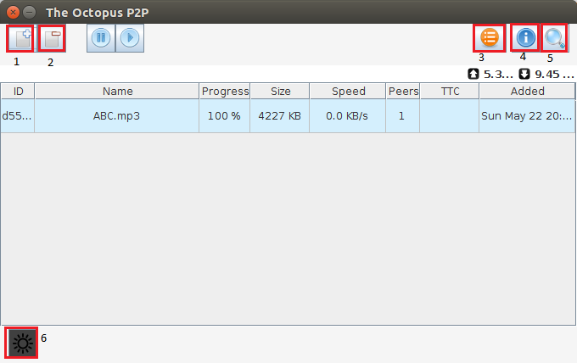

Picture 1.1

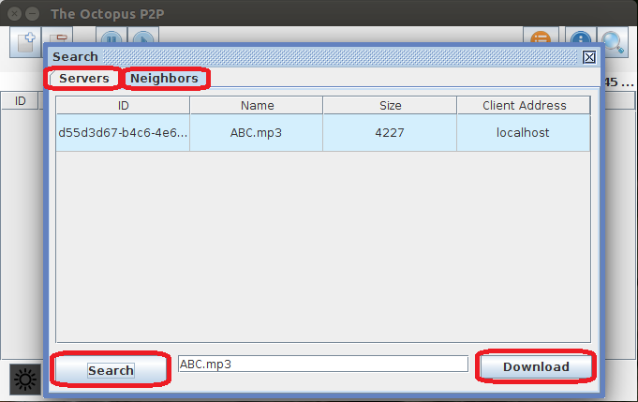

Picture 1.2

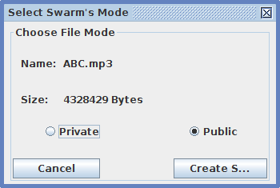

Picture 1.3

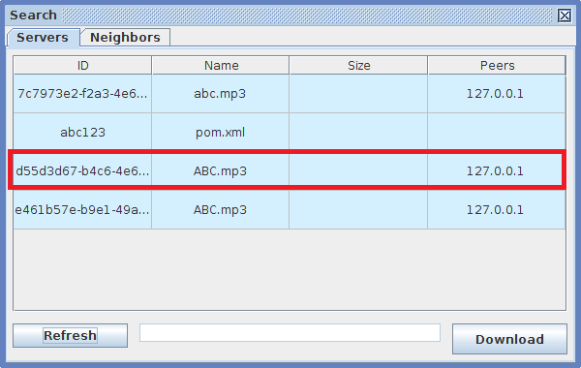

Picture 1.4

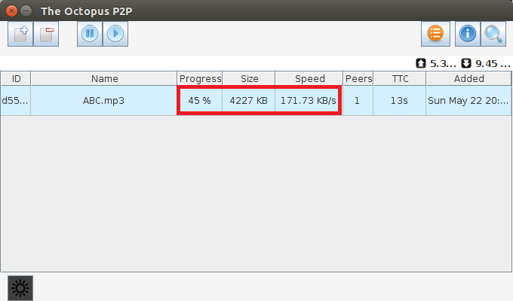

Picture 1.5

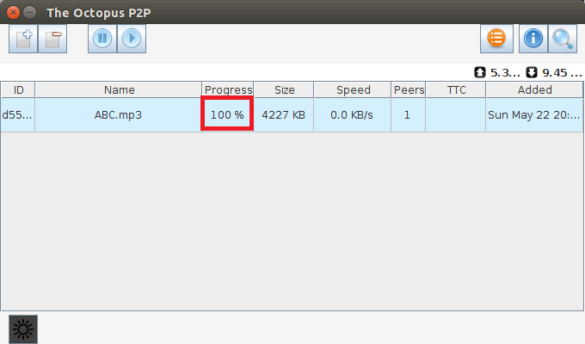

Picture 1.6

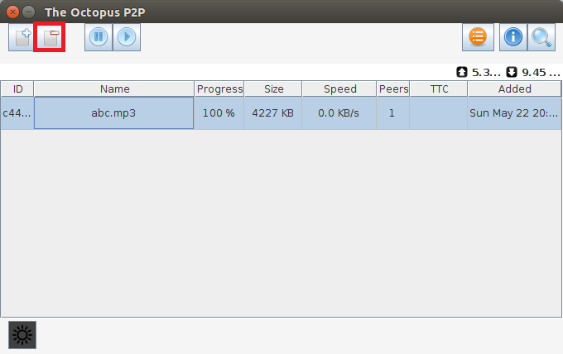

Picture 1.7