
SMART CLINIC MANAGEMENT SYSTEM
Final Release Document
Release Version 1.0

– Da Nang, July 2026 –

Document Control
Document Title | Smart Clinic Management System – Final Release Document
Project / Group Code | SWP391_Team3
Course | SWP39
Class | SE20A09
Lecturer | Nguyễn Thị Hạnh
Prepared by | Lưu Hòa  Trần Văn Thanh Binh  Nguyễn Anh Trịnh  Nguyễn Anh Tấn  Võ Hoàng Long
Release Version | 1.0
Release Date | July 20, 2026
Repository | https://github.com/BTHL-123/clinic-management-system

Release Scope
This release delivers a full-stack clinic management platform covering patient registration, AI-assisted symptom triage, online and walk-in booking, appointment check-in, queue coordination, medical consultation, laboratory processing, prescription and medicine dispensing, billing, online payment, refunds, inventory management, reporting, and system administration.
The current source code uses a Spring Boot backend, a React/Vite frontend, PostgreSQL, JWT authentication, Google Sign-In, WebSocket/STOMP notifications, and AI providers configured through the backend. The ai-services directory is reserved for future standalone services; no separate Python AI process is required for this release.

Project Team
- Lưu Hòa
- Trần Văn Thanh Binh
- Nguyễn Anh Trịnh
- Nguyễn Anh Tấn
- Võ Hoàng Long
Group code: SWP391_Team3 | Course: SWP39 | Class: SE20A09 | Lecturer: Nguyễn Thị Hạnh.

Table of Contents
Document Control 2
Release Scope 2
Information Still Required for the Submission Copy 2
I. Deliverable Package 7
Other Related Deliverables 7
II. Installation Guides 9
2.1. Release Architecture 9
2.2. Prerequisite Software 9
2.3. Clone the Source Code 9
2.4. Create the PostgreSQL Database 10
2.5. Configure Backend Environment Variables 10
2.6. Start the Backend 11
2.7. Configure and Start the Frontend 12
2.8. Seeded Demonstration Accounts 12
2.9. Installation Verification Checklist 13
2.10. Common Installation Problems 13
III. User Manual 14
1. Overview 14
1.1. Actors and Main Responsibilities 14
1.2. Main End-to-End Workflows 14
1.3. Key Status Dictionary 15
2. User Manual Guide for Guest and Authentication 16
2.1. View the Public Landing Page 16
2.2. Login with Email and Password 17
2.3. Login with Google 18
2.4. Register a New Patient Account 19
2.5. Recover a Forgotten Password 20
3. User Manual Guide for All Authenticated Users 21
3.1. Open the Role Dashboard 21
3.2. View and Update Profile 22
3.3. Change Password 23
3.4. Manage Notifications 24
3.5. Logout 25
4. User Manual Guide for Patient 26
4.1. View the Patient Dashboard 27
4.2. Use AI Symptom Triage 28
4.3. View Doctors and Specialties 29
4.4. View Medical Service Prices 30
4.5. Manage Patient and Dependent Profiles 31
4.6. Book an Appointment Online 32
4.7. Complete the Appointment Deposit 33
4.8. View Appointment List and Details 34
4.9. Reschedule an Appointment 35
4.10. Cancel an Appointment and Request Refund 36
4.11. Track the Real-Time Queue 37
4.12. View Medical History, Lab Results, and Prescriptions 38
4.13. Pay a Final Invoice Online 39
4.14. Submit a Review 40
5. User Manual Guide for Receptionist 41
5.1. View the Receptionist Dashboard 42
5.2. Search, Create, and Update Patient Profiles 43
5.3. Check In a Scheduled Patient 44
5.4. Mark a Patient as No-Show 45
5.5. Create a Walk-In Appointment 46
5.6. Manage the Patient Queue 47
5.7. View and Manage Clinic Appointments and Schedules 48
5.8. Manage Invoices 49
5.9. Create and Confirm Payments 50
5.10. Process Refund Requests 51
6. User Manual Guide for Doctor 52
6.1. View the Doctor Dashboard 53
6.2. View Work Schedule and Scheduled Patients 54
6.3. Submit a Leave or Schedule-Change Request 55
6.4. View Today’s Appointments and Patient Records 56
6.5. Call and Start Examination from the Queue 57
6.6. Record Vital Signs and Review Patient History 58
6.7. Use AI to Standardize Clinical Notes 59
6.8. Create or Update the Medical Record 60
6.9. Order Laboratory Tests and Review Results 61
6.10. Create a Prescription and Check Drug Interactions 62
6.11. Complete the Consultation 63
6.12. Create and Manage Medical Articles 64
7. User Manual Guide for Lab Technician 65
7.1. View the Laboratory Dashboard 66
7.2. Process a Laboratory Request 67
7.3. Manage the Laboratory Test Catalog 68
8. User Manual Guide for Pharmacist 69
8.1. View the Pharmacy Dashboard 70
8.2. Review and Dispense a Prescription 71
8.3. Manage the Medicine Catalog 72
8.4. Manage Suppliers 73
8.5. Import and Manage Medicine Batches 74
8.6. Record Manual Stock Export and Review Transactions 75
8.7. Monitor Inventory Alerts 76
9. User Manual Guide for Administrator 77
9.1. View the Administrative Dashboard and Reports 78
9.2. Manage User Accounts 79
9.3. Manage Roles and Permissions 80
9.4. Manage Doctors 81
9.5. Manage Departments and Medical Services 82
9.6. Manage Doctor Schedules and Appointment Slots 83
9.7. Review and Approve Doctor Leave Requests 84
9.8. Manage Patients and Appointments 85
9.9. Manage Laboratory, Medicines, Suppliers, and Inventory 86
9.10. Manage Invoices, Payments, and Refunds 87
9.11. Manage Health Articles and Patient Reviews 88
9.12. View Audit Logs 89
9.13. Manage System Settings 90
Appendix A. Screenshot Insertion Checklist 91
Appendix B. Final Submission Checklist 91

I. Deliverable Package
This section lists the source programs, database scripts, technical documents, project tracking artifacts, and related release links included in the final handover package for SWP391_Team3.
No. | File | Notes
1 | SWP391_Team3_SmartClinic_DB_Final.sql | Final PostgreSQL database script, including table structures, constraints, indexes, and final release seed data.
2 | SWP391_Team3_SmartClinic_RDS_Final.docx | Final Requirement & Design Specification covering actors, use cases, screen flows, authorization, database design, and detailed design specifications.
3 | SWP391_Team3_SmartClinic_SDS_Final.docx | Final Software Design Specification covering system architecture, backend and frontend components, APIs, database mapping, security, integrations, and deployment design.
4 | SWP391_Team3_SmartClinic_Final_Product_Backlog.xlsx | Final product backlog containing features, roles, descriptions, owners, planned and actual iterations, final status, notes, and traceability links.
5 | SWP391_Team3_SmartClinic_Issues_Report.xlsx | Final issue and defect tracking list for the entire project, including status, severity, owner, resolution, and verification result.
6 | SWP391_Team3_SmartClinic_Project_Tracking.xlsx | Final iteration and team progress tracking file, including milestones, work assignments, evidence, and completion status.
7 | SWP391_Team3_SmartClinic_AI_Audit_Log.xlsx | Consolidated AI interaction and audit log used during project analysis, design, implementation, documentation, and verification.
8 | SWP391_Team3_SmartClinic_Final_Release_Document.docx | Final release document containing the deliverable package, installation instructions, demonstration accounts, and role-based user manuals.

Other Related Deliverables
Tagged source code / repository: https://github.com/BTHL-123/clinic-management-system
Final release tag: v1.0.0

II. Installation Guides
The following instructions describe how to prepare a local development environment, configure PostgreSQL and environment variables, start the Spring Boot backend, start the React frontend, and verify the complete system. The commands assume the repository root is clinic-management-system.

2.1. Release Architecture
The application follows a client-server architecture. The React frontend sends authenticated HTTP requests to the Spring Boot REST API. Spring Security validates JWT access tokens, JPA/Hibernate communicates with PostgreSQL, and WebSocket/STOMP supports real-time queue and notification updates. AI requests are handled inside the backend through the configured Groq or Gemini provider.
clinic-management-system/
├── backend/ Spring Boot REST API, security, business logic and data access
├── frontend/ React 19 + Vite user interface
├── ai-services/ Reserved directory; no separate service required in this release
├── database/ PostgreSQL schema script
└── docs/ RDS, API design, database design and project guides

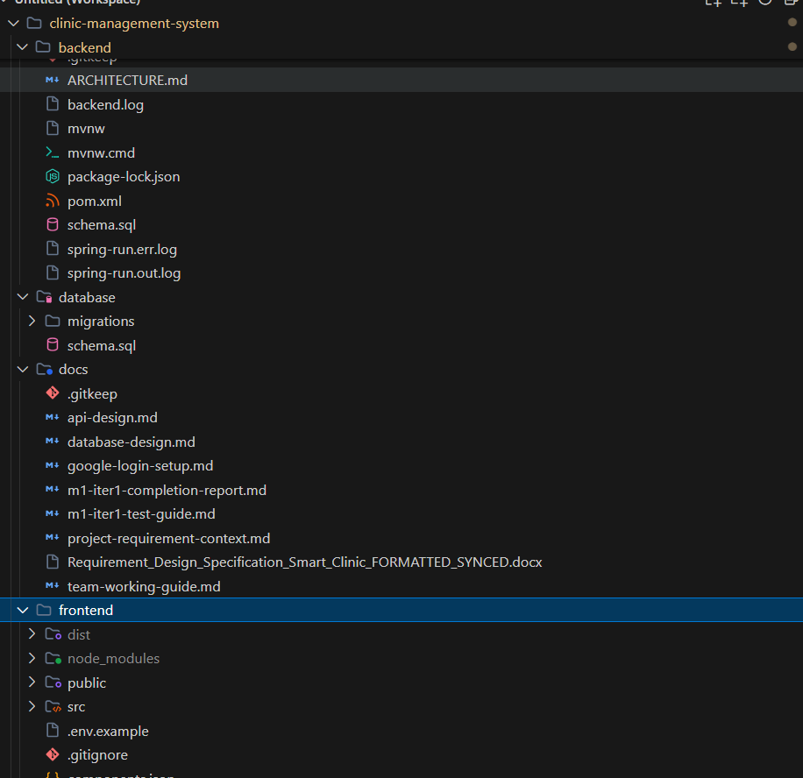

2.2. Prerequisite Software
Software | Recommended Version | Purpose
Git | 2.40 or later | Clone and update the repository.
Java Development Kit | 21 | Compile and run the Spring Boot backend.
PostgreSQL | 14 or later | Primary relational database.
Node.js | 20 LTS or later | Run Vite and frontend build tools.
npm | Bundled with Node.js | Install frontend dependencies.
IDE | IntelliJ IDEA / VS Code / Eclipse | Recommended for source configuration and debugging.
Web browser | Chrome / Edge / Firefox | Open the frontend and Google Sign-In flow.

2.3. Clone the Source Code
Step 1: Open Terminal, PowerShell, Git Bash, or the integrated terminal in your IDE.
Step 2: Clone the repository and move into the project directory.
git clone https://github.com/BTHL-123/clinic-management-system.git
cd clinic-management-system

Step 3: Check out the team-approved final tag or release branch before installation.
git fetch --all --tags
git checkout <FINAL_TAG_OR_BRANCH>
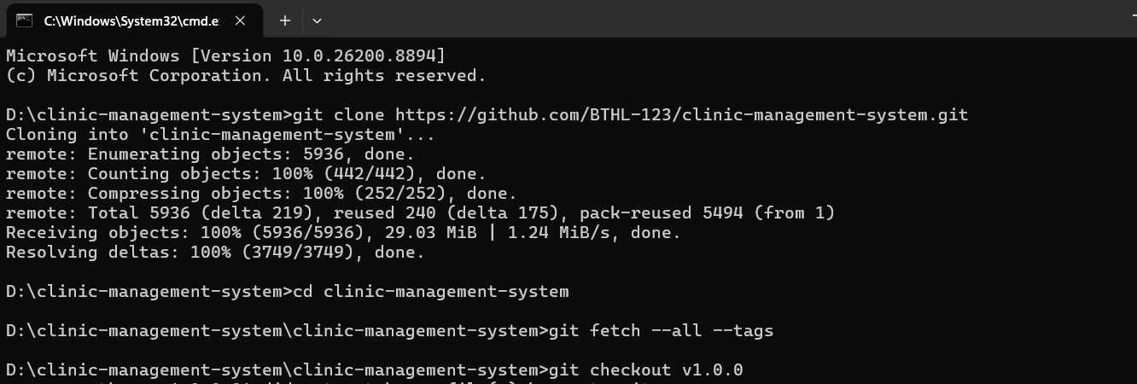

2.4. Create the PostgreSQL Database
Step 1: Start the PostgreSQL service and open pgAdmin or psql.
Step 2: Create an empty database named clinic_management. UTF-8 encoding is recommended.
CREATE DATABASE clinic_management
WITH ENCODING = 'UTF8';

Step 3: Choose one database initialization method:
- Recommended for an exact release copy: import the final [GROUP]-SmartClinic_DB_final.sql file into clinic_management.
- Development alternative: start the backend with an empty database. Hibernate uses ddl-auto=update and DataSeeder creates the initial roles, users, medical services, laboratory tests, and sample records.
Step 4: Confirm that the PostgreSQL account has permission to create and update tables, sequences, constraints, and indexes in the selected database.
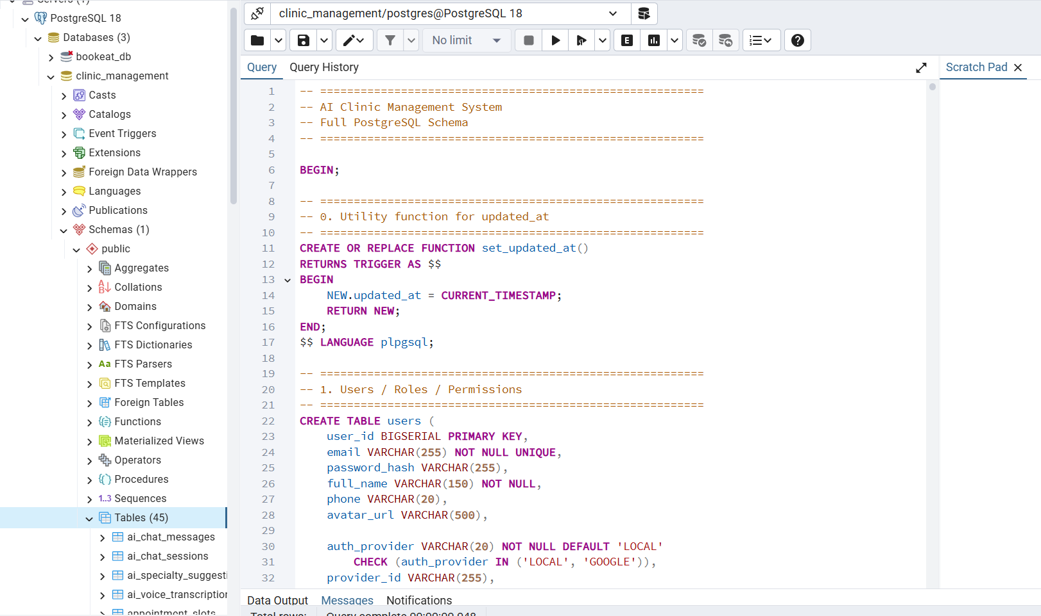

2.5. Configure Backend Environment Variables
The backend reads configuration through environment variables referenced by backend/src/main/resources/application.yml. The backend/.env.example file is a reference file; a plain .env file is not automatically loaded by Spring Boot unless the IDE or operating system exports those variables.
Variable | Example | Purpose
DB_URL | jdbc:postgresql://localhost:5432/clinic_management | PostgreSQL connection URL.
DB_USERNAME | postgres | Database account.
DB_PASSWORD | <your-password> | Database password.
JWT_SECRET | <at-least-32-random-characters> | Signs access and refresh tokens.
CORS_ALLOWED_ORIGINS | http://localhost:5173 | Allowed frontend origins.
APP_MAIL_ENABLED | false for local demo / true for SMTP | Controls whether OTP is logged or emailed.
MAIL_HOST / MAIL_PORT | smtp.gmail.com / 587 | SMTP server when email is enabled.
GOOGLE_CLIENT_ID | <Google OAuth client ID> | Backend verification of Google credentials.
AI_PROVIDER | groq or gemini | Active AI provider.
GROQ_API_KEY / GEMINI_API_KEY | <secret API key> | Required for the selected AI provider.
SEPAY_API_KEY | <SePay API key> | Required for transaction verification.
SEPAY_BANK_ACCOUNT / SEPAY_BANK_CODE | <clinic account> | Displayed in online payment QR information.
APP_ADMIN_EMAIL | admin@example.com | Seed administrator email.
APP_ADMIN_PASSWORD | <secure demo password> | Seed administrator password.
Security requirement: do not submit or commit real API keys, SMTP passwords, JWT secrets, or payment credentials. Use placeholders in documentation and inject secrets through the environment.
When APP_MAIL_ENABLED=false, generated OTP codes are written to the backend log for local testing. Registration and reset-password OTPs expire after 10 minutes.

2.6. Start the Backend
Step 1: Open a terminal in the backend directory.
cd backend

Step 2: Export the required environment variables in the operating system or configure them in the IDE run configuration.
Step 3: Run the Spring Boot application using the Maven Wrapper.
# Windows
mvnw.cmd spring-boot:run
# macOS / Linux
chmod +x mvnw
./mvnw spring-boot:run

Step 4: Wait until the application reports that the embedded server has started on port 8080.
Step 5: Verify the API base address: http://localhost:8080/api.
The first run may take longer because Maven downloads dependencies. Internet access is required for a clean first-time build.
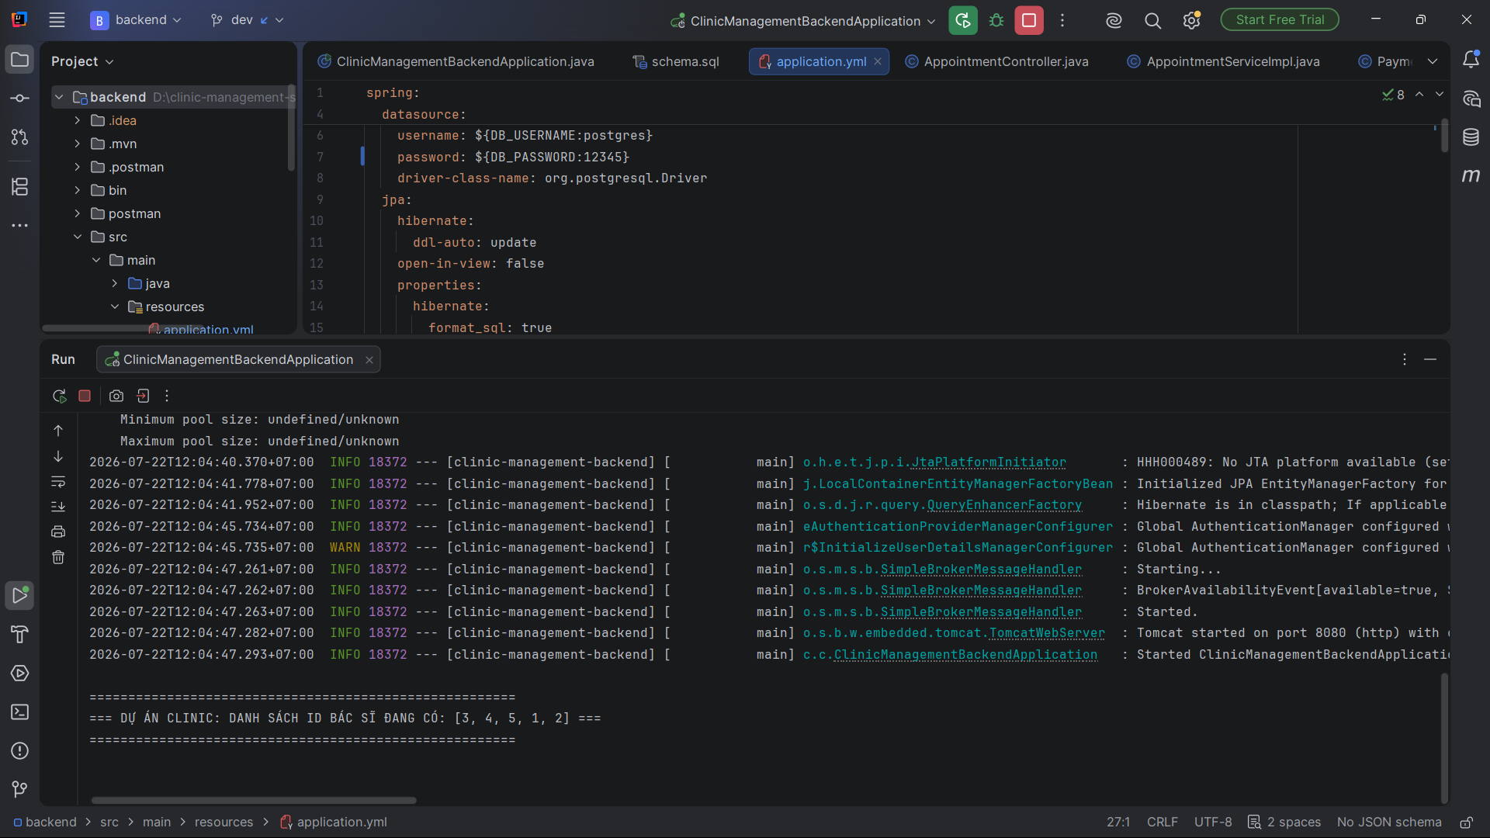

2.7. Configure and Start the Frontend
Step 1: Open a second terminal in the frontend directory.
cd frontend

Step 2: Create frontend/.env and configure the API URL and Google Client ID.
VITE_API_BASE_URL=http://localhost:8080/api
VITE_GOOGLE_CLIENT_ID=<same Google OAuth client ID used by the backend>

Step 3: Install dependencies and start the Vite development server.
npm install
npm run dev

Step 4: Open http://localhost:5173 in a browser.
Step 5: For a production verification build, run npm run build and ensure the command completes without errors.
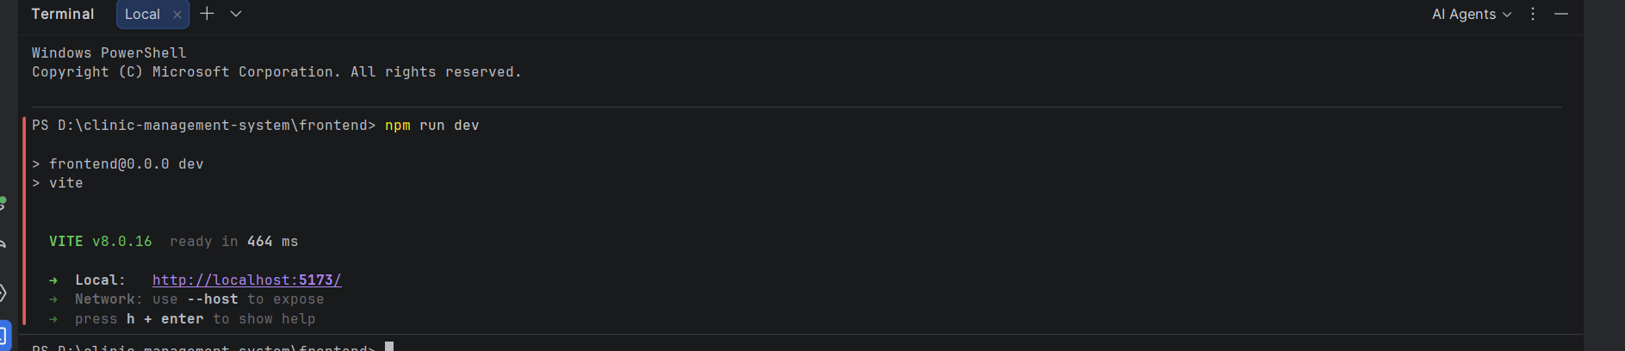

2.8. Seeded Demonstration Accounts
The current DataSeeder creates the following accounts when they do not already exist. Change passwords before any non-local deployment.
User | Email | Password | Role
Administrator | admin@example.com | Value of APP_ADMIN_PASSWORD; development fallback is 123456 | ADMIN
Patient | patient@example.com | 123456 | PATIENT
Doctor 1 | doctor@example.com | 123456 | DOCTOR
Doctors 2–5 | doctor2@example.com through doctor5@example.com | 123456 | DOCTOR
Receptionist | Create from Admin > Tài khoản | Admin-defined temporary password | RECEPTIONIST
Pharmacist | Create from Admin > Tài khoản | Admin-defined temporary password | PHARMACIST
Lab Technician | Create from Admin > Tài khoản | Admin-defined temporary password | LAB_TECHNICIAN

2.9. Installation Verification Checklist
- Backend starts without a database connection error.
- Frontend opens at http://localhost:5173 and can call the backend API.
- Administrator can sign in and view the system dashboard.
- Patient can sign in and view available appointment slots.
- OTP appears in email when SMTP is enabled, or in backend logs when email is disabled.
- Google Sign-In works when both frontend and backend use the same Google Client ID.
- AI chat returns a response when the selected provider key is valid.
- A test payment can create a QR/payment record when SePay variables are configured.
- WebSocket queue/notification updates work without CORS errors.

2.10. Common Installation Problems
Problem | Resolution
Backend cannot connect to PostgreSQL | Check that PostgreSQL is running, the database exists, DB_URL is correct, and the configured user has sufficient privileges.
Port 8080 or 5173 is already in use | Stop the conflicting process or change SERVER_PORT / Vite port and update VITE_API_BASE_URL and CORS_ALLOWED_ORIGINS.
401 after login | Clear accessToken and refreshToken from browser local storage, then sign in again. Confirm JWT_SECRET remains stable while the backend is running.
OTP does not arrive | Set APP_MAIL_ENABLED=true and verify SMTP settings. For local mode with APP_MAIL_ENABLED=false, read the OTP from the backend console.
Google login is unavailable | Configure the same Google Client ID in GOOGLE_CLIENT_ID and VITE_GOOGLE_CLIENT_ID, and add the local origin in Google Cloud Console.
AI chat fails | Set AI_PROVIDER to groq or gemini and configure the corresponding API key. The ai-services folder does not need to be started.
Online payment verification fails | Check SePay API key, bank account configuration, network connectivity, transaction content, and callback/webhook settings.
Frontend displays CORS errors | Add the frontend origin to CORS_ALLOWED_ORIGINS and restart the backend.

III. User Manual

1. Overview
Smart Clinic Management System is a digital platform for small and medium-sized clinics. It connects patients, doctors, receptionists, laboratory technicians, pharmacists, and administrators in one workflow from appointment booking to final payment and medicine dispensing.
The platform provides role-specific dashboards and permission checks. In the current implementation, the six active application roles are PATIENT, DOCTOR, RECEPTIONIST, PHARMACIST, LAB_TECHNICIAN, and ADMIN. Audit-log responsibilities are handled by the ADMIN role.

1.1. Actors and Main Responsibilities
Actor | Responsibility
Guest | Views public clinic content and opens Login or Register.
Patient | Registers, manages profiles, receives AI triage, books and manages appointments, tracks queues, views medical records, pays invoices, requests refunds, and submits reviews.
Receptionist | Creates walk-in appointments, checks patients in, marks no-shows, coordinates queues, manages patient demographics, processes payments, and handles refunds.
Doctor | Views schedules and patient queues, conducts consultations, records medical information, requests tests, creates prescriptions, checks drug interactions, and submits leave requests.
Lab Technician | Processes laboratory requests, enters results and conclusions, and maintains the laboratory test catalog.
Pharmacist | Reviews prescriptions, dispenses medicines using stock batches, manages medicines, suppliers, imports/exports, and inventory alerts.
Administrator | Controls users, roles, clinic catalogs, schedules, finance, reports, leave approvals, content, audit logs, and system settings.

1.2. Main End-to-End Workflows
Online appointment: Patient selects a doctor and available slot → system locks the slot → appointment is created as PENDING_PAYMENT when a deposit is required → patient completes the deposit → appointment becomes CONFIRMED and the slot becomes BOOKED.
Walk-in appointment: Receptionist selects an available slot → finds or creates a patient profile → creates a WALK_IN appointment → appointment is confirmed → a queue ticket is created for the patient.
Clinical workflow: Receptionist checks the patient in → queue ticket becomes WAITING → doctor calls and starts examination → doctor records findings, requests tests, and creates a prescription → lab technician completes requested tests → doctor completes the consultation → invoice is generated/updated → patient pays → pharmacist dispenses medicine.

1.3. Key Status Dictionary
Object | Statuses
Appointment | PENDING_PAYMENT, CONFIRMED, CHECKED_IN, WAITING, IN_PROGRESS, PAYMENT_DUE, COMPLETED, CANCELLED, NO_SHOW, RESCHEDULED
Appointment slot | AVAILABLE, LOCKED, BOOKED, BLOCKED, CANCELLED
Queue ticket | WAITING, CALLED, IN_EXAMINATION, WAITING_LAB, DONE, CANCELLED, SKIPPED
Consultation | WAITING, IN_PROGRESS, WAITING_LAB_RESULT, PRESCRIBED, COMPLETED
Laboratory request | REQUESTED, IN_PROGRESS, COMPLETED, CANCELLED
Prescription | CREATED, CHECKED, DISPENSED, CANCELLED
Invoice | UNPAID, PARTIALLY_PAID, PAID, FAILED, REFUNDED, CANCELLED
Payment | PENDING, PAID, FAILED, REFUNDED, CANCELLED
Refund | PENDING, APPROVED, REJECTED, COMPLETED, FAILED
Medicine batch | AVAILABLE, LOW_STOCK, EXPIRED, OUT_OF_STOCK, CANCELLED

2. User Manual Guide for Guest and Authentication

2.1. View the Public Landing Page
Purpose. Allows guests and signed-in users to view clinic information, featured doctors, health service packages, the booking process, contact information, and navigation to authentication.
Step 1: Open the frontend URL in a supported web browser.
Step 2: Review the hero section, featured doctor cards, service packages, and clinic information.
Step 3: Use the public search field if available to explore clinic content.
Step 4: Click Đăng nhập to open the authentication page. Signed-in users can click the dashboard button to return to their portal.
Expected result. The user can understand the clinic offering and navigate to Login or Register.
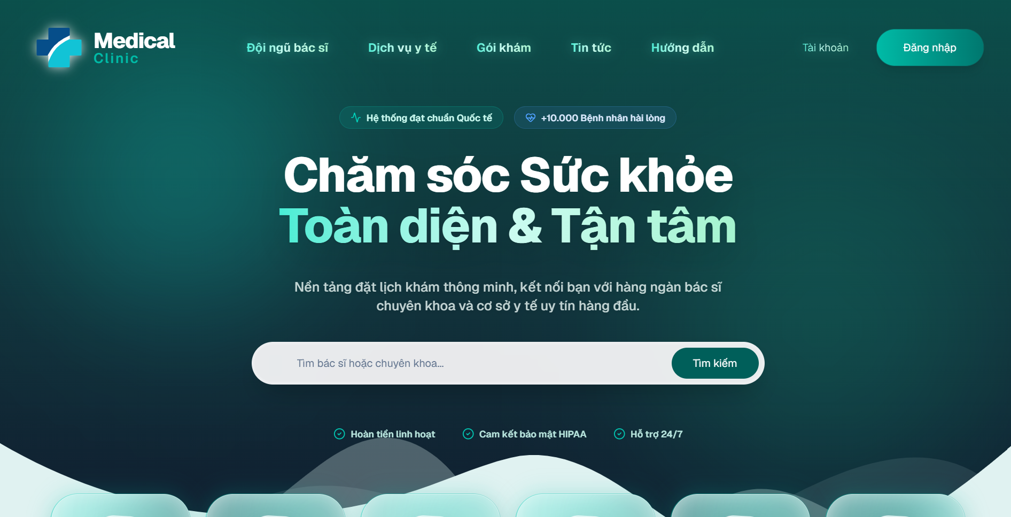
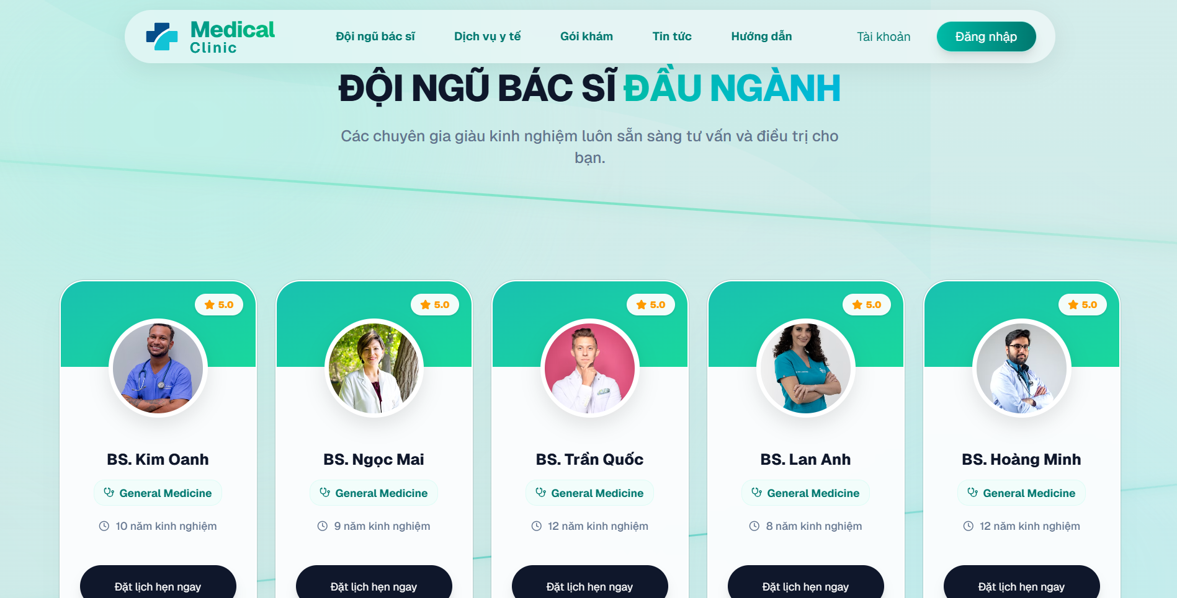

2.2. Login with Email and Password
Purpose. Authenticates an existing local account and redirects the user to the dashboard associated with their role.
Preconditions. The user account must be ACTIVE and not locked.
Step 1: Open the Login page from the public header.
Step 2: Enter the registered email address in the Email field.
Step 3: Enter the account password.
Step 4: Click Đăng nhập.
Step 5: Wait for the system to validate the credentials and redirect to /dashboard.
Expected result. JWT access and refresh tokens are stored by the client and the user sees the correct role dashboard.
Important notes. Invalid credentials, locked accounts, or expired tokens display an error. A 401 response clears stored tokens and returns the browser to Login.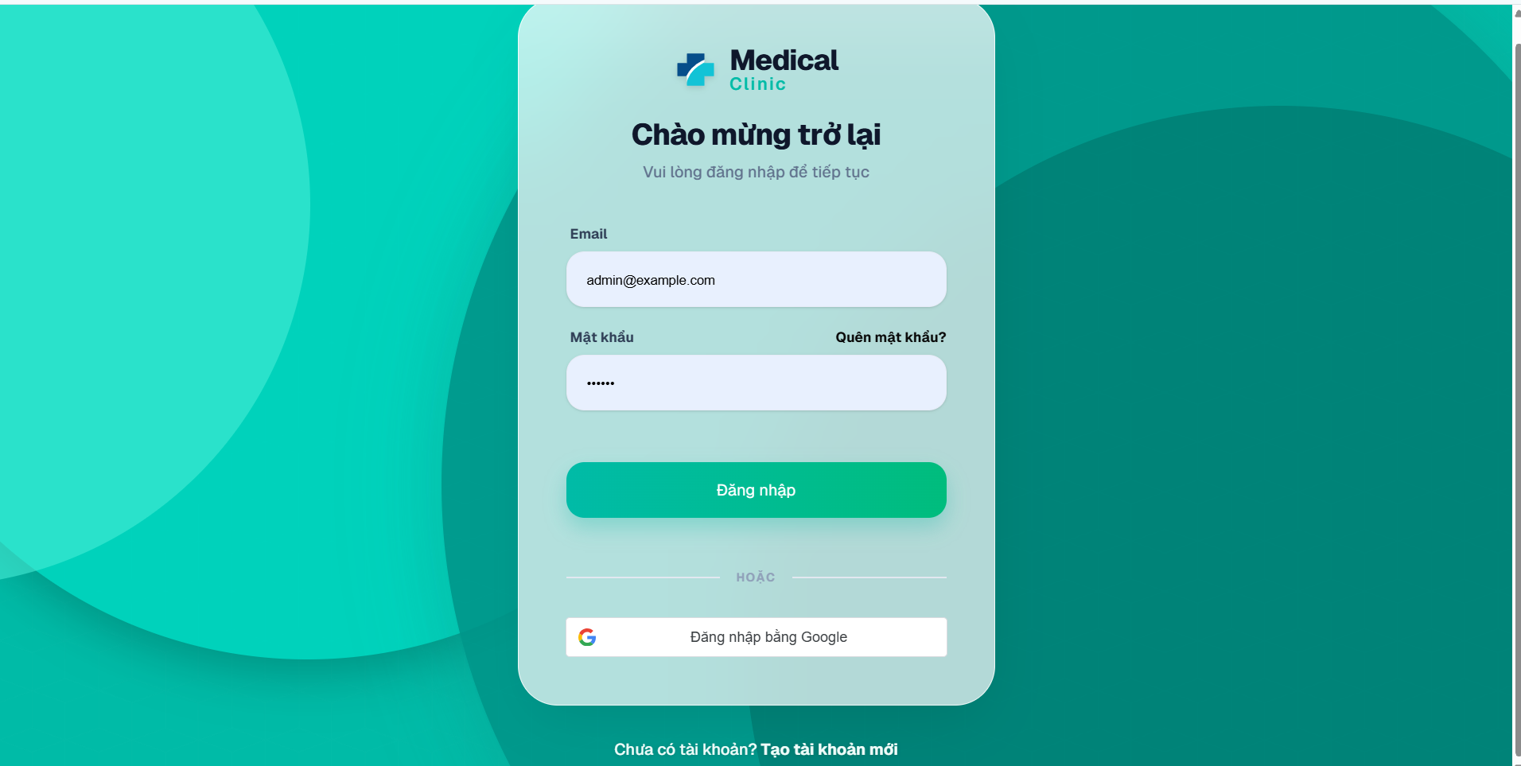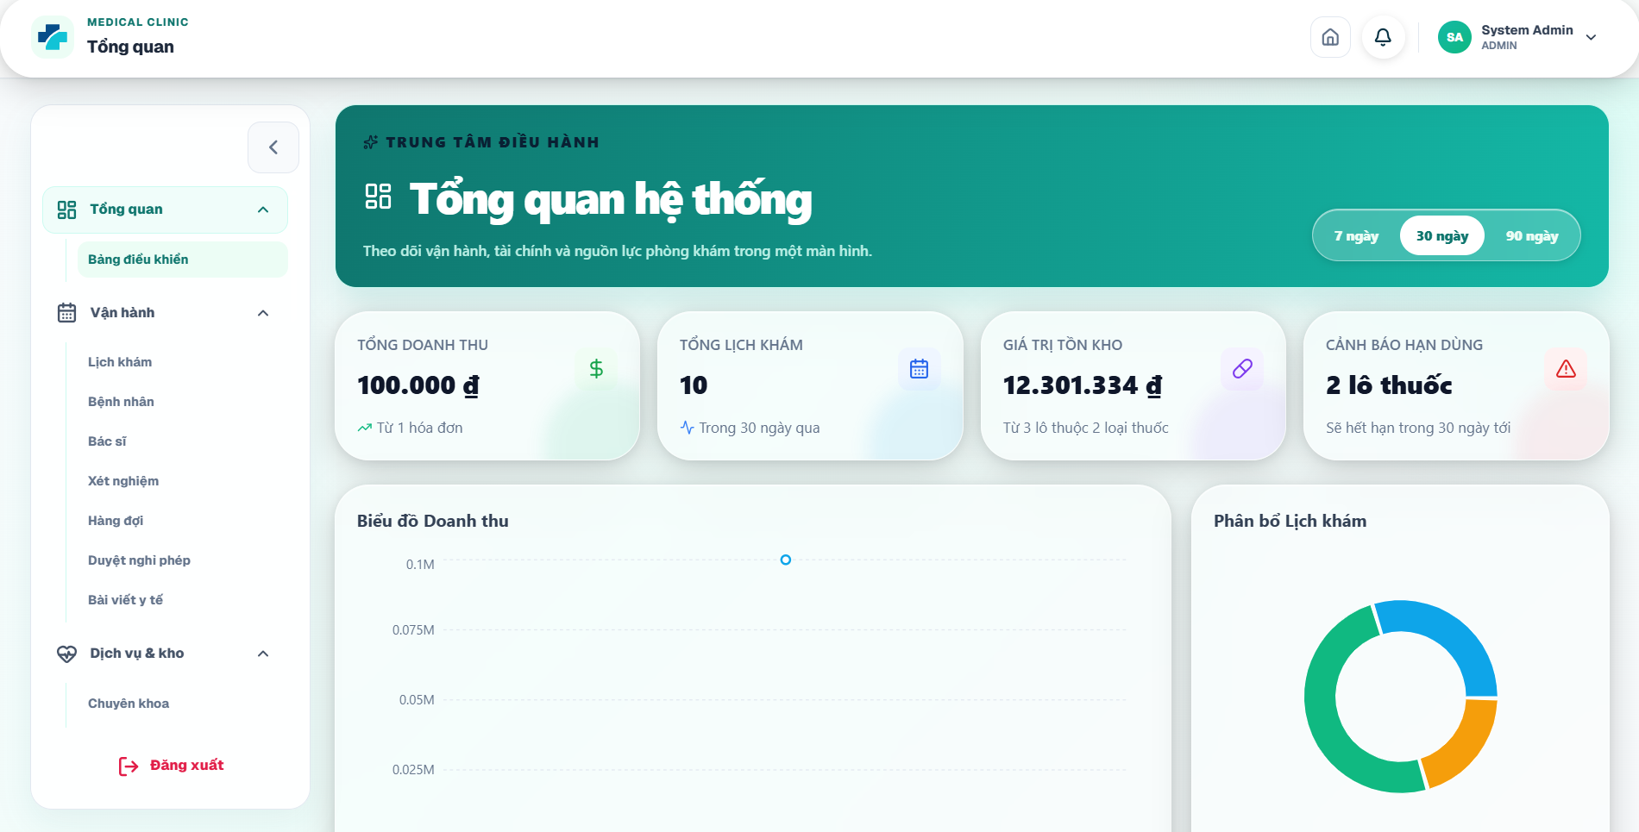

2.3. Login with Google
Purpose. Authenticates a user through Google Identity Services when Google OAuth is configured.
Preconditions. GOOGLE_CLIENT_ID and VITE_GOOGLE_CLIENT_ID must contain the same valid OAuth client ID.
Step 1: Open the Login page.
Step 2: Click the Google sign-in control displayed below the standard login form.
Step 3: Select an existing Google account or choose another account.
Step 4: Complete Google authentication and consent when prompted.
Step 5: Wait for the system to verify the Google credential and redirect to the dashboard.
Expected result. The backend returns application tokens and the user enters the authorized dashboard.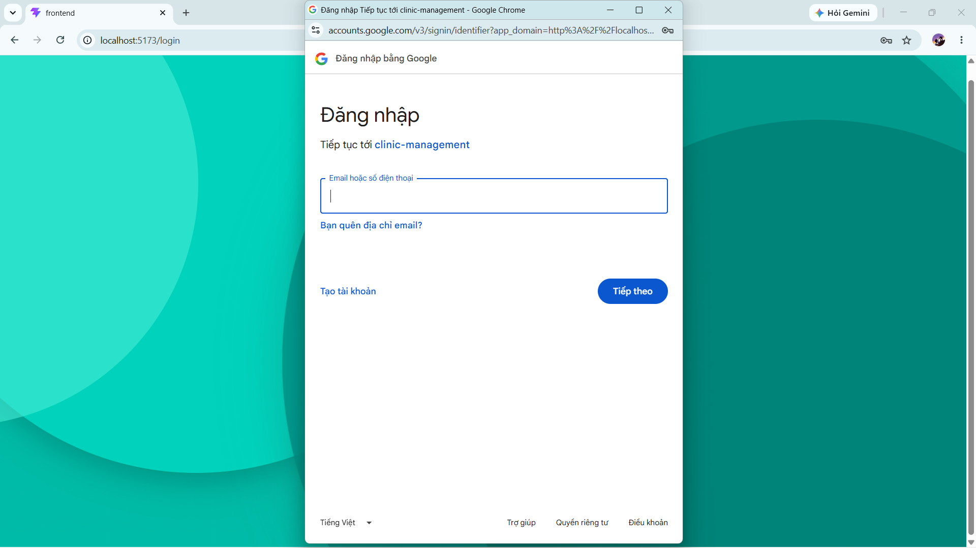

2.4. Register a New Patient Account
Purpose. Creates a new patient account after email OTP verification.
Step 1: Open Register from the Login page or public site.
Step 2: Enter Họ tên, Email, Mật khẩu, Số điện thoại, Giới tính, and Ngày sinh. Password length must be at least six characters.
Step 3: Click Gửi OTP. The system sends a six-digit code to the email address or writes it to the backend log when email delivery is disabled.
Step 4: Enter the Mã OTP email field. The code is valid for 10 minutes.
Step 5: Click Xác thực và đăng ký.
Step 6: After successful registration, sign in using the new account.
Expected result. A USER account with PATIENT role and an initial patient profile is created, then the browser returns to Login.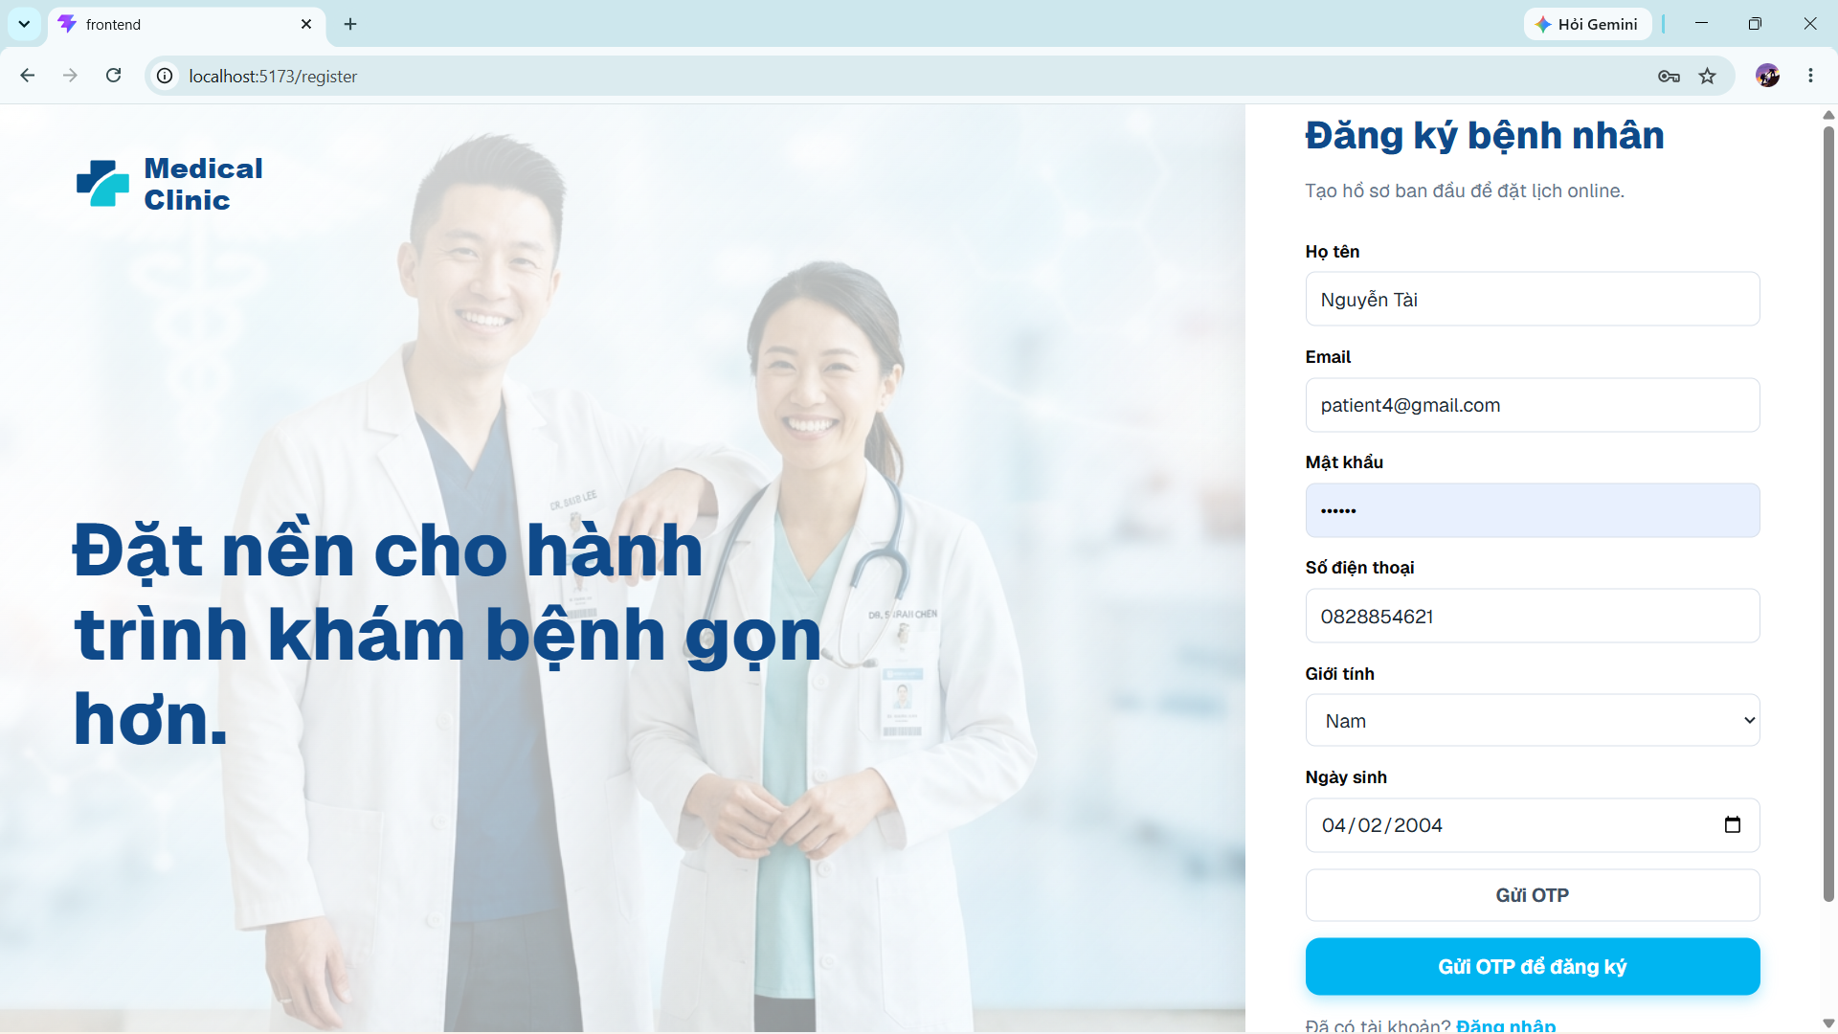

2.5. Recover a Forgotten Password
Purpose. Resets a local account password through email OTP verification.
Step 1: From Login, click Quên mật khẩu?.
Step 2: Enter the registered email address and click Gửi mã OTP.
Step 3: Open the email or backend console and obtain the six-digit OTP.
Step 4: Enter Mã OTP and Mật khẩu mới.
Step 5: Click Đặt lại mật khẩu.
Step 6: After the success message, return to Login and use the new password.
Expected result. The old local password is replaced and the OTP is consumed.

3. User Manual Guide for All Authenticated Users

3.1. Open the Role Dashboard
Purpose. Displays role-specific operational summaries and navigation shortcuts.
Step 1: Log in with a valid account.
Step 2: The system reads the assigned role and opens the corresponding dashboard: Admin, Doctor, Patient, Receptionist, Pharmacist, or Lab Technician.
Step 3: Use the left sidebar to open authorized modules.
Step 4: Use the header notification bell and profile controls for common actions.
Expected result. Only modules permitted for the current role are shown in the sidebar and protected by backend authorization.
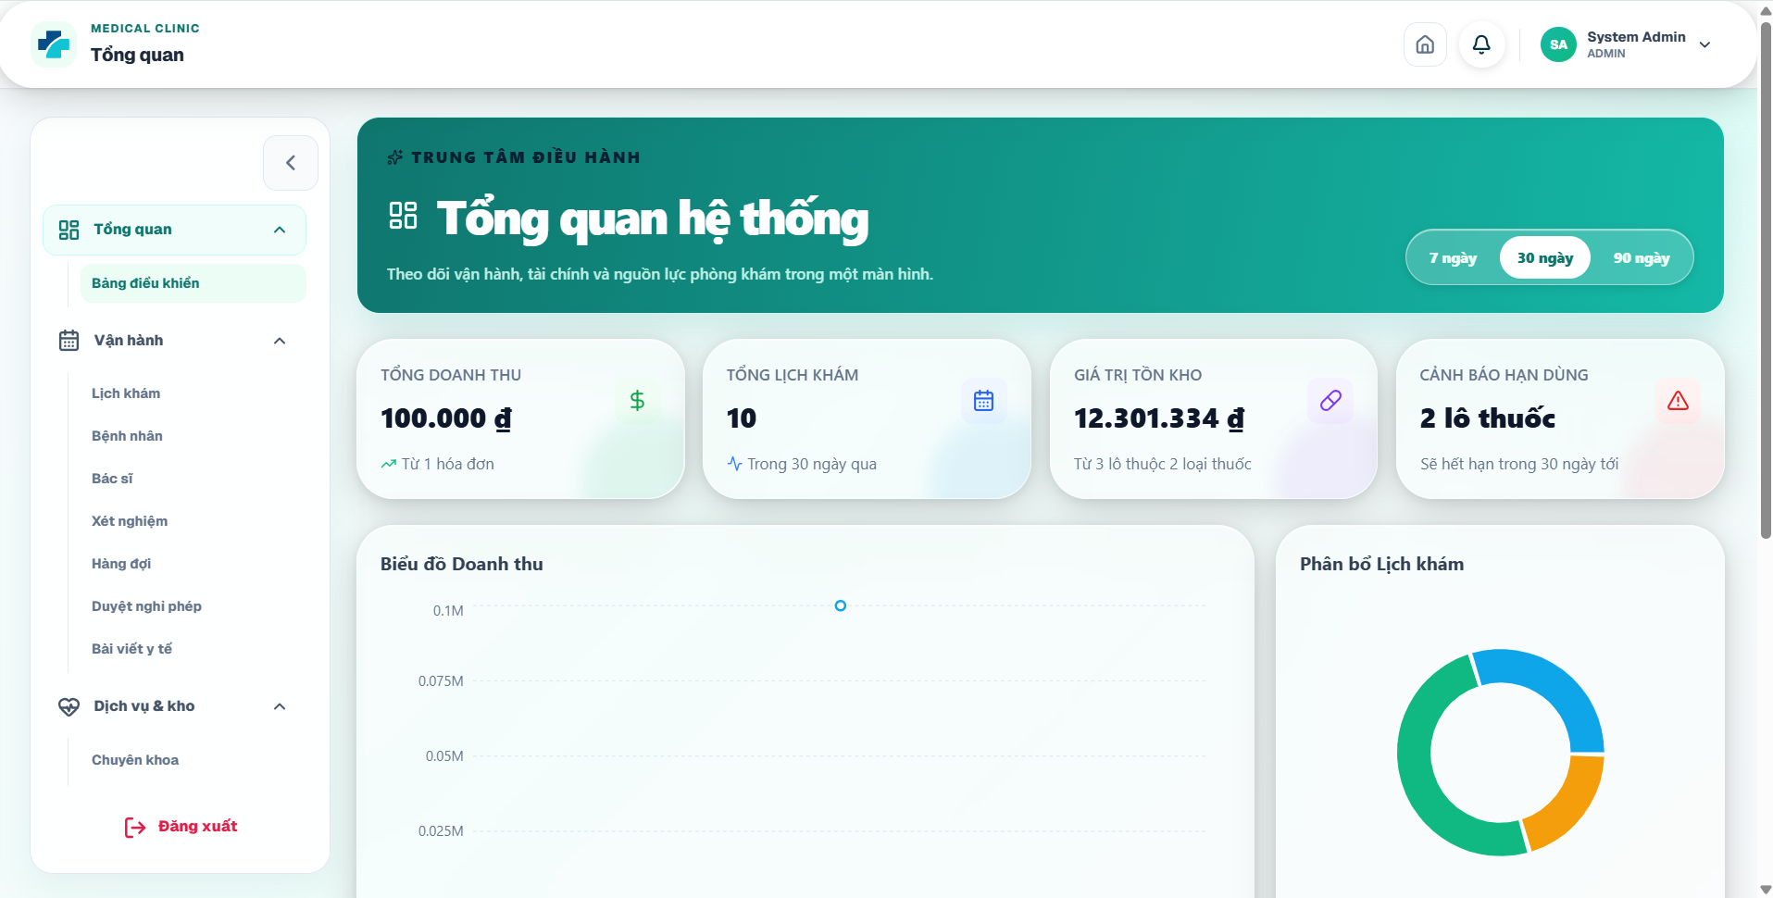


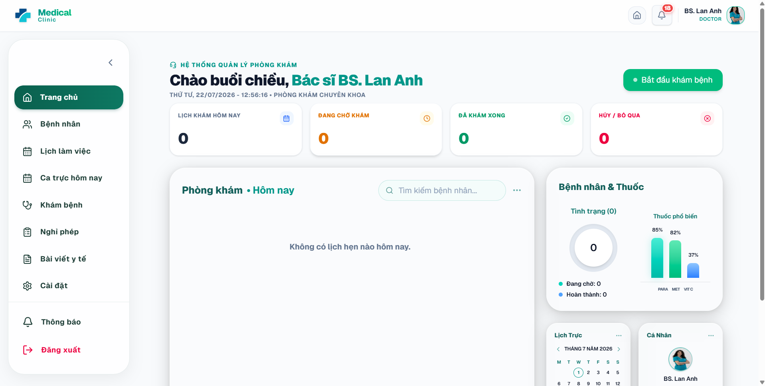
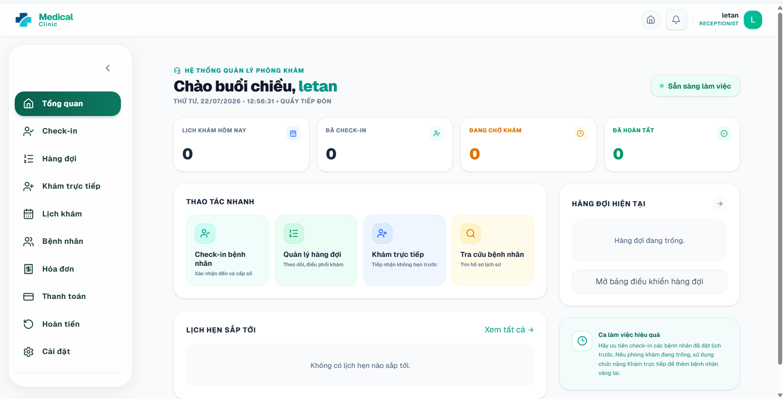

3.2. View and Update Profile
Purpose. Allows users to update their account name, phone number, avatar, and role-specific profile data.
Step 1: Open Cài đặt or Hồ sơ của tôi from the sidebar.
Step 2: Review the account email and assigned roles. These fields are read-only for normal users.
Step 3: Edit Họ và tên and Số điện thoại as required.
Step 4: Click Chọn avatar to upload a PNG, JPEG, WebP, or GIF image.
Step 5: For patient or doctor accounts, update the additional role-specific profile fields shown below the account card.
Step 6: Click Lưu hồ sơ.
Expected result. The updated profile is saved and reflected in the header/dashboard.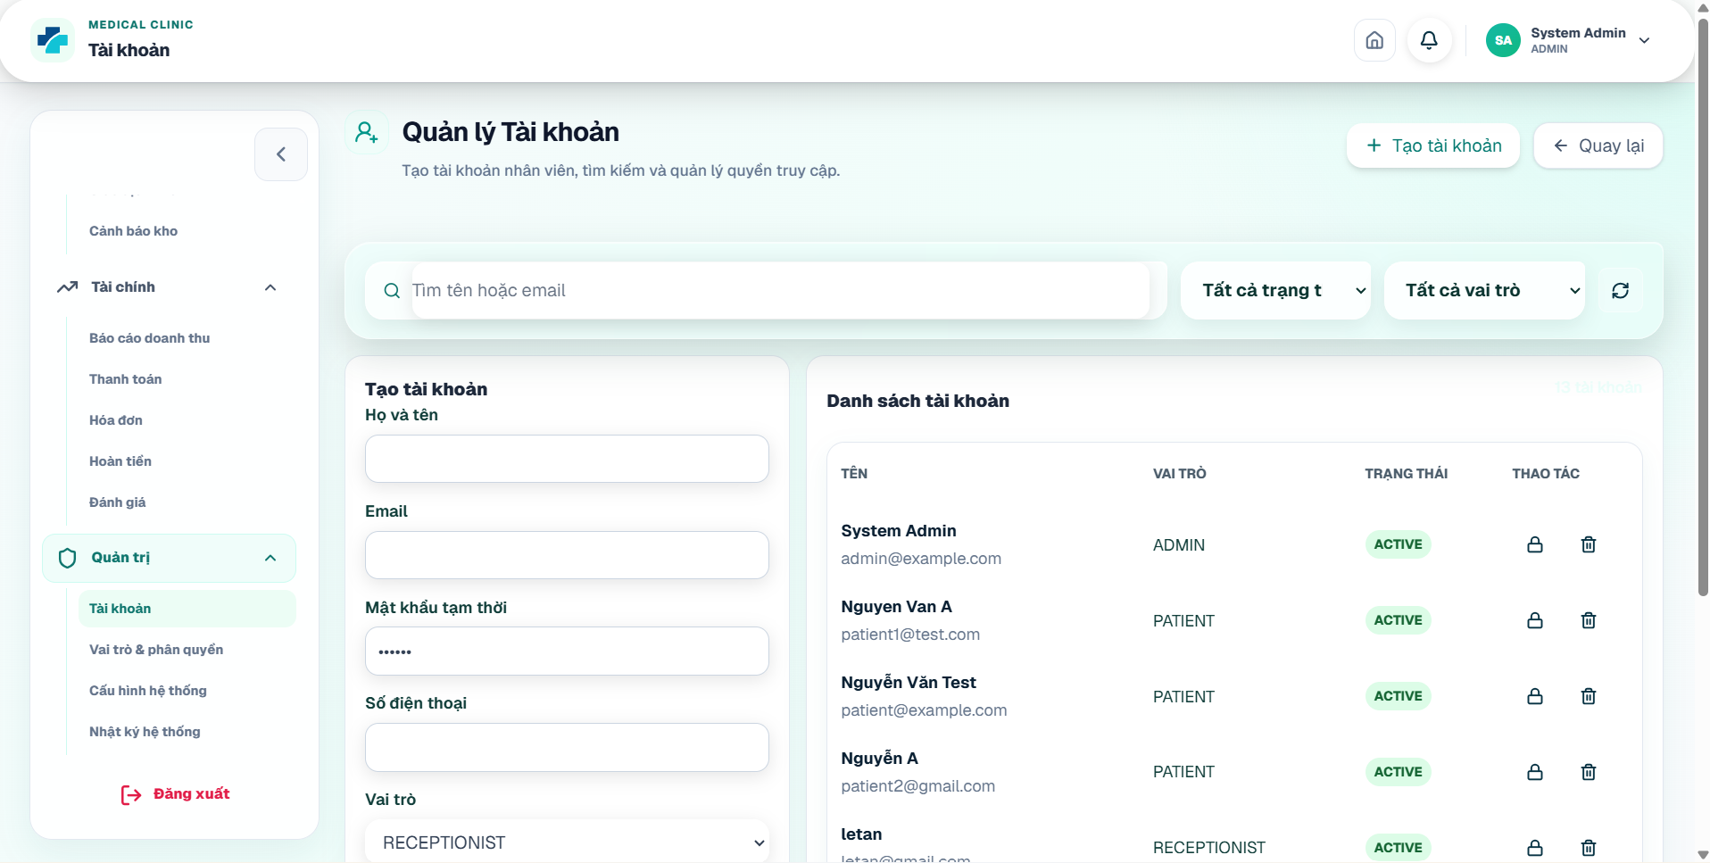

3.3. Change Password
Purpose. Changes the password for a local account.
Preconditions. This function applies to local-password accounts. Google-only accounts may not have a local password.
Step 1: Open Cài đặt and select Đổi mật khẩu.
Step 2: Enter Mật khẩu hiện tại.
Step 3: Enter Mật khẩu mới with at least six characters.
Step 4: Re-enter the same value in Xác nhận mật khẩu mới.
Step 5: Click Đổi mật khẩu.
Expected result. The password is updated and a confirmation message is displayed.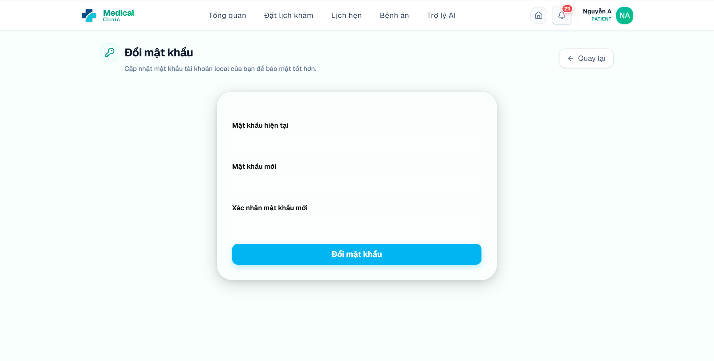

3.4. Manage Notifications
Purpose. Allows users to review appointment reminders, queue events, laboratory updates, payment events, and other system messages.
Step 1: Click the notification bell or open Thông báo from the sidebar.
Step 2: Use the displayed filters or pagination controls to find notifications.
Step 3: Click a notification to review its title, message, and time.
Step 4: Click the read action on an individual unread item, or click the control to mark all notifications as read.
Step 5: Use Refresh to load the latest data.
Expected result. Unread counts and message states are updated for the current user.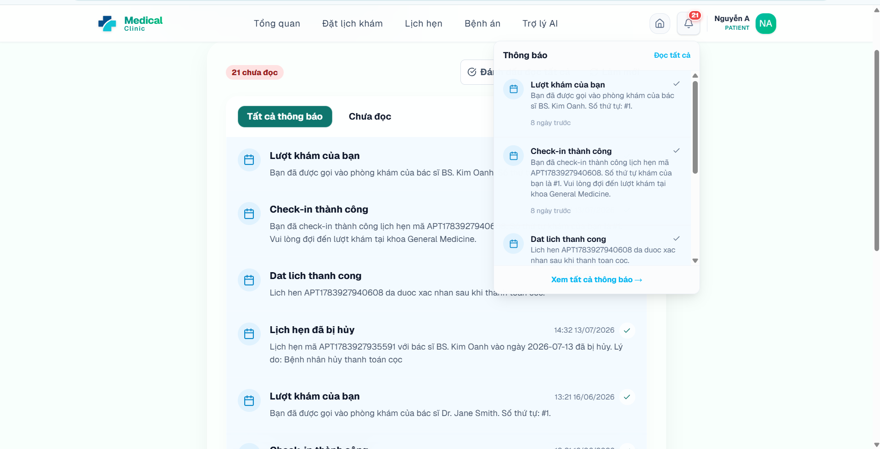

3.5. Logout
Purpose. Ends the current session and removes locally stored application tokens.
Step 1: Click Đăng xuất at the bottom of the role sidebar.
Step 2: Wait for the application to invalidate or discard session tokens.
Step 3: Confirm that the browser returns to Login.
Expected result. Protected pages can no longer be accessed without signing in again.

4. User Manual Guide for Patient

4.1. View the Patient Dashboard
Purpose. Provides a summary of appointments, health information, and quick access to booking and medical records.
Step 1: Log in with a PATIENT account.
Step 2: Review upcoming appointment cards and status information.
Step 3: Use the quick-action card Đặt lịch khám to open available slots.
Step 4: Use the Hồ sơ bệnh án card to open medical history.
Step 5: Use the patient sidebar for Lịch hẹn, Hàng đợi, Bệnh án, Xét nghiệm, Bác sĩ, Bảng giá, Trợ lý AI, and Cài đặt.
Expected result. The patient can navigate to all self-service functions.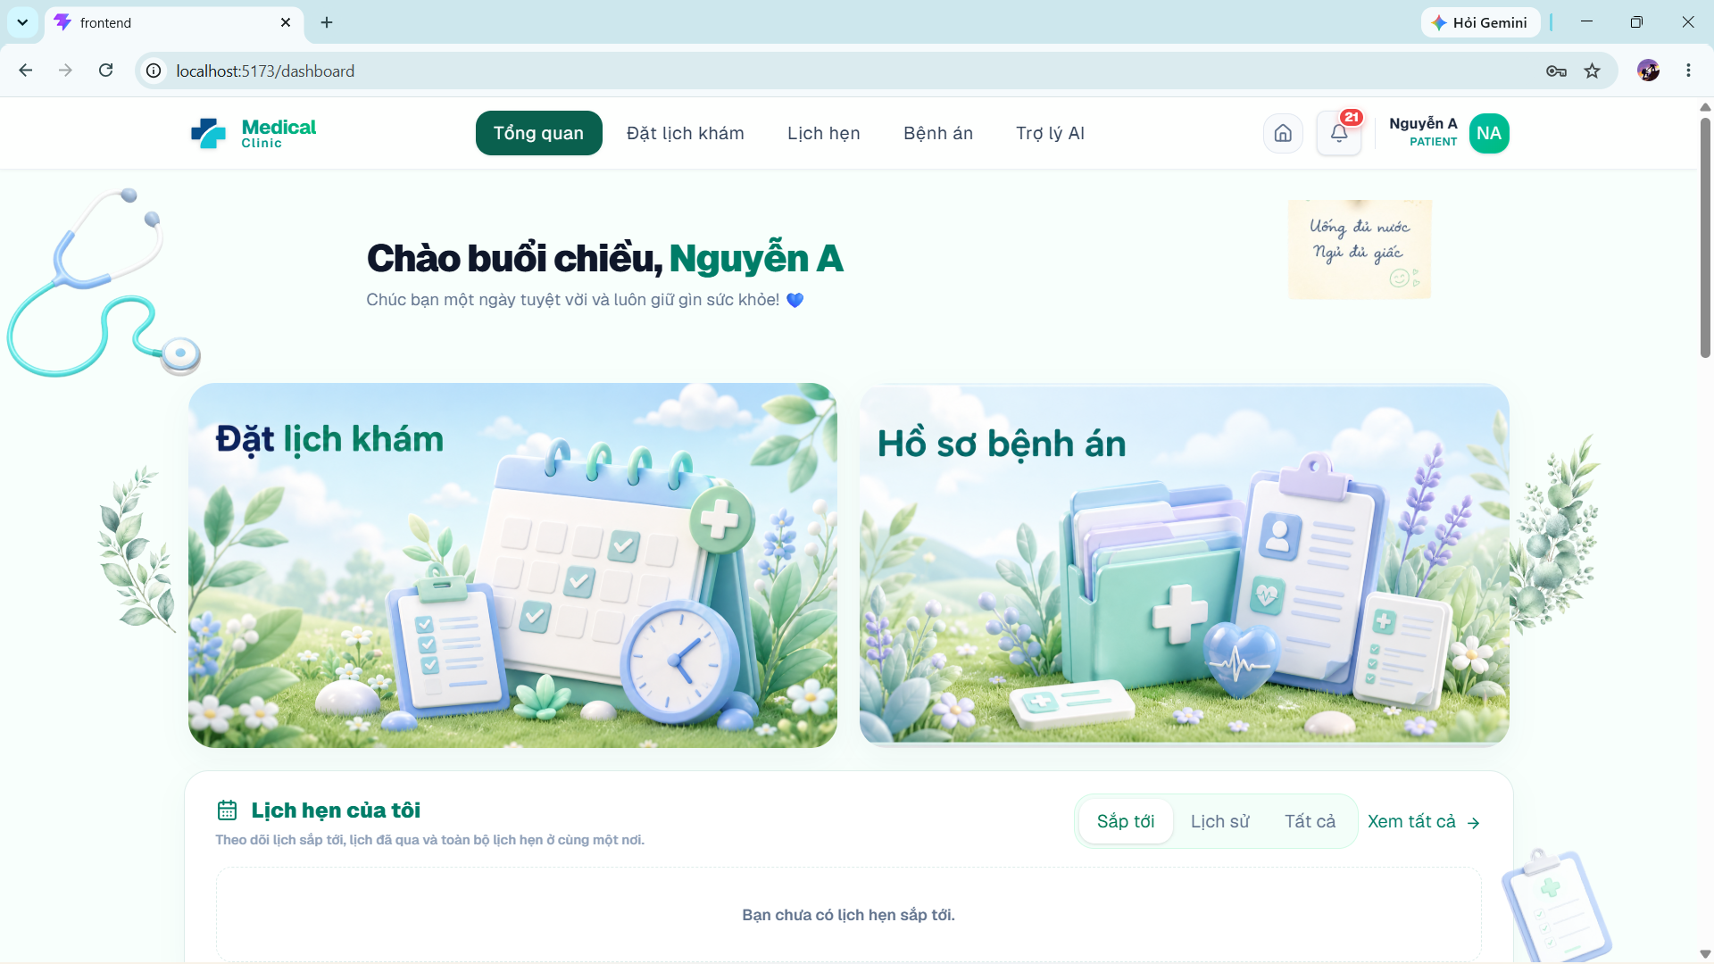

4.2. Use AI Symptom Triage
Purpose. Allows patients to describe symptoms and receive an AI-generated preliminary specialty suggestion.
Preconditions. A valid Groq or Gemini API key must be configured.
Step 1: Open Trợ lý AI from the patient sidebar.
Step 2: Start or open an AI chat session.
Step 3: Type a clear description of symptoms, duration, severity, age context, and relevant medical history.
Step 4: Click Send and wait while the system displays Đang phân tích triệu chứng....
Step 5: Review the AI response and the Chuyên khoa phù hợp nhất suggestion.
Step 6: Use the recommendation as a booking aid, not as a final medical diagnosis.
Expected result. The chat message and specialty suggestion are stored in the patient AI session.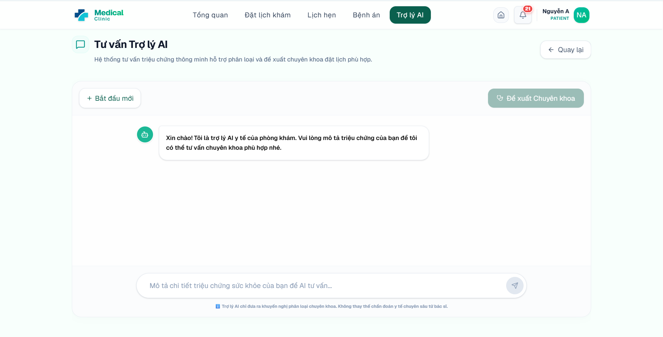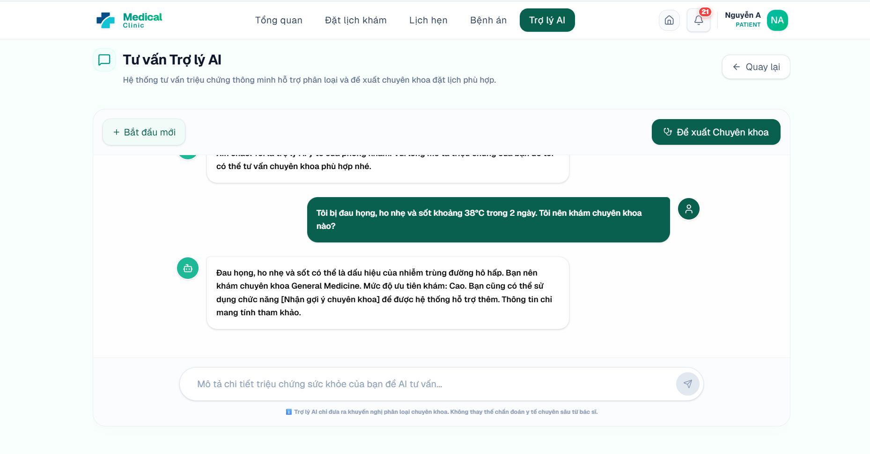

4.3. View Doctors and Specialties
Purpose. Allows patients to browse doctors and filter by name, specialization, or department.
Step 1: Open Bác sĩ from the patient sidebar.
Step 2: Use the search field to enter a doctor name or specialty.
Step 3: Choose Tất cả chuyên khoa or a specific specialty from the filter.
Step 4: Review doctor cards, qualifications, experience, and biography.
Step 5: Open the doctor detail view when more information is needed.
Expected result. The patient identifies a suitable doctor before booking.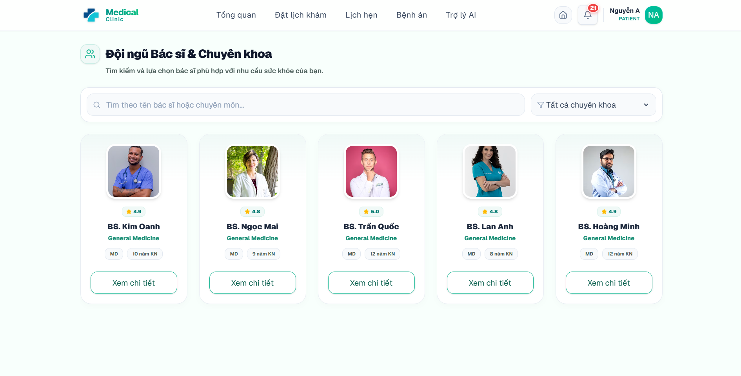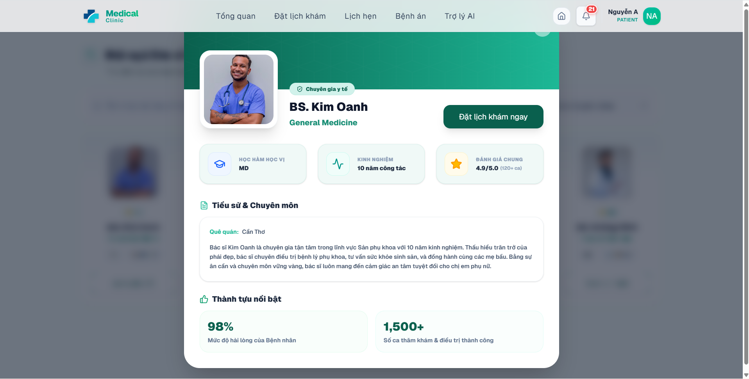

4.4. View Medical Service Prices
Purpose. Displays the active clinic services and published prices.
Step 1: Open Bảng giá from the patient sidebar.
Step 2: Use the search field to find a service by name or description.
Step 3: Review the service name, type, description, and price.
Step 4: Use the displayed information to estimate appointment, laboratory, or procedure costs.
Expected result. The patient can review public service pricing before booking or payment.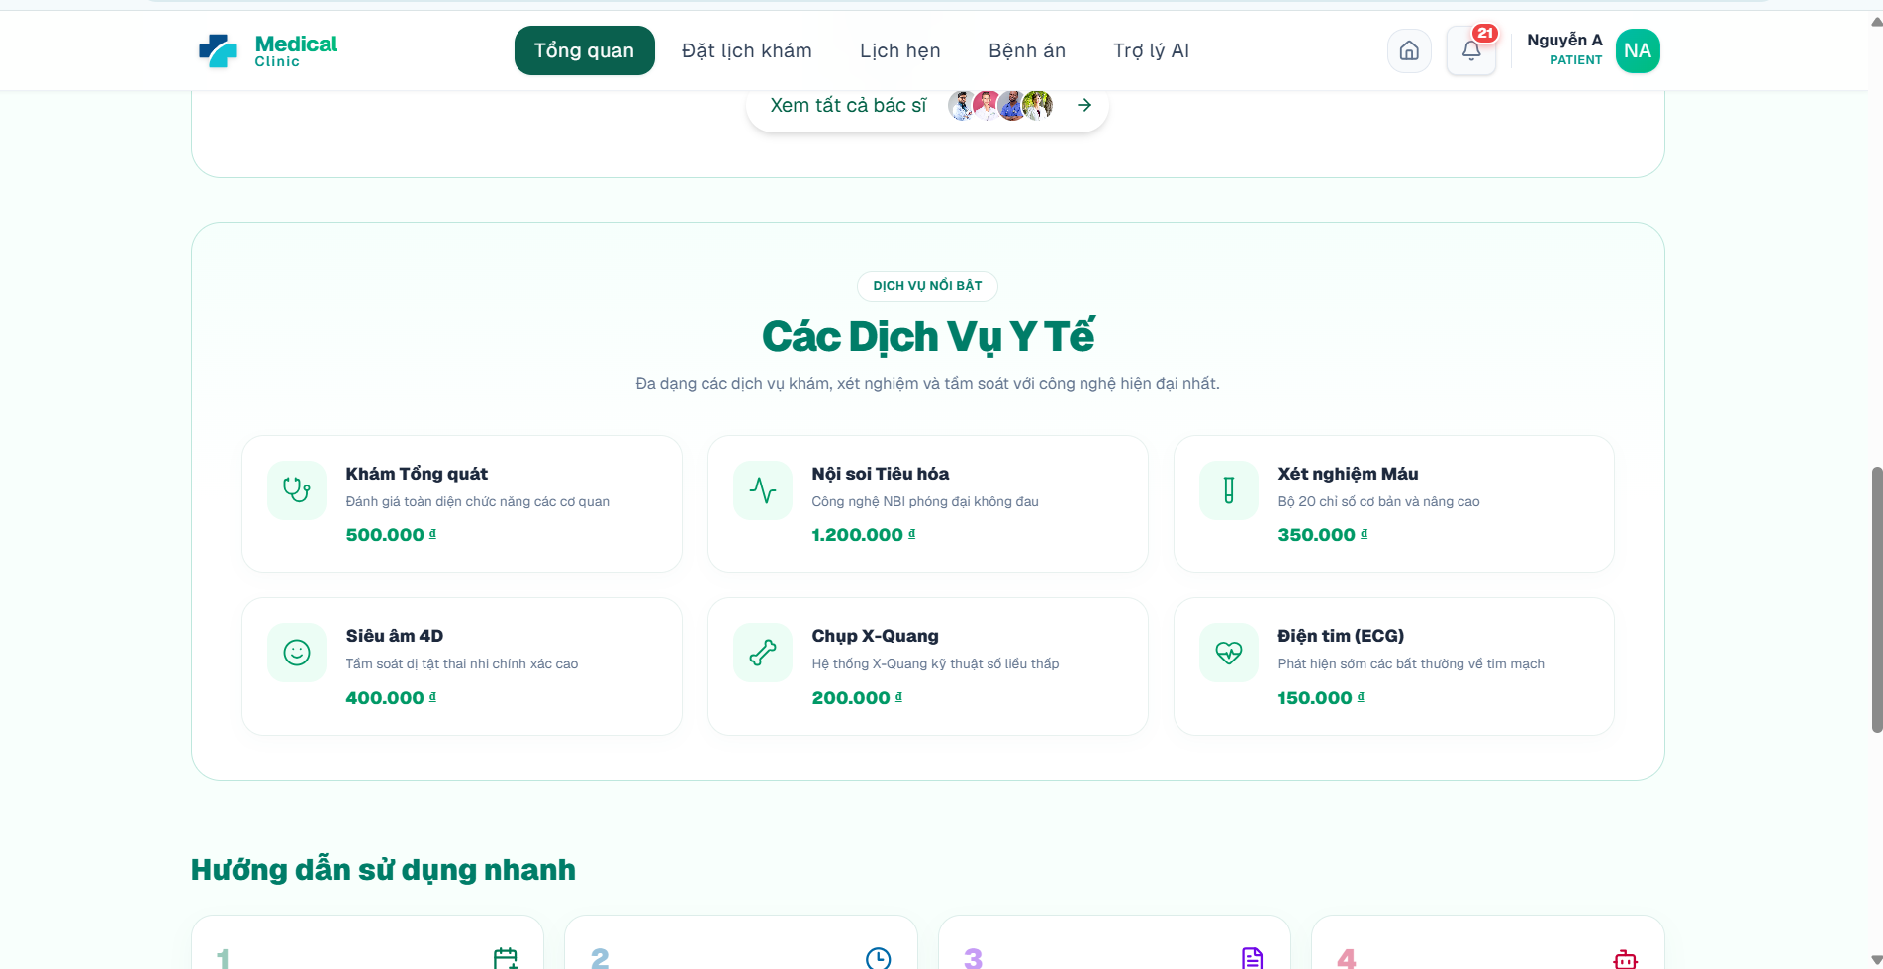

4.5. Manage Patient and Dependent Profiles
Purpose. Allows an account owner to use their own patient profile or create a profile for a family member/dependent.
Step 1: Open Hồ sơ của tôi and review the linked patient profile.
Step 2: Update personal medical-demographic information where editable.
Step 3: When booking, open Chọn Hồ sơ Bệnh nhân.
Step 4: Select the existing self profile or a saved dependent profile.
Step 5: To add a dependent, enter the dependent full name, phone, date of birth, gender, and relationship information requested by the form.
Step 6: Save/select the profile before continuing the booking process.
Expected result. Appointments and future medical records are linked to the selected patient profile, while account ownership remains unchanged.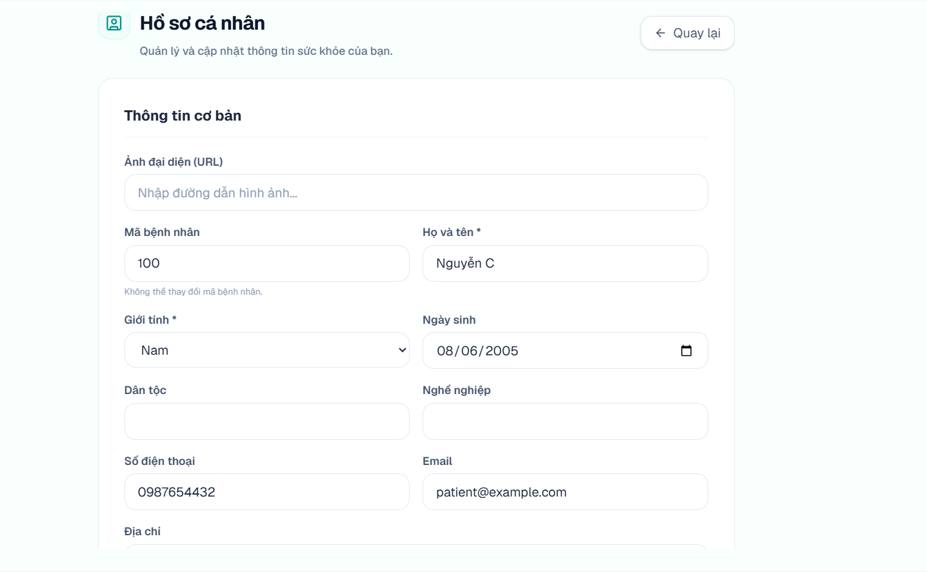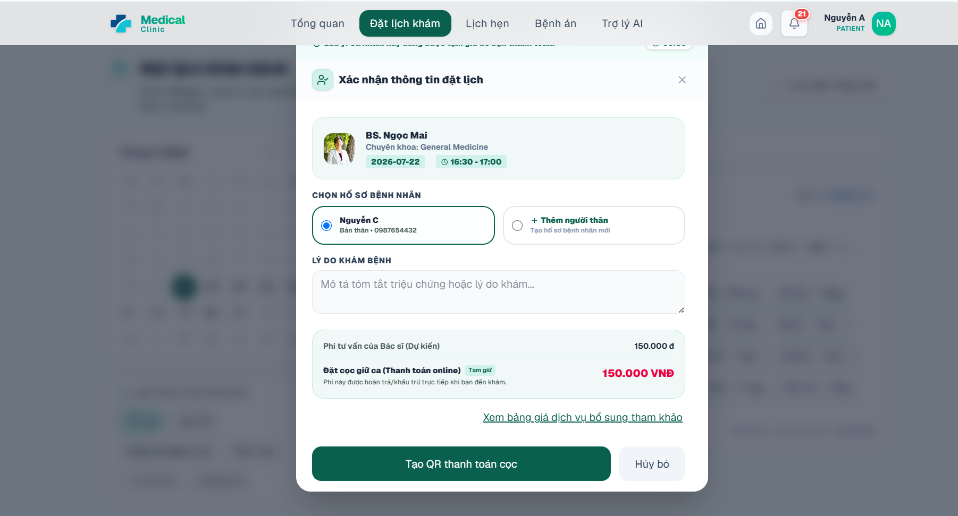

4.6. Book an Appointment Online
Purpose. Creates an online appointment using an available doctor slot.
Step 1: Open Đặt lịch from the patient sidebar.
Step 2: Select the desired date and optionally filter by specialty or search for a doctor.
Step 3: Review doctor schedules and click an AVAILABLE time slot.
Step 4: Click the booking action for the selected doctor and time.
Step 5: Choose the patient profile to be examined.
Step 6: Enter the reason for visit or initial symptoms.
Step 7: Review the doctor, date, time, consultation fee, and deposit information.
Step 8: Confirm the booking. The system validates that the slot is still available and checks for overlapping patient appointments.
Expected result. If no deposit is required, the appointment becomes CONFIRMED. If a deposit is required, it becomes PENDING_PAYMENT and the slot is temporarily LOCKED.
Important notes. A locked slot expires when payment is not completed within the configured payment.deposit.expiry_minutes period.

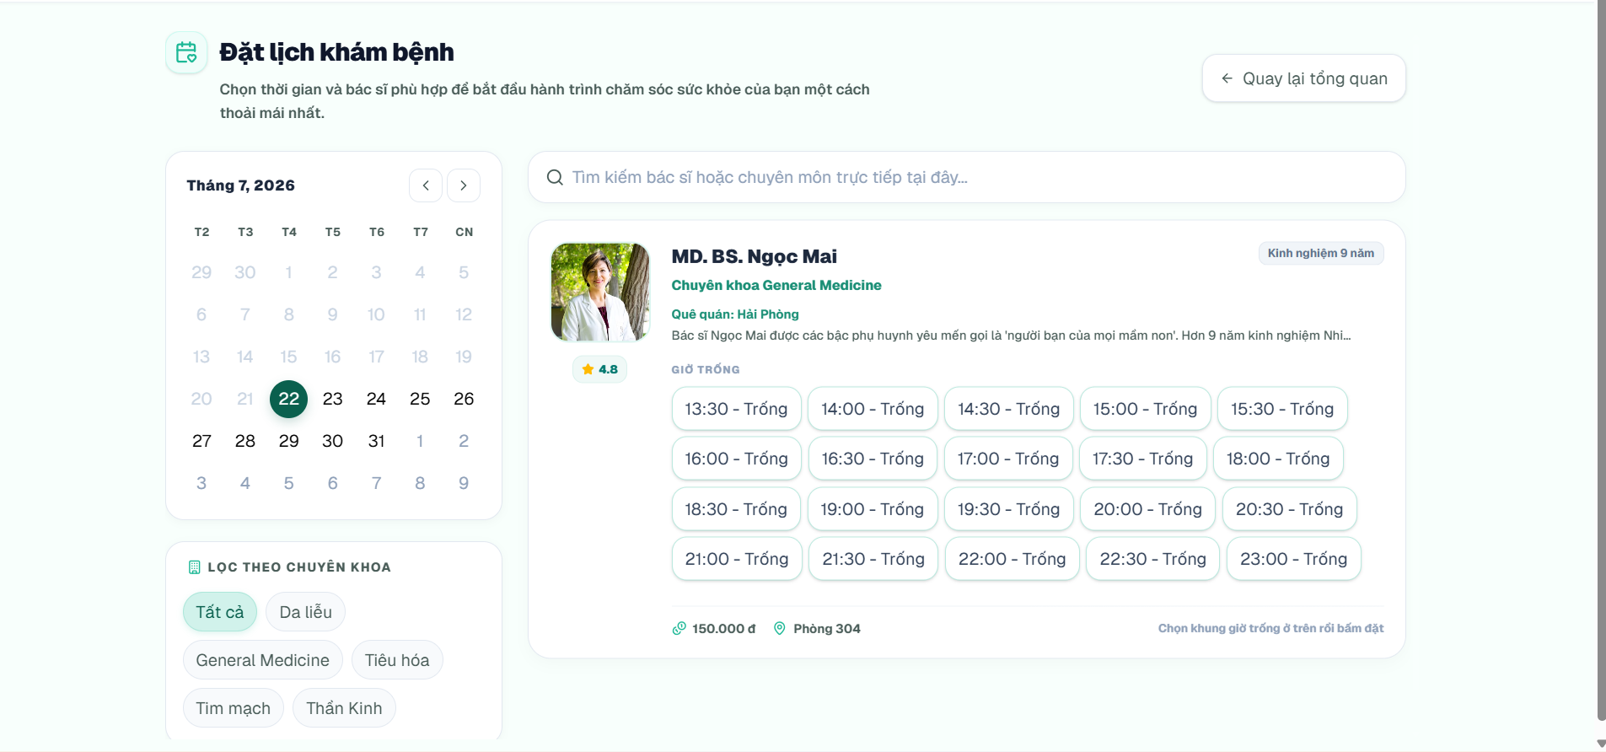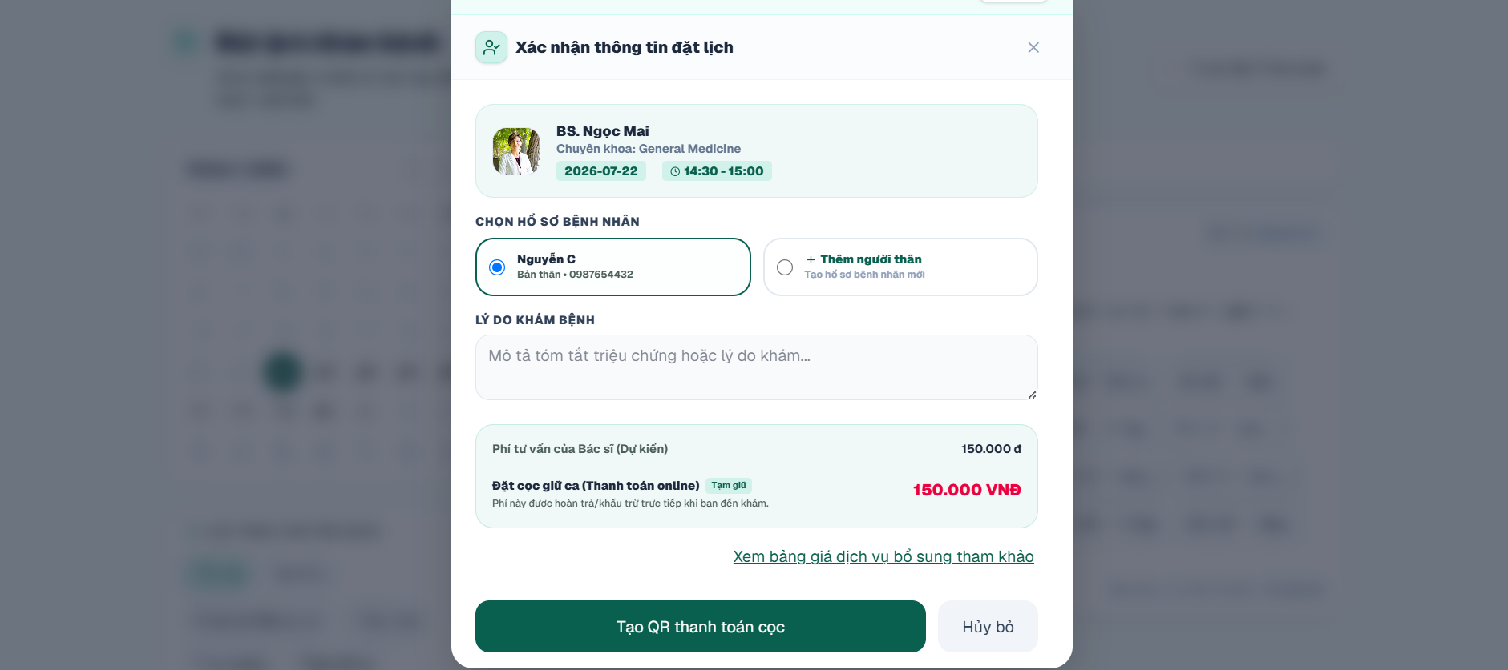

4.7. Complete the Appointment Deposit
Purpose. Confirms a PENDING_PAYMENT appointment by completing an online deposit.
Preconditions. SePay configuration and network access must be available.
Step 1: After booking, review the QR/payment modal and payment amount.
Step 2: Use a banking application to transfer the exact amount using the displayed content/payment code.
Step 3: Return to the modal and click the transaction verification action.
Step 4: If the modal was closed, open Lịch hẹn, select the pending appointment, and click Thanh toán cọc.
Step 5: Wait for the system to verify the SePay transaction.
Expected result. The payment becomes PAID, the appointment becomes CONFIRMED, and the selected slot becomes BOOKED.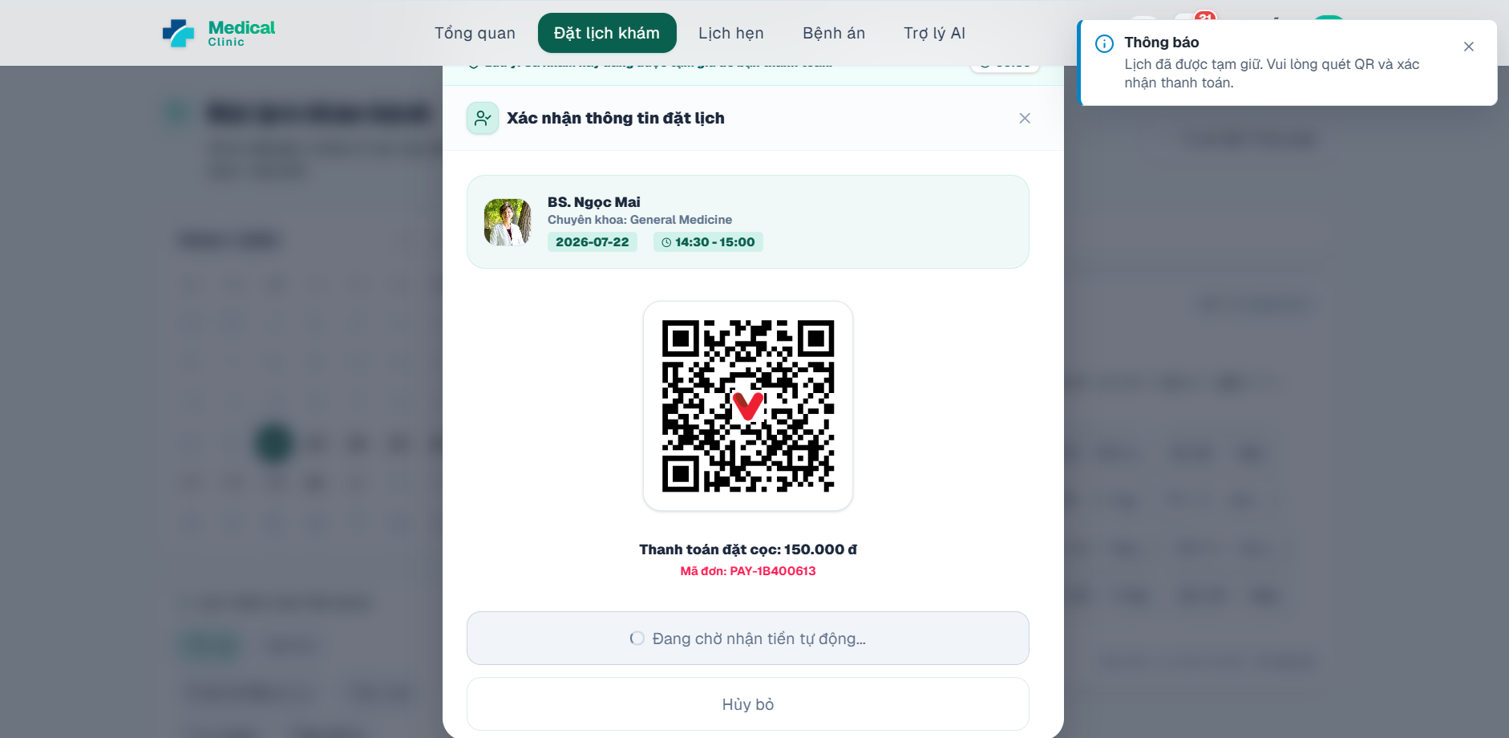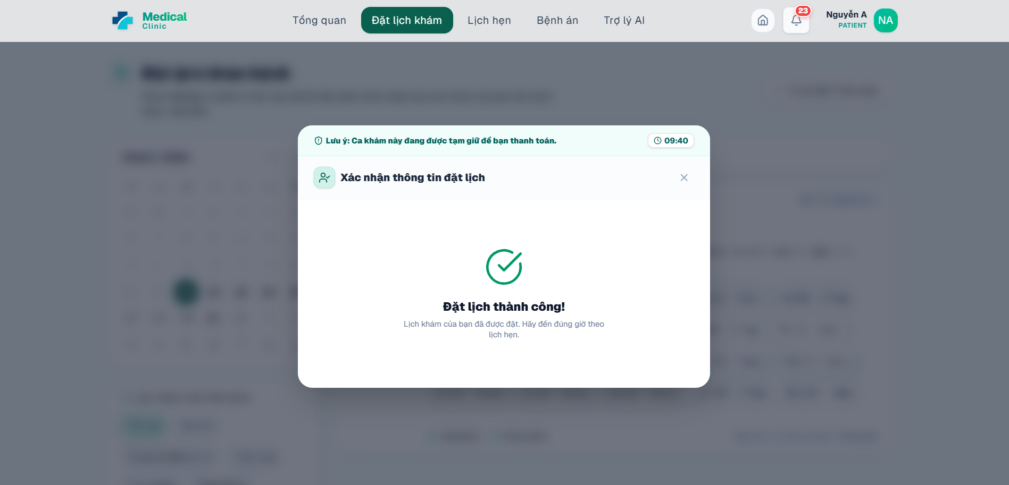

4.8. View Appointment List and Details
Purpose. Allows patients to search, filter, and review current and historical appointments.
Step 1: Open Lịch hẹn from the patient sidebar.
Step 2: Choose the relevant tab, such as upcoming or history.
Step 3: Use doctor, department, or keyword filters when necessary.
Step 4: Select an appointment card to view booking type, patient profile, doctor, date/time, reason, payment state, and status.
Step 5: Open Chi tiết đặt hẹn or the dedicated appointment detail page for a focused view.
Expected result. The patient can determine the next available actions based on appointment status.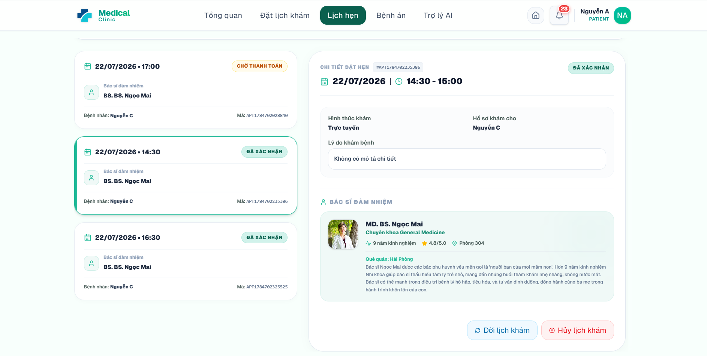

4.9. Reschedule an Appointment
Purpose. Moves an eligible appointment to another available slot and records the original appointment relationship.
Preconditions. The appointment must not be completed, checked in, cancelled, or too close to the examination time according to the active business rules.
Step 1: Open Lịch hẹn and select an appointment that allows changes.
Step 2: Click Đổi lịch.
Step 3: Choose a new date, doctor schedule, and available slot in the reschedule dialog.
Step 4: Review the new date and time.
Step 5: Confirm the reschedule request.
Expected result. The previous appointment is marked RESCHEDULED and the new appointment/slot is reserved as applicable.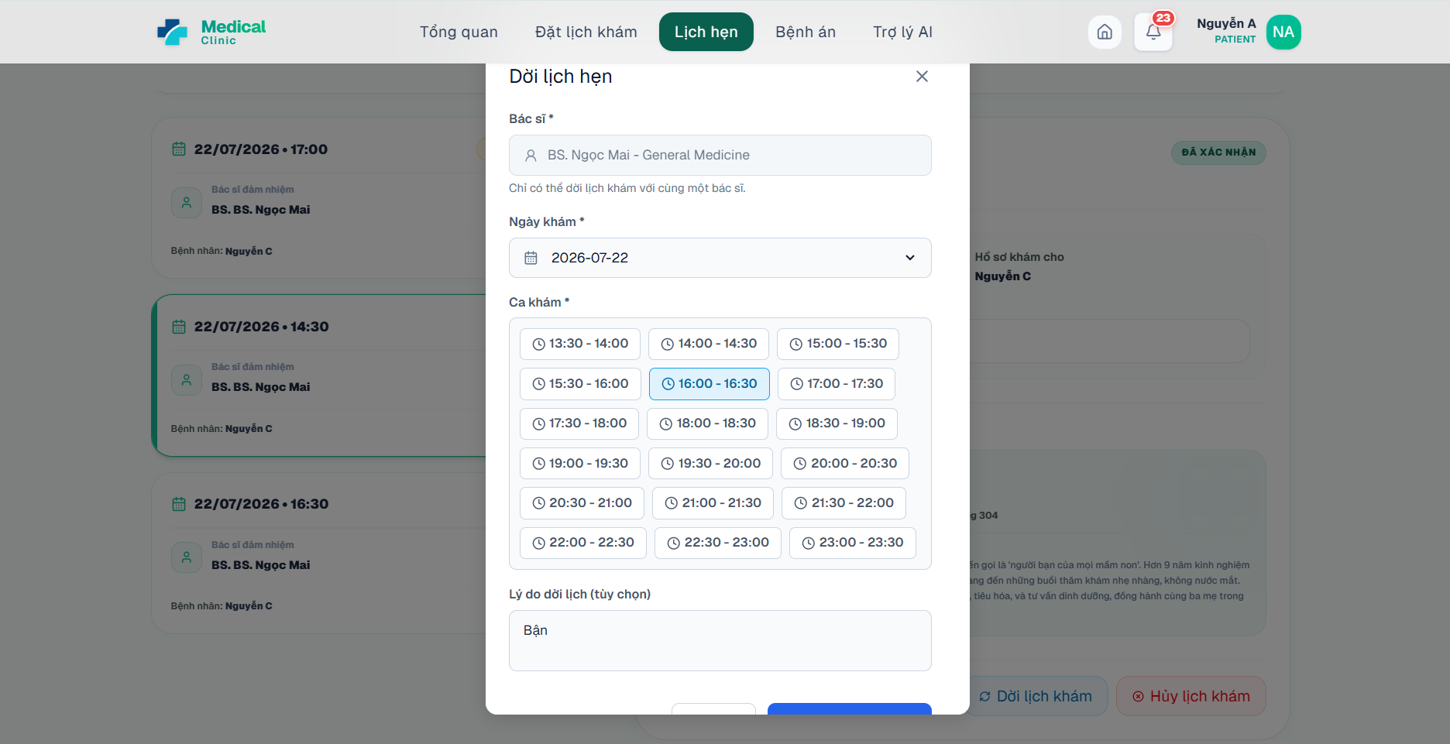

4.10. Cancel an Appointment and Request Refund
Purpose. Cancels an eligible appointment, releases the slot, and creates refund information when a paid deposit qualifies.
Step 1: Open Lịch hẹn and select the appointment.
Step 2: Click Hủy lịch khám.
Step 3: Enter a clear cancellation reason.
Step 4: When a refund is available, enter Bank name, Account number, and Account holder name.
Step 5: Review any warning for late cancellation. The default policy provides a full refund before 24 hours, a configurable partial refund before two hours, and no refund when cancelled too close to the appointment.
Step 6: Click Xác nhận hủy.
Expected result. The appointment becomes CANCELLED, pending payments are cancelled, the slot is released, and an eligible refund request is created.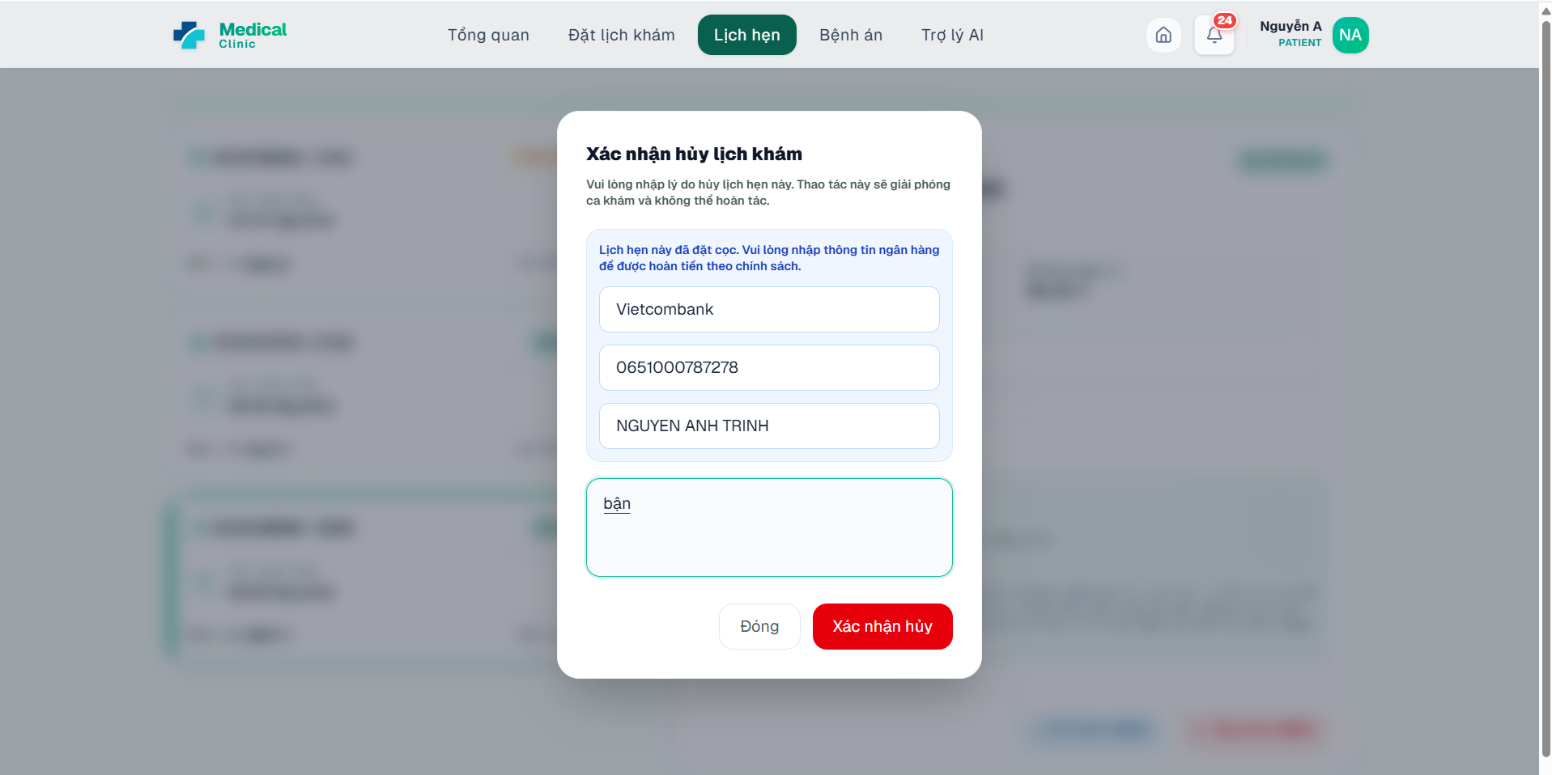
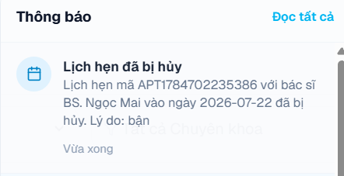

4.11. Track the Real-Time Queue
Purpose. Shows the patient’s queue number, current called number, people ahead, and estimated waiting time.
Preconditions. The patient must have a valid appointment and a queue ticket created by check-in or walk-in registration.
Step 1: On the examination date, complete check-in with the receptionist.
Step 2: Open Hàng đợi from the patient sidebar.
Step 3: Review the appointment code, doctor, and queue status.
Step 4: Observe Số thứ tự của bạn, Đang khám số, Người phía trước, and Thời gian chờ.
Step 5: Keep the page open to receive real-time updates when available.
Expected result. The patient can wait outside the examination room and follow queue progress.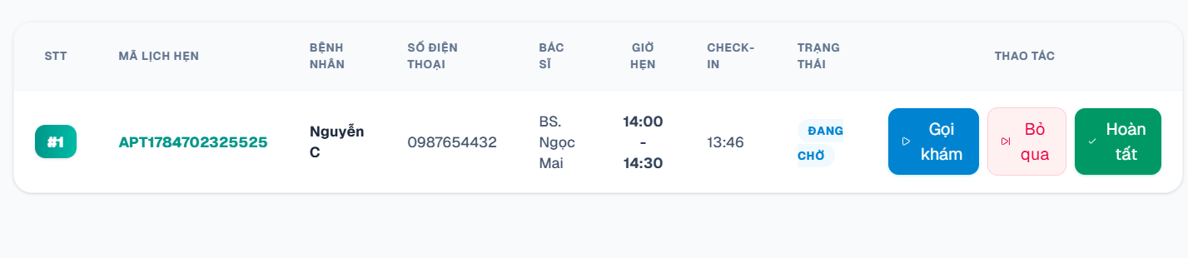

4.12. View Medical History, Lab Results, and Prescriptions
Purpose. Provides the patient with read-only access to personal electronic health records.
Preconditions. The signed-in account must be linked to the patient profile whose records are requested.
Step 1: Open Bệnh án from the patient sidebar.
Step 2: Review the patient identity block and medical record timeline.
Step 3: Open a visit to view symptoms, clinical findings, diagnosis, treatment plan, doctor note, and follow-up information.
Step 4: Open the laboratory/history tab to review requested tests, result values, reference ranges, conclusions, and attached report files when available.
Step 5: Open a prescription to view medicine, dosage, quantity, frequency, duration, time-of-day doses, and instructions.
Step 6: Review invoice/payment information linked to the completed visit when displayed.
Expected result. The patient can review completed clinical information without modifying it.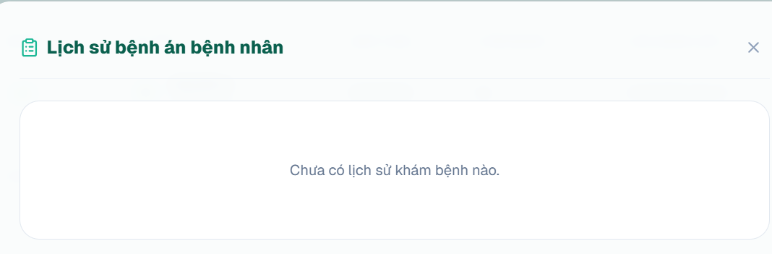

4.13. Pay a Final Invoice Online
Purpose. Pays an unpaid or partially paid consultation invoice.
Step 1: Open the invoice/payment action available from the appointment or medical history area.
Step 2: Review invoice items, subtotal, discount, paid amount, and remaining amount.
Step 3: Choose Chuyển khoản or the available online payment method.
Step 4: Create the payment and use the generated QR/payment content.
Step 5: Transfer the exact remaining amount and verify the transaction.
Step 6: Refresh the invoice status.
Expected result. The payment becomes PAID; when the remaining balance reaches zero, the invoice becomes PAID and the appointment becomes COMPLETED.
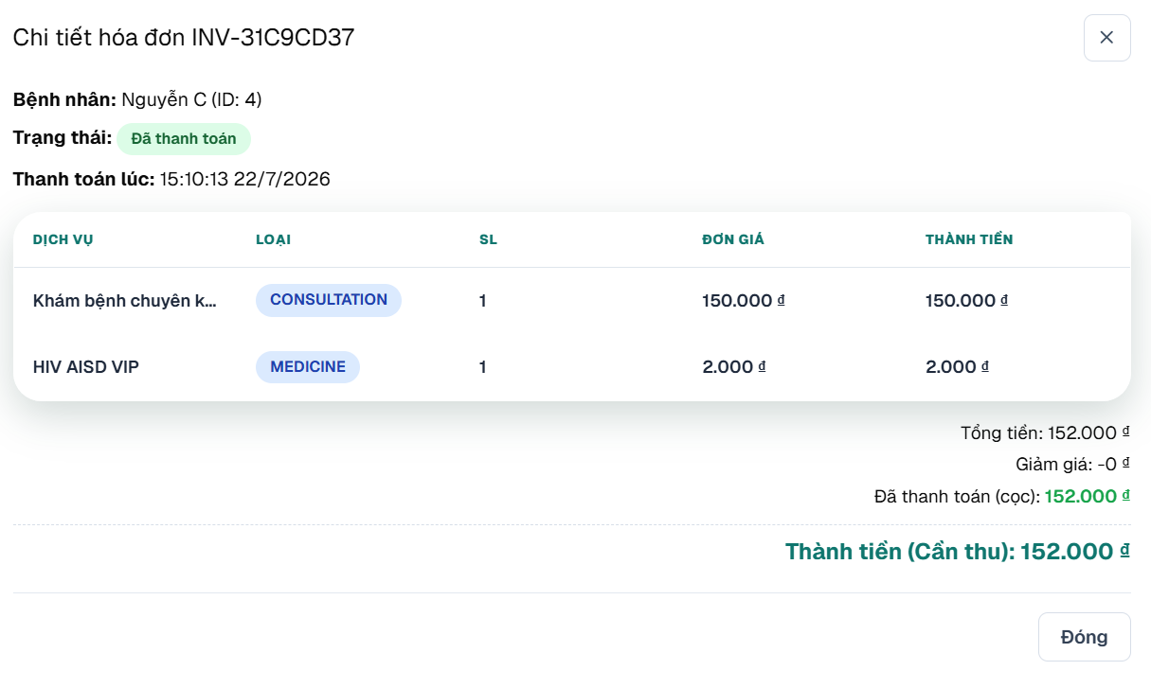

4.14. Submit a Review
Purpose. Allows patients to rate a completed appointment and provide optional feedback.
Step 1: Open Lịch hẹn and select a COMPLETED appointment that has not been reviewed.
Step 2: Click the review action.
Step 3: Select a rating from one to five stars.
Step 4: Enter an optional comment.
Step 5: Click Submit/Confirm in the review dialog.
Expected result. A review is stored for the doctor/appointment and becomes available for authorized moderation.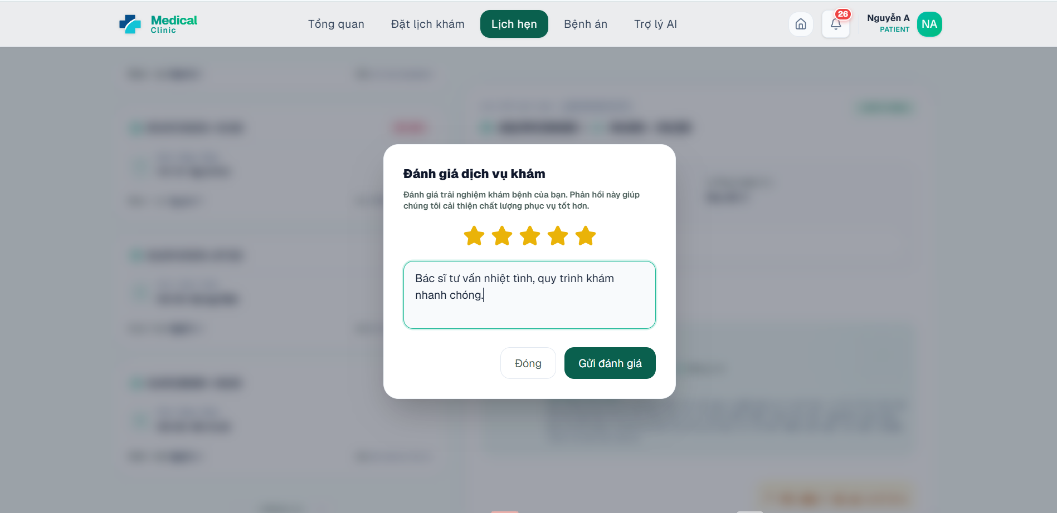

5. User Manual Guide for Receptionist

5.1. View the Receptionist Dashboard
Purpose. Summarizes today’s appointments, checked-in patients, waiting patients, completed visits, and active queue information.
Step 1: Log in with a RECEPTIONIST account.
Step 2: Review the summary cards for Lịch khám hôm nay, Đã Check-in, Đang chờ khám, and Đã hoàn tất.
Step 3: Review the upcoming appointment list and current queue panel.
Step 4: Use sidebar shortcuts for Check-in, Hàng đợi, Khám trực tiếp, Lịch khám, Bệnh nhân, Thanh toán, Hoàn tiền, and Cài đặt.
Expected result. The receptionist identifies the highest-priority front-desk tasks.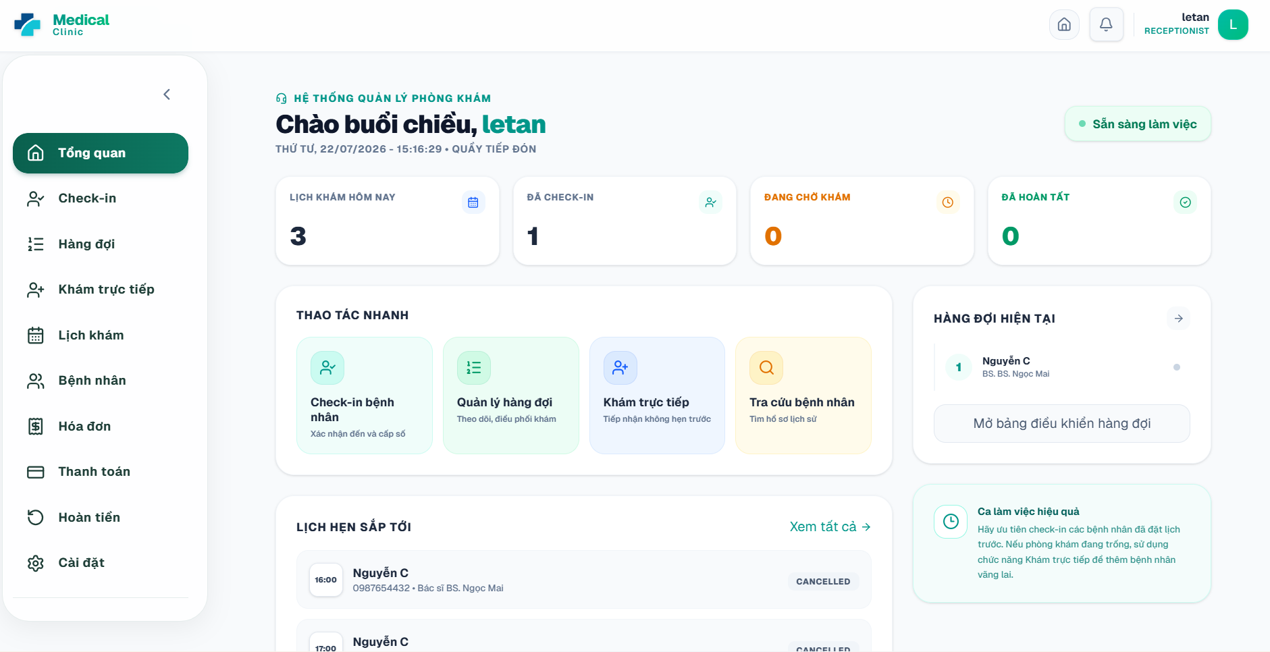

5.2. Search, Create, and Update Patient Profiles
Purpose. Maintains patient demographic and contact information for front-desk operations.
Step 1: Open Bệnh nhân from the receptionist sidebar.
Step 2: Use the search field to find a patient by code, name, phone, or other displayed information.
Step 3: Open Hồ sơ chi tiết to review identity and emergency-contact information.
Step 4: To create a new profile, enter patient code if required, full name, gender, date of birth, phone, email, address, ID number, health-insurance code, emergency contact, allergies, occupation, and medical history fields.
Step 5: Click Save/Create.
Step 6: To change an existing record, click Chỉnh sửa, update the fields, and save.
Expected result. The patient profile is available for check-in, walk-in booking, consultation, and billing.
Important notes. Only ADMIN can permanently delete a patient record through the current backend permission rules.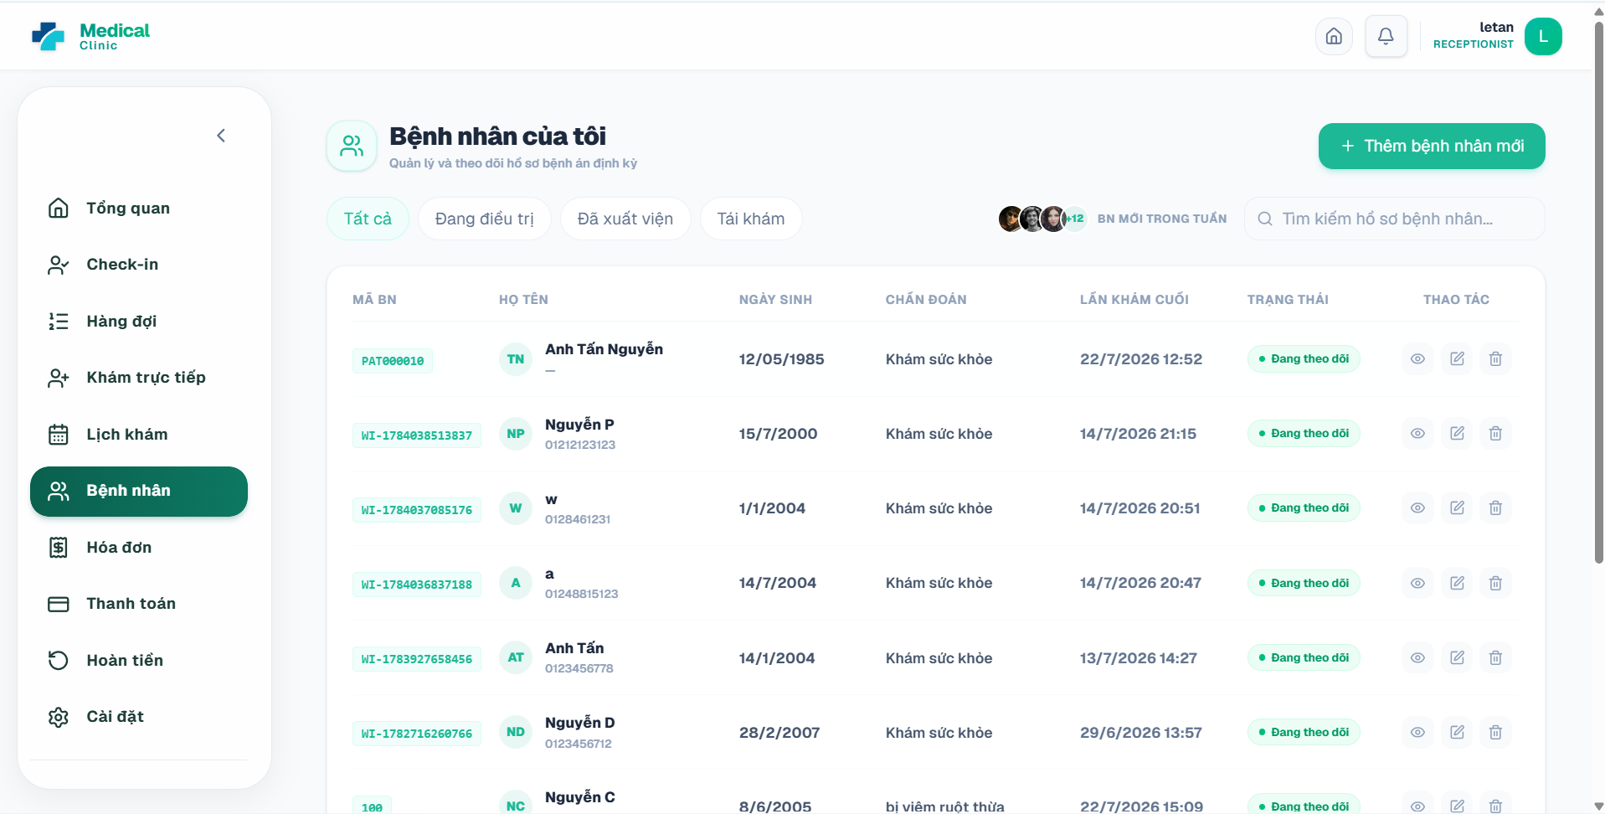

5.3. Check In a Scheduled Patient
Purpose. Confirms arrival for a valid appointment and creates a queue ticket.
Preconditions. The appointment must be on the current date, not already checked in, and not cancelled/completed/no-show.
Step 1: Open Check-in from the receptionist sidebar.
Step 2: Filter by date, status, appointment code, patient name, or phone number.
Step 3: Find an appointment in CONFIRMED status for the current date.
Step 4: Click Check-in in the action column.
Step 5: Review the confirmation message and assigned queue number.
Expected result. Appointment becomes CHECKED_IN and a WAITING queue ticket is created for the correct doctor.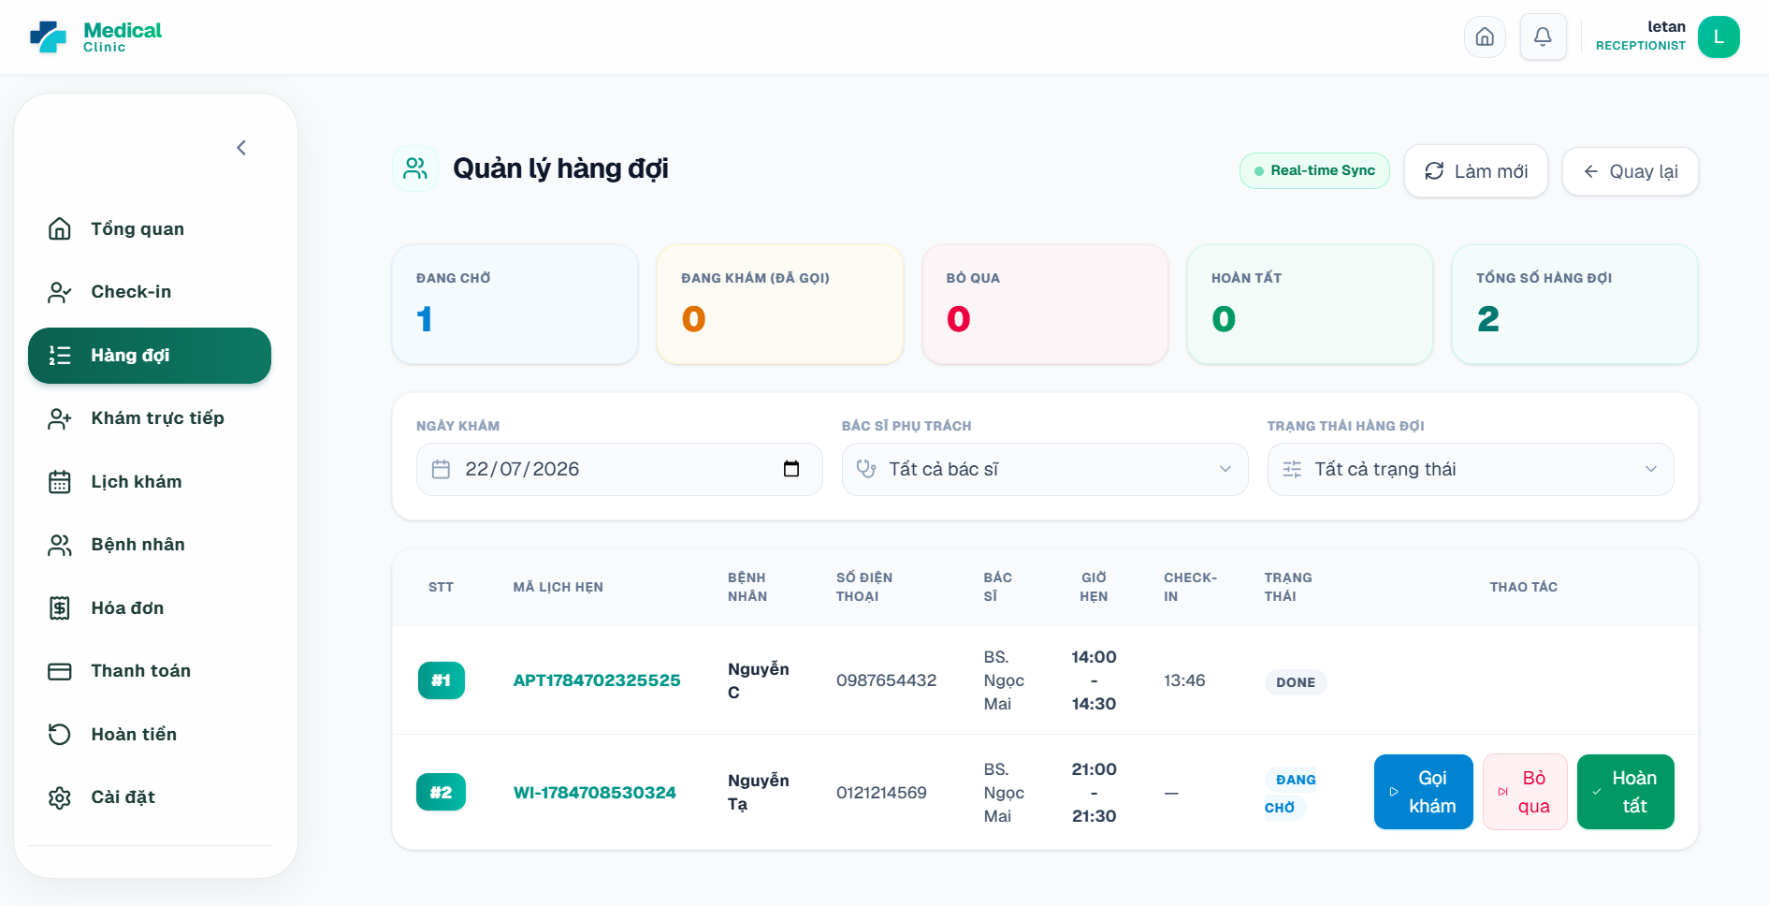

5.4. Mark a Patient as No-Show
Purpose. Records that a scheduled patient did not attend.
Step 1: Open Check-in and locate the scheduled appointment.
Step 2: Click Đánh dấu Không đến.
Step 3: Enter an operational note, for example that the patient was contacted but did not answer.
Step 4: Confirm the action.
Expected result. The appointment becomes NO_SHOW and is excluded from active check-in flow.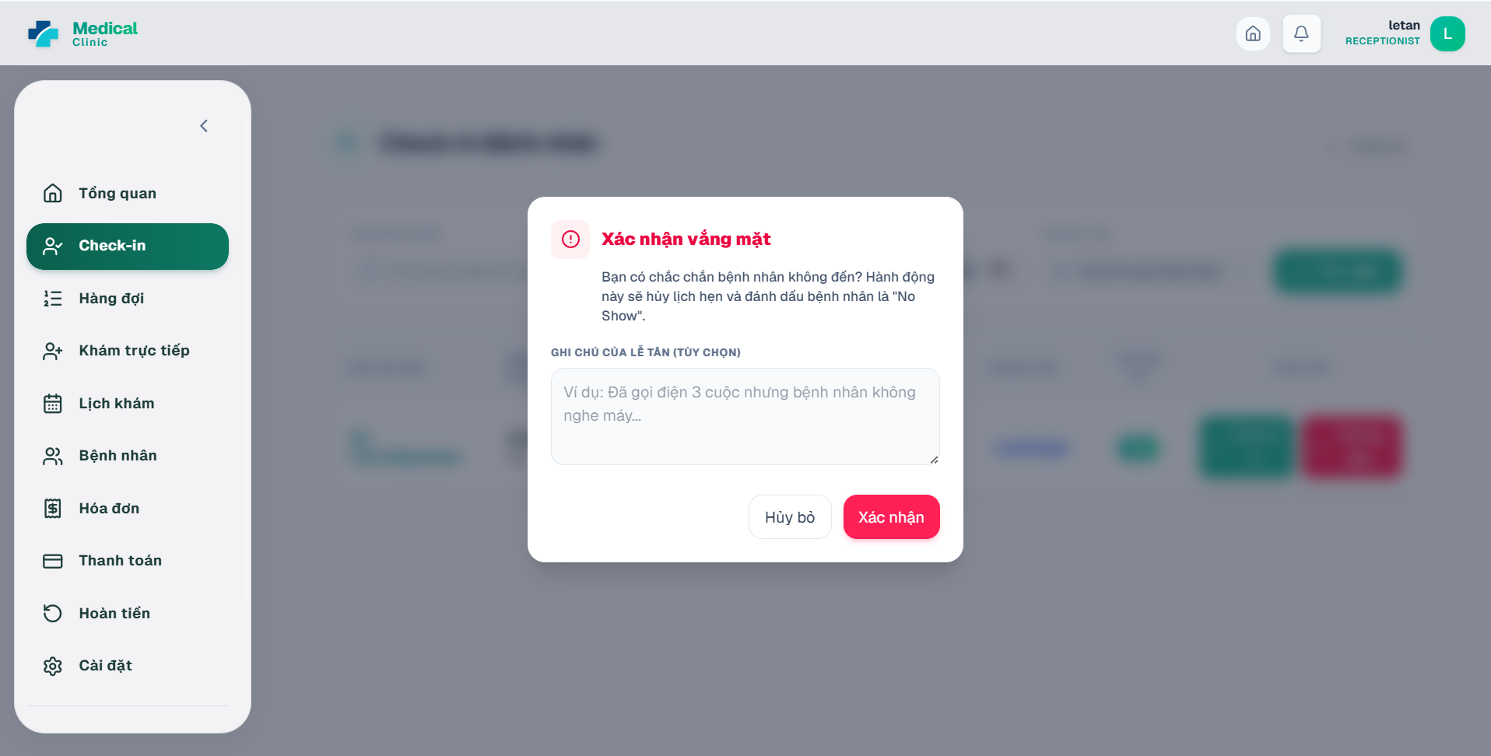

5.5. Create a Walk-In Appointment
Purpose. Registers an immediate appointment for a patient who did not book online.
Step 1: Open Khám trực tiếp from the receptionist sidebar.
Step 2: Choose the examination date and review the doctor schedule grid.
Step 3: Click a green available slot.
Step 4: Search for an existing patient by phone or name. Select the profile when found.
Step 5: If the patient is new, enter Họ và tên, Số điện thoại, Ngày sinh, Giới tính, and other required information.
Step 6: Enter Lý do khám / Triệu chứng and review the consultation fee.
Step 7: Click Tạo lịch khám trực tiếp.
Expected result. A WALK_IN appointment is confirmed, the slot becomes BOOKED, and a WAITING queue ticket is generated.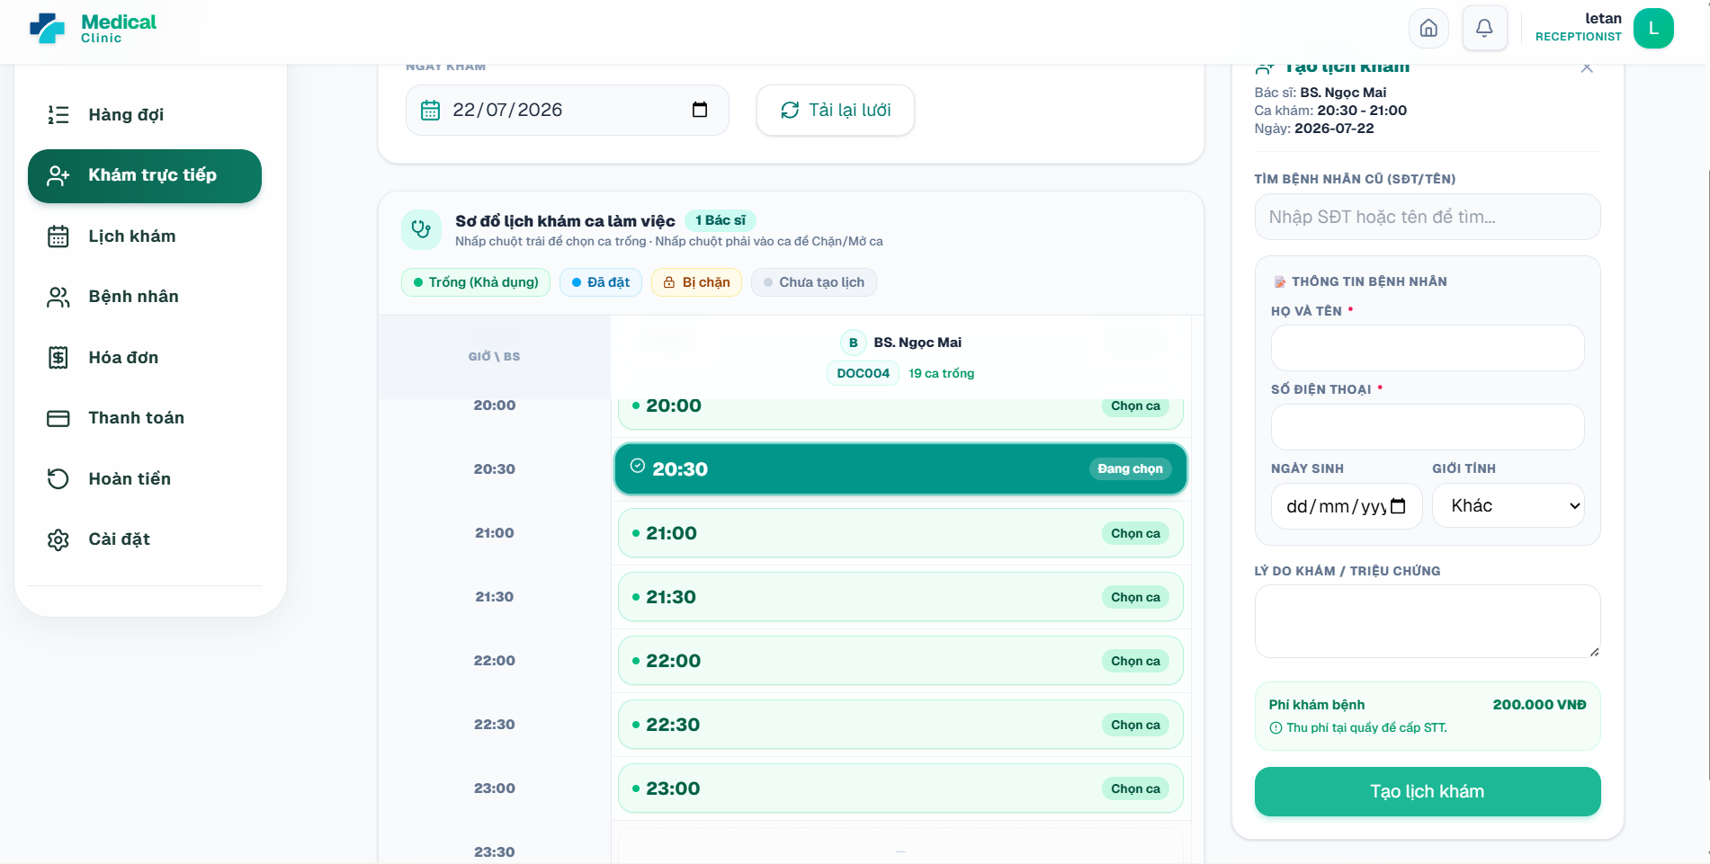

5.6. Manage the Patient Queue
Purpose. Coordinates waiting, called, examination, skipped, and completed queue tickets.
Step 1: Open Hàng đợi from the receptionist sidebar.
Step 2: Filter by examination date, doctor, or queue status.
Step 3: Review queue number, patient, phone, doctor, appointment time, check-in time, and status.
Step 4: Use Gọi khám bệnh nhân to move the selected ticket to CALLED when operationally appropriate.
Step 5: Use Bỏ qua lượt bệnh nhân when the patient is temporarily unavailable, and enter a reason if requested.
Step 6: Use Hoàn tất lượt khám only when the clinical workflow has finished or the authorized operational process requires it.
Expected result. Queue status changes are pushed to authorized dashboards and the patient queue page.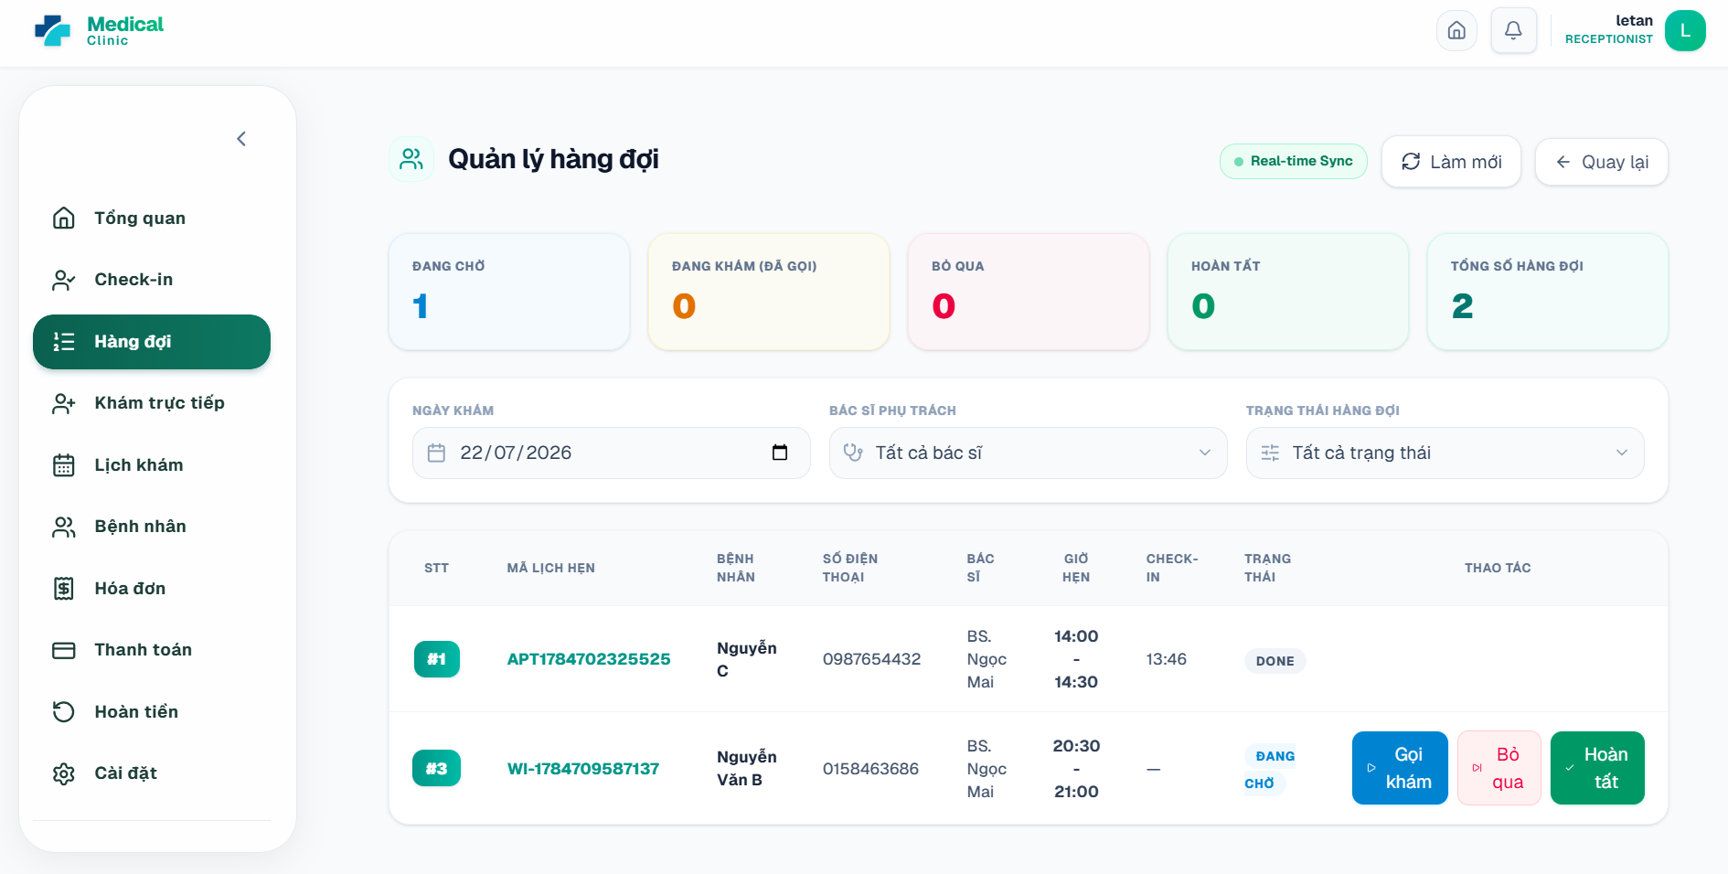

5.7. View and Manage Clinic Appointments and Schedules
Purpose. Provides a calendar view of doctor schedules, appointment slots, locked slots, and booked slots.
Step 1: Open Lịch khám from the receptionist sidebar.
Step 2: Choose Hôm nay, previous week, or next week.
Step 3: Filter by doctor when necessary.
Step 4: Review the legend for Trống, Có lịch, Đã đặt, Đang khóa, Đã chặn, and Đã hủy.
Step 5: Click a calendar block to view appointment or slot details.
Step 6: Use the permitted scheduling actions to create a single doctor schedule or bulk schedule, generate slots, block/cancel a slot, or cancel a schedule.
Expected result. The clinic calendar reflects the latest doctor availability and bookings.
Important notes. Some schedule-creation actions may be restricted to ADMIN depending on the active deployment policy.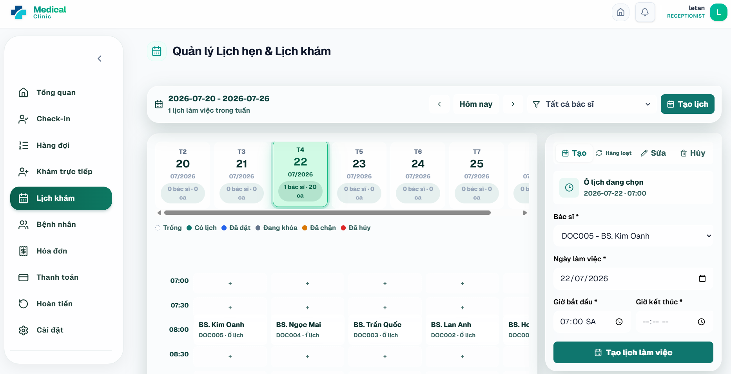

5.8. Manage Invoices
Purpose. Creates, reviews, updates, or cancels clinic invoices.
Step 1: Open the Invoice Management page from the finance area or an invoice link associated with a visit.
Step 2: Search by invoice code or patient name, or filter by status.
Step 3: Open Xem chi tiết to review the patient, appointment, services, medicines, discount, total, paid amount, and status.
Step 4: To create a manual invoice, select the patient, optional appointment, services/medicines, quantities, and discount.
Step 5: Click Create/Save.
Step 6: Use Chỉnh sửa only while the invoice is eligible, and use Hủy hóa đơn only after confirming the cancellation prompt.
Expected result. Invoice totals and statuses are stored for later cash or online payment.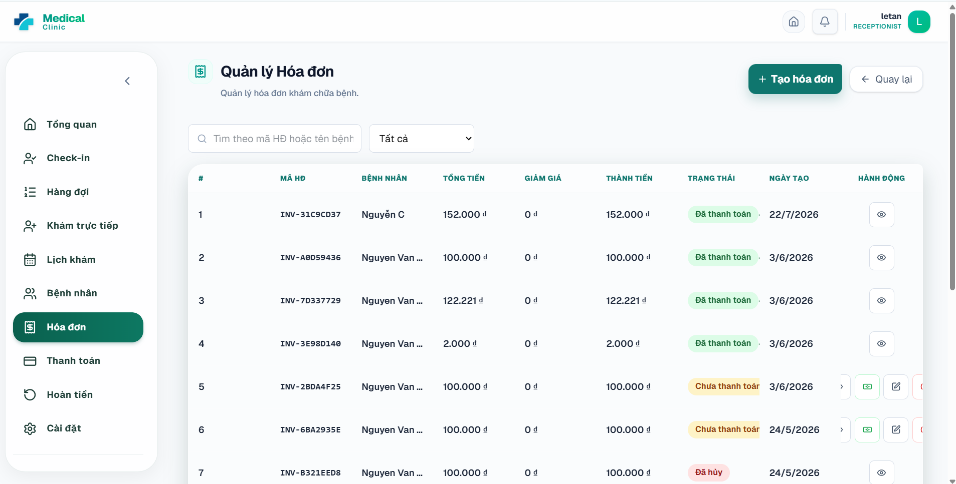

5.9. Create and Confirm Payments
Purpose. Records consultation/deposit payments and confirms cash transactions.
Step 1: Open Thanh toán from the receptionist sidebar.
Step 2: Use filters or search by payment code, invoice, appointment, type, method, or status.
Step 3: To create a payment, click Tạo thanh toán mới and enter Invoice ID, optional Appointment ID, payment type, method, and amount.
Step 4: For cash, create the payment and click Xác nhận thanh toán. Confirm the cash action.
Step 5: For transfer transactions, use the verification action when the system provides it.
Step 6: Open Xem chi tiết to review payer, confirmer, created time, and paid time.
Expected result. A successful payment becomes PAID and the linked invoice/appointment is recalculated.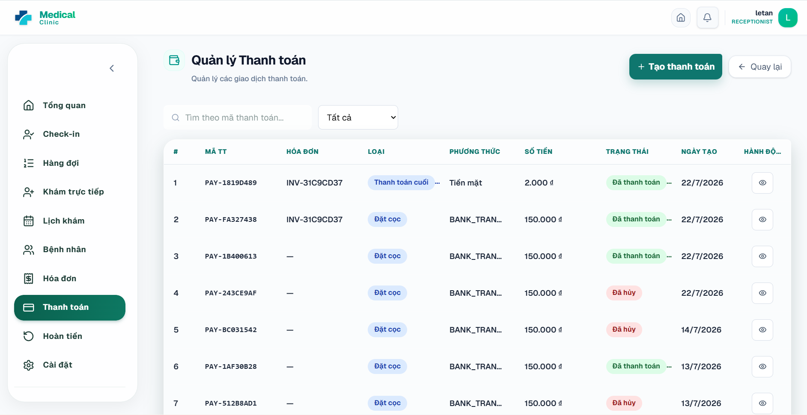

5.10. Process Refund Requests
Purpose. Reviews patient bank information, approves or rejects requests, and records completed transfers.
Step 1: Open Hoàn tiền from the receptionist sidebar.
Step 2: Filter by Chờ duyệt, Chờ chuyển tiền, Đã chuyển tiền, or Đã từ chối.
Step 3: Open a request and review payment, patient, amount, reason, bank name, account number, and account holder.
Step 4: Approve the request when it satisfies the cancellation/refund policy, or reject it and enter a rejection reason.
Step 5: After the refund is transferred, enter the transaction reference or evidence link and select the refund method.
Step 6: Click Xác nhận đã chuyển tiền.
Expected result. Refund status becomes APPROVED, REJECTED, or COMPLETED and the linked payment/invoice state is updated when applicable.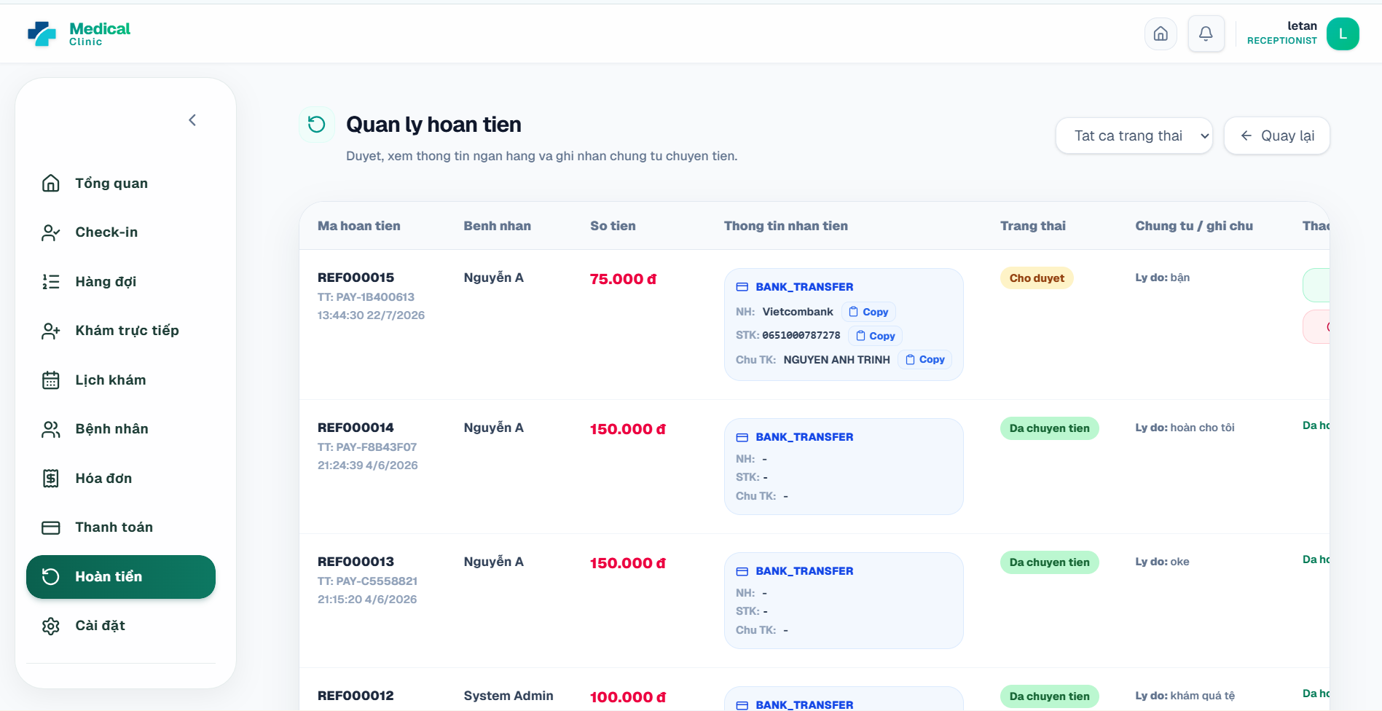

6. User Manual Guide for Doctor

6.1. View the Doctor Dashboard
Purpose. Summarizes today’s workload, waiting patients, completed appointments, and schedule information.
Step 1: Log in with a DOCTOR account.
Step 2: Review today’s appointment, waiting, completed, and cancelled/skipped statistics.
Step 3: Review the current patient list and schedule cards.
Step 4: Use sidebar shortcuts for Bệnh nhân, Lịch làm việc, Ca trực hôm nay, Khám bệnh, Nghỉ phép, Bài viết y tế, and Cài đặt.
Expected result. The doctor can quickly enter today’s clinical workflow.
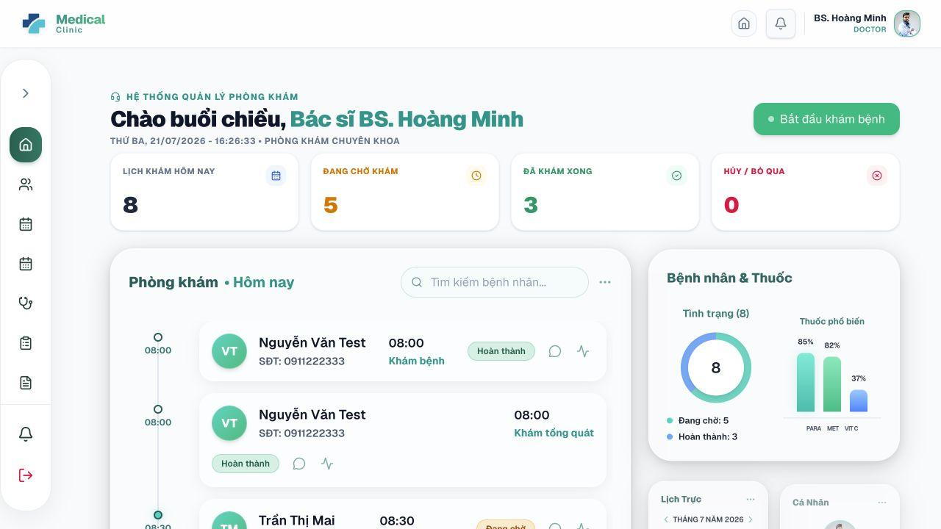
Figure 6.1 – View the Doctor Dashboard

6.2. View Work Schedule and Scheduled Patients
Purpose. Shows the doctor’s shifts and patients assigned to each schedule.
Step 1: Open Lịch làm việc.
Step 2: Review the weekly/monthly schedule and identify the current day.
Step 3: Select a work shift to load the associated patient list.
Step 4: Review patient appointment times and statuses.
Step 5: Use Làm mới to reload the latest booking information.
Expected result. The doctor sees the expected work periods and booked patients.
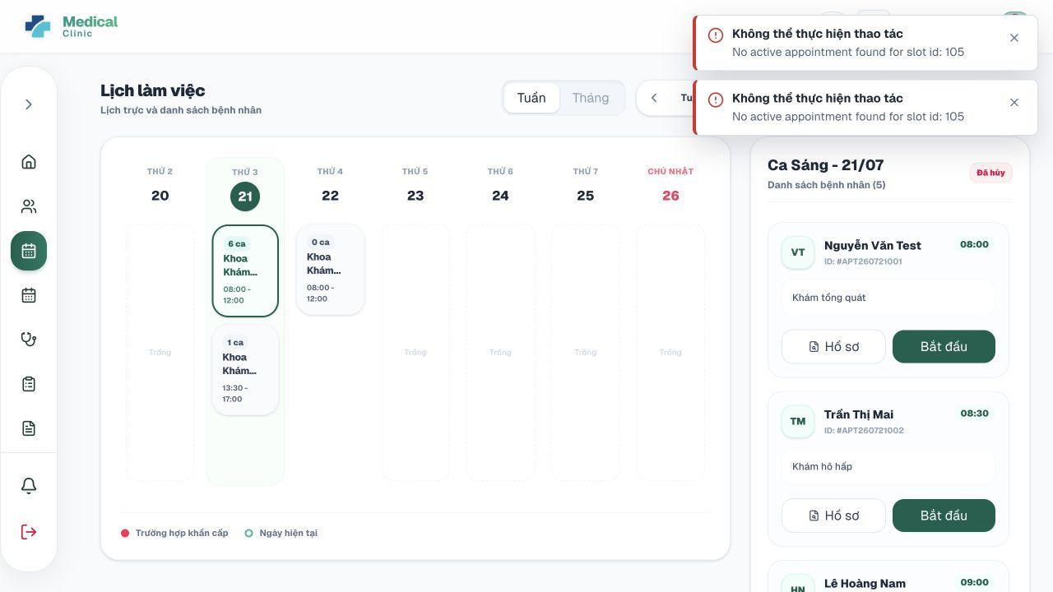
Figure 6.2 – View Work Schedule and Scheduled Patients

6.3. Submit a Leave or Schedule-Change Request
Purpose. Sends a leave request to the administrator and checks its approval status.
Step 1: Open Nghỉ phép.
Step 2: Click Gửi đơn mới.
Step 3: Choose Nghỉ phép năm or Thay đổi lịch trực.
Step 4: Select the date and, when required, from/to times.
Step 5: Enter a detailed reason.
Step 6: Submit the request.
Step 7: Review the request in Lịch sử nghỉ phép and monitor PENDING, APPROVED, or REJECTED status.
Expected result. The request is stored for administrator review. Approved leave may update or cancel conflicting schedules/appointments according to the business rules.
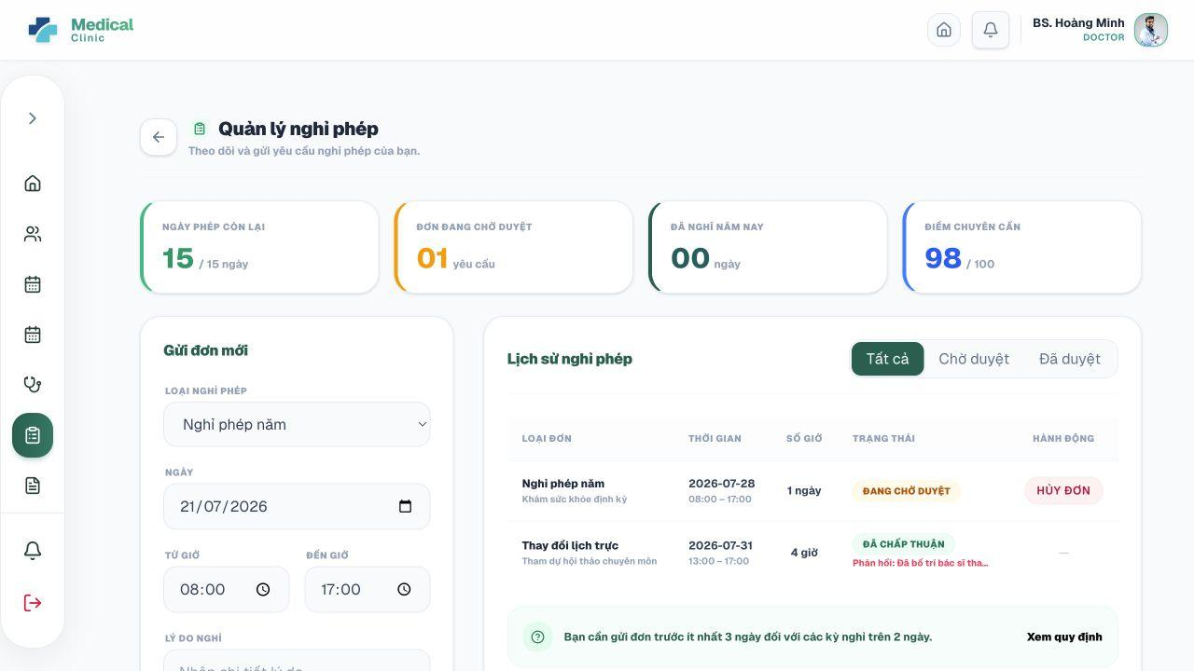
Figure 6.3 – Submit a Leave or Schedule-Change Request

6.4. View Today’s Appointments and Patient Records
Purpose. Allows the doctor to review current appointments and open the corresponding patient record.
Step 1: Open Ca trực hôm nay.
Step 2: Review total patients, completed patients, remaining patients, and the current examination.
Step 3: Select a patient appointment card.
Step 4: Click Xem bệnh án to review previous medical records before examination.
Step 5: Use the examination action when the patient is checked in and ready.
Expected result. The doctor has the context required to call or examine the patient.
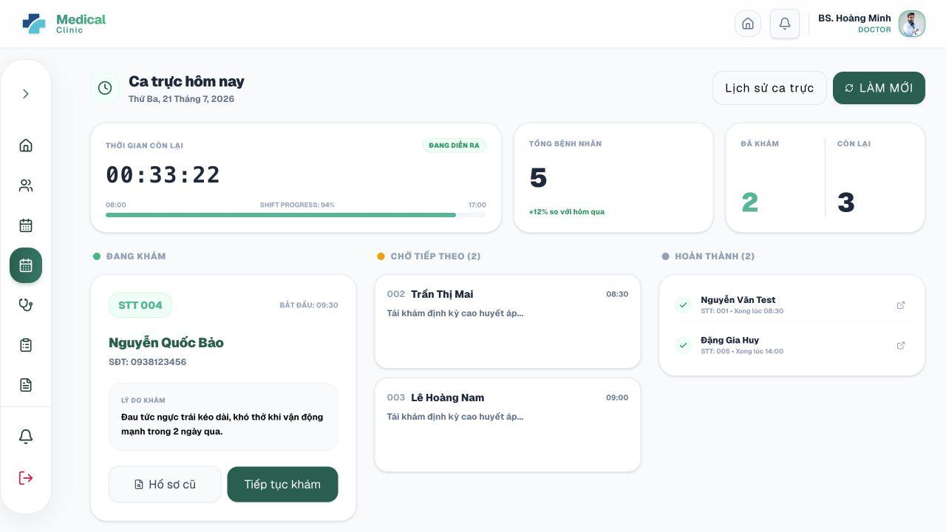
Figure 6.4 – View Today’s Appointments and Patient Records

6.5. Call and Start Examination from the Queue
Purpose. Moves a waiting patient into the active consultation.
Preconditions. The queue ticket must belong to the signed-in doctor and be in a valid status.
Step 1: Open Khám bệnh or the consultation queue.
Step 2: Filter the list by status when necessary.
Step 3: For a WAITING ticket, click Gọi vào.
Step 4: When the patient enters, click Bắt đầu khám or Vào phòng khám.
Step 5: Confirm that the queue ticket becomes IN_EXAMINATION and the consultation becomes IN_PROGRESS.
Expected result. The appointment/queue/consultation states move into the examination phase.
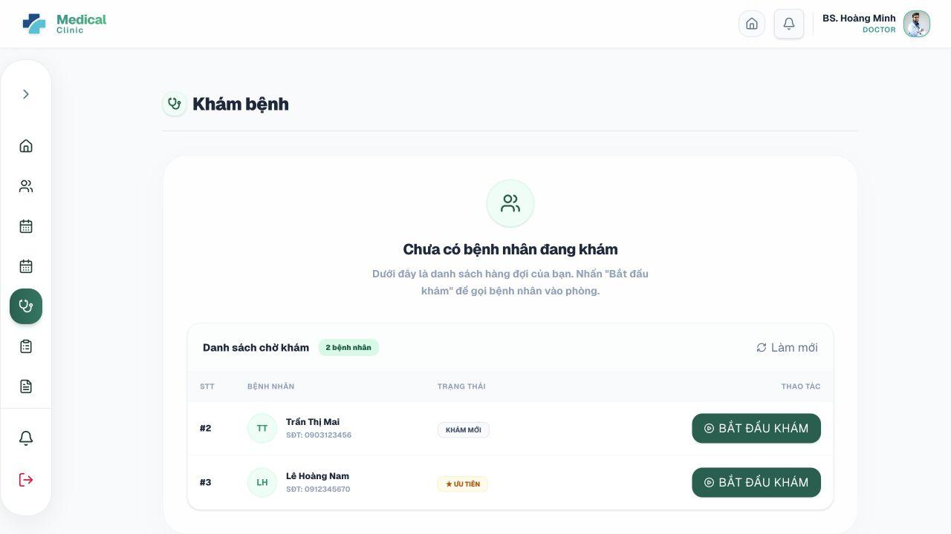
Figure 6.5 – Call and Start Examination from the Queue

6.6. Record Vital Signs and Review Patient History
Purpose. Captures current measurements and provides previous clinical context.
Step 1: Open the active Examination workspace.
Step 2: Review patient age, gender, allergies, medical history, and previous visits.
Step 3: Open the vital-sign section.
Step 4: Enter or review blood pressure, pulse, temperature, SpO2, weight, height, or other available measurements.
Step 5: Save the vital-sign record.
Step 6: Review CÁC LẦN KHÁM TRƯỚC before making the current diagnosis.
Expected result. The measurements are linked to the current consultation and available for clinical decisions.
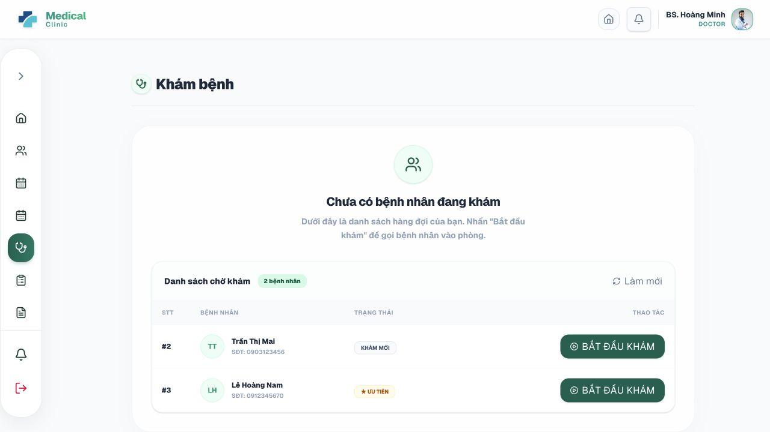
Figure 6.6 – Record Vital Signs and Review Patient History

6.7. Use AI to Standardize Clinical Notes
Purpose. Transforms a short free-form clinical note into structured content for the medical record.
Preconditions. The selected AI provider must be configured.
Step 1: In the Examination workspace, open Trợ lý chuẩn hóa bệnh án AI.
Step 2: Enter a concise raw note containing symptoms, findings, age/sex context, and preliminary diagnosis.
Step 3: Run the standardization action.
Step 4: Review the AI-generated structured fields before accepting them.
Step 5: Apply or copy the suggested content into Triệu chứng, Khám lâm sàng, Chẩn đoán, Kế hoạch điều trị, or other fields.
Step 6: Edit any inaccurate content manually.
Expected result. The doctor receives structured draft content while retaining full responsibility for final medical documentation.

Figure 6.7 – Use AI to Standardize Clinical Notes

6.8. Create or Update the Medical Record
Purpose. Stores symptoms, diagnosis, findings, treatment, doctor instructions, and follow-up information.
Step 1: In the active examination, enter Triệu chứng lâm sàng.
Step 2: Enter Mã ICD-10 when available and Chẩn đoán xác định.
Step 3: Complete Khám lâm sàng / Thực thể and Kế hoạch & Phác đồ điều trị.
Step 4: Enter Lời dặn của bác sĩ.
Step 5: If follow-up is needed, choose Ngày tái khám and enter Ghi chú tái khám.
Step 6: Save the medical record before completing the consultation.
Expected result. The current consultation has a persistent electronic medical record accessible to authorized users.

Figure 6.8 – Create or Update the Medical Record

6.9. Order Laboratory Tests and Review Results
Purpose. Creates test requests and reviews completed results during the consultation.
Step 1: Open the Cận lâm sàng section.
Step 2: Use Tìm kiếm & Thêm xét nghiệm to select one or more active laboratory tests.
Step 3: Enter Ghi chú chỉ định when clinical context is required.
Step 4: Submit the lab request.
Step 5: Review Lịch sử chỉ định xét nghiệm and identify Chờ KQ or Có KQ items.
Step 6: After the laboratory completes the request, review result value, unit, reference range, conclusion, and attachments.
Expected result. A REQUESTED laboratory order is available to Lab Technician, and completed results return to the doctor/patient record.

Figure 6.9 – Order Laboratory Tests and Review Results

6.10. Create a Prescription and Check Drug Interactions
Purpose. Builds a structured prescription and validates medicine combinations.
Step 1: Open the Đơn thuốc section of the Examination workspace.
Step 2: Click Add medicine and select an active medicine.
Step 3: Enter quantity, dosage, frequency, duration, instructions, and morning/noon/evening/night doses as applicable.
Step 4: Repeat for each prescribed medicine.
Step 5: Run the draft drug-interaction check before finalizing.
Step 6: Review all warnings and revise the prescription when clinically necessary.
Step 7: Enter additional prescription instructions and save the prescription.
Expected result. A CREATED/CHECKED prescription is linked to the consultation and becomes visible to the pharmacist and patient.

Figure 6.10 – Create a Prescription and Check Drug Interactions

6.11. Complete the Consultation
Purpose. Finalizes clinical documentation and moves the visit to billing.
Step 1: Confirm that the medical record is saved.
Step 2: Confirm that required laboratory results have been reviewed or the workflow supports completion without waiting.
Step 3: Confirm that the prescription is correct, when one is required.
Step 4: Use the Complete consultation action.
Step 5: Review the success message and return to the queue.
Expected result. Consultation becomes COMPLETED, queue becomes DONE, appointment becomes PAYMENT_DUE, and invoice items are generated or refreshed.

Figure 6.11 – Complete the Consultation

6.12. Create and Manage Medical Articles
Purpose. Allows doctors and administrators to publish clinical education content.
Step 1: Open Bài viết y tế.
Step 2: Use date/sort filters to review existing articles.
Step 3: Click Viết bài mới.
Step 4: Enter the article title, optional image URL, and detailed content.
Step 5: Click Đăng bài viết.
Step 6: Use Sửa bài viết or Xóa bài viết for content the role is allowed to manage.
Expected result. The article is stored and displayed according to its publication status.
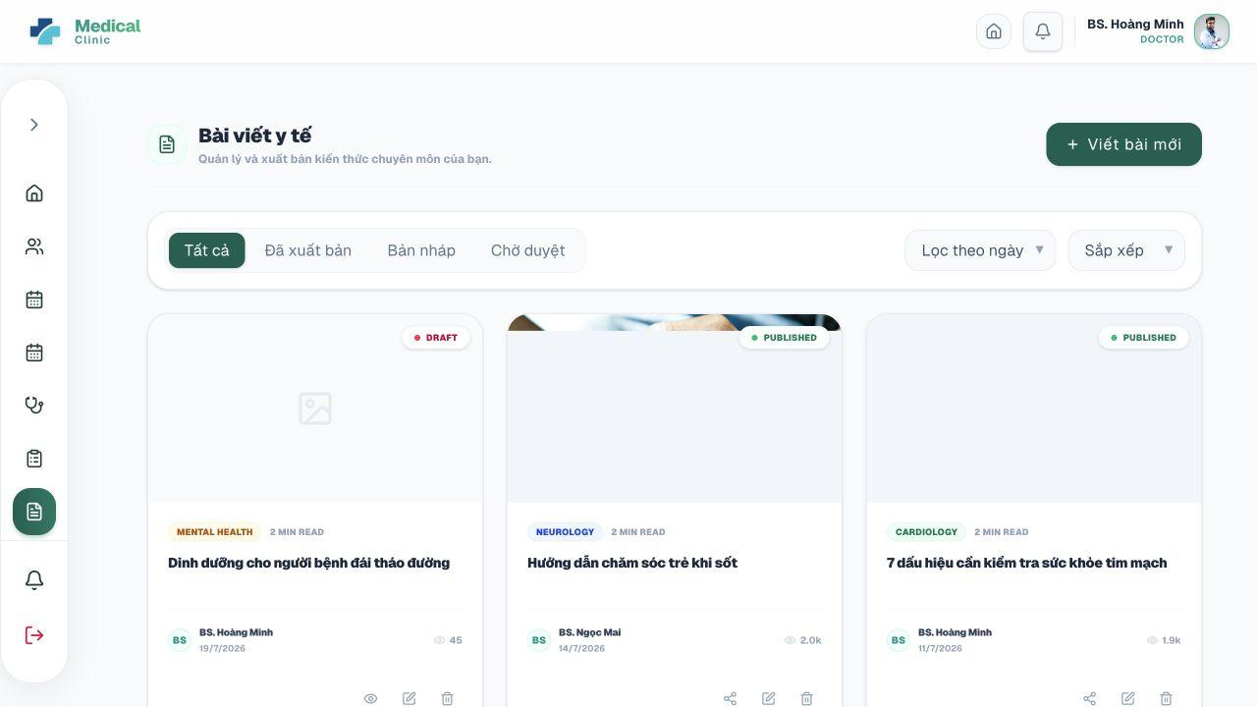
Figure 6.12 – Create and Manage Medical Articles

7. User Manual Guide for Lab Technician

7.1. View the Laboratory Dashboard
Purpose. Summarizes pending, in-progress, and completed laboratory requests.
Step 1: Log in with a LAB_TECHNICIAN account.
Step 2: Review the request counts and latest request cards.
Step 3: Use the sidebar to open Phòng xét nghiệm, Danh mục xét nghiệm, Hồ sơ của tôi, Thông báo, and Đổi mật khẩu.
Expected result. The technician can prioritize new and in-progress requests.
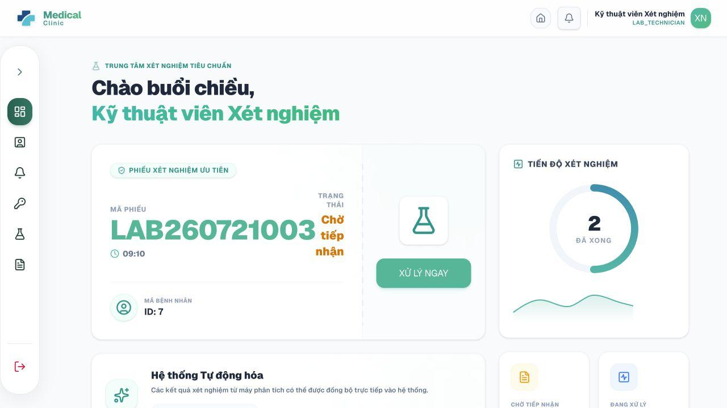
Figure 7.1 – View the Laboratory Dashboard

7.2. Process a Laboratory Request
Purpose. Accepts an incoming request, records each test result, and completes the request.
Step 1: Open Phòng xét nghiệm.
Step 2: Use search to find a request by code, patient name, or patient code.
Step 3: Open Chi tiết phiếu chỉ định.
Step 4: Review patient information, requested tests, request time, and doctor notes.
Step 5: Start processing the request so its status becomes IN_PROGRESS.
Step 6: For each test item, enter Giá trị kết quả, Đơn vị, Khoảng bình thường, and Kết luận.
Step 7: Attach a result file when supported and required.
Step 8: Mark each item completed and complete the entire request when all items are finished.
Expected result. The request becomes COMPLETED and its results are available to the doctor and patient.
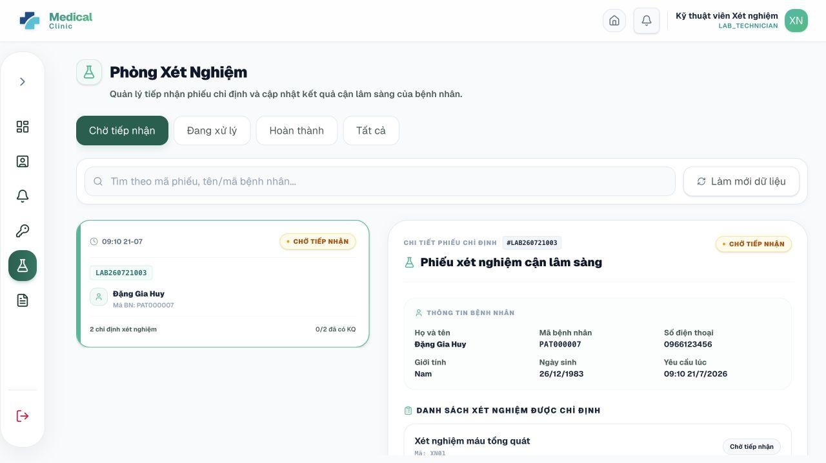
Figure 7.2 – Process a Laboratory Request

7.3. Manage the Laboratory Test Catalog
Purpose. Creates and maintains test definitions and prices.
Step 1: Open Danh mục xét nghiệm.
Step 2: Use search to find a test by code or name.
Step 3: To add a test, enter Mã Xét Nghiệm, Tên Xét Nghiệm, Giá tiền, Mô tả, and Trạng thái.
Step 4: Save the new test.
Step 5: To change a test, open its information, edit fields, and save.
Step 6: Set a test to Ngừng hoạt động when it should no longer be selectable for new requests.
Expected result. The active test catalog is available in the doctor’s laboratory-order selector.
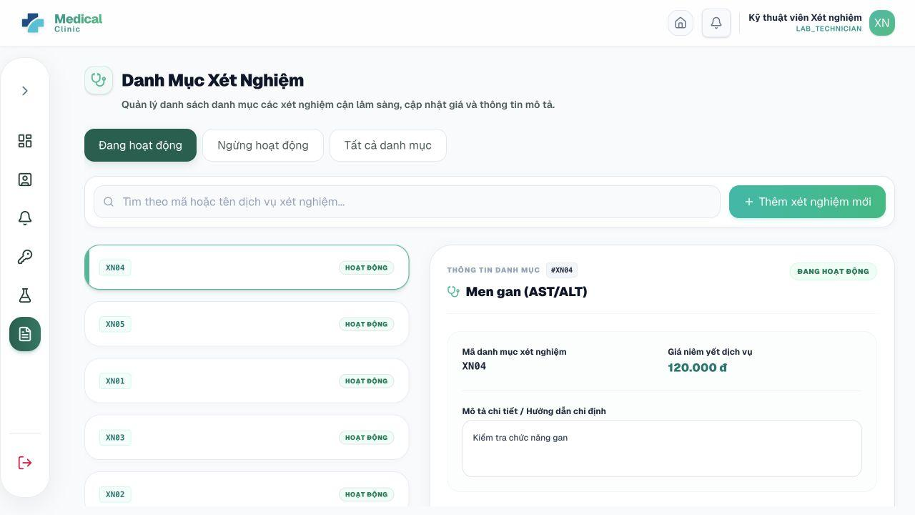
Figure 7.3 – Manage the Laboratory Test Catalog

8. User Manual Guide for Pharmacist

8.1. View the Pharmacy Dashboard
Purpose. Summarizes pending prescriptions, low-stock medicines, expiring batches, inventory value, and recent transactions.
Step 1: Log in with a PHARMACIST account.
Step 2: Review Đơn Chờ Cấp Phát, Thuốc Sắp Hết Hàng, Lô Sắp / Đã Hết Hạn, and Giá Trị Tồn Kho.
Step 3: Review recent import/export activity and the inventory safety chart.
Step 4: Use sidebar shortcuts for Phát thuốc, Danh mục Thuốc, Lô thuốc, Xuất/Nhập kho, Nhà cung cấp, Cảnh báo, and Cài đặt.
Expected result. The pharmacist identifies dispensing and inventory tasks that require attention.
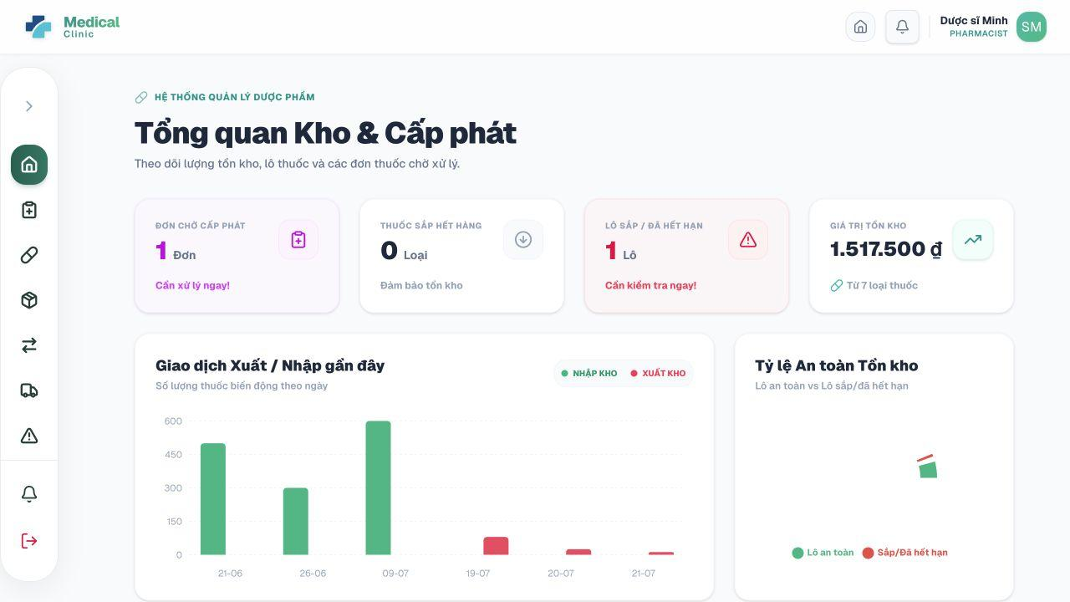
Figure 8.1 – View the Pharmacy Dashboard

8.2. Review and Dispense a Prescription
Purpose. Validates a prescription, checks stock availability, and confirms medicine dispensing.
Preconditions. The prescription must not already be DISPENSED or CANCELLED, and sufficient usable stock must exist.
Step 1: Open Phát thuốc.
Step 2: Search by prescription code or consultation code and filter by status if available.
Step 3: Open the prescription detail.
Step 4: Review patient/visit information, interaction-check state, medicines, formulation, strength, quantity, dosage, frequency, time-of-day doses, and doctor instructions.
Step 5: Prepare the required medicines.
Step 6: Click the dispensing confirmation action.
Step 7: Confirm the operation.
Expected result. The system deducts stock using FEFO (nearest-expiry usable batches first), creates EXPORT stock transactions, updates low/out-of-stock statuses, and marks the prescription DISPENSED.
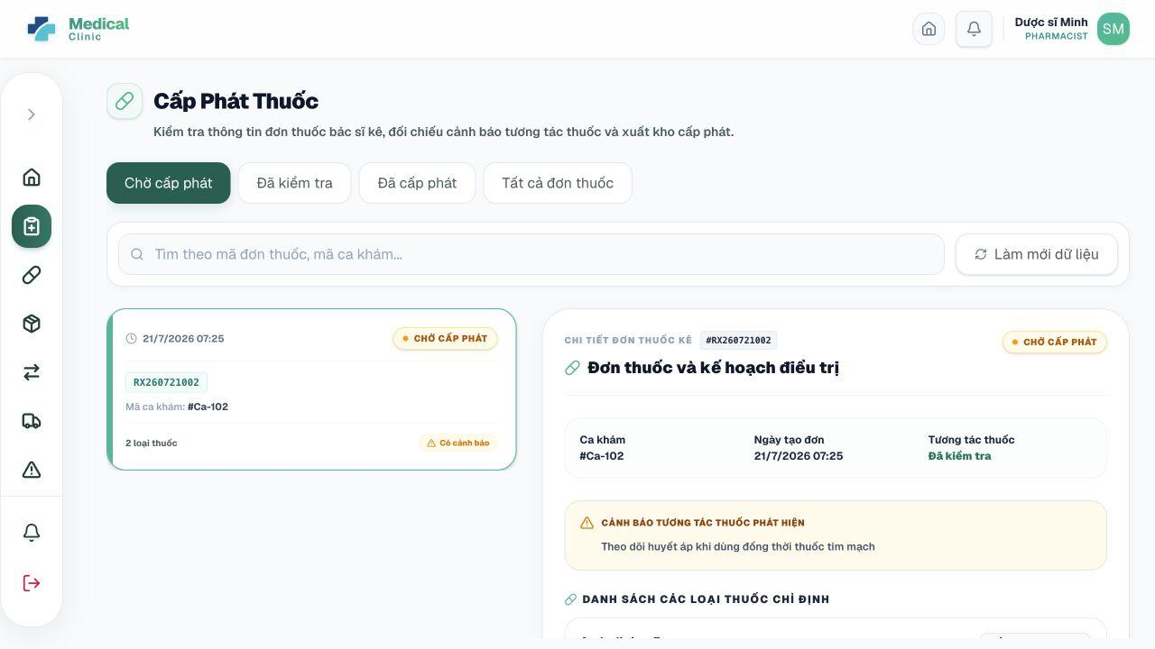
Figure 8.2 – Review and Dispense a Prescription

8.3. Manage the Medicine Catalog
Purpose. Creates, updates, searches, and deactivates medicines.
Step 1: Open Danh mục Thuốc.
Step 2: Search by medicine code or name.
Step 3: To add a medicine, enter code or leave it for automatic generation, name, active ingredient, dosage form, strength, unit, RxNorm code, description, default instructions, and status.
Step 4: Save the medicine.
Step 5: To update, open the medicine information, edit the required fields, and save.
Step 6: Set the medicine to Ngừng bán when it should not be selected for new prescriptions.
Expected result. The medicine catalog is available to doctors and inventory workflows.
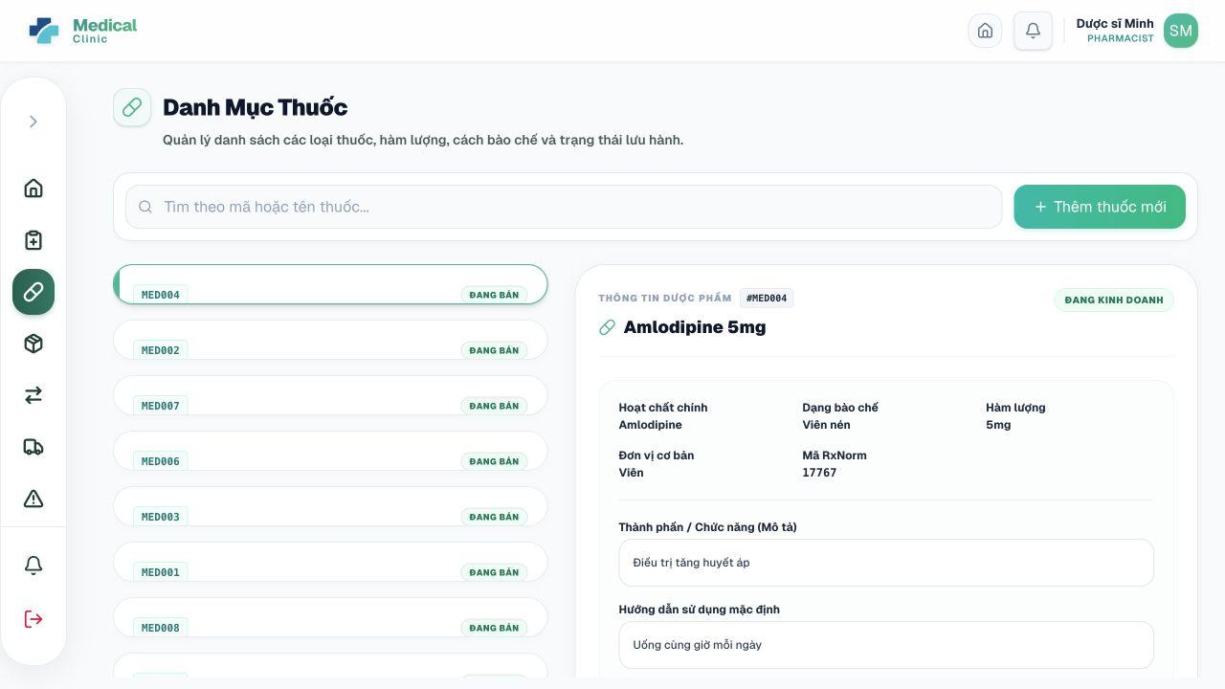
Figure 8.3 – Manage the Medicine Catalog

8.4. Manage Suppliers
Purpose. Maintains pharmaceutical supplier contact and status information.
Step 1: Open Nhà cung cấp.
Step 2: Use search to find a supplier by name or phone.
Step 3: Create a supplier by entering name, phone, email, address, and status.
Step 4: Save the supplier.
Step 5: Edit existing details when contact information changes.
Step 6: Set a supplier to Ngừng hoạt động instead of deleting historical records.
Expected result. Supplier information is available when importing medicine batches.
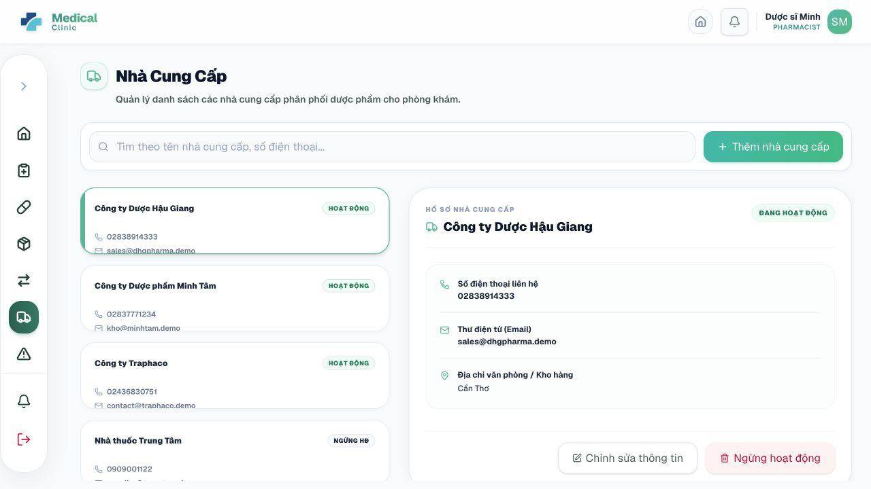
Figure 8.4 – Manage Suppliers

8.5. Import and Manage Medicine Batches
Purpose. Records medicine receipts, expiry dates, quantities, and costs.
Step 1: Open Lô thuốc.
Step 2: Click the add/import batch action.
Step 3: Select the medicine and optional supplier.
Step 4: Enter Số lô, Số lượng nhập, Ngày sản xuất when available, Ngày hết hạn, Giá nhập, and Giá bán dự kiến.
Step 5: Save the import.
Step 6: Open an existing batch to review current quantity and status, or update allowed fields.
Expected result. A batch is created as AVAILABLE and an IMPORT stock transaction is recorded.
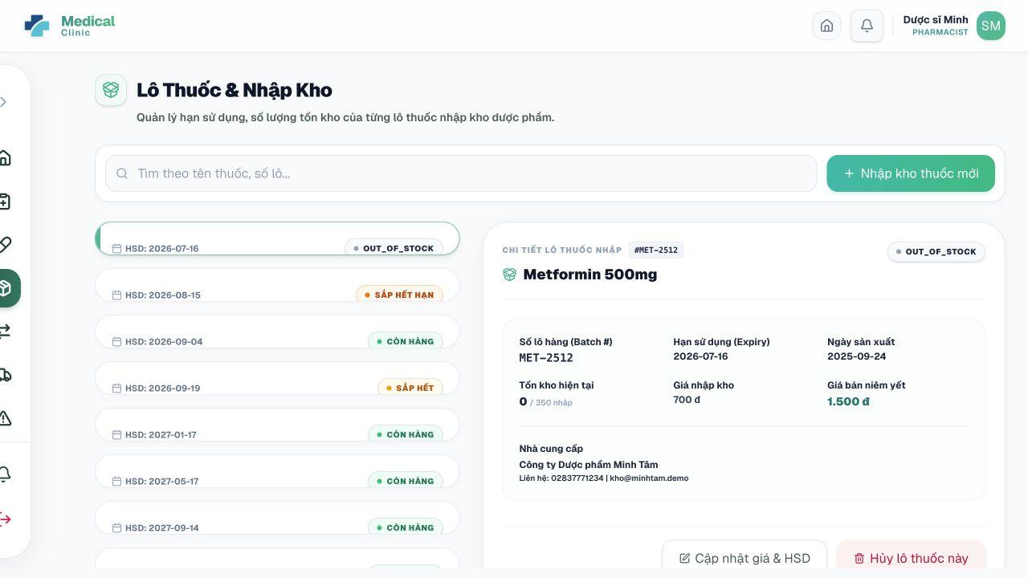
Figure 8.5 – Import and Manage Medicine Batches

8.6. Record Manual Stock Export and Review Transactions
Purpose. Creates non-prescription stock exports and audits all stock movements.
Step 1: Open Xuất/Nhập kho.
Step 2: Use search to review transaction history by medicine, batch, or reference type.
Step 3: To export manually, select a medicine and an available batch.
Step 4: Enter the export quantity and a required reason, such as expired goods, damaged packaging, or inventory adjustment.
Step 5: Confirm the export.
Step 6: Open a transaction to review quantity change, batch, time, reference, and note.
Expected result. The batch quantity decreases, an EXPORT transaction is stored, and batch/alert status is recalculated.
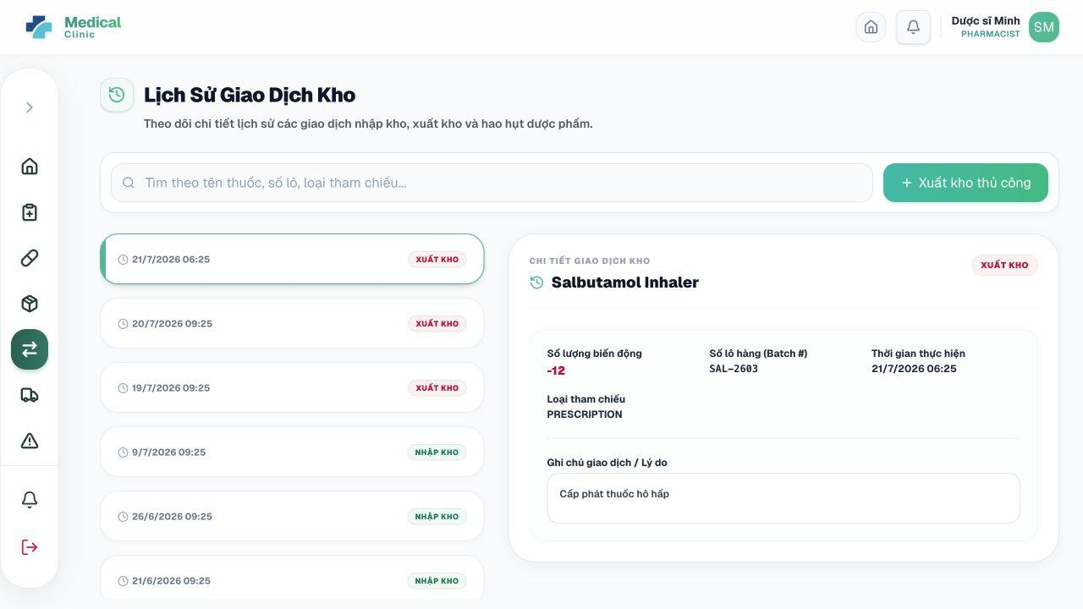
Figure 8.6 – Record Manual Stock Export and Review Transactions

8.7. Monitor Inventory Alerts
Purpose. Displays low-stock, out-of-stock, and expiry alerts generated by the system.
Step 1: Open Cảnh báo.
Step 2: Review the alert category, medicine, related batch, created time, and message.
Step 3: Open the related batch or medicine when action is required.
Step 4: Import new stock, correct a batch, or remove expired stock using the appropriate inventory function.
Step 5: Refresh the page to verify the alert state.
Expected result. The pharmacist can respond before medicine availability or expiry affects patient care.
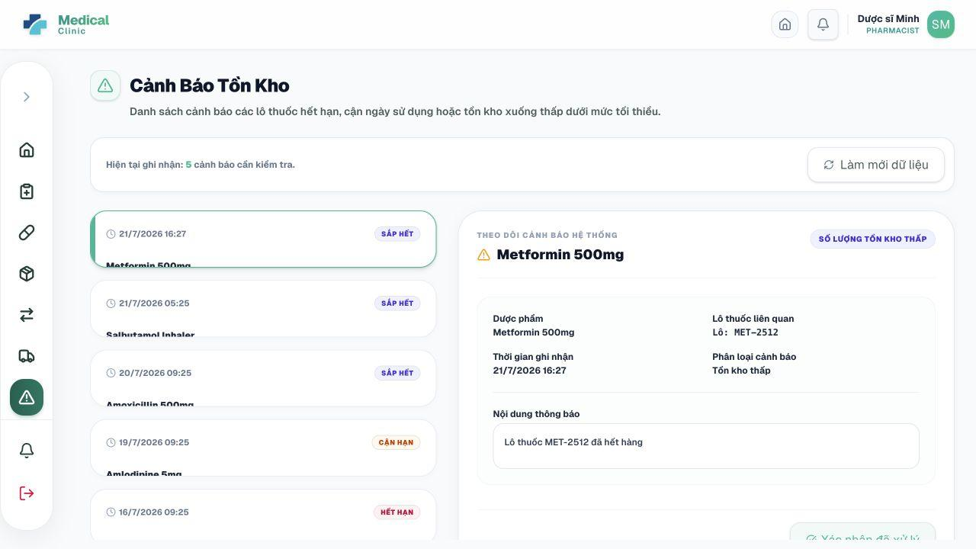
Figure 8.7 – Monitor Inventory Alerts

9. User Manual Guide for Administrator

9.1. View the Administrative Dashboard and Reports
Purpose. Provides operational, financial, appointment, doctor-performance, and inventory summaries.
Step 1: Log in with an ADMIN account.
Step 2: Review Tổng doanh thu, Tổng lịch khám, Giá trị tồn kho, and Cảnh báo hạn dùng.
Step 3: Review the revenue chart and appointment distribution chart.
Step 4: Review doctor performance and expiring batch tables.
Step 5: Use dashboard filters or date ranges when available to change the reporting period.
Expected result. The administrator receives a consolidated view of clinic performance.
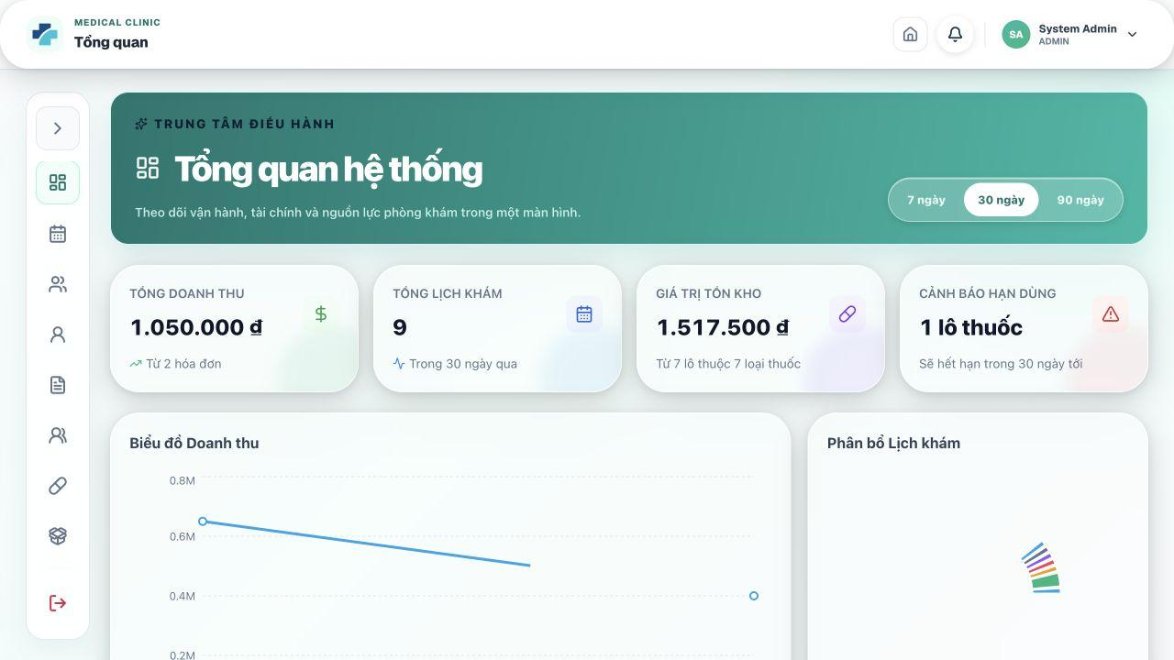
Figure 9.1 – View the Administrative Dashboard and Reports

9.2. Manage User Accounts
Purpose. Creates staff accounts, updates profiles/roles, and locks, unlocks, or deletes accounts.
Step 1: Open Quản trị > Tài khoản.
Step 2: Use keyword, status, and role filters to find an account.
Step 3: Click Create/Add account.
Step 4: Enter Họ và tên, Email, optional temporary password, Phone, and one or more Roles.
Step 5: When the role includes DOCTOR, select department and enter doctor code, degree, specialization, experience, and consultation fee.
Step 6: Save the account.
Step 7: Use Edit to change authorized information.
Step 8: Use Lock user or Unlock user to control access. Use Delete user only when data-retention rules allow it.
Expected result. The account and its role-specific profile are available or restricted according to the selected action.
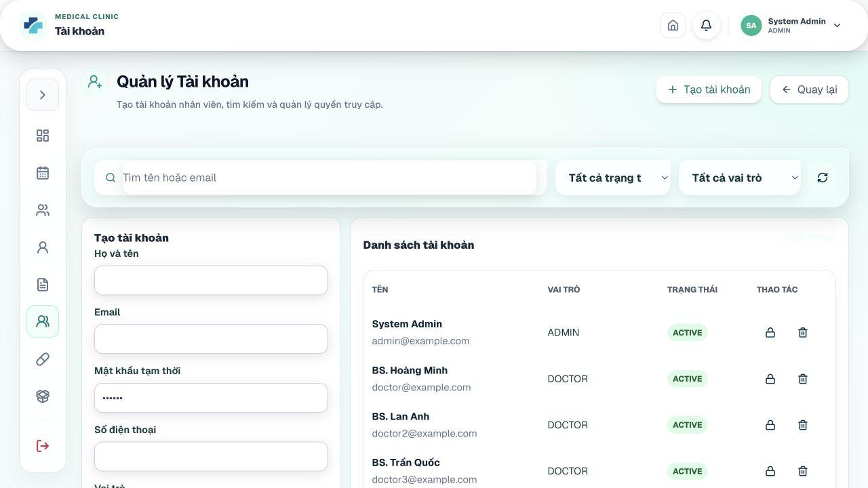
Figure 9.2 – Manage User Accounts

9.3. Manage Roles and Permissions
Purpose. Maintains role definitions and permission assignments.
Step 1: Open Quản trị > Vai trò & phân quyền.
Step 2: Review the role list and assigned permission codes.
Step 3: Create a role by entering a unique role name and description when custom roles are required.
Step 4: Edit an existing custom role when necessary.
Step 5: Open permission assignment and select the permissions the role should receive.
Step 6: Save the assignment.
Step 7: Delete only unused custom roles; preserve core roles used by the application.
Expected result. Backend authorization decisions reflect the saved role-permission mapping where the application uses permissions.
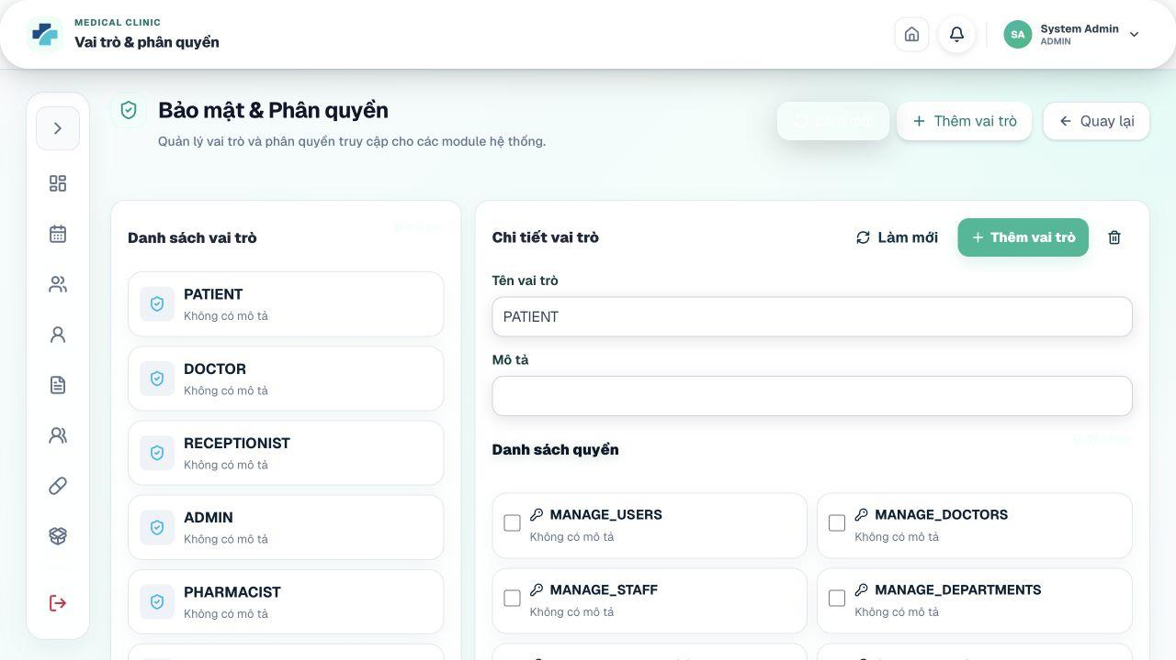
Figure 9.3 – Manage Roles and Permissions

9.4. Manage Doctors
Purpose. Creates and updates doctor professional profiles and availability state.
Step 1: Open Vận hành > Bác sĩ.
Step 2: Use search/filter to locate a doctor.
Step 3: Create or edit the linked user and professional profile.
Step 4: Enter doctor code, degree, specialization, years of experience, biography, hometown, consultation fee, department, and status.
Step 5: Save changes.
Step 6: Use profile details to verify the public doctor information and booking availability.
Expected result. Doctor information is available to schedules, booking, consultation, and the public/patient doctor directory.
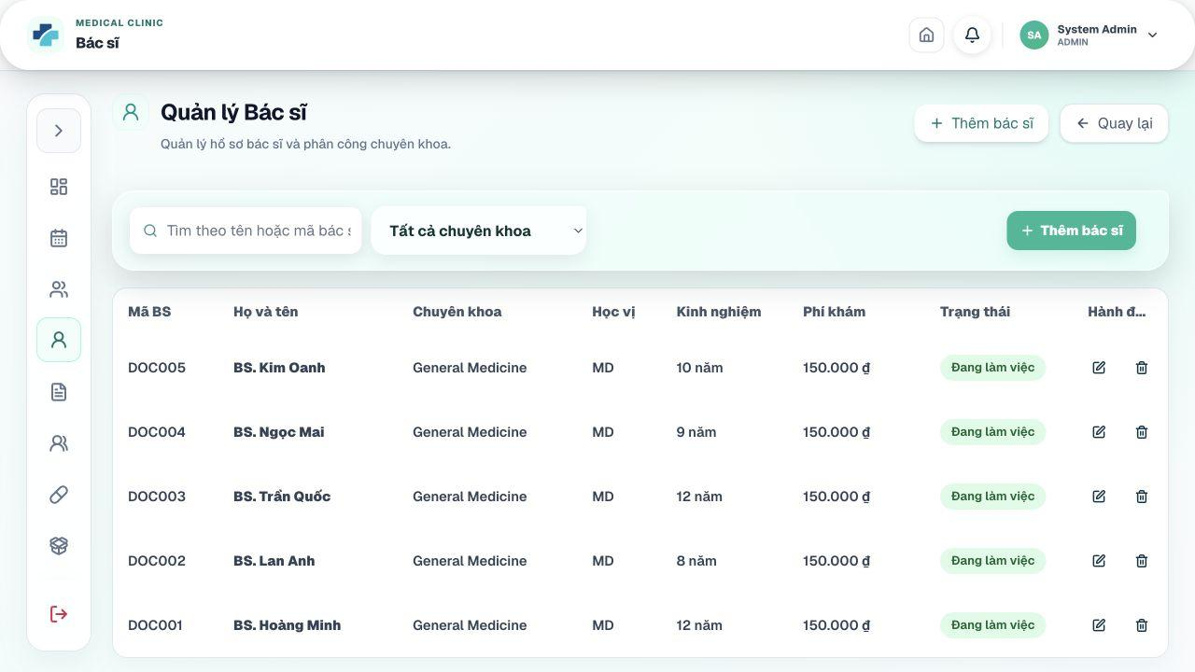
Figure 9.4 – Manage Doctors

9.5. Manage Departments and Medical Services
Purpose. Maintains clinic specialties and the priced service catalog.
Step 1: Open Dịch vụ & kho > Chuyên khoa.
Step 2: Create or edit department name, description, and status.
Step 3: Open Dịch vụ & kho > Dịch vụ y tế.
Step 4: Create or edit service code, name, type, price, description, and status.
Step 5: Use search and status controls to review existing records.
Step 6: Deactivate obsolete entries instead of removing data used by historical records.
Expected result. Active departments support doctor/appointment classification and active services support price display and invoice generation.
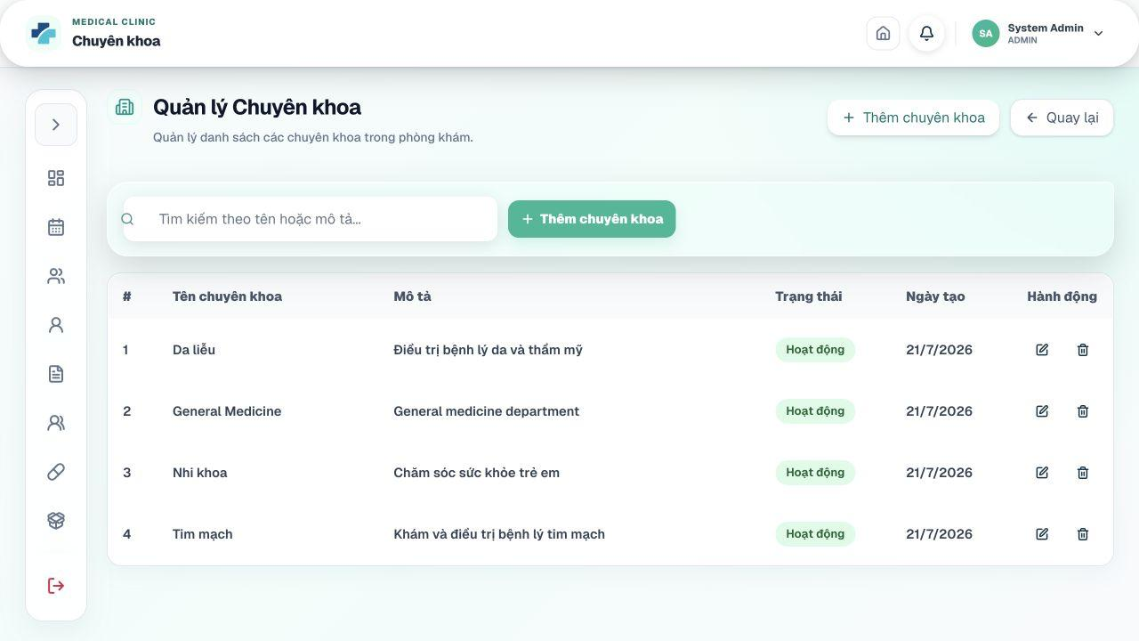
Figure 9.5 – Manage Departments and Medical Services

9.6. Manage Doctor Schedules and Appointment Slots
Purpose. Creates single or recurring work schedules and controls slot availability.
Step 1: Open Vận hành > Lịch khám.
Step 2: Choose a doctor and date range.
Step 3: Create a single schedule by entering work date, start time, and end time, or create a bulk schedule by selecting date range and weekdays.
Step 4: Choose slot duration, such as 15, 30, 45, or 60 minutes.
Step 5: Generate appointment slots.
Step 6: Use the calendar to block, cancel, or inspect individual slots and schedules.
Step 7: Confirm that existing BOOKED or LOCKED slots are handled according to the warning/business rule before cancellation.
Expected result. The doctor’s available booking capacity is updated for patients and receptionists.
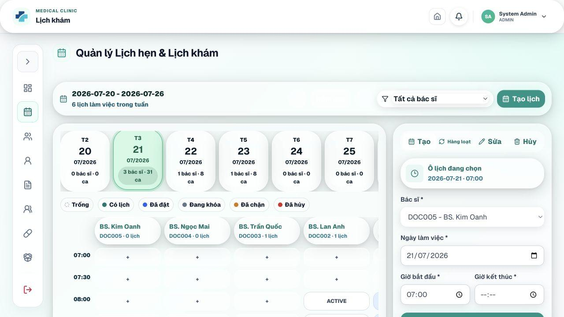
Figure 9.6 – Manage Doctor Schedules and Appointment Slots

9.7. Review and Approve Doctor Leave Requests
Purpose. Approves or rejects doctor leave/schedule-change requests.
Step 1: Open Vận hành > Duyệt nghỉ phép.
Step 2: Filter or review the list of pending requests.
Step 3: Open a request to view doctor, request type, date/time, reason, and conflicting appointments when provided.
Step 4: Click Approve when staffing and appointment conditions allow it.
Step 5: To reject, enter Lý do từ chối and confirm.
Step 6: Review the resulting request status.
Expected result. The request becomes APPROVED or REJECTED, and related schedule handling is applied by the service.
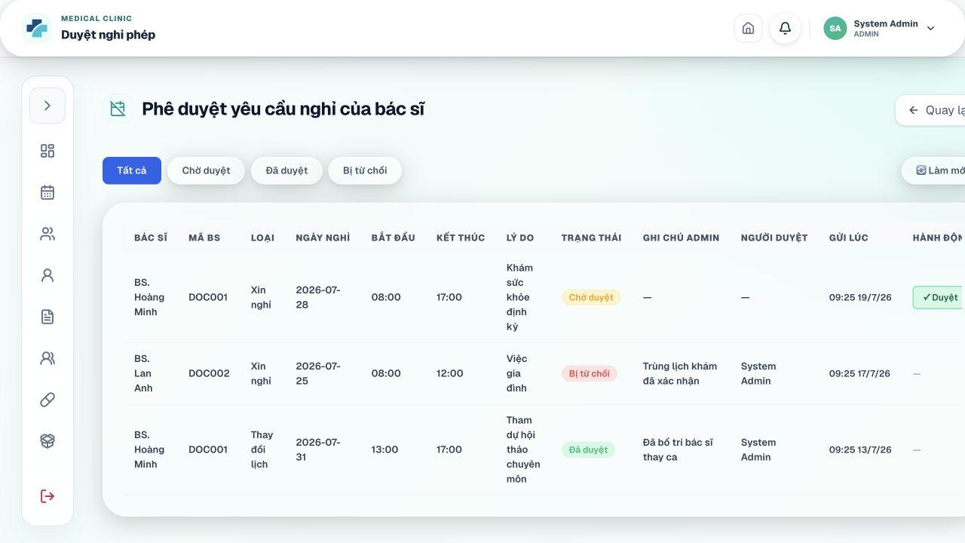
Figure 9.7 – Review and Approve Doctor Leave Requests

9.8. Manage Patients and Appointments
Purpose. Provides full administrative oversight of patient profiles and appointment records.
Step 1: Open Vận hành > Bệnh nhân to search, create, edit, view, or—when allowed—delete patient records.
Step 2: Open Vận hành > Lịch khám to review appointments by doctor and date.
Step 3: Open appointment details to review patient, doctor, slot, booking type, reason, status, payment/deposit information, and history.
Step 4: Use authorized actions for check-in, cancellation, rescheduling, no-show, or other status changes when operationally justified.
Expected result. Administrators can correct data and supervise booking operations across the clinic.
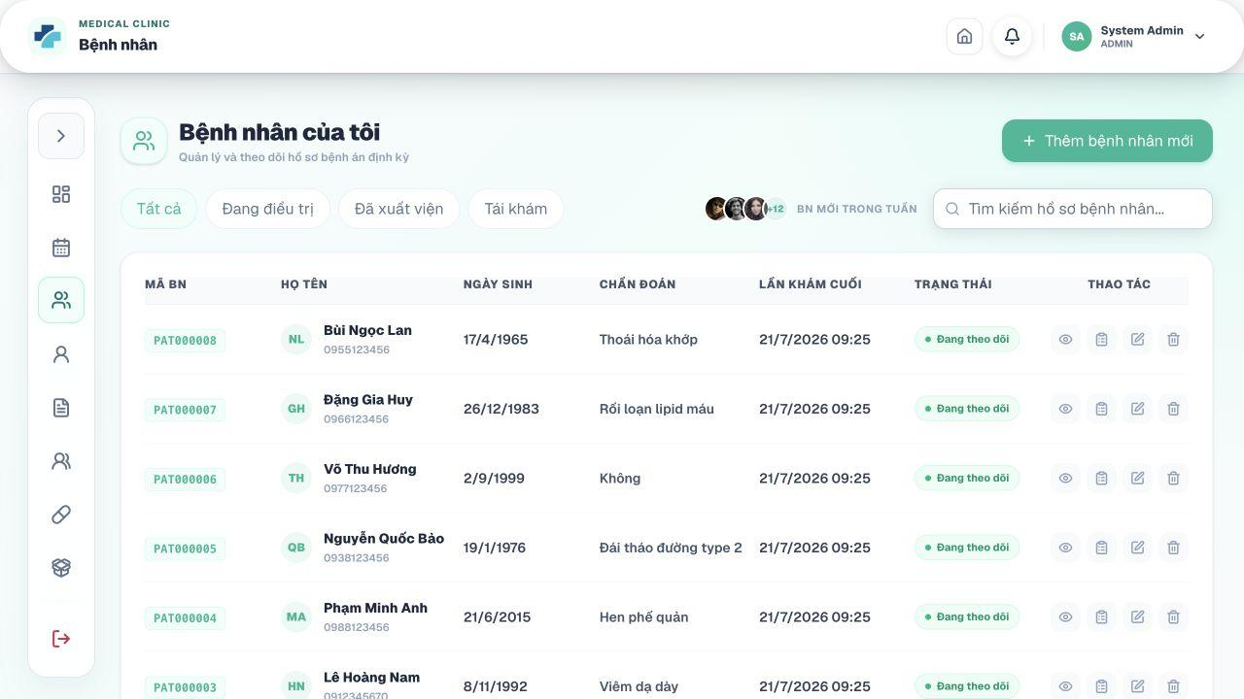
Figure 9.8 – Manage Patients and Appointments

9.9. Manage Laboratory, Medicines, Suppliers, and Inventory
Purpose. Provides administrative access to clinical catalogs and pharmacy inventory.
Step 1: Open Xét nghiệm to review laboratory requests and test results.
Step 2: Open the laboratory test catalog to create/update test definitions where authorized.
Step 3: Open Thuốc, Nhà cung cấp, Lô thuốc, Giao dịch kho, and Cảnh báo kho.
Step 4: Use the same create/update/import/export procedures described in Sections 7 and 8.
Step 5: Review changes carefully because they affect prescribing, dispensing, billing, and stock reports.
Expected result. Central clinical catalogs and stock data remain consistent across modules.
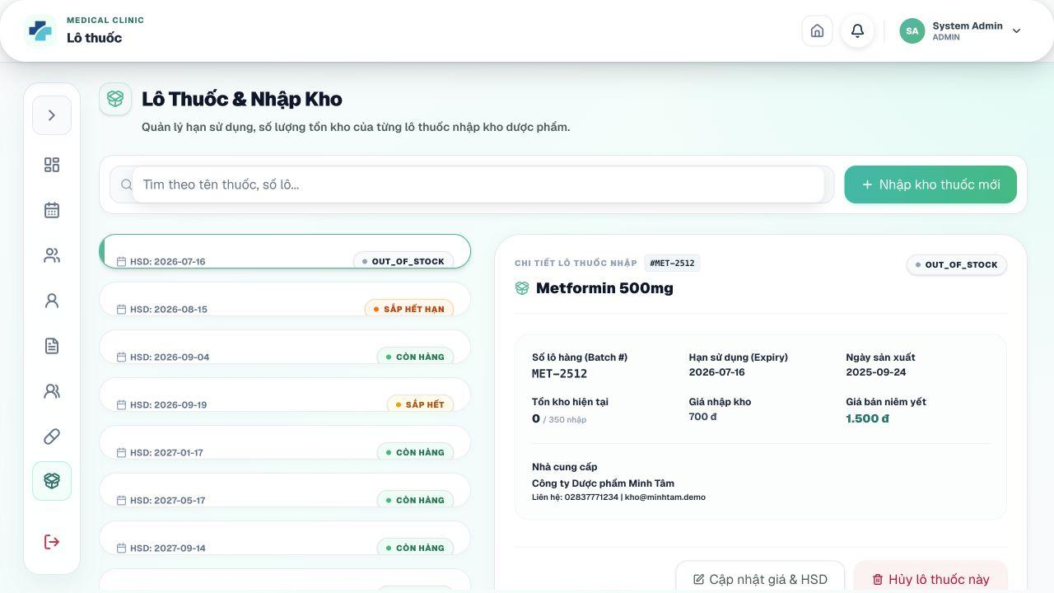
Figure 9.9 – Manage Laboratory, Medicines, Suppliers, and Inventory

9.10. Manage Invoices, Payments, and Refunds
Purpose. Supervises all billing documents and financial transactions.
Step 1: Open Tài chính > Hóa đơn to search, create, update, inspect, or cancel invoices.
Step 2: Open Tài chính > Thanh toán to inspect payment records, create payments, confirm cash, or verify supported online transfers.
Step 3: Open Tài chính > Hoàn tiền to approve, reject, or complete refund requests.
Step 4: Use status and date filters to isolate pending or failed records.
Step 5: Compare invoice totals with paid/refunded amounts before taking any irreversible action.
Expected result. The linked invoice, payment, refund, and appointment statuses remain synchronized.
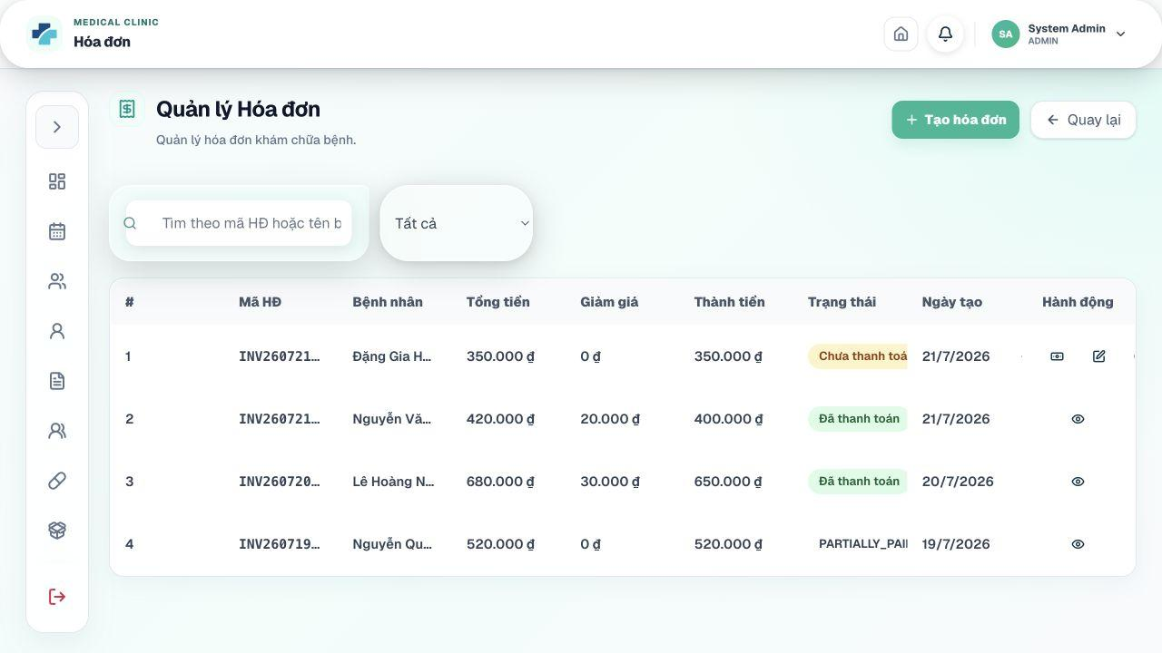
Figure 9.10 – Manage Invoices, Payments, and Refunds

9.11. Manage Health Articles and Patient Reviews
Purpose. Publishes clinic content and moderates user feedback.
Step 1: Open Vận hành > Bài viết y tế to create, edit, publish, archive, or delete articles as permitted.
Step 2: Open Tài chính > Đánh giá.
Step 3: Search or filter reviews by patient, doctor, rating, date, or visibility when available.
Step 4: Use the visibility toggle to hide inappropriate content without losing the review record.
Step 5: Use Xóa vĩnh viễn only for content that must be removed according to project rules.
Expected result. Public/authorized content remains current and moderated.
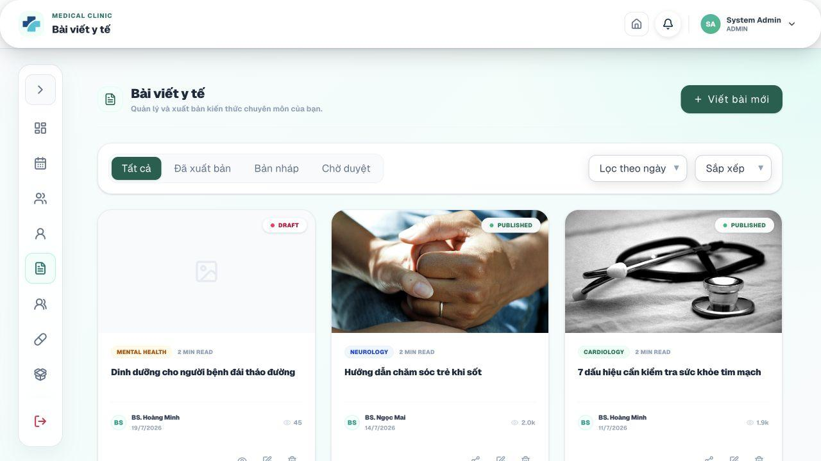
Figure 9.11 – Manage Health Articles and Patient Reviews

9.12. View Audit Logs
Purpose. Reviews recorded system actions for security and traceability.
Step 1: Open Quản trị > Nhật ký hệ thống.
Step 2: Filter by action, table/resource, user ID, log ID, email, IP address, or other displayed fields.
Step 3: Open a log entry to review time, actor, action, record ID, user agent, old value, and new value.
Step 4: Use the record to investigate unexpected modifications or security events.
Expected result. The administrator can trace important system activity without editing the log.
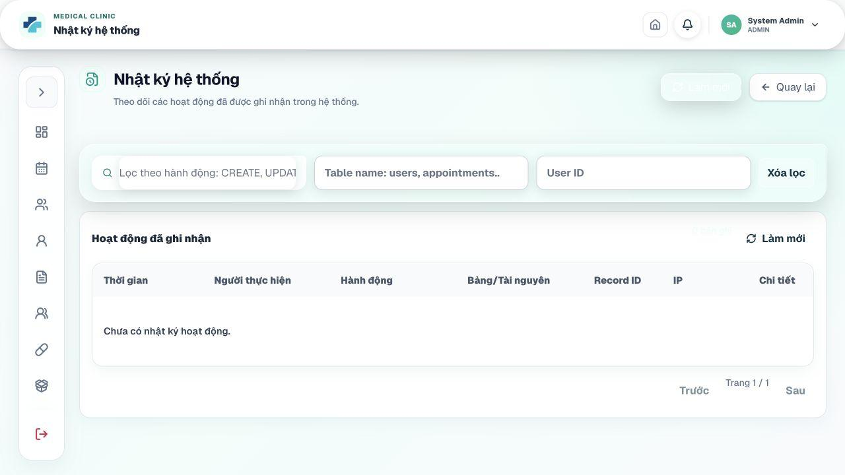
Figure 9.12 – View Audit Logs

9.13. Manage System Settings
Purpose. Creates and updates global configuration values used by business services.
Step 1: Open Quản trị > Cấu hình hệ thống.
Step 2: Review setting key, value, description, and updated time.
Step 3: Open an existing key and edit its value, or create a new supported key.
Step 4: Use only letters, numbers, dots, underscores, and hyphens in setting keys.
Step 5: Save the setting and verify the related function.
Step 6: Delete a setting only when the application has a safe fallback value.
Expected result. Subsequent business operations use the updated configuration according to the backend implementation.
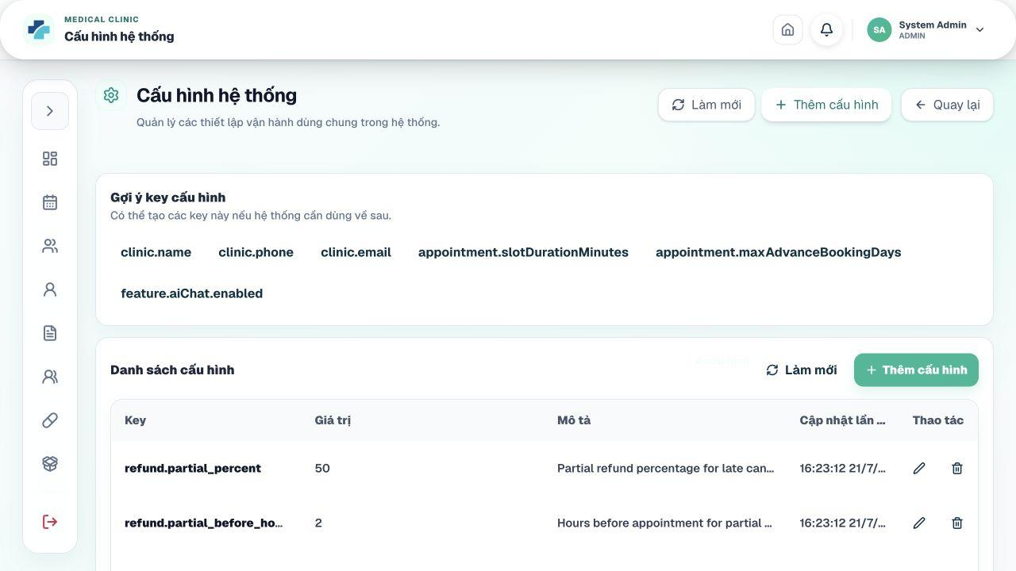
Figure 9.13 – Manage System Settings
Important notes. Never store raw API keys or passwords in a screenshot submitted with this document.

Appendix A. Screenshot Insertion Checklist
Use this checklist after taking screenshots. Paste each screenshot directly below its corresponding SCREENSHOT NOTE in the user manual. Crop unnecessary browser/desktop areas, keep the relevant button visible, and mask real personal, bank, API, or credential data.
Area | Required Screenshots | Completed
Installation | Repository clone, PostgreSQL database, backend started, frontend started, landing page | ☐
Guest/Auth | Landing, Login, Google login, Register before/after OTP, Forgot Password steps | ☐
Common | Role dashboards, Profile, Change Password, Notifications, Logout | ☐
Patient | Dashboard, AI chat, doctor list/detail, prices, patient/dependent profile, booking slot, booking confirmation, deposit QR/success, appointment list/detail, reschedule, cancel/refund, queue, medical record, lab result, prescription, invoice/payment, review | ☐
Receptionist | Dashboard, patient list/form, check-in before/after, no-show, walk-in grid/form, queue actions, schedule calendar, invoice, payment, refund | ☐
Doctor | Dashboard, work schedule, leave request/history, today appointments, queue call/start, examination summary, vital signs, history, AI note, medical record, lab order/results, prescription/interaction, consultation completion, articles | ☐
Lab Technician | Dashboard, lab request list/detail/result entry, lab test catalog/form | ☐
Pharmacist | Dashboard, prescription list/detail/dispense, medicine form, supplier form, batch import, stock export/history, alerts | ☐
Administrator | Dashboard/reports, users/create/lock, roles/permissions, doctors, departments/services, schedules, leave approval, patient/appointment oversight, inventory, finance, articles/reviews, audit logs, settings | ☐

Appendix B. Final Submission Checklist
- Replace every highlighted [TO BE PROVIDED] / [VERIFY] / [GROUP] placeholder.
- Update the Table of Contents in Microsoft Word after all screenshots are inserted.
- Verify heading numbering and page numbers after image placement.
- Use the official final Git tag and demo video link.
- Confirm all screenshots come from the final release build and show consistent test data.
- Mask passwords, OTPs, bank details, API keys, JWT secrets, personal IDs, and private medical data.
- Check that each listed deliverable filename exactly matches the submitted package.
- Run spelling and grammar checks, then export a final PDF if required by the lecturer.

SMART CLINIC MANAGEMENT SYSTEM
Final Release Document
Release Version 1.0

– Da Nang, July 2026 –

Document Control
Document Title | Smart Clinic Management System – Final Release Document
Project / Group Code | SWP391_Team3
Course | SWP39
Class | SE20A09
Lecturer | Nguyễn Thị Hạnh
Prepared by | Lưu Hòa  Trần Văn Thanh Binh  Nguyễn Anh Trịnh  Nguyễn Anh Tấn  Võ Hoàng Long
Release Version | 1.0
Release Date | July 20, 2026
Repository | https://github.com/BTHL-123/clinic-management-system

Release Scope
This release delivers a full-stack clinic management platform covering patient registration, AI-assisted symptom triage, online and walk-in booking, appointment check-in, queue coordination, medical consultation, laboratory processing, prescription and medicine dispensing, billing, online payment, refunds, inventory management, reporting, and system administration.
The current source code uses a Spring Boot backend, a React/Vite frontend, PostgreSQL, JWT authentication, Google Sign-In, WebSocket/STOMP notifications, and AI providers configured through the backend. The ai-services directory is reserved for future standalone services; no separate Python AI process is required for this release.

Project Team
- Lưu Hòa
- Trần Văn Thanh Binh
- Nguyễn Anh Trịnh
- Nguyễn Anh Tấn
- Võ Hoàng Long
Group code: SWP391_Team3 | Course: SWP39 | Class: SE20A09 | Lecturer: Nguyễn Thị Hạnh.

Table of Contents
Document Control 2
Release Scope 2
Information Still Required for the Submission Copy 2
I. Deliverable Package 7
Other Related Deliverables 7
II. Installation Guides 9
2.1. Release Architecture 9
2.2. Prerequisite Software 9
2.3. Clone the Source Code 9
2.4. Create the PostgreSQL Database 10
2.5. Configure Backend Environment Variables 10
2.6. Start the Backend 11
2.7. Configure and Start the Frontend 12
2.8. Seeded Demonstration Accounts 12
2.9. Installation Verification Checklist 13
2.10. Common Installation Problems 13
III. User Manual 14
1. Overview 14
1.1. Actors and Main Responsibilities 14
1.2. Main End-to-End Workflows 14
1.3. Key Status Dictionary 15
2. User Manual Guide for Guest and Authentication 16
2.1. View the Public Landing Page 16
2.2. Login with Email and Password 17
2.3. Login with Google 18
2.4. Register a New Patient Account 19
2.5. Recover a Forgotten Password 20
3. User Manual Guide for All Authenticated Users 21
3.1. Open the Role Dashboard 21
3.2. View and Update Profile 22
3.3. Change Password 23
3.4. Manage Notifications 24
3.5. Logout 25
4. User Manual Guide for Patient 26
4.1. View the Patient Dashboard 27
4.2. Use AI Symptom Triage 28
4.3. View Doctors and Specialties 29
4.4. View Medical Service Prices 30
4.5. Manage Patient and Dependent Profiles 31
4.6. Book an Appointment Online 32
4.7. Complete the Appointment Deposit 33
4.8. View Appointment List and Details 34
4.9. Reschedule an Appointment 35
4.10. Cancel an Appointment and Request Refund 36
4.11. Track the Real-Time Queue 37
4.12. View Medical History, Lab Results, and Prescriptions 38
4.13. Pay a Final Invoice Online 39
4.14. Submit a Review 40
5. User Manual Guide for Receptionist 41
5.1. View the Receptionist Dashboard 42
5.2. Search, Create, and Update Patient Profiles 43
5.3. Check In a Scheduled Patient 44
5.4. Mark a Patient as No-Show 45
5.5. Create a Walk-In Appointment 46
5.6. Manage the Patient Queue 47
5.7. View and Manage Clinic Appointments and Schedules 48
5.8. Manage Invoices 49
5.9. Create and Confirm Payments 50
5.10. Process Refund Requests 51
6. User Manual Guide for Doctor 52
6.1. View the Doctor Dashboard 53
6.2. View Work Schedule and Scheduled Patients 54
6.3. Submit a Leave or Schedule-Change Request 55
6.4. View Today’s Appointments and Patient Records 56
6.5. Call and Start Examination from the Queue 57
6.6. Record Vital Signs and Review Patient History 58
6.7. Use AI to Standardize Clinical Notes 59
6.8. Create or Update the Medical Record 60
6.9. Order Laboratory Tests and Review Results 61
6.10. Create a Prescription and Check Drug Interactions 62
6.11. Complete the Consultation 63
6.12. Create and Manage Medical Articles 64
7. User Manual Guide for Lab Technician 65
7.1. View the Laboratory Dashboard 66
7.2. Process a Laboratory Request 67
7.3. Manage the Laboratory Test Catalog 68
8. User Manual Guide for Pharmacist 69
8.1. View the Pharmacy Dashboard 70
8.2. Review and Dispense a Prescription 71
8.3. Manage the Medicine Catalog 72
8.4. Manage Suppliers 73
8.5. Import and Manage Medicine Batches 74
8.6. Record Manual Stock Export and Review Transactions 75
8.7. Monitor Inventory Alerts 76
9. User Manual Guide for Administrator 77
9.1. View the Administrative Dashboard and Reports 78
9.2. Manage User Accounts 79
9.3. Manage Roles and Permissions 80
9.4. Manage Doctors 81
9.5. Manage Departments and Medical Services 82
9.6. Manage Doctor Schedules and Appointment Slots 83
9.7. Review and Approve Doctor Leave Requests 84
9.8. Manage Patients and Appointments 85
9.9. Manage Laboratory, Medicines, Suppliers, and Inventory 86
9.10. Manage Invoices, Payments, and Refunds 87
9.11. Manage Health Articles and Patient Reviews 88
9.12. View Audit Logs 89
9.13. Manage System Settings 90
Appendix A. Screenshot Insertion Checklist 91
Appendix B. Final Submission Checklist 91

I. Deliverable Package
This section lists the source programs, database scripts, technical documents, project tracking artifacts, and related release links included in the final handover package for SWP391_Team3.
No. | File | Notes
1 | SWP391_Team3_SmartClinic_DB_Final.sql | Final PostgreSQL database script, including table structures, constraints, indexes, and final release seed data.
2 | SWP391_Team3_SmartClinic_RDS_Final.docx | Final Requirement & Design Specification covering actors, use cases, screen flows, authorization, database design, and detailed design specifications.
3 | SWP391_Team3_SmartClinic_SDS_Final.docx | Final Software Design Specification covering system architecture, backend and frontend components, APIs, database mapping, security, integrations, and deployment design.
4 | SWP391_Team3_SmartClinic_Final_Product_Backlog.xlsx | Final product backlog containing features, roles, descriptions, owners, planned and actual iterations, final status, notes, and traceability links.
5 | SWP391_Team3_SmartClinic_Issues_Report.xlsx | Final issue and defect tracking list for the entire project, including status, severity, owner, resolution, and verification result.
6 | SWP391_Team3_SmartClinic_Project_Tracking.xlsx | Final iteration and team progress tracking file, including milestones, work assignments, evidence, and completion status.
7 | SWP391_Team3_SmartClinic_AI_Audit_Log.xlsx | Consolidated AI interaction and audit log used during project analysis, design, implementation, documentation, and verification.
8 | SWP391_Team3_SmartClinic_Final_Release_Document.docx | Final release document containing the deliverable package, installation instructions, demonstration accounts, and role-based user manuals.

Other Related Deliverables
Tagged source code / repository: https://github.com/BTHL-123/clinic-management-system
Final release tag: v1.0.0

II. Installation Guides
The following instructions describe how to prepare a local development environment, configure PostgreSQL and environment variables, start the Spring Boot backend, start the React frontend, and verify the complete system. The commands assume the repository root is clinic-management-system.

2.1. Release Architecture
The application follows a client-server architecture. The React frontend sends authenticated HTTP requests to the Spring Boot REST API. Spring Security validates JWT access tokens, JPA/Hibernate communicates with PostgreSQL, and WebSocket/STOMP supports real-time queue and notification updates. AI requests are handled inside the backend through the configured Groq or Gemini provider.
clinic-management-system/
├── backend/ Spring Boot REST API, security, business logic and data access
├── frontend/ React 19 + Vite user interface
├── ai-services/ Reserved directory; no separate service required in this release
├── database/ PostgreSQL schema script
└── docs/ RDS, API design, database design and project guides

SCREENSHOT NOTE: Insert a system architecture diagram or a repository folder-tree screenshot showing backend, frontend, database, docs, and ai-services.

2.2. Prerequisite Software
Software | Recommended Version | Purpose
Git | 2.40 or later | Clone and update the repository.
Java Development Kit | 21 | Compile and run the Spring Boot backend.
PostgreSQL | 14 or later | Primary relational database.
Node.js | 20 LTS or later | Run Vite and frontend build tools.
npm | Bundled with Node.js | Install frontend dependencies.
IDE | IntelliJ IDEA / VS Code / Eclipse | Recommended for source configuration and debugging.
Web browser | Chrome / Edge / Firefox | Open the frontend and Google Sign-In flow.

2.3. Clone the Source Code
Step 1: Open Terminal, PowerShell, Git Bash, or the integrated terminal in your IDE.
Step 2: Clone the repository and move into the project directory.
git clone https://github.com/BTHL-123/clinic-management-system.git
cd clinic-management-system

Step 3: Check out the team-approved final tag or release branch before installation.
git fetch --all --tags
git checkout <FINAL_TAG_OR_BRANCH>

SCREENSHOT NOTE: Insert a terminal screenshot showing the successful clone and the selected final branch/tag.

2.4. Create the PostgreSQL Database
Step 1: Start the PostgreSQL service and open pgAdmin or psql.
Step 2: Create an empty database named clinic_management. UTF-8 encoding is recommended.
CREATE DATABASE clinic_management
WITH ENCODING = 'UTF8';

Step 3: Choose one database initialization method:
- Recommended for an exact release copy: import the final [GROUP]-SmartClinic_DB_final.sql file into clinic_management.
- Development alternative: start the backend with an empty database. Hibernate uses ddl-auto=update and DataSeeder creates the initial roles, users, medical services, laboratory tests, and sample records.
Step 4: Confirm that the PostgreSQL account has permission to create and update tables, sequences, constraints, and indexes in the selected database.
SCREENSHOT NOTE: Insert a pgAdmin screenshot showing the clinic_management database and its Tables node after initialization.

2.5. Configure Backend Environment Variables
The backend reads configuration through environment variables referenced by backend/src/main/resources/application.yml. The backend/.env.example file is a reference file; a plain .env file is not automatically loaded by Spring Boot unless the IDE or operating system exports those variables.
Variable | Example | Purpose
DB_URL | jdbc:postgresql://localhost:5432/clinic_management | PostgreSQL connection URL.
DB_USERNAME | postgres | Database account.
DB_PASSWORD | <your-password> | Database password.
JWT_SECRET | <at-least-32-random-characters> | Signs access and refresh tokens.
CORS_ALLOWED_ORIGINS | http://localhost:5173 | Allowed frontend origins.
APP_MAIL_ENABLED | false for local demo / true for SMTP | Controls whether OTP is logged or emailed.
MAIL_HOST / MAIL_PORT | smtp.gmail.com / 587 | SMTP server when email is enabled.
GOOGLE_CLIENT_ID | <Google OAuth client ID> | Backend verification of Google credentials.
AI_PROVIDER | groq or gemini | Active AI provider.
GROQ_API_KEY / GEMINI_API_KEY | <secret API key> | Required for the selected AI provider.
SEPAY_API_KEY | <SePay API key> | Required for transaction verification.
SEPAY_BANK_ACCOUNT / SEPAY_BANK_CODE | <clinic account> | Displayed in online payment QR information.
APP_ADMIN_EMAIL | admin@example.com | Seed administrator email.
APP_ADMIN_PASSWORD | <secure demo password> | Seed administrator password.
Security requirement: do not submit or commit real API keys, SMTP passwords, JWT secrets, or payment credentials. Use placeholders in documentation and inject secrets through the environment.
When APP_MAIL_ENABLED=false, generated OTP codes are written to the backend log for local testing. Registration and reset-password OTPs expire after 10 minutes.

2.6. Start the Backend
Step 1: Open a terminal in the backend directory.
cd backend

Step 2: Export the required environment variables in the operating system or configure them in the IDE run configuration.
Step 3: Run the Spring Boot application using the Maven Wrapper.
# Windows
mvnw.cmd spring-boot:run
# macOS / Linux
chmod +x mvnw
./mvnw spring-boot:run

Step 4: Wait until the application reports that the embedded server has started on port 8080.
Step 5: Verify the API base address: http://localhost:8080/api.
The first run may take longer because Maven downloads dependencies. Internet access is required for a clean first-time build.
SCREENSHOT NOTE: Insert a terminal screenshot showing “Started ClinicManagementBackendApplication” and the server port 8080.

2.7. Configure and Start the Frontend
Step 1: Open a second terminal in the frontend directory.
cd frontend

Step 2: Create frontend/.env and configure the API URL and Google Client ID.
VITE_API_BASE_URL=http://localhost:8080/api
VITE_GOOGLE_CLIENT_ID=<same Google OAuth client ID used by the backend>

Step 3: Install dependencies and start the Vite development server.
npm install
npm run dev

Step 4: Open http://localhost:5173 in a browser.
Step 5: For a production verification build, run npm run build and ensure the command completes without errors.
SCREENSHOT NOTE: Insert a terminal screenshot showing the Vite local URL and a browser screenshot of the Smart Clinic landing page.

2.8. Seeded Demonstration Accounts
The current DataSeeder creates the following accounts when they do not already exist. Change passwords before any non-local deployment.
User | Email | Password | Role
Administrator | admin@example.com | Value of APP_ADMIN_PASSWORD; development fallback is 123456 | ADMIN
Patient | patient@example.com | 123456 | PATIENT
Doctor 1 | doctor@example.com | 123456 | DOCTOR
Doctors 2–5 | doctor2@example.com through doctor5@example.com | 123456 | DOCTOR
Receptionist | Create from Admin > Tài khoản | Admin-defined temporary password | RECEPTIONIST
Pharmacist | Create from Admin > Tài khoản | Admin-defined temporary password | PHARMACIST
Lab Technician | Create from Admin > Tài khoản | Admin-defined temporary password | LAB_TECHNICIAN

2.9. Installation Verification Checklist
- Backend starts without a database connection error.
- Frontend opens at http://localhost:5173 and can call the backend API.
- Administrator can sign in and view the system dashboard.
- Patient can sign in and view available appointment slots.
- OTP appears in email when SMTP is enabled, or in backend logs when email is disabled.
- Google Sign-In works when both frontend and backend use the same Google Client ID.
- AI chat returns a response when the selected provider key is valid.
- A test payment can create a QR/payment record when SePay variables are configured.
- WebSocket queue/notification updates work without CORS errors.

2.10. Common Installation Problems
Problem | Resolution
Backend cannot connect to PostgreSQL | Check that PostgreSQL is running, the database exists, DB_URL is correct, and the configured user has sufficient privileges.
Port 8080 or 5173 is already in use | Stop the conflicting process or change SERVER_PORT / Vite port and update VITE_API_BASE_URL and CORS_ALLOWED_ORIGINS.
401 after login | Clear accessToken and refreshToken from browser local storage, then sign in again. Confirm JWT_SECRET remains stable while the backend is running.
OTP does not arrive | Set APP_MAIL_ENABLED=true and verify SMTP settings. For local mode with APP_MAIL_ENABLED=false, read the OTP from the backend console.
Google login is unavailable | Configure the same Google Client ID in GOOGLE_CLIENT_ID and VITE_GOOGLE_CLIENT_ID, and add the local origin in Google Cloud Console.
AI chat fails | Set AI_PROVIDER to groq or gemini and configure the corresponding API key. The ai-services folder does not need to be started.
Online payment verification fails | Check SePay API key, bank account configuration, network connectivity, transaction content, and callback/webhook settings.
Frontend displays CORS errors | Add the frontend origin to CORS_ALLOWED_ORIGINS and restart the backend.

III. User Manual

1. Overview
Smart Clinic Management System is a digital platform for small and medium-sized clinics. It connects patients, doctors, receptionists, laboratory technicians, pharmacists, and administrators in one workflow from appointment booking to final payment and medicine dispensing.
The platform provides role-specific dashboards and permission checks. In the current implementation, the six active application roles are PATIENT, DOCTOR, RECEPTIONIST, PHARMACIST, LAB_TECHNICIAN, and ADMIN. Audit-log responsibilities are handled by the ADMIN role.

1.1. Actors and Main Responsibilities
Actor | Responsibility
Guest | Views public clinic content and opens Login or Register.
Patient | Registers, manages profiles, receives AI triage, books and manages appointments, tracks queues, views medical records, pays invoices, requests refunds, and submits reviews.
Receptionist | Creates walk-in appointments, checks patients in, marks no-shows, coordinates queues, manages patient demographics, processes payments, and handles refunds.
Doctor | Views schedules and patient queues, conducts consultations, records medical information, requests tests, creates prescriptions, checks drug interactions, and submits leave requests.
Lab Technician | Processes laboratory requests, enters results and conclusions, and maintains the laboratory test catalog.
Pharmacist | Reviews prescriptions, dispenses medicines using stock batches, manages medicines, suppliers, imports/exports, and inventory alerts.
Administrator | Controls users, roles, clinic catalogs, schedules, finance, reports, leave approvals, content, audit logs, and system settings.

1.2. Main End-to-End Workflows
Online appointment: Patient selects a doctor and available slot → system locks the slot → appointment is created as PENDING_PAYMENT when a deposit is required → patient completes the deposit → appointment becomes CONFIRMED and the slot becomes BOOKED.
Walk-in appointment: Receptionist selects an available slot → finds or creates a patient profile → creates a WALK_IN appointment → appointment is confirmed → a queue ticket is created for the patient.
Clinical workflow: Receptionist checks the patient in → queue ticket becomes WAITING → doctor calls and starts examination → doctor records findings, requests tests, and creates a prescription → lab technician completes requested tests → doctor completes the consultation → invoice is generated/updated → patient pays → pharmacist dispenses medicine.
SCREENSHOT NOTE: Insert a single end-to-end workflow diagram showing Patient → Receptionist → Doctor → Laboratory → Billing → Pharmacy.

1.3. Key Status Dictionary
Object | Statuses
Appointment | PENDING_PAYMENT, CONFIRMED, CHECKED_IN, WAITING, IN_PROGRESS, PAYMENT_DUE, COMPLETED, CANCELLED, NO_SHOW, RESCHEDULED
Appointment slot | AVAILABLE, LOCKED, BOOKED, BLOCKED, CANCELLED
Queue ticket | WAITING, CALLED, IN_EXAMINATION, WAITING_LAB, DONE, CANCELLED, SKIPPED
Consultation | WAITING, IN_PROGRESS, WAITING_LAB_RESULT, PRESCRIBED, COMPLETED
Laboratory request | REQUESTED, IN_PROGRESS, COMPLETED, CANCELLED
Prescription | CREATED, CHECKED, DISPENSED, CANCELLED
Invoice | UNPAID, PARTIALLY_PAID, PAID, FAILED, REFUNDED, CANCELLED
Payment | PENDING, PAID, FAILED, REFUNDED, CANCELLED
Refund | PENDING, APPROVED, REJECTED, COMPLETED, FAILED
Medicine batch | AVAILABLE, LOW_STOCK, EXPIRED, OUT_OF_STOCK, CANCELLED

2. User Manual Guide for Guest and Authentication

2.1. View the Public Landing Page
Purpose. Allows guests and signed-in users to view clinic information, featured doctors, health service packages, the booking process, contact information, and navigation to authentication.
Step 1: Open the frontend URL in a supported web browser.
Step 2: Review the hero section, featured doctor cards, service packages, and clinic information.
Step 3: Use the public search field if available to explore clinic content.
Step 4: Click Đăng nhập to open the authentication page. Signed-in users can click the dashboard button to return to their portal.
Expected result. The user can understand the clinic offering and navigate to Login or Register.
SCREENSHOT NOTE: Capture the full landing page header and hero area with the Smart Clinic logo and “Đăng nhập” button.

SCREENSHOT NOTE: Capture the featured doctors or health packages section to demonstrate public clinic content.

2.2. Login with Email and Password
Purpose. Authenticates an existing local account and redirects the user to the dashboard associated with their role.
Preconditions. The user account must be ACTIVE and not locked.
Step 1: Open the Login page from the public header.
Step 2: Enter the registered email address in the Email field.
Step 3: Enter the account password.
Step 4: Click Đăng nhập.
Step 5: Wait for the system to validate the credentials and redirect to /dashboard.
Expected result. JWT access and refresh tokens are stored by the client and the user sees the correct role dashboard.
Important notes. Invalid credentials, locked accounts, or expired tokens display an error. A 401 response clears stored tokens and returns the browser to Login.
SCREENSHOT NOTE: Capture the Login page with the Email, Password, “Quên mật khẩu?” link, and “Đăng nhập” button.

SCREENSHOT NOTE: Capture one successful role dashboard immediately after login.

2.3. Login with Google
Purpose. Authenticates a user through Google Identity Services when Google OAuth is configured.
Preconditions. GOOGLE_CLIENT_ID and VITE_GOOGLE_CLIENT_ID must contain the same valid OAuth client ID.
Step 1: Open the Login page.
Step 2: Click the Google sign-in control displayed below the standard login form.
Step 3: Select an existing Google account or choose another account.
Step 4: Complete Google authentication and consent when prompted.
Step 5: Wait for the system to verify the Google credential and redirect to the dashboard.
Expected result. The backend returns application tokens and the user enters the authorized dashboard.
SCREENSHOT NOTE: Capture the Login page showing the Google sign-in control.

SCREENSHOT NOTE: Capture the Google account selection or consent screen without exposing private account data.

2.4. Register a New Patient Account
Purpose. Creates a new patient account after email OTP verification.
Step 1: Open Register from the Login page or public site.
Step 2: Enter Họ tên, Email, Mật khẩu, Số điện thoại, Giới tính, and Ngày sinh. Password length must be at least six characters.
Step 3: Click Gửi OTP. The system sends a six-digit code to the email address or writes it to the backend log when email delivery is disabled.
Step 4: Enter the Mã OTP email field. The code is valid for 10 minutes.
Step 5: Click Xác thực và đăng ký.
Step 6: After successful registration, sign in using the new account.
Expected result. A USER account with PATIENT role and an initial patient profile is created, then the browser returns to Login.
SCREENSHOT NOTE: Capture the “Đăng ký bệnh nhân” form before OTP is requested.

SCREENSHOT NOTE: Capture the same form after the “Mã OTP email” field appears.

2.5. Recover a Forgotten Password
Purpose. Resets a local account password through email OTP verification.
Step 1: From Login, click Quên mật khẩu?.
Step 2: Enter the registered email address and click Gửi mã OTP.
Step 3: Open the email or backend console and obtain the six-digit OTP.
Step 4: Enter Mã OTP and Mật khẩu mới.
Step 5: Click Đặt lại mật khẩu.
Step 6: After the success message, return to Login and use the new password.
Expected result. The old local password is replaced and the OTP is consumed.
SCREENSHOT NOTE: Capture the Forgot Password email step.

SCREENSHOT NOTE: Capture the OTP and new-password step with the “Đặt lại mật khẩu” button.

3. User Manual Guide for All Authenticated Users

3.1. Open the Role Dashboard
Purpose. Displays role-specific operational summaries and navigation shortcuts.
Step 1: Log in with a valid account.
Step 2: The system reads the assigned role and opens the corresponding dashboard: Admin, Doctor, Patient, Receptionist, Pharmacist, or Lab Technician.
Step 3: Use the left sidebar to open authorized modules.
Step 4: Use the header notification bell and profile controls for common actions.
Expected result. Only modules permitted for the current role are shown in the sidebar and protected by backend authorization.
SCREENSHOT NOTE: Capture one screenshot for each role dashboard used in the final demonstration.

3.2. View and Update Profile
Purpose. Allows users to update their account name, phone number, avatar, and role-specific profile data.
Step 1: Open Cài đặt or Hồ sơ của tôi from the sidebar.
Step 2: Review the account email and assigned roles. These fields are read-only for normal users.
Step 3: Edit Họ và tên and Số điện thoại as required.
Step 4: Click Chọn avatar to upload a PNG, JPEG, WebP, or GIF image.
Step 5: For patient or doctor accounts, update the additional role-specific profile fields shown below the account card.
Step 6: Click Lưu hồ sơ.
Expected result. The updated profile is saved and reflected in the header/dashboard.
SCREENSHOT NOTE: Capture the Profile page showing account information, avatar control, and “Lưu hồ sơ” button.

3.3. Change Password
Purpose. Changes the password for a local account.
Preconditions. This function applies to local-password accounts. Google-only accounts may not have a local password.
Step 1: Open Cài đặt and select Đổi mật khẩu.
Step 2: Enter Mật khẩu hiện tại.
Step 3: Enter Mật khẩu mới with at least six characters.
Step 4: Re-enter the same value in Xác nhận mật khẩu mới.
Step 5: Click Đổi mật khẩu.
Expected result. The password is updated and a confirmation message is displayed.
SCREENSHOT NOTE: Capture the Change Password page with all three password fields.

3.4. Manage Notifications
Purpose. Allows users to review appointment reminders, queue events, laboratory updates, payment events, and other system messages.
Step 1: Click the notification bell or open Thông báo from the sidebar.
Step 2: Use the displayed filters or pagination controls to find notifications.
Step 3: Click a notification to review its title, message, and time.
Step 4: Click the read action on an individual unread item, or click the control to mark all notifications as read.
Step 5: Use Refresh to load the latest data.
Expected result. Unread counts and message states are updated for the current user.
SCREENSHOT NOTE: Capture the Notifications page containing unread and read messages and the “mark all as read” control.

3.5. Logout
Purpose. Ends the current session and removes locally stored application tokens.
Step 1: Click Đăng xuất at the bottom of the role sidebar.
Step 2: Wait for the application to invalidate or discard session tokens.
Step 3: Confirm that the browser returns to Login.
Expected result. Protected pages can no longer be accessed without signing in again.
SCREENSHOT NOTE: Capture the expanded sidebar with the “Đăng xuất” action highlighted.

4. User Manual Guide for Patient

4.1. View the Patient Dashboard
Purpose. Provides a summary of appointments, health information, and quick access to booking and medical records.
Step 1: Log in with a PATIENT account.
Step 2: Review upcoming appointment cards and status information.
Step 3: Use the quick-action card Đặt lịch khám to open available slots.
Step 4: Use the Hồ sơ bệnh án card to open medical history.
Step 5: Use the patient sidebar for Lịch hẹn, Hàng đợi, Bệnh án, Xét nghiệm, Bác sĩ, Bảng giá, Trợ lý AI, and Cài đặt.
Expected result. The patient can navigate to all self-service functions.
SCREENSHOT NOTE: Capture the Patient dashboard showing quick-action cards and the appointment summary.

4.2. Use AI Symptom Triage
Purpose. Allows patients to describe symptoms and receive an AI-generated preliminary specialty suggestion.
Preconditions. A valid Groq or Gemini API key must be configured.
Step 1: Open Trợ lý AI from the patient sidebar.
Step 2: Start or open an AI chat session.
Step 3: Type a clear description of symptoms, duration, severity, age context, and relevant medical history.
Step 4: Click Send and wait while the system displays Đang phân tích triệu chứng....
Step 5: Review the AI response and the Chuyên khoa phù hợp nhất suggestion.
Step 6: Use the recommendation as a booking aid, not as a final medical diagnosis.
Expected result. The chat message and specialty suggestion are stored in the patient AI session.
SCREENSHOT NOTE: Capture the empty AI chat page with the symptom input.

SCREENSHOT NOTE: Capture a completed AI response showing a recommended specialty, using non-sensitive test data.

4.3. View Doctors and Specialties
Purpose. Allows patients to browse doctors and filter by name, specialization, or department.
Step 1: Open Bác sĩ from the patient sidebar.
Step 2: Use the search field to enter a doctor name or specialty.
Step 3: Choose Tất cả chuyên khoa or a specific specialty from the filter.
Step 4: Review doctor cards, qualifications, experience, and biography.
Step 5: Open the doctor detail view when more information is needed.
Expected result. The patient identifies a suitable doctor before booking.
SCREENSHOT NOTE: Capture the doctor list with the specialty filter and search field.

SCREENSHOT NOTE: Capture a doctor detail modal/card showing specialty and biography.

4.4. View Medical Service Prices
Purpose. Displays the active clinic services and published prices.
Step 1: Open Bảng giá from the patient sidebar.
Step 2: Use the search field to find a service by name or description.
Step 3: Review the service name, type, description, and price.
Step 4: Use the displayed information to estimate appointment, laboratory, or procedure costs.
Expected result. The patient can review public service pricing before booking or payment.
SCREENSHOT NOTE: Capture the “Bảng giá Dịch vụ Y tế” page with several service cards or rows.

4.5. Manage Patient and Dependent Profiles
Purpose. Allows an account owner to use their own patient profile or create a profile for a family member/dependent.
Step 1: Open Hồ sơ của tôi and review the linked patient profile.
Step 2: Update personal medical-demographic information where editable.
Step 3: When booking, open Chọn Hồ sơ Bệnh nhân.
Step 4: Select the existing self profile or a saved dependent profile.
Step 5: To add a dependent, enter the dependent full name, phone, date of birth, gender, and relationship information requested by the form.
Step 6: Save/select the profile before continuing the booking process.
Expected result. Appointments and future medical records are linked to the selected patient profile, while account ownership remains unchanged.
SCREENSHOT NOTE: Capture the patient profile section.

SCREENSHOT NOTE: Capture the appointment confirmation form with the “Chọn Hồ sơ Bệnh nhân” selector and dependent fields.

4.6. Book an Appointment Online
Purpose. Creates an online appointment using an available doctor slot.
Step 1: Open Đặt lịch from the patient sidebar.
Step 2: Select the desired date and optionally filter by specialty or search for a doctor.
Step 3: Review doctor schedules and click an AVAILABLE time slot.
Step 4: Click the booking action for the selected doctor and time.
Step 5: Choose the patient profile to be examined.
Step 6: Enter the reason for visit or initial symptoms.
Step 7: Review the doctor, date, time, consultation fee, and deposit information.
Step 8: Confirm the booking. The system validates that the slot is still available and checks for overlapping patient appointments.
Expected result. If no deposit is required, the appointment becomes CONFIRMED. If a deposit is required, it becomes PENDING_PAYMENT and the slot is temporarily LOCKED.
Important notes. A locked slot expires when payment is not completed within the configured payment.deposit.expiry_minutes period.
SCREENSHOT NOTE: Capture the available-slot page with an available time highlighted.

SCREENSHOT NOTE: Capture the confirmation panel showing doctor, date/time, patient profile, reason, and price.

4.7. Complete the Appointment Deposit
Purpose. Confirms a PENDING_PAYMENT appointment by completing an online deposit.
Preconditions. SePay configuration and network access must be available.
Step 1: After booking, review the QR/payment modal and payment amount.
Step 2: Use a banking application to transfer the exact amount using the displayed content/payment code.
Step 3: Return to the modal and click the transaction verification action.
Step 4: If the modal was closed, open Lịch hẹn, select the pending appointment, and click Thanh toán cọc.
Step 5: Wait for the system to verify the SePay transaction.
Expected result. The payment becomes PAID, the appointment becomes CONFIRMED, and the selected slot becomes BOOKED.
SCREENSHOT NOTE: Capture the deposit QR/payment modal with sensitive account details masked if required.

SCREENSHOT NOTE: Capture the successful payment confirmation and appointment status.

4.8. View Appointment List and Details
Purpose. Allows patients to search, filter, and review current and historical appointments.
Step 1: Open Lịch hẹn from the patient sidebar.
Step 2: Choose the relevant tab, such as upcoming or history.
Step 3: Use doctor, department, or keyword filters when necessary.
Step 4: Select an appointment card to view booking type, patient profile, doctor, date/time, reason, payment state, and status.
Step 5: Open Chi tiết đặt hẹn or the dedicated appointment detail page for a focused view.
Expected result. The patient can determine the next available actions based on appointment status.
SCREENSHOT NOTE: Capture the “Lịch hẹn của tôi” list with tabs and filters.

SCREENSHOT NOTE: Capture an appointment detail panel showing code, patient, doctor, date, time, and status.

4.9. Reschedule an Appointment
Purpose. Moves an eligible appointment to another available slot and records the original appointment relationship.
Preconditions. The appointment must not be completed, checked in, cancelled, or too close to the examination time according to the active business rules.
Step 1: Open Lịch hẹn and select an appointment that allows changes.
Step 2: Click Đổi lịch.
Step 3: Choose a new date, doctor schedule, and available slot in the reschedule dialog.
Step 4: Review the new date and time.
Step 5: Confirm the reschedule request.
Expected result. The previous appointment is marked RESCHEDULED and the new appointment/slot is reserved as applicable.
SCREENSHOT NOTE: Capture the appointment action area with “Đổi lịch”.

SCREENSHOT NOTE: Capture the Reschedule modal with a new available slot selected.

4.10. Cancel an Appointment and Request Refund
Purpose. Cancels an eligible appointment, releases the slot, and creates refund information when a paid deposit qualifies.
Step 1: Open Lịch hẹn and select the appointment.
Step 2: Click Hủy lịch khám.
Step 3: Enter a clear cancellation reason.
Step 4: When a refund is available, enter Bank name, Account number, and Account holder name.
Step 5: Review any warning for late cancellation. The default policy provides a full refund before 24 hours, a configurable partial refund before two hours, and no refund when cancelled too close to the appointment.
Step 6: Click Xác nhận hủy.
Expected result. The appointment becomes CANCELLED, pending payments are cancelled, the slot is released, and an eligible refund request is created.
SCREENSHOT NOTE: Capture the cancellation dialog with reason and bank fields.

SCREENSHOT NOTE: Capture the late-cancellation no-refund warning or a created refund request status.

4.11. Track the Real-Time Queue
Purpose. Shows the patient’s queue number, current called number, people ahead, and estimated waiting time.
Preconditions. The patient must have a valid appointment and a queue ticket created by check-in or walk-in registration.
Step 1: On the examination date, complete check-in with the receptionist.
Step 2: Open Hàng đợi from the patient sidebar.
Step 3: Review the appointment code, doctor, and queue status.
Step 4: Observe Số thứ tự của bạn, Đang khám số, Người phía trước, and Thời gian chờ.
Step 5: Keep the page open to receive real-time updates when available.
Expected result. The patient can wait outside the examination room and follow queue progress.
SCREENSHOT NOTE: Capture the Patient Queue Status page with queue number and estimated waiting time.

4.12. View Medical History, Lab Results, and Prescriptions
Purpose. Provides the patient with read-only access to personal electronic health records.
Preconditions. The signed-in account must be linked to the patient profile whose records are requested.
Step 1: Open Bệnh án from the patient sidebar.
Step 2: Review the patient identity block and medical record timeline.
Step 3: Open a visit to view symptoms, clinical findings, diagnosis, treatment plan, doctor note, and follow-up information.
Step 4: Open the laboratory/history tab to review requested tests, result values, reference ranges, conclusions, and attached report files when available.
Step 5: Open a prescription to view medicine, dosage, quantity, frequency, duration, time-of-day doses, and instructions.
Step 6: Review invoice/payment information linked to the completed visit when displayed.
Expected result. The patient can review completed clinical information without modifying it.
SCREENSHOT NOTE: Capture the medical history timeline and one expanded medical record.

SCREENSHOT NOTE: Capture one lab result and one prescription detail using test data.

4.13. Pay a Final Invoice Online
Purpose. Pays an unpaid or partially paid consultation invoice.
Step 1: Open the invoice/payment action available from the appointment or medical history area.
Step 2: Review invoice items, subtotal, discount, paid amount, and remaining amount.
Step 3: Choose Chuyển khoản or the available online payment method.
Step 4: Create the payment and use the generated QR/payment content.
Step 5: Transfer the exact remaining amount and verify the transaction.
Step 6: Refresh the invoice status.
Expected result. The payment becomes PAID; when the remaining balance reaches zero, the invoice becomes PAID and the appointment becomes COMPLETED.
SCREENSHOT NOTE: Capture an invoice detail showing itemized charges.

SCREENSHOT NOTE: Capture the final-payment QR and the PAID invoice state.

4.14. Submit a Review
Purpose. Allows patients to rate a completed appointment and provide optional feedback.
Step 1: Open Lịch hẹn and select a COMPLETED appointment that has not been reviewed.
Step 2: Click the review action.
Step 3: Select a rating from one to five stars.
Step 4: Enter an optional comment.
Step 5: Click Submit/Confirm in the review dialog.
Expected result. A review is stored for the doctor/appointment and becomes available for authorized moderation.
SCREENSHOT NOTE: Capture the review dialog showing star selection and comment field.

5. User Manual Guide for Receptionist

5.1. View the Receptionist Dashboard
Purpose. Summarizes today’s appointments, checked-in patients, waiting patients, completed visits, and active queue information.
Step 1: Log in with a RECEPTIONIST account.
Step 2: Review the summary cards for Lịch khám hôm nay, Đã Check-in, Đang chờ khám, and Đã hoàn tất.
Step 3: Review the upcoming appointment list and current queue panel.
Step 4: Use sidebar shortcuts for Check-in, Hàng đợi, Khám trực tiếp, Lịch khám, Bệnh nhân, Thanh toán, Hoàn tiền, and Cài đặt.
Expected result. The receptionist identifies the highest-priority front-desk tasks.
SCREENSHOT NOTE: Capture the receptionist dashboard with summary cards and current queue.

5.2. Search, Create, and Update Patient Profiles
Purpose. Maintains patient demographic and contact information for front-desk operations.
Step 1: Open Bệnh nhân from the receptionist sidebar.
Step 2: Use the search field to find a patient by code, name, phone, or other displayed information.
Step 3: Open Hồ sơ chi tiết to review identity and emergency-contact information.
Step 4: To create a new profile, enter patient code if required, full name, gender, date of birth, phone, email, address, ID number, health-insurance code, emergency contact, allergies, occupation, and medical history fields.
Step 5: Click Save/Create.
Step 6: To change an existing record, click Chỉnh sửa, update the fields, and save.
Expected result. The patient profile is available for check-in, walk-in booking, consultation, and billing.
Important notes. Only ADMIN can permanently delete a patient record through the current backend permission rules.
SCREENSHOT NOTE: Capture the patient list with search and action controls.

SCREENSHOT NOTE: Capture the patient create/edit form containing demographic and emergency-contact fields.

5.3. Check In a Scheduled Patient
Purpose. Confirms arrival for a valid appointment and creates a queue ticket.
Preconditions. The appointment must be on the current date, not already checked in, and not cancelled/completed/no-show.
Step 1: Open Check-in from the receptionist sidebar.
Step 2: Filter by date, status, appointment code, patient name, or phone number.
Step 3: Find an appointment in CONFIRMED status for the current date.
Step 4: Click Check-in in the action column.
Step 5: Review the confirmation message and assigned queue number.
Expected result. Appointment becomes CHECKED_IN and a WAITING queue ticket is created for the correct doctor.
SCREENSHOT NOTE: Capture the Receptionist Appointments page with filters and a CONFIRMED appointment.

SCREENSHOT NOTE: Capture the same row after check-in, showing CHECKED_IN status and queue number.

5.4. Mark a Patient as No-Show
Purpose. Records that a scheduled patient did not attend.
Step 1: Open Check-in and locate the scheduled appointment.
Step 2: Click Đánh dấu Không đến.
Step 3: Enter an operational note, for example that the patient was contacted but did not answer.
Step 4: Confirm the action.
Expected result. The appointment becomes NO_SHOW and is excluded from active check-in flow.
SCREENSHOT NOTE: Capture the no-show note dialog and the updated NO_SHOW status.

5.5. Create a Walk-In Appointment
Purpose. Registers an immediate appointment for a patient who did not book online.
Step 1: Open Khám trực tiếp from the receptionist sidebar.
Step 2: Choose the examination date and review the doctor schedule grid.
Step 3: Click a green available slot.
Step 4: Search for an existing patient by phone or name. Select the profile when found.
Step 5: If the patient is new, enter Họ và tên, Số điện thoại, Ngày sinh, Giới tính, and other required information.
Step 6: Enter Lý do khám / Triệu chứng and review the consultation fee.
Step 7: Click Tạo lịch khám trực tiếp.
Expected result. A WALK_IN appointment is confirmed, the slot becomes BOOKED, and a WAITING queue ticket is generated.
SCREENSHOT NOTE: Capture the walk-in schedule grid with a green available slot selected.

SCREENSHOT NOTE: Capture the patient lookup/new-patient form and “Tạo lịch khám trực tiếp” button.

5.6. Manage the Patient Queue
Purpose. Coordinates waiting, called, examination, skipped, and completed queue tickets.
Step 1: Open Hàng đợi from the receptionist sidebar.
Step 2: Filter by examination date, doctor, or queue status.
Step 3: Review queue number, patient, phone, doctor, appointment time, check-in time, and status.
Step 4: Use Gọi khám bệnh nhân to move the selected ticket to CALLED when operationally appropriate.
Step 5: Use Bỏ qua lượt bệnh nhân when the patient is temporarily unavailable, and enter a reason if requested.
Step 6: Use Hoàn tất lượt khám only when the clinical workflow has finished or the authorized operational process requires it.
Expected result. Queue status changes are pushed to authorized dashboards and the patient queue page.
SCREENSHOT NOTE: Capture the Queue Management table with WAITING, CALLED, and IN_EXAMINATION examples.

SCREENSHOT NOTE: Capture the action menu containing call, skip, and complete controls.

5.7. View and Manage Clinic Appointments and Schedules
Purpose. Provides a calendar view of doctor schedules, appointment slots, locked slots, and booked slots.
Step 1: Open Lịch khám from the receptionist sidebar.
Step 2: Choose Hôm nay, previous week, or next week.
Step 3: Filter by doctor when necessary.
Step 4: Review the legend for Trống, Có lịch, Đã đặt, Đang khóa, Đã chặn, and Đã hủy.
Step 5: Click a calendar block to view appointment or slot details.
Step 6: Use the permitted scheduling actions to create a single doctor schedule or bulk schedule, generate slots, block/cancel a slot, or cancel a schedule.
Expected result. The clinic calendar reflects the latest doctor availability and bookings.
Important notes. Some schedule-creation actions may be restricted to ADMIN depending on the active deployment policy.
SCREENSHOT NOTE: Capture the weekly appointment/schedule calendar and status legend.

SCREENSHOT NOTE: Capture a create-schedule or bulk-schedule form showing doctor, date, start/end time, and slot duration.

5.8. Manage Invoices
Purpose. Creates, reviews, updates, or cancels clinic invoices.
Step 1: Open the Invoice Management page from the finance area or an invoice link associated with a visit.
Step 2: Search by invoice code or patient name, or filter by status.
Step 3: Open Xem chi tiết to review the patient, appointment, services, medicines, discount, total, paid amount, and status.
Step 4: To create a manual invoice, select the patient, optional appointment, services/medicines, quantities, and discount.
Step 5: Click Create/Save.
Step 6: Use Chỉnh sửa only while the invoice is eligible, and use Hủy hóa đơn only after confirming the cancellation prompt.
Expected result. Invoice totals and statuses are stored for later cash or online payment.
SCREENSHOT NOTE: Capture the Invoice Management list.

SCREENSHOT NOTE: Capture an itemized invoice detail including total and payment status.

5.9. Create and Confirm Payments
Purpose. Records consultation/deposit payments and confirms cash transactions.
Step 1: Open Thanh toán from the receptionist sidebar.
Step 2: Use filters or search by payment code, invoice, appointment, type, method, or status.
Step 3: To create a payment, click Tạo thanh toán mới and enter Invoice ID, optional Appointment ID, payment type, method, and amount.
Step 4: For cash, create the payment and click Xác nhận thanh toán. Confirm the cash action.
Step 5: For transfer transactions, use the verification action when the system provides it.
Step 6: Open Xem chi tiết to review payer, confirmer, created time, and paid time.
Expected result. A successful payment becomes PAID and the linked invoice/appointment is recalculated.
SCREENSHOT NOTE: Capture the Payment Management table.

SCREENSHOT NOTE: Capture the create-payment form and the cash confirmation dialog.

5.10. Process Refund Requests
Purpose. Reviews patient bank information, approves or rejects requests, and records completed transfers.
Step 1: Open Hoàn tiền from the receptionist sidebar.
Step 2: Filter by Chờ duyệt, Chờ chuyển tiền, Đã chuyển tiền, or Đã từ chối.
Step 3: Open a request and review payment, patient, amount, reason, bank name, account number, and account holder.
Step 4: Approve the request when it satisfies the cancellation/refund policy, or reject it and enter a rejection reason.
Step 5: After the refund is transferred, enter the transaction reference or evidence link and select the refund method.
Step 6: Click Xác nhận đã chuyển tiền.
Expected result. Refund status becomes APPROVED, REJECTED, or COMPLETED and the linked payment/invoice state is updated when applicable.
SCREENSHOT NOTE: Capture the Refund Management table with status filters.

SCREENSHOT NOTE: Capture a refund detail containing bank information and approve/reject/complete actions.

6. User Manual Guide for Doctor

6.1. View the Doctor Dashboard
Purpose. Summarizes today’s workload, waiting patients, completed appointments, and schedule information.
Step 1: Log in with a DOCTOR account.
Step 2: Review today’s appointment, waiting, completed, and cancelled/skipped statistics.
Step 3: Review the current patient list and schedule cards.
Step 4: Use sidebar shortcuts for Bệnh nhân, Lịch làm việc, Ca trực hôm nay, Khám bệnh, Nghỉ phép, Bài viết y tế, and Cài đặt.
Expected result. The doctor can quickly enter today’s clinical workflow.

Figure 6.1 – View the Doctor Dashboard

6.2. View Work Schedule and Scheduled Patients
Purpose. Shows the doctor’s shifts and patients assigned to each schedule.
Step 1: Open Lịch làm việc.
Step 2: Review the weekly/monthly schedule and identify the current day.
Step 3: Select a work shift to load the associated patient list.
Step 4: Review patient appointment times and statuses.
Step 5: Use Làm mới to reload the latest booking information.
Expected result. The doctor sees the expected work periods and booked patients.

Figure 6.2 – View Work Schedule and Scheduled Patients

6.3. Submit a Leave or Schedule-Change Request
Purpose. Sends a leave request to the administrator and checks its approval status.
Step 1: Open Nghỉ phép.
Step 2: Click Gửi đơn mới.
Step 3: Choose Nghỉ phép năm or Thay đổi lịch trực.
Step 4: Select the date and, when required, from/to times.
Step 5: Enter a detailed reason.
Step 6: Submit the request.
Step 7: Review the request in Lịch sử nghỉ phép and monitor PENDING, APPROVED, or REJECTED status.
Expected result. The request is stored for administrator review. Approved leave may update or cancel conflicting schedules/appointments according to the business rules.

Figure 6.3 – Submit a Leave or Schedule-Change Request

6.4. View Today’s Appointments and Patient Records
Purpose. Allows the doctor to review current appointments and open the corresponding patient record.
Step 1: Open Ca trực hôm nay.
Step 2: Review total patients, completed patients, remaining patients, and the current examination.
Step 3: Select a patient appointment card.
Step 4: Click Xem bệnh án to review previous medical records before examination.
Step 5: Use the examination action when the patient is checked in and ready.
Expected result. The doctor has the context required to call or examine the patient.

Figure 6.4 – View Today’s Appointments and Patient Records

6.5. Call and Start Examination from the Queue
Purpose. Moves a waiting patient into the active consultation.
Preconditions. The queue ticket must belong to the signed-in doctor and be in a valid status.
Step 1: Open Khám bệnh or the consultation queue.
Step 2: Filter the list by status when necessary.
Step 3: For a WAITING ticket, click Gọi vào.
Step 4: When the patient enters, click Bắt đầu khám or Vào phòng khám.
Step 5: Confirm that the queue ticket becomes IN_EXAMINATION and the consultation becomes IN_PROGRESS.
Expected result. The appointment/queue/consultation states move into the examination phase.

Figure 6.5 – Call and Start Examination from the Queue

6.6. Record Vital Signs and Review Patient History
Purpose. Captures current measurements and provides previous clinical context.
Step 1: Open the active Examination workspace.
Step 2: Review patient age, gender, allergies, medical history, and previous visits.
Step 3: Open the vital-sign section.
Step 4: Enter or review blood pressure, pulse, temperature, SpO2, weight, height, or other available measurements.
Step 5: Save the vital-sign record.
Step 6: Review CÁC LẦN KHÁM TRƯỚC before making the current diagnosis.
Expected result. The measurements are linked to the current consultation and available for clinical decisions.

Figure 6.6 – Record Vital Signs and Review Patient History

6.7. Use AI to Standardize Clinical Notes
Purpose. Transforms a short free-form clinical note into structured content for the medical record.
Preconditions. The selected AI provider must be configured.
Step 1: In the Examination workspace, open Trợ lý chuẩn hóa bệnh án AI.
Step 2: Enter a concise raw note containing symptoms, findings, age/sex context, and preliminary diagnosis.
Step 3: Run the standardization action.
Step 4: Review the AI-generated structured fields before accepting them.
Step 5: Apply or copy the suggested content into Triệu chứng, Khám lâm sàng, Chẩn đoán, Kế hoạch điều trị, or other fields.
Step 6: Edit any inaccurate content manually.
Expected result. The doctor receives structured draft content while retaining full responsibility for final medical documentation.

Figure 6.7 – Use AI to Standardize Clinical Notes

6.8. Create or Update the Medical Record
Purpose. Stores symptoms, diagnosis, findings, treatment, doctor instructions, and follow-up information.
Step 1: In the active examination, enter Triệu chứng lâm sàng.
Step 2: Enter Mã ICD-10 when available and Chẩn đoán xác định.
Step 3: Complete Khám lâm sàng / Thực thể and Kế hoạch & Phác đồ điều trị.
Step 4: Enter Lời dặn của bác sĩ.
Step 5: If follow-up is needed, choose Ngày tái khám and enter Ghi chú tái khám.
Step 6: Save the medical record before completing the consultation.
Expected result. The current consultation has a persistent electronic medical record accessible to authorized users.

Figure 6.8 – Create or Update the Medical Record

6.9. Order Laboratory Tests and Review Results
Purpose. Creates test requests and reviews completed results during the consultation.
Step 1: Open the Cận lâm sàng section.
Step 2: Use Tìm kiếm & Thêm xét nghiệm to select one or more active laboratory tests.
Step 3: Enter Ghi chú chỉ định when clinical context is required.
Step 4: Submit the lab request.
Step 5: Review Lịch sử chỉ định xét nghiệm and identify Chờ KQ or Có KQ items.
Step 6: After the laboratory completes the request, review result value, unit, reference range, conclusion, and attachments.
Expected result. A REQUESTED laboratory order is available to Lab Technician, and completed results return to the doctor/patient record.

Figure 6.9 – Order Laboratory Tests and Review Results

6.10. Create a Prescription and Check Drug Interactions
Purpose. Builds a structured prescription and validates medicine combinations.
Step 1: Open the Đơn thuốc section of the Examination workspace.
Step 2: Click Add medicine and select an active medicine.
Step 3: Enter quantity, dosage, frequency, duration, instructions, and morning/noon/evening/night doses as applicable.
Step 4: Repeat for each prescribed medicine.
Step 5: Run the draft drug-interaction check before finalizing.
Step 6: Review all warnings and revise the prescription when clinically necessary.
Step 7: Enter additional prescription instructions and save the prescription.
Expected result. A CREATED/CHECKED prescription is linked to the consultation and becomes visible to the pharmacist and patient.

Figure 6.10 – Create a Prescription and Check Drug Interactions

6.11. Complete the Consultation
Purpose. Finalizes clinical documentation and moves the visit to billing.
Step 1: Confirm that the medical record is saved.
Step 2: Confirm that required laboratory results have been reviewed or the workflow supports completion without waiting.
Step 3: Confirm that the prescription is correct, when one is required.
Step 4: Use the Complete consultation action.
Step 5: Review the success message and return to the queue.
Expected result. Consultation becomes COMPLETED, queue becomes DONE, appointment becomes PAYMENT_DUE, and invoice items are generated or refreshed.

Figure 6.11 – Complete the Consultation

6.12. Create and Manage Medical Articles
Purpose. Allows doctors and administrators to publish clinical education content.
Step 1: Open Bài viết y tế.
Step 2: Use date/sort filters to review existing articles.
Step 3: Click Viết bài mới.
Step 4: Enter the article title, optional image URL, and detailed content.
Step 5: Click Đăng bài viết.
Step 6: Use Sửa bài viết or Xóa bài viết for content the role is allowed to manage.
Expected result. The article is stored and displayed according to its publication status.

Figure 6.12 – Create and Manage Medical Articles

7. User Manual Guide for Lab Technician

7.1. View the Laboratory Dashboard
Purpose. Summarizes pending, in-progress, and completed laboratory requests.
Step 1: Log in with a LAB_TECHNICIAN account.
Step 2: Review the request counts and latest request cards.
Step 3: Use the sidebar to open Phòng xét nghiệm, Danh mục xét nghiệm, Hồ sơ của tôi, Thông báo, and Đổi mật khẩu.
Expected result. The technician can prioritize new and in-progress requests.

Figure 7.1 – View the Laboratory Dashboard

7.2. Process a Laboratory Request
Purpose. Accepts an incoming request, records each test result, and completes the request.
Step 1: Open Phòng xét nghiệm.
Step 2: Use search to find a request by code, patient name, or patient code.
Step 3: Open Chi tiết phiếu chỉ định.
Step 4: Review patient information, requested tests, request time, and doctor notes.
Step 5: Start processing the request so its status becomes IN_PROGRESS.
Step 6: For each test item, enter Giá trị kết quả, Đơn vị, Khoảng bình thường, and Kết luận.
Step 7: Attach a result file when supported and required.
Step 8: Mark each item completed and complete the entire request when all items are finished.
Expected result. The request becomes COMPLETED and its results are available to the doctor and patient.

Figure 7.2 – Process a Laboratory Request

7.3. Manage the Laboratory Test Catalog
Purpose. Creates and maintains test definitions and prices.
Step 1: Open Danh mục xét nghiệm.
Step 2: Use search to find a test by code or name.
Step 3: To add a test, enter Mã Xét Nghiệm, Tên Xét Nghiệm, Giá tiền, Mô tả, and Trạng thái.
Step 4: Save the new test.
Step 5: To change a test, open its information, edit fields, and save.
Step 6: Set a test to Ngừng hoạt động when it should no longer be selectable for new requests.
Expected result. The active test catalog is available in the doctor’s laboratory-order selector.

Figure 7.3 – Manage the Laboratory Test Catalog

8. User Manual Guide for Pharmacist

8.1. View the Pharmacy Dashboard
Purpose. Summarizes pending prescriptions, low-stock medicines, expiring batches, inventory value, and recent transactions.
Step 1: Log in with a PHARMACIST account.
Step 2: Review Đơn Chờ Cấp Phát, Thuốc Sắp Hết Hàng, Lô Sắp / Đã Hết Hạn, and Giá Trị Tồn Kho.
Step 3: Review recent import/export activity and the inventory safety chart.
Step 4: Use sidebar shortcuts for Phát thuốc, Danh mục Thuốc, Lô thuốc, Xuất/Nhập kho, Nhà cung cấp, Cảnh báo, and Cài đặt.
Expected result. The pharmacist identifies dispensing and inventory tasks that require attention.

Figure 8.1 – View the Pharmacy Dashboard

8.2. Review and Dispense a Prescription
Purpose. Validates a prescription, checks stock availability, and confirms medicine dispensing.
Preconditions. The prescription must not already be DISPENSED or CANCELLED, and sufficient usable stock must exist.
Step 1: Open Phát thuốc.
Step 2: Search by prescription code or consultation code and filter by status if available.
Step 3: Open the prescription detail.
Step 4: Review patient/visit information, interaction-check state, medicines, formulation, strength, quantity, dosage, frequency, time-of-day doses, and doctor instructions.
Step 5: Prepare the required medicines.
Step 6: Click the dispensing confirmation action.
Step 7: Confirm the operation.
Expected result. The system deducts stock using FEFO (nearest-expiry usable batches first), creates EXPORT stock transactions, updates low/out-of-stock statuses, and marks the prescription DISPENSED.

Figure 8.2 – Review and Dispense a Prescription

8.3. Manage the Medicine Catalog
Purpose. Creates, updates, searches, and deactivates medicines.
Step 1: Open Danh mục Thuốc.
Step 2: Search by medicine code or name.
Step 3: To add a medicine, enter code or leave it for automatic generation, name, active ingredient, dosage form, strength, unit, RxNorm code, description, default instructions, and status.
Step 4: Save the medicine.
Step 5: To update, open the medicine information, edit the required fields, and save.
Step 6: Set the medicine to Ngừng bán when it should not be selected for new prescriptions.
Expected result. The medicine catalog is available to doctors and inventory workflows.

Figure 8.3 – Manage the Medicine Catalog

8.4. Manage Suppliers
Purpose. Maintains pharmaceutical supplier contact and status information.
Step 1: Open Nhà cung cấp.
Step 2: Use search to find a supplier by name or phone.
Step 3: Create a supplier by entering name, phone, email, address, and status.
Step 4: Save the supplier.
Step 5: Edit existing details when contact information changes.
Step 6: Set a supplier to Ngừng hoạt động instead of deleting historical records.
Expected result. Supplier information is available when importing medicine batches.

Figure 8.4 – Manage Suppliers

8.5. Import and Manage Medicine Batches
Purpose. Records medicine receipts, expiry dates, quantities, and costs.
Step 1: Open Lô thuốc.
Step 2: Click the add/import batch action.
Step 3: Select the medicine and optional supplier.
Step 4: Enter Số lô, Số lượng nhập, Ngày sản xuất when available, Ngày hết hạn, Giá nhập, and Giá bán dự kiến.
Step 5: Save the import.
Step 6: Open an existing batch to review current quantity and status, or update allowed fields.
Expected result. A batch is created as AVAILABLE and an IMPORT stock transaction is recorded.

Figure 8.5 – Import and Manage Medicine Batches

8.6. Record Manual Stock Export and Review Transactions
Purpose. Creates non-prescription stock exports and audits all stock movements.
Step 1: Open Xuất/Nhập kho.
Step 2: Use search to review transaction history by medicine, batch, or reference type.
Step 3: To export manually, select a medicine and an available batch.
Step 4: Enter the export quantity and a required reason, such as expired goods, damaged packaging, or inventory adjustment.
Step 5: Confirm the export.
Step 6: Open a transaction to review quantity change, batch, time, reference, and note.
Expected result. The batch quantity decreases, an EXPORT transaction is stored, and batch/alert status is recalculated.

Figure 8.6 – Record Manual Stock Export and Review Transactions

8.7. Monitor Inventory Alerts
Purpose. Displays low-stock, out-of-stock, and expiry alerts generated by the system.
Step 1: Open Cảnh báo.
Step 2: Review the alert category, medicine, related batch, created time, and message.
Step 3: Open the related batch or medicine when action is required.
Step 4: Import new stock, correct a batch, or remove expired stock using the appropriate inventory function.
Step 5: Refresh the page to verify the alert state.
Expected result. The pharmacist can respond before medicine availability or expiry affects patient care.

Figure 8.7 – Monitor Inventory Alerts

9. User Manual Guide for Administrator

9.1. View the Administrative Dashboard and Reports
Purpose. Provides operational, financial, appointment, doctor-performance, and inventory summaries.
Step 1: Log in with an ADMIN account.
Step 2: Review Tổng doanh thu, Tổng lịch khám, Giá trị tồn kho, and Cảnh báo hạn dùng.
Step 3: Review the revenue chart and appointment distribution chart.
Step 4: Review doctor performance and expiring batch tables.
Step 5: Use dashboard filters or date ranges when available to change the reporting period.
Expected result. The administrator receives a consolidated view of clinic performance.

Figure 9.1 – View the Administrative Dashboard and Reports

9.2. Manage User Accounts
Purpose. Creates staff accounts, updates profiles/roles, and locks, unlocks, or deletes accounts.
Step 1: Open Quản trị > Tài khoản.
Step 2: Use keyword, status, and role filters to find an account.
Step 3: Click Create/Add account.
Step 4: Enter Họ và tên, Email, optional temporary password, Phone, and one or more Roles.
Step 5: When the role includes DOCTOR, select department and enter doctor code, degree, specialization, experience, and consultation fee.
Step 6: Save the account.
Step 7: Use Edit to change authorized information.
Step 8: Use Lock user or Unlock user to control access. Use Delete user only when data-retention rules allow it.
Expected result. The account and its role-specific profile are available or restricted according to the selected action.

Figure 9.2 – Manage User Accounts

9.3. Manage Roles and Permissions
Purpose. Maintains role definitions and permission assignments.
Step 1: Open Quản trị > Vai trò & phân quyền.
Step 2: Review the role list and assigned permission codes.
Step 3: Create a role by entering a unique role name and description when custom roles are required.
Step 4: Edit an existing custom role when necessary.
Step 5: Open permission assignment and select the permissions the role should receive.
Step 6: Save the assignment.
Step 7: Delete only unused custom roles; preserve core roles used by the application.
Expected result. Backend authorization decisions reflect the saved role-permission mapping where the application uses permissions.

Figure 9.3 – Manage Roles and Permissions

9.4. Manage Doctors
Purpose. Creates and updates doctor professional profiles and availability state.
Step 1: Open Vận hành > Bác sĩ.
Step 2: Use search/filter to locate a doctor.
Step 3: Create or edit the linked user and professional profile.
Step 4: Enter doctor code, degree, specialization, years of experience, biography, hometown, consultation fee, department, and status.
Step 5: Save changes.
Step 6: Use profile details to verify the public doctor information and booking availability.
Expected result. Doctor information is available to schedules, booking, consultation, and the public/patient doctor directory.

Figure 9.4 – Manage Doctors

9.5. Manage Departments and Medical Services
Purpose. Maintains clinic specialties and the priced service catalog.
Step 1: Open Dịch vụ & kho > Chuyên khoa.
Step 2: Create or edit department name, description, and status.
Step 3: Open Dịch vụ & kho > Dịch vụ y tế.
Step 4: Create or edit service code, name, type, price, description, and status.
Step 5: Use search and status controls to review existing records.
Step 6: Deactivate obsolete entries instead of removing data used by historical records.
Expected result. Active departments support doctor/appointment classification and active services support price display and invoice generation.

Figure 9.5 – Manage Departments and Medical Services

9.6. Manage Doctor Schedules and Appointment Slots
Purpose. Creates single or recurring work schedules and controls slot availability.
Step 1: Open Vận hành > Lịch khám.
Step 2: Choose a doctor and date range.
Step 3: Create a single schedule by entering work date, start time, and end time, or create a bulk schedule by selecting date range and weekdays.
Step 4: Choose slot duration, such as 15, 30, 45, or 60 minutes.
Step 5: Generate appointment slots.
Step 6: Use the calendar to block, cancel, or inspect individual slots and schedules.
Step 7: Confirm that existing BOOKED or LOCKED slots are handled according to the warning/business rule before cancellation.
Expected result. The doctor’s available booking capacity is updated for patients and receptionists.

Figure 9.6 – Manage Doctor Schedules and Appointment Slots

9.7. Review and Approve Doctor Leave Requests
Purpose. Approves or rejects doctor leave/schedule-change requests.
Step 1: Open Vận hành > Duyệt nghỉ phép.
Step 2: Filter or review the list of pending requests.
Step 3: Open a request to view doctor, request type, date/time, reason, and conflicting appointments when provided.
Step 4: Click Approve when staffing and appointment conditions allow it.
Step 5: To reject, enter Lý do từ chối and confirm.
Step 6: Review the resulting request status.
Expected result. The request becomes APPROVED or REJECTED, and related schedule handling is applied by the service.

Figure 9.7 – Review and Approve Doctor Leave Requests

9.8. Manage Patients and Appointments
Purpose. Provides full administrative oversight of patient profiles and appointment records.
Step 1: Open Vận hành > Bệnh nhân to search, create, edit, view, or—when allowed—delete patient records.
Step 2: Open Vận hành > Lịch khám to review appointments by doctor and date.
Step 3: Open appointment details to review patient, doctor, slot, booking type, reason, status, payment/deposit information, and history.
Step 4: Use authorized actions for check-in, cancellation, rescheduling, no-show, or other status changes when operationally justified.
Expected result. Administrators can correct data and supervise booking operations across the clinic.

Figure 9.8 – Manage Patients and Appointments

9.9. Manage Laboratory, Medicines, Suppliers, and Inventory
Purpose. Provides administrative access to clinical catalogs and pharmacy inventory.
Step 1: Open Xét nghiệm to review laboratory requests and test results.
Step 2: Open the laboratory test catalog to create/update test definitions where authorized.
Step 3: Open Thuốc, Nhà cung cấp, Lô thuốc, Giao dịch kho, and Cảnh báo kho.
Step 4: Use the same create/update/import/export procedures described in Sections 7 and 8.
Step 5: Review changes carefully because they affect prescribing, dispensing, billing, and stock reports.
Expected result. Central clinical catalogs and stock data remain consistent across modules.

Figure 9.9 – Manage Laboratory, Medicines, Suppliers, and Inventory

9.10. Manage Invoices, Payments, and Refunds
Purpose. Supervises all billing documents and financial transactions.
Step 1: Open Tài chính > Hóa đơn to search, create, update, inspect, or cancel invoices.
Step 2: Open Tài chính > Thanh toán to inspect payment records, create payments, confirm cash, or verify supported online transfers.
Step 3: Open Tài chính > Hoàn tiền to approve, reject, or complete refund requests.
Step 4: Use status and date filters to isolate pending or failed records.
Step 5: Compare invoice totals with paid/refunded amounts before taking any irreversible action.
Expected result. The linked invoice, payment, refund, and appointment statuses remain synchronized.

Figure 9.10 – Manage Invoices, Payments, and Refunds

9.11. Manage Health Articles and Patient Reviews
Purpose. Publishes clinic content and moderates user feedback.
Step 1: Open Vận hành > Bài viết y tế to create, edit, publish, archive, or delete articles as permitted.
Step 2: Open Tài chính > Đánh giá.
Step 3: Search or filter reviews by patient, doctor, rating, date, or visibility when available.
Step 4: Use the visibility toggle to hide inappropriate content without losing the review record.
Step 5: Use Xóa vĩnh viễn only for content that must be removed according to project rules.
Expected result. Public/authorized content remains current and moderated.

Figure 9.11 – Manage Health Articles and Patient Reviews

9.12. View Audit Logs
Purpose. Reviews recorded system actions for security and traceability.
Step 1: Open Quản trị > Nhật ký hệ thống.
Step 2: Filter by action, table/resource, user ID, log ID, email, IP address, or other displayed fields.
Step 3: Open a log entry to review time, actor, action, record ID, user agent, old value, and new value.
Step 4: Use the record to investigate unexpected modifications or security events.
Expected result. The administrator can trace important system activity without editing the log.

Figure 9.12 – View Audit Logs

9.13. Manage System Settings
Purpose. Creates and updates global configuration values used by business services.
Step 1: Open Quản trị > Cấu hình hệ thống.
Step 2: Review setting key, value, description, and updated time.
Step 3: Open an existing key and edit its value, or create a new supported key.
Step 4: Use only letters, numbers, dots, underscores, and hyphens in setting keys.
Step 5: Save the setting and verify the related function.
Step 6: Delete a setting only when the application has a safe fallback value.
Expected result. Subsequent business operations use the updated configuration according to the backend implementation.

Figure 9.13 – Manage System Settings
Important notes. Never store raw API keys or passwords in a screenshot submitted with this document.

Appendix A. Screenshot Insertion Checklist
Use this checklist after taking screenshots. Paste each screenshot directly below its corresponding SCREENSHOT NOTE in the user manual. Crop unnecessary browser/desktop areas, keep the relevant button visible, and mask real personal, bank, API, or credential data.
Area | Required Screenshots | Completed
Installation | Repository clone, PostgreSQL database, backend started, frontend started, landing page | ☐
Guest/Auth | Landing, Login, Google login, Register before/after OTP, Forgot Password steps | ☐
Common | Role dashboards, Profile, Change Password, Notifications, Logout | ☐
Patient | Dashboard, AI chat, doctor list/detail, prices, patient/dependent profile, booking slot, booking confirmation, deposit QR/success, appointment list/detail, reschedule, cancel/refund, queue, medical record, lab result, prescription, invoice/payment, review | ☐
Receptionist | Dashboard, patient list/form, check-in before/after, no-show, walk-in grid/form, queue actions, schedule calendar, invoice, payment, refund | ☐
Doctor | Dashboard, work schedule, leave request/history, today appointments, queue call/start, examination summary, vital signs, history, AI note, medical record, lab order/results, prescription/interaction, consultation completion, articles | ☐
Lab Technician | Dashboard, lab request list/detail/result entry, lab test catalog/form | ☐
Pharmacist | Dashboard, prescription list/detail/dispense, medicine form, supplier form, batch import, stock export/history, alerts | ☐
Administrator | Dashboard/reports, users/create/lock, roles/permissions, doctors, departments/services, schedules, leave approval, patient/appointment oversight, inventory, finance, articles/reviews, audit logs, settings | ☐

Appendix B. Final Submission Checklist
- Replace every highlighted [TO BE PROVIDED] / [VERIFY] / [GROUP] placeholder.
- Update the Table of Contents in Microsoft Word after all screenshots are inserted.
- Verify heading numbering and page numbers after image placement.
- Use the official final Git tag and demo video link.
- Confirm all screenshots come from the final release build and show consistent test data.
- Mask passwords, OTPs, bank details, API keys, JWT secrets, personal IDs, and private medical data.
- Check that each listed deliverable filename exactly matches the submitted package.
- Run spelling and grammar checks, then export a final PDF if required by the lecturer.

