
AI CLINIC MANAGEMENT SYSTEM
Software Design Specification
Version 1.0
- Da Nang, July 2026 -

RECORD OF CHANGES
Date | A*  M, D | In Charge | Change Description
14/07/2026 | A | All | Initial Software Design Specification for AI Clinic Management System.

*A - Added M - Modified D - Deleted

Table of Contents
I. Overview 004
1. Code Packages 004
2. Database Design 005
II. Code Designs 009
1. Authentication and Account Management 009
1.1. Register Patient Account 009
1.2. Login, Google Login and Token Refresh 011
1.3. Forgot and Change Password 013
1.4. Profile and Staff Account Management 015
2. Appointment Booking and Queue Management 017
2.1. AI Symptom Triage 017
2.2. Book, Cancel and Reschedule Appointment 019
2.3. Walk-in Appointment and Check-in 021
2.4. Queue Management and Patient Tracking 023
3. Consultation and Diagnostics 025
3.1. Conduct Consultation and Maintain EHR 025
3.2. Order and Process Laboratory Tests 027
3.3. Prescribe Medications and Check Safety 029
4. Pharmacy and Inventory 031
4.1. Dispense Medication 031
4.2. Manage Medicine Inventory 033
5. Billing and Administration 035
5.1. Generate Invoice and Process Payment 035
5.2. Request and Process Refund 037
5.3. Doctor Leave Request and Schedule Blocking 039
5.4. User, Security and System Settings Administration 041
6. Notifications, Reporting and Audit 043
6.1. Notification Center 043
6.2. Reports and Audit Logs 045
III. Design Considerations 047
1. Technology Stack 047
2. Security and Error Handling 047
3. Traceability and Constraints 047
IV. Additional Use Case Designs 049

I. Overview

1. Code Packages
The solution follows a layered web architecture. React pages and layouts own screen composition; frontend services call secured REST endpoints; Spring controllers delegate to domain services; repositories persist JPA entities in PostgreSQL. External identity, AI, mail, payment, and real-time providers are isolated behind integration services.
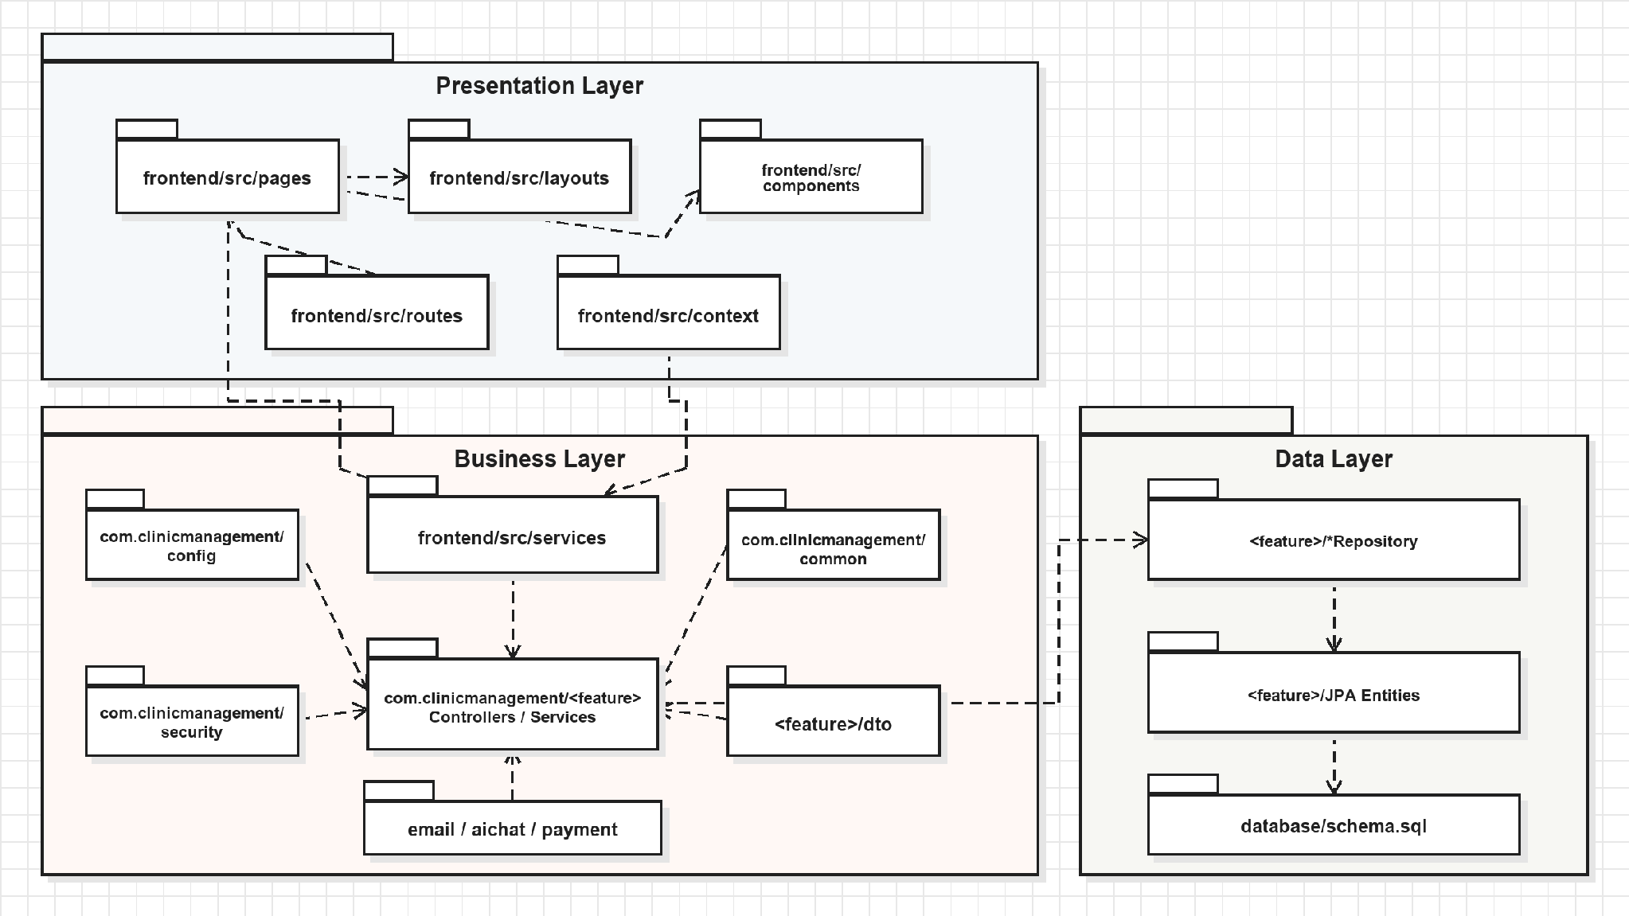
Figure I-1. UML code package dependencies
Package descriptions
No | Package | Description
1 | frontend/src/pages | Role-oriented pages for authentication, booking, consultation, laboratory, pharmacy, billing, and administration.
2 | frontend/src/layouts | Dashboard shells and sidebars for Patient, Doctor, Receptionist, Pharmacist, Lab Technician, and Admin roles.
3 | frontend/src/services | Axios-based feature clients and request/response adapters for backend endpoints.
4 | frontend/src/context and routes | Authentication state, protected routing, and shared toast state.
5 | backend Controller | HTTP mapping, request validation, authorization, and response construction.
6 | backend Service / ServiceImpl | Transactional workflow rules and cross-entity business logic.
7 | backend Repository | Spring Data JPA queries, specifications, pagination, and persistence.
8 | backend Entity / DTO | Relational domain model plus validated request and stable response contracts.
9 | External integrations | Google identity, email OTP, Gemini/Groq AI, online payment, and optional WebSocket messaging.

2. Database Design

a. Database Schema
The logical data model is split into a core clinical path and a supporting administrative path. Foreign keys preserve ownership and workflow continuity from identity through appointment, consultation, laboratory, prescription, billing, and follow-up.

Figure I-2. User & HR Management (Quản lý người dùng và nhân sự)

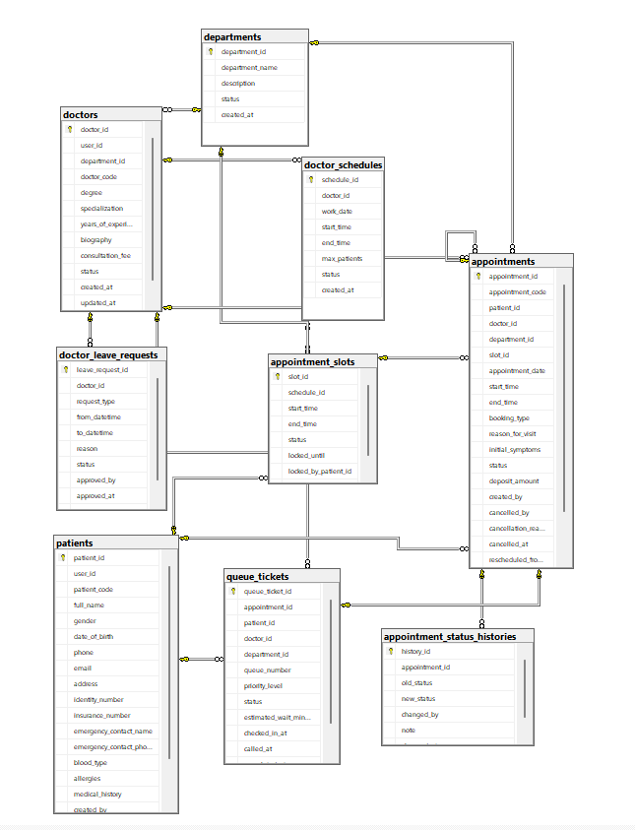
Figure I-3. Booking & Queue Management (Quản lý đặt chỗ và xếp hàng)
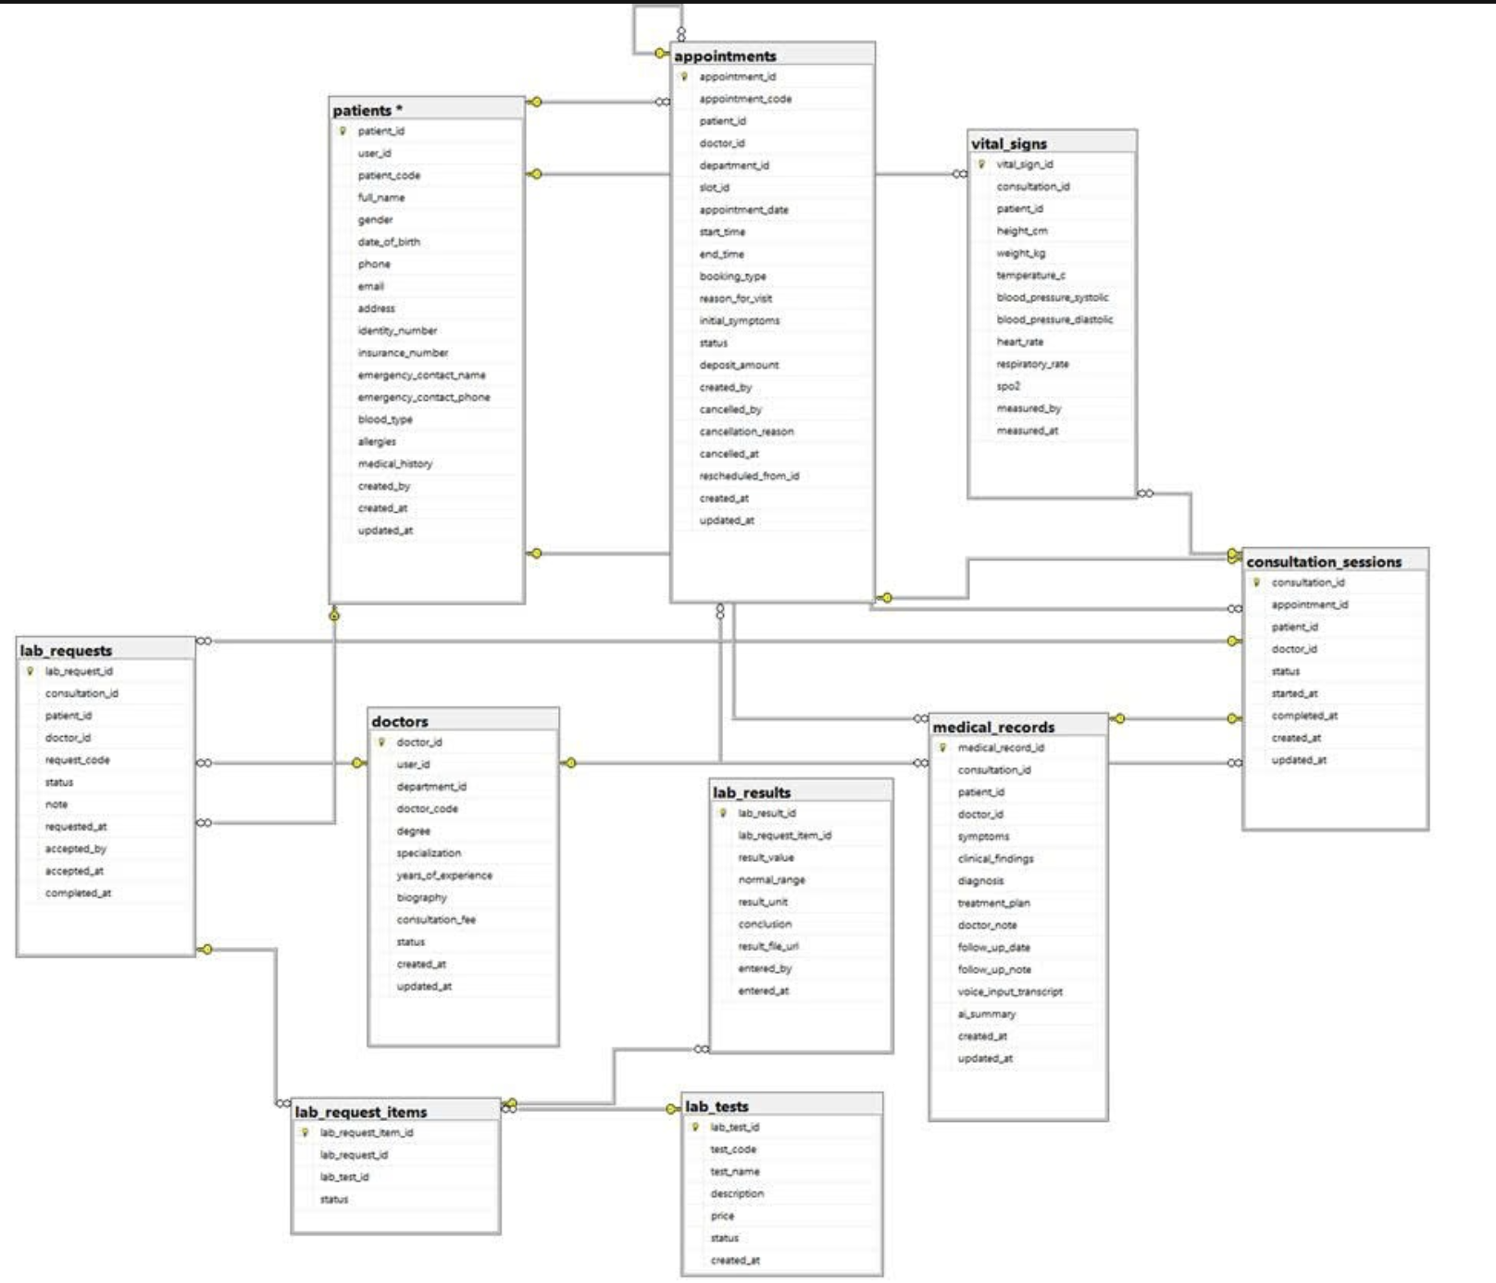
Figure I-4. Examination, Lab & EHR (Khám bệnh, xét nghiệm và hồ sơ bệnh án điện tử)
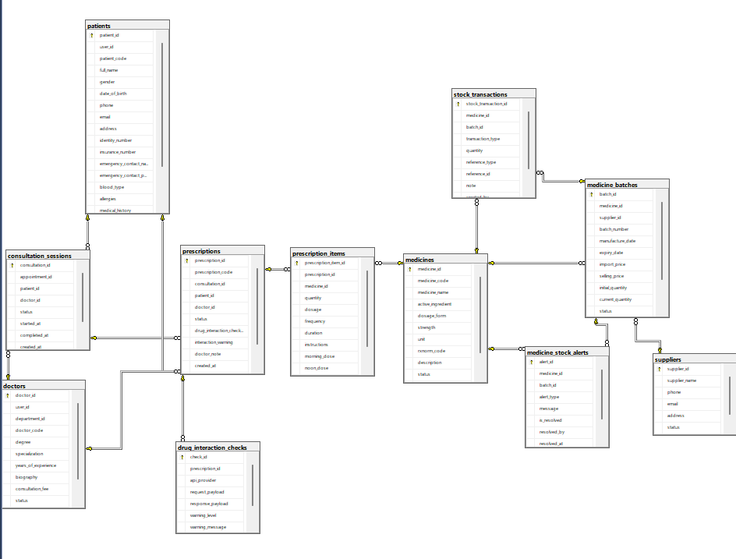
Figure I-5. Prescription & Pharmacy (Đơn thuốc & Nhà thuốc)
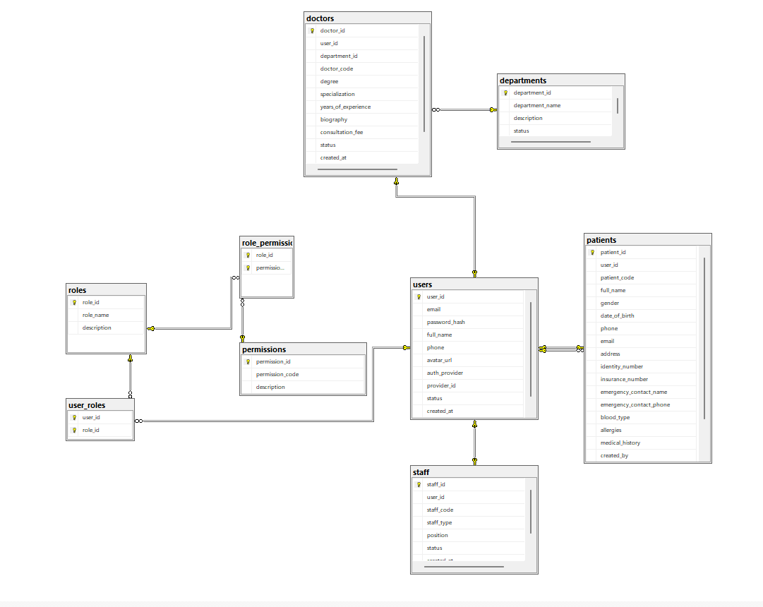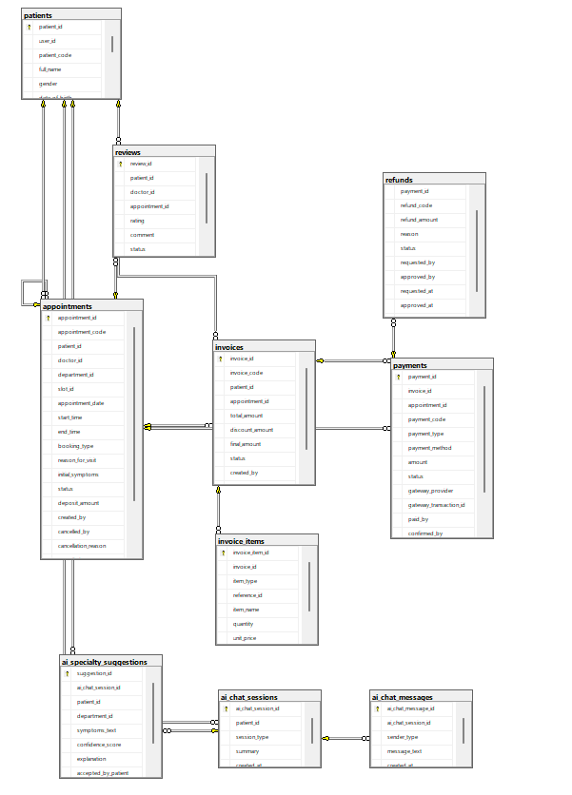
Figure I-6. Billing & CRM (Quản lý hóa đơn và CRM)

b. Table Description
No | Module | Table | Description
1 | Access Control | users | Authentication identity, profile, provider, and account status.
2 | Access Control | roles | Named roles including PATIENT, DOCTOR, RECEPTIONIST, ADMIN, PHARMACIST, and LAB_TECHNICIAN.
3 | Access Control | permissions | Fine-grained application permission catalog.
4 | Access Control | user_roles | Many-to-many assignments between users and roles.
5 | Access Control | role_permissions | Many-to-many assignments between roles and permissions.
6 | Access Control | email_otps | Expiring one-time codes for registration and password reset.
7 | Clinical Identity | patients | Patient demographics, contacts, insurance, allergies, and history.
8 | Clinical Identity | departments | Clinic specialties and operational state.
9 | Clinical Identity | doctors | Doctor profile linked to a user and department.
10 | Clinical Identity | staff | Non-doctor employee profile linked to a user.
11 | Scheduling | doctor_schedules | Doctor work dates and shift boundaries.
12 | Scheduling | appointment_slots | Bookable, lockable, and blockable schedule intervals.
13 | Scheduling | doctor_leave_requests | Doctor leave requests and administrative review metadata.
14 | Scheduling | appointments | Online and walk-in visit reservations and status lifecycle.
15 | Scheduling | appointment_status_histories | Immutable appointment status transition history.
16 | Scheduling | queue_tickets | Daily clinic queue position, state, and timestamps.
17 | Consultation | consultation_sessions | Clinical encounter lifecycle linked to appointment, doctor, and patient.
18 | Consultation | medical_records | Symptoms, findings, diagnosis, and treatment plan produced by a consultation.
19 | Consultation | vital_signs | Measured blood pressure, temperature, pulse, oxygen saturation, height, and weight.
20 | Laboratory | lab_tests | Laboratory test catalog and reference metadata.
21 | Laboratory | lab_requests | Doctor order for one or more tests within a consultation.
22 | Laboratory | lab_request_items | Individual requested tests and processing state.
23 | Laboratory | lab_results | Measured value, range, unit, conclusion, and file reference.
24 | Services | medical_services | Billable clinic service catalog and pricing.
25 | Pharmacy | medicines | Medicine catalog, active ingredient, dosage form, and status.
26 | Pharmacy | prescriptions | Prescription header linked to a consultation, patient, and doctor.
27 | Pharmacy | prescription_items | Medicine quantities, dosage schedule, duration, and instructions.
28 | Pharmacy | drug_interaction_checks | Recorded interaction-check request and response evidence.
29 | Inventory | suppliers | Medicine supplier identity and contact information.
30 | Inventory | medicine_batches | Physical stock lot, quantity, cost, dates, and stock state.
31 | Inventory | stock_transactions | Immutable import/export inventory ledger.
32 | Inventory | medicine_stock_alerts | Low-stock, out-of-stock, and expiry alerts.
33 | Billing | invoices | Invoice totals and lifecycle linked to patient and appointment.
34 | Billing | invoice_items | Billable service, medicine, and other invoice lines.
35 | Billing | payments | Cash or online payment attempts and gateway metadata.
36 | Billing | refunds | Refund request, review, approval, and completion state.
37 | AI Support | ai_chat_sessions | Patient-owned symptom triage conversation session.
38 | AI Support | ai_chat_messages | Ordered patient and assistant messages.
39 | AI Support | ai_specialty_suggestions | AI-supported department suggestion and acceptance state.
40 | AI Support | ai_voice_transcriptions | Optional clinical voice transcription evidence.
41 | Engagement | notifications | User-scoped application notifications and read state.
42 | Engagement | reviews | Patient review of doctor or completed appointment.
43 | Content | articles | Administrator-managed clinic articles.
44 | Administration | audit_logs | Immutable actor, action, table, and record audit evidence.
45 | Administration | system_settings | Typed operational settings keyed by unique setting name.

II. Code Designs
Each workflow below follows the template pattern of class diagram, class specifications, sequence diagram, and database queries. Sequence diagrams identify concrete frontend pages such as LoginPage, AvailableSlots, and ExaminationPage; no generic presentation lifeline is used.

1. Authentication and Account Management

1.1. Register Patient Account

a. Class Diagram
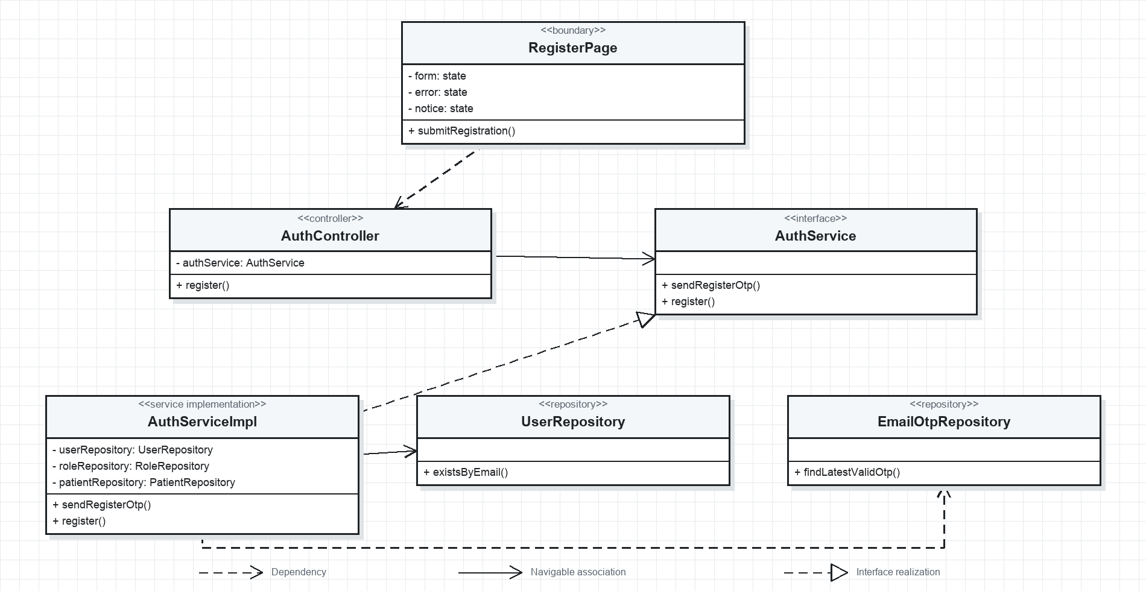
Figure II-1. Register Patient Account UML class diagram

b. Class Specifications
No | Class / Method | Description
01 | RegisterPage.submitRegistration() | Validates the form, sends the OTP and registration payload, and displays the returned account state.
02 | AuthController.register() | Accepts a validated RegisterRequest and returns the created user and patient identifiers.
03 | AuthService.sendRegisterOtp() | Checks email uniqueness, creates an expiring OTP, persists it, and triggers email delivery.
04 | AuthService.register() | Verifies the OTP, hashes the password, assigns PATIENT role, and creates the linked patient profile.
05 | UserRepository.existsByEmail() | Checks whether the requested login email is already registered.
06 | EmailOtpRepository.findLatestValidOtp() | Retrieves the most recent unexpired OTP for verification.

c. Sequence Diagram(s)
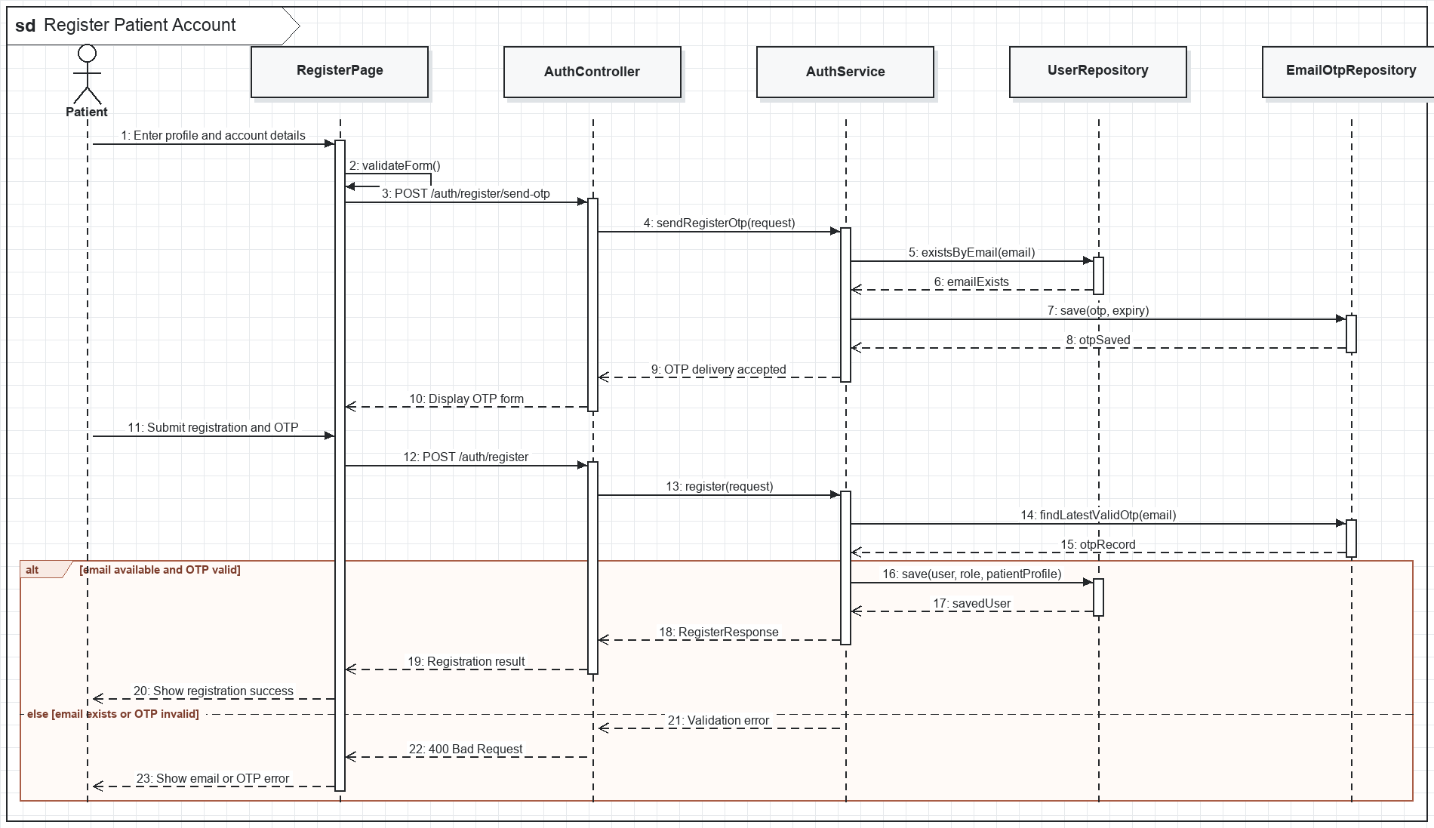
Figure II-2. Register Patient Account sequence

d. Database Queries
1. Repository operation
SELECT EXISTS (SELECT 1 FROM users WHERE email = ?);
2. Repository operation
INSERT INTO email_otps (email, otp_code, purpose, expires_at, used) VALUES (?, ?, 'REGISTER', ?, FALSE);
3. Repository operation
INSERT INTO users (email, password_hash, full_name, phone, status, created_at) VALUES (?, ?, ?, ?, 'ACTIVE', CURRENT_TIMESTAMP);
4. Repository operation
INSERT INTO user_roles (user_id, role_id) SELECT ?, role_id FROM roles WHERE role_name = 'PATIENT';
5. Repository operation
INSERT INTO patients (user_id, patient_code, full_name, phone, email, created_at) VALUES (?, ?, ?, ?, ?, CURRENT_TIMESTAMP);

1.2. Login, Google Login and Token Refresh

a. Class Diagram
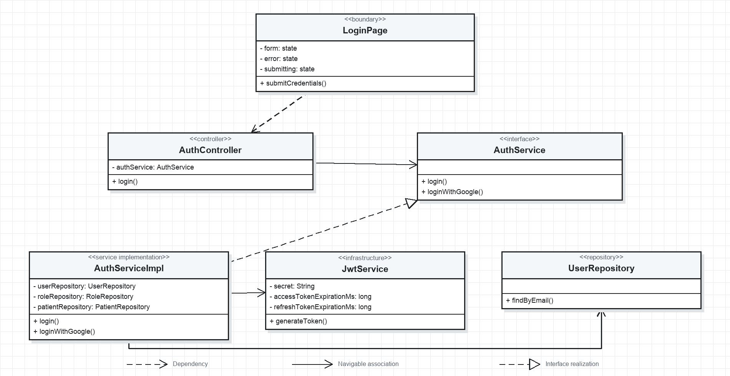
Figure II-3. Login and Token Refresh UML class diagram

b. Class Specifications
No | Class / Method | Description
01 | LoginPage.submitCredentials() | Submits credentials and stores the authenticated user and token pair in the authentication context.
02 | AuthController.login() | Receives LoginRequest and returns LoginResponse with role-aware user data.
03 | AuthService.login() | Verifies password and account state before issuing tokens.
04 | AuthService.loginWithGoogle() | Validates the Google identity and creates or loads the matching local user.
05 | JwtService.generateToken() | Signs access and refresh tokens with subject, roles, and expiration claims.
06 | UserRepository.findByEmail() | Loads user identity and assigned roles for authentication.

c. Sequence Diagram(s)
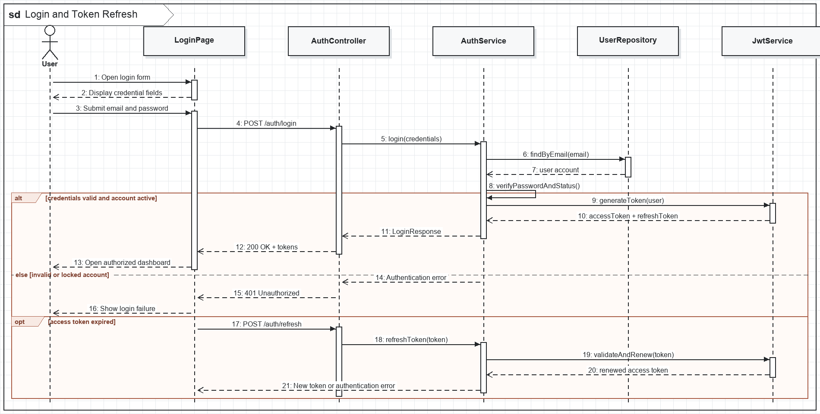
Figure II-4. Login and Token Refresh sequence

d. Database Queries
1. Repository operation
SELECT u.* FROM users u WHERE LOWER(u.email) = LOWER(?);
2. Repository operation
SELECT r.role_name FROM roles r JOIN user_roles ur ON ur.role_id = r.role_id WHERE ur.user_id = ?;
3. Repository operation
INSERT INTO users (email, full_name, auth_provider, provider_id, status) VALUES (?, ?, 'GOOGLE', ?, 'ACTIVE') ON CONFLICT (email) DO UPDATE SET provider_id = EXCLUDED.provider_id;

1.3. Forgot and Change Password

a. Class Diagram
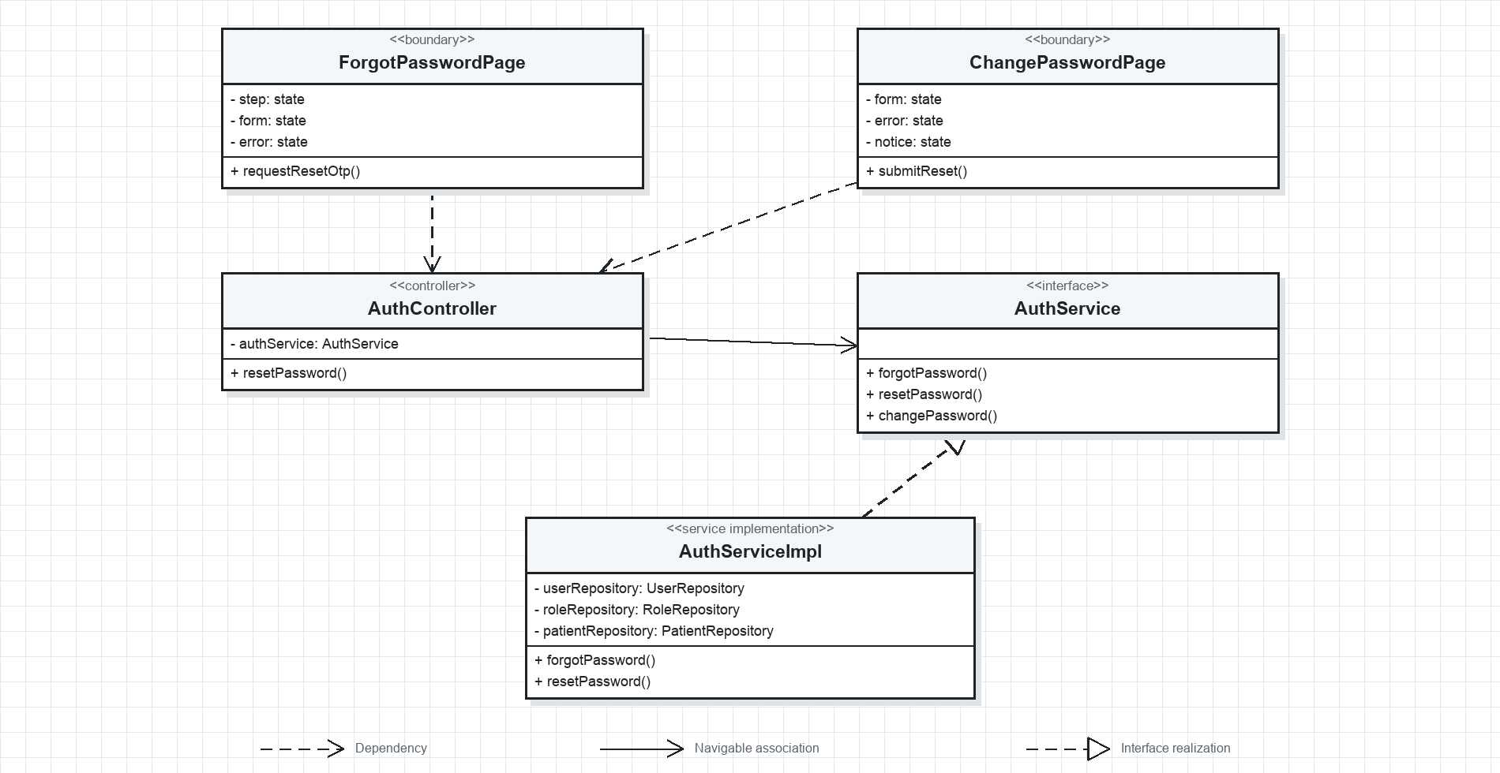
Figure II-5. Forgot and Change Password UML class diagram

b. Class Specifications
No | Class / Method | Description
01 | ForgotPasswordPage.requestResetOtp() | Requests a password-reset OTP without exposing whether an email is registered.
02 | ChangePasswordPage.submitReset() | Submits OTP, new password, and confirmation with client-side strength checks.
03 | AuthController.resetPassword() | Validates ResetPasswordRequest and delegates password replacement.
04 | AuthService.forgotPassword() | Creates and sends a time-limited password-reset OTP.
05 | AuthService.resetPassword() | Verifies OTP state, hashes the new password, and marks the OTP as used.
06 | AuthService.changePassword() | Requires the current password for an already authenticated account.

c. Sequence Diagram(s)
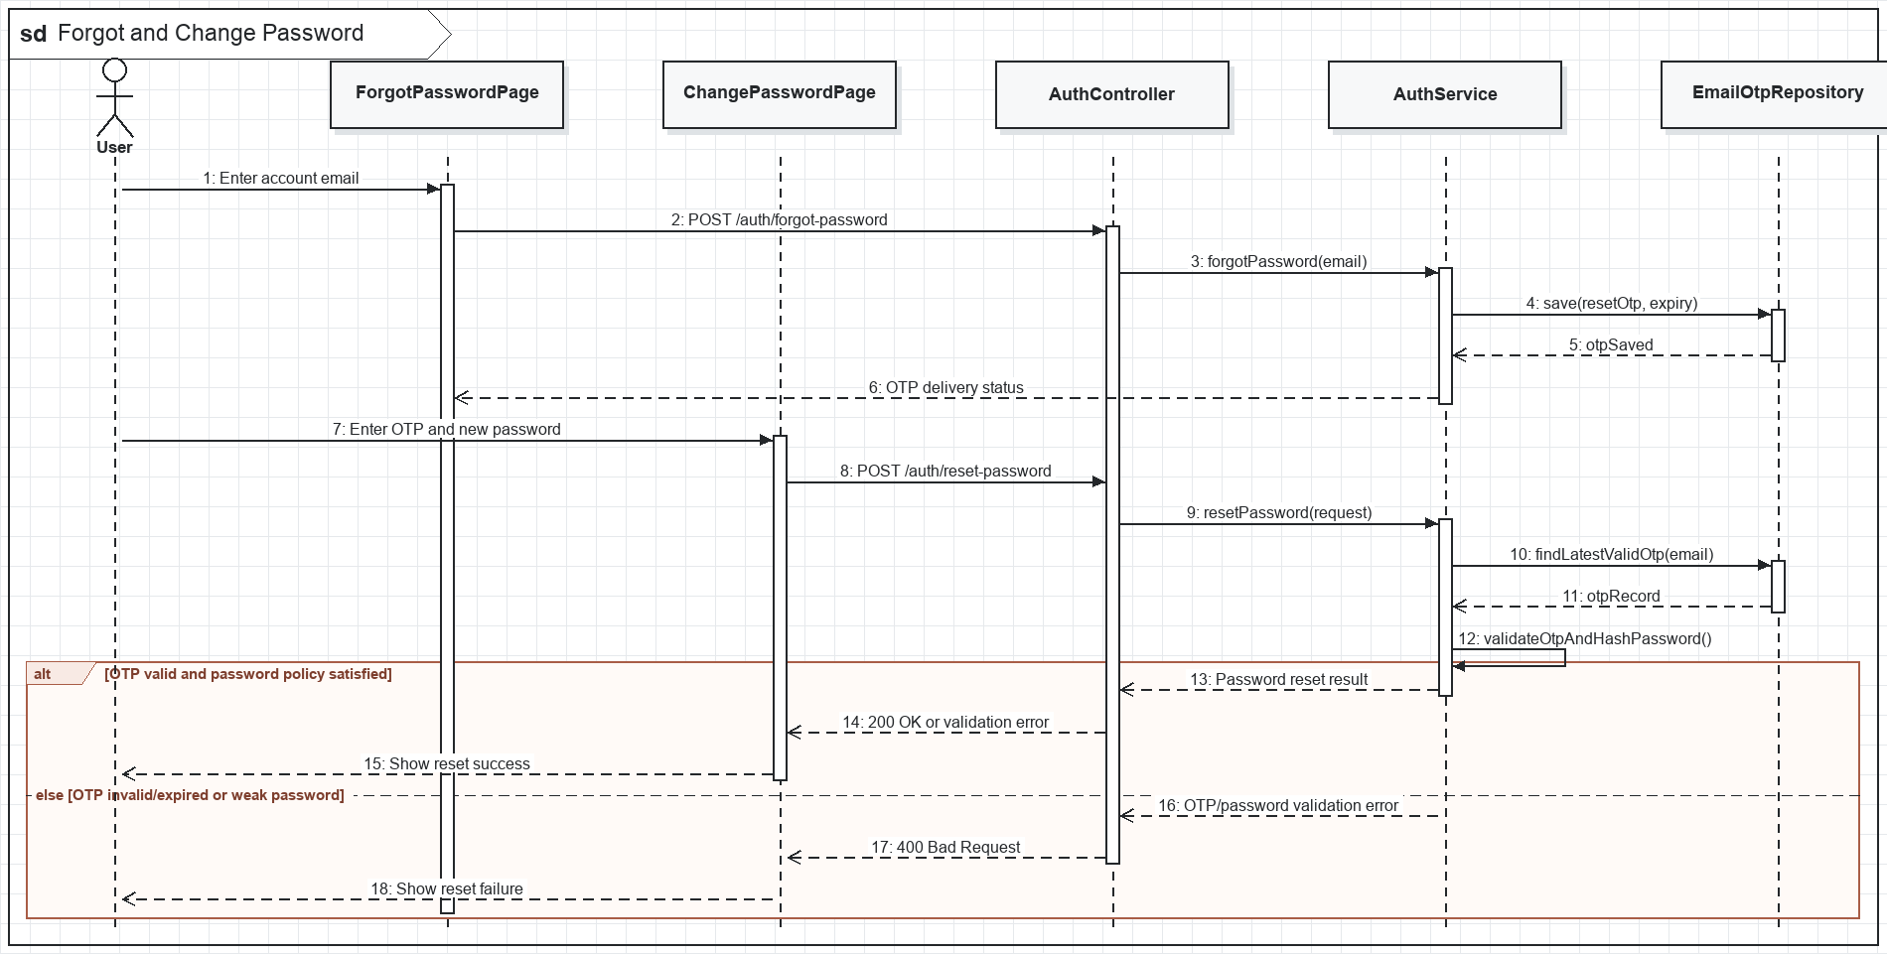
Figure II-6. Forgot and Change Password sequence

d. Database Queries
1. Repository operation
SELECT user_id, password_hash, status FROM users WHERE LOWER(email) = LOWER(?);
2. Repository operation
SELECT * FROM email_otps WHERE email = ? AND purpose = 'RESET_PASSWORD' AND used = FALSE AND expires_at > CURRENT_TIMESTAMP ORDER BY created_at DESC LIMIT 1;
3. Repository operation
UPDATE users SET password_hash = ?, updated_at = CURRENT_TIMESTAMP WHERE user_id = ?;
4. Repository operation
UPDATE email_otps SET used = TRUE WHERE otp_id = ?;

1.4. Profile and Staff Account Management

a. Class Diagram
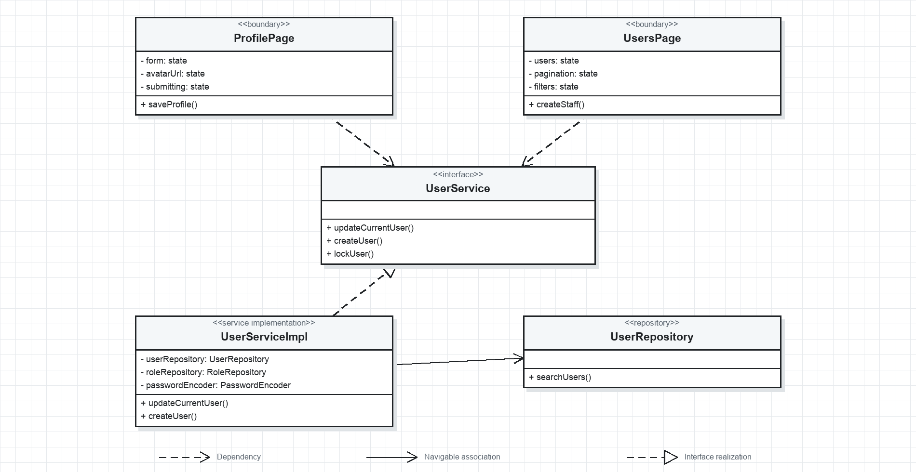
Figure II-7. Profile and Staff Accounts UML class diagram

b. Class Specifications
No | Class / Method | Description
01 | ProfilePage.saveProfile() | Updates permitted personal fields for the authenticated user.
02 | UsersPage.createStaff() | Allows an administrator to create operational staff accounts and assign roles.
03 | UserService.updateCurrentUser() | Applies self-service profile changes while protecting role and status fields.
04 | UserService.createUser() | Creates a staff user and validates email and role assignments.
05 | UserService.lockUser() | Changes account state to LOCKED so authentication is rejected.
06 | UserRepository.searchUsers() | Supports keyword, status, role, and pageable account queries.

c. Sequence Diagram(s)
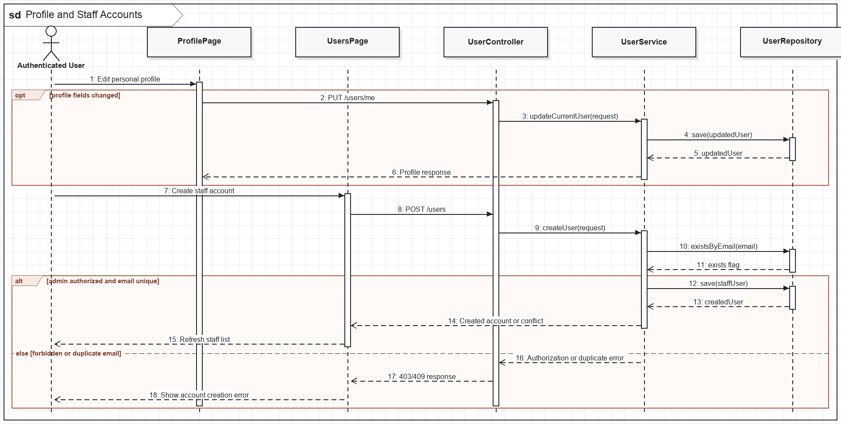
Figure II-8. Profile and Staff Accounts sequence

d. Database Queries
1. Repository operation
SELECT u.* FROM users u WHERE u.user_id = ?;
2. Repository operation
UPDATE users SET full_name = ?, phone = ?, avatar_url = ?, updated_at = CURRENT_TIMESTAMP WHERE user_id = ?;
3. Repository operation
UPDATE users SET status = ? WHERE user_id = ?;
4. Repository operation
INSERT INTO user_roles (user_id, role_id) VALUES (?, ?);

2. Appointment Booking and Queue Management

2.1. AI Symptom Triage

a. Class Diagram
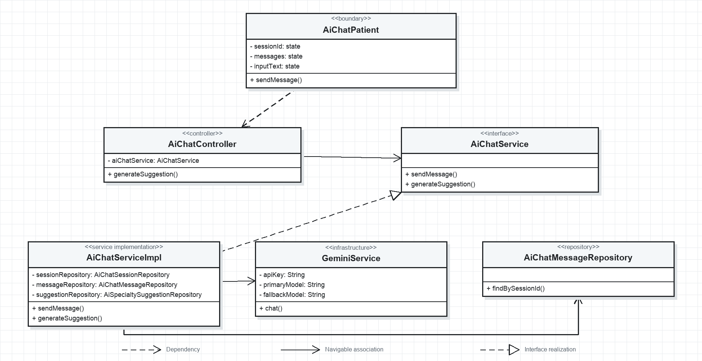
Figure II-9. AI Symptom Triage UML class diagram

b. Class Specifications
No | Class / Method | Description
01 | AiChatPatient.sendMessage() | Appends patient input to the active chat and renders the assistant response.
02 | AiChatController.generateSuggestion() | Requests a structured specialty recommendation for the authenticated patient.
03 | AiChatService.sendMessage() | Persists both sides of the conversation and enforces session ownership.
04 | AiChatService.generateSuggestion() | Maps AI output to an active clinic department and saves the suggestion.
05 | GeminiService.chat() | Uses configured primary/fallback providers with retry, bounded medical prompts, and safe fallback text.
06 | AiChatMessageRepository.findBySessionId() | Loads ordered conversation history for prompt context.

c. Sequence Diagram(s)
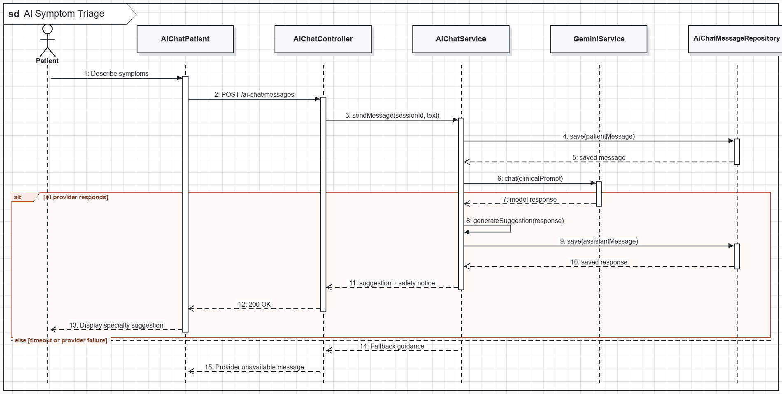
Figure II-10. AI Symptom Triage sequence

d. Database Queries
1. Repository operation
INSERT INTO ai_chat_sessions (patient_id, started_at, status) VALUES (?, CURRENT_TIMESTAMP, 'ACTIVE');
2. Repository operation
INSERT INTO ai_chat_messages (ai_chat_session_id, sender_type, message_text, sent_at) VALUES (?, ?, ?, CURRENT_TIMESTAMP);
3. Repository operation
INSERT INTO ai_specialty_suggestions (ai_chat_session_id, patient_id, department_id, reason, confidence_score, created_at) VALUES (?, ?, ?, ?, ?, CURRENT_TIMESTAMP);
4. Repository operation
SELECT * FROM ai_chat_messages WHERE ai_chat_session_id = ? ORDER BY sent_at ASC;

2.2. Book, Cancel and Reschedule Appointment

a. Class Diagram
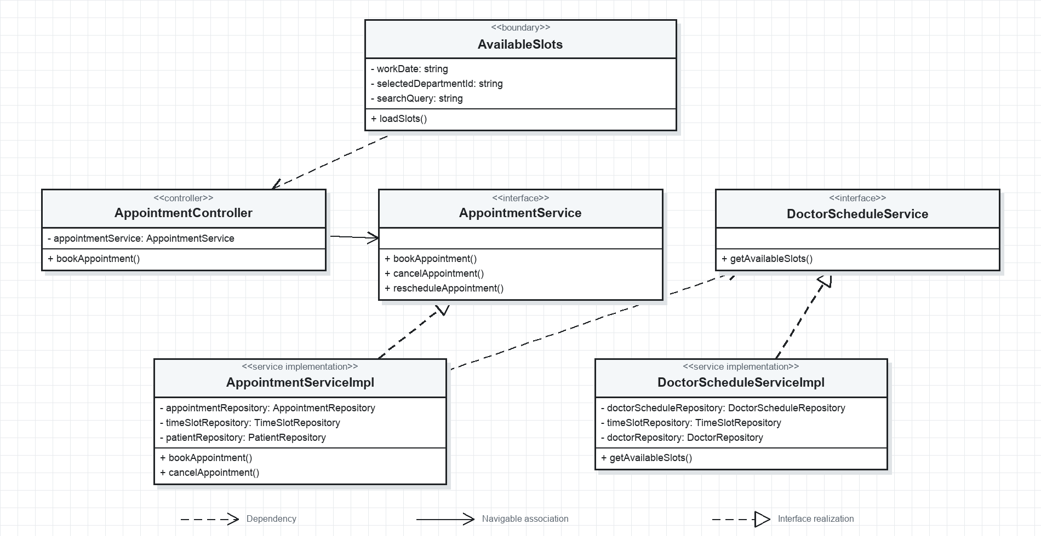
Figure II-11. Appointment Booking UML class diagram

b. Class Specifications
No | Class / Method | Description
01 | AvailableSlots.loadSlots() | Retrieves patient-visible slots filtered by doctor and work date.
02 | AppointmentController.bookAppointment() | Creates an appointment for the authenticated user from BookAppointmentRequest.
03 | AppointmentService.bookAppointment() | Validates patient ownership, slot availability, schedule state, and duplicate booking rules.
04 | AppointmentService.cancelAppointment() | Changes an allowed appointment to CANCELLED and releases its slot.
05 | AppointmentService.rescheduleAppointment() | Moves an appointment to another available slot and records the prior relationship.
06 | DoctorScheduleService.getAvailableSlots() | Returns available slots while applying the stricter patient visibility rules.

c. Sequence Diagram(s)
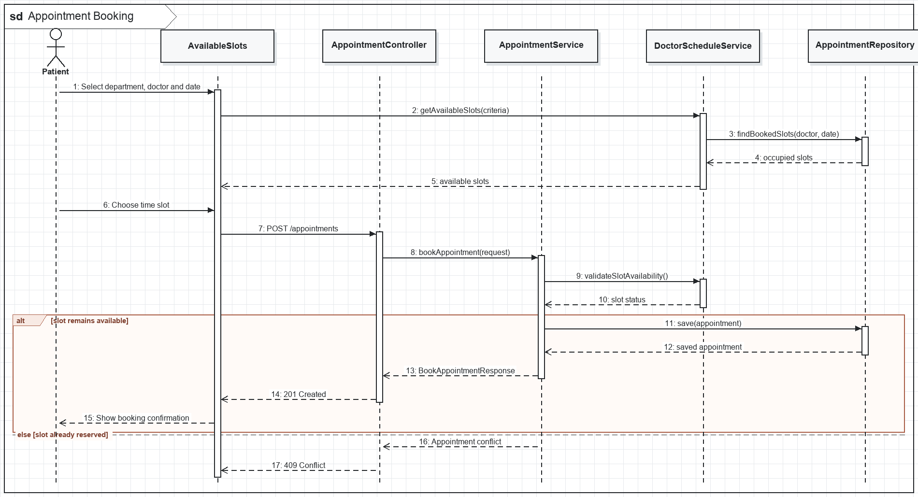
Figure II-12. Appointment Booking sequence

d. Database Queries
1. Repository operation
SELECT s.* FROM appointment_slots s JOIN doctor_schedules ds ON ds.schedule_id = s.schedule_id WHERE ds.doctor_id = ? AND ds.work_date = ? AND s.status = 'AVAILABLE' ORDER BY s.start_time;
2. Repository operation
INSERT INTO appointments (appointment_code, patient_id, doctor_id, department_id, slot_id, appointment_date, status, created_by) VALUES (?, ?, ?, ?, ?, ?, 'CONFIRMED', ?);
3. Repository operation
UPDATE appointment_slots SET status = 'BOOKED', locked_by_patient_id = NULL, locked_at = NULL WHERE slot_id = ? AND status IN ('AVAILABLE', 'LOCKED');
4. Repository operation
INSERT INTO appointment_status_histories (appointment_id, old_status, new_status, changed_by, changed_at) VALUES (?, ?, ?, ?, CURRENT_TIMESTAMP);
5. Repository operation
UPDATE appointments SET status = 'CANCELLED', cancellation_reason = ?, cancelled_by = ? WHERE appointment_id = ?;

2.3. Walk-in Appointment and Check-in

a. Class Diagram
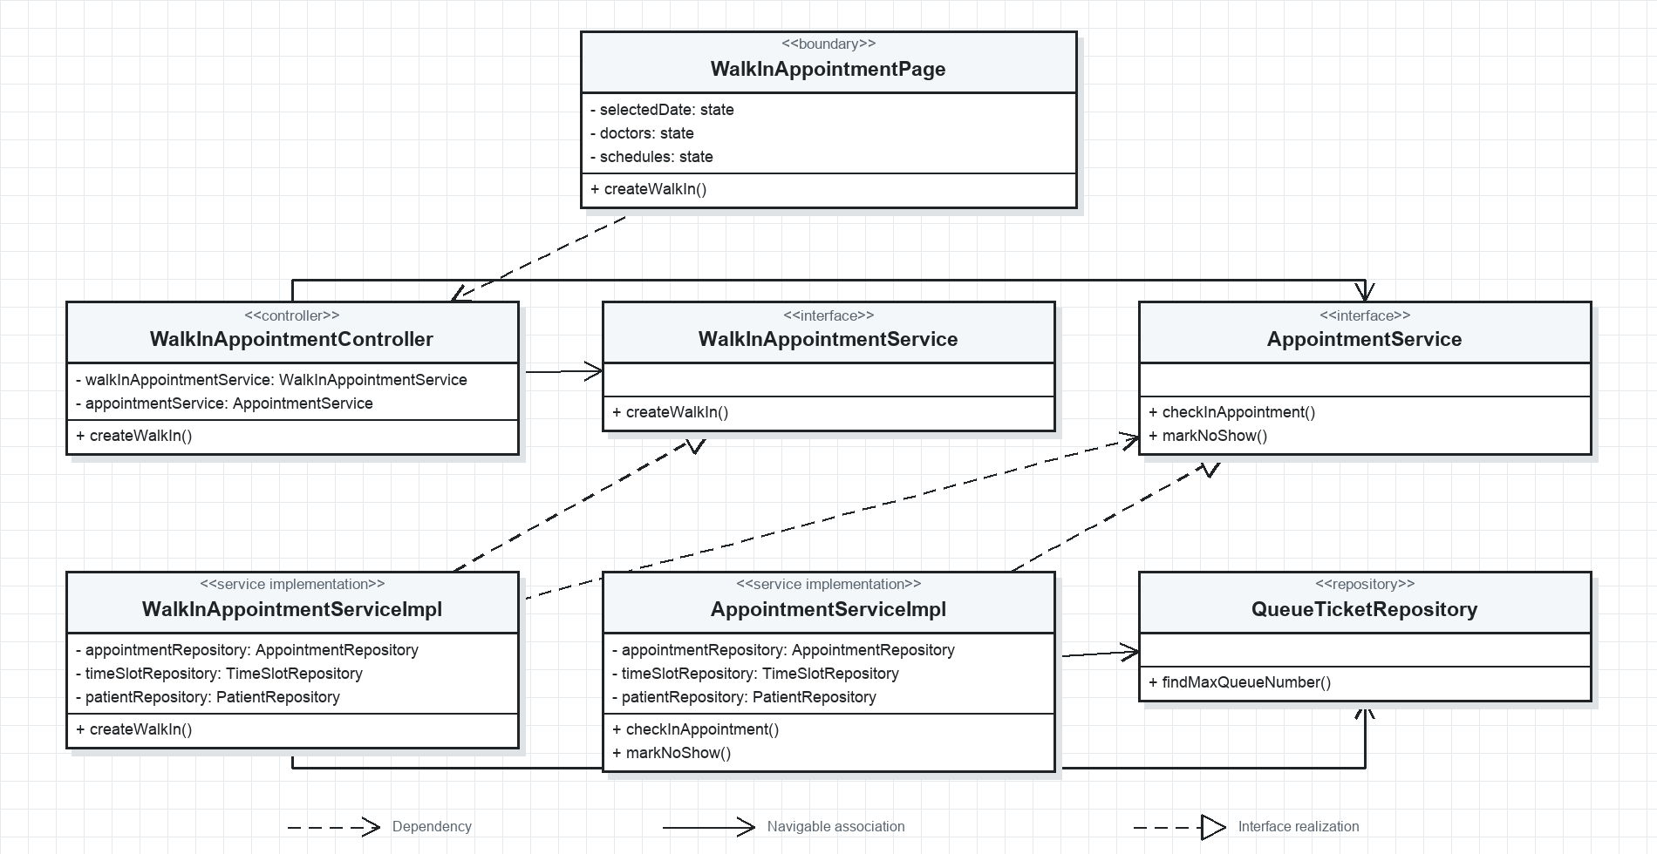
Figure II-13. Walk-in and Check-in UML class diagram

b. Class Specifications
No | Class / Method | Description
01 | WalkInAppointmentPage.createWalkIn() | Captures patient, department, doctor, visit reason, and optional new patient data.
02 | WalkInAppointmentController.createWalkIn() | Creates an offline appointment for an authenticated receptionist.
03 | WalkInAppointmentService.createWalkIn() | Resolves the patient, assigns a code, and persists the walk-in appointment.
04 | AppointmentService.checkInAppointment() | Validates arrival state, marks the appointment checked in, and creates a queue ticket.
05 | AppointmentService.markNoShow() | Records a missed visit and releases operational queue state.
06 | QueueTicketRepository.findMaxQueueNumber() | Supports sequential queue numbering per date and doctor or department.

c. Sequence Diagram(s)
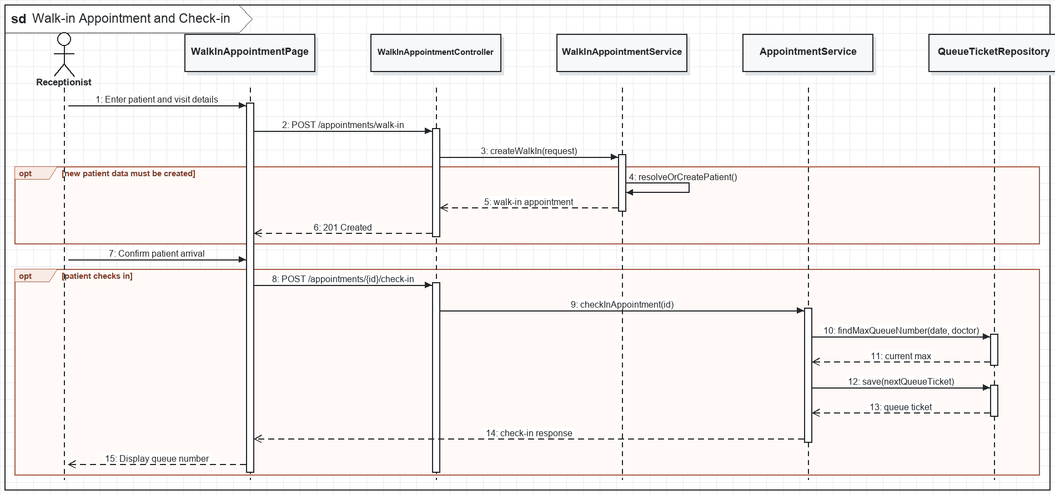
Figure II-14. Walk-in and Check-in sequence

d. Database Queries
1. Repository operation
INSERT INTO appointments (appointment_code, patient_id, doctor_id, department_id, appointment_date, visit_reason, status, booking_type, created_by) VALUES (?, ?, ?, ?, ?, ?, 'CONFIRMED', 'WALK_IN', ?);
2. Repository operation
UPDATE appointments SET status = 'CHECKED_IN', check_in_time = CURRENT_TIMESTAMP WHERE appointment_id = ?;
3. Repository operation
SELECT COALESCE(MAX(queue_number), 0) + 1 FROM queue_tickets WHERE queue_date = ? AND doctor_id = ?;
4. Repository operation
INSERT INTO queue_tickets (appointment_id, patient_id, doctor_id, department_id, queue_number, queue_date, status, check_in_time) VALUES (?, ?, ?, ?, ?, ?, 'WAITING', CURRENT_TIMESTAMP);

2.4. Queue Management and Patient Tracking

a. Class Diagram
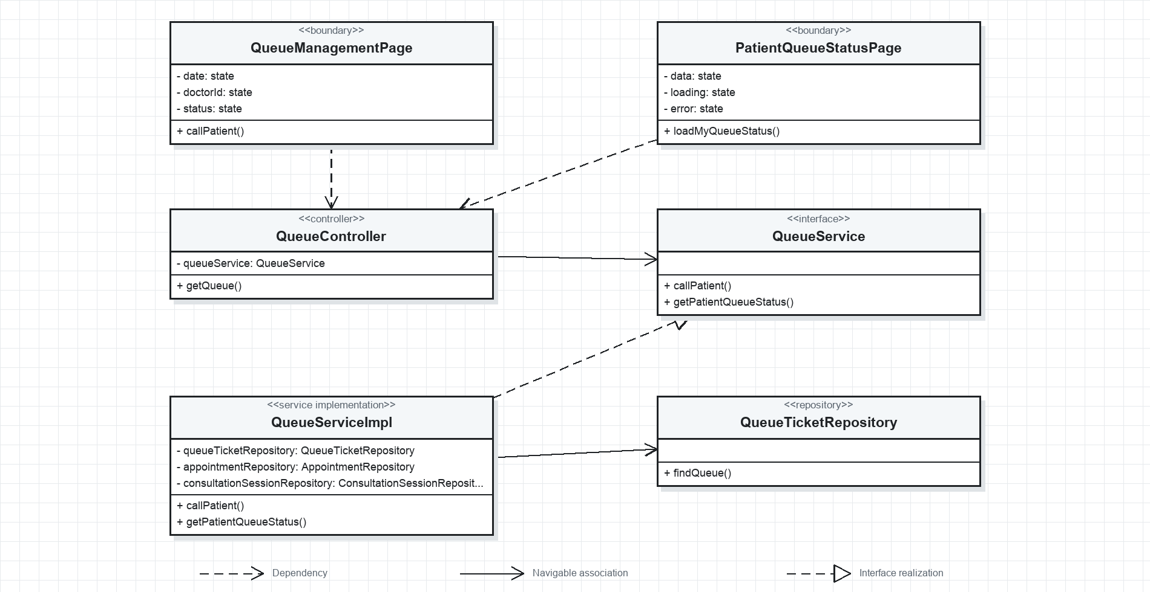
Figure II-15. Queue Management UML class diagram

b. Class Specifications
No | Class / Method | Description
01 | QueueManagementPage.callPatient() | Changes the selected waiting ticket to CALLED and refreshes the visible queue.
02 | PatientQueueStatusPage.loadMyQueueStatus() | Displays the patient's current number, people ahead, and estimated wait.
03 | QueueController.getQueue() | Returns operational queue data to authorized staff.
04 | QueueService.callPatient() | Sets status and called time while preserving a valid queue transition.
05 | QueueService.getPatientQueueStatus() | Calculates queue position and waiting estimate for the authenticated patient.
06 | QueueTicketRepository.findQueue() | Loads queue tickets ordered by priority and queue number.

c. Sequence Diagram(s)
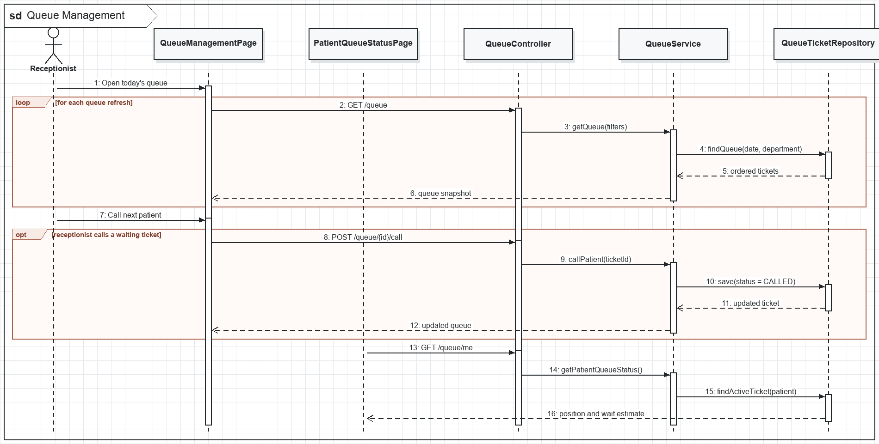
Figure II-16. Queue Management sequence

d. Database Queries
1. Repository operation
SELECT * FROM queue_tickets WHERE queue_date = ? AND (? IS NULL OR doctor_id = ?) AND (? IS NULL OR status = ?) ORDER BY priority DESC, queue_number ASC;
2. Repository operation
UPDATE queue_tickets SET status = 'CALLED', called_time = CURRENT_TIMESTAMP WHERE queue_ticket_id = ? AND status IN ('WAITING', 'SKIPPED');
3. Repository operation
UPDATE queue_tickets SET status = 'SKIPPED' WHERE queue_ticket_id = ? AND status = 'CALLED';
4. Repository operation
UPDATE queue_tickets SET status = 'COMPLETED', completed_time = CURRENT_TIMESTAMP WHERE queue_ticket_id = ?;

3. Consultation and Diagnostics

3.1. Conduct Consultation and Maintain EHR

a. Class Diagram
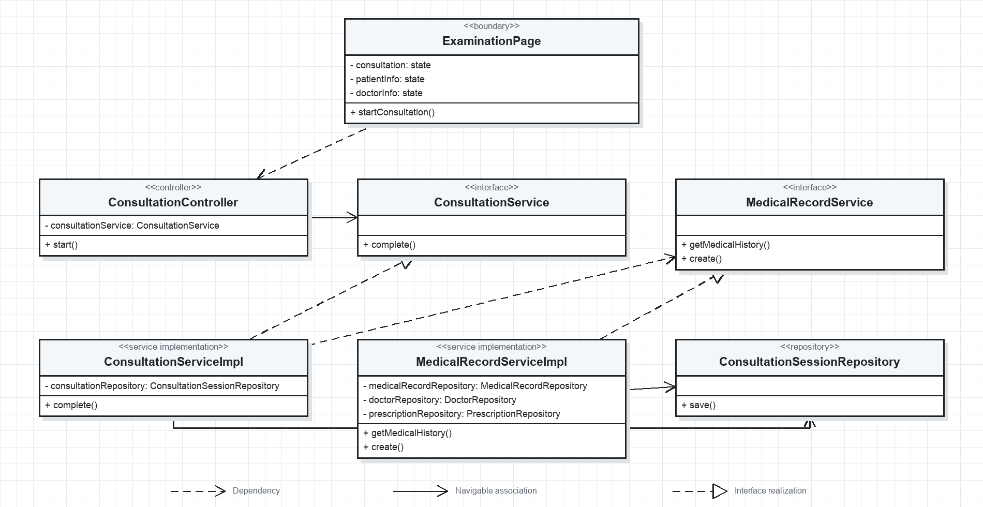
Figure II-17. Consultation and EHR UML class diagram

b. Class Specifications
No | Class / Method | Description
01 | ExaminationPage.startConsultation() | Starts or opens the consultation workspace for an authorized doctor.
02 | ConsultationController.start() | Transitions an existing consultation session to IN_PROGRESS.
03 | ConsultationService.complete() | Validates completion conditions and records the end time.
04 | MedicalRecordService.getMedicalHistory() | Returns chronological medical records for clinical context.
05 | MedicalRecordService.create() | Creates the EHR record linked to the consultation, patient, and doctor.
06 | ConsultationSessionRepository.save() | Persists session status and lifecycle timestamps transactionally.

c. Sequence Diagram(s)
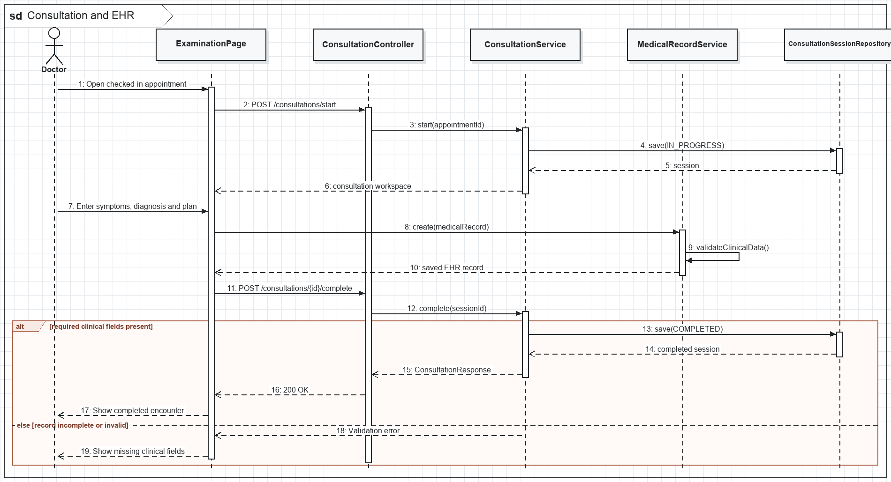
Figure II-18. Consultation and EHR sequence

d. Database Queries
1. Repository operation
INSERT INTO consultation_sessions (appointment_id, patient_id, doctor_id, status, started_at) VALUES (?, ?, ?, 'IN_PROGRESS', CURRENT_TIMESTAMP);
2. Repository operation
SELECT * FROM medical_records WHERE patient_id = ? ORDER BY created_at DESC;
3. Repository operation
INSERT INTO medical_records (consultation_id, patient_id, doctor_id, symptoms, clinical_findings, diagnosis, treatment_plan, created_at) VALUES (?, ?, ?, ?, ?, ?, ?, CURRENT_TIMESTAMP);
4. Repository operation
UPDATE consultation_sessions SET status = 'COMPLETED', ended_at = CURRENT_TIMESTAMP WHERE consultation_id = ?;
5. Repository operation
UPDATE appointments SET status = 'COMPLETED' WHERE appointment_id = ?;

3.2. Order and Process Laboratory Tests

a. Class Diagram
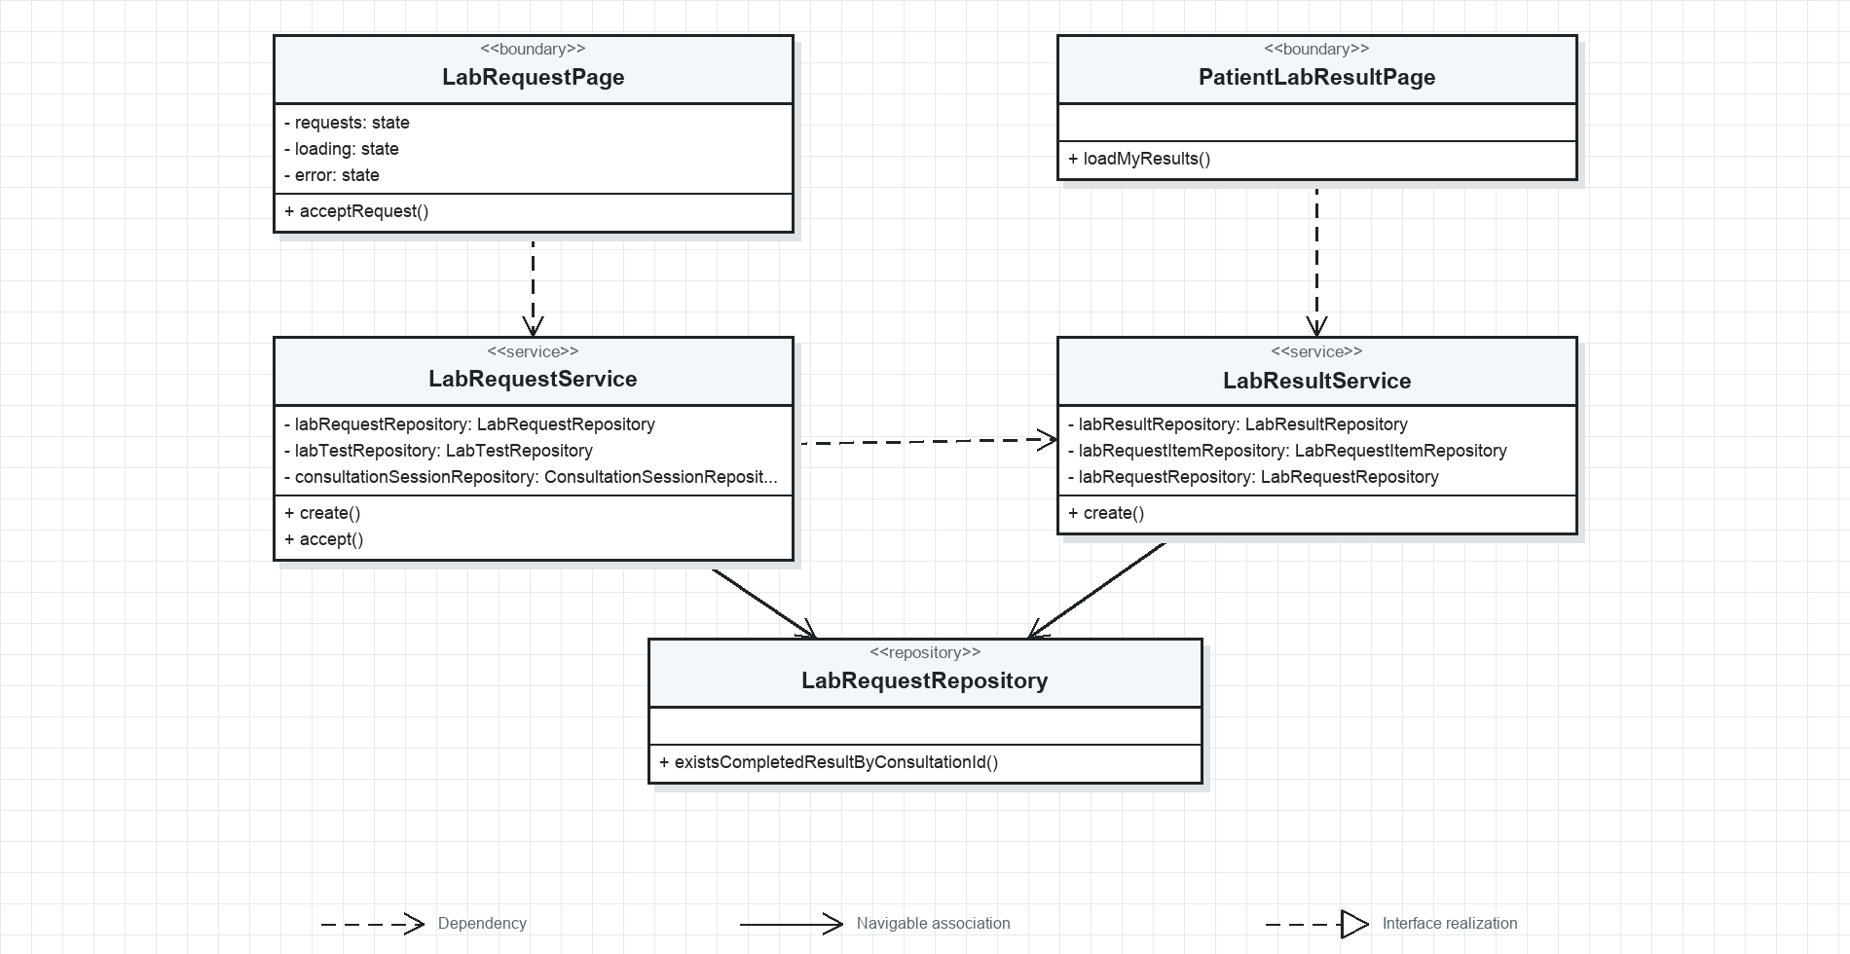
Figure II-19. Laboratory Workflow UML class diagram

b. Class Specifications
No | Class / Method | Description
01 | LabRequestPage.acceptRequest() | Lets authorized lab staff claim a requested laboratory order.
02 | PatientLabResultPage.loadMyResults() | Shows only completed laboratory results owned by the patient.
03 | LabRequestService.create() | Validates consultation, patient, doctor, and requested test identifiers.
04 | LabRequestService.accept() | Records accepting user and timestamp and moves all request items to IN_PROGRESS.
05 | LabResultService.create() | Creates one result per request item and completes the parent request when every item is done.
06 | LabRequestRepository.existsCompletedResultByConsultationId() | Determines whether a consultation has completed laboratory evidence.

c. Sequence Diagram(s)
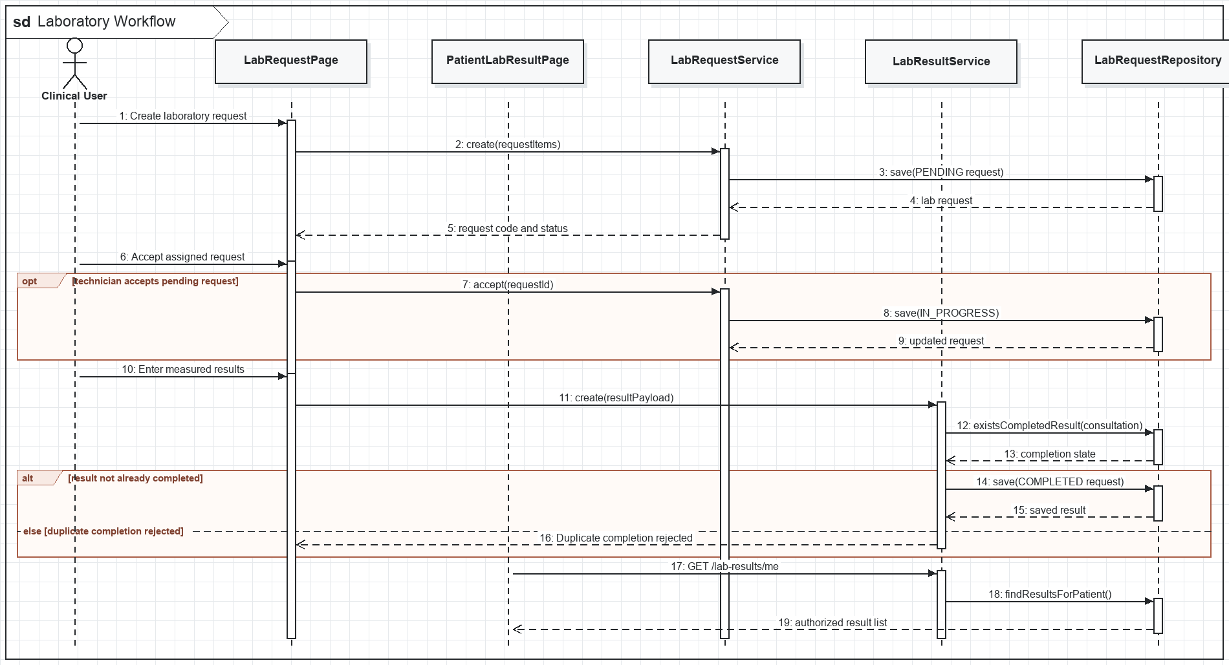
Figure II-20. Laboratory Workflow sequence

d. Database Queries
1. Repository operation
INSERT INTO lab_requests (consultation_id, patient_id, doctor_id, request_code, note, status) VALUES (?, ?, ?, ?, ?, 'REQUESTED');
2. Repository operation
INSERT INTO lab_request_items (lab_request_id, lab_test_id, status) VALUES (?, ?, 'REQUESTED');
3. Repository operation
UPDATE lab_requests SET status = 'IN_PROGRESS', accepted_by = ?, accepted_at = CURRENT_TIMESTAMP WHERE lab_request_id = ?;
4. Repository operation
INSERT INTO lab_results (lab_request_item_id, result_value, normal_range, result_unit, conclusion, result_file_url, entered_by) VALUES (?, ?, ?, ?, ?, ?, ?);
5. Repository operation
UPDATE lab_requests SET status = 'COMPLETED', completed_at = CURRENT_TIMESTAMP WHERE lab_request_id = ?;

3.3. Prescribe Medications and Check Safety

a. Class Diagram
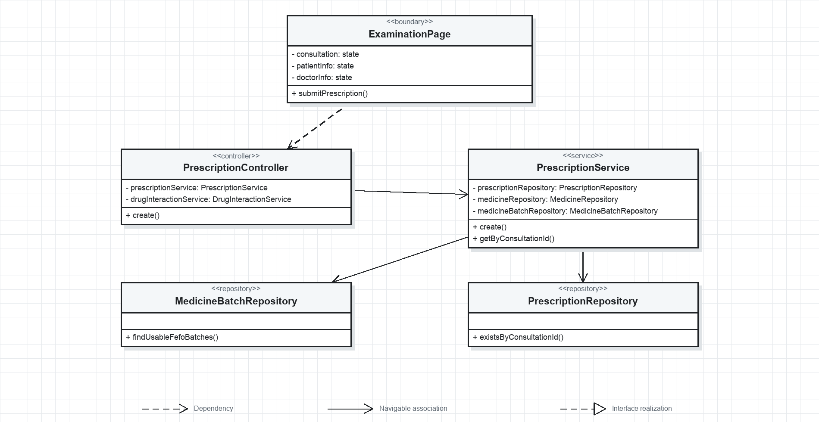
Figure II-21. Prescription Creation UML class diagram

b. Class Specifications
No | Class / Method | Description
01 | ExaminationPage.submitPrescription() | Submits the complete prescription only after required dose and instruction fields are valid.
02 | PrescriptionController.create() | Accepts the doctor's CreatePrescriptionRequest.
03 | PrescriptionService.create() | Prevents duplicates and enforces stock, allergy, and daily-dose safety rules.
04 | PrescriptionService.getByConsultationId() | Returns the prescription associated with one consultation.
05 | MedicineBatchRepository.findUsableFefoBatches() | Returns non-expired stock ordered by earliest expiry date.
06 | PrescriptionRepository.existsByConsultationId() | Enforces one active prescription per consultation.

c. Sequence Diagram(s)
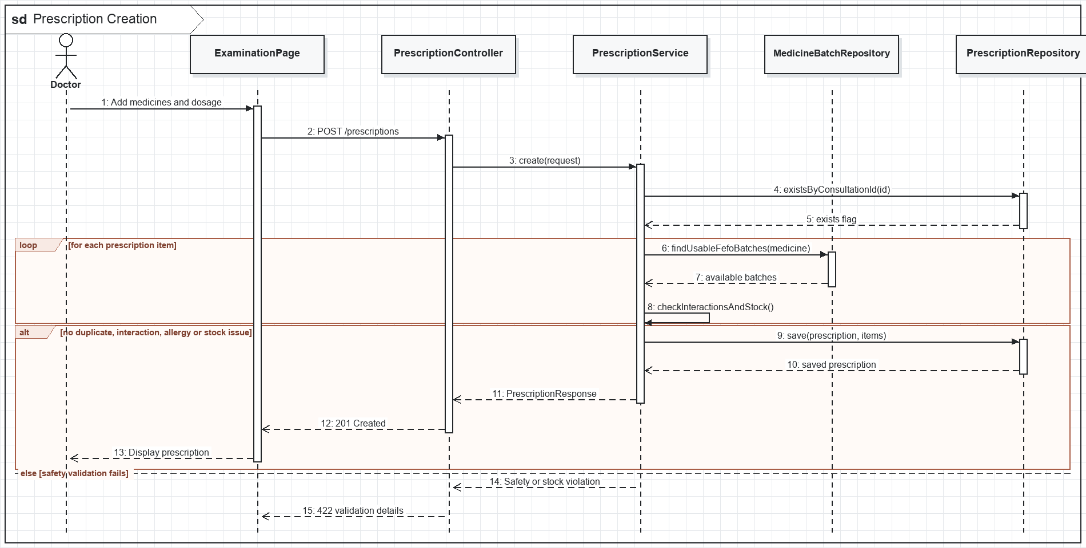
Figure II-22. Prescription Creation sequence

d. Database Queries
1. Repository operation
SELECT EXISTS (SELECT 1 FROM prescriptions WHERE consultation_id = ?);
2. Repository operation
SELECT mb.* FROM medicine_batches mb WHERE mb.medicine_id = ? AND mb.current_quantity > 0 AND mb.expiry_date >= CURRENT_DATE ORDER BY mb.expiry_date ASC;
3. Repository operation
SELECT allergies FROM patients WHERE patient_id = ?;
4. Repository operation
INSERT INTO prescriptions (prescription_code, consultation_id, patient_id, doctor_id, doctor_note, status) VALUES (?, ?, ?, ?, ?, 'CREATED');
5. Repository operation
INSERT INTO prescription_items (prescription_id, medicine_id, quantity, dosage, frequency, duration, instructions, morning_dose, noon_dose, evening_dose, night_dose) VALUES (?, ?, ?, ?, ?, ?, ?, ?, ?, ?, ?);

4. Pharmacy and Inventory

4.1. Dispense Medication

a. Class Diagram
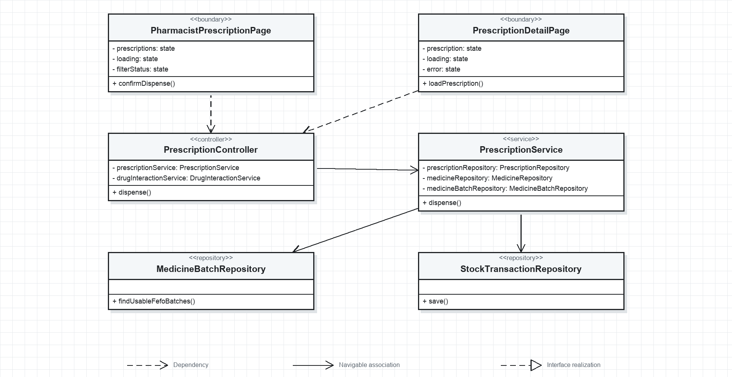
Figure II-23. Dispense Medication UML class diagram

b. Class Specifications
No | Class / Method | Description
01 | PharmacistPrescriptionPage.confirmDispense() | Requires explicit pharmacist confirmation before inventory is changed.
02 | PrescriptionDetailPage.loadPrescription() | Displays medicine, quantity, timing, duration, and doctor's note.
03 | PrescriptionController.dispense() | Authorizes pharmacist/admin roles and delegates transactional dispensing.
04 | PrescriptionService.dispense() | Deducts non-expired batches using FEFO and changes prescription state to DISPENSED.
05 | MedicineBatchRepository.findUsableFefoBatches() | Returns usable batches for deterministic stock deduction.
06 | StockTransactionRepository.save() | Persists one EXPORT ledger record for each deducted batch.

c. Sequence Diagram(s)
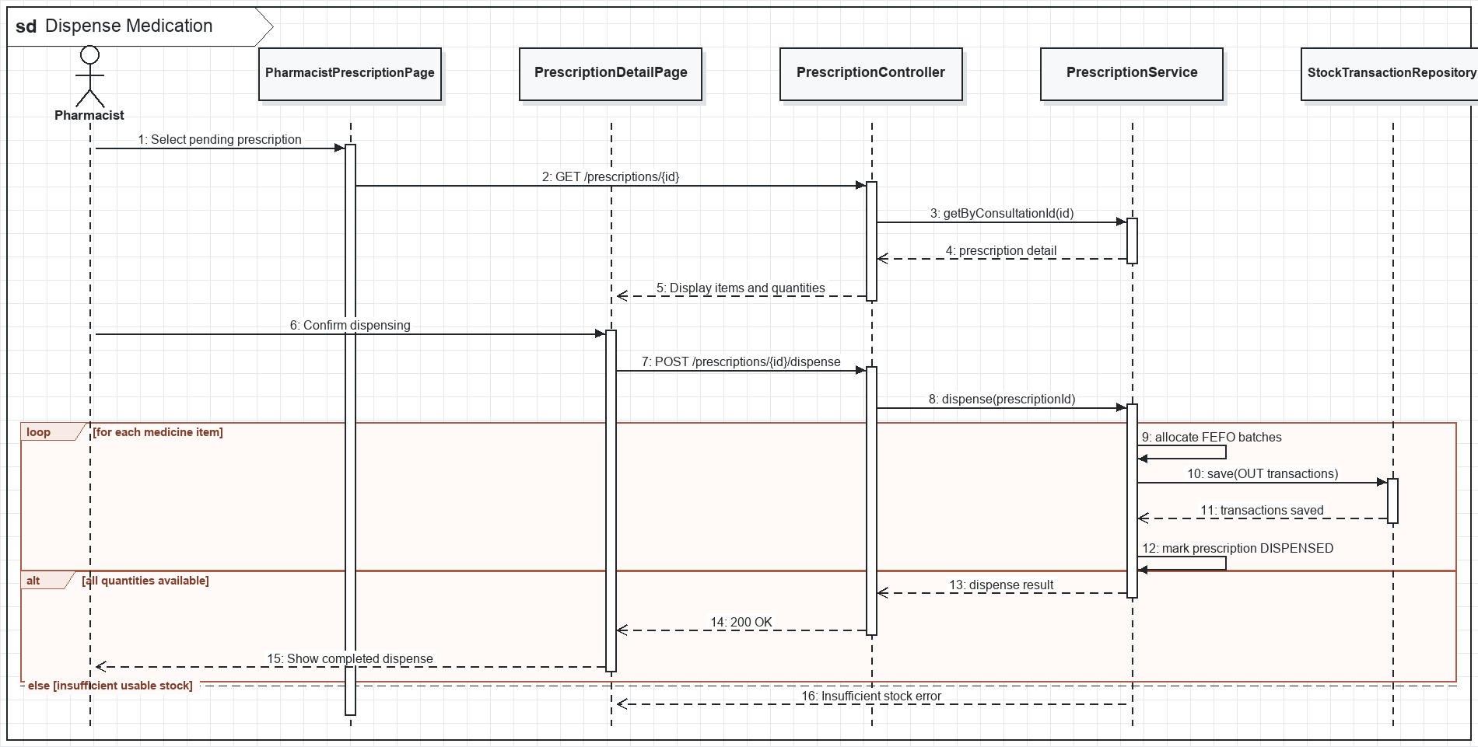
Figure II-24. Dispense Medication sequence

d. Database Queries
1. Repository operation
SELECT * FROM prescriptions WHERE prescription_id = ? FOR UPDATE;
2. Repository operation
SELECT * FROM medicine_batches WHERE medicine_id = ? AND current_quantity > 0 AND expiry_date >= CURRENT_DATE ORDER BY expiry_date ASC FOR UPDATE;
3. Repository operation
UPDATE medicine_batches SET current_quantity = ?, status = ? WHERE medicine_batch_id = ?;
4. Repository operation
INSERT INTO stock_transactions (medicine_id, batch_id, transaction_type, quantity, reference_type, reference_id, note, created_by) VALUES (?, ?, 'EXPORT', ?, 'PRESCRIPTION', ?, ?, ?);
5. Repository operation
UPDATE prescriptions SET status = 'DISPENSED', dispensed_at = CURRENT_TIMESTAMP WHERE prescription_id = ?;

4.2. Manage Medicine Inventory

a. Class Diagram
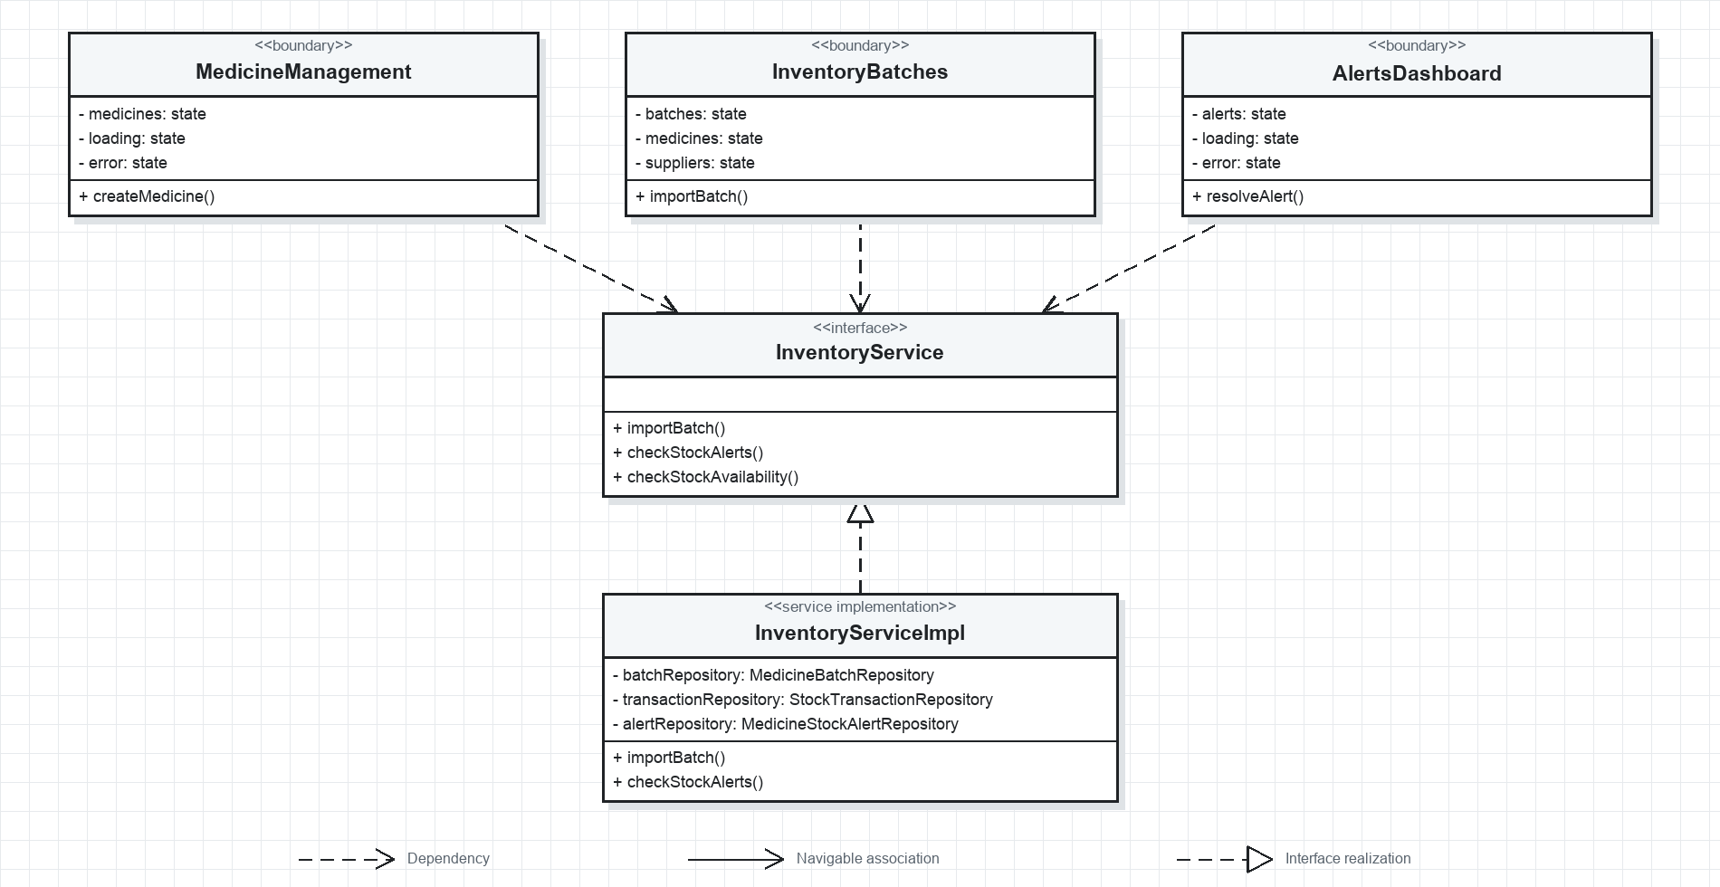
Figure II-25. Inventory Management UML class diagram

b. Class Specifications
No | Class / Method | Description
01 | MedicineManagement.createMedicine() | Maintains the medicine catalog independently from physical stock batches.
02 | InventoryBatches.importBatch() | Captures supplier, lot, quantity, cost, manufacture date, and expiry date.
03 | AlertsDashboard.resolveAlert() | Marks a stock alert handled by the authenticated pharmacist or administrator.
04 | InventoryService.importBatch() | Creates or updates stock and writes the matching IMPORT transaction.
05 | InventoryService.checkStockAlerts() | Creates low-stock, out-of-stock, and near-expiry alerts on demand or schedule.
06 | InventoryService.checkStockAvailability() | Rejects stock-consuming actions that exceed usable quantity.

c. Sequence Diagram(s)
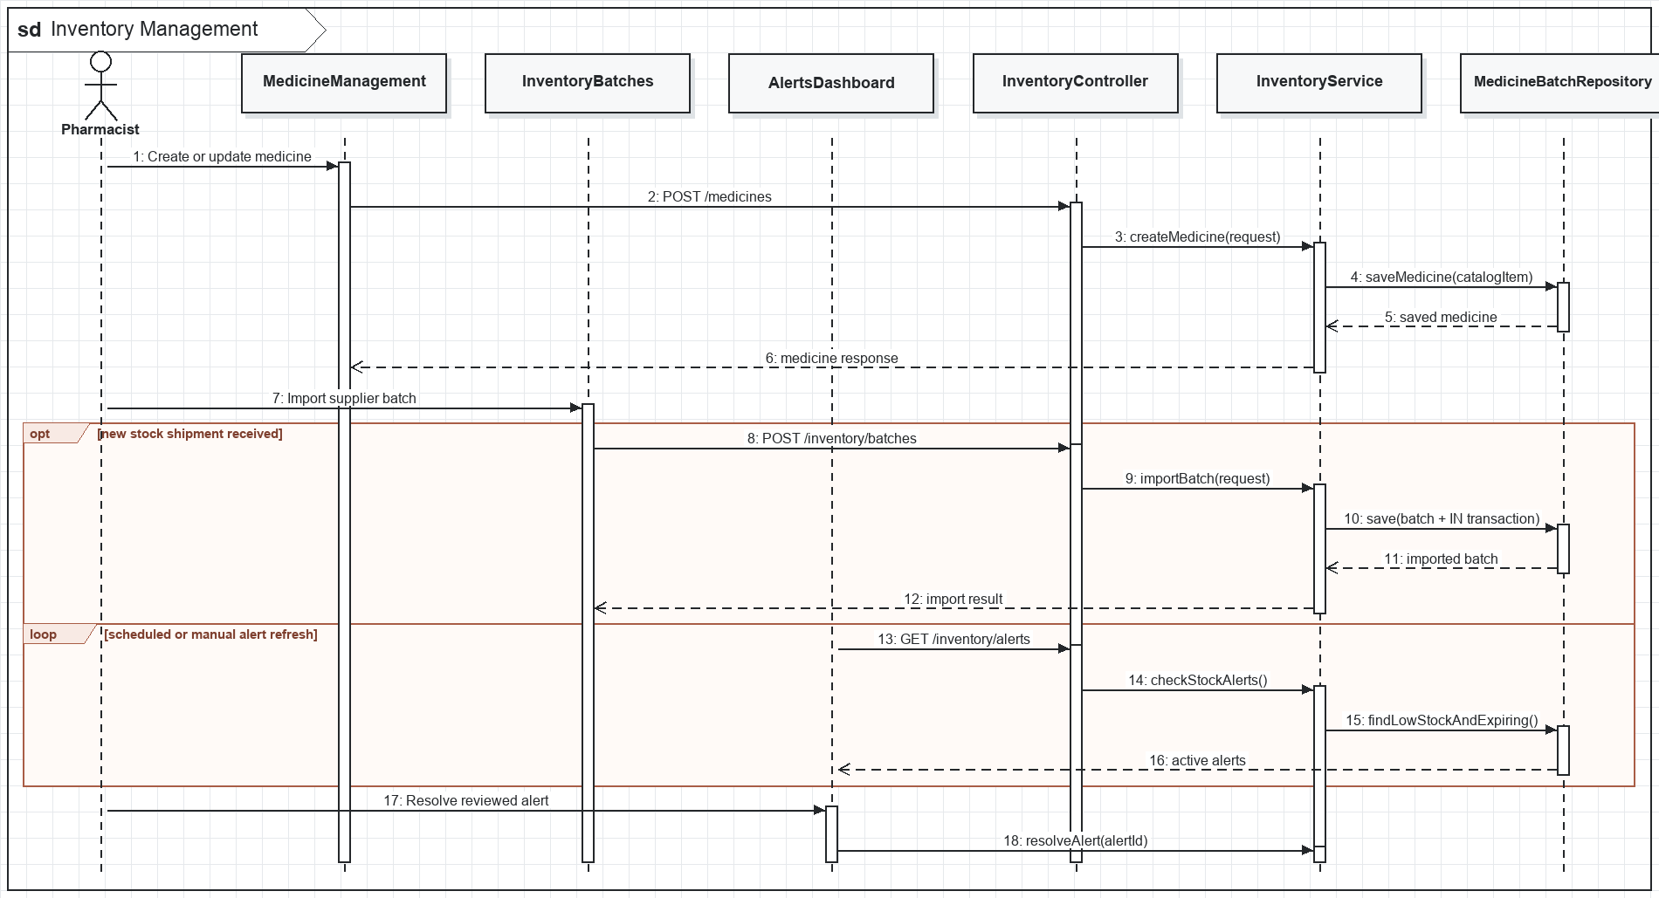
Figure II-26. Inventory Management sequence

d. Database Queries
1. Repository operation
INSERT INTO medicine_batches (medicine_id, supplier_id, batch_number, import_quantity, current_quantity, unit_cost, manufacture_date, expiry_date, imported_by, status) VALUES (?, ?, ?, ?, ?, ?, ?, ?, ?, 'AVAILABLE');
2. Repository operation
INSERT INTO stock_transactions (medicine_id, batch_id, transaction_type, quantity, reference_type, note, created_by) VALUES (?, ?, 'IMPORT', ?, 'PURCHASE', ?, ?);
3. Repository operation
SELECT * FROM medicine_stock_alerts WHERE resolved = FALSE ORDER BY created_at DESC;
4. Repository operation
INSERT INTO medicine_stock_alerts (medicine_id, batch_id, alert_type, message, created_at, resolved) VALUES (?, ?, ?, ?, CURRENT_TIMESTAMP, FALSE);
5. Repository operation
UPDATE medicine_stock_alerts SET resolved = TRUE, resolved_by = ?, resolved_at = CURRENT_TIMESTAMP WHERE alert_id = ?;

5. Billing and Administration

5.1. Generate Invoice and Process Payment

a. Class Diagram
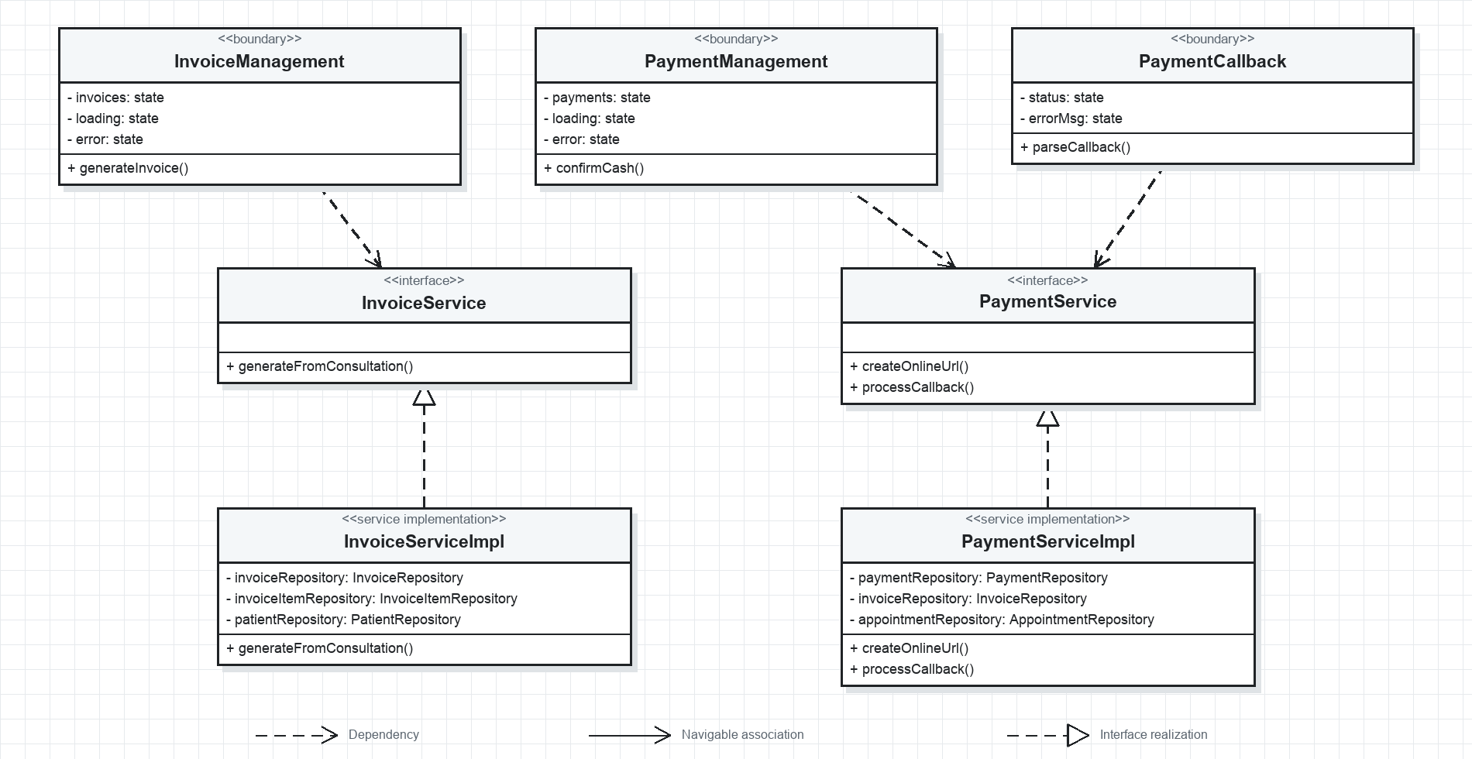
Figure II-27. Invoice and Payment UML class diagram

b. Class Specifications
No | Class / Method | Description
01 | InvoiceManagement.generateInvoice() | Builds invoice items from a completed consultation and related services.
02 | PaymentManagement.confirmCash() | Allows authorized staff to confirm a previously created cash payment.
03 | PaymentCallback.parseCallback() | Submits gateway callback parameters for server-side signature verification.
04 | InvoiceService.generateFromConsultation() | Creates an invoice linked to the appointment/patient and calculates totals.
05 | PaymentService.createOnlineUrl() | Persists a pending payment and returns the signed provider URL.
06 | PaymentService.processCallback() | Verifies callback integrity and atomically updates payment and invoice status.

c. Sequence Diagram(s)
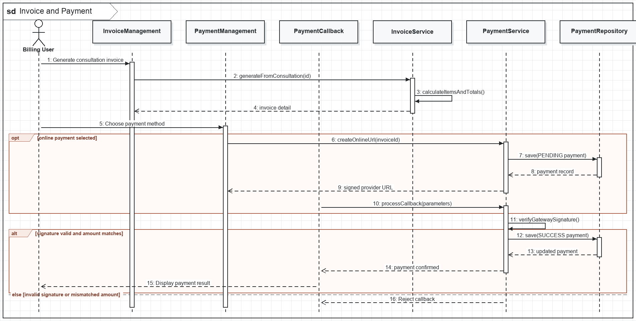
Figure II-28. Invoice and Payment sequence

d. Database Queries
1. Repository operation
INSERT INTO invoices (invoice_code, patient_id, appointment_id, subtotal, discount_amount, total_amount, status, created_by) VALUES (?, ?, ?, ?, ?, ?, 'UNPAID', ?);
2. Repository operation
INSERT INTO invoice_items (invoice_id, item_type, reference_id, description, quantity, unit_price, amount) VALUES (?, ?, ?, ?, ?, ?, ?);
3. Repository operation
INSERT INTO payments (invoice_id, appointment_id, payment_method, amount, transaction_code, status, paid_by) VALUES (?, ?, ?, ?, ?, 'PENDING', ?);
4. Repository operation
UPDATE payments SET status = ?, gateway_transaction_id = ?, paid_at = CURRENT_TIMESTAMP WHERE payment_id = ?;
5. Repository operation
UPDATE invoices SET status = 'PAID', paid_at = CURRENT_TIMESTAMP WHERE invoice_id = ?;

5.2. Request and Process Refund

a. Class Diagram
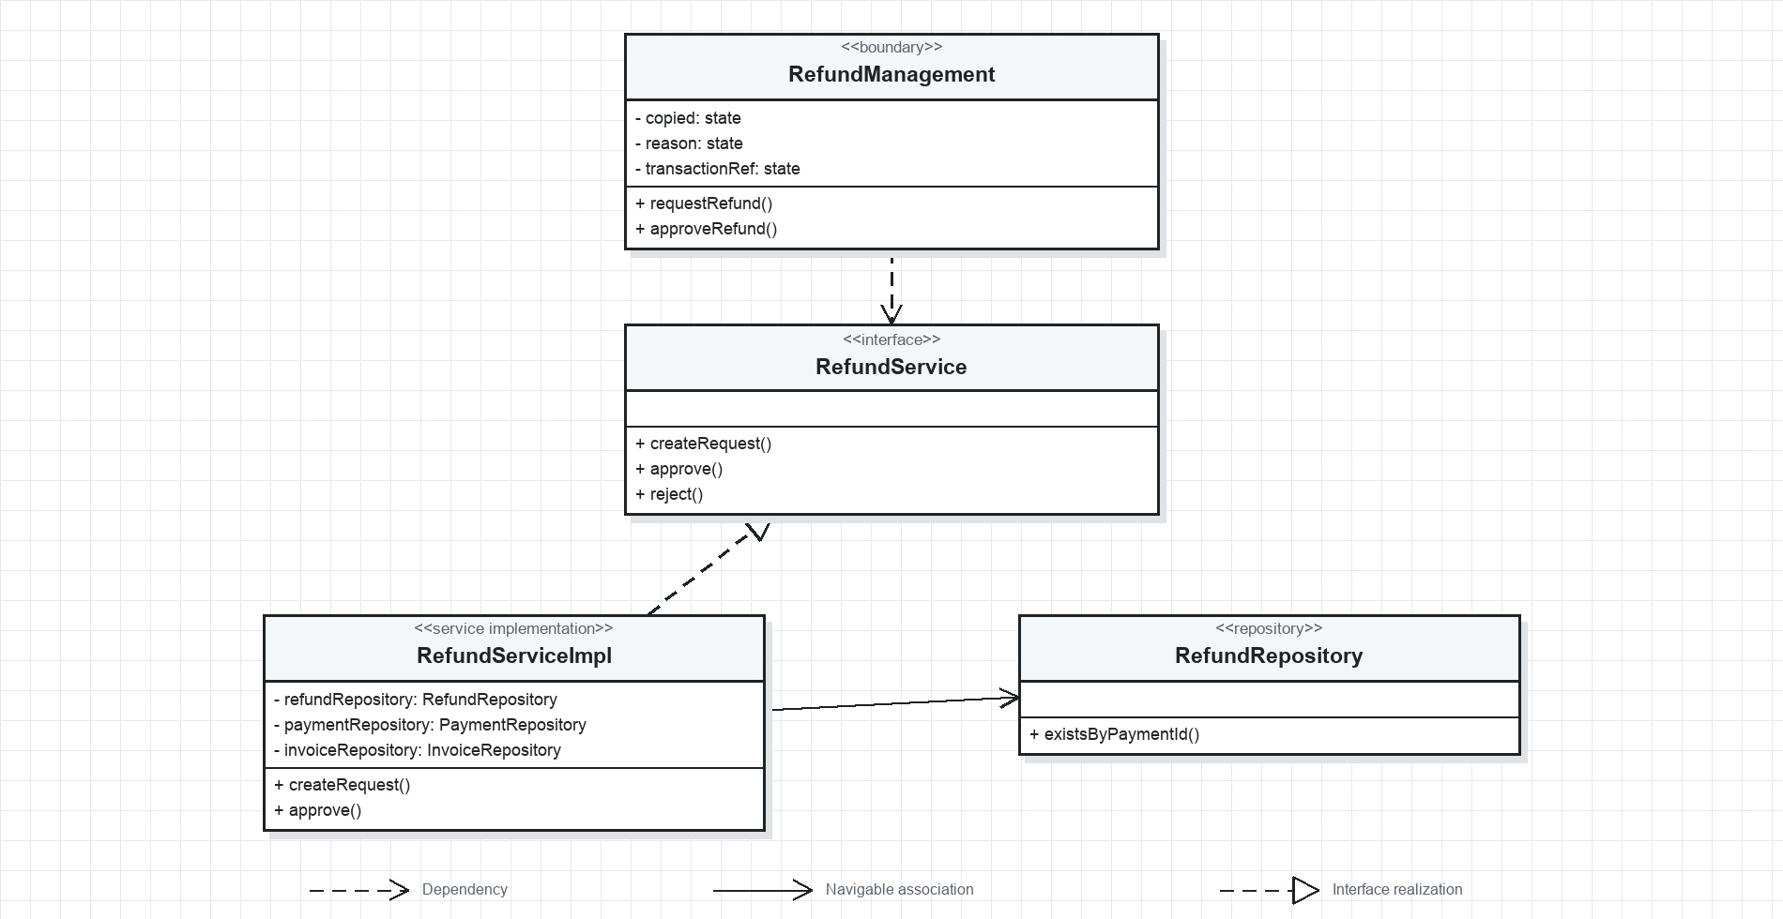
Figure II-29. Refund Processing UML class diagram

b. Class Specifications
No | Class / Method | Description
01 | RefundManagement.requestRefund() | Collects refund reason and requested amount for an eligible payment.
02 | RefundManagement.approveRefund() | Allows an administrator to approve a pending refund after review.
03 | RefundService.createRequest() | Checks payment ownership, paid state, uniqueness, and amount boundaries.
04 | RefundService.approve() | Records approving user, decision time, and approved amount.
05 | RefundService.reject() | Records a mandatory rejection reason without changing the payment.
06 | RefundRepository.existsByPaymentId() | Prevents duplicate active refunds for the same payment.

c. Sequence Diagram(s)
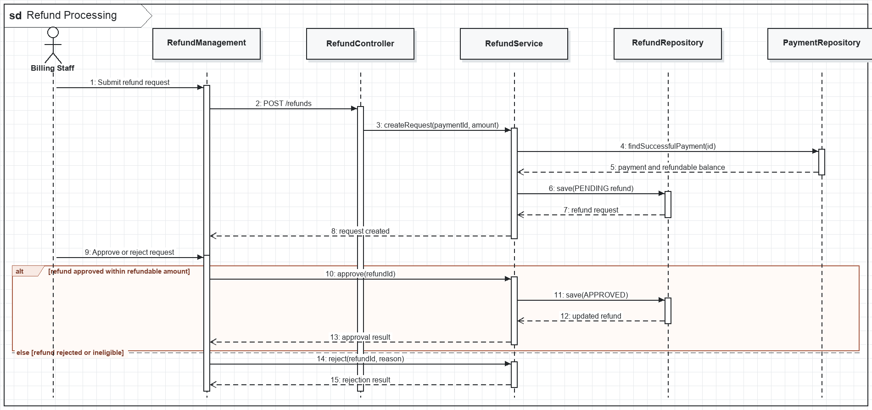
Figure II-30. Refund Processing sequence

d. Database Queries
1. Repository operation
SELECT * FROM payments WHERE payment_id = ? AND status = 'SUCCESS';
2. Repository operation
SELECT EXISTS (SELECT 1 FROM refunds WHERE payment_id = ? AND status IN ('REQUESTED', 'APPROVED', 'COMPLETED'));
3. Repository operation
INSERT INTO refunds (payment_id, requested_by, requested_amount, reason, status, requested_at) VALUES (?, ?, ?, ?, 'REQUESTED', CURRENT_TIMESTAMP);
4. Repository operation
UPDATE refunds SET status = 'APPROVED', approved_by = ?, approved_amount = ?, approved_at = CURRENT_TIMESTAMP WHERE refund_id = ?;
5. Repository operation
UPDATE payments SET status = 'REFUNDED' WHERE payment_id = ?;

5.3. Doctor Leave Request and Schedule Blocking

a. Class Diagram
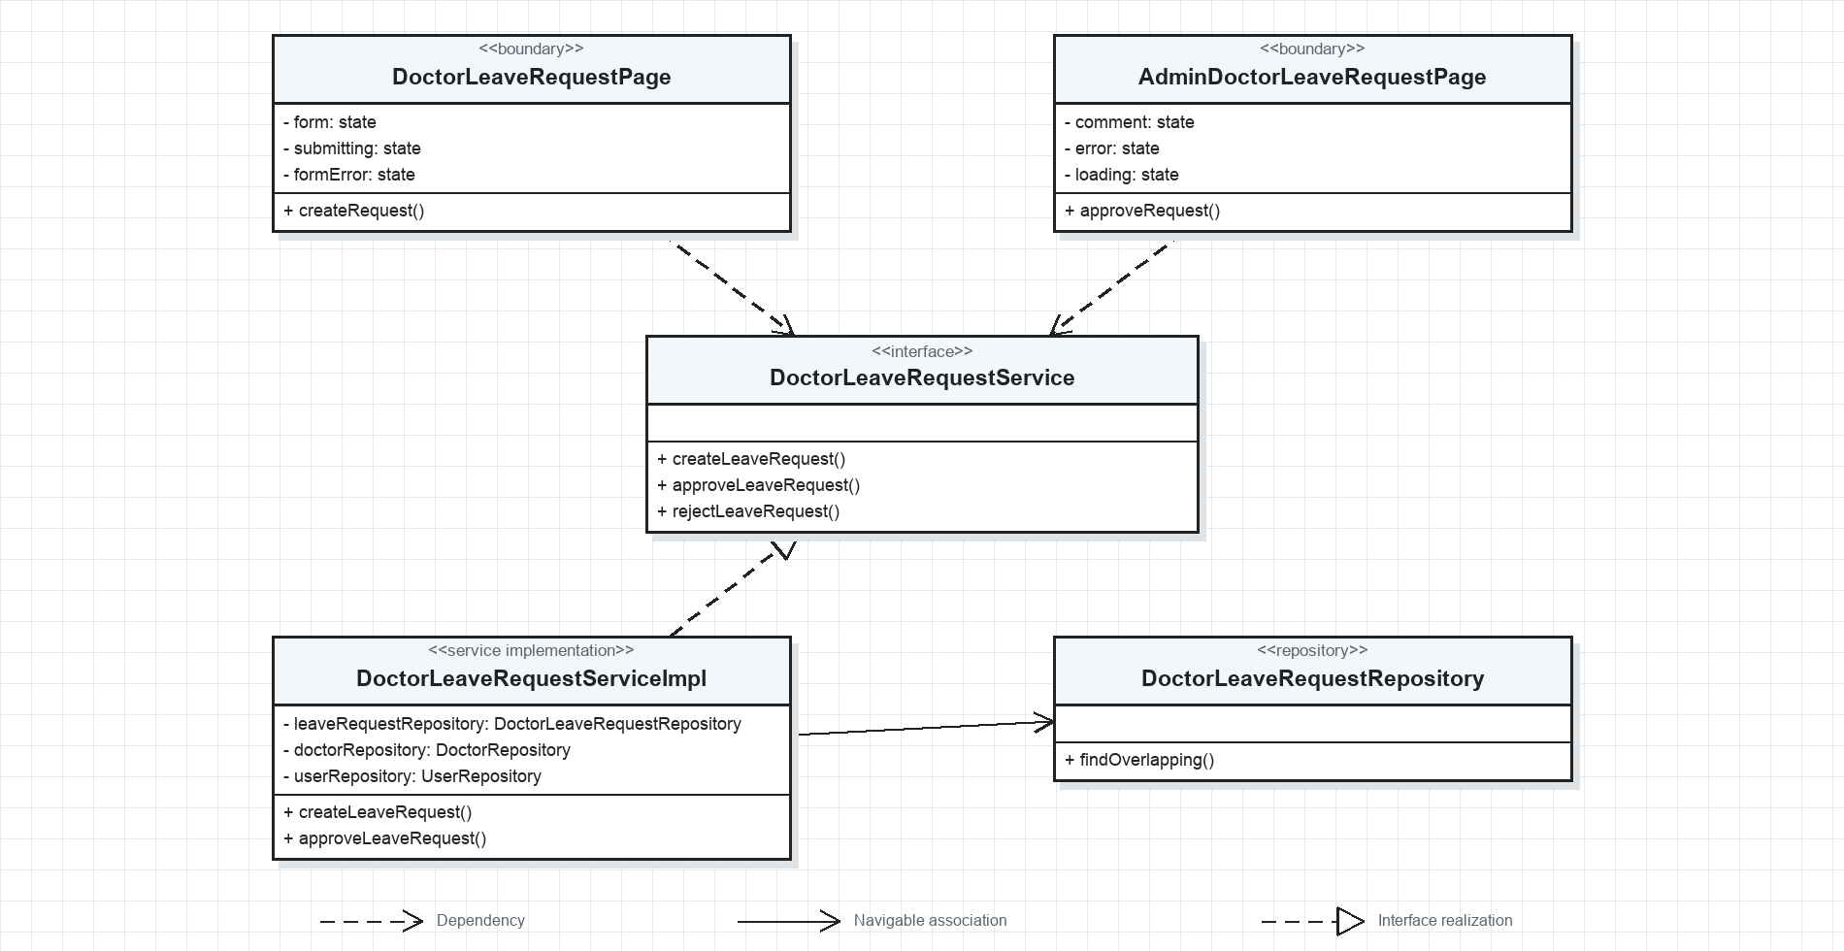
Figure II-31. Doctor Leave Approval UML class diagram

b. Class Specifications
No | Class / Method | Description
01 | DoctorLeaveRequestPage.createRequest() | Submits a non-overlapping leave date range owned by the current doctor.
02 | AdminDoctorLeaveRequestPage.approveRequest() | Approves a pending request after reviewing affected schedules.
03 | DoctorLeaveRequestService.createLeaveRequest() | Resolves the doctor identity and validates date and overlap rules.
04 | DoctorLeaveRequestService.approveLeaveRequest() | Records approval and blocks affected appointment slots according to schedule policy.
05 | DoctorLeaveRequestService.rejectLeaveRequest() | Records administrative rejection and reviewer note.
06 | DoctorLeaveRequestRepository.findOverlapping() | Detects conflicting leave requests for the same doctor.

c. Sequence Diagram(s)
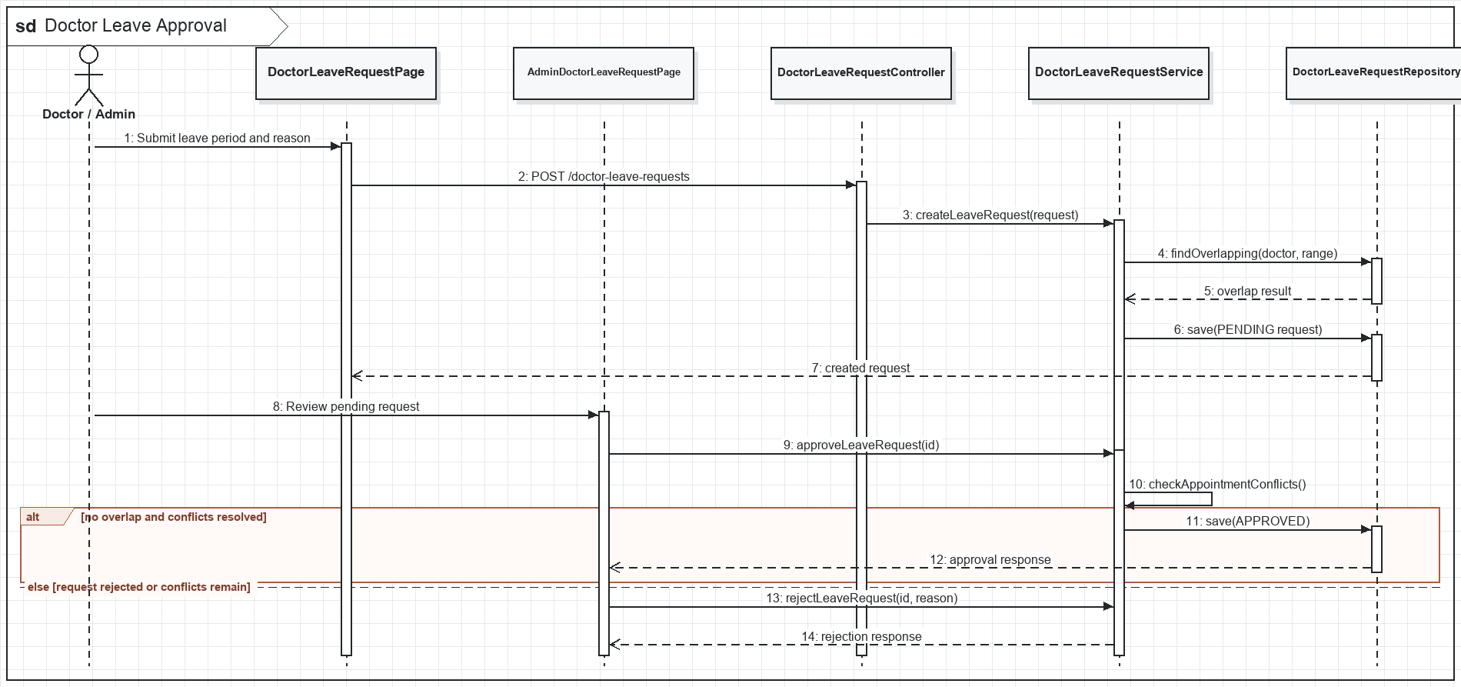
Figure II-32. Doctor Leave Approval sequence

d. Database Queries
1. Repository operation
SELECT EXISTS (SELECT 1 FROM doctor_leave_requests WHERE doctor_id = ? AND status IN ('PENDING', 'APPROVED') AND start_date <= ? AND end_date >= ?);
2. Repository operation
INSERT INTO doctor_leave_requests (doctor_id, start_date, end_date, reason, status, created_at) VALUES (?, ?, ?, ?, 'PENDING', CURRENT_TIMESTAMP);
3. Repository operation
UPDATE doctor_leave_requests SET status = 'APPROVED', approved_by = ?, reviewed_at = CURRENT_TIMESTAMP WHERE leave_request_id = ?;
4. Repository operation
UPDATE appointment_slots SET status = 'BLOCKED' WHERE schedule_id IN (SELECT schedule_id FROM doctor_schedules WHERE doctor_id = ? AND work_date BETWEEN ? AND ?) AND status = 'AVAILABLE';

5.4. User, Security and System Settings Administration

a. Class Diagram
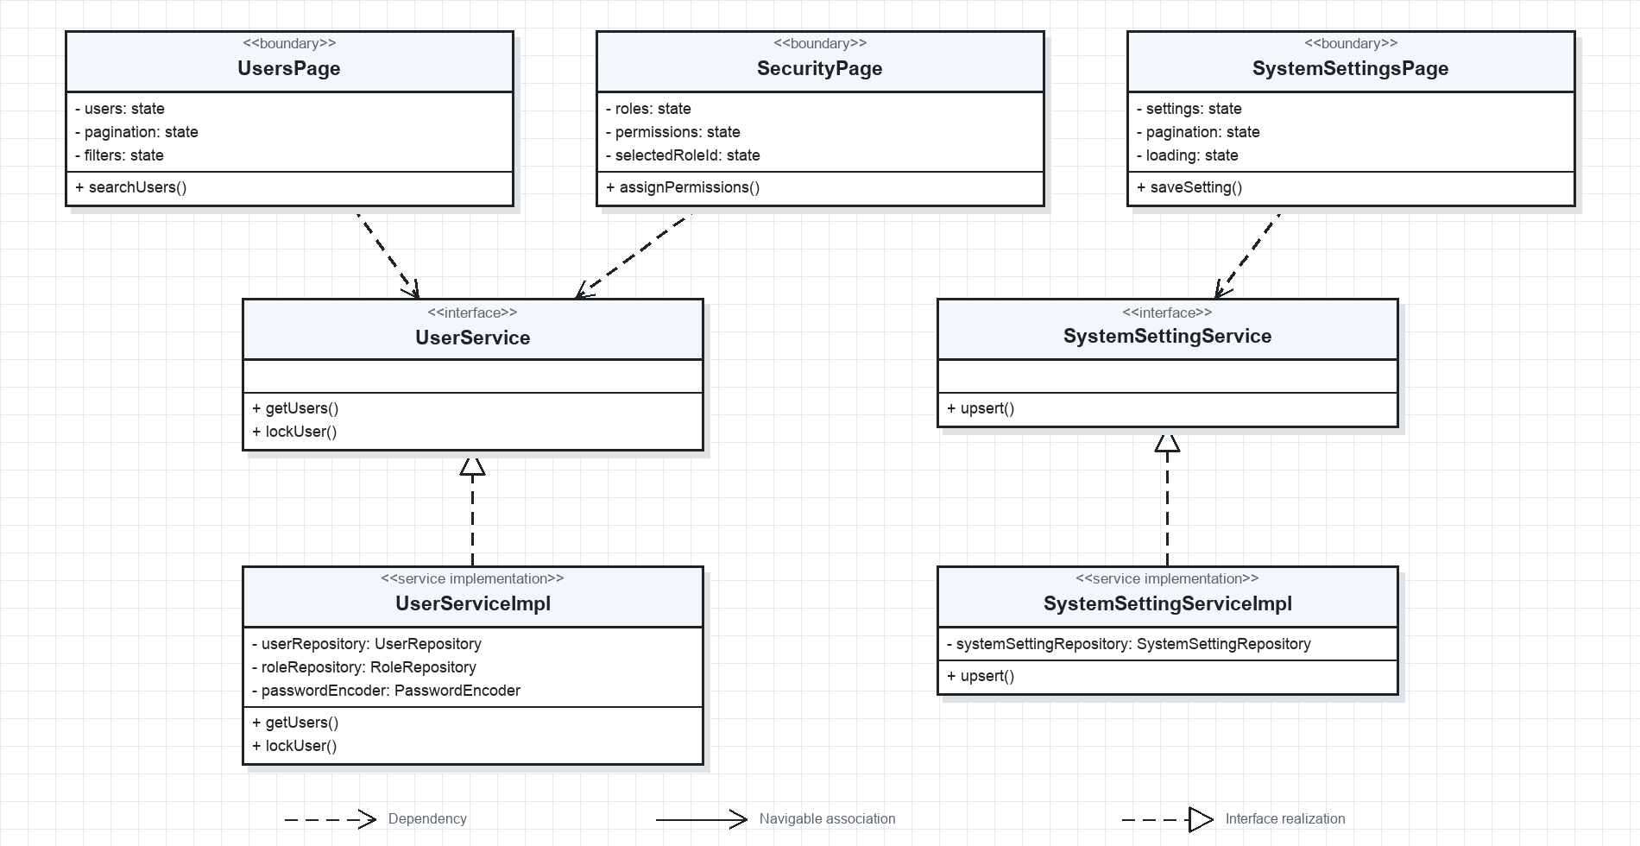
Figure II-33. System Administration UML class diagram

b. Class Specifications
No | Class / Method | Description
01 | UsersPage.searchUsers() | Filters accounts by keyword, status, and role with pagination.
02 | SecurityPage.assignPermissions() | Maintains role-permission mappings under administrator authorization.
03 | SystemSettingsPage.saveSetting() | Creates or updates a typed system setting by key.
04 | UserService.getUsers() | Returns pageable user summaries for administrative scanning.
05 | UserService.lockUser() | Prevents future authentication without deleting history.
06 | SystemSettingService.upsert() | Creates or updates a setting while preserving key uniqueness.

c. Sequence Diagram(s)
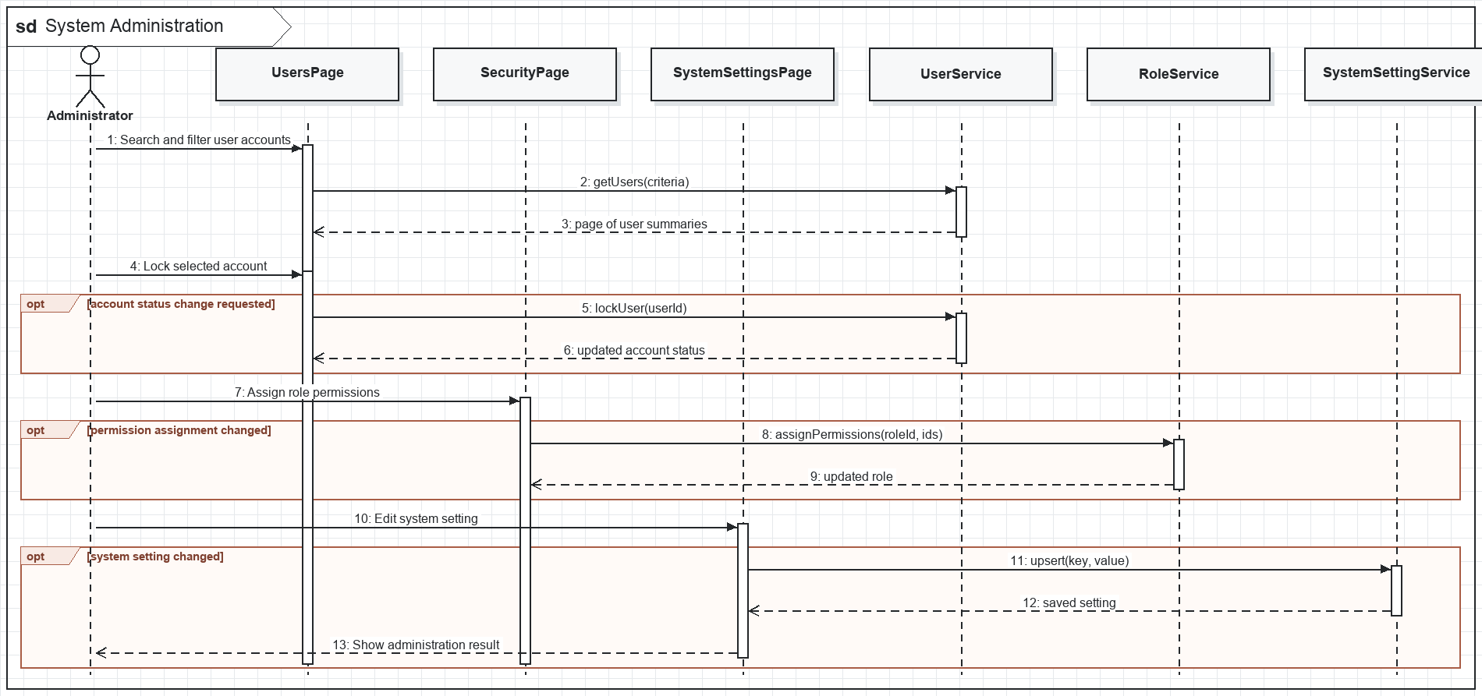
Figure II-34. System Administration sequence

d. Database Queries
1. Repository operation
SELECT u.* FROM users u WHERE (? IS NULL OR LOWER(u.full_name) LIKE LOWER(CONCAT('%', ?, '%'))) AND (? IS NULL OR u.status = ?);
2. Repository operation
SELECT p.permission_code FROM permissions p JOIN role_permissions rp ON rp.permission_id = p.permission_id WHERE rp.role_id = ?;
3. Repository operation
INSERT INTO role_permissions (role_id, permission_id) VALUES (?, ?) ON CONFLICT DO NOTHING;
4. Repository operation
INSERT INTO system_settings (setting_key, setting_value, description, updated_at) VALUES (?, ?, ?, CURRENT_TIMESTAMP) ON CONFLICT (setting_key) DO UPDATE SET setting_value = EXCLUDED.setting_value, description = EXCLUDED.description, updated_at = CURRENT_TIMESTAMP;

6. Notifications, Reporting and Audit

6.1. Notification Center

a. Class Diagram
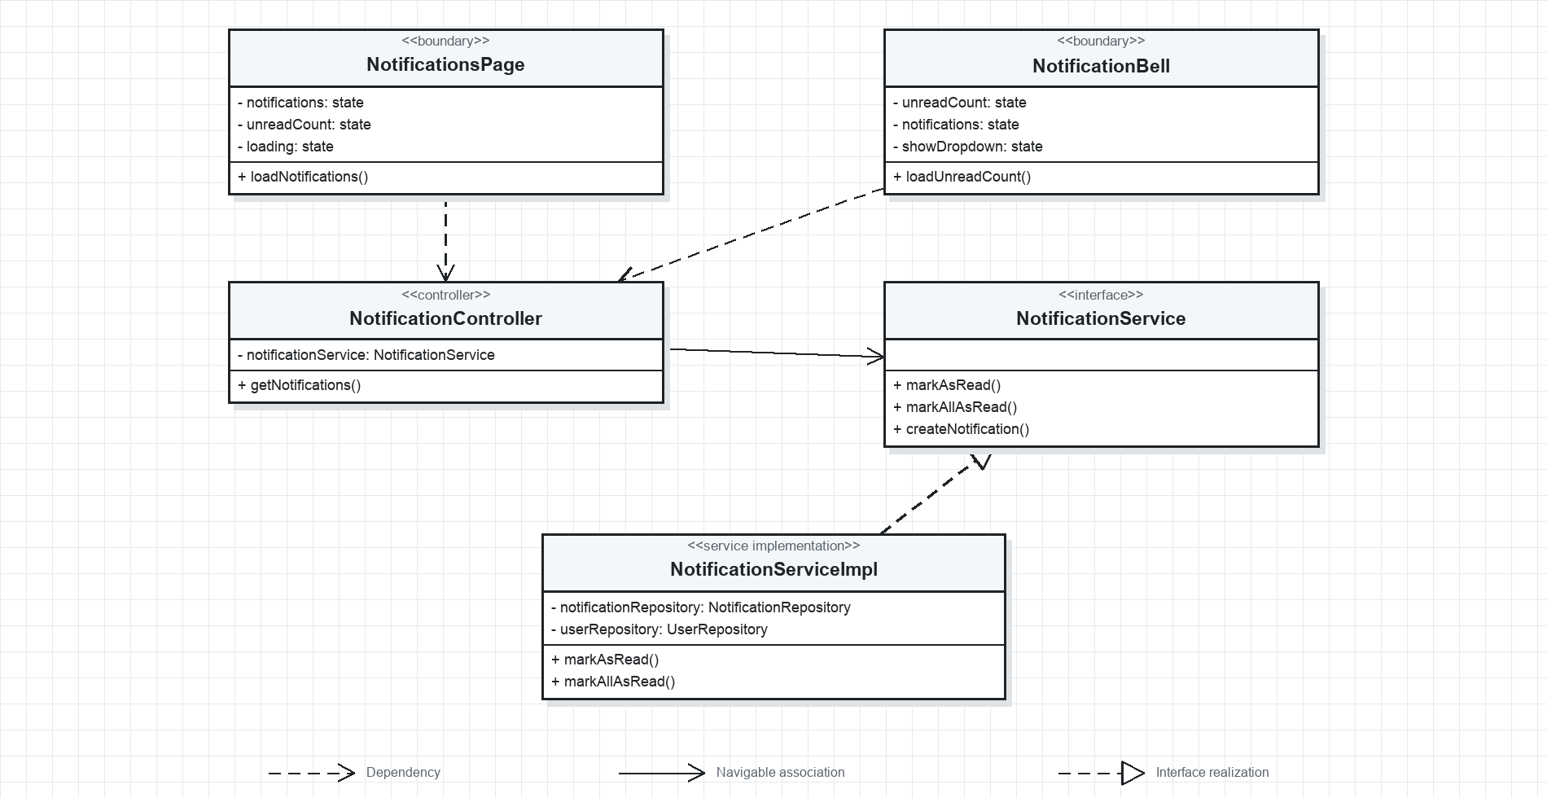
Figure II-35. Notification Center UML class diagram

b. Class Specifications
No | Class / Method | Description
01 | NotificationsPage.loadNotifications() | Loads paginated notifications owned by the authenticated user.
02 | NotificationBell.loadUnreadCount() | Displays a compact unread count in the shared dashboard header.
03 | NotificationController.getNotifications() | Enforces authentication and delegates the user-scoped query.
04 | NotificationService.markAsRead() | Verifies ownership before changing one notification.
05 | NotificationService.markAllAsRead() | Marks every unread notification owned by the current user.
06 | NotificationService.createNotification() | Creates domain notifications for appointment, lab, payment, leave, and stock events.

c. Sequence Diagram(s)
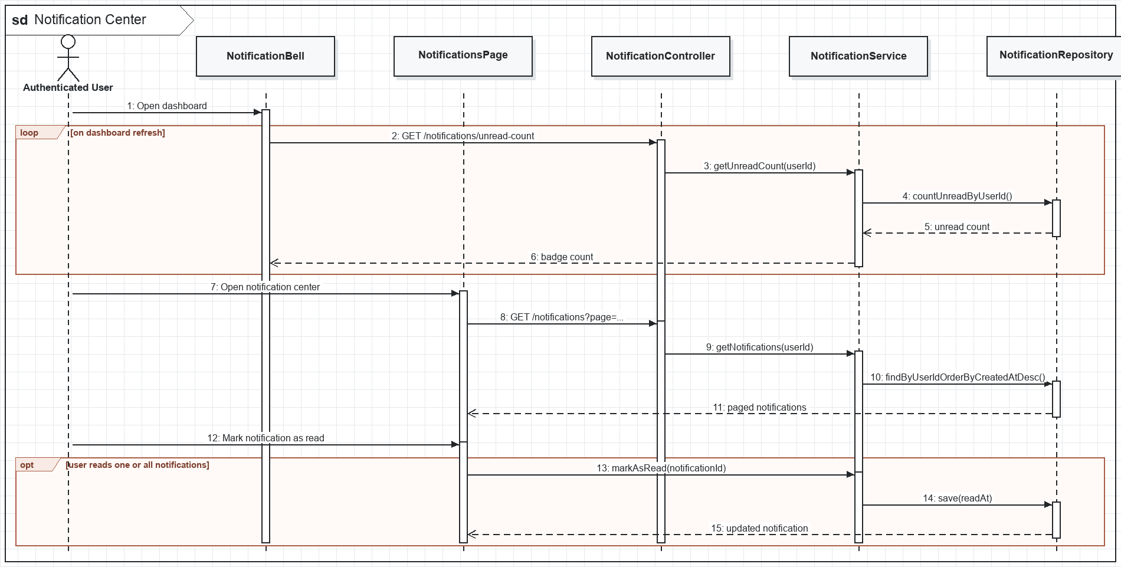
Figure II-36. Notification Center sequence

d. Database Queries
1. Repository operation
SELECT * FROM notifications WHERE user_id = ? ORDER BY created_at DESC LIMIT ? OFFSET ?;
2. Repository operation
SELECT COUNT(*) FROM notifications WHERE user_id = ? AND is_read = FALSE;
3. Repository operation
UPDATE notifications SET is_read = TRUE, read_at = CURRENT_TIMESTAMP WHERE notification_id = ? AND user_id = ?;
4. Repository operation
UPDATE notifications SET is_read = TRUE, read_at = CURRENT_TIMESTAMP WHERE user_id = ? AND is_read = FALSE;

6.2. Reports and Audit Logs

a. Class Diagram
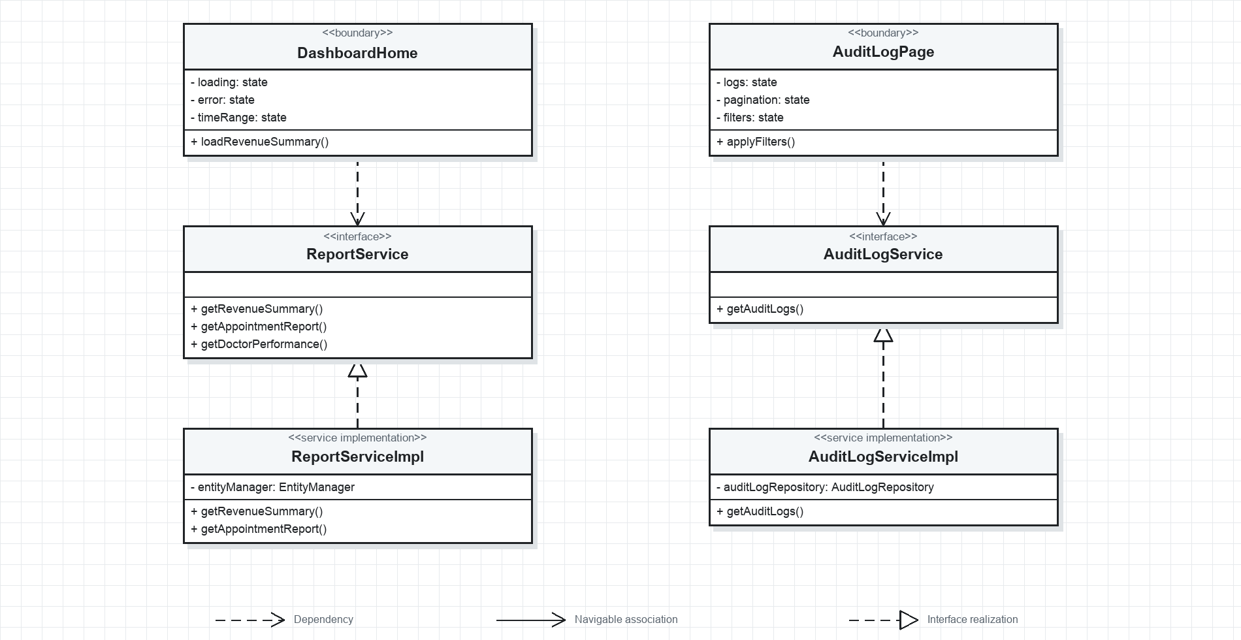
Figure II-37. Reports and Audit Logs UML class diagram

b. Class Specifications
No | Class / Method | Description
01 | DashboardHome.loadRevenueSummary() | Loads aggregate paid revenue for the selected period.
02 | AuditLogPage.applyFilters() | Filters immutable audit events by actor, action, and affected table.
03 | ReportService.getRevenueSummary() | Aggregates successful payments and invoice totals by period.
04 | ReportService.getAppointmentReport() | Summarizes appointment counts and statuses by date.
05 | ReportService.getDoctorPerformance() | Calculates consultation and completion measures per doctor.
06 | AuditLogService.getAuditLogs() | Returns pageable audit evidence without mutation operations.

c. Sequence Diagram(s)
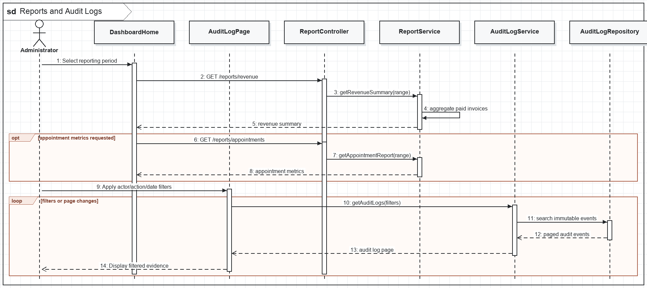
Figure II-38. Reports and Audit Logs sequence

d. Database Queries
1. Repository operation
SELECT DATE(p.paid_at) AS report_date, SUM(p.amount) AS revenue FROM payments p WHERE p.status = 'SUCCESS' AND p.paid_at BETWEEN ? AND ? GROUP BY DATE(p.paid_at) ORDER BY report_date;
2. Repository operation
SELECT status, COUNT(*) FROM appointments WHERE appointment_date BETWEEN ? AND ? GROUP BY status;
3. Repository operation
SELECT doctor_id, COUNT(*) AS completed_consultations FROM consultation_sessions WHERE status = 'COMPLETED' AND started_at BETWEEN ? AND ? GROUP BY doctor_id;
4. Repository operation
SELECT * FROM audit_logs WHERE (? IS NULL OR user_id = ?) AND (? IS NULL OR action = ?) AND (? IS NULL OR table_name = ?) ORDER BY created_at DESC;

III. Design Considerations

1. Technology Stack
No | Area | Design
1 | Frontend | React 19, React Router 7, Vite 8, Axios, Tailwind CSS 4, Base UI, Lucide, Recharts
2 | Backend | Java 21, Spring Boot 3.5, Spring Web, Spring Security, Validation, Mail, WebSocket
3 | Persistence | Spring Data JPA with PostgreSQL; H2 is available for runtime/test profiles
4 | Authentication | JWT access/refresh tokens, password hashing, Google identity validation, role-based authorization
5 | AI integration | Configurable Gemini or Groq provider with primary/fallback models and safe mock fallback
6 | Realtime | STOMP over WebSocket/SockJS for operational updates where enabled

2. Security and Error Handling
Authentication. Protected endpoints require a Bearer JWT. Refresh tokens use a separate expiration path, and Google identity data is verified server-side.
Authorization. Spring Security method rules restrict each controller operation to the intended role set. Frontend protected routes improve navigation but are not the authorization boundary.
Medical safety. AI output is advisory, must not be treated as a final diagnosis, and is bounded to active clinic departments. Final diagnosis and prescription remain doctor-owned actions.
Data integrity. Appointment slot changes, dispensing, payment callbacks, and laboratory completion run transactionally to prevent partial workflow state.
Validation. Request DTOs apply Jakarta validation; services enforce ownership, status-transition, date, stock, duplicate, and clinical safety rules.
Error model. ResourceNotFoundException maps to 404, authorization failures to 401/403, business-rule violations to 400/409, and unexpected failures to a sanitized 500 response.
Auditability. Administrative and sensitive business actions are represented in audit logs and immutable history or ledger tables where required.

3. Traceability and Constraints
No | Requirement | Design Section | Concrete Pages
1 | UC-01 to UC-04 | Authentication and Account Management | RegisterPage, LoginPage, ForgotPasswordPage, ChangePasswordPage, ProfilePage, UsersPage
2 | UC-05 to UC-09 | Appointment Booking and Queue Management | AiChatPatient, AvailableSlots, WalkInAppointmentPage, QueueManagementPage, PatientQueueStatusPage
3 | UC-10 to UC-13 | Consultation and Diagnostics | ConsultationPage, ExaminationPage, LabRequestPage, PatientLabResultPage, PrescriptionDetailPage
4 | UC-14 to UC-15 | Pharmacy and Inventory | PharmacistPrescriptionPage, MedicineManagement, InventoryBatches, AlertsDashboard
5 | UC-16 to UC-17 | Billing and Administration | InvoiceManagement, PaymentManagement, PaymentCallback, RefundManagement, DoctorLeaveRequestPage
6 | Cross-cutting | Notification, reporting, and audit | NotificationsPage, DashboardHome, AuditLogPage, SystemSettingsPage

Known constraint: the schema file contains a repeated notifications table declaration near its end. The implemented JPA model and the first complete notifications definition are treated as authoritative; database migration review should remove or reconcile the duplicate declaration before clean-schema provisioning.

IV. Additional Use Case Designs
This section completes the design coverage for project modules that are implemented in the application but are not represented by the nineteen core workflows in Section II. Each use case identifies concrete frontend pages, backend components, UML relationships, detailed interactions, and the primary persistence operations.

1. Master Data Administration

1.1. Patient and Doctor Management

a. Class Diagram
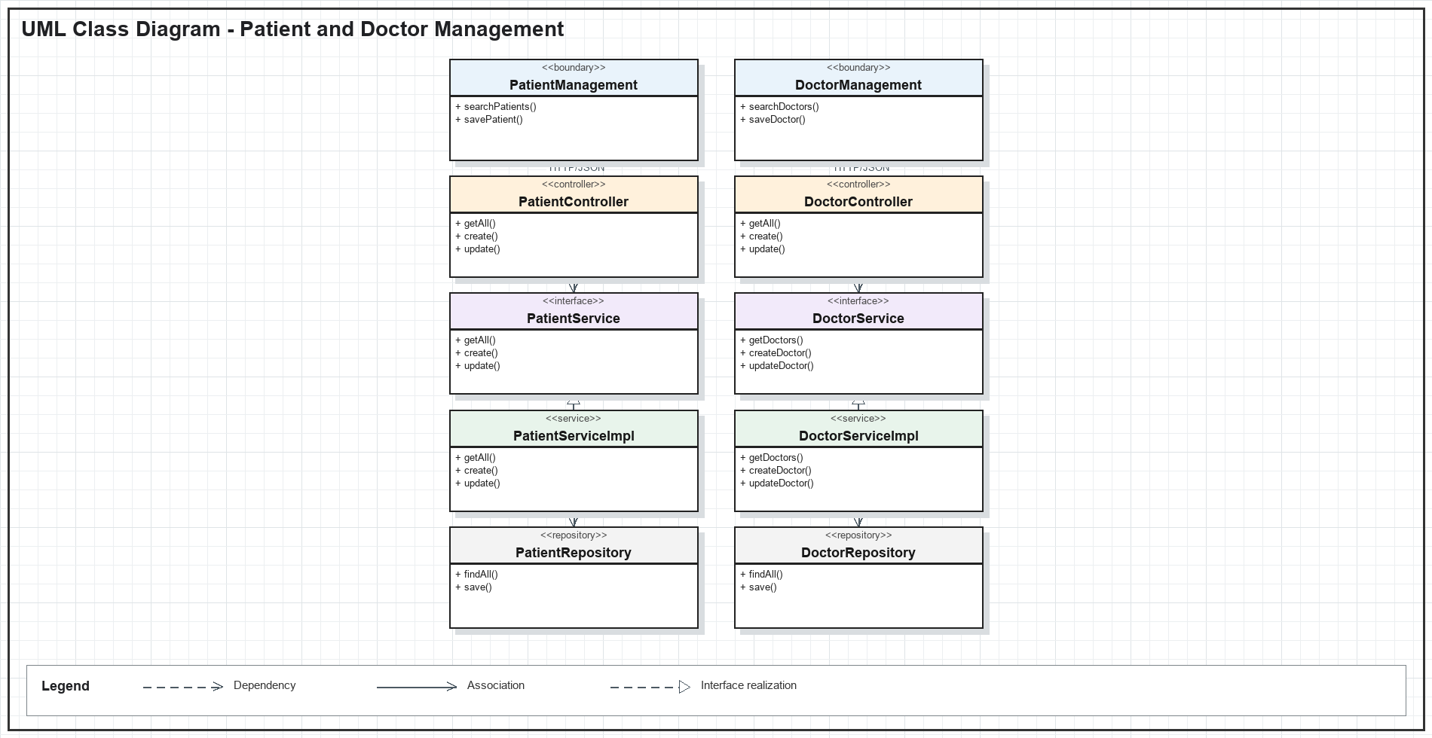
Figure IV-1. Patient and Doctor Management UML class diagram

b. Class Specifications
Class | Method | Description
PatientManagement | searchPatients() | Loads a pageable patient list using the entered keyword.
DoctorManagement | saveDoctor() | Creates or updates a doctor profile from the administration form.
PatientController | create() | Validates and exposes the patient creation endpoint.
DoctorController | update() | Accepts an authorized doctor profile update.
PatientService | getAll() | Defines patient search and pagination behavior.
DoctorService | getDoctors() | Defines doctor filtering by department, status, and keyword.

c. Sequence Diagram
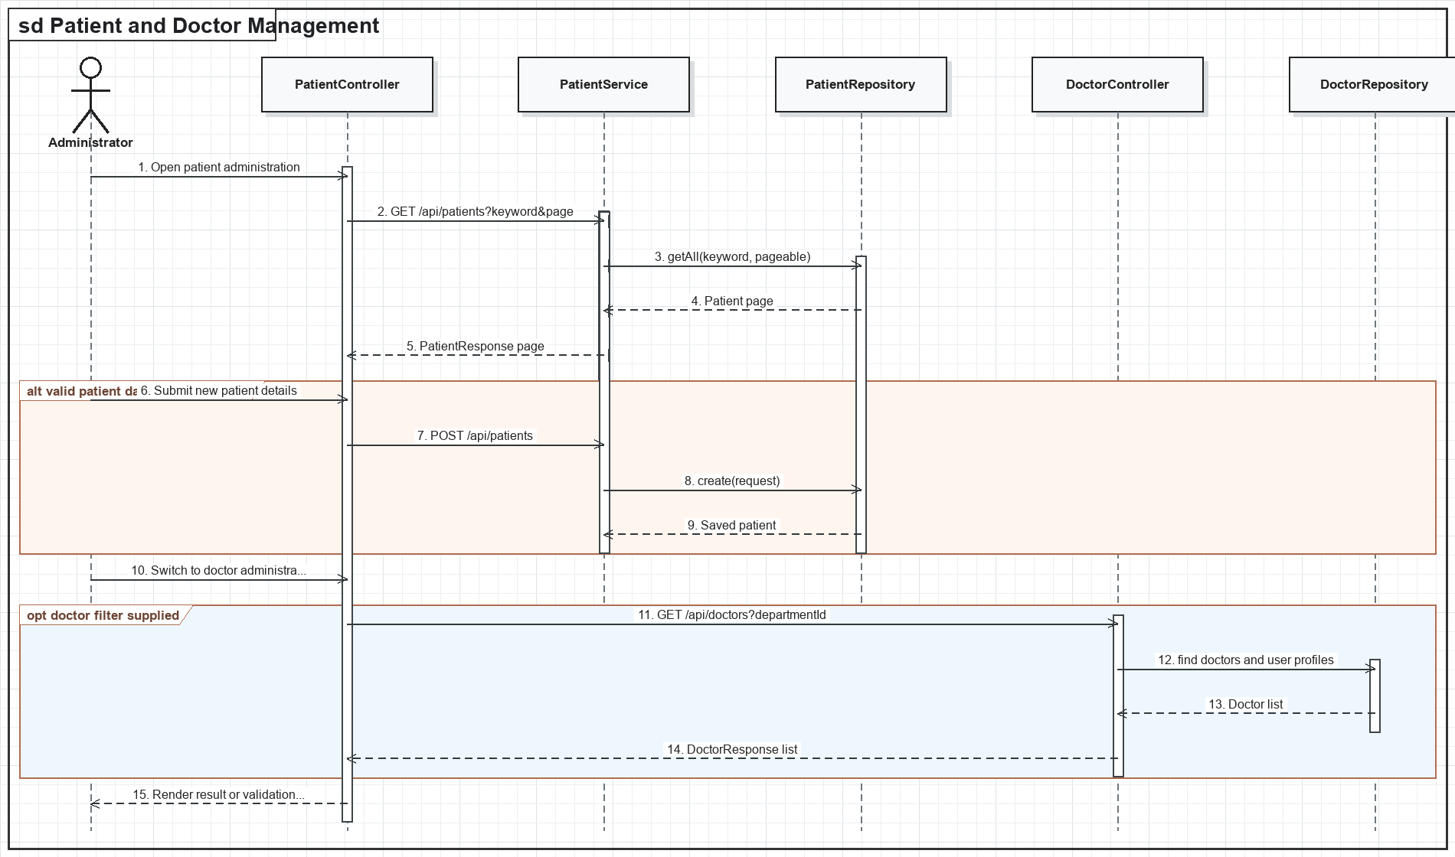
Figure IV-2. Patient and Doctor Management sequence diagram

d. Database Queries
Search patients
SELECT * FROM patients WHERE LOWER(full_name) LIKE LOWER(:keyword) ORDER BY created_at DESC;
Create patient
INSERT INTO patients (patient_code, full_name, phone, email, created_by) VALUES (:code, :name, :phone, :email, :userId);
Filter doctors
SELECT d.* FROM doctors d WHERE (:departmentId IS NULL OR d.department_id = :departmentId) AND d.status = :status;
Update doctor
UPDATE doctors SET department_id = :departmentId, specialization = :specialization, status = :status, updated_at = CURRENT_TIMESTAMP WHERE doctor_id = :doctorId;

1.2. Department and Medical Service Management

a. Class Diagram
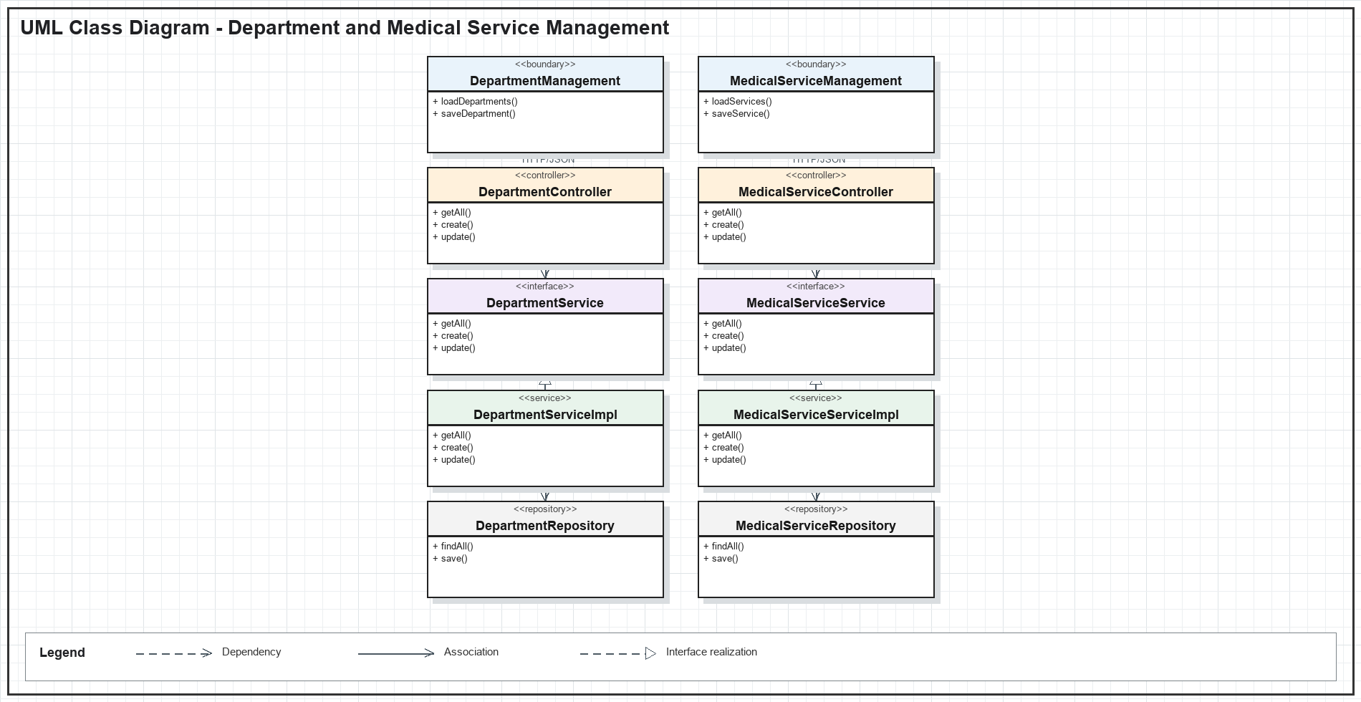
Figure IV-3. Department and Medical Service Management UML class diagram

b. Class Specifications
Class | Method | Description
DepartmentManagement | loadDepartments() | Loads active and inactive departments for administration.
MedicalServiceManagement | saveService() | Submits medical service code, type, price, and status.
DepartmentController | create() | Creates a department after authorization and validation.
MedicalServiceController | update() | Updates an existing medical service catalog entry.
DepartmentService | getAllActive() | Returns departments available to operational workflows.
MedicalServiceService | getAll() | Returns pageable or filtered medical services.

c. Sequence Diagram
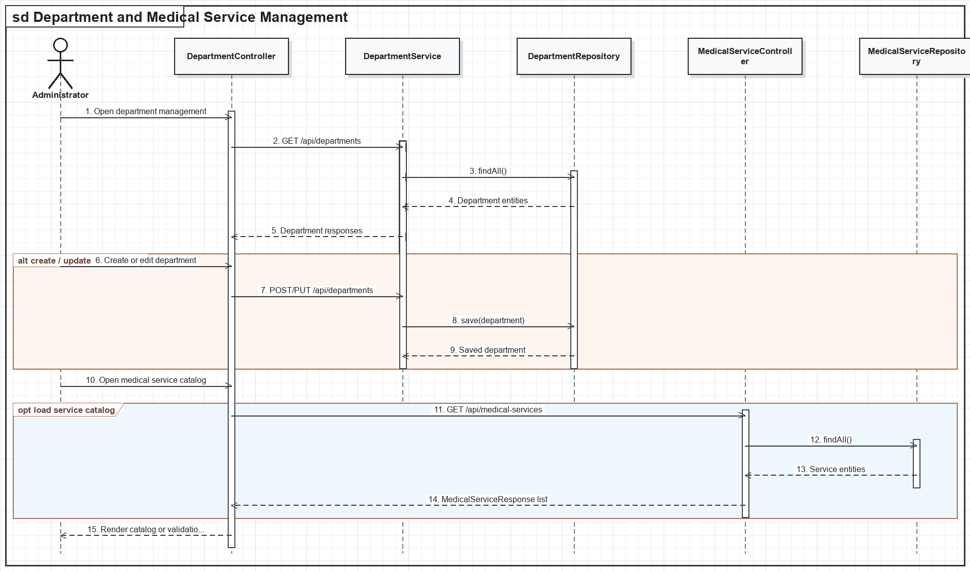
Figure IV-4. Department and Medical Service Management sequence diagram

d. Database Queries
List departments
SELECT * FROM departments ORDER BY department_name;
Create department
INSERT INTO departments (department_name, description, status) VALUES (:name, :description, :status);
List medical services
SELECT * FROM medical_services WHERE (:status IS NULL OR status = :status) ORDER BY service_name;
Update service
UPDATE medical_services SET service_name = :name, service_type = :type, price = :price, status = :status WHERE service_id = :serviceId;

1.3. Doctor Schedule and Slot Management

a. Class Diagram
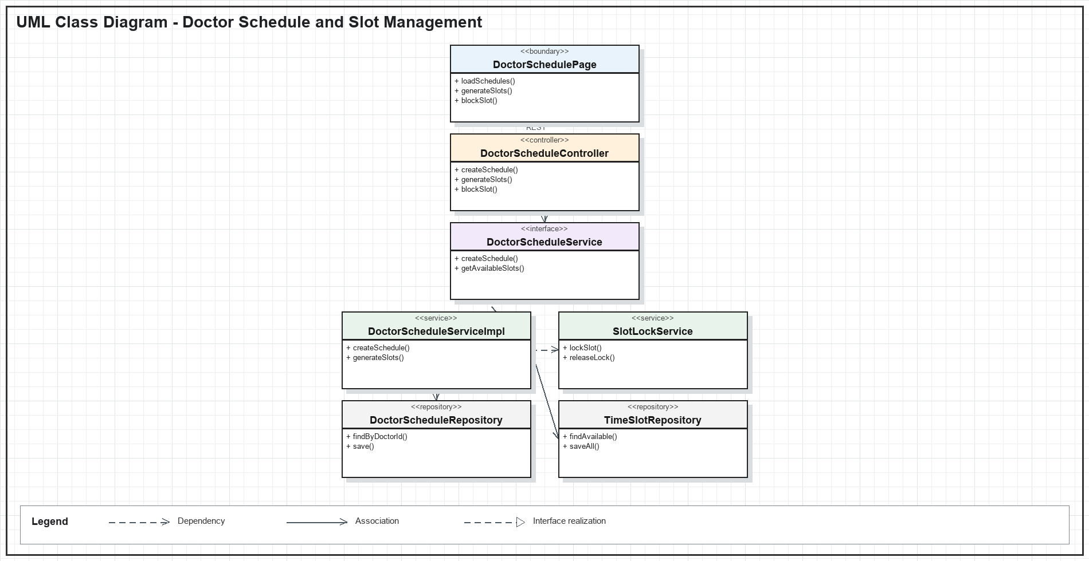
Figure IV-5. Doctor Schedule and Slot Management UML class diagram

b. Class Specifications
Class | Method | Description
DoctorSchedulePage | loadSchedules() | Loads schedules and generated slots for the selected doctor and date.
DoctorScheduleController | createSchedule() | Creates a validated working interval for a doctor.
DoctorScheduleController | blockSlot() | Blocks an unavailable slot from patient booking.
DoctorScheduleService | getAvailableSlots() | Returns bookable slots after lock and status checks.
SlotLockService | lockSlot() | Temporarily reserves a slot during an appointment transaction.
TimeSlotRepository | saveAll() | Persists generated appointment slots in one operation.

c. Sequence Diagram
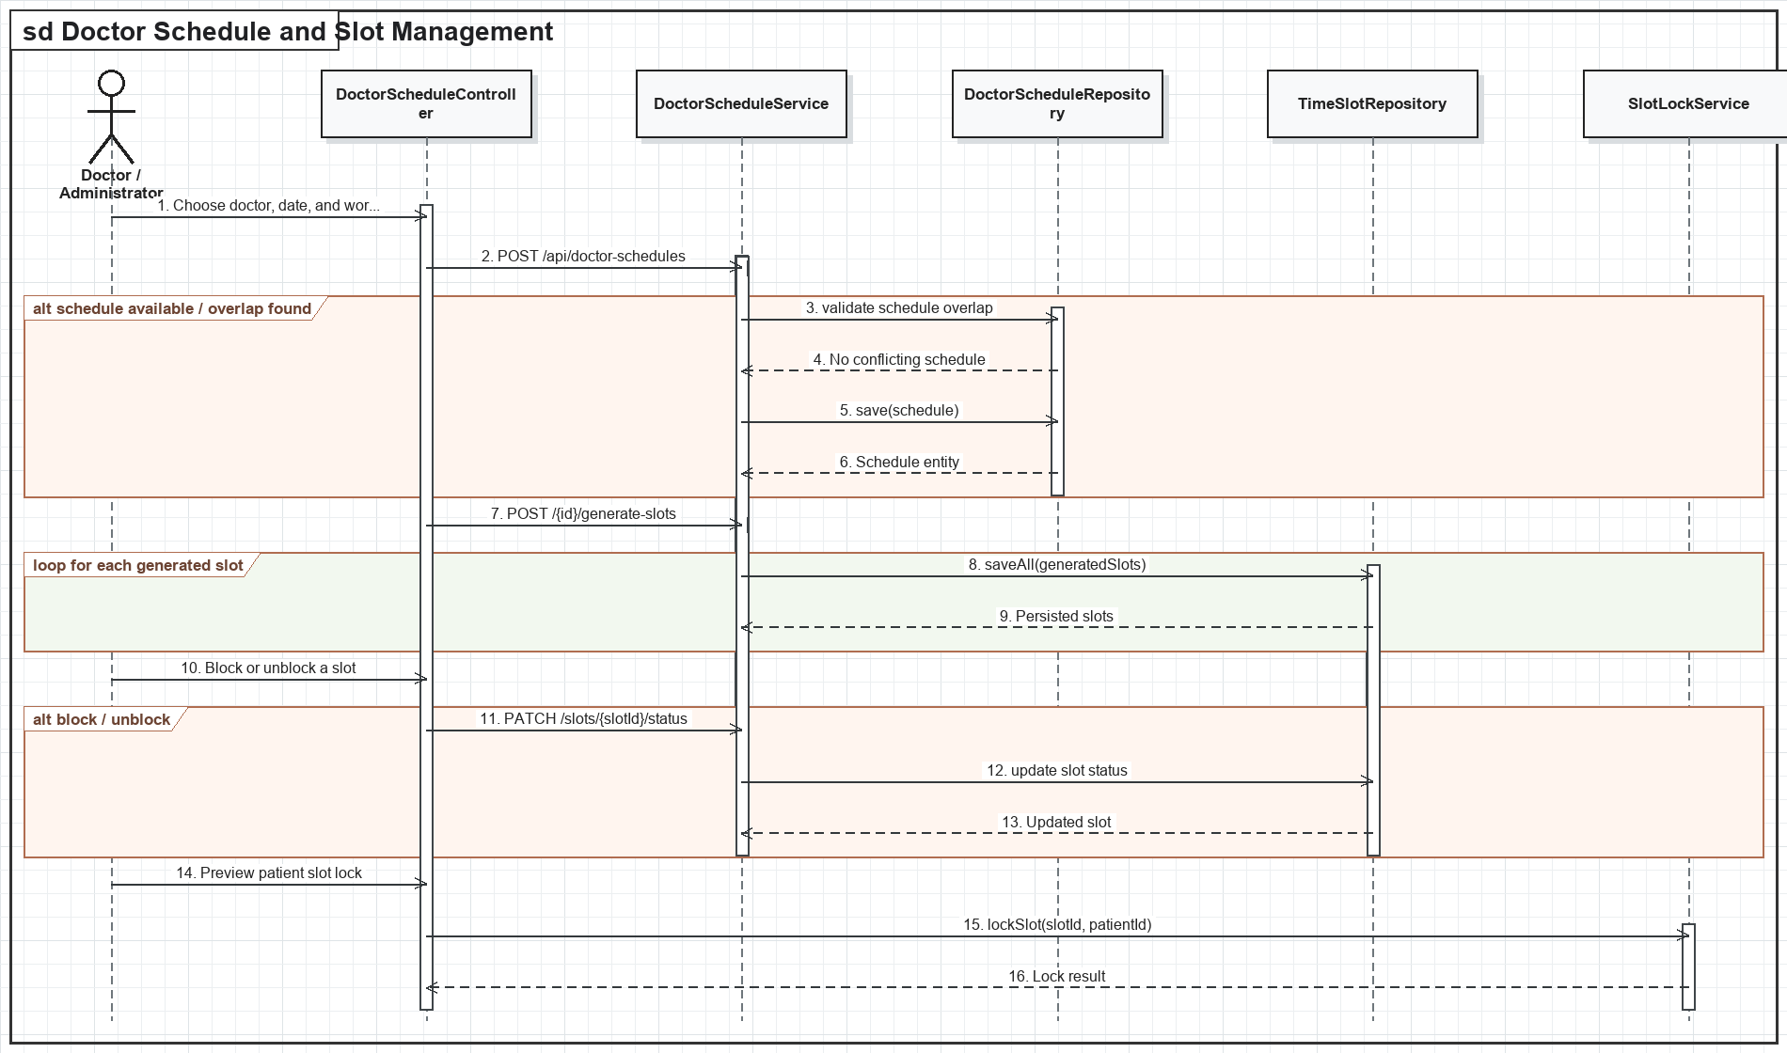
Figure IV-6. Doctor Schedule and Slot Management sequence diagram

d. Database Queries
Create schedule
INSERT INTO doctor_schedules (doctor_id, work_date, start_time, end_time, max_patients) VALUES (:doctorId, :date, :start, :end, :maxPatients);
Generate slot
INSERT INTO appointment_slots (schedule_id, start_time, end_time, status) VALUES (:scheduleId, :start, :end, 'AVAILABLE');
Block slot
UPDATE appointment_slots SET status = 'BLOCKED', locked_until = NULL WHERE slot_id = :slotId AND status = 'AVAILABLE';
Lock slot
UPDATE appointment_slots SET status = 'LOCKED', locked_until = :expiresAt, locked_by_patient_id = :patientId WHERE slot_id = :slotId AND status = 'AVAILABLE';

1.4. Laboratory Test Catalog Management

a. Class Diagram
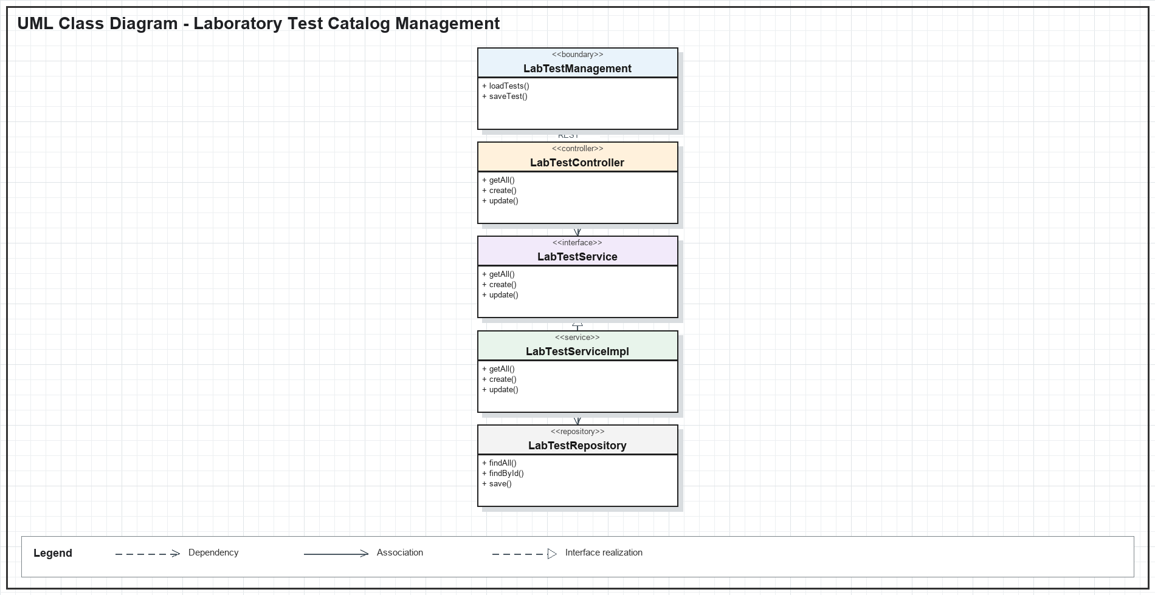
Figure IV-7. Laboratory Test Catalog Management UML class diagram

b. Class Specifications
Class | Method | Description
LabTestManagement | loadTests() | Loads laboratory test codes, descriptions, prices, and statuses.
LabTestManagement | saveTest() | Submits a create or edit form for a catalog test.
LabTestController | create() | Creates a unique laboratory test definition.
LabTestController | delete() | Removes or deactivates a laboratory test according to constraints.
LabTestService | update() | Defines validation and update behavior for test metadata.
LabTestRepository | findById() | Retrieves the persistent test before update or deletion.

c. Sequence Diagram
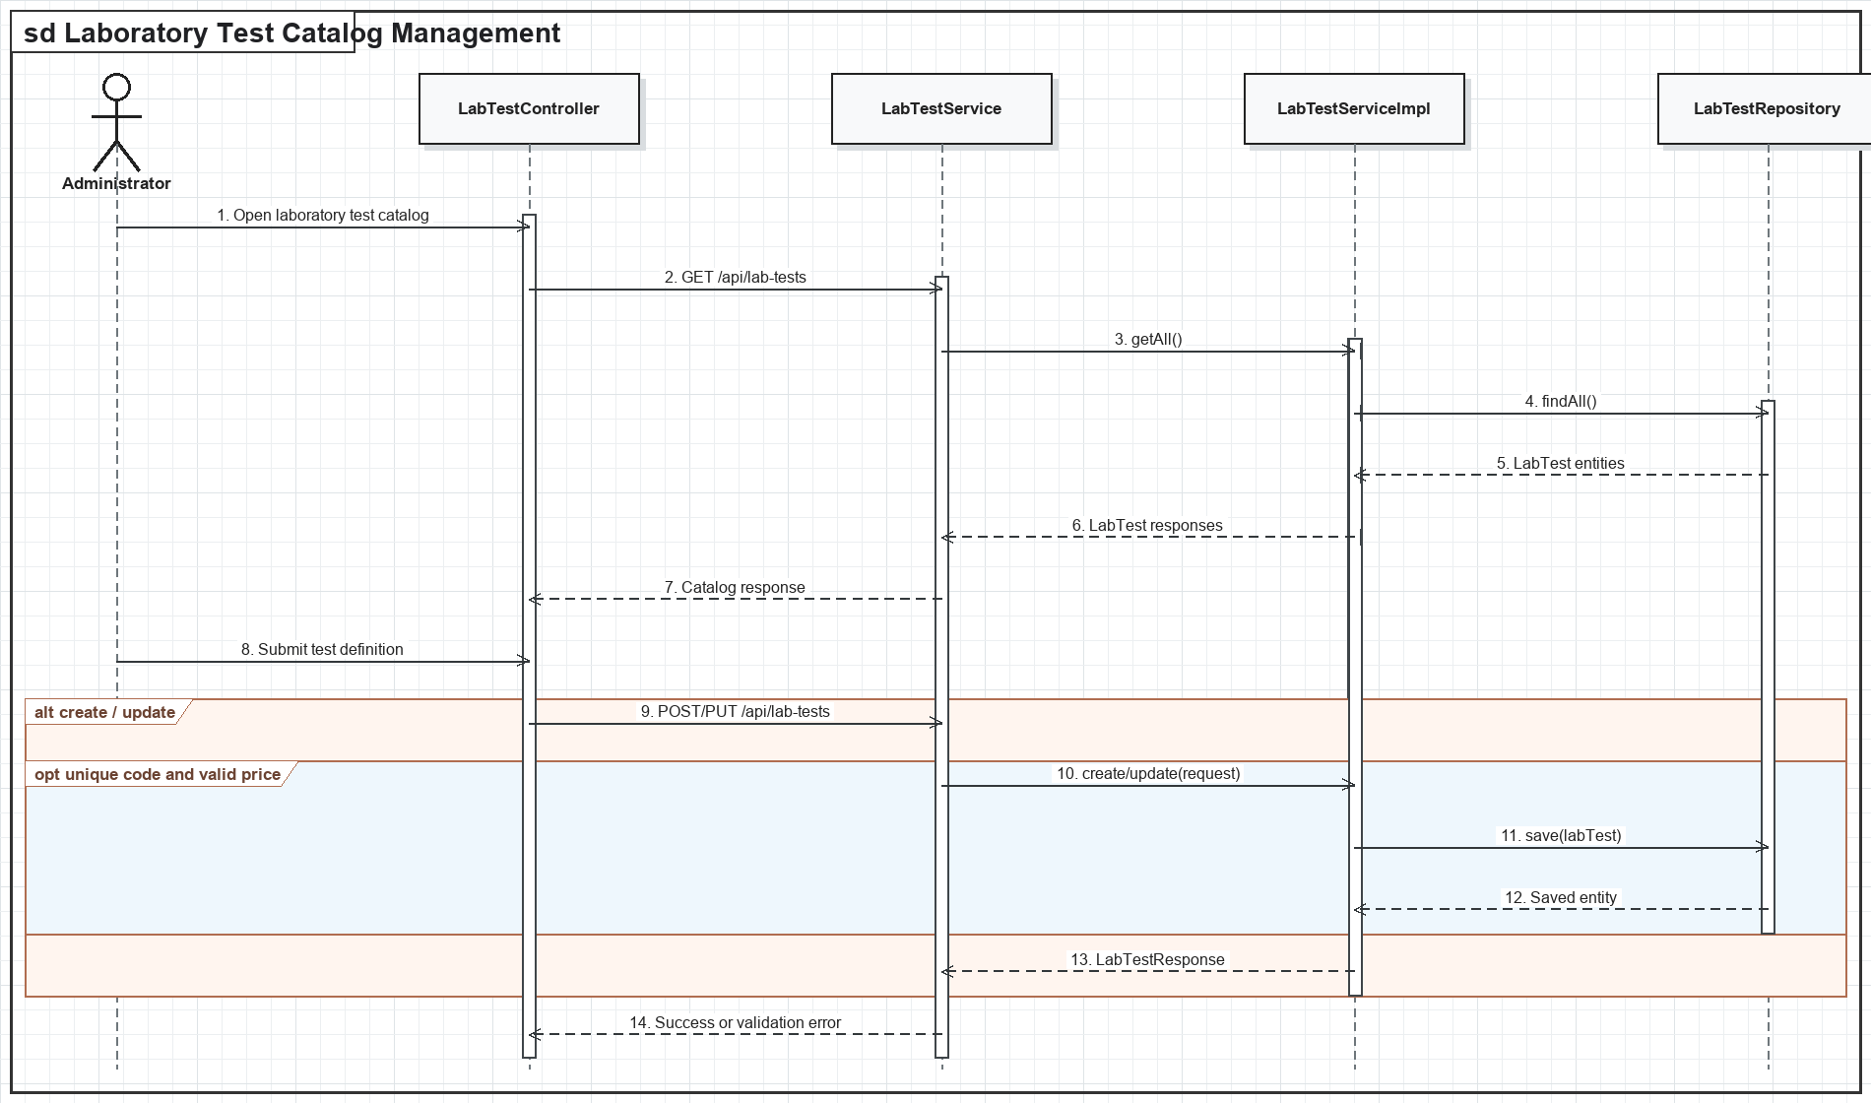
Figure IV-8. Laboratory Test Catalog Management sequence diagram

d. Database Queries
List tests
SELECT * FROM lab_tests WHERE (:status IS NULL OR status = :status) ORDER BY test_name;
Create test
INSERT INTO lab_tests (test_code, test_name, description, price, status) VALUES (:code, :name, :description, :price, :status);
Update test
UPDATE lab_tests SET test_name = :name, description = :description, price = :price, status = :status WHERE lab_test_id = :testId;
Delete test
DELETE FROM lab_tests WHERE lab_test_id = :testId;

2. Extended Clinical and Patient Services

2.1. Record and View Vital Signs

a. Class Diagram
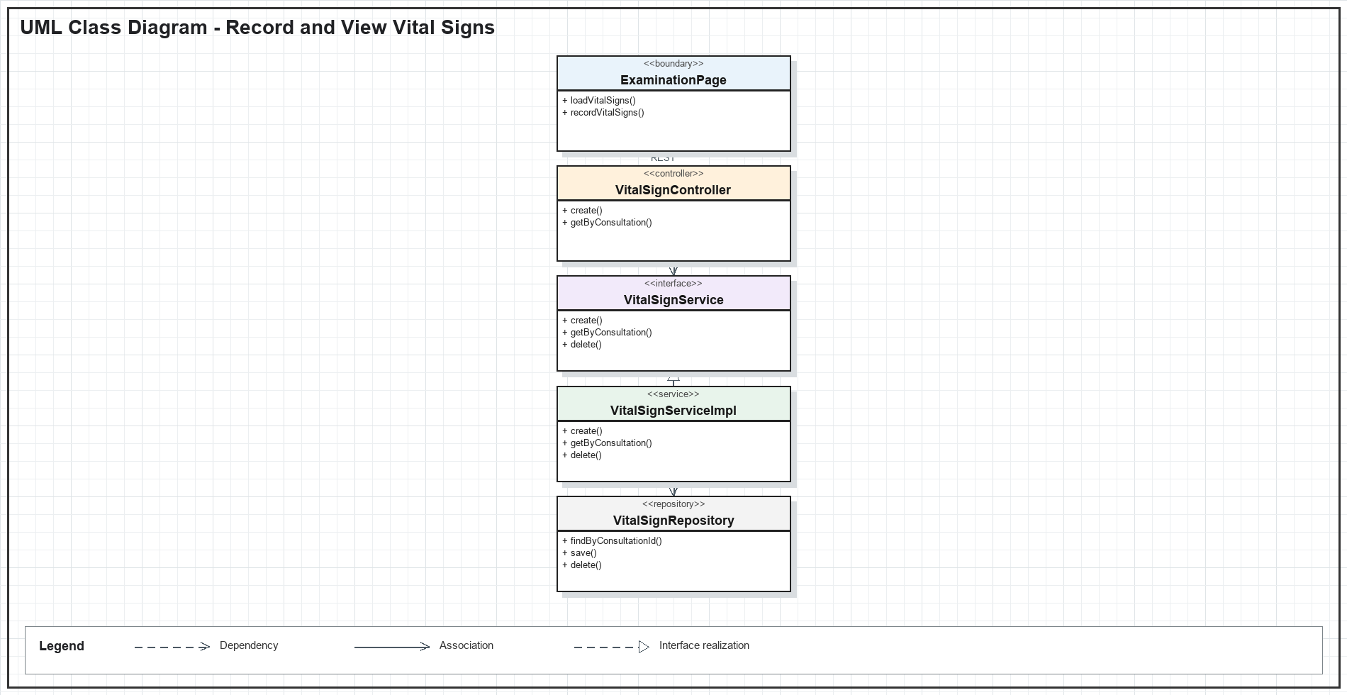
Figure IV-9. Record and View Vital Signs UML class diagram

b. Class Specifications
Class | Method | Description
ExaminationPage | loadVitalSigns() | Loads measurements associated with the active consultation.
ExaminationPage | recordVitalSigns() | Collects and validates clinical measurement input.
VitalSignController | create() | Creates a vital-sign record for an authorized staff member.
VitalSignController | getByConsultation() | Returns measurements for a consultation.
VitalSignService | create() | Validates ranges and resolves patient and consultation context.
VitalSignRepository | findByConsultationId() | Retrieves measurements in chronological order.

c. Sequence Diagram
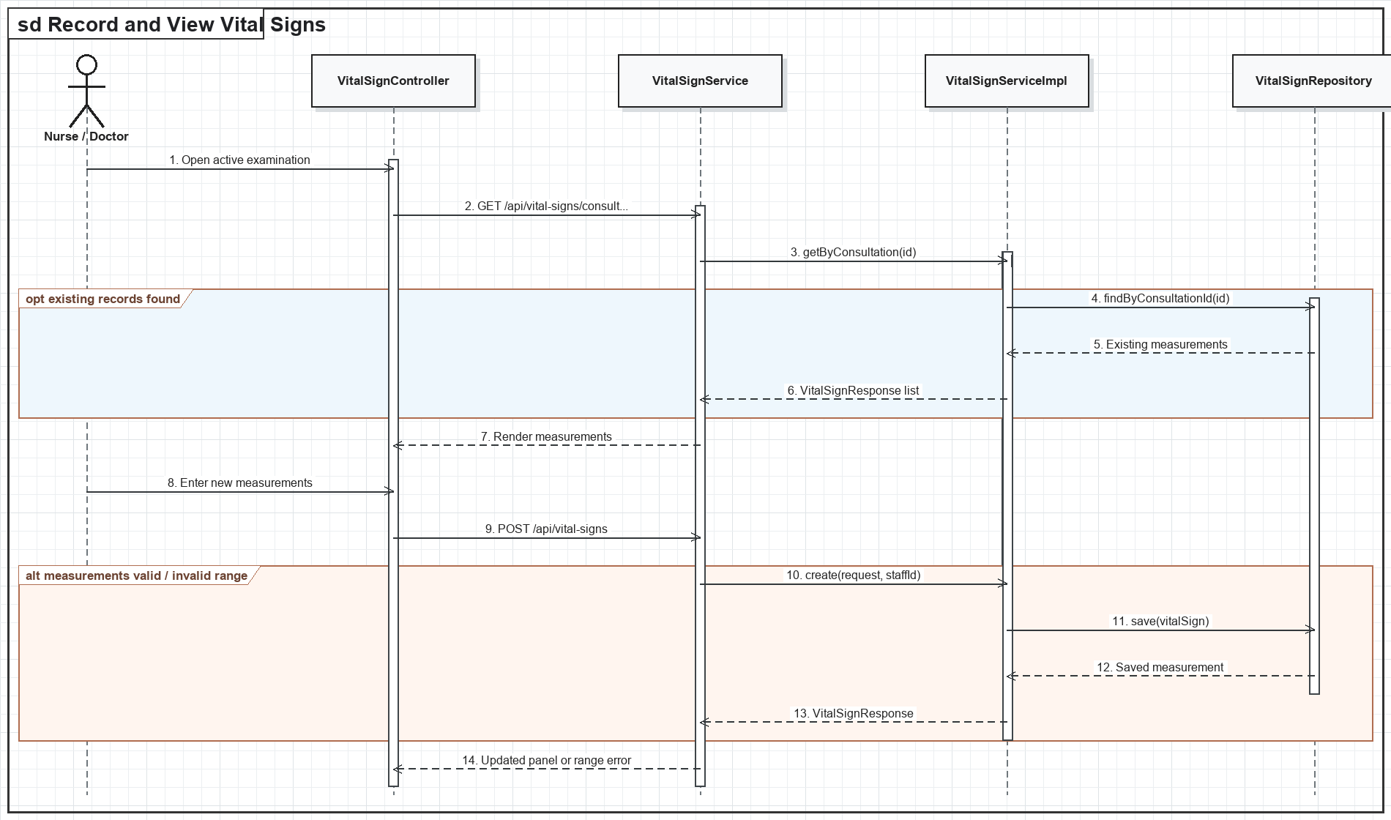
Figure IV-10. Record and View Vital Signs sequence diagram

d. Database Queries
Read measurements
SELECT * FROM vital_signs WHERE consultation_id = :consultationId ORDER BY measured_at DESC;
Record measurements
INSERT INTO vital_signs (consultation_id, patient_id, temperature_c, blood_pressure_systolic, blood_pressure_diastolic, heart_rate, spo2, measured_by) VALUES (:consultationId, :patientId, :temperature, :systolic, :diastolic, :heartRate, :spo2, :staffId);
Update measurements
UPDATE vital_signs SET weight_kg = :weight, height_cm = :height, respiratory_rate = :respiratoryRate WHERE vital_sign_id = :vitalSignId;
Delete incorrect record
DELETE FROM vital_signs WHERE vital_sign_id = :vitalSignId;

2.2. Patient Self-Service Records

a. Class Diagram
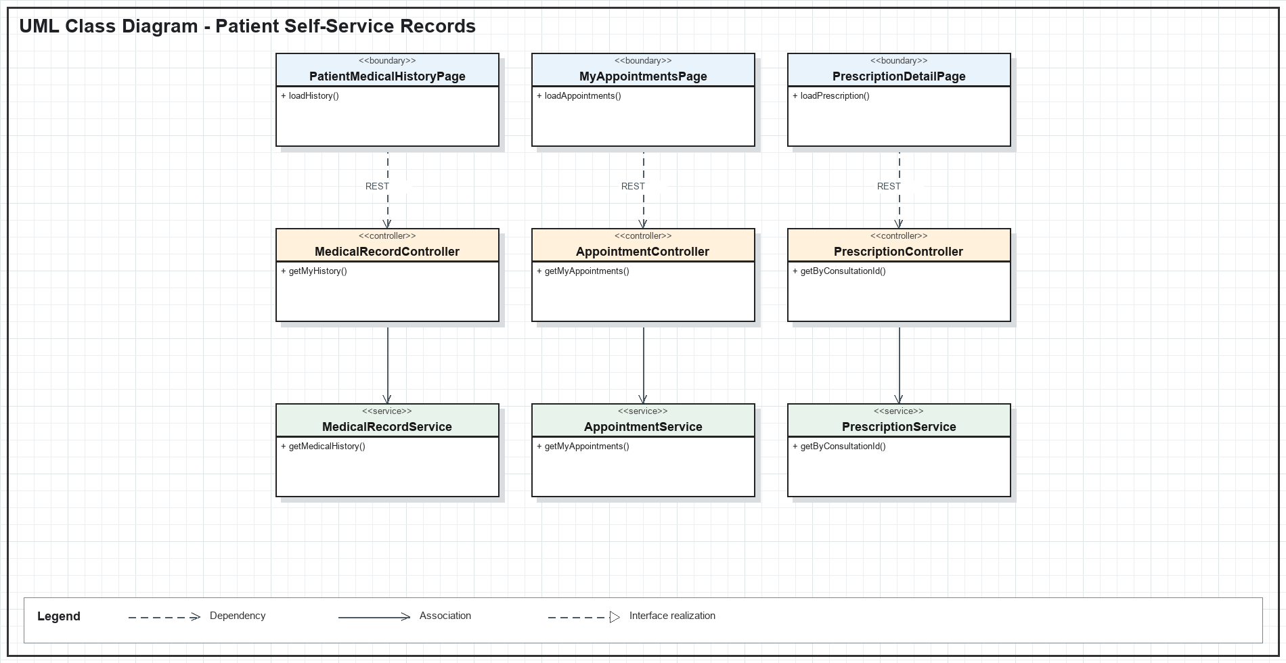
Figure IV-11. Patient Self-Service Records UML class diagram

b. Class Specifications
Class | Method | Description
PatientMedicalHistoryPage | loadHistory() | Loads the authenticated patient's longitudinal medical history.
MyAppointmentsPage | loadAppointments() | Loads the patient's past and upcoming appointments.
PrescriptionDetailPage | loadPrescription() | Displays prescription items for an owned consultation.
MedicalRecordService | getMedicalHistory() | Returns records only when the requester owns the patient profile.
AppointmentService | getMyAppointments() | Filters appointments by the authenticated patient.
PrescriptionService | getByConsultationId() | Returns prescription and medication details for a consultation.

c. Sequence Diagram
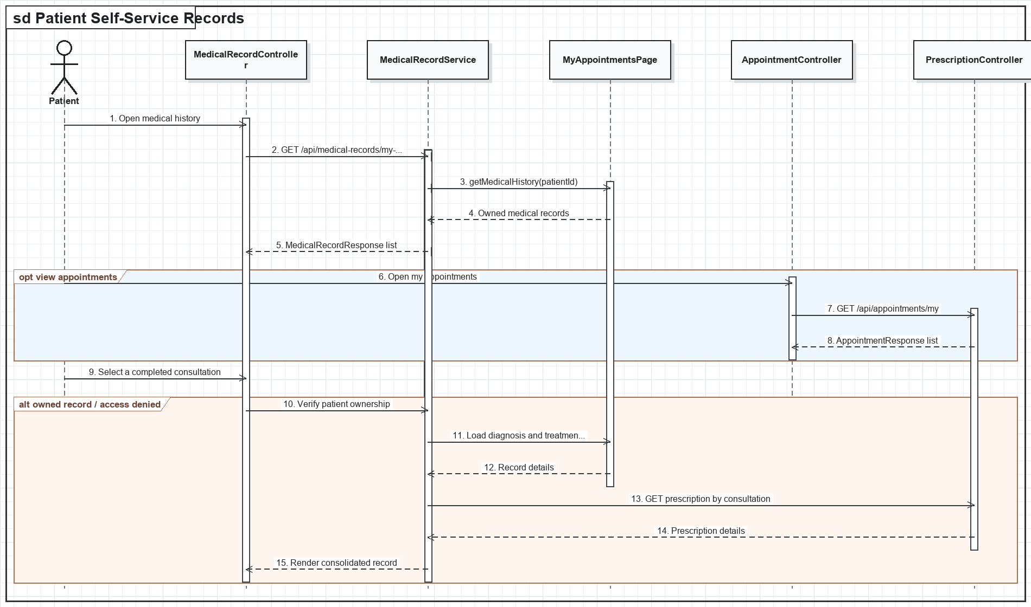
Figure IV-12. Patient Self-Service Records sequence diagram

d. Database Queries
Medical history
SELECT mr.* FROM medical_records mr WHERE mr.patient_id = :patientId ORDER BY mr.created_at DESC;
Patient appointments
SELECT * FROM appointments WHERE patient_id = :patientId ORDER BY appointment_date DESC, start_time DESC;
Prescription header
SELECT * FROM prescriptions WHERE consultation_id = :consultationId AND patient_id = :patientId;
Prescription items
SELECT pi.*, m.medicine_name FROM prescription_items pi JOIN medicines m ON m.medicine_id = pi.medicine_id WHERE pi.prescription_id = :prescriptionId;

2.3. Reviews and Ratings

a. Class Diagram
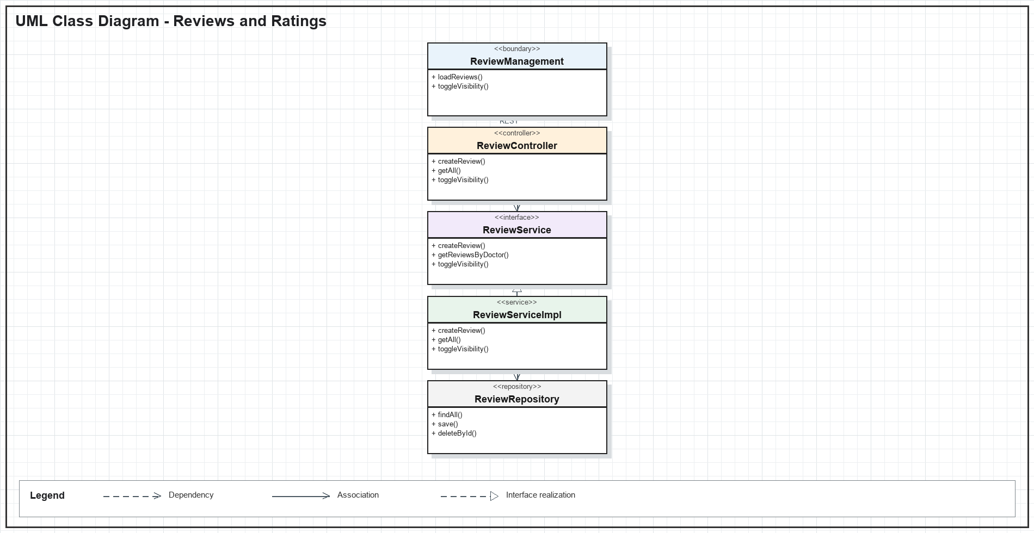
Figure IV-13. Reviews and Ratings UML class diagram

b. Class Specifications
Class | Method | Description
ReviewManagement | loadReviews() | Loads reviews for moderation and filtering.
ReviewManagement | toggleVisibility() | Hides or restores a review from public display.
ReviewController | createReview() | Accepts a rating from an authenticated patient.
ReviewController | delete() | Deletes a review when authorized by policy.
ReviewService | getReviewsByDoctor() | Returns visible ratings for a selected doctor.
ReviewRepository | save() | Persists new reviews and moderation status changes.

c. Sequence Diagram
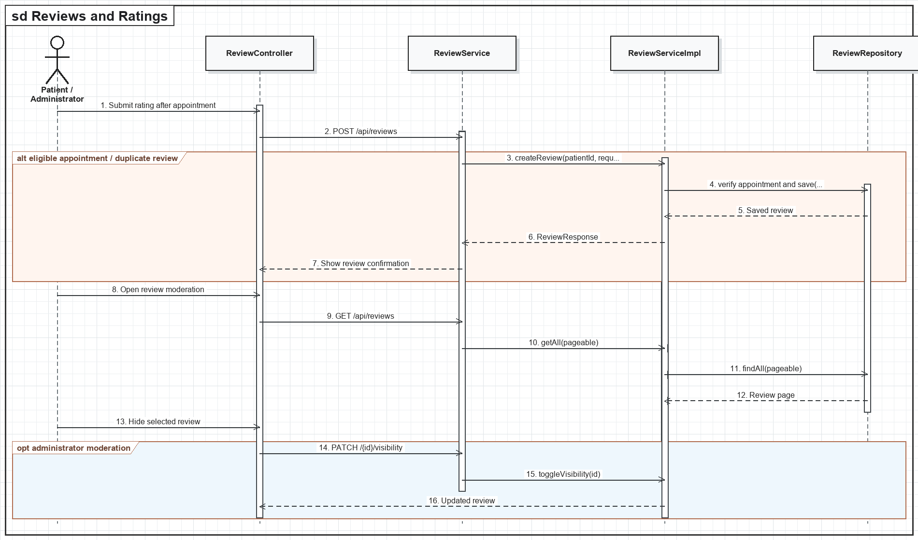
Figure IV-14. Reviews and Ratings sequence diagram

d. Database Queries
Create review
INSERT INTO reviews (patient_id, doctor_id, appointment_id, rating, comment) VALUES (:patientId, :doctorId, :appointmentId, :rating, :comment);
Doctor reviews
SELECT * FROM reviews WHERE doctor_id = :doctorId AND status = 'VISIBLE' ORDER BY created_at DESC;
Moderate review
UPDATE reviews SET status = CASE WHEN status = 'VISIBLE' THEN 'HIDDEN' ELSE 'VISIBLE' END WHERE review_id = :reviewId;
Delete review
DELETE FROM reviews WHERE review_id = :reviewId;

2.4. Medical Articles

a. Class Diagram
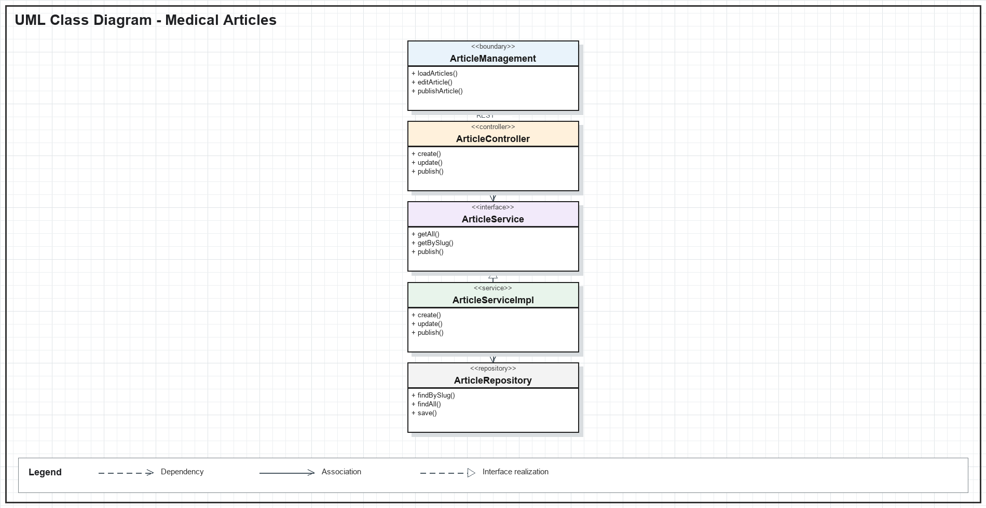
Figure IV-15. Medical Articles UML class diagram

b. Class Specifications
Class | Method | Description
ArticleManagement | loadArticles() | Loads draft, published, and archived articles.
ArticleManagement | publishArticle() | Requests publication of a reviewed draft.
ArticleController | create() | Creates an article draft for an authorized administrator.
ArticleController | getBySlug() | Returns a public published article by its slug.
ArticleService | publish() | Transitions a valid draft to published state.
ArticleRepository | findBySlug() | Resolves the unique article route.

c. Sequence Diagram
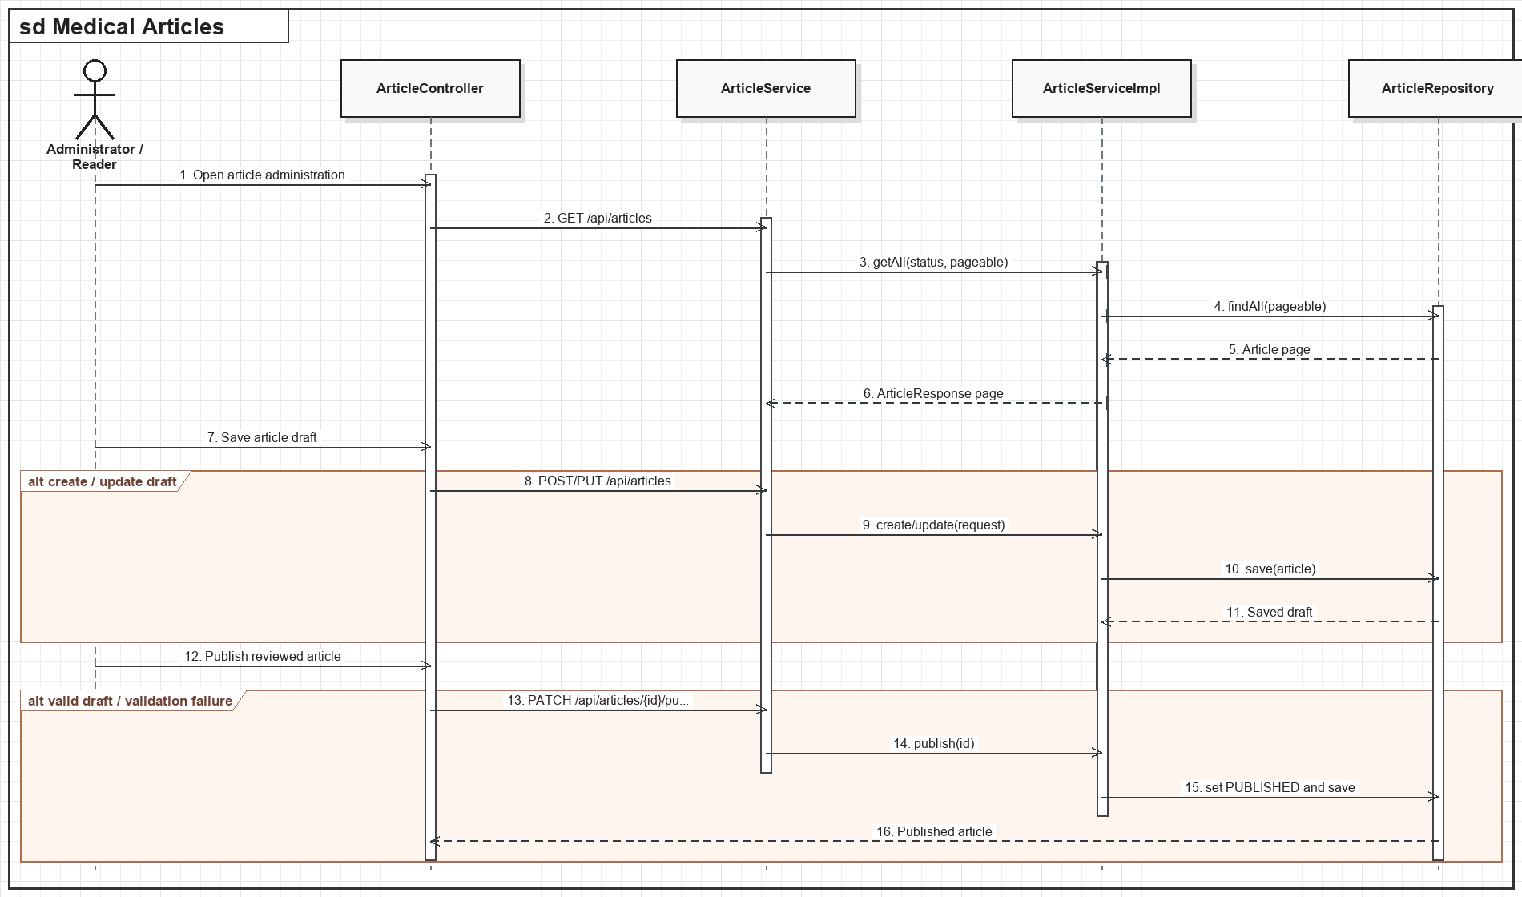
Figure IV-16. Medical Articles sequence diagram

d. Database Queries
List articles
SELECT * FROM articles WHERE (:status IS NULL OR status = :status) ORDER BY updated_at DESC;
Create draft
INSERT INTO articles (title, slug, content, thumbnail_url, status, created_by) VALUES (:title, :slug, :content, :thumbnailUrl, 'DRAFT', :userId);
Publish article
UPDATE articles SET status = 'PUBLISHED', published_at = CURRENT_TIMESTAMP, updated_at = CURRENT_TIMESTAMP WHERE article_id = :articleId AND status = 'DRAFT';
Delete article
DELETE FROM articles WHERE article_id = :articleId;

3. Extended Operations and Security

3.1. Supplier and Stock Transaction Management

a. Class Diagram
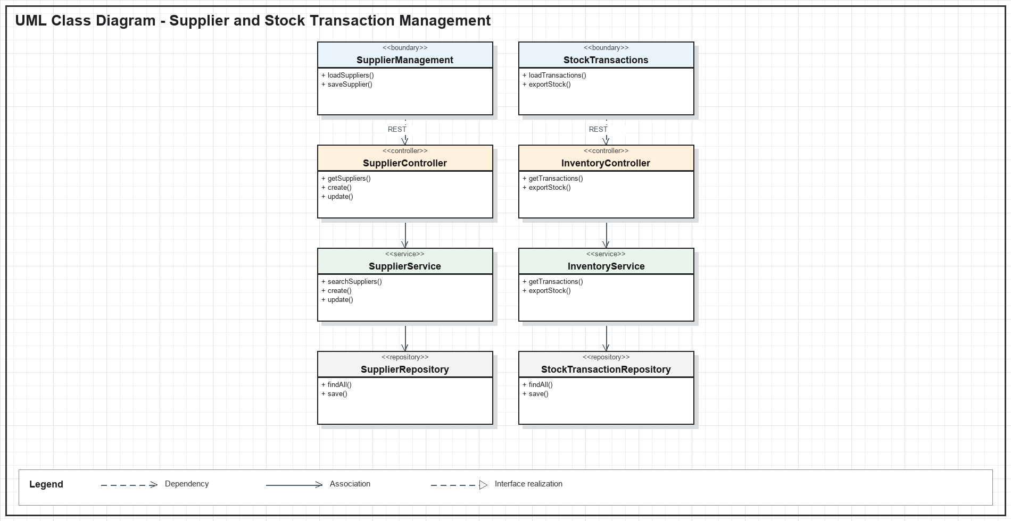
Figure IV-17. Supplier and Stock Transaction Management UML class diagram

b. Class Specifications
Class | Method | Description
SupplierManagement | loadSuppliers() | Loads and filters supplier master data.
StockTransactions | exportStock() | Submits a controlled manual stock export.
SupplierController | create() | Creates a supplier after validating contact data.
InventoryController | getTransactions() | Returns filtered inventory movement history.
SupplierService | searchSuppliers() | Searches suppliers by name and status.
InventoryService | exportStock() | Checks batch quantity and records an export atomically.

c. Sequence Diagram
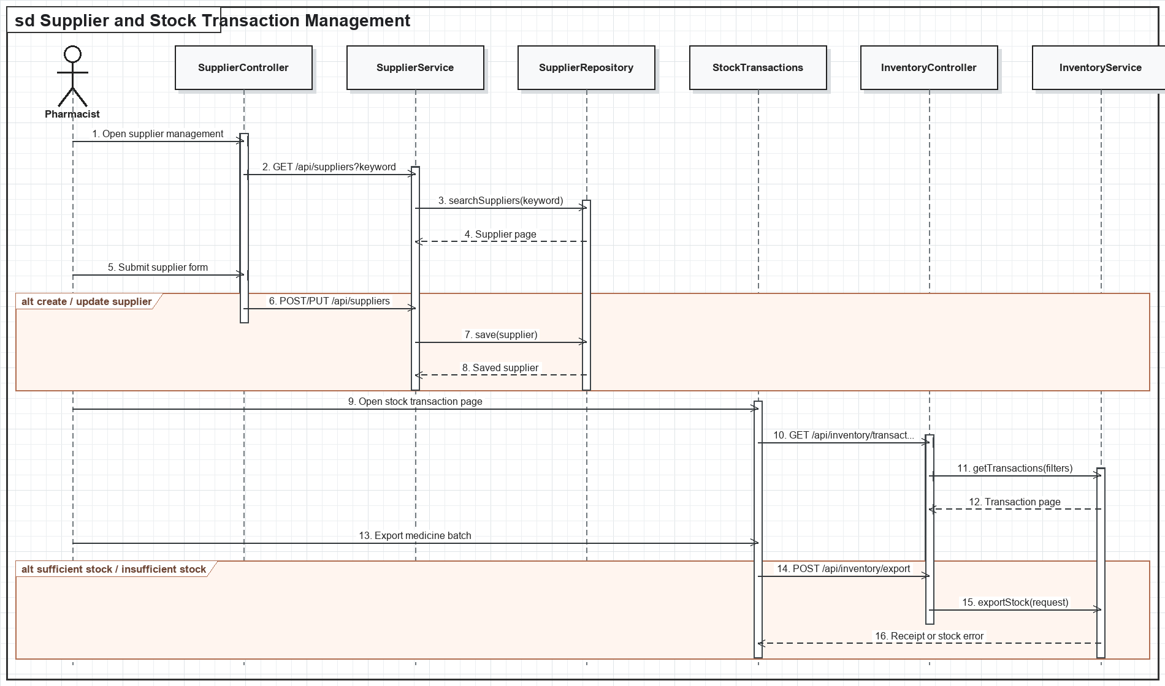
Figure IV-18. Supplier and Stock Transaction Management sequence diagram

d. Database Queries
Search suppliers
SELECT * FROM suppliers WHERE LOWER(supplier_name) LIKE LOWER(:keyword) AND (:status IS NULL OR status = :status);
Create supplier
INSERT INTO suppliers (supplier_name, phone, email, address, status) VALUES (:name, :phone, :email, :address, 'ACTIVE');
Record export
INSERT INTO stock_transactions (medicine_id, batch_id, transaction_type, quantity, reference_type, note, created_by) VALUES (:medicineId, :batchId, 'EXPORT', :quantity, :referenceType, :note, :userId);
Decrease batch
UPDATE medicine_batches SET current_quantity = current_quantity - :quantity WHERE batch_id = :batchId AND current_quantity >= :quantity;

3.2. Logout and Session Restore

a. Class Diagram
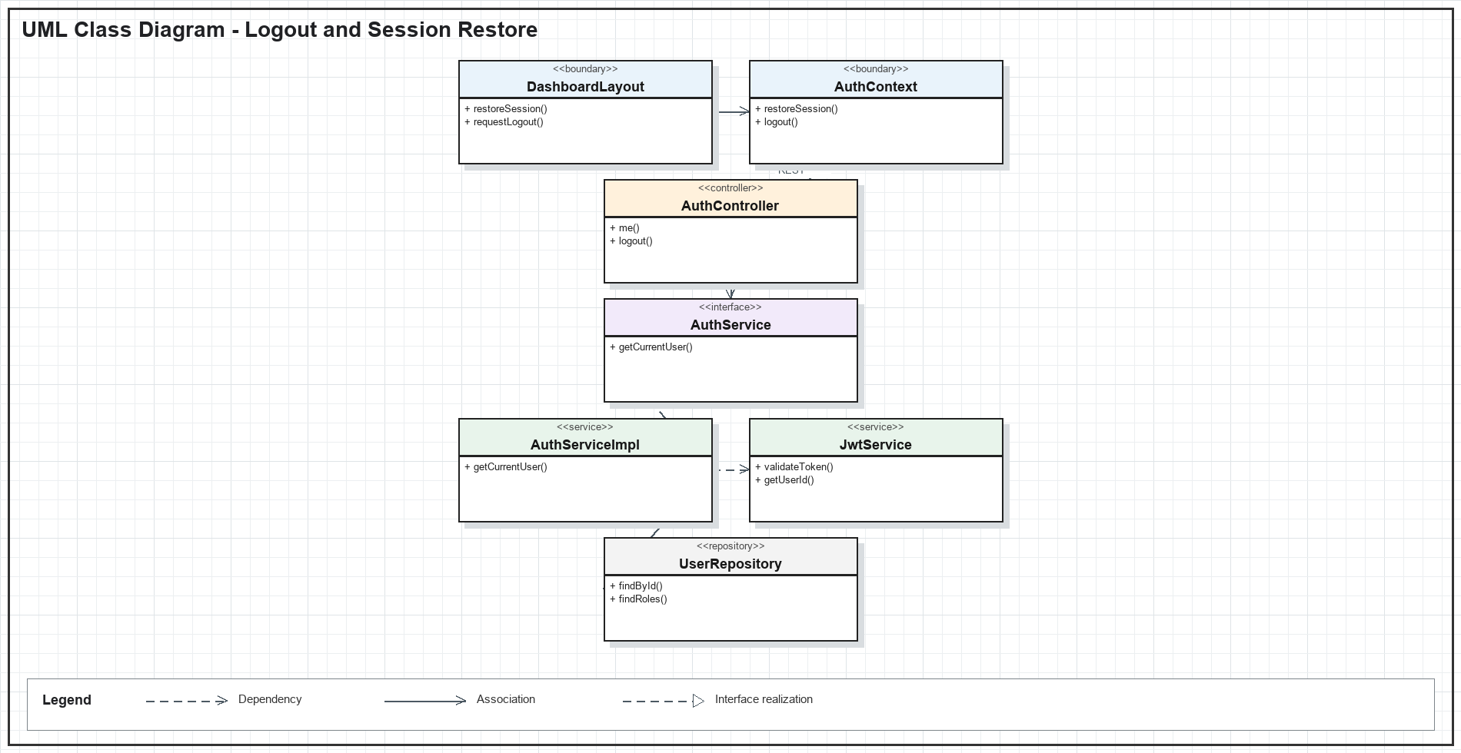
Figure IV-19. Logout and Session Restore UML class diagram

b. Class Specifications
Class | Method | Description
DashboardLayout | restoreSession() | Requests session restoration before protected content is rendered.
AuthContext | logout() | Calls logout and clears access and refresh tokens from client storage.
AuthController | me() | Returns the authenticated user's profile and roles.
AuthController | logout() | Completes stateless logout without persisting a server session.
JwtService | validateToken() | Validates signature, expiry, and token claims.
UserRepository | findById() | Loads the current active user for session restoration.

c. Sequence Diagram
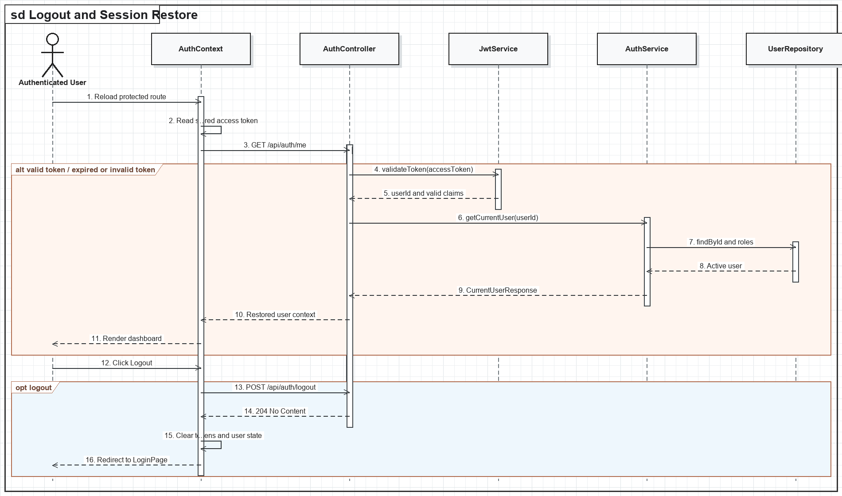
Figure IV-20. Logout and Session Restore sequence diagram

d. Database Queries
Restore user
SELECT user_id, email, full_name, status FROM users WHERE user_id = :userId AND status = 'ACTIVE';
Restore roles
SELECT r.role_name FROM user_roles ur JOIN roles r ON r.role_id = ur.role_id WHERE ur.user_id = :userId;
Logout persistence
-- No database write: logout is stateless and client tokens are removed by AuthContext.

3.3. Appointment Exception Handling

a. Class Diagram
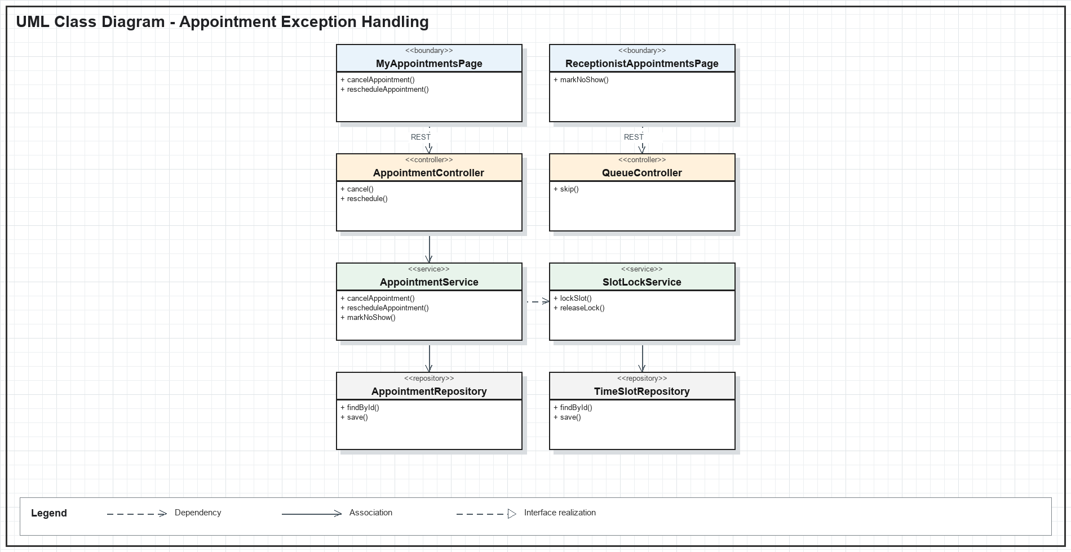
Figure IV-21. Appointment Exception Handling UML class diagram

b. Class Specifications
Class | Method | Description
MyAppointmentsPage | cancelAppointment() | Submits an owned appointment cancellation and reason.
MyAppointmentsPage | rescheduleAppointment() | Selects and requests a replacement available slot.
ReceptionistAppointmentsPage | markNoShow() | Marks a missed appointment after operational confirmation.
AppointmentController | reschedule() | Validates ownership and delegates atomic rescheduling.
AppointmentService | cancelAppointment() | Updates status and releases the previous slot when allowed.
SlotLockService | lockSlot() | Locks a replacement slot before a reschedule is committed.

c. Sequence Diagram
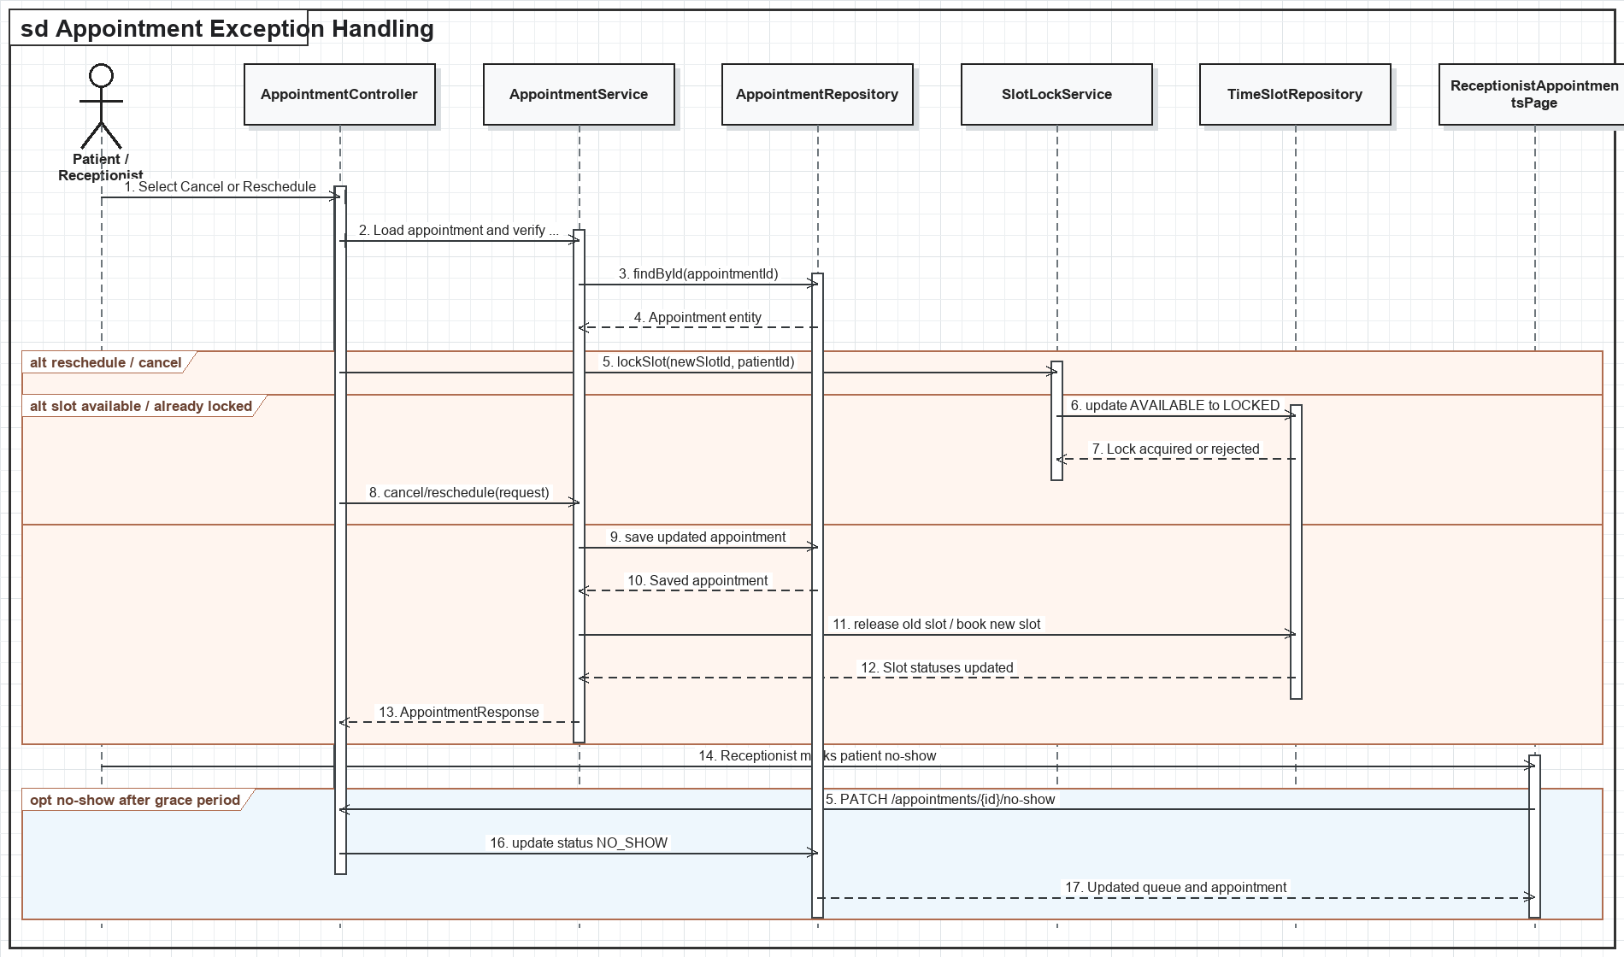
Figure IV-22. Appointment Exception Handling sequence diagram

d. Database Queries
Cancel appointment
UPDATE appointments SET status = 'CANCELLED', cancelled_by = :userId, cancellation_reason = :reason, cancelled_at = CURRENT_TIMESTAMP WHERE appointment_id = :appointmentId;
Reschedule appointment
UPDATE appointments SET status = 'RESCHEDULED', rescheduled_from_id = :oldAppointmentId, slot_id = :newSlotId, appointment_date = :newDate, start_time = :start, end_time = :end WHERE appointment_id = :appointmentId;
Release slot
UPDATE appointment_slots SET status = 'AVAILABLE', locked_until = NULL, locked_by_patient_id = NULL WHERE slot_id = :oldSlotId;
Mark no-show
UPDATE appointments SET status = 'NO_SHOW', updated_at = CURRENT_TIMESTAMP WHERE appointment_id = :appointmentId AND status IN ('CONFIRMED', 'WAITING');

3.4. AI Session and Clinical Note Tools

a. Class Diagram
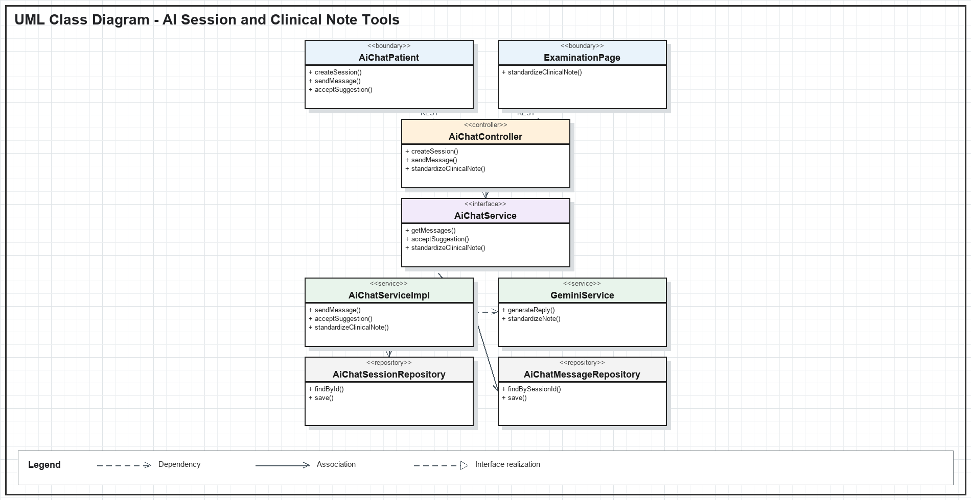
Figure IV-23. AI Session and Clinical Note Tools UML class diagram

b. Class Specifications
Class | Method | Description
AiChatPatient | createSession() | Starts an owned symptom-check or specialty-suggestion session.
AiChatPatient | acceptSuggestion() | Accepts a generated specialty suggestion before booking.
ExaminationPage | standardizeClinicalNote() | Requests AI formatting of a clinician-authored note.
AiChatController | sendMessage() | Accepts a patient message and returns the AI response.
AiChatService | getMessages() | Returns the ordered conversation after ownership validation.
GeminiService | standardizeNote() | Generates structured clinical text without replacing doctor approval.

c. Sequence Diagram
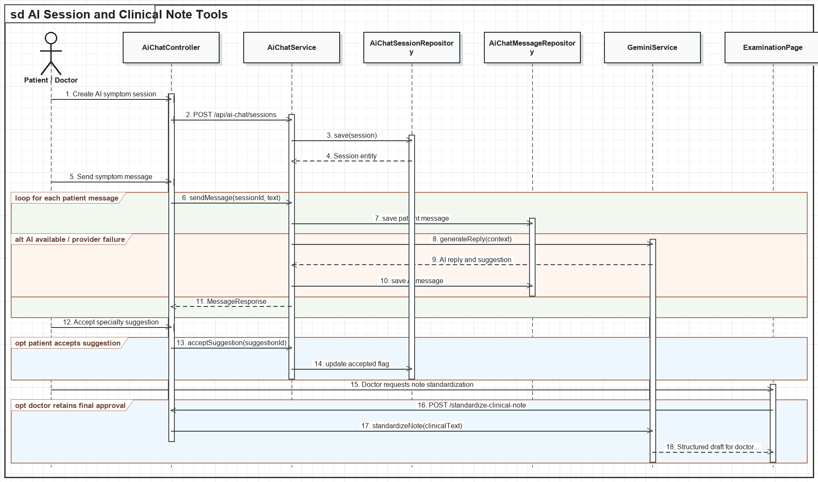
Figure IV-24. AI Session and Clinical Note Tools sequence diagram

d. Database Queries
Create session
INSERT INTO ai_chat_sessions (patient_id, session_type) VALUES (:patientId, :sessionType);
Store message
INSERT INTO ai_chat_messages (ai_chat_session_id, sender_type, message_text) VALUES (:sessionId, :senderType, :messageText);
Read conversation
SELECT * FROM ai_chat_messages WHERE ai_chat_session_id = :sessionId ORDER BY created_at, ai_chat_message_id;
Accept suggestion
UPDATE ai_specialty_suggestions SET accepted_by_patient = TRUE WHERE suggestion_id = :suggestionId AND patient_id = :patientId;

