

Requirement & Design Specification
Smart Clinic Management System
Version: 2.0

Record of Changes
Version | Date | A*M, D | In charge | Change Description
V1.0 | 14/06/2026 | A | Smart Clinic Team | Initial Consolidated Draft adhering strictly to the required RDS template structure.
V2.0 | 14/06/2026 | M | Smart Clinic Team | Refactored Use Case diagrams, ERD schema, Database Tables, and Code Packages into 5 distinct modules based on Progress Report 1.
*A - Added M - Modified D - Deleted

I. Overview

1. User Requirements

1.1 Actors
# | Actor | Description
1 | Admin | Creates and maintains user accounts, manages roles, creates clinic departments, approves leaves, and oversees system settings and audit logs.
2 | Doctor | Medical professional who views appointment schedules, conducts consultations, records vital signs, writes prescriptions, and submits leave requests.
3 | Receptionist | Front-desk staff managing walk-in appointments, patient check-in, queue operations, demographics, and initial payment collection.
4 | Patient | Self-registers, books appointments, views medical records, uses AI Chat for triage, and processes invoice payments.
5 | Pharmacist | Reviews dispensing queue, verifies prescription details, dispenses medicine, and manages inventory.
6 | Lab Technician | Accepts incoming lab requests, processes samples, and enters lab results and conclusions.
7 | System Auditor | Holds read-only access privileges to the comprehensive audit trail log for compliance.

1.2 Use Cases

a. Diagram(s)

Sơ đồ 1: Phân hệ Bệnh nhân (Patient)
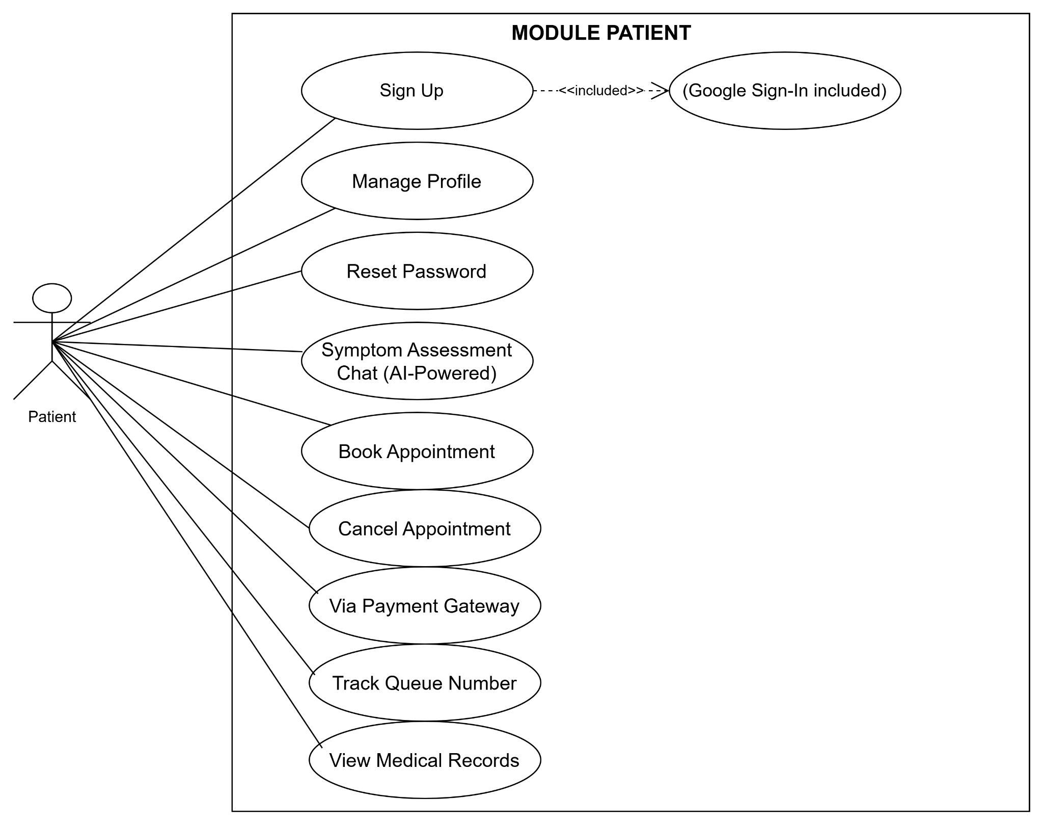

Sơ đồ 2: Phân hệ Bác sĩ (Doctor)
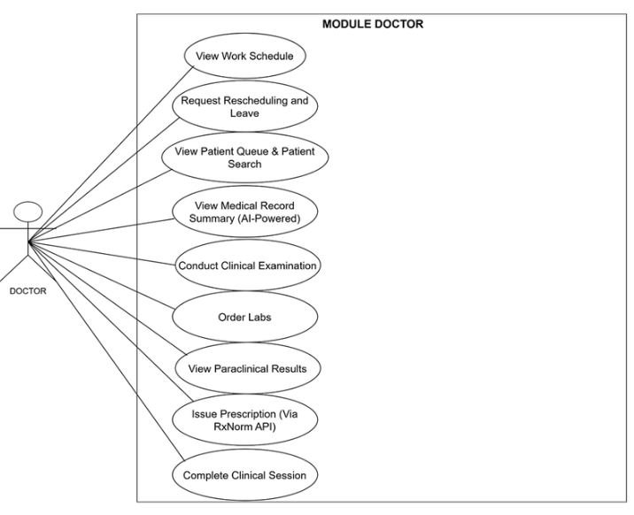

Sơ đồ 3: Phân hệ Lễ tân (Receptionist)
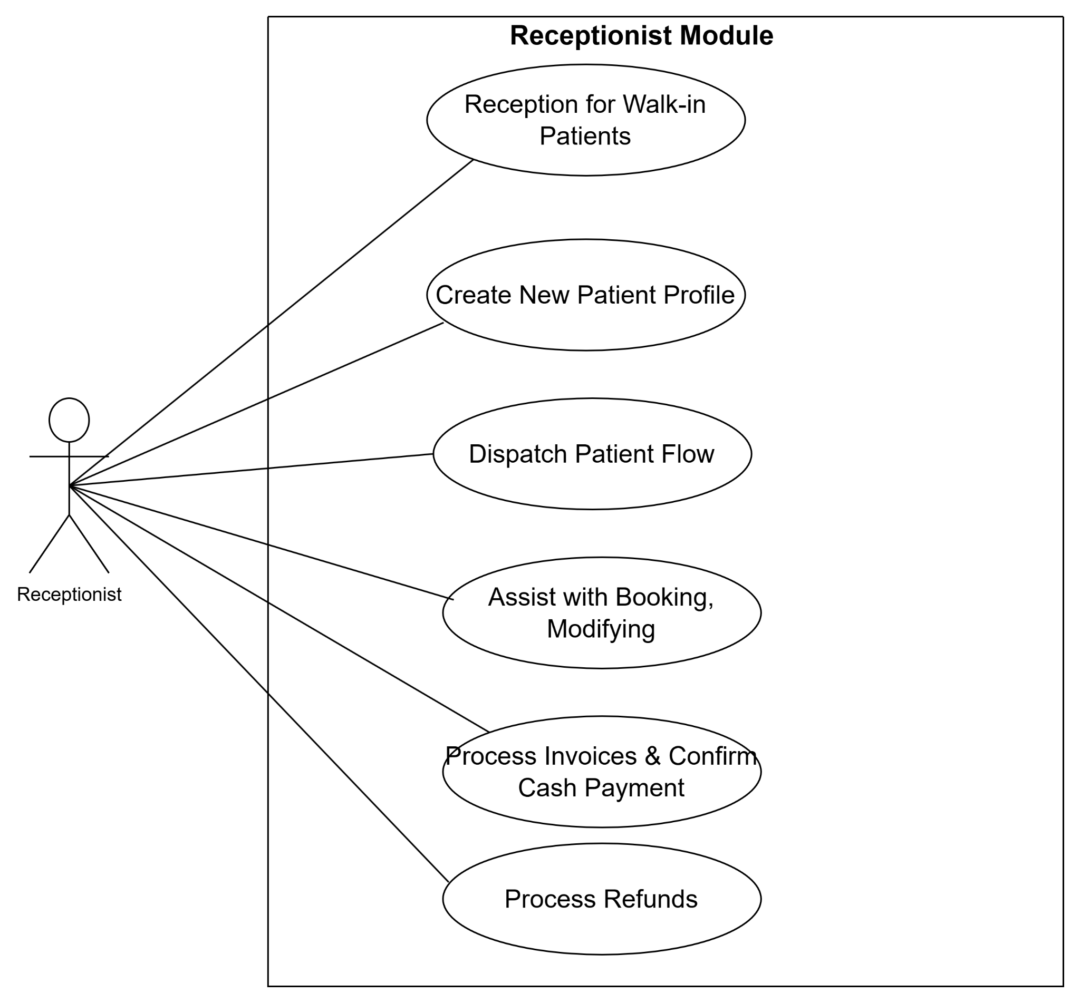

Sơ đồ 4: Phân hệ Admin, Dược sĩ & Xét nghiệm

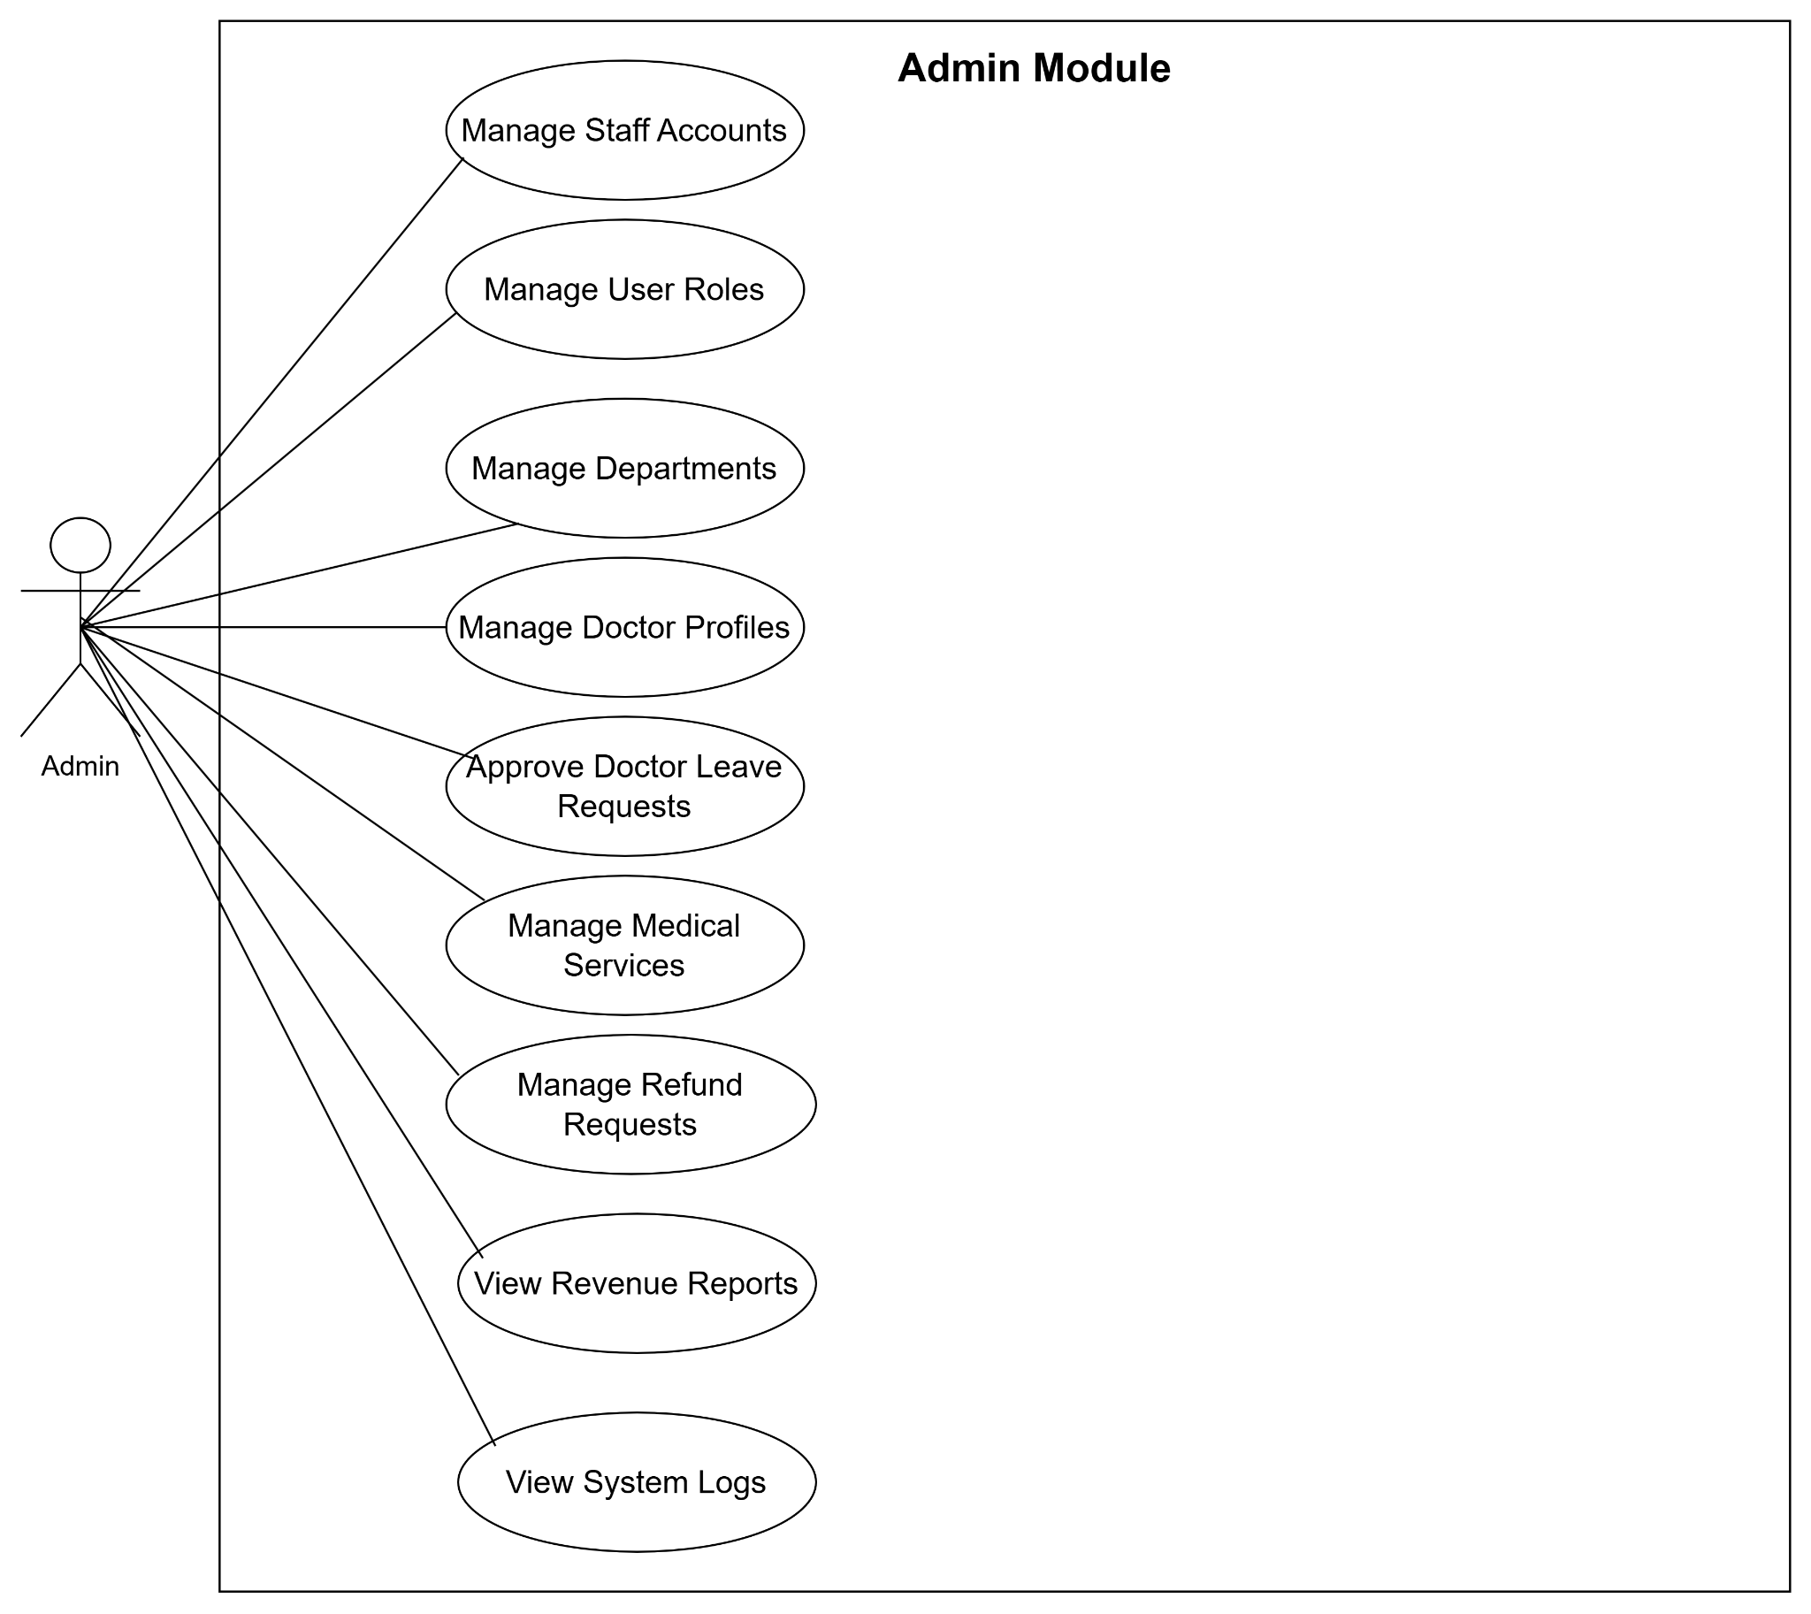
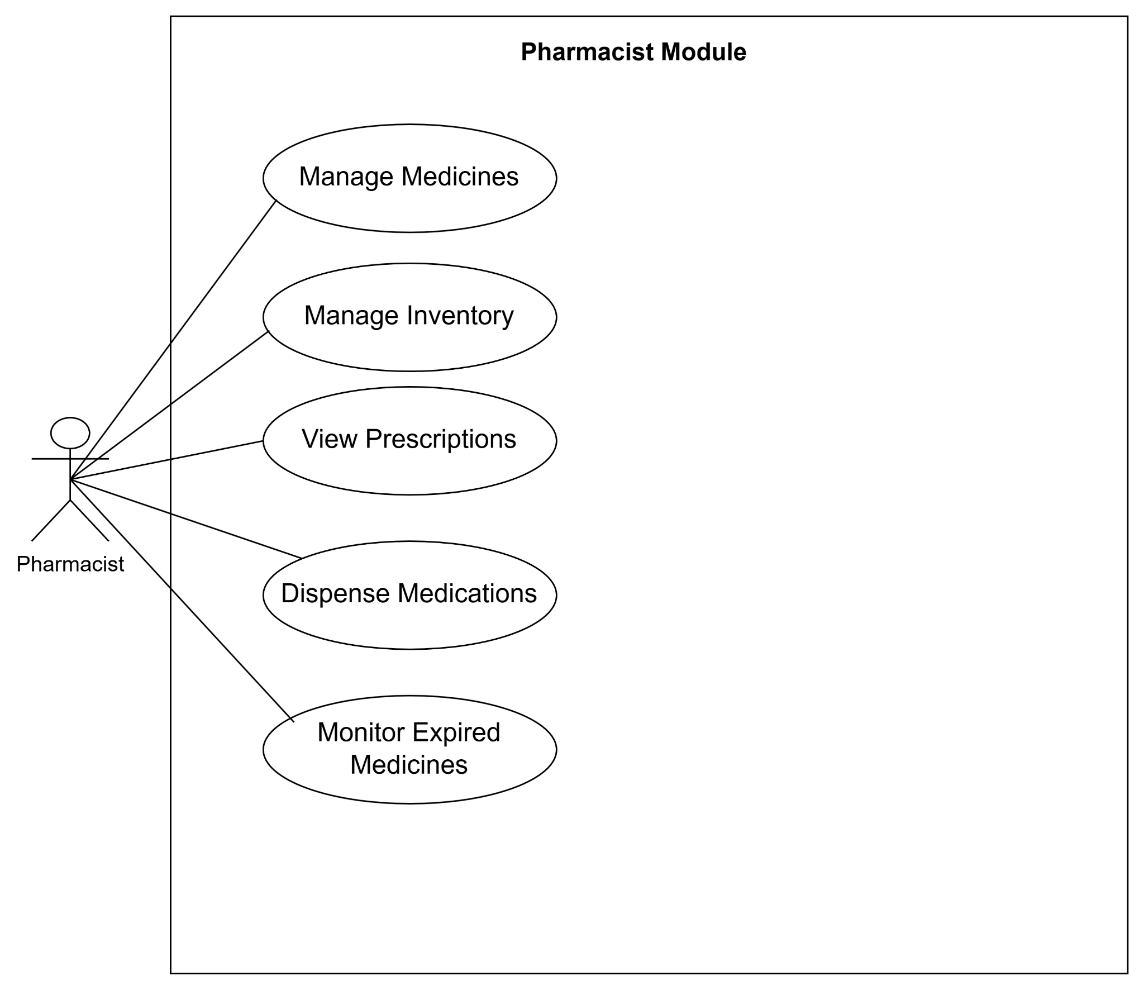

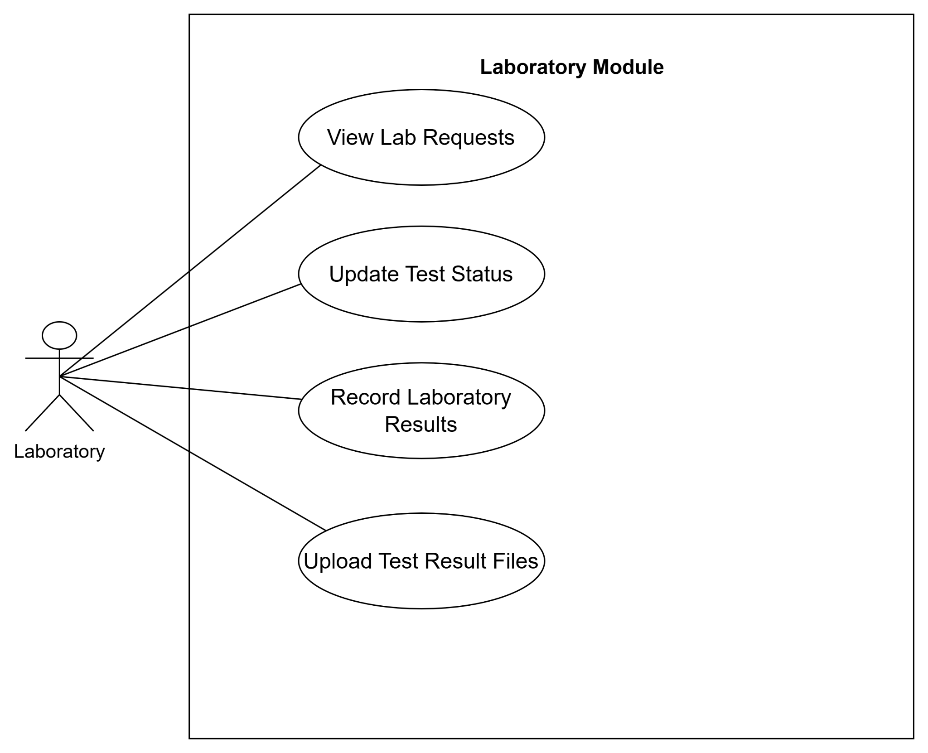

b. Descriptions

ID | Feature | Use case | Description
UC-01 | Authentication | Register Account | Allows patients to register a new account on the clinic platform.
UC-02 | Authentication | Login | Allows users to log into the system using standard credentials or a Google account.
UC-03 | Authentication | Recover Password | Allows users to reset or recover their forgotten password via email/OTP.
UC-04 | User Management | Manage Profile | Allows users (patients/staff) to view and update their personal profile information.
UC-05 | Notification | Receive Notifications | Pushes alerts, appointment reminders, and status updates to users.
UC-06 | AI Support | AI Symptom Triage | Allows patients to chat with the AI to analyze initial symptoms and receive specialty recommendations.
UC-07 | Booking | Book Appointment | Allows patients to schedule an appointment by selecting a specialty, doctor, and time slot.
UC-08 | Booking | Manage Appointment | Allows patients and receptionists to modify or cancel an existing appointment.
UC-09 | Queue Mgmt | Track Queue Status | Allows patients to monitor their queue number, appointment status, and estimated wait time.
UC-10 | EHR | View Medical Records | Allows patients to access their medical history, lab results, prescriptions, and invoices.
UC-11 | Feedback | Submit Feedback | Allows patients to rate and submit reviews regarding doctors or clinic services.
UC-12 | Clinical | View Work Schedule | Allows doctors to view their personal work schedule and patient queue for the day.
UC-13 | Clinical | Transfer Shift/Schedule | Allows doctors to transfer shifts or redirect patient appointments to another available doctor.
UC-14 | Clinical | Conduct Consultation | Allows doctors to view patient history, perform exams, and input diagnoses with AI voice-to-text support.
UC-15 | Clinical | Request Lab Tests | Allows doctors to order laboratory or clinical tests for the patient.
UC-16 | Prescription | Create Prescription | Allows doctors to prescribe medication; system integrates with RxNorm/Drug API to trigger drug interaction alerts.
UC-17 | HR Mgmt | Request Leave | Allows doctors to submit requests for schedule changes or leave time.
UC-18 | Reception | Manage Check-in | Allows receptionists to confirm online check-ins, register walk-in patients, and create new patient profiles.
UC-19 | Queue Mgmt | Coordinate Queue | Allows receptionists to issue queue numbers and manage the flow of online vs. walk-in patients.
UC-20 | Billing | Process Invoices | Allows receptionists to generate invoices, process cash payments, and handle refund requests.
UC-21 | Billing | Process Online Payment | Processes online booking/consultation fees via the Payment Gateway and returns transaction statuses.
UC-22 | Pharmacy | Manage Inventory | Allows pharmacists to perform CRUD operations on the medicine catalog and receive expiration alerts.
UC-23 | Pharmacy | Dispense Medicine | Allows pharmacists to view the dispensing queue, verify prescriptions, and issue medicines to patients.
UC-24 | Laboratory | Manage Lab Requests | Allows lab technicians to view the queue of incoming lab requests and update processing statuses.
UC-25 | Laboratory | Submit Lab Results | Allows lab technicians to input test results, attach files, and send them back to the requesting doctor.
UC-26 | System Admin | Manage Users & Roles | Allows admins to perform CRUD operations on doctor, staff, and patient profiles, as well as manage role-based access.
UC-27 | System Admin | Manage Clinic Catalog | Allows admins to perform CRUD operations on clinic specialties, medical services, news, and articles.
UC-28 | System Admin | Approve Leave Requests | Allows admins to review and approve/reject schedule change or leave requests submitted by doctors.
UC-29 | Reporting | View Statistical Reports | Allows admins and receptionists to view dashboards regarding revenue, visit counts, and cancellation rates.
UC-30 | Security | View Audit Logs | Allows admins to monitor system activity logs (e.g., login history, data modifications).
UC-31 | System Admin | Manage System Data | Allows admins to configure system settings, perform data backups, and restore data from previous versions.

2. Overall Functionalities

2.1 Screens Flow

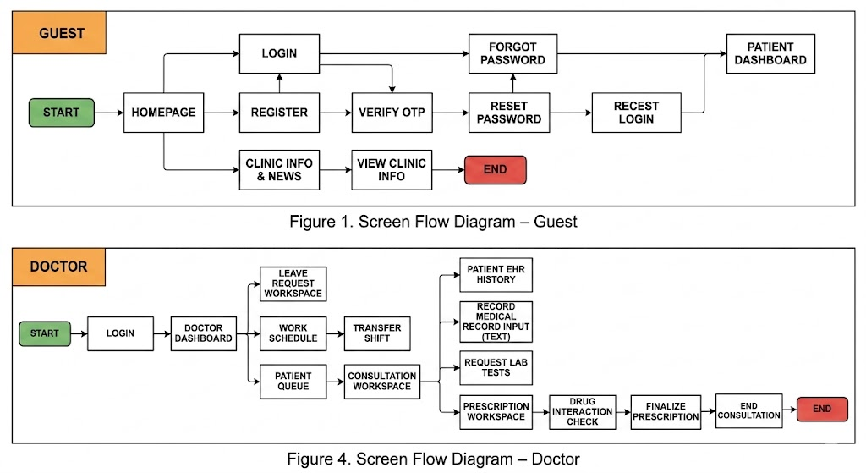
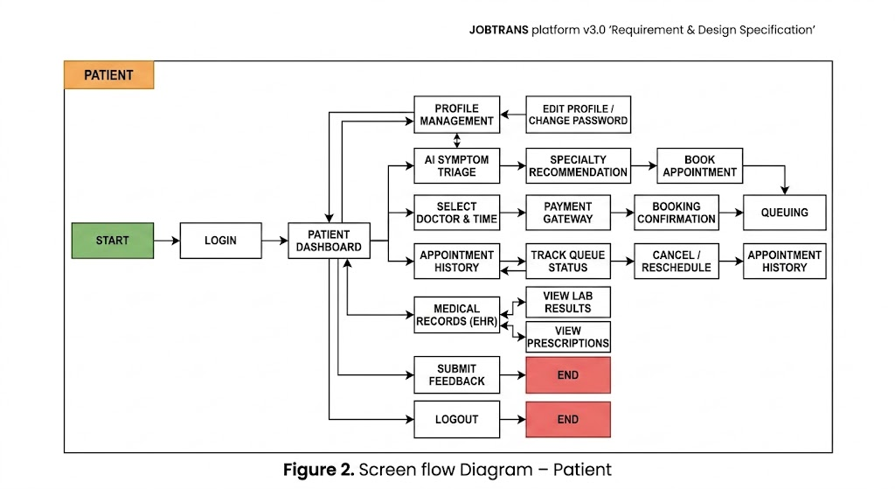
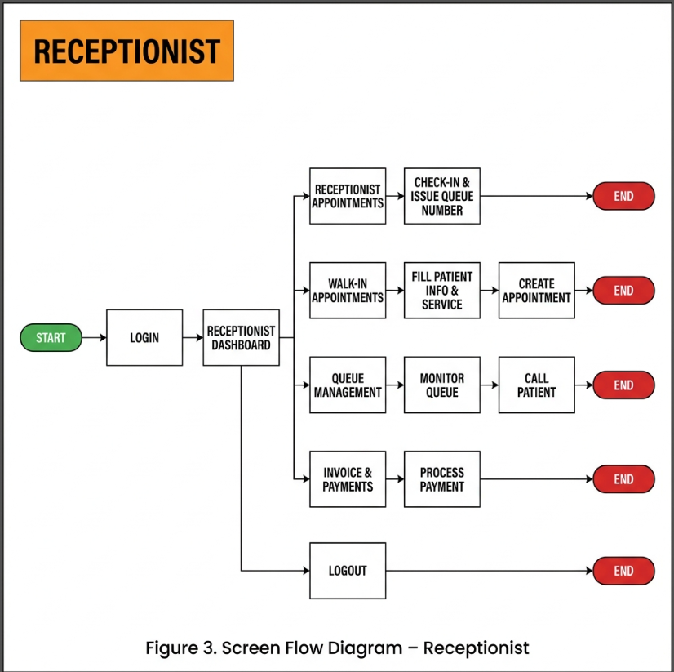


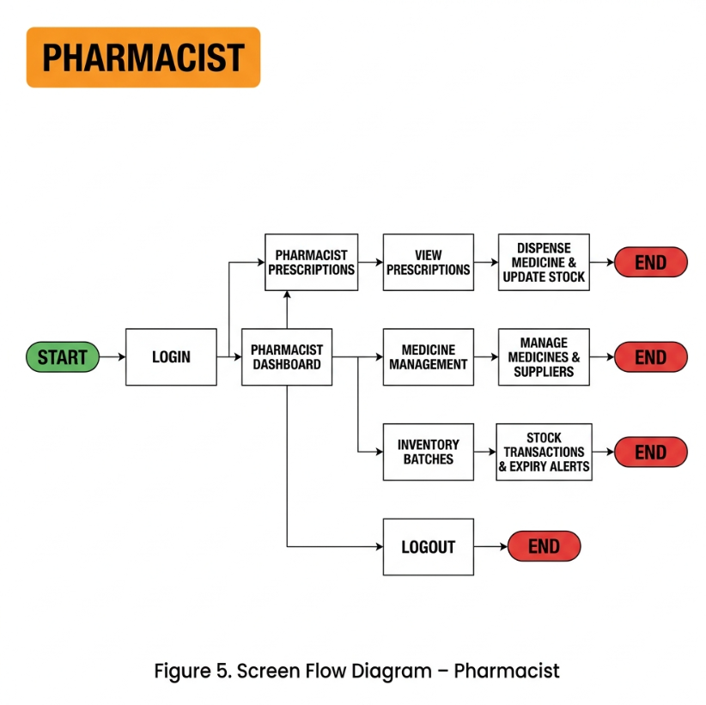
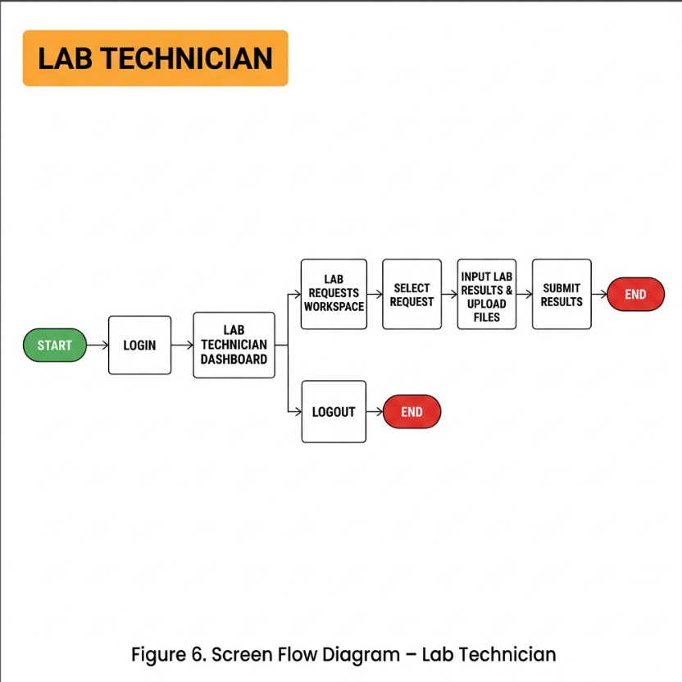
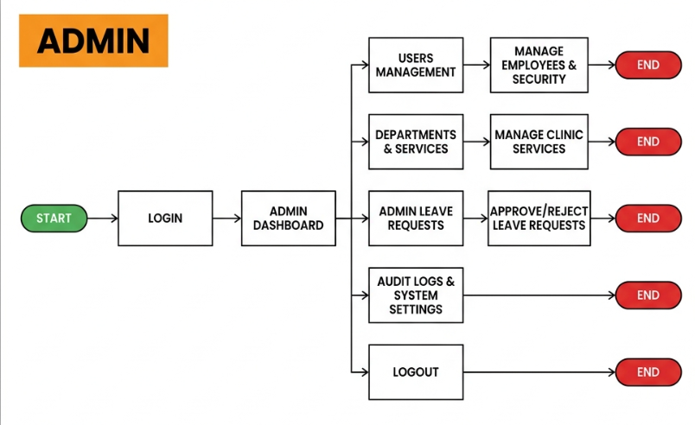

2.2 Screen Descriptions
ID | Feature | Screen | Description
1 | View homepage and clinic news | Homepage (Landing page) | Allows guests to view clinic information, introductions, public news, services, and navigate to Login or Register.
2 | User login | Login Page | Allows guests (patients, doctors, receptionist, pharmacist, admin) to authenticate with their credentials to access dashboards.
3 | Account registration | Register Page | Allows new patients to register an account by providing basic personal details.
4 | Reset forgotten password | Forgot Password | Allows users to request a password reset link or OTP verification via their registered email.
5 | OTP verification | Verify OTP | Allows users to verify their identity using a one-time password sent to their registered device/email.
6 | View summary status and shortcuts | Patient Dashboard | Allows logged-in patients to view upcoming appointments, medical alerts, and quick actions.
7 | Manage personal information | Profile Page | Allows patients to update their contact details, address, and edit personal profile information.
8 | Change account password | Change Password | Allows users to change their current password to a new one for security purposes.
9 | Diagnose symptoms using AI | AI Symptom Triage | Provides an AI chat interface that helps patients check symptoms and receive department recommendations.
10 | Select doctor and appointment slot | Book Appointment | Allows patients to select specialized departments, specific doctors, date, and available time slots.
11 | View appointment history | Appointment History | Allows patients to track their past and scheduled appointments and view detailed status.
12 | Track queuing number in real-time | Track Queue Status | Allows patients to view their current position in the clinic queue for their scheduled room.
13 | View personal medical records | Medical Records (EHR) | Allows patients to view their personal Electronic Health Records, including history of visits, diagnoses, and lab results.
14 | View laboratory test results | View Lab Results | Allows patients to check and download results of clinical tests ordered by doctors.
15 | View prescriptions | View Prescriptions | Allows patients to view prescribed medicines, dosages, and usage instructions after consultation.
16 | Submit clinic feedback | Submit Feedback / Review | Allows patients to write feedback, ratings, and reviews for clinic services and doctors.
17 | Manage doctor scheduling | Work Schedule | Allows doctors to view their weekly/monthly schedules and request to transfer shifts with colleagues.
18 | Request leave | Leave Request | Allows doctors to submit leave requests or absent days with reasons for admin approval.
19 | Manage doctor queue | Patient Queue | Allows doctors to see the queue of patients waiting outside their consultation room and call the next patient.
20 | Consult and diagnose patients | Consultation Workspace | Provides doctors with a workspace to view patient history, record symptoms, diagnose, and input medical records.
21 | Order laboratory tests | Request Lab Tests | Allows doctors to order specific lab tests (blood tests, X-rays, etc.) for the patient during consultation.
22 | Prescribe medications | Prescription Workspace | Allows doctors to search for medicines in inventory, specify dosages, check drug interactions, and finalize prescriptions.
23 | Check-in scheduled patients | Receptionist Appointments | Allows receptionists to verify patient appointment details, confirm attendance, and assign queue numbers.
24 | Book direct appointments | Walk-in Appointment | Allows receptionists to register and book immediate slots for walk-in patients who did not schedule online.
25 | Manage clinic traffic and queues | Queue Management | Allows receptionists to monitor active queues, re-route patients to different rooms, and manage clinic workflow.
26 | Manage invoices and billing | Invoice Management | Allows receptionists to view, generate, print, and track invoices for medical services and examinations.
27 | Process patient payments | Payment Gateway | Integrates payment options to charge patients for invoices and update status to paid.
28 | Process payment refunds | Refund Management | Allows receptionists to process refund requests for canceled appointments or incorrect charges.
29 | Search patient records | Patient Database | Allows receptionists to search and view profiles and contact details of all registered patients.
30 | View pending prescriptions | Pharmacist Dashboard | Allows pharmacists to view a real-time list of prescriptions waiting to be prepared and dispensed.
31 | Dispense medications | Pharmacist Prescriptions | Allows pharmacists to view prescription details, verify items, prepare packages, and confirm dispensing to patients.
32 | Manage medicine directory | Medicine Management | Allows pharmacists to view, add, edit, and delete details of medicines in the clinic catalog.
33 | Manage inventory suppliers | Supplier Management | Allows pharmacists to manage details of pharmaceutical suppliers and distributors.
34 | Track medicine inventory batches | Inventory Batches | Allows pharmacists to manage specific batches of imported medicines, tracking manufacture and expiry dates.
35 | Monitor stock transactions | Stock Transactions | Logs all imports and exports of medicines to ensure complete inventory tracking and transparency.
36 | Check inventory notifications | Alerts Dashboard | Displays warnings for low stock levels and items that are close to or past their expiration dates.
37 | Manage laboratory requests | Lab Request Workspace | Allows lab technicians to view pending lab orders, input test results, upload reports/files, and complete requests.
38 | Manage clinic employees | Users Page (Admin) | Allows administrators to create, edit, lock, or unlock accounts for clinic staff (doctors, receptionists, pharmacists, etc.).
39 | Manage departments and clinics | Department Management | Allows administrators to manage clinic departments, specialties, and assign physical rooms.
40 | Manage medical services prices | Medical Services | Allows administrators to define, add, edit, and set pricing for clinical services and test types.
41 | Approve doctor leaves | Admin Leave Requests | Allows administrators to review, approve, or reject leave requests submitted by doctors.
42 | Monitor system actions | Audit Log Page | Allows administrators to view system-wide audit trails, logging actions performed by all users for security.
43 | Configure system-wide settings | System Settings | Allows administrators to modify global configurations, clinic operation hours, and AI engine parameters.

2.3 Screen Authorization

Screen | Guest | Patient | Doctor | Receptionist | Pharmacist | Lab Tech | Admin
Homepage (Landing page) | X | X | X | X | X | X | X
Login | X
Log in with Credentials | X
Log in with Google (OAuth2) | X
Register | X
Forgot Password / Verify OTP | X
Dashboard Layout (Portal) |  | X | X | X | X | X | X
Profile & Change Password |  | X | X | X | X | X | X
AI Symptom Triage (Chat) |  | X
Book Appointment |  | X
Patient Queue Status |  | X
Patient Appointment History |  | X
Patient Medical Records (EHR) |  | X
Patient Lab Results & Prescriptions |  | X
Submit Feedback / Review |  | X
Doctor Today's Appointments |  |  | X
Doctor Leave Requests |  |  | X
Consultation Workspace |  |  | X
Examination Details |  |  | X
Receptionist Appointments (Check-in) |  |  |  | X
Walk-in Appointment Booking |  |  |  | X
Queue Management & Traffic |  |  |  | X
Invoice & Payment Management |  |  |  | X
Refund Management |  |  |  | X
Patient Database Search |  |  |  | X
Pharmacist Prescriptions (Dispense) |  |  |  |  | X
Medicine & Supplier Management |  |  |  |  | X
Inventory Batches & Transactions |  |  |  |  | X
Low Stock / Expiring Alerts |  |  |  |  | X
Lab Requests (Process Test) |  |  | X |  |  | X
Users Management (Staff Accounts) |  |  |  |  |  |  | X
Security Configuration |  |  |  |  |  |  | X
Department Management |  |  |  |  |  |  | X
Medical Service & Price Management |  |  |  |  |  |  | X
Admin Approve Leave Requests |  |  |  |  |  |  | X
Audit Logs |  |  |  |  |  |  | X
System Settings |  |  |  |  |  |  | X
Notifications Panel |  | X | X | X | X | X | X

2.4 Non-UI Functions
# | Feature | System Function | Description
1 | Auth | Email OTP Service | Delivers registration and password-reset OTP codes to the user's email.
2 | Pharmacy | Drug Interaction API | Automatically validates added medicines against an interaction database.
3 | Billing | Payment Webhook | Receives callback notification carrying the transaction result payload.

3. System High Level Design

3.1 Database Design

a. Database Schema

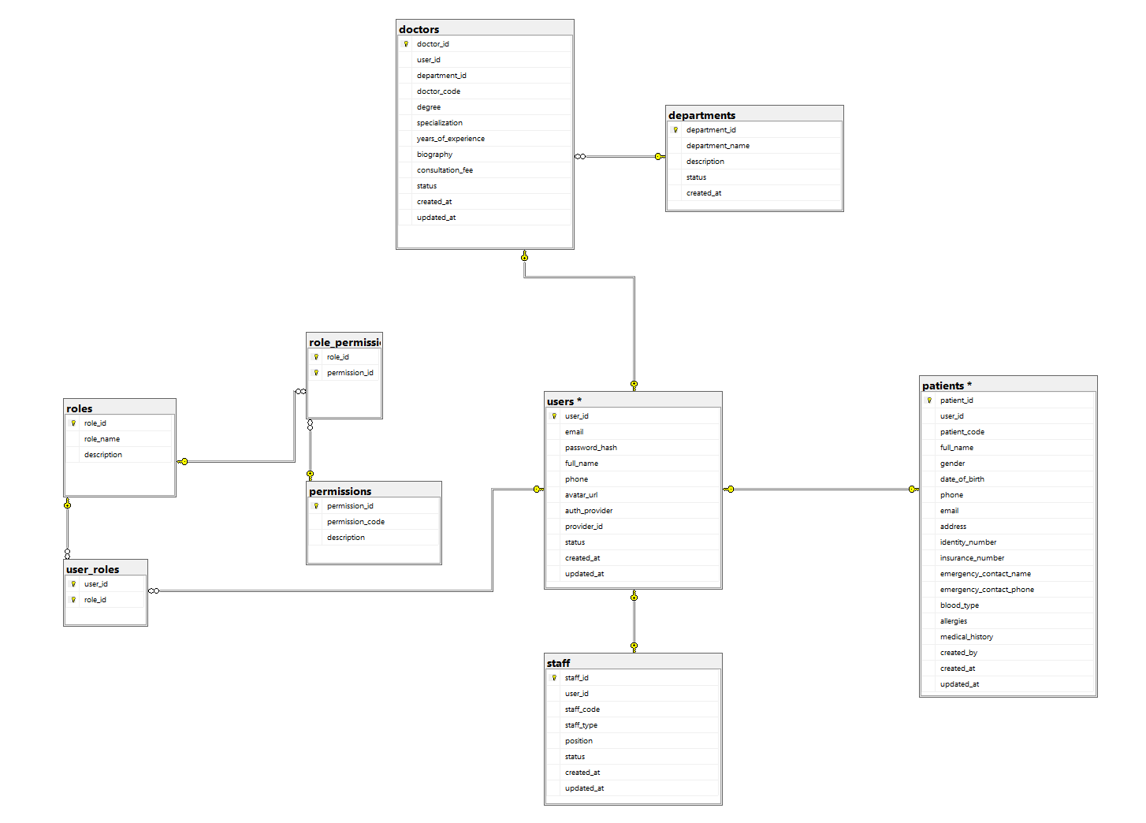
Module 1: Lược đồ User & HR Management

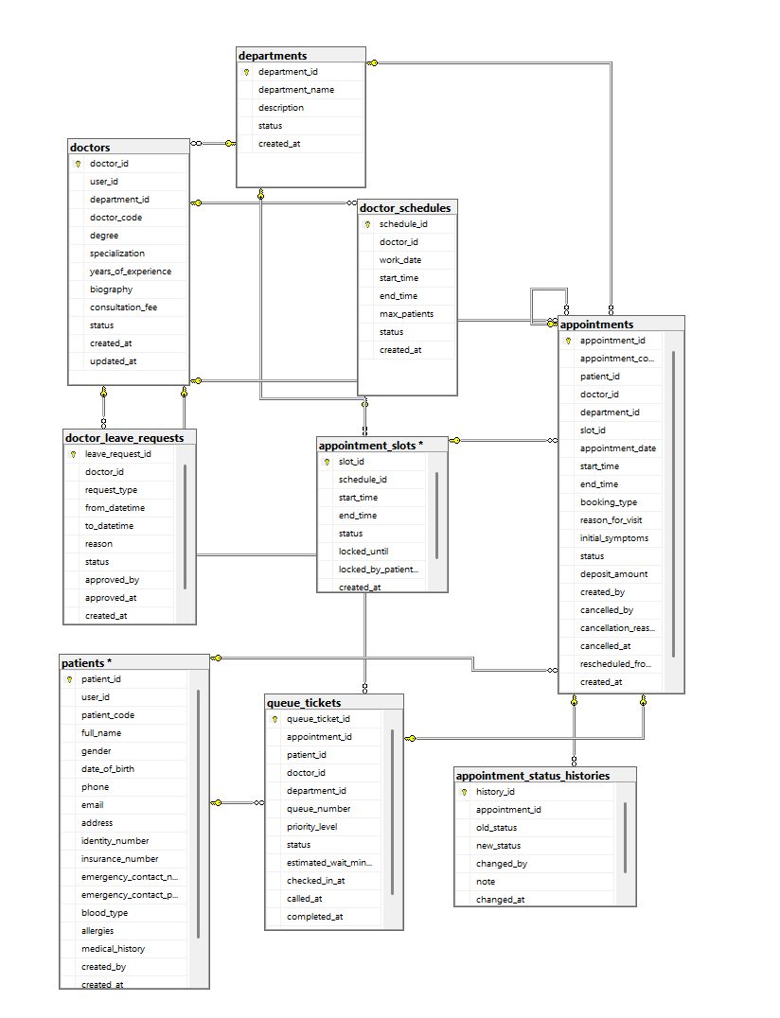
Module 2: Lược đồ Booking & Queue Management

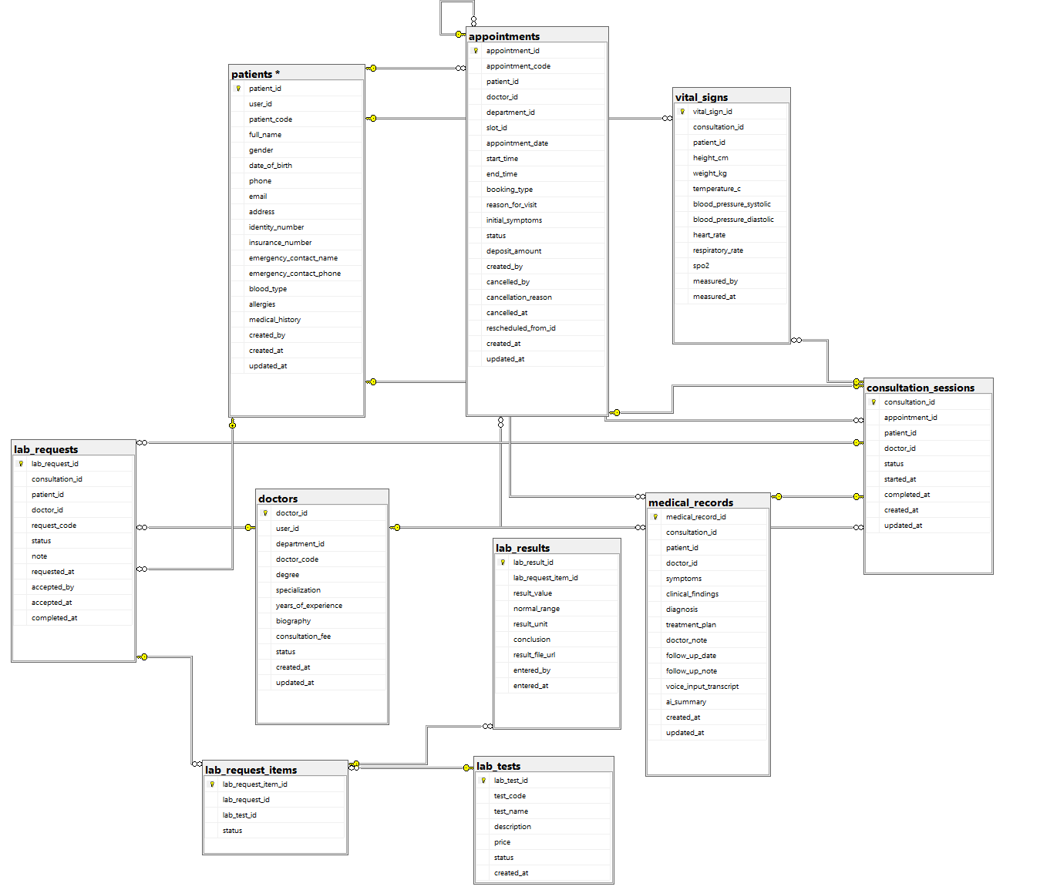
Module 3: Lược đồ Examination, Lab & EHR

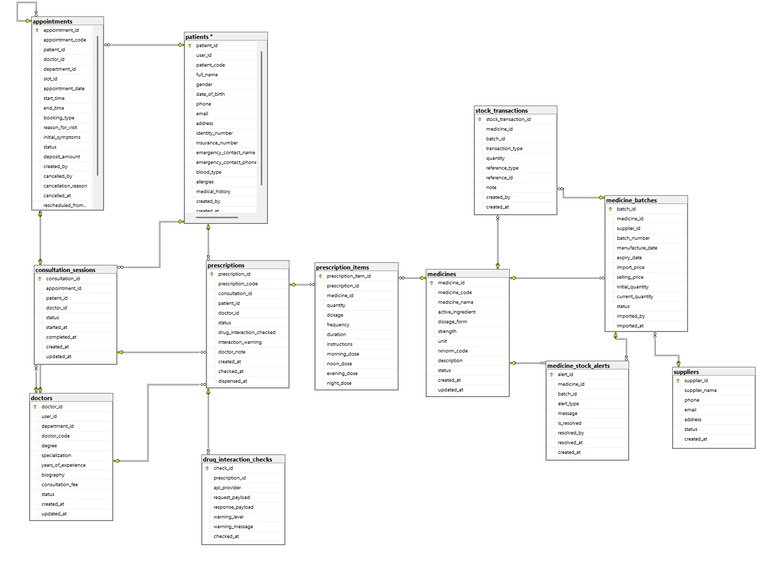
Module 4: Lược đồ Prescription & Pharmacy

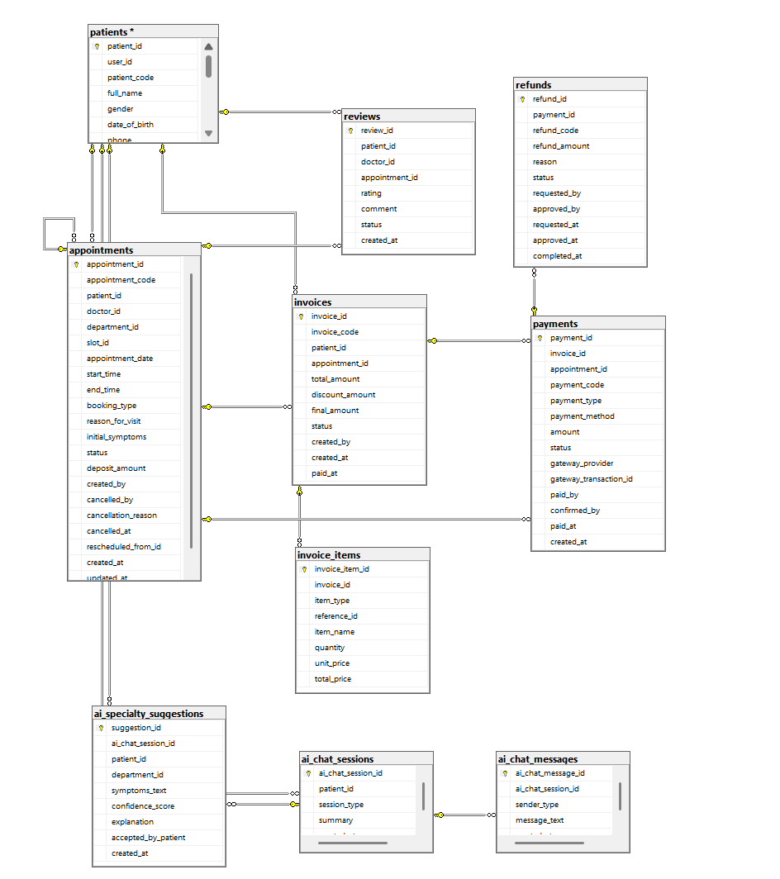
Module 5: Lược đồ Billing & CRM

b. Table Descriptions
No | Table | Description
01 | users  (User & HR) | Identity record: email, password_hash, full_name, phone, status.  - Primary keys: user_id
02 | doctors  (User & HR) | Professional clinical classifications, licensing identifiers, billing rates.  - Primary keys: doctor_id  - Foreign keys: user_id
03 | appointments  (Booking & Queue) | Maintains doctor appointment slot availability and booking status.  - Primary keys: appointment_id  - Foreign keys: patient_id, doctor_id
04 | medical_records  (Exam, Lab & EHR) | Stores diagnoses, treatment plans, consultation outcomes.  - Primary keys: record_id  - Foreign keys: patient_id, appointment_id
05 | lab_requests  (Exam, Lab & EHR) | Stores lab test requests and results.  - Primary keys: lab_id  - Foreign keys: record_id, lab_tech_id
06 | prescriptions  (Prescription & Pharmacy) | Stores prescribed medicines linked to a medical record.  - Primary keys: prescription_id  - Foreign keys: record_id, pharmacist_id
07 | medicines  (Prescription & Pharmacy) | Inventory of medicines and RxNorm integration keys.  - Primary keys: medicine_id
08 | invoices  (Billing & CRM) | Structured billing document store linking computed service totals.  - Primary keys: invoice_id  - Foreign keys: patient_id, appointment_id

3.2 Code Packages
No | Package | Description
01 | com.clinic.auth | Contains JWT security filters, Auth controllers, and OAuth2 services.
02 | com.clinic.hr | Contains User, Role, and Doctor/Staff management logic.
03 | com.clinic.booking | Contains Appointment scheduling and Queue management logic.
04 | com.clinic.clinical | Contains EHR, Lab requests, and Examination workflows.
05 | com.clinic.pharmacy | Contains Prescription creation, Drug interaction API, and Inventory logic.
06 | com.clinic.billing | Contains Invoicing, Payments, and Payment Webhook handling.

II. Requirement Specifications

1. Authentication

1.1 UC-01_Register

a. Functionalities
UC ID and Name: | UC-01_Register
Created By: | Nguyễn Anh Trịnh
Date Created: | 17/06/2026
Primary Actor: | Guest
Secondary Actors: | System
Trigger: | Guest clicks the “Register” button.
Description: | As a guest, I want to register a patient account so that I can access the clinic system and use online medical services.
Preconditions: | The guest has not logged in and has valid personal information.
Postconditions: | A new patient account is created successfully and can be used to log in.
Normal Flow: | 1.0 Register Patient Account  1. Guest opens the Smart Clinic Management System website.  2. Guest clicks the “Register” button.  3. System displays the registration form.  4. Guest enters full name, email, phone number, password, and required personal information.  5. Guest submits the registration form.  6. System validates the entered information.  7. System checks whether the email or phone number already exists.  8. System creates a new patient account.  9. System displays a successful registration message.
Alternative Flows: | 1.0.A1 Guest cancels registration  1. Guest leaves the registration page before submitting.  2. System does not save any account information.
Exceptions: | 1.0.E1 Invalid registration information  1. System detects invalid email, phone number, or password format.  2. System displays an error message and asks the guest to correct the information.  1.0.E2 Email or phone number already exists  1. System detects duplicated email or phone number.  2. System displays an error message and prevents account creation.
Priority: | Must have
Frequency of Use: | On demand
Business Rules: | BR-01, BR-02, BR-03
Other Information: | Only patient accounts are allowed to self-register.
Assumptions: | The system is available and connected to the database.

b. Business Rules
ID | Business Rule | Business Rule Description
BR-01 | Unique Account Rule | Email and phone number must be unique in the system.
BR-02 | Password Format Rule | Password must meet the required length and security format.
BR-03 | Patient Self-registration Rule | Only Patient accounts can be created through the public registration form.

1.2 UC-02_Login

a. Functionalities
UC ID and Name: | UC-02_Login
Created By: | Nguyễn Anh Trịnh
Date Created: | 17/06/2026
Primary Actor: | Patient, Doctor, Receptionist, Pharmacist, Lab Technician, Admin
Secondary Actors: | System
Trigger: | User enters login credentials and clicks the “Login” button.
Description: | As a user, I want to log in to the system so that I can access functions based on my assigned role.
Preconditions: | User already has an active account in the system.
Postconditions: | User logs in successfully and is redirected to the correct dashboard.
Normal Flow: | 1.0 Login System  1. User opens the login page.  2. User enters email and password.  3. User clicks the “Login” button.  4. System validates the login credentials.  5. System checks the user role and account status.  6. System creates an authenticated session/token.  7. System redirects the user to the dashboard based on their role.
Alternative Flows: | 1.0.A1 User chooses forgot password  1. User clicks “Forgot Password”.  2. System redirects the user to the password recovery page.
Exceptions: | 1.0.E1 Wrong email or password  1. System detects invalid credentials.  2. System displays an error message.  1.0.E2 Account is inactive  1. System detects that the account has been deactivated.  2. System blocks the login request and displays a notification.
Priority: | Must have
Frequency of Use: | Frequently
Business Rules: | BR-04, BR-05
Other Information: | Each actor can only access functions allowed by their role.
Assumptions: | User remembers the registered email and password.

b. Business Rules
ID | Business Rule | Business Rule Description
BR-04 | Authentication Rule | User must provide correct email and password to log in.
BR-05 | Role-based Access Rule | User can only access features that match their assigned role.

1.3 UC-03_Forgot_Password

a. Functionalities
UC ID and Name: | UC-03_Forgot_Password
Created By: | Nguyễn Anh Trịnh
Date Created: | 17/06/2026
Primary Actor: | Patient, Doctor, Receptionist, Pharmacist, Lab Technician, Admin
Secondary Actors: | System, Email Service
Trigger: | User clicks the “Forgot Password” link on the login page.
Description: | As a user, I want to reset my password so that I can regain access to my account.
Preconditions: | User has an existing email registered in the system.
Postconditions: | User can set a new password and use it to log in.
Normal Flow: | 1.0 Reset Password  1. User clicks “Forgot Password”.  2. System displays the password recovery form.  3. User enters the registered email address.  4. System validates the email address.  5. System sends a password reset link or verification code to the email.  6. User opens the reset link or enters the verification code.  7. User enters a new password and confirms it.  8. System validates the new password.  9. System updates the password successfully.
Alternative Flows: | 1.0.A1 User returns to login page  1. User cancels the password recovery process.  2. System redirects the user back to the login page.
Exceptions: | 1.0.E1 Email does not exist  1. System cannot find the entered email.  2. System displays an error message.  1.0.E2 Password confirmation does not match  1. System detects that the new password and confirmation password are different.  2. System asks the user to re-enter the password.
Priority: | Should have
Frequency of Use: | On demand
Business Rules: | BR-06, BR-07
Other Information: | Reset link or verification code should be valid for a limited time.
Assumptions: | Email service is available.

b. Business Rules
ID | Business Rule | Business Rule Description
BR-06 | Registered Email Rule | Password reset is only allowed for registered email addresses.
BR-07 | Password Reset Security Rule | New password must follow the system password format and confirmation must match.

1.4 UC-04_Manage_Staff_Accounts

a. Functionalities
UC ID and Name: | UC-04_Manage_Staff_Accounts
Created By: | Nguyễn Anh Trịnh
Date Created: | 17/06/2026
Primary Actor: | Admin
Secondary Actors: | System, Staff
Trigger: | Admin opens the staff account management page.
Description: | As an Admin, I want to manage staff accounts so that clinic staff can access the system with correct roles.
Preconditions: | Admin has logged in successfully.
Postconditions: | Staff account information is created, updated, deactivated, or assigned a role successfully.
Normal Flow: | 1.0 Manage Staff Account  1. Admin opens the staff account management page.  2. System displays the list of staff accounts.  3. Admin chooses to add, update, deactivate, or assign role to a staff account.  4. Admin enters or modifies staff information.  5. System validates the entered information.  6. System saves the staff account changes.  7. System displays a success message and updates the staff list.
Alternative Flows: | 1.0.A1 Admin searches for a staff account  1. Admin enters staff name, email, or role in the search field.  2. System displays matching staff accounts.
Exceptions: | 1.0.E1 Duplicate staff email  1. System detects that the staff email already exists.  2. System prevents saving and displays an error message.  1.0.E2 Invalid role assignment  1. Admin selects an invalid or unavailable role.  2. System rejects the request and displays an error message.
Priority: | Must have
Frequency of Use: | On demand
Business Rules: | BR-08, BR-09, BR-10
Other Information: | Staff accounts include Doctor, Receptionist, Pharmacist, Lab Technician, and Admin.
Assumptions: | Admin has permission to manage staff accounts.

b. Business Rules
ID | Business Rule | Business Rule Description
BR-08 | Staff Account Permission Rule | Only Admin can create, update, deactivate, and assign staff roles.
BR-09 | Unique Staff Email Rule | Each staff account must have a unique email address.
BR-10 | Account Deactivation Rule | Deactivated accounts cannot log in to the system.

2. Appointment Booking & Queue Management

2.1 UC-05_AI_Symptom_Triage

a. Functionalities
UC ID and Name: | UC-05_AI_Symptom_Triage
Created By: | Nguyễn Anh Trịnh
Date Created: | 17/06/2026
Primary Actor: | Patient
Secondary Actors: | AI Assistant, System
Trigger: | Patient enters symptoms into the AI medical assistant.
Description: | As a Patient, I want to describe my symptoms to the AI assistant so that I can receive basic health guidance and department suggestions.
Preconditions: | Patient has logged in and can access the AI assistant feature.
Postconditions: | System displays AI response and suggested medical department if applicable.
Normal Flow: | 1.0 AI Symptom Triage  1. Patient opens the AI assistant page.  2. System displays the chat interface.  3. Patient enters symptoms or health concerns.  4. System sends the message to the AI service.  5. AI analyzes the symptoms and generates a response.  6. System displays the AI response to the patient.  7. Patient may use the suggestion to book an appointment with a suitable department.
Alternative Flows: | 1.0.A1 Patient continues the conversation  1. Patient asks follow-up questions.  2. System continues displaying AI responses based on conversation history.
Exceptions: | 1.0.E1 AI service unavailable  1. System cannot connect to the AI service.  2. System displays a temporary unavailable message.  1.0.E2 Empty symptom input  1. Patient sends an empty message.  2. System asks the patient to enter symptom details.
Priority: | Should have
Frequency of Use: | On demand
Business Rules: | BR-11, BR-12
Other Information: | AI advice is for reference only and does not replace professional diagnosis.
Assumptions: | AI service is configured and available.

b. Business Rules
ID | Business Rule | Business Rule Description
BR-11 | AI Medical Disclaimer Rule | AI response must include medical safety guidance and recommend visiting a doctor when necessary.
BR-12 | AI Input Rule | Patient must enter valid symptom information before receiving AI advice.

2.2 UC-06_Book_Appointment

a. Functionalities
UC ID and Name: | UC-06_Book_Appointment
Created By: | Nguyễn Anh Trịnh
Date Created: | 17/06/2026
Primary Actor: | Patient
Secondary Actors: | Doctor, System
Trigger: | Patient clicks the “Book Appointment” button.
Description: | As a Patient, I want to book an online appointment so that I can schedule a medical consultation in advance.
Preconditions: | Patient has logged in and doctors or departments are available.
Postconditions: | Appointment is created successfully and the selected time slot is reserved.
Normal Flow: | 1.0 Book Online Appointment  1. Patient opens the appointment booking page.  2. System displays available departments, doctors, and schedules.  3. Patient selects department, doctor, date, and available time slot.  4. Patient enters the reason for visit if required.  5. Patient submits the booking request.  6. System validates the booking information.  7. System checks whether the selected slot is still available.  8. System creates the appointment.  9. System reserves the selected slot.  10. System displays booking confirmation to the patient.
Alternative Flows: | 1.0.A1 Patient changes selected slot  1. Patient selects another date or time slot before submitting.  2. System refreshes the available slots.
Exceptions: | 1.0.E1 Slot is no longer available  1. System detects that the selected slot has been booked by another patient.  2. System asks the patient to choose another available slot.  1.0.E2 Missing booking information  1. System detects missing required fields.  2. System displays validation messages.
Priority: | Must have
Frequency of Use: | Frequently
Business Rules: | BR-13, BR-14, BR-15
Other Information: | Appointment may generate related payment information depending on clinic policy.
Assumptions: | Doctor schedules are already configured.

b. Business Rules
ID | Business Rule | Business Rule Description
BR-13 | Available Slot Rule | Patient can only book an appointment in an available time slot.
BR-14 | Appointment Ownership Rule | Patient can only book and view their own appointments.
BR-15 | Duplicate Booking Rule | The same patient should not book duplicate appointments in the same time slot.

2.3 UC-07_Book_WalkIn_Appointment

a. Functionalities
UC ID and Name: | UC-07_Book_WalkIn_Appointment
Created By: | Nguyễn Anh Trịnh
Date Created: | 17/06/2026
Primary Actor: | Receptionist
Secondary Actors: | Patient, System
Trigger: | Receptionist receives a walk-in patient at the clinic counter.
Description: | As a Receptionist, I want to create a walk-in appointment so that patients without online booking can register for examination.
Preconditions: | Receptionist has logged in and the patient provides necessary information.
Postconditions: | Walk-in appointment is created and ready for check-in or queue processing.
Normal Flow: | 1.0 Create Walk-in Appointment  1. Patient arrives at the clinic reception counter.  2. Receptionist opens the walk-in appointment page.  3. Receptionist searches for an existing patient or enters new patient information.  4. Receptionist selects department, doctor, and appointment information.  5. System validates the entered information.  6. System creates a walk-in appointment.  7. System displays the appointment information to the receptionist.
Alternative Flows: | 1.0.A1 New patient registration at counter  1. Receptionist cannot find the patient in the system.  2. Receptionist enters new patient profile information.  3. System creates patient information before creating the walk-in appointment.
Exceptions: | 1.0.E1 Missing patient information  1. System detects missing required patient information.  2. System asks the receptionist to complete the information.  1.0.E2 Doctor unavailable  1. System detects that the selected doctor is unavailable.  2. System asks receptionist to select another doctor or department.
Priority: | Must have
Frequency of Use: | Frequently
Business Rules: | BR-16, BR-17
Other Information: | Walk-in appointments are usually created by receptionist, not by patient.
Assumptions: | Receptionist has permission to create walk-in appointments.

b. Business Rules
ID | Business Rule | Business Rule Description
BR-16 | Walk-in Creation Rule | Only Receptionist can create walk-in appointments at the clinic counter.
BR-17 | Patient Information Rule | Required patient information must be provided before a walk-in appointment is created.

2.4 UC-08_CheckIn_Patient

a. Functionalities
UC ID and Name: | UC-08_CheckIn_Patient
Created By: | Nguyễn Anh Trịnh
Date Created: | 17/06/2026
Primary Actor: | Receptionist
Secondary Actors: | Patient, System
Trigger: | Patient arrives at the clinic and receptionist clicks “Check-in”.
Description: | As a Receptionist, I want to check in patients so that their arrival is confirmed and queue number is issued.
Preconditions: | Patient has an appointment for the current day or a valid walk-in registration.
Postconditions: | Patient is checked in and a queue ticket is created.
Normal Flow: | 1.0 Check-in Patient  1. Patient arrives at the clinic counter.  2. Receptionist searches the appointment by appointment code, phone number, or patient name.  3. System displays matching appointment information.  4. Receptionist verifies patient information.  5. Receptionist clicks the “Check-in” button.  6. System updates appointment status to checked-in.  7. System creates a queue ticket for the patient.  8. System displays the queue number.
Alternative Flows: | 1.0.A1 Appointment not found by code  1. Receptionist searches by phone number or patient name.  2. System displays matching results if available.
Exceptions: | 1.0.E1 Appointment is not for today  1. System detects that the appointment date is not today.  2. System prevents check-in and displays an error message.  1.0.E2 Patient already checked in  1. System detects an existing queue ticket.  2. System prevents duplicate check-in.
Priority: | Must have
Frequency of Use: | Daily
Business Rules: | BR-18, BR-19
Other Information: | Queue number is used for consultation order.
Assumptions: | Appointment data is available in the system.

b. Business Rules
ID | Business Rule | Business Rule Description
BR-18 | Same-day Check-in Rule | Patient can only be checked in for appointments scheduled on the current day.
BR-19 | Unique Queue Ticket Rule | Each checked-in appointment can only have one active queue ticket.

2.5 UC-09_Manage_Queue

a. Functionalities
UC ID and Name: | UC-09_Manage_Queue
Created By: | Nguyễn Anh Trịnh
Date Created: | 17/06/2026
Primary Actor: | Receptionist
Secondary Actors: | Doctor, Patient, System
Trigger: | Receptionist opens the queue management page.
Description: | As a Receptionist, I want to manage the patient queue so that patients are called and processed in the correct order.
Preconditions: | Patients have checked in and queue tickets have been created.
Postconditions: | Queue status is updated correctly.
Normal Flow: | 1.0 Manage Patient Queue  1. Receptionist opens the queue management page.  2. System displays the list of waiting patients.  3. Receptionist selects the next patient in the queue.  4. Receptionist clicks “Call Next”.  5. System updates the selected queue ticket status.  6. Patient is called for consultation.  7. Receptionist may skip or complete queue tickets when needed.  8. System updates the queue list in real time or after refresh.
Alternative Flows: | 1.0.A1 Skip patient  1. Patient is not available when called.  2. Receptionist clicks “Skip”.  3. System updates the queue status as skipped and moves to the next patient.
Exceptions: | 1.0.E1 No waiting patient  1. System detects that the waiting queue is empty.  2. System displays a message that no patient is waiting.  1.0.E2 Invalid queue status change  1. Receptionist tries to update a completed queue ticket.  2. System prevents the action.
Priority: | Must have
Frequency of Use: | Daily
Business Rules: | BR-20, BR-21
Other Information: | Queue status may include waiting, called, skipped, and completed.
Assumptions: | Receptionist manages queue based on clinic operation rules.

b. Business Rules
ID | Business Rule | Business Rule Description
BR-20 | Queue Order Rule | Patients should be called based on queue order unless special handling is required.
BR-21 | Queue Status Rule | Queue ticket status must follow a valid transition sequence.

3. Consultation & Diagnostics

3.1 UC-10_Conduct_Consultation

a. Functionalities
UC ID and Name: | UC-10_Conduct_Consultation
Created By: | Lưu Hòa
Date Created: | 17/06/2026
Primary Actor: | Doctor
Secondary Actors: | Patient, System
Trigger: | Doctor opens the consultation screen for a checked-in patient.
Description: | As a Doctor, I want to conduct a consultation so that I can examine the patient, record diagnosis, and update medical records.
Preconditions: | Doctor has logged in and the patient has checked in.
Postconditions: | Consultation information, diagnosis, and medical record are saved successfully.
Normal Flow: | 1.0 Conduct Patient Consultation  1. Doctor opens the consultation page.  2. System displays the list of patients waiting for consultation.  3. Doctor selects a patient.  4. System displays patient information, appointment details, and medical history.  5. Doctor examines the patient and records symptoms, vital signs, diagnosis, and clinical notes.  6. Doctor saves the consultation result.  7. System validates and stores the consultation information.  8. System updates the patient medical record.
Alternative Flows: | 1.0.A1 Doctor updates consultation note  1. Doctor edits consultation information before finalizing.  2. System saves the updated information.
Exceptions: | 1.0.E1 Missing required diagnosis information  1. System detects missing required fields.  2. System displays validation messages.  1.0.E2 Patient record cannot be loaded  1. System fails to load patient medical history.  2. System displays an error message and asks doctor to retry.
Priority: | Must have
Frequency of Use: | Daily
Business Rules: | BR-22, BR-23
Other Information: | Consultation may lead to lab test order or medication prescription.
Assumptions: | Doctor has permission to access assigned patient consultations.

b. Business Rules
ID | Business Rule | Business Rule Description
BR-22 | Doctor Access Rule | Doctor can only conduct consultations for assigned or valid clinic patients.
BR-23 | Medical Record Rule | Diagnosis and consultation notes must be stored in the patient medical record.

3.2 UC-11_Order_Lab_Tests

a. Functionalities
UC ID and Name: | UC-11_Order_Lab_Tests
Created By: | Lưu Hòa
Date Created: | 17/06/2026
Primary Actor: | Doctor
Secondary Actors: | Lab Technician, Patient, System
Trigger: | Doctor selects “Order Lab Test” during consultation.
Description: | As a Doctor, I want to order laboratory tests so that the patient can receive further diagnostic examination.
Preconditions: | A consultation is in progress or has been created for the patient.
Postconditions: | Lab test request is created and sent to Lab Technician for processing.
Normal Flow: | 1.0 Order Laboratory Test  1. Doctor opens the consultation detail page.  2. Doctor selects the “Order Lab Test” function.  3. System displays available laboratory services.  4. Doctor selects one or more lab tests.  5. Doctor enters test notes or instructions if needed.  6. Doctor submits the lab test request.  7. System validates the selected test information.  8. System creates lab test request records.  9. System sends the request to Lab Technician.
Alternative Flows: | 1.0.A1 Doctor removes selected test  1. Doctor removes a selected lab test before submission.  2. System updates the selected test list.
Exceptions: | 1.0.E1 No lab test selected  1. System detects that no test has been selected.  2. System asks doctor to select at least one lab test.  1.0.E2 Invalid consultation status  1. System detects that the consultation is not valid for ordering tests.  2. System blocks the request.
Priority: | Must have
Frequency of Use: | Frequently
Business Rules: | BR-24, BR-25
Other Information: | Lab test results will be returned by Lab Technician.
Assumptions: | Laboratory service list is available in the system.

b. Business Rules
ID | Business Rule | Business Rule Description
BR-24 | Lab Order Permission Rule | Only Doctor can order lab tests for patients during or after consultation.
BR-25 | Lab Service Selection Rule | At least one valid laboratory service must be selected to create a lab request.

3.3 UC-12_Prescribe_Medications

a. Functionalities
UC ID and Name: | UC-12_Prescribe_Medications
Created By: | Lưu Hòa
Date Created: | 17/06/2026
Primary Actor: | Doctor
Secondary Actors: | Pharmacist, Patient, System
Trigger: | Doctor selects “Create Prescription” during consultation.
Description: | As a Doctor, I want to prescribe medications so that the patient can receive proper treatment after consultation.
Preconditions: | Consultation has been created and patient diagnosis is available.
Postconditions: | Prescription is created and can be viewed by Pharmacist for medication dispensing.
Normal Flow: | 1.0 Prescribe Medication  1. Doctor opens the patient consultation page.  2. Doctor selects the prescription function.  3. System displays available medicines.  4. Doctor selects medicine and enters dosage, quantity, frequency, and instructions.  5. Doctor adds one or more medicines to the prescription.  6. Doctor submits the prescription.  7. System validates prescription details.  8. System saves the prescription.  9. System makes the prescription available to Pharmacist.
Alternative Flows: | 1.0.A1 Doctor edits medicine details  1. Doctor modifies dosage, quantity, or instruction before saving.  2. System updates the prescription draft.
Exceptions: | 1.0.E1 Missing dosage or quantity  1. System detects missing required medication information.  2. System displays validation messages.  1.0.E2 Medicine unavailable  1. System detects that selected medicine is inactive or unavailable.  2. System prevents the medicine from being prescribed.
Priority: | Must have
Frequency of Use: | Frequently
Business Rules: | BR-26, BR-27
Other Information: | Prescription is used by Pharmacist for dispensing medicine.
Assumptions: | Medicine catalog is maintained by Pharmacist.

b. Business Rules
ID | Business Rule | Business Rule Description
BR-26 | Prescription Permission Rule | Only Doctor can create prescriptions for patients.
BR-27 | Prescription Detail Rule | Each prescribed medicine must include dosage, quantity, and usage instruction.

3.4 UC-13_Process_Lab_Test

a. Functionalities
UC ID and Name: | UC-13_Process_Lab_Test
Created By: | Lưu Hòa
Date Created: | 17/06/2026
Primary Actor: | Lab Technician
Secondary Actors: | Doctor, Patient, System
Trigger: | Lab Technician opens the lab request management page.
Description: | As a Lab Technician, I want to process lab test requests so that test results can be recorded and returned to the doctor.
Preconditions: | Doctor has created a lab test request.
Postconditions: | Lab test result is recorded and made available to Doctor and Patient if allowed.
Normal Flow: | 1.0 Process Laboratory Test  1. Lab Technician opens the lab request page.  2. System displays pending lab test requests.  3. Lab Technician selects a lab request.  4. System displays request details and patient information.  5. Lab Technician updates test status to processing.  6. Lab Technician records test result information.  7. Lab Technician uploads result file if needed.  8. System validates and saves the lab result.  9. System updates the lab request status to completed.  10. System makes the result available for doctor review.
Alternative Flows: | 1.0.A1 Lab Technician updates test status only  1. Lab Technician changes the test status without uploading result yet.  2. System saves the updated status.
Exceptions: | 1.0.E1 Missing lab result information  1. System detects missing required result data.  2. System asks Lab Technician to complete the information.  1.0.E2 Invalid file upload  1. System detects unsupported file type or upload failure.  2. System displays an error message.
Priority: | Must have
Frequency of Use: | Daily
Business Rules: | BR-28, BR-29
Other Information: | Lab result may include text result and uploaded result file.
Assumptions: | Lab Technician has permission to access lab requests.

b. Business Rules
ID | Business Rule | Business Rule Description
BR-28 | Lab Technician Permission Rule | Only Lab Technician can process lab test requests and upload test results.
BR-29 | Lab Result Completion Rule | A lab request can only be completed when required result information is provided.

4. Pharmacy & Inventory

4.1 UC-14_Dispense_Medication

a. Functionalities
UC ID and Name: | UC-14_Dispense_Medication
Created By: | Lưu Hòa
Date Created: | 17/06/2026
Primary Actor: | Pharmacist
Secondary Actors: | Doctor, Patient, System
Trigger: | Pharmacist opens a patient prescription for dispensing.
Description: | As a Pharmacist, I want to dispense medicine based on the prescription so that the patient receives the correct medication.
Preconditions: | Doctor has created a prescription for the patient.
Postconditions: | Medicine is dispensed and inventory stock is updated.
Normal Flow: | 1.0 Dispense Medication  1. Pharmacist opens the prescription management page.  2. System displays prescriptions waiting for dispensing.  3. Pharmacist selects a prescription.  4. System displays medicine list, dosage, quantity, and instructions.  5. Pharmacist checks available stock.  6. Pharmacist confirms dispensing.  7. System updates prescription dispensing status.  8. System deducts medicine quantity from inventory.  9. System displays dispensing confirmation.
Alternative Flows: | 1.0.A1 Partial medicine unavailable  1. Pharmacist detects that some medicine is insufficient.  2. Pharmacist informs patient or waits for stock update according to clinic policy.
Exceptions: | 1.0.E1 Insufficient stock  1. System detects that stock quantity is not enough.  2. System prevents dispensing and displays an error message.  1.0.E2 Prescription already dispensed  1. System detects that the prescription has already been dispensed.  2. System prevents duplicate dispensing.
Priority: | Must have
Frequency of Use: | Daily
Business Rules: | BR-30, BR-31
Other Information: | Dispensing should follow doctor’s prescription.
Assumptions: | Inventory data is updated and accurate.

b. Business Rules
ID | Business Rule | Business Rule Description
BR-30 | Prescription-based Dispensing Rule | Pharmacist can only dispense medicine based on a valid doctor prescription.
BR-31 | Inventory Deduction Rule | Medicine stock must be deducted after successful dispensing.

4.2 UC-15_Manage_Inventory

a. Functionalities
UC ID and Name: | UC-15_Manage_Inventory
Created By: | Lưu Hòa
Date Created: | 17/06/2026
Primary Actor: | Pharmacist
Secondary Actors: | System
Trigger: | Pharmacist opens the medicine and inventory management page.
Description: | As a Pharmacist, I want to manage medicine information and inventory stock so that the clinic can maintain accurate medicine availability.
Preconditions: | Pharmacist has logged in successfully.
Postconditions: | Medicine information or stock quantity is updated successfully.
Normal Flow: | 1.0 Manage Medicine Inventory  1. Pharmacist opens the inventory management page.  2. System displays the list of medicines and stock quantities.  3. Pharmacist selects an action such as add medicine, update medicine, deactivate medicine, or update stock.  4. Pharmacist enters medicine details or stock transaction information.  5. System validates the entered data.  6. System saves the medicine or inventory changes.  7. System updates the medicine list and stock quantity.
Alternative Flows: | 1.0.A1 Pharmacist searches medicine  1. Pharmacist enters medicine name or category.  2. System displays matching medicine records.
Exceptions: | 1.0.E1 Invalid stock quantity  1. System detects negative or invalid quantity.  2. System displays an error message.  1.0.E2 Duplicate medicine information  1. System detects duplicate medicine code or name according to system rule.  2. System prevents saving and displays an error message.
Priority: | Must have
Frequency of Use: | Frequently
Business Rules: | BR-32, BR-33
Other Information: | Inventory must be accurate for prescription and invoice processing.
Assumptions: | Pharmacist is responsible for maintaining medicine data.

b. Business Rules
ID | Business Rule | Business Rule Description
BR-32 | Inventory Permission Rule | Only Pharmacist or authorized staff can manage medicine inventory.
BR-33 | Stock Quantity Rule | Stock quantity cannot be negative and must be updated through valid inventory actions.

5. Billing & Administration

5.1 UC-16_Process_Payment

a. Functionalities
UC ID and Name: | UC-16_Process_Payment
Created By: | Lưu Hòa
Date Created: | 17/06/2026
Primary Actor: | Receptionist
Secondary Actors: | Patient, System, Payment Service
Trigger: | Receptionist opens an unpaid invoice and selects payment processing.
Description: | As a Receptionist, I want to process patient payments so that medical services and medicine fees are recorded and invoices are completed.
Preconditions: | Patient has an appointment, consultation, service, prescription, or invoice requiring payment.
Postconditions: | Payment is recorded and invoice status is updated.
Normal Flow: | 1.0 Process Patient Payment  1. Receptionist opens the payment management page.  2. System displays unpaid invoices or pending payments.  3. Receptionist selects the patient invoice.  4. System displays invoice details, including service fee, medicine fee, and total amount.  5. Receptionist selects payment method such as cash or online payment.  6. Receptionist confirms the payment.  7. System records the payment transaction.  8. System updates payment status and invoice status.  9. System displays payment success confirmation.
Alternative Flows: | 1.0.A1 Online payment selected  1. Receptionist or patient selects online payment method.  2. System creates online payment information or QR code.  3. Payment Service confirms payment result.  4. System updates payment status after successful confirmation.
Exceptions: | 1.0.E1 Payment amount is invalid  1. System detects invalid or insufficient payment amount.  2. System prevents confirmation and displays an error message.  1.0.E2 Online payment failed  1. Payment Service returns failed or pending status.  2. System keeps payment status as unpaid or pending.
Priority: | Must have
Frequency of Use: | Daily
Business Rules: | BR-34, BR-35, BR-36
Other Information: | Payment may include appointment fee, medical service fee, lab test fee, and medicine fee.
Assumptions: | Invoice information has been generated correctly.

b. Business Rules
ID | Business Rule | Business Rule Description
BR-34 | Payment Confirmation Rule | Invoice can only be marked as paid after valid payment confirmation.
BR-35 | Payment Method Rule | Payment method must be selected before confirming payment.
BR-36 | Invoice Status Rule | Invoice status must be updated according to the related payment status.

5.2 UC-17_Approve_Leave_Requests

a. Functionalities
UC ID and Name: | UC-17_Approve_Leave_Requests
Created By: | Lưu Hòa
Date Created: | 17/06/2026
Primary Actor: | Admin
Secondary Actors: | Doctor, System
Trigger: | Admin opens the doctor leave request management page.
Description: | As an Admin, I want to approve or reject doctor leave requests so that doctor availability and appointment scheduling can be managed properly.
Preconditions: | Doctor has submitted a leave request.
Postconditions: | Leave request status is updated to approved or rejected.
Normal Flow: | 1.0 Approve or Reject Leave Request  1. Admin opens the leave request management page.  2. System displays pending doctor leave requests.  3. Admin selects a leave request to review.  4. System displays doctor information, leave date, reason, and related schedule information.  5. Admin checks whether there are appointment conflicts.  6. Admin chooses to approve or reject the request.  7. Admin enters a note if needed.  8. System updates the leave request status.  9. System updates doctor availability if the request is approved.  10. System displays a success message.
Alternative Flows: | 1.0.A1 Admin rejects request due to schedule conflict  1. System shows conflicting appointments or unavailable conditions.  2. Admin rejects the leave request and enters rejection reason.  3. System updates the request status as rejected.
Exceptions: | 1.0.E1 Leave request already processed  1. System detects that the request has already been approved or rejected.  2. System prevents duplicate processing.  1.0.E2 Appointment conflict exists  1. System detects active appointments overlapping with the leave period.  2. System alerts Admin before approval.
Priority: | Must have
Frequency of Use: | On demand
Business Rules: | BR-37, BR-38, BR-39
Other Information: | Approved leave affects doctor schedule and appointment availability.
Assumptions: | Doctor leave request feature is available in the system.

b. Business Rules
ID | Business Rule | Business Rule Description
BR-37 | Leave Approval Permission Rule | Only Admin can approve or reject doctor leave requests.
BR-38 | Leave Conflict Rule | Doctor leave request should be checked against existing active appointments before approval.
BR-39 | Doctor Availability Rule | Approved leave must update doctor availability for the affected period.

III. Design Specifications

This section describes the detailed screen designs, user interface field mappings, and database access logic (CRUD tables and SQL queries) for the five core screens of the Clinic Management System.

1. Login Page

1.1 Login Page Specifications
Allows users (patients, doctors, receptionists, pharmacists, and admins) to authenticate and access their respective portals using registered email credentials or Google OAuth2.

UI Design

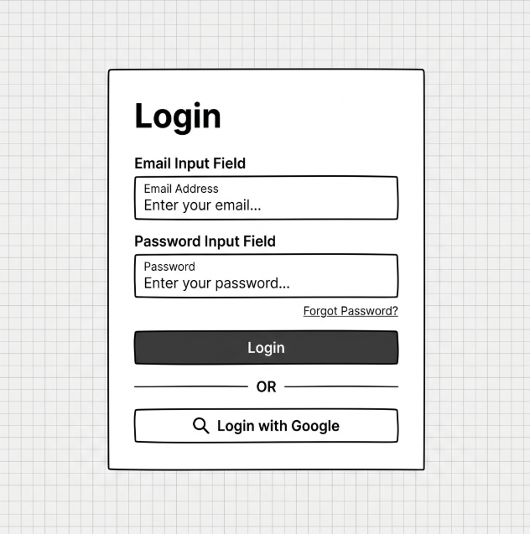
Figure III-1. Login Page Mockup (to be inserted later).

UI Field Mapping
Field Name | Field Type | Description
Login | Heading | Displays the main dialog header title.
Email Address | Text Input | Input field where users enter their registered email address.
Password | Password Input | Input field where users enter their password (characters are masked).
Forgot Password? | Link | Navigates the user to the Forgot Password OTP recovery page.
Login | Button | Submits credentials for authentication and accesses the portal.
Login with Google | Button | Initiates the external Google OAuth2 authentication flow.
Error Message | Label | Displays inline validation errors (e.g. "Wrong password", "Account is locked").

Database Access
Table | CRUD | Description
users | R | Selects the user record by email to verify password and status.
user_roles | R | Selects roles associated with the authenticated user.
roles | R | Reads role names (e.g. ADMIN, DOCTOR, PATIENT) to route the user.

1. Select user by email:
SELECT user_id, email, password_hash, full_name, status, auth_provider
FROM users
WHERE email = :email LIMIT 1;

2. Retrieve user roles:
SELECT r.role_name
FROM roles r
JOIN user_roles ur ON r.role_id = ur.role_id
WHERE ur.user_id = :userId;

2. Doctor Consultation Workspace

2.1 Doctor Consultation Workspace Specifications
Provides doctors with a consolidated dashboard to check patient history, record symptoms, document diagnoses, order laboratory tests, and prescribe medications.

UI Design
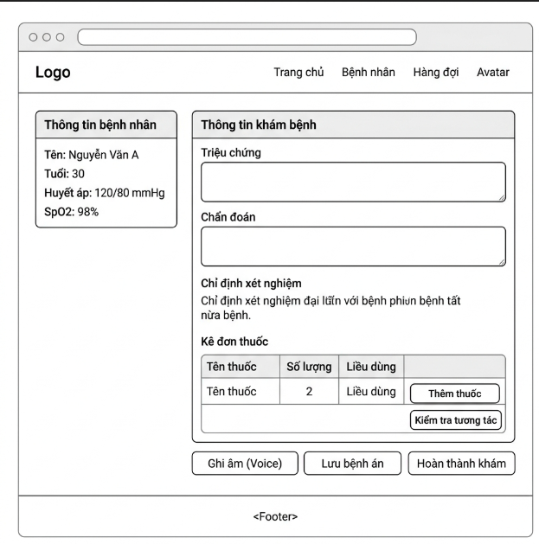
Figure III-2. Consultation Workspace Mockup (to be inserted later).

UI Field Mapping
Field Name | Field Type | Description
Patient Profile | Card/Panel | Displays patient summary (Name, Age, BP, SpO2, Heart Rate).
Triệu chứng (Symptoms) | Text Area | Input area for recording symptoms reported by the patient.
Khám lâm sàng | Text Area | Input area for recording physical/clinical examination findings.
Chẩn đoán (Diagnosis) | Text Area | Input area for entering the final diagnosis.
Chỉ định xét nghiệm | Checklist | Multi-select checkboxes for ordering clinic lab tests.
Kê đơn thuốc Table | Grid/Table | Grid listing prescribed medicines, quantities, dosages, and timings.
Thêm thuốc | Button | Opens a modal to search and select medicines from the inventory.
Kiểm tra tương tác | Button | Triggers an AI-powered RxNorm check for potential drug-drug interactions.
Ghi âm (Voice) | Button | Toggles AI voice-to-text recording to transcribe doctor notes.
Lưu bệnh án | Button | Saves draft examination notes and orders.
Hoàn thành khám | Button | Finalizes the consultation session and routes the ticket to Completed.

Database Access
Table | CRUD | Description
consultation_sessions | U | Updates consultation status to IN_PROGRESS or COMPLETED.
medical_records | C / U | Inserts/Updates clinical notes, diagnosis, symptoms, and AI transcripts.
lab_requests | C | Inserts new laboratory test request orders.
prescriptions | C | Inserts new patient prescription headers.
prescription_items | C | Inserts medication items associated with the prescription.

1. Start or resume consultation session:
UPDATE consultation_sessions
SET status = 'IN_PROGRESS', started_at = CURRENT_TIMESTAMP
WHERE consultation_id = :consultationId;

2. Insert or update medical record details:
INSERT INTO medical_records (consultation_id, patient_id, doctor_id, symptoms, clinical_findings, diagnosis, voice_input_transcript)
VALUES (:consultationId, :patientId, :doctorId, :symptoms, :clinicalFindings, :diagnosis, :transcript)
ON CONFLICT (consultation_id)
DO UPDATE SET
symptoms = EXCLUDED.symptoms,
clinical_findings = EXCLUDED.clinical_findings,
diagnosis = EXCLUDED.diagnosis,
voice_input_transcript = EXCLUDED.voice_input_transcript,
updated_at = CURRENT_TIMESTAMP;

3. Create lab requests order:
INSERT INTO lab_requests (consultation_id, patient_id, doctor_id, request_code, status, note)
VALUES (:consultationId, :patientId, :doctorId, :requestCode, 'REQUESTED', :note);

3. Queue Management & Check-in

3.1 Queue Management & Check-in Specifications
Allows receptionists to manage patient check-ins, issue queue tickets, view queue status across physical clinic rooms, and call patients.

UI Design
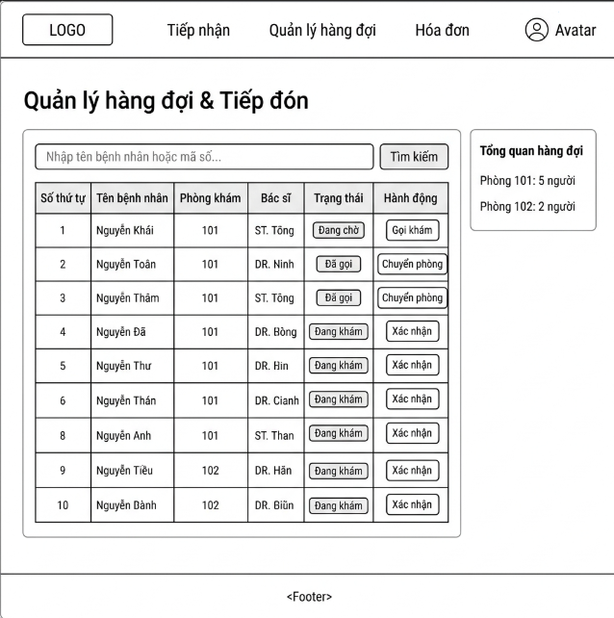
Figure III-3. Queue Management Mockup (to be inserted later).

UI Field Mapping
Field Name | Field Type | Description
Tìm kiếm Input | Text Input | Search input to find patients by Name, Code, or Phone.
Tìm kiếm | Button | Submits the query to filter the appointment list.
Hàng đợi Table | Grid/Table | Grid listing queue items (STT, Patient Name, Room, Doctor, Status).
Gọi khám | Button | Action to call the selected patient to their assigned room.
Chuyển phòng | Button | Action to re-route a patient to another department or doctor queue.
Xác nhận (Check-in) | Button | Action to confirm patient presence and generate their STT.
Tổng quan hàng đợi | Sidebar | Panel showing load summary (e.g. Room 101: 5 waiting).

Database Access
Table | CRUD | Description
appointments | R / U | Selects appointments for check-in; updates status to CHECKED_IN.
queue_tickets | C / U | Inserts a new ticket with queue numbers; updates status (e.g. CALLED).

1. Retrieve appointments by date:
SELECT appointment_id, appointment_code, patient_id, doctor_id, status
FROM appointments
WHERE appointment_date = CURRENT_DATE
AND (appointment_code ILIKE :search OR patient_id IN (
SELECT patient_id FROM patients WHERE full_name ILIKE :search
));

2. Check-in and create queue ticket:
UPDATE appointments SET status = 'CHECKED_IN' WHERE appointment_id = :appointmentId;

INSERT INTO queue_tickets (appointment_id, patient_id, doctor_id, department_id, queue_number, status, checked_in_at)
VALUES (:appointmentId, :patientId, :doctorId, :departmentId,
(SELECT COALESCE(MAX(queue_number), 0) + 1 FROM queue_tickets WHERE doctor_id = :doctorId AND queue_date = CURRENT_DATE),
'WAITING', CURRENT_TIMESTAMP);

4. Dispense Medication

4.1 Dispense Medication Specifications
Provides pharmacists with tools to review doctors' prescriptions, check medicine details/stocks, dispense medication to patients, and update the inventory.

UI Design
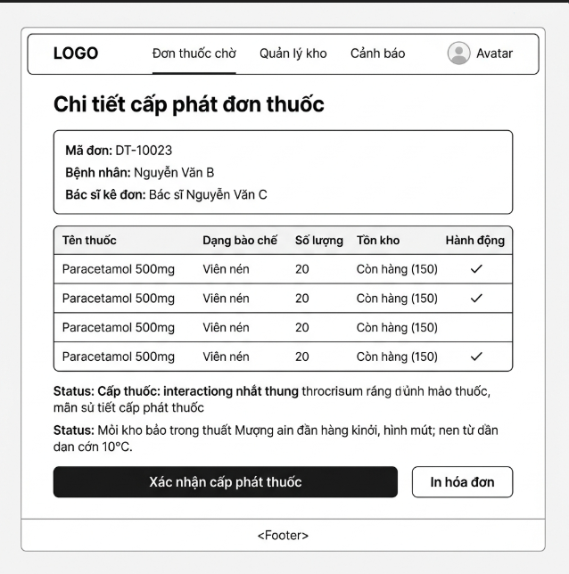
Figure III-4. Dispense Medication Mockup (to be inserted later).

UI Field Mapping
Field Name | Field Type | Description
Mã đơn | Label | Displays prescription ID code.
Bệnh nhân | Label | Displays patient full name.
Bác sĩ kê đơn | Label | Displays doctor full name.
Bảng đơn thuốc | Grid/Table | Grid listing medicines, dosage form, quantities, and current stock status.
Tồn kho Status | Badge/Label | Shows stock indicator (e.g. "Còn hàng (150)", "Hết hàng").
Xác nhận cấp phát | Button | Dispenses the items, updates quantities, and marks prescription as DISPENSED.
In hóa đơn | Button | Triggers a print window for the patient receipt.

Database Access
Table | CRUD | Description
prescriptions | R / U | Reads prescriptions by code; updates status to DISPENSED.
prescription_items | R | Reads items to calculate medication quantities.
medicine_batches | U | Decrements current medicine stock quantity.
stock_transactions | C | Records stock changes (EXPORT type for PRESCRIPTION reference).

1. Read prescription items:
SELECT pi.prescription_item_id, m.medicine_name, pi.quantity, m.unit, m.medicine_id
FROM prescription_items pi
JOIN medicines m ON pi.medicine_id = m.medicine_id
WHERE pi.prescription_id = :prescriptionId;

2. Confirm dispense and deduct inventory:
UPDATE prescriptions
SET status = 'DISPENSED', dispensed_at = CURRENT_TIMESTAMP
WHERE prescription_id = :prescriptionId;

-- Decrement from available batch (starting from oldest batch / FIFO)
UPDATE medicine_batches
SET current_quantity = current_quantity - :dispensedQuantity
WHERE batch_id = :batchId;

INSERT INTO stock_transactions (medicine_id, batch_id, transaction_type, quantity, reference_type, reference_id)
VALUES (:medicineId, :batchId, 'EXPORT', :dispensedQuantity, 'PRESCRIPTION', :prescriptionId);

5. AI Symptom Triage

5.1 AI Symptom Triage Specifications
Allows patients to query symptoms via a chat-like assistant powered by Gemini AI, receive department suggestions, and book immediate slots.

UI Design
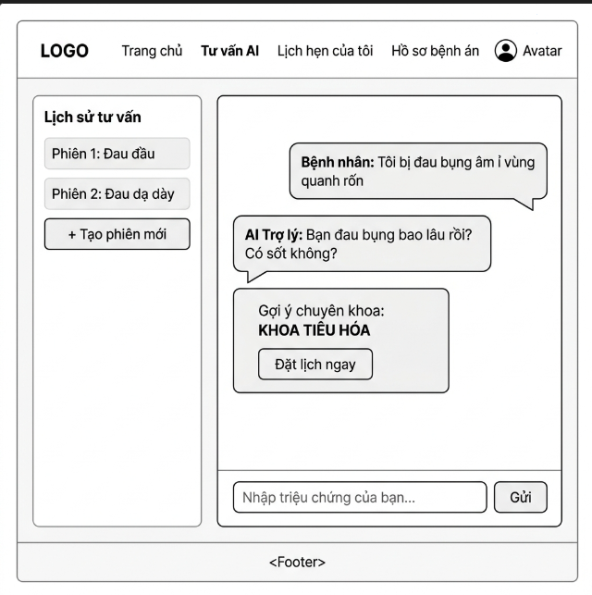
Figure III-5. AI Symptom Triage Mockup (to be inserted later).

UI Field Mapping
Field Name | Field Type | Description
Lịch sử tư vấn | Sidebar | Lists historical symptom triage chat sessions.
+ Tạo phiên mới | Button | Starts a new AI triage chat session.
Chat Bubble (AI/User) | Panel | Renders text responses and patient messages.
Gợi ý chuyên khoa | Card/Box | Highlights the AI-suggested department (e.g. KHOA TIÊU HÓA).
Đặt lịch ngay | Button | Navigates directly to booking page with recommended department selected.
Input triệu chứng | Text Input | Text field to describe active symptoms.
Gửi | Button | Submits text to AI model and logs conversation.

Database Access
Table | CRUD | Description
ai_chat_sessions | C / R | Creates new sessions; retrieves patient chat history list.
ai_chat_messages | C / R | Inserts user/AI chat lines; retrieves active chat logs.
ai_specialty_suggestions | C / U | Inserts suggested department, confidence, and accepted status.

1. Retrieve session list:
SELECT ai_chat_session_id, session_type, created_at
FROM ai_chat_sessions
WHERE patient_id = :patientId
ORDER BY created_at DESC;

2. Save chat message:
INSERT INTO ai_chat_messages (ai_chat_session_id, sender_type, message_text)
VALUES (:sessionId, :senderType, :messageText);

3. Create AI specialty suggestion:
INSERT INTO ai_specialty_suggestions (ai_chat_session_id, patient_id, department_id, confidence_score, explanation)
VALUES (:sessionId, :patientId, :departmentId, :confidenceScore, :explanation);

IV. Appendix
This appendix provides supporting information for the Smart Clinic Management System, including assumptions, project dependencies, known limitations, business rules, and system application messages.

1. Assumptions & Dependencies

Assumptions:
ID | Assumption Description
AS-1 | Users (patients and clinic staff) will have stable internet access to utilize the Clinic Management System web portal.
AS-2 | Clinic staff (doctors, receptionists, pharmacists, and lab technicians) possess basic technological knowledge to navigate their respective dashboard interfaces effectively.
AS-3 | Patients will provide accurate personal details, allergy histories, and symptoms to ensure safe and effective clinical diagnostics.
AS-4 | The clinic's physical laboratory testing devices support manual result entry into the system by the lab technicians.
AS-5 | Doctors and receptionists will maintain real-time updates of their shifts and queues to ensure the accuracy of patient queue tickets.

Dependencies:
ID | Dependency Description
DE-1 | The project relies on modern web front-end technologies (HTML, Vanilla CSS, React, and Lucide React) for developing the user interface.
DE-2 | The platform utilizes a PostgreSQL database management system to store patient profiles, medical history, scheduling records, and billing transactions securely.
DE-3 | The AI Symptom Triage and transcription features depend on the integration with external APIs (such as Google Gemini API) for language processing.
DE-4 | Integration with local digital payment service providers (like VNPAY) is required to facilitate online deposit transactions for booking confirmations.
DE-5 | The system depends on the RxNorm database or equivalent drug interaction APIs to perform real-time drug interaction checks.

2. Limitations & Exclusions
ID | Limitation / Exclusion | Description
LI-1 | Native Mobile Application | The initial release of the platform will not include native iOS or Android mobile applications. The system is accessible strictly through web browsers on responsive screens.
LI-2 | Automated Payment Refunds | Automated direct online money refunding through payment gateways is excluded. Refunding approvals will be logged online, but physical cash returns or manual transfers are handled offline by the receptionist.
LI-3 | Insurance Database Sync | Real-time integration and validation with national health insurance databases (BHYT) are excluded. Insurance card numbers are recorded as text fields for manual check-in verification.

3. Business Rules
ID | Category | Rule Definition
BR-01 | Authentication & User Management | Unique Account Rule: Email and phone number must be unique in the system.
BR-02 | Authentication & User Management | Password Format Rule: Password must meet the required length and security format.
BR-03 | Authentication & User Management | Patient Self-registration Rule: Only Patient accounts can be created through the public registration form.
BR-04 | Authentication & User Management | Authentication Rule: User must provide correct email and password to log in.
BR-05 | Authentication & User Management | Role-based Access Rule: User can only access features that match their assigned role.
BR-06 | Authentication & User Management | Registered Email Rule: Password reset is only allowed for registered email addresses.
BR-07 | Authentication & User Management | Password Reset Security Rule: New password must follow the system password format and confirmation must match.
BR-08 | Authentication & User Management | Staff Account Permission Rule: Only Admin can create, update, deactivate, and assign staff roles.
BR-09 | Authentication & User Management | Unique Staff Email Rule: Each staff account must have a unique email address.
BR-10 | Authentication & User Management | Account Deactivation Rule: Deactivated accounts cannot log in to the system.
BR-11 | Appointment Booking & Queue Management | AI Medical Disclaimer Rule: AI response must include medical safety guidance and recommend visiting a doctor when necessary.
BR-12 | Appointment Booking & Queue Management | AI Input Rule: Patient must enter valid symptom information before receiving AI advice.
BR-13 | Appointment Booking & Queue Management | Available Slot Rule: Patient can only book an appointment in an available time slot.
BR-14 | Appointment Booking & Queue Management | Appointment Ownership Rule: Patient can only book and view their own appointments.
BR-15 | Appointment Booking & Queue Management | Duplicate Booking Rule: The same patient should not book duplicate appointments in the same time slot.
BR-16 | Appointment Booking & Queue Management | Walk-in Creation Rule: Only Receptionist can create walk-in appointments at the clinic counter.
BR-17 | Appointment Booking & Queue Management | Patient Information Rule: Required patient information must be provided before a walk-in appointment is created.
BR-18 | Appointment Booking & Queue Management | Same-day Check-in Rule: Patient can only be checked in for appointments scheduled on the current day.
BR-19 | Appointment Booking & Queue Management | Unique Queue Ticket Rule: Each checked-in appointment can only have one active queue ticket.
BR-20 | Appointment Booking & Queue Management | Queue Order Rule: Patients should be called based on queue order unless special handling is required.
BR-21 | Appointment Booking & Queue Management | Queue Status Rule: Queue ticket status must follow a valid transition sequence.
BR-22 | Consultation & Diagnostics | Doctor Access Rule: Doctor can only conduct consultations for assigned or valid clinic patients.
BR-23 | Consultation & Diagnostics | Medical Record Rule: Diagnosis and consultation notes must be stored in the patient medical record.
BR-24 | Consultation & Diagnostics | Lab Order Permission Rule: Only Doctor can order lab tests for patients during or after consultation.
BR-25 | Consultation & Diagnostics | Lab Service Selection Rule: At least one valid laboratory service must be selected to create a lab request.
BR-26 | Consultation & Diagnostics | Prescription Permission Rule: Only Doctor can create prescriptions for patients.
BR-27 | Consultation & Diagnostics | Prescription Detail Rule: Each prescribed medicine must include dosage, quantity, and usage instruction.
BR-28 | Consultation & Diagnostics | Lab Technician Permission Rule: Only Lab Technician can process lab test requests and upload test results.
BR-29 | Consultation & Diagnostics | Lab Result Completion Rule: A lab request can only be completed when required result information is provided.
BR-30 | Pharmacy & Inventory | Prescription-based Dispensing Rule: Pharmacist can only dispense medicine based on a valid doctor prescription.
BR-31 | Pharmacy & Inventory | Inventory Deduction Rule: Medicine stock must be deducted after successful dispensing.
BR-32 | Pharmacy & Inventory | Inventory Permission Rule: Only Pharmacist or authorized staff can manage medicine inventory.
BR-33 | Pharmacy & Inventory | Stock Quantity Rule: Stock quantity cannot be negative and must be updated through valid inventory actions.
BR-34 | Billing & Administration | Payment Confirmation Rule: Invoice can only be marked as paid after valid payment confirmation.
BR-35 | Billing & Administration | Payment Method Rule: Payment method must be selected before confirming payment.
BR-36 | Billing & Administration | Invoice Status Rule: Invoice status must be updated according to the related payment status.
BR-37 | Billing & Administration | Leave Approval Permission Rule: Only Admin can approve or reject doctor leave requests.
BR-38 | Billing & Administration | Leave Conflict Rule: Doctor leave request should be checked against existing active appointments before approval.
BR-39 | Billing & Administration | Doctor Availability Rule: Approved leave must update doctor availability for the affected period.

4. Application Messages List
# | Message Code | Message Type | Context | Content
1 | MSG01 | In line | Invalid email format when user fills out the email field | Sai định dạng email
2 | MSG02 | In line | Password does not meet the minimum length of 8 characters | Mật khẩu phải từ 8 ký tự trở lên
3 | MSG03 | Toast message | Email is already used when attempting to register | Email này đã được sử dụng để đăng ký
4 | MSG04 | Toast message | Login failed due to incorrect credentials | Đăng nhập thất bại. Vui lòng kiểm tra lại tài khoản hoặc mật khẩu
5 | MSG05 | Toast message | Login succeeded with correct credentials | Đăng nhập thành công
6 | MSG06 | Toast message | Password change failed | Đổi mật khẩu thất bại
7 | MSG07 | Toast message | Clinic appointment booked successfully | Đặt lịch khám thành công
8 | MSG08 | Toast message | Appointment booking failed because the slot is occupied | Đặt lịch thất bại. Lịch hẹn không còn trống
9 | MSG09 | Toast message | Check-in confirmed and queue number issued | Tiếp nhận thành công và đã cấp số thứ tự
10 | MSG10 | Popup alert | Dangerous drug-drug interaction found in prescription | Cảnh báo: Phát hiện tương tác thuốc mức độ nghiêm trọng
11 | MSG11 | Toast message | Lab examination results recorded successfully | Cập nhật kết quả xét nghiệm thành công
12 | MSG12 | Toast message | Medicine dispensed successfully and stock decremented | Cấp phát thuốc và cập nhật kho thành công
13 | MSG13 | Toast message | Medicine batch quantity drops below safety threshold | Cảnh báo: Thuốc trong kho sắp hết
14 | MSG14 | Toast message | Patient refund request approved successfully | Yêu cầu hoàn tiền đã được phê duyệt thành công

