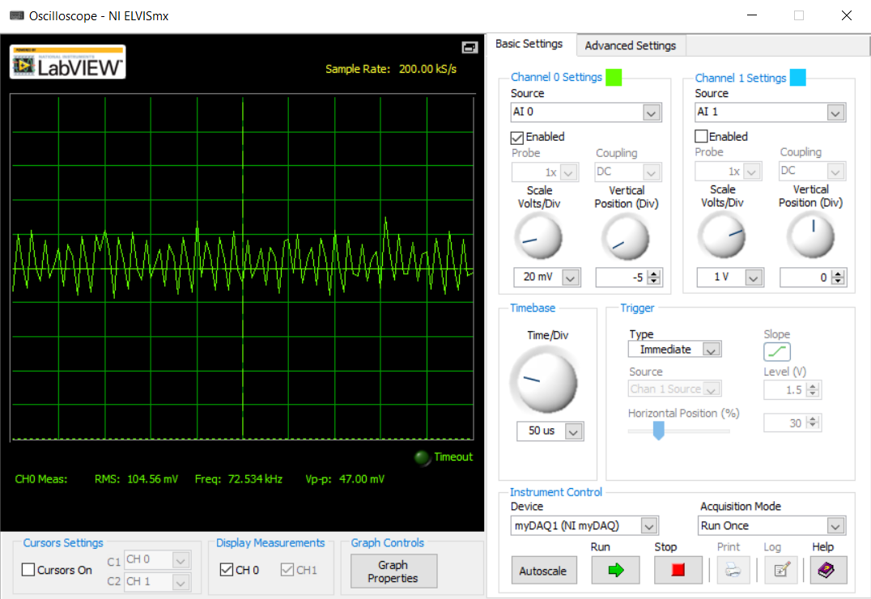4.5V input, Rs = 0.2 ohms, CTRL floating, green trace is across Rs (Setup 1)

104.5 mV -> 530 mA RMS (theoretical 500mA according to Irms = 0.1/Rs)

47 mV -> 240 mA p-p ripple (theoretical 0.4 Irms = 200mA)

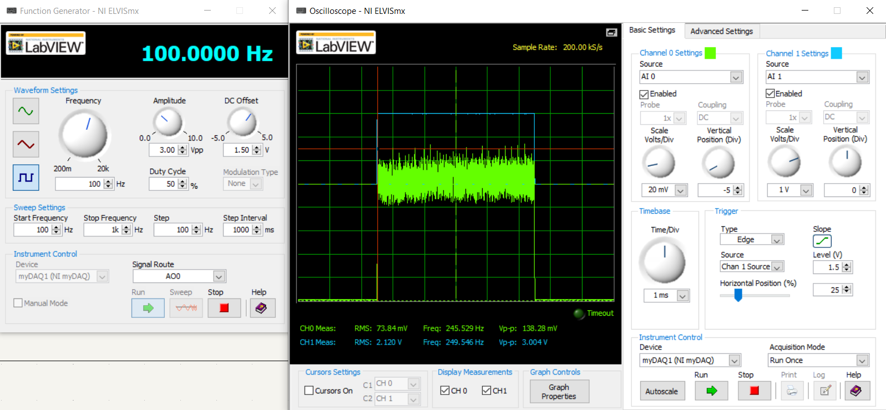4.5 V input, Rs = 0.2 ohms, Ctrl driven by 3 Vp-p 100 Hz square wave, green trace is across Rs and blue trace is Ctrl

This test of the current response time may be useful if a similar circuit is used to power the heading LEDs inside the robot. The circuit is suitable for 100 Hz -> 6000 RPM

Setup 1, 7.5 V in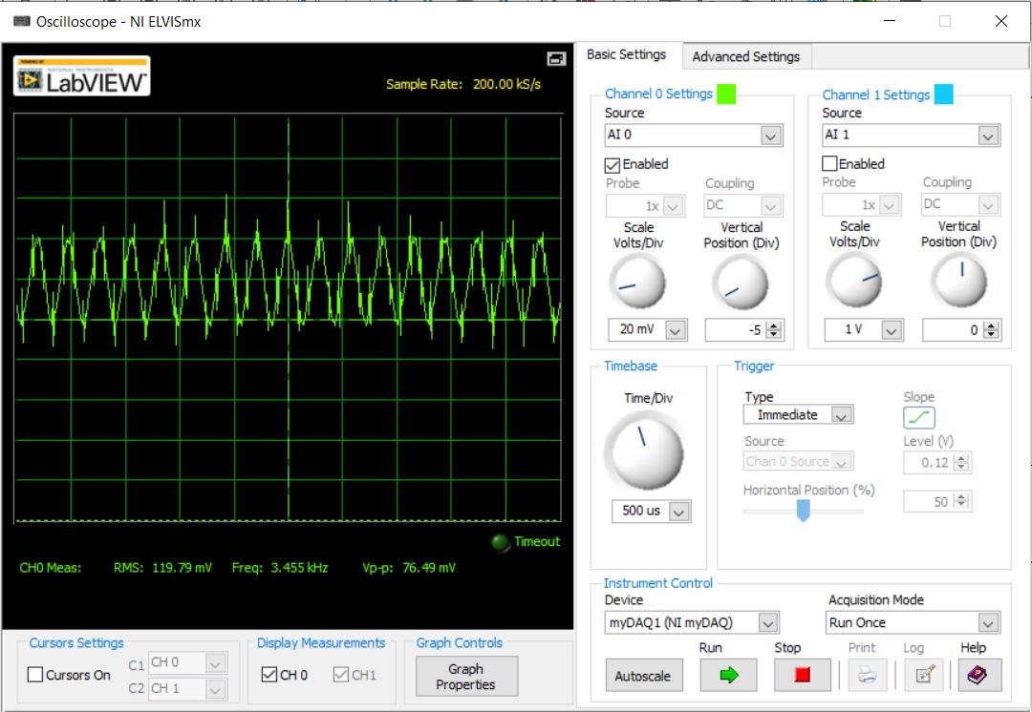

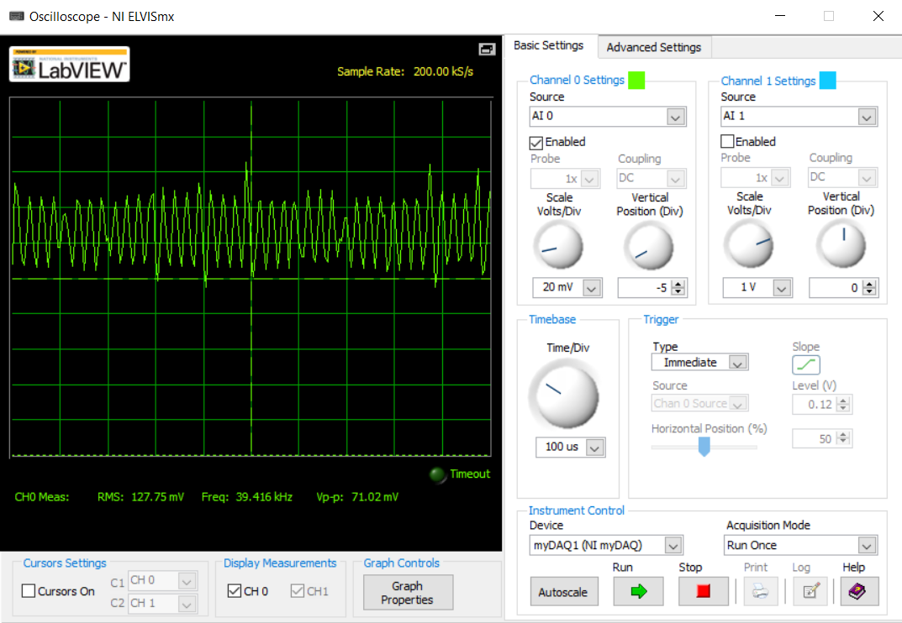Setup 1, 6 V in

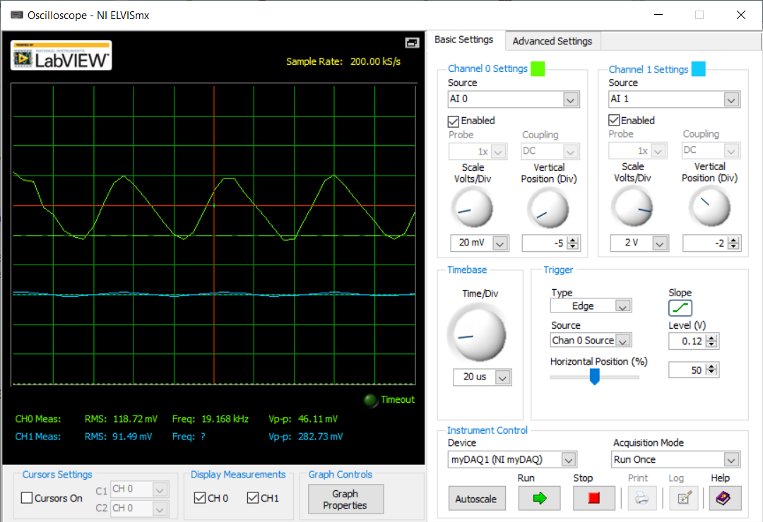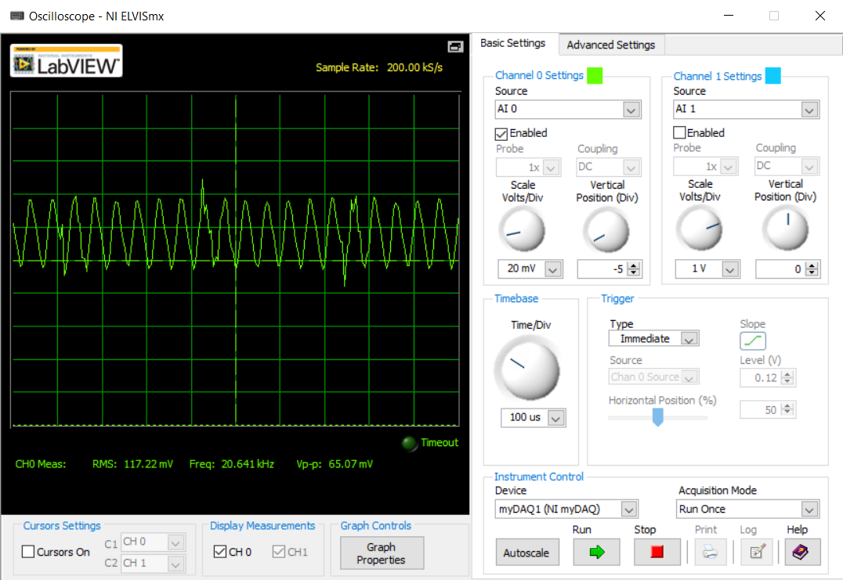Setup 1- 9 V in

Blue trace – unconnected