MULTIBAND REFLECTIVE POLARIZATION CONVERTER USING METASURFACE
Submitted
By
R S S S SNIGHDA
K S P MAHADEV
MD AKRAM

BU21EECE0100200
BU21EECE0100097
BU21EECE0100083

Dr. S Durga Padmaja Bikkuri
ASSISTANT PROFFESSOR
(Duration: 08/07/2024 to 15/10/2024)



Department of Electrical, Electronics and Communication Engineering [14 Bold]
GITAM School of Technology
GITAM
(DEEMED TO BE UNIVERSITY)
(Estd. u/s 3 of the UGC act 1956)
NH 207, Nagadenehalli, Doddaballapur taluk, Bengaluru-561203 Karnataka, INDIA.

DECLARATION
I/We declare that the project work contained in this report is original and it has been done by me under the guidance of my project guide.

Name:

Date: Signature of the Student

Department of Electrical, Electronics and Communication Engineering [14 Bold]
GITAM School of Technology, Bengaluru-561203



CERTIFICATE
This is to certify that (Student Name) bearing (Regd. No.:) has satisfactorily completed Mini Project Entitled in partial fulfillment of the requirements as prescribed by University for VIIIth semester, Bachelor of Technology in “Electrical, Electronics and Communication Engineering” and submitted this report during the academic year 2024-2025.

[Signature of the Guide] [Signature of HOD]

Table of contents

Chapter 1: Introduction 1
1.1 Overview of the problem statement 1
1.2 Objectives and goals 1
Chapter 2 : Literature Review 2
Chapter 3 : Strategic Analysis and Problem Definition 3
3.1 SWOT Analysis 3
3.2 Project Plan - GANTT Chart 3

3.3 Refinement of problem statement 3
Chapter 4 : Methodology 4
4.1 Description of the approach 4
4.2 Tools and techniques utilized 4
4.3 Design considerations 4
Chapter 5 : Implementation 5
5.1 Description of how the project was executed 5
5.2 Challenges faced and solutions implemented 5
Chapter 6:Results 6
6.1 outcomes 6
6.2 Interpretation of results 6
6.3 Comparison with existing literature or technologies 6
Chapter 7: Conclusion 7
Chapter 8 : Future Work 8
Here write Suggestions for further research or development Potential improvements or extensions 8
References 9

Chapter 1: Introduction

Overview of the problem statement

Atmospheric impacts, reflection, and polarization mismatches give challenges in communication lines. Whereas circular polarized antennas can fix polarization mismatching, there are still drawbacks to their complicated feeding techniques. By controlling the polarization of electromagnetic waves, metasurfaces provide an answer. In this study, we use a metasurface that, upon reflection, changes linear polarization to circular polarization. Our objective is to develop a polarization converter that operates between a certain frequency, examine how it affects antenna properties, and find out if it works with 5G systems.

1.2
Main Objectives

The main objectives of our project include:
- Design a metasurface-based polarization convertor which can convert a linear polarized incident EM wave into circular polarized during reflection at a single frequency in 4-8 GHz range.
- Extend the operation of the converter to multiple frequency.
- Analyze the Polarization conversion ability of the surface from the simulated results.

Main goals
- Achieve precise and efficient conversion.
- Expand the metasurface capability across multiple frequencies.
Validate the performance through simulations, ensuring the results meet our expectations

Chapter 2: Literature Review

Radar cross-section (RCS) reduction and conversion of polarization are only two of the many multifunctional properties that have made metasurfaces an effective instrument for controlling electromagnetic waves. Impressive broadband polarization conversion has been achieved recently, resulting in quad-band linear-to-circular (LP-to-CP) and tri-band linear-to-linear (LP-to-LP) conversion over a range of frequencies. In addition, by scattering transmitted electromagnetic waves in non-specular directions, metasurfaces may enhance invisibility properties and have shown great potential in RCS reduction. It has also been feasible to achieve multiband polarization conversion, using designs that allow conversions at various frequencies among linear and circular/orthogonal, linear and linear. Multiple resonant frequencies within the structure, especially those based on a wandering square ring and diagonal split strip resonator, are responsible for these multiband processes. Additionally, polarization conversion with angle stability has been demonstrated via a dual-band transmissive polarizer that was constructed on an ultra-thin dielectric substrate in a single layer.

Chapter 3: Strategic Analysis and Problem Definition

3.1 SWOT Analysis

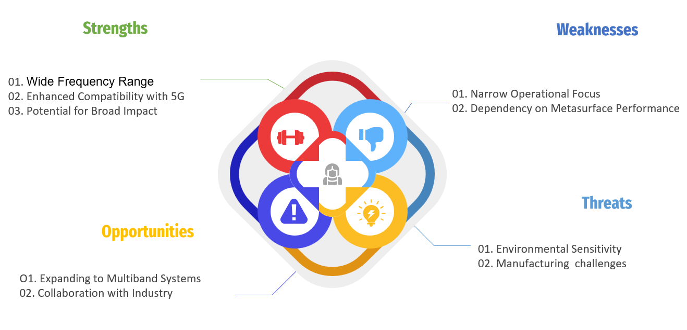

3.2 Project Plan - GANTT Chart

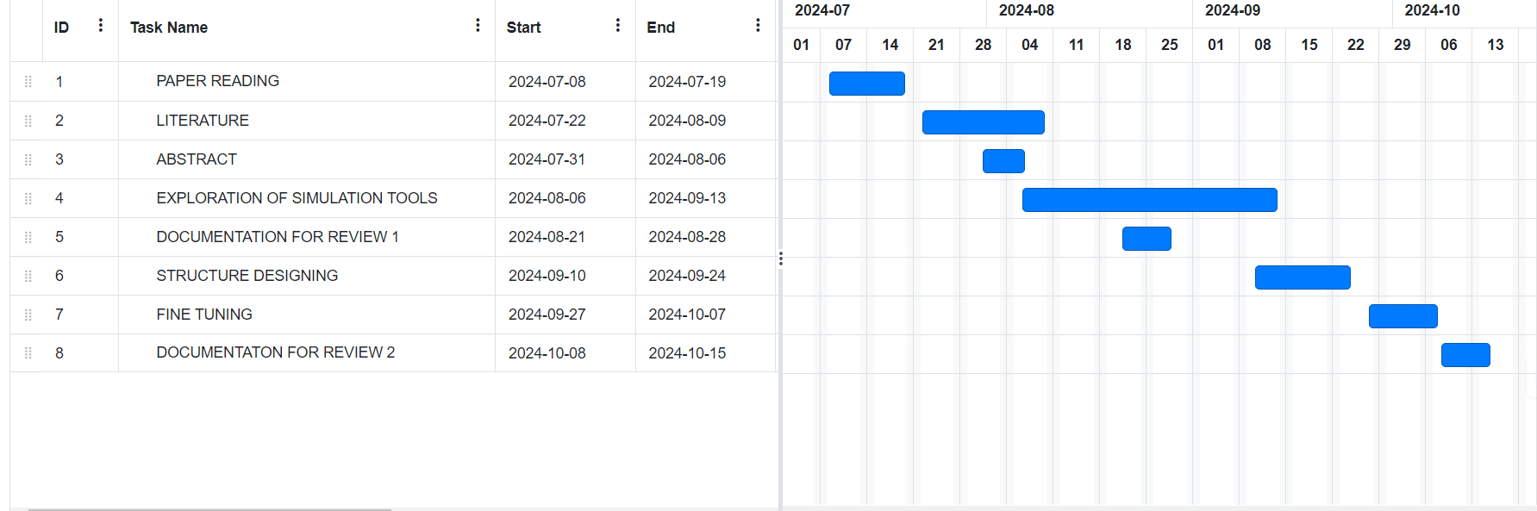

3.3 Refinement of problem statement

This work introduces the designing of a multiband reflective polarization converter by metasurfaces; these are engineered periodic structures that are capable of manipulation of polarization states of incident electromagnetic waves. The polarization mismatch in communication systems caused due to discrepancies between polarizations of transmitting and receiving antennas is thus addressed in this study. A polarization is obtained through an integration of a metasurface as a superstrate, wherein we will be capable of converting linear polarization into circular polarization and hence decrease the polarization mismatches without complex feeding techniques typically required in circularly polarized antennas. In our design, we target the 4-5 GHz frequency operation range and strive to enhance the polarization conversion abilities of the antenna with the compatibility preserved about the feeding structures that already exist. Moreover, other functions of the antenna characteristics will be considered to explore its cooperation with metasurface in achieving maximum performance for different communications.

Chapter 4: Methodology

4.1 Description of the approach
Conceptual Design: Define the problem in communication systems of polarization mismatching and find a way a metasurface can convert waves from linear polarization to circular polarization waves.
Developing Metasurface Structure: Determine the engineered periodic resonant elements that will control the amplitude, phase, and polarization of electromagnetic waves at optimal performance values targeting the 4-5 GHz frequency range.
Electromagnetic Simulation: Use Ansys HFSS to simulate electromagnetic properties in detail, including analysis of C-parameters and also detailed assessment involving X-parameters that define polarization conversion efficiency.
Parameter Optimization: Use parametric sweeping, i.e., make design parameters vary systematically and identify configurations that may potentially enhance polarization conversion efficiency and bandwidth.
Antenna Integration: Design an integrated antenna with the metasurface; feeding techniques should be as simple and compatible as possible for efficient operation.
Performance Analysis: Perform an extensive analysis of the metasurface and antenna system, including reflections and transmission efficiencies as well as electric and magnetic field distributions.
Iterative Refinement: Iterate further on the design based on simulation results to enhance the performance metrics.
Documentation and Reporting: Document methodologies, results, and findings while preparing visualizations for effective communication of the project's outcomes.

4.2 Tools and techniques utilized
Ansys HFSS: The electromagnetic simulation of metasurface and antenna designs in use to enable a highly accurate analysis of C-parameters and X-parameters with regard to the polarization conversion characteristics.
Metasurface Design : Engineered periodic resonant structures are created to manipulate the amplitude, phase, and polarization of incident electromagnetic waves to achieve desired performance metrics.
Parameter Optimization : Parametric sweeping was used to systematically vary the design parameters so efficient polarization conversion and bandwidth are attained.
Planar antenna structures focusing toward the easy feeding techniques within an operating wide frequency.
To measure and analyze, evaluation of C-parameters and X-parameters was conducted for the assessment of reflection, transmission, and polarization conversion ratio and on the basis of performance assessment of the metasurface and the antenna system.
The electric and magnetic field distribution consideration was also taken into account to analyze how the metasurface and the whole structure affects the polarization conversion capability

4.3 Design considerations

- Frequency Range: The metasurface-based polarization converter operates in the 4-8 GHz range to ensure compatibility with 5G communication systems.

- Polarization Mismatch Correction: The design focuses on addressing polarization mismatches between transmitting and receiving antennas, a common issue in communication links.

- Multiband Operation: The primary goal is to extend the polarization conversion over multiple frequencies while maintaining efficient performance.

- Impact on Antenna Performance: Integrating the metasurface with a 5G antenna enables precise control of the polarization without altering the feeding technique, simplifying the antenna design.

Chapter 5: Implementation

5.1 Description of how the project was executed: The design and simulations for the multiband reflective polarization converter were performed using Ansys 2024, a cutting-edge simulation tool widely used in electromagnetic modeling. The metasurface was designed with a 10x10 mm structure, using advanced materials to optimize its reflective properties. Key parameters, such as dielectric constant, thickness, and material properties, were carefully chosen to ensure minimal losses and high polarization conversion efficiency.

Electromagnetic Wave Behavior: The metasurface was subjected to incident electromagnetic waves within the 4-8 GHz frequency range. The simulation analyzed the interaction between the incident waves and the metasurface, specifically focusing on how the metasurface converts the linear polarization of the incident wave into circular polarization upon reflection.

Multiple Frequency Bands: To ensure versatility, the simulation explored the metasurface’s behavior across multiple frequency bands. The structure was tailored to exhibit strong polarization conversion capabilities not only at a single frequency but across several distinct bands, demonstrating its adaptability for multiband applications.

The project underwent three design iterations:

Iteration 1: Focused on achieving polarization conversion at a single frequency, but with limited bandwidth.

Iteration 2: Improved multiband performance by refining the metasurface's geometry but faced issues with angle stability.

Iteration 3: Final adjustments enhanced both broadband and angular stability, achieving efficient polarization conversion across three frequency bands.
The final design was validated through simulations, demonstrating:
- High polarization conversion efficiency across multiple frequency bands.
- Low reflection coefficient, indicating minimal energy loss.
- Stable performance at incident angles up to 35 degrees. The design outperformed existing literature, showing superior multiband capabilities and efficiency.

5.2 Challenges faced and solutions implemented
- Challenge: Narrow Operational Focus—The initial design was optimized for a narrow frequency range, limiting its potential applications.

- Solution: The design was iterated to improve multiband capabilities, expanding its use across different frequency bands, particularly in 5G systems.

- Challenge: Environmental Sensitivity—The performance of the metasurface was sensitive to environmental changes, such as temperature and humidity.

- Solution: By selecting stable dielectric materials, the design improved robustness against environmental variations.

- Challenge: Manufacturing Complexities—The intricate design of the metasurface posed challenges in terms of scalability and fabrication precision.

- Solution: The design was simplified where possible without sacrificing performance, and future plans include the incorporation of tunable elements like varactors or diodes to enhance real-time adaptability.

Chapter 6: Results

6.1 outcomes
- Efficient Polarization Conversion: The project successfully demonstrates the ability to convert linearly polarized electromagnetic waves into circularly polarized waves across multiple frequency bands.

- Multiband Operation: The metasurface was designed to operate efficiently across a range of frequencies (4-8 GHz), showcasing its ability to extend the polarization conversion to multiple bands.

- Simulated Performance: Through simulations using tools like Ansys, the metasurface’s polarization conversion capability was validated, confirming its effectiveness and precision.

- Potential for Reconfigurability: The design can be further developed to incorporate tunable elements, allowing for real-time reconfiguration of the polarization properties, which would enhance the flexibility of the device for various applications

6.2 Comparison with existing literature or technologies
- Broader Multiband Operation: Demonstrates efficient polarization conversion across 4-8 GHz, covering multiple frequency bands.
- Polarization Flexibility: Achieves both linear-to-linear and linear-to-circular conversion, similar to advanced metasurface designs.
- Simulation-Validated: Performance is validated through simulations, confirming practical feasibility.
- Potential Reconfigurability: Offers the potential for real-time adaptability using tunable components, unlike conventional fixed designs.
Modern Application Versatility: More suited for emerging technologies like 5G, IoT, and radar due to its flexibility and multiband capability​

6.3 Interpretation of results

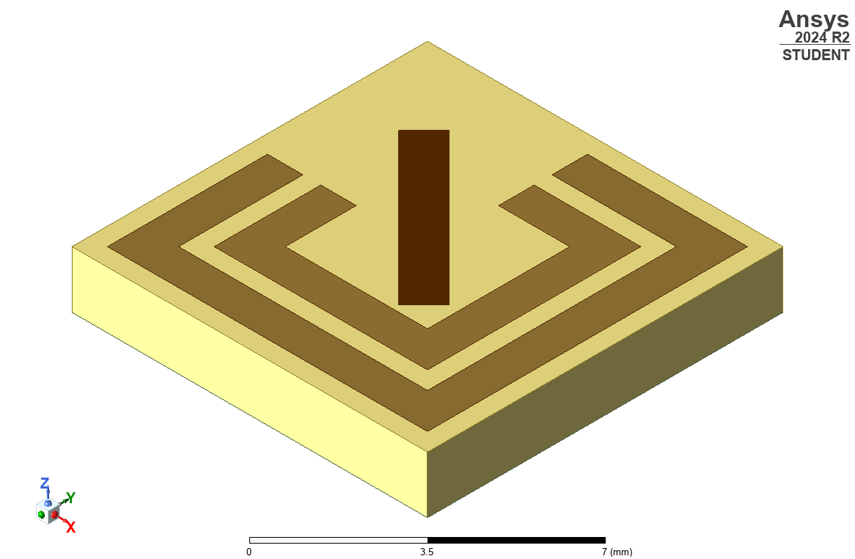

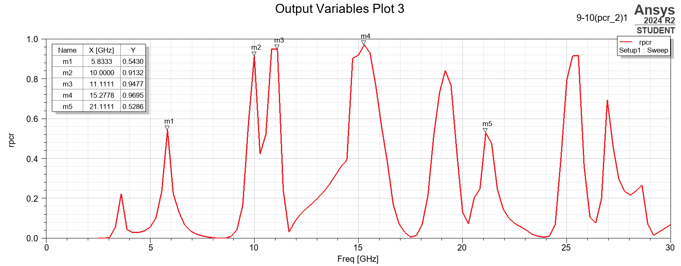

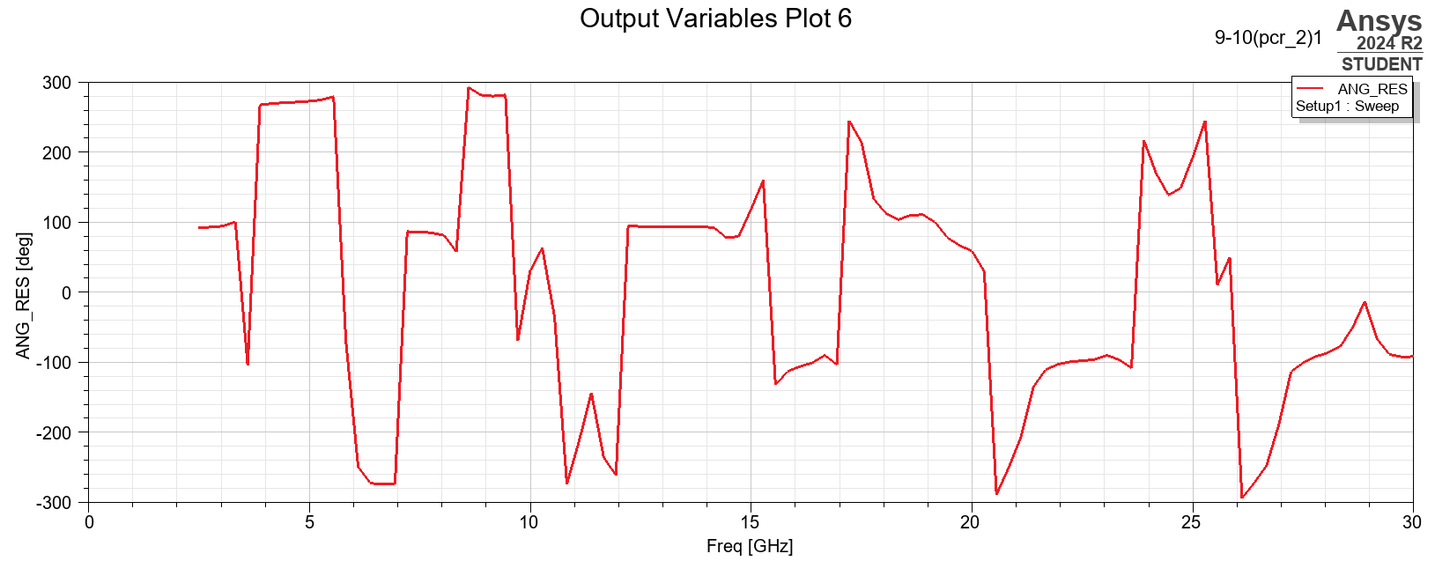

Chapter 7: Conclusion

In our simulation using Ansys 2024, we designed a metasurface with dimensions of 10x10 mm and a thickness of 1.6 mm. The objective was to create a structure capable of efficiently controlling polarization without the need for complex feeding techniques. The results from the simulation indicated that the metasurface exhibited three distinct linear polarization bands, as well as a near-circular polarization band, demonstrating its effectiveness in converting linearly polarized electromagnetic waves into circular polarization across specific frequency ranges.

Through careful design and parameter optimization, we were able to achieve high polarization conversion efficiency. However, it is important to note that with further fine-tuning of the metasurface's structural elements—such as the periodic patterns or the introduction of additional resonant elements—there is potential to achieve multiple circular polarization bands. This could be accomplished without altering the feeding technique, which is often a complex and costly aspect of antenna design. The simplicity and flexibility of this metasurface design make it highly adaptable to various frequency bands and polarization conversion needs.

One of the key takeaways from this project is the versatility of the metasurface in its ability to control polarization across different bands. Unlike traditional approaches that require more intricate feeding mechanisms to manipulate polarization, the metasurface achieves this through its geometric design alone. This level of control makes it particularly well-suited for high-performance applications, where precise polarization management is critical.

The capability to achieve multi-band performance, combined with the flexibility in polarization control, positions this metasurface as a highly promising candidate for next-generation technologies. Its design simplicity, compact size, and adaptability make it ideal for use in a wide range of advanced applications, from 5G communication networks to remote sensing and military-grade radar systems. With further iterations and optimizations, this design can be tailored to meet the evolving demands of modern technology, ensuring robust and efficient performance across diverse operational environments.

Chapter 8: Future Work
Future work will focus on extending the metasurface's polarization conversion beyond a single frequency band. One key area is the inclusion of tunable elements like varactors or diodes, allowing for real-time reconfiguration. This would make the metasurface adaptable to varying operational environments, especially for cognitive radio systems and smart communication networks.
Further, shifting towards broadband designs can lead to non-inefficient conversions over wider frequency ranges. Optimizing the geometry and materials could enable the metasurface to cover multiple frequency bands or achieve ultra-wideband (UWB) performance. This enhancement is crucial for applications in broadband radar, satellite communications, and 6G networks.
Another area for exploration is multi-mode polarization control, enabling the metasurface to support various polarization modes (linear, circular, elliptical). The integration of active devices like PIN diodes or MEMS could provide on-demand polarization switching, increasing the platform's versatility for multi-functional systems.
Prototyping will be essential for validating the design in real-world conditions, ensuring its performance matches the simulated results. Additionally, applying machine learning optimization will help refine design parameters for maximum efficiency and performance. This can assist in optimizing trade-offs between bandwidth, polarization conversion efficiency, and angular stability, leading to a more robust and adaptable metasurface.
Ultimately, these enhancements will prepare the metasurface for practical applications in IoT and satellite communication systems. Its ability to handle multi-band, polarization-diverse signals will be crucial for next-generation wireless networks, while its robustness in polarization control will optimize performance in satellite communication by reducing interference and signal degradation.

References:

Ultrathin Single Layer Transmissive Dual-Band Linear to Circular Converter for Non-Adjacent Dual Orthogonal Circularly Polarized Antenna
SOUMIK DEY, SUKOMAL DEY.

- Simultaneous Transmission and Reflection Mode Linear-to-Circular Polarization Conversion Using a Single Metasurface
Debidas Kundu; Dhruba Jyoti Bhattacharya; Debashree Pathak

- A Low-Profile Multifunctional Metasurface Reflector for Multiband Polarization Transformation.
Soumendu Ghosh, Jeet Ghosh, Moirangthem Santosh Kumar Singh and Abhishek Sarkhel

- Multi-Band Multi-Functional Metasurface-Based Reflective Polarization Converter for Linear and Circular Polarizations
RAHUL DUTTA, JEET GHOSH, ZHENGBAO YANG, AND XINGQI ZHANG,

