AUTOMATION STANDARDS FRAMEWORK
Enterprise Requirements and Governance Policy

Prepared by: Automation Services Team
Date: February 18, 2026
Status: Draft for Leadership Review
Contact: ASE@metlife.com

Executive Summary
As automation becomes central to enterprise operations, clear and enforceable standards are essential to ensure automation is safe, recoverable, and reliable at scale. This framework establishes three mandatory core requirements that all automation must satisfy before production deployment, supported by a comprehensive set of technical and governance standards.

Business Impact | Strategic Alignment
- Reduces risk of failed changes impacting production  - Enables faster recovery during incidents  - Provides audit trail and compliance support  - Increases operational stability and confidence | - Supports the enterprise automation-first initiative  - Establishes governance for enterprise-scale operations  - Enables data-driven ROI visibility and decision making  - Creates a shared quality baseline across all teams

1. Core Requirements (Mandatory)
The following three requirements are mandatory for all automation. Failure to satisfy any single requirement results in rejection from the production approval process.

1.1 Automation-First Approach
All processes must be evaluated for automation suitability. Where full automation is feasible, it must be implemented end-to-end. Where partial automation is feasible, repetitive portions must be automated.

Requirements
- Automation is required for: Repetitive tasks, routine operations, predictable workflows, and redundant manual processes.
- Hybrid approach is appropriate for: Complex workflows containing some predictable steps alongside steps requiring human judgment.
- Automation may not be appropriate for: Tasks requiring critical human judgment, regulatory approvals, or unique situational analysis.
- Manual or hybrid approaches require written justification that includes:
  - A clear explanation of why full automation is not appropriate
  - Identification of which steps are automated vs. manual
  - Technical, business, regulatory, or operational constraints
- All automation — regardless of scope — must meet testing and backout requirements.

Rationale: Manual steps introduce delays, inconsistency, and human error. Full automation enables scale, repeatability, and supports the automation-first direction. Requiring documented justification for any manual approach ensures that teams genuinely evaluate automation potential rather than defaulting to manual processes out of convenience.

1.2 Tested and Approved
All automation must be fully tested prior to production deployment and must pass all defined quality gates before receiving approval.

Requirements
- Automation must demonstrate successful execution in a non-production test environment.
- All quality gates must be passed: linting, security scanning, and standards compliance checks.
- Code must be peer-reviewed and formally approved prior to promotion to production.
- Testing evidence must be documented and retained as part of the approval record.

Rationale: Untested automation at scale amplifies risk exponentially. Testing catches issues before they impact production, and peer review ensures knowledge sharing while catching edge cases a single developer might miss. This requirement prevents unvalidated deployments that can cause significant business disruption.

1.3 Automatic Backout with Post-Validation
Every automation that changes system state must include an automatic backout mechanism and a post-execution validation step to confirm the intended outcome was achieved.

Requirements
- Every state-changing automation must have a tested, documented backout mechanism.
- Post-validation must automatically verify that the change achieved its intended outcome.
- If validation fails or an unhandled error occurs, automatic backout must be triggered immediately.
- If error handling cannot determine the issue or recovery path, backout must be triggered as a fail-safe.
- Backout must be "single-button" and accessible to all authorized teams without requiring deep automation knowledge.
- Exception: Read-only and informational actions (e.g., querying data, reading files) are exempt from backout requirements.

Rationale: Automation introduces risk at scale. When automation fails, recovery speed is critical to minimizing business impact. Automated backout ensures rapid recovery, minimizes blast radius, and protects production systems from partial or failed changes. Post-validation prevents silent failures. The guiding principle is: when in doubt, back out.

2. Production Approval Gate
Before any automation is approved for production deployment, it must satisfy all three of the following criteria. A single "NO" answer results in automatic rejection and the automation must not be promoted.

Core Requirement | Status | Classification
Is the process automated end-to-end (or partially with documented justification)? | YES | Required
Has it been tested and proven to work in a non-production environment? | YES | Required
Does it include automatic backout with post-validation? | YES | Required
WARNING: If any answer is NO, the automation is REJECTED and must not be promoted to production.

Rationale: A clear, objective approval gate ensures consistent enforcement of standards across all teams and removes ambiguity from the approval process. This protects the organization from automation that introduces unacceptable risk while enabling fast-track approval for fully compliant automation.

3. Supporting Standards (Mandatory)
The following standards support and enable the three core requirements. All are mandatory and will be enforced as part of the overall compliance framework.

3.1 No Hardcoding of Values or Configuration
- Hardcoded values are strictly prohibited in all automation.
- All configurations must be supplied through external variables.
- Inventory must use dynamic sources where technically feasible.
Rationale: Hardcoding reduces portability, increases risk, and complicates reuse across environments. Variable-driven design enables environment independence, safe scaling, and supports automation reusability without code modification.

3.2 Mandatory Linting and Git Hooks
- Linting must be enforced on all code prior to commit.
- Git hooks must prevent merging if any linting checks fail.
- All code must pass quality checks before entering shared repositories.
Rationale: Early enforcement prevents non-compliant automation from entering production pipelines and reduces downstream remediation costs. Automated quality gates remove the burden of manual code review for basic compliance checks, ensuring issues are caught at the earliest possible stage.

3.3 Idempotency
- All playbooks must be idempotent — safe to run multiple times without unintended side effects.
- Supporting scripts and extensions (Shell, Python, PowerShell, etc.) must also be idempotent.
Rationale: Idempotency allows safe re-execution, simplifies retries, and prevents unintended side effects during orchestration or recovery. This directly supports the backout requirement by ensuring both forward and rollback operations can be safely executed without causing additional system damage.

3.4 Main Branch Execution Only
- Only automation from the main branch may run in execution environments.
- All code must be reviewed, approved, and merged before execution.
- Version control and branching governance must be strictly enforced.
Rationale: Main-branch enforcement provides a clear audit trail and ensures that only reviewed, approved automation runs in production — directly supporting Core Requirement 1.2.

3.5 Automation Classification and Legacy Handling
- All automation must be classified as compliant or non-compliant.
- Non-compliant automation is designated as legacy and subject to the remediation grace period.
- Legacy automation will be blocked from execution after the grace period expires.
- A complete catalog of all available automation workflows and changes must be maintained.
Rationale: Classification enables risk visibility and controlled modernization without abruptly disrupting existing workflows. Blocking legacy automation after a defined grace period ensures standards are enforced consistently across all platforms and tooling.

3.6 KPI and Metadata Reporting
- KPI collection and metadata reporting must be built into automation from the start — not added as an afterthought.
- Required metrics: Hours saved, success rate, number of runs, and backout usage.
Rationale: Operational insight enables continuous improvement, capacity planning, and executive visibility into automation value and risk. Metrics demonstrate ROI, identify problematic automation early, and support data-driven decision making.

3.7 Modularity and Reusability
- Automation must be designed to be modular and reusable across teams and contexts.
- SOLID design principles must be applied where applicable:
  - Single Responsibility Principle (SRP)
  - Open/Closed Principle (OCP)
  - Liskov Substitution Principle (LSP)
  - Interface Segregation Principle (ISP)
  - Dependency Inversion Principle (DIP)
- Automation made available to other teams must meet all core requirements before sharing.
Rationale: Modularity reduces duplication, improves testability, and accelerates delivery. Reusable, compliant components raise the quality bar across the organization without requiring teams to rebuild common patterns from scratch.

3.8 Logging and Error Reporting
- All automation must include structured logging throughout the entire execution lifecycle.
- Log messages must be concise and clearly explain what occurred at each step.
- Error and failure messages must explicitly state what went wrong and why.
- Logs must be written for operators and support teams — not only developers.
- When backout is triggered, logs must clearly indicate the failure reason and all recovery actions taken.
Rationale: During incidents and backout scenarios, clear logging is critical for rapid troubleshooting and root cause analysis. Concise, understandable logging reduces mean time to resolution (MTTR), enables better post-mortems, and helps teams learn from failures. This directly supports the backout requirement.

Backout Lifecycle Logging Reference
The following table defines logging requirements and accountability at each stage of the automation execution and backout lifecycle.

Stage | What Happens | Logging Requirement | Responsible Party
Pre-Execution | Document backout plan and test rollback procedure | Log backout plan validation and test results | Development Team
Execution | Automation runs and makes changes to the target system | Log each step with clear success/failure indicators | Automation System
Post-Validation | Verify change was successful and system is in expected state | Log validation checks and results (pass/fail with details) | Automation System
Backout Trigger | Error detected or validation failed — backout initiated | Log clear reason for backout: what failed and why | Automation System
Backout Execution | Restore system to its original pre-change state | Log each rollback step with confirmation of restoration | Automation System
Backout Validation | Verify original state has been fully restored | Log verification that system returned to pre-change state | Automation System
Notification | Alert teams of failure and recovery outcome | Log incident summary with failure cause and recovery actions | Automation System

3.9 Secret and Credential Management
All secrets, credentials, and sensitive configuration must be managed through approved systems. The following requirements apply:

Storage Requirements
- Secrets must be stored only in approved secret management systems (e.g., CyberArk, Azure Key Vault).
- No passwords, API keys, tokens, or certificates may appear in code, configuration files, or version control.

Retrieval and Usage
- Automation must retrieve secrets dynamically at runtime using secure authentication methods.
- Secrets must never appear in logs, console output, or error messages. All sensitive values must be masked or redacted.

Access Control and Lifecycle
- Follow the principle of least privilege for all secret access.
- Document which automation requires access to which secrets.
- Regularly review and audit secret access permissions.
- Support secret rotation without requiring code changes.
- Automation must handle secret expiration gracefully without failure.

Rationale: Hardcoded secrets represent a critical security vulnerability that can lead to unauthorized access, data breaches, and compliance violations. Approved secret management systems provide encryption, access controls, audit trails, and rotation capabilities that manual handling cannot match. This requirement protects the organization from security incidents and reputational damage.

4. Implementation Approach
The framework will be rolled out in three structured phases designed to minimize disruption while establishing full enforcement within six months of adoption.

Phase | Timeline | Key Objectives | Success Criteria
Phase 1: Adoption | Month 1-2 | - Publish standards documentation  - Provide reference templates and examples  - Conduct team training  - Apply standards to all new automation | All new automation meets standards; training completed
Phase 2: Remediation | Month 3-6 | - Identify all non-compliant automation  - Issue 90-120 day grace period  - Provide remediation support to teams  - Track and report progress | Legacy catalog complete; remediation >75% complete
Phase 3: Enforcement | Month 7+ | - Block non-compliant automation from execution  - Full approval gate enforcement  - Ongoing compliance monitoring and reporting | 100% of automation compliant; zero unapproved deployments

5. Risk Mitigation
The following table maps the key operational risks addressed by this framework to the specific standards and requirements that mitigate them.

Risk Without Standards | How Standards Address It | Related Requirement
Failed changes impact production systems | Automatic backout limits blast radius and enables rapid recovery | Section 1.3 — Automatic Backout
No way to recover quickly from failures | Single-button rollback enables fast, consistent recovery | Section 1.3 — Automatic Backout
Untested automation causes outages | Testing requirement catches issues prior to production deployment | Section 1.2 — Testing & Approval
Manual processes cannot scale to enterprise demand | Full automation enables repeatable, enterprise-wide deployment | Section 1.1 — Automation-First
Inconsistent approaches across teams | Standardization creates predictability and shared quality bars | All Requirements
Silent failures go undetected | Post-validation catches unsuccessful changes before they persist | Section 1.3 — Post-Validation

6. Alignment with Enterprise Direction
This framework directly supports and enforces the enterprise automation-first mandate. The Automation Services Team is responsible for defining what "automation-ready" means in practice, and these standards ensure automation is implemented safely, consistently, and at enterprise scale.
Without clear standards, the automation-first mandate introduces unacceptable operational and security risk. This framework provides the governance structure necessary to execute the mandate responsibly and at scale.

7. Approval Request
Leadership approval is requested for the following actions:

1. | Adopt the three core requirements as mandatory organizational standards
2. | Establish and operationalize the Production Approval Gate for all automation
3. | Begin phased implementation with a defined grace period for legacy automation
4. | Enforce standards after the grace period expires, including blocking of non-compliant automation

Rationale: Leadership endorsement provides the authority needed to enforce standards consistently across all teams and ensures organizational alignment. Clear approval removes ambiguity about whether these standards are mandatory or optional, and empowers the Automation Services Team to act decisively.

8. Questions for Leadership Decision
The following decisions require leadership input to finalize the implementation plan. Recommendations are provided for consideration.

Topic | Recommendation | Rationale
Grace Period Duration | 90-120 days for legacy automation remediation | Provides sufficient time for remediation without delaying enforcement indefinitely. Creates urgency while remaining realistic about team capacity.
Approval Authority | Automation Standards Board or designated team leaders | Centralized authority ensures consistent interpretation and prevents self-certification of non-compliant automation.
Exceptions Process | Emergency-only with a time-bound remediation plan | Allows flexibility for genuine business emergencies while preventing exceptions from becoming the norm.
Enforcement Start | Immediately for new automation; grace period for legacy | Prevents new technical debt from accumulating while providing a fair timeline for addressing existing automation.

9. Creating an Ansible Playbook
Ansible is the enterprise-standard tool for automation authoring within this framework. The following step-by-step guide defines the required process for creating a compliant Ansible playbook that satisfies the Core Requirements outlined in Sections 1–3 of this document. All automation authored using Ansible must follow these steps prior to submission for production approval.
Step 1: Set Up Your Project Structure
Organize your working directory before writing any code. Every Ansible project must follow a consistent folder layout to ensure maintainability and compliance with team standards. Create a project folder containing an inventory.ini file to define your target hosts and a playbook.yml file as the playbook entry point. A roles/ subdirectory is optional but required for larger, multi-component playbooks.
Step 2: Define the Playbook Anatomy
A playbook is a YAML file composed of one or more plays. Each play targets a host group from your inventory and defines a list of tasks to execute. Every play must include a human-readable name, a target hosts group, and a privilege escalation setting (become: yes for sudo/root access where required).
Step 3: Write Your Tasks
Each task calls an Ansible module — a built-in function that performs a specific action on the target host. Common modules include apt (package installation), copy (file deployment), service (service management), and shell (command execution). Use the register keyword to capture task output for downstream use in post-validation logic (required per Section 1.3).
Step 4: Add Handlers
Handlers are event-driven tasks that execute only when notified by another task. This ensures reactive, state-aware automation — for example, restarting a service only when its configuration file has actually changed. Handlers support the backout and post-validation requirements by ensuring corrective actions fire automatically on detected state changes.
Step 5: Define Variables and Templates
All configurable values must be expressed as variables using the {{ }} Jinja2 syntax. This is a mandatory requirement per Section 3.1 (No Hardcoding of Values). Variables may be defined in the play’s vars: block, in a separate variable file, or passed in at runtime. Jinja2 templates (.j2 files) should be used for all dynamic configuration file generation.
Step 6: Validate and Dry Run
Before any execution, all playbooks must pass a two-stage pre-flight check. First, run ansible-playbook playbook.yml --syntax-check to catch YAML and structural errors. Second, execute a dry run with the --check flag to simulate execution against the target hosts without making any actual changes. This satisfies the non-production testing requirement in Section 1.2 and must be completed before proceeding to live execution.
Step 7: Execute and Review Output
Once dry-run validation passes, execute the playbook against the target environment. Ansible color-codes all output: green indicates success with no change, yellow indicates a successful change, and red indicates failure. If any task fails, automatic backout must be triggered per Section 1.3. The play recap summary at the end of each run must be reviewed and retained as part of the testing and approval record required by Section 1.2.
Figure 9.1 — Ansible Playbook Build Flow and Structure Diagram
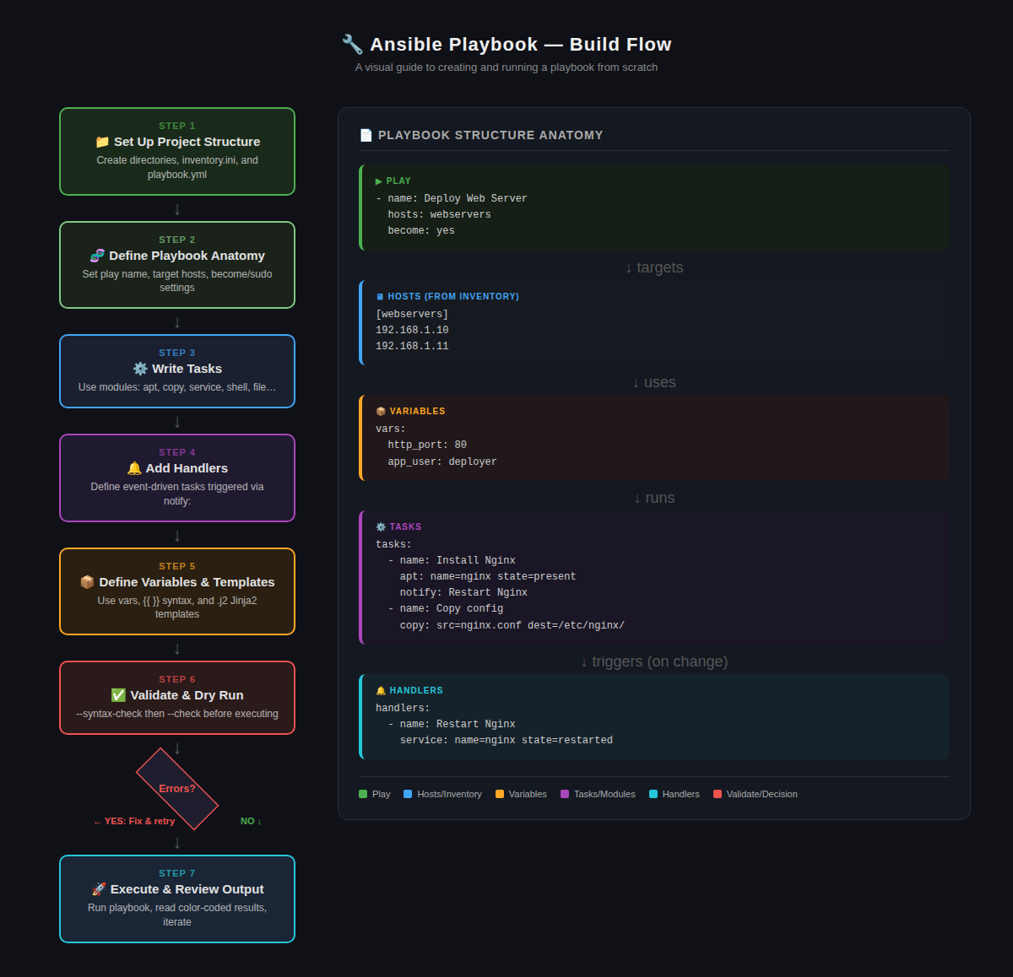
The left panel shows the 7-step build flow with error decision gate. The right panel illustrates the playbook’s internal structure: Play → Hosts → Variables → Tasks → Handlers.
Compliance Note: All Ansible playbooks submitted for production approval must demonstrate: (1) variable-driven configuration with no hardcoded values (Section 3.1), (2) successful syntax check and dry-run evidence (Section 1.2), (3) a tested backout mechanism triggered on failure (Section 1.3), and (4) post-execution validation logic confirming the intended outcome was achieved (Section 1.3).

Appendix A: Automation Execution and Backout Workflow
The diagram below illustrates the required execution flow for all state-changing automation, including the mandatory post-validation and automatic backout decision points.

STEP 1 | EXECUTE CHANGE
Automation performs the intended system change
|
STEP 2 | POST-VALIDATION CHECK
Did the change achieve the intended outcome?
| |  | |
SUCCESS  Close Change Record  Log Success & Update Metrics |  | FAILED / ERROR  Trigger Automatic Backout  Restore State & Alert Teams

Following execution, the system evaluates the outcome of the post-validation check. A SUCCESS result closes the change record and updates operational metrics. A FAILED or ERROR result triggers the automatic backout sequence, restoring the system to its pre-change state and alerting all relevant teams with a clear incident summary.

Appendix B: Contact and Feedback
Leadership and operational teams are encouraged to submit feedback to ensure these standards remain practical and effective in real-world operations.

Team | Automation Services Team
Email | ASE@metlife.com
Purpose | Standards feedback, exception requests, and implementation support

Rationale: Open communication channels ensure standards remain practical and address real operational challenges. Feedback loops enable continuous improvement of the framework itself.

