**Return VIDEO**

**Description:** This use case describes how a Customer return a video from the store

**Actor**: Customer, Store Clerk

**Precondition:** Store Clerk must be logged on to the system and has navigated to the Return Video Screen

**Scenarios**

**Main Success Scenario**

1. **Customer** brings their rented video(s) to the store counter
2. **Store clerk** asks **Customer** for membership card id number
3. **Customer** tell **Store clerk** id number
4. **Store clerk** type id number to the **System**

**- System** displays **data not found** , **Customer** provides **store clerk** wrong id(alternate)

1. **System** displays **Customer** details
2. **Store clerk** click **Show detail** button to check rented video data**.**
3. **Customer** hands over the rented video(s)
4. **Store clerk** checks the rented video(s)
5. **Store clerk** click **Update** button
6. **System** displays update completed

**Alternate Scenarios**

**System** displays data not found, **Customer** provides wrong id

1. **Store clerk** inform that the **data not found**
2. **Store clerk** ask **Customer** for the right ID

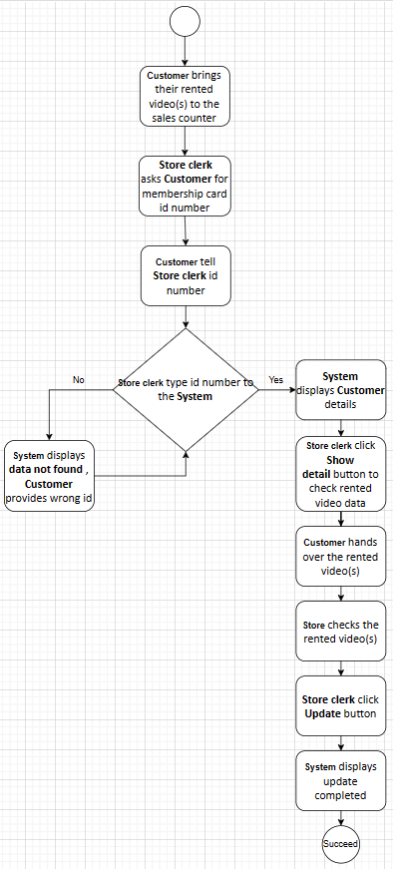

-

**Post Condition**

**Success end condition**

- Video is returned to the store, status return is updated in database

**Failure end condition**

- Video is not rented and status return is not change

**Minimal Guarantee**

- Video Inventory of store will correctly reflect the inventory of available videos

**Provide wrong id**

**Description:** This use case describes what happens when customer provide wrong id number

**Actor:** Customer, Store Clerk

**Precondition:** Customer provide wrong id number

**Scenarios**

**Main Success Scenario**

1. **Store Clerk** asks **Customer** for member card.
2. **Customer** give **Store clerk** member card.

**- Customer** forget the id number and doesn’t bring member card (alternate).

1. **Store Clerk** receives member card and takes the member id.

**Alternate Scenarios**

1. **Store Clerk** determines that him/her cannot start the video return process if **Customer** can’t give right member id
2. **Store Clerk** informs the **customer** must come back and bring the member card to the store.
3. Use Case ends with Failure

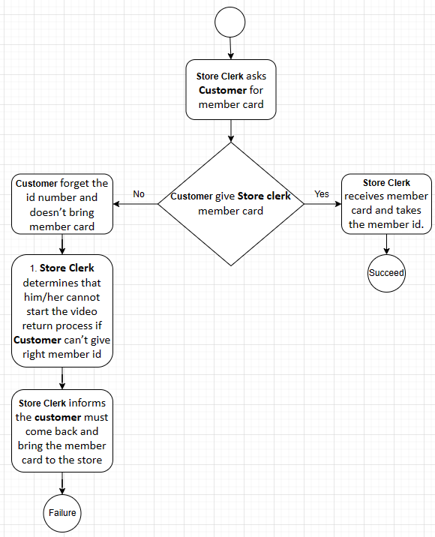

**Post Condition**

**Success end condition**

- **Store Clerk** received customer’s member card

**Failure end condition**

- **Customer** forgeted the id number and didn’t bring member card

**Minimal Guarantee**

- None