Table S1. Clinical characteristics by imaging coverage
Characteristic | Retained clinical cohort | Imaging coverage | No imaging coverage
Examinations, n | 238 | 182 | 56
Unique source patients, n | 176 | 135 | 41
Age, years | 56.0 [47.0, 64.8] | 56.5 [49.0, 66.0] | 53.5 [45.0, 62.0]
Male sex at birth | 166/238 (69.7%) | 132/182 (72.5%) | 34/56 (60.7%)
Tumor-labeled examinations | 187/238 (78.6%) | 141/182 (77.5%) | 46/56 (82.1%)
Treatment-related-change examinations | 51/238 (21.4%) | 41/182 (22.5%) | 10/56 (17.9%)
Days since initial event (known only) | 153.5 [37.0, 364.2] | 154.0 [40.5, 359.5] | 153.0 [33.5, 439.2]
Known interval | 192/238 (80.7%) | 146/182 (80.2%) | 46/56 (82.1%)
Missing interval | 46/238 (19.3%) | 36/182 (19.8%) | 10/56 (17.9%)
Other treatment before imaging | 38/238 (16.0%) | 25/182 (13.7%) | 13/56 (23.2%)
Values are counts or n/N (%), except continuous variables, which are median [Q1, Q3]. Percentages use the examination count in each column. Q1 and Q3 denote the first and third quartiles.
Coverage refers to the accessed image mirror. The 135 patients with coverage and 41 without coverage do not overlap in this cohort. The initial event denotes recorded surgery, treatment or diagnosis; interval summaries use known values without imputation. No between-group significance tests were performed.

Table S2. Predictor definitions and processing
Variable | Definition | Models | Processing and units
age_years | Age at imaging | M0 M1 Fusion | Years; standardized within each training fold.
sex_male | Male sex at birth | M0 M1 Fusion | Male=1, female=0; not scaled.
log_initial_event_days | Interval since initial event | M1 Fusion | Natural log of one plus elapsed days; training-fold median imputation and standardization.
other_treatment_prior | Other treatment before imaging | M1 Fusion | Yes=1, no=0; not scaled.
initial_event_missing | Missing initial-event interval | M1 Fusion | Missing=1, observed=0; not scaled.
FLAIR_mean | FLAIR mean | MRI Fusion | Dimensionless, unclipped percentile-scaled ROI mean; training-fold standardization.
FLAIR_std | FLAIR standard deviation | MRI Fusion | Dimensionless; population SD (ddof=0); training-fold standardization.
FLAIR_entropy | FLAIR entropy | MRI Fusion | Bits; Shannon entropy with 32 ROI-range bins; training-fold standardization.
FLAIR_glcm_contrast | FLAIR GLCM contrast | MRI Fusion | Squared bin-index differences; symmetric counts merged across 13 directions; training-fold standardization.
T1post_mean | Postcontrast T1 mean | MRI Fusion | Dimensionless, unclipped percentile-scaled ROI mean; training-fold standardization.
T1post_std | Postcontrast T1 standard deviation | MRI Fusion | Dimensionless; population SD (ddof=0); training-fold standardization.
T1post_entropy | Postcontrast T1 entropy | MRI Fusion | Bits; Shannon entropy with 32 ROI-range bins; training-fold standardization.
T1post_glcm_contrast | Postcontrast T1 GLCM contrast | MRI Fusion | Squared bin-index differences; symmetric counts merged across 13 directions; training-fold standardization.
M0: age and sex; M1: expanded clinical model; MRI: image features only; Fusion: clinical and MRI inputs. All learning of imputation and scaling parameters was confined to training folds.
The initial event could be initial surgery, another initial treatment, or diagnosis; only strictly negative source offsets were accepted as preceding the examination. Missing or nonnegative offsets were not treated as valid elapsed intervals.
MRI inputs used the union of positive supplied BraTS labels, without tissue-specific reinterpretation. The supplied spatial units were unknown; physical volumes and quantitative ADC were not included.

Table S3. Fixed-threshold classification and calibration diagnostics
Model | Treatment change correct, n/N | Tumor correct, n/N | Balanced accuracy | Calibration offset intercept | Calibration slope
M0 | 0/41 | 140/141 | 0.496 | -0.023 | 0.311
M1 | 2/41 | 134/141 | 0.500 | -0.023 | 0.761
MRI | 12/41 | 128/141 | 0.600 | -0.058 | 0.678
Fusion | 12/41 | 130/141 | 0.607 | -0.121 | 0.667
All counts refer to the same 182 examinations from 135 patients. Tumor probability at least 0.5 is classified as tumor; a lower probability is classified as treatment-related change. Balanced accuracy is the mean of tumor sensitivity and treatment-change recognition.
The calibration offset intercept is estimated with the predicted log odds as a fixed offset and slope set to one. The calibration slope is estimated jointly with a free intercept in a separate unpenalized logistic diagnostic regression. These two intercept definitions are distinct; the joint intercept is not shown here.
Calibration uses the pooled OOF predictions without subsequent recalibration or threshold changes. Values are descriptive estimates without calibration confidence intervals. Metrics are displayed to three decimals; class counts retain their exact denominators.

Table S4. Original ROI and eroded-boundary sensitivity
Model | ROC AUC (95% interval) | Brier score | AP for treatment change | Treatment change correct, n/N
Original MRI | 0.762 [0.683, 0.838] | 0.151 | 0.444 | 12/41
Original Fusion | 0.782 [0.698, 0.859] | 0.144 | 0.505 | 12/41
Eroded MRI | 0.765 [0.684, 0.844] | 0.149 | 0.458 | 11/41
Eroded Fusion | 0.788 [0.706, 0.867] | 0.141 | 0.529 | 14/41
All models used the same 182 examinations, patient groups, folds and fixed model settings. Eroded models replaced the eight MRI features while retaining the image-specific normalization parameters and full-ROI discretization boundaries.
The paired eroded-minus-original Fusion AUC difference was 0.0062 (95% interval, -0.0051 to 0.0183). Intervals use 2000 patient-cluster bootstrap attempts with fixed OOF probabilities and no refitting; they do not include full retraining or partition variability.
AP denotes average precision for treatment-related change, using one minus the tumor probability. Lower Brier scores indicate smaller probability error. Treatment-change correct counts use tumor probability below 0.5. The original ROI remained primary. Performance values are displayed to three decimals; the small paired AUC difference and its interval are shown to four decimals.

Table S5A. Performance across 20 fixed patient-grouped partitions
Model | Median ROC AUC [Q1, Q3] | ROC AUC range | Median Brier score
M0 | 0.556 [0.528, 0.567] | [0.489, 0.594] | 0.174
M1 | 0.667 [0.650, 0.670] | [0.620, 0.685] | 0.163
MRI | 0.775 [0.768, 0.783] | [0.759, 0.792] | 0.148
Fusion | 0.784 [0.775, 0.795] | [0.759, 0.809] | 0.143
All 20 repetitions were complete. Each repetition evaluated the same 182 examinations from 135 patients, using patient-grouped five-fold validation and the same fixed settings for M0, M1, MRI and Fusion.
Q1 and Q3 are the first and third quartiles across the 20 repetition-level estimates. Ranges are observed minima and maxima, not 95% confidence intervals. Repetitions reuse the same patients and are not independent studies. The primary Fusion AUC remains 0.782 from repetition 1.

Table S5B. Fusion-minus-M1 differences across the 20 partitions
Metric | Median difference [Q1, Q3] | Difference range | Favorable repetitions, n/N
ROC AUC | +0.125 [0.118, 0.135] | [0.103, 0.150] | 20/20
Treatment-related-change AP | +0.125 [0.108, 0.139] | [0.068, 0.176] | 20/20
Brier score | -0.019 [-0.023, -0.018] | [-0.027, -0.014] | 20/20
Logarithmic loss | -0.047 [-0.058, -0.038] | [-0.071, -0.022] | 20/20
Differences are calculated as Fusion minus M1 within each repetition, then summarized across repetitions. The median paired difference is not obtained by subtracting the two models’ separate medians.
Positive AUC or treatment-change AP differences and negative Brier-score or logarithmic-loss differences favor Fusion. AP denotes average precision for treatment-related change. Q1 and Q3 are quartiles, and ranges are observed minima and maxima.
Sign counts, including 20/20, are descriptive summaries of reused patients across fixed partitions. They are not independent replications or hypothesis tests and do not replace the primary paired patient-bootstrap intervals. Values are displayed to three decimals.

Table S6. Performance in the one-examination-per-patient analysis
Model | ROC AUC (95% interval) | Brier score | AP for treatment change | Treatment change correct, n/N
M0 | 0.501 [0.364, 0.639] | 0.137 | 0.205 | 0/22
M1 | 0.609 [0.438, 0.776] | 0.132 | 0.283 | 0/22
MRI | 0.729 [0.609, 0.837] | 0.130 | 0.316 | 2/22
Fusion | 0.730 [0.606, 0.833] | 0.133 | 0.322 | 2/22
The selected cohort contains 135 examinations from 135 patients, including 113 tumor and 22 treatment-related-change examinations. Each patient contributes the smallest available numeric session in the imaging subset; this is not necessarily the first clinical examination.
Four models share the rebuilt patient-grouped five-fold partition. Intervals use 2000 patient-bootstrap attempts with fixed OOF probabilities and no model refitting. They do not capture full retraining or partition variability.
AP denotes average precision for treatment-related change, scored by one minus the tumor probability. Correct treatment-change counts use tumor probability below 0.5. Values are displayed to three decimals. The cohort has different examination composition, class distribution and training data from the primary analysis.

Table S7. Paired Fusion-minus-M1 differences in the single-scan analysis
Metric | Fusion minus M1 | 95% paired interval
ROC AUC | +0.1203 | [-0.0151, 0.2522]
Treatment-related-change AP | +0.0385 | [-0.0733, 0.1566]
Brier score | +0.0004 | [-0.0171, 0.0197]
Logarithmic loss | -0.0141 | [-0.0731, 0.0501]
Differences use the same 135 selected examinations and rebuilt grouped folds. Positive AUC or treatment-change AP differences favor Fusion; negative Brier-score or logarithmic-loss differences favor Fusion.
Intervals are the 2.5th and 97.5th percentiles of 2000 paired patient-bootstrap attempts with fixed OOF predictions and no refitting. All four intervals include zero. The result does not replace the primary comparison.
AP denotes average precision for treatment-related change. Differences are calculated from unrounded metrics and displayed to four decimals to preserve the small positive Brier difference. This is a sensitivity comparison within the selected cohort, not a paired contrast between the 135- and 182-examination analyses.

Figure S1
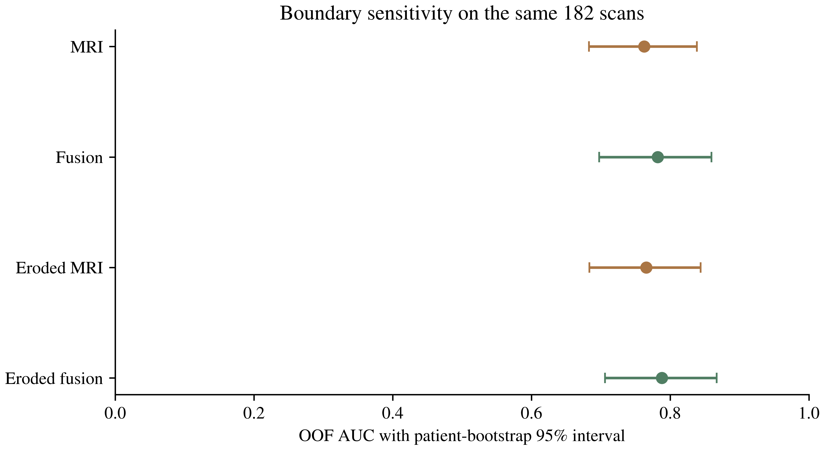
Figure S1. Boundary sensitivity in the same 182 examinations from 135 patients. Points show pooled OOF AUCs for the original and eroded MRI and Fusion models. Error bars are 95% patient-cluster bootstrap percentile intervals conditional on fixed OOF probabilities, without model refitting. The paired eroded-minus-original Fusion difference is reported in the text and Table S4 notes. Erosion used one iteration of the six-neighbor operation on the supplied voxel grid; this was not interpreted as a fixed millimeter distance. The original ROI analysis remained primary.

Figure S2
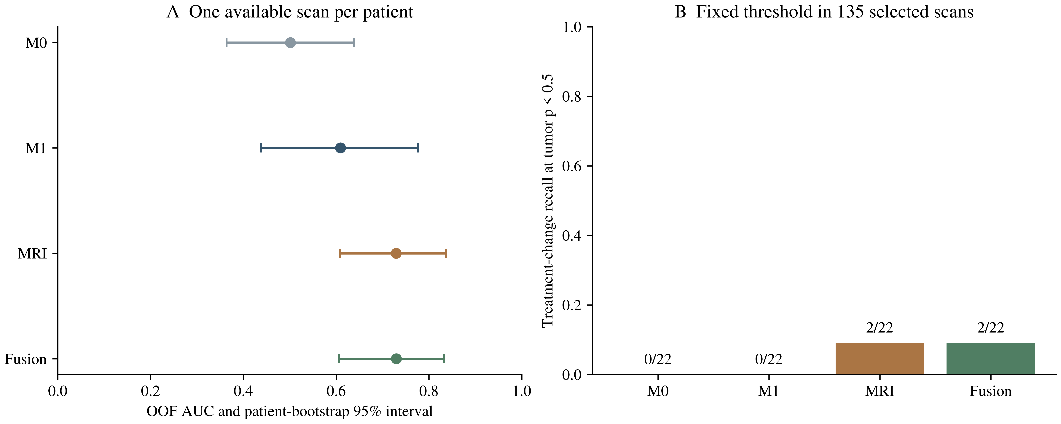
Figure S2. Sensitivity analysis using one available examination per patient. The selected cohort contains 135 examinations, including 113 tumor and 22 treatment-related-change examinations. A, Pooled OOF AUCs with patient-bootstrap 95% percentile intervals conditional on fixed predictions without refitting. B, Treatment-change recognition at the fixed tumor-probability threshold of 0.5, with exact correct/total counts. Selection used the smallest numeric session available in the imaging subset and does not establish the true first clinical visit. The analysis used rebuilt grouped folds and does not replace the primary 182-examination analysis.

