Results

3.3 Four-model discrimination
Each of the four fixed models provided an OOF probability for all 182 examinations under the same patient-grouped five-fold partition. The pooled ROC AUC was 0.526 for M0 (95% patient-bootstrap percentile interval, 0.404 to 0.644), 0.672 for M1 (0.553 to 0.778), 0.762 for MRI (0.683 to 0.838) and 0.782 for Fusion (0.698 to 0.859; Table 2 and Figure 2A). Treatment-related-change AP was 0.261, 0.354, 0.444 and 0.505 for M0, M1, MRI and Fusion, respectively, against a treatment-related-change prevalence of 0.225 in this cohort (Figure 2B). The corresponding Brier scores were 0.177, 0.163, 0.151 and 0.144. Fusion had the largest AUC and treatment-related-change AP point estimates and the lowest Brier score among the four models in this partition. The intervals summarized patient-sampling uncertainty conditional on the saved OOF probabilities; they did not include the full variability of model retraining or alternative fold assignments. These results represent internal validation in the same imaging cohort. The prespecified paired Fusion-minus-M1 comparison is reported separately, because the ordering of model-specific point estimates alone does not quantify the uncertainty in their difference.
四个固定模型均在相同的患者分组五折划分下，为全部182次检查提供OOF概率。汇总ROC AUC分别为M0的0.526（95%患者bootstrap百分位区间0.404至0.644）、M1的0.672（0.553至0.778）、MRI的0.762（0.683至0.838）及Fusion的0.782（0.698至0.859；Table 2和Figure 2A）。M0、M1、MRI与Fusion的治疗相关改变AP分别为0.261、0.354、0.444和0.505，该队列治疗相关改变的比例为0.225（Figure 2B）。相应Brier评分分别为0.177、0.163、0.151和0.144。在本次划分中，Fusion在四模型中具有最大的AUC与治疗相关改变AP点估计，以及最低的Brier评分。这些区间概括条件于已保存OOF概率的患者抽样不确定性，不涵盖模型重新训练或其他分折的全部变异。上述结果属于同一影像队列中的内部验证。预设的Fusion减去M1配对比较另节报告，因为仅凭各模型点估计排序，无法量化模型差值的不确定性。

Table 2. Performance of the four fixed models
Model | ROC AUC (95% interval) | Brier score | AP for treatment change | Treatment change correct, n/N
M0 | 0.526 [0.404, 0.644] | 0.177 | 0.261 | 0/41
M1 | 0.672 [0.553, 0.778] | 0.163 | 0.354 | 2/41
MRI | 0.762 [0.683, 0.838] | 0.151 | 0.444 | 12/41
Fusion | 0.782 [0.698, 0.859] | 0.144 | 0.505 | 12/41
M0: age and sex; M1: expanded clinical inputs; MRI: eight MRI features; Fusion: clinical and MRI inputs. All models used the same 182 examinations and patient-grouped five-fold partition.
AUC intervals are the 2.5th and 97.5th percentiles of 2000 paired patient-cluster bootstrap attempts using fixed OOF probabilities without refitting. They do not capture full retraining or partition variability.
AP is average precision for treatment-related change, scored by one minus the tumor probability; its prevalence is 41/182 (0.225). Lower Brier scores indicate smaller probability error. Correct treatment-change counts use tumor probability below 0.5. Displayed metrics are rounded to three decimals; the accompanying CSV retains the original precision.

Figure 2
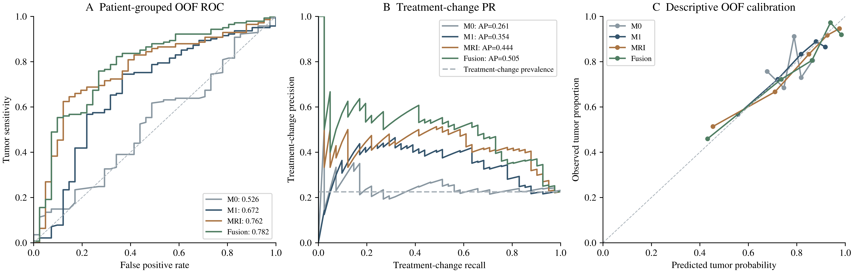
Figure 2. Internal validation of the four fixed models in 182 examinations from 135 patients. A, ROC curves based on pooled patient-grouped OOF probabilities. B, Precision-recall curves for treatment-related change; the dashed horizontal line marks its examination-level prevalence. AP denotes average precision. C, Descriptive calibration using predicted-probability quantile groups, with mean predicted tumor probability plotted against observed tumor proportion. The diagonal line in A is a reference for nondiscrimination and in C for agreement. Calibration summaries were not used to recalibrate the evaluated probabilities.

