Supplementary material

Additional sensitivity analyses

Repeated patient-grouped partitions
All 20 patient-grouped five-fold repetitions were completed. Median AUCs were 0.556 for M0, 0.667 for M1, 0.775 for MRI and 0.784 for Fusion (Supplementary Table S5A; Figure S3A). Fusion's AUC quartiles were 0.775 and 0.795, with an observed range of 0.759–0.809. The median Fusion-minus-M1 AUC difference was 0.125, ranging from 0.103 to 0.150, and was positive in all 20 partitions (Supplementary Table S5B; Figure S3B). AP, Brier-score and logarithmic-loss differences also favored Fusion in all repetitions. These descriptive summaries showed a consistent direction of benefit across partitions of the same cohort. The first partition reproduced the primary Fusion AUC of 0.782.

Single-scan analysis
Selecting one available examination per patient retained 135 examinations, including 113 tumor and 22 treatment-related-change examinations. AUCs were 0.501 for M0, 0.609 for M1, 0.729 for MRI and 0.730 for Fusion; Fusion's 95% percentile interval was 0.606–0.833 (Supplementary Table S6; Figure S2A). The Fusion-minus-M1 AUC difference was 0.120 (-0.015 to 0.252; Supplementary Table S7). Its interval and those for AP, Brier-score and logarithmic-loss differences included zero. At the fixed threshold, Fusion correctly recognized 109/113 tumor examinations (96.5%) and 2/22 treatment-related-change examinations (9.1%; Figure S2B). Its descriptive calibration slope was 0.539. The AUC increment remained positive in its point estimate, with wider uncertainty in this selected cohort.

Table S1. Clinical characteristics by imaging coverage
Characteristic | Retained clinical cohort | Imaging coverage | No imaging coverage
Examinations, n | 238 | 182 | 56
Unique source patients, n | 176 | 135 | 41
Age, years | 56.0 [47.0, 64.8] | 56.5 [49.0, 66.0] | 53.5 [45.0, 62.0]
Male sex at birth | 166/238 (69.7%) | 132/182 (72.5%) | 34/56 (60.7%)
Tumor-labeled examinations | 187/238 (78.6%) | 141/182 (77.5%) | 46/56 (82.1%)
Treatment-related-change examinations | 51/238 (21.4%) | 41/182 (22.5%) | 10/56 (17.9%)
Days since initial event (known only) | 153.5 [37.0, 364.2] | 154.0 [40.5, 359.5] | 153.0 [33.5, 439.2]
Known interval | 192/238 (80.7%) | 146/182 (80.2%) | 46/56 (82.1%)
Missing interval | 46/238 (19.3%) | 36/182 (19.8%) | 10/56 (17.9%)
Other treatment before imaging | 38/238 (16.0%) | 25/182 (13.7%) | 13/56 (23.2%)
Values are counts or n/N (%), except continuous variables, which are median [Q1, Q3]. Percentages use the examination count in each column. Q1 and Q3 denote the first and third quartiles.
Coverage refers to availability in the accessed image mirror. Coverage groups contain 135 and 41 distinct patients, respectively. Interval summaries use observed values for recorded initial surgery, treatment or diagnosis.

Table S2. Predictor definitions and processing
Variable | Definition | Models | Processing and units
age_years | Age at imaging | M0 M1 Fusion | Years; standardized within each training fold.
sex_male | Male sex at birth | M0 M1 Fusion | Male=1, female=0; not scaled.
log_initial_event_days | Interval since initial event | M1 Fusion | Natural log of one plus elapsed days; training-fold median imputation and standardization.
other_treatment_prior | Other treatment before imaging | M1 Fusion | Yes=1, no=0; not scaled.
initial_event_missing | Missing initial-event interval | M1 Fusion | Missing=1, observed=0; not scaled.
FLAIR_mean | FLAIR mean | MRI Fusion | Dimensionless, unclipped percentile-scaled ROI mean; training-fold standardization.
FLAIR_std | FLAIR standard deviation | MRI Fusion | Dimensionless; population SD (ddof=0); training-fold standardization.
FLAIR_entropy | FLAIR entropy | MRI Fusion | Bits; Shannon entropy with 32 ROI-range bins; training-fold standardization.
FLAIR_glcm_contrast | FLAIR GLCM contrast | MRI Fusion | Squared bin-index differences; symmetric counts merged across 13 directions; training-fold standardization.
T1post_mean | Postcontrast T1 mean | MRI Fusion | Dimensionless, unclipped percentile-scaled ROI mean; training-fold standardization.
T1post_std | Postcontrast T1 standard deviation | MRI Fusion | Dimensionless; population SD (ddof=0); training-fold standardization.
T1post_entropy | Postcontrast T1 entropy | MRI Fusion | Bits; Shannon entropy with 32 ROI-range bins; training-fold standardization.
T1post_glcm_contrast | Postcontrast T1 GLCM contrast | MRI Fusion | Squared bin-index differences; symmetric counts merged across 13 directions; training-fold standardization.
M0: age and sex; M1: five clinical inputs; MRI: eight MRI features; Fusion: clinical and MRI inputs. Imputation and standardization parameters were estimated within training folds.
The initial event is recorded initial surgery, other initial treatment or diagnosis. Elapsed days were transformed as ln(1 + days).
MRI features use the positive-label union of the supplied standard BraTS mask. Texture distances are expressed in voxel-grid units.

Table S3. Fixed-threshold classification and calibration diagnostics
Model | Treatment change correct, n/N | Tumor correct, n/N | Balanced accuracy | Calibration offset intercept | Calibration slope
M0 | 0/41 | 140/141 | 0.496 | -0.023 | 0.311
M1 | 2/41 | 134/141 | 0.500 | -0.023 | 0.761
MRI | 12/41 | 128/141 | 0.600 | -0.058 | 0.678
Fusion | 12/41 | 130/141 | 0.607 | -0.121 | 0.667
The cohort contains 182 examinations from 135 patients. A tumor probability of at least 0.5 defines tumor. Balanced accuracy is the mean of tumor sensitivity and treatment-change recognition.
The calibration offset intercept fixes the predicted-log-odds coefficient at one. The calibration slope is jointly estimated with a free intercept in a separate unpenalized logistic diagnostic regression.
Calibration estimates describe the pooled OOF predictions. Metrics are rounded to three decimals; classification counts retain exact denominators.

Table S4. Original ROI and eroded-boundary sensitivity
Model | ROC AUC (95% interval) | Brier score | AP for treatment change | Treatment change correct, n/N
Original MRI | 0.762 [0.683, 0.838] | 0.151 | 0.444 | 12/41
Original Fusion | 0.782 [0.698, 0.859] | 0.144 | 0.505 | 12/41
Eroded MRI | 0.765 [0.684, 0.844] | 0.149 | 0.458 | 11/41
Eroded Fusion | 0.788 [0.706, 0.867] | 0.141 | 0.529 | 14/41
All models used the same 182 examinations, patient groups, folds and fixed model settings. Eroded models replaced the eight MRI features while retaining the image-specific normalization parameters and full-ROI discretization boundaries.
Intervals are the 2.5th and 97.5th percentiles of 2000 paired patient-cluster bootstrap attempts, conditional on fixed OOF predictions. The eroded-minus-original Fusion AUC difference was 0.0062 (-0.0051 to 0.0183).
AP denotes average precision for treatment-related change, scored by one minus the tumor probability. Correct treatment-change counts use tumor probability below 0.5. The original ROI defines the primary analysis. Metrics use three decimals; the paired AUC difference uses four.

Table S5A. Performance across 20 fixed patient-grouped partitions
Model | Median ROC AUC [Q1, Q3] | ROC AUC range | Median Brier score
M0 | 0.556 [0.528, 0.567] | [0.489, 0.594] | 0.174
M1 | 0.667 [0.650, 0.670] | [0.620, 0.685] | 0.163
MRI | 0.775 [0.768, 0.783] | [0.759, 0.792] | 0.148
Fusion | 0.784 [0.775, 0.795] | [0.759, 0.809] | 0.143
All 20 repetitions were complete. Each repetition evaluated the same 182 examinations from 135 patients, using patient-grouped five-fold validation and the same fixed settings for M0, M1, MRI and Fusion.
Q1 and Q3 are quartiles across the 20 partitions. Ranges are observed minima and maxima in this cohort. The primary Fusion AUC is 0.782 from partition 1.

Table S5B. Fusion-minus-M1 differences across the 20 partitions
Metric | Median difference [Q1, Q3] | Difference range | Favorable repetitions, n/N
ROC AUC | +0.125 [0.118, 0.135] | [0.103, 0.150] | 20/20
Treatment-related-change AP | +0.125 [0.108, 0.139] | [0.068, 0.176] | 20/20
Brier score | -0.019 [-0.023, -0.018] | [-0.027, -0.014] | 20/20
Logarithmic loss | -0.047 [-0.058, -0.038] | [-0.071, -0.022] | 20/20
Fusion-minus-M1 differences were calculated within each repetition before summarizing their median and quartiles.
Differences are Fusion minus M1. Positive AUC or AP and negative Brier-score or logarithmic-loss differences favor Fusion. Q1 and Q3 are quartiles; ranges are observed minima and maxima.
Favorable-repetition counts describe the direction of paired estimates across the 20 partitions of the same cohort. Values are displayed to three decimals.

Table S6. Performance in the one-examination-per-patient analysis
Model | ROC AUC (95% interval) | Brier score | AP for treatment change | Treatment change correct, n/N
M0 | 0.501 [0.364, 0.639] | 0.137 | 0.205 | 0/22
M1 | 0.609 [0.438, 0.776] | 0.132 | 0.283 | 0/22
MRI | 0.729 [0.609, 0.837] | 0.130 | 0.316 | 2/22
Fusion | 0.730 [0.606, 0.833] | 0.133 | 0.322 | 2/22
The selected cohort contains 135 examinations from 135 patients: 113 tumor and 22 treatment-related-change examinations. Each patient contributes the smallest available numeric session in the imaging subset.
Four models share the rebuilt patient-grouped five-fold partition. Intervals are the 2.5th and 97.5th percentiles of 2000 paired patient-cluster bootstrap attempts, conditional on fixed OOF predictions.
AP denotes average precision for treatment-related change, scored by one minus the tumor probability. Correct treatment-change counts use tumor probability below 0.5. Values are rounded to three decimals.

Table S7. Paired Fusion-minus-M1 differences in the single-scan analysis
Metric | Fusion minus M1 | 95% paired interval
ROC AUC | +0.1203 | [-0.0151, 0.2522]
Treatment-related-change AP | +0.0385 | [-0.0733, 0.1566]
Brier score | +0.0004 | [-0.0171, 0.0197]
Logarithmic loss | -0.0141 | [-0.0731, 0.0501]
Differences are Fusion minus M1. Positive AUC or AP and negative Brier-score or logarithmic-loss differences favor Fusion. The comparison uses the same 135 selected examinations and rebuilt folds.
Intervals are the 2.5th and 97.5th percentiles of 2000 paired patient-cluster bootstrap attempts, conditional on fixed OOF predictions. All four intervals include zero.
AP denotes average precision for treatment-related change. Differences use unrounded metrics and are displayed to four decimals.

Figure S1
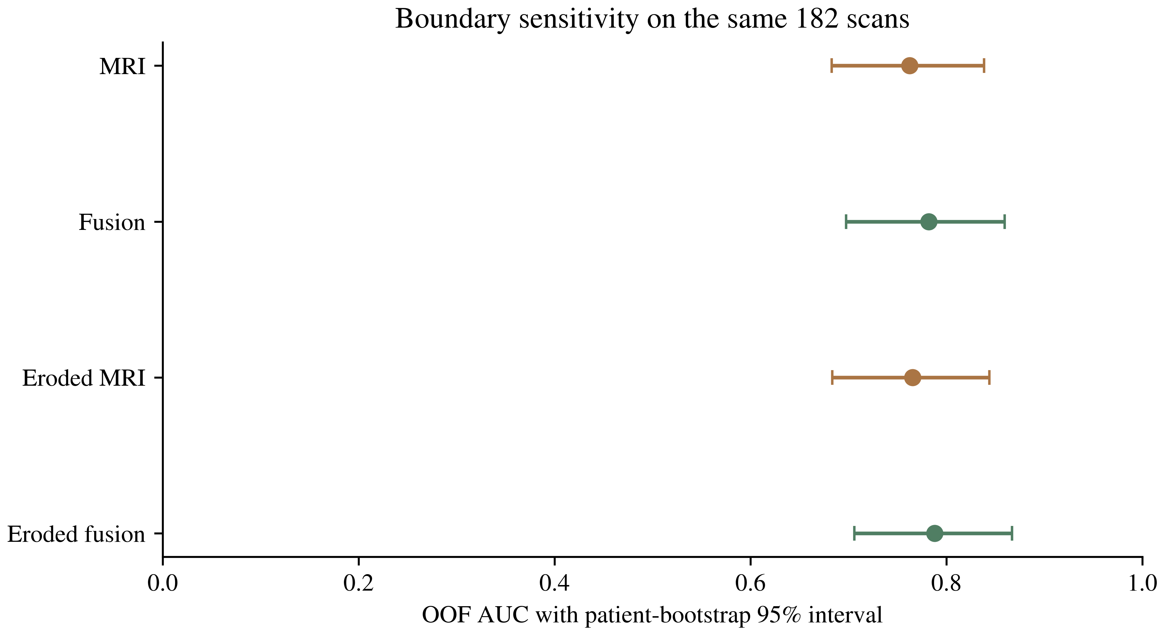
Figure S1. Boundary sensitivity in 182 examinations from 135 patients. Points show OOF AUCs for the original and eroded MRI and Fusion models. Error bars are 95% patient-cluster bootstrap percentile intervals conditional on fixed OOF probabilities. Erosion used one iteration of the six-neighbor operation on the supplied voxel grid. The paired Fusion difference is reported in Table S4.

Figure S2
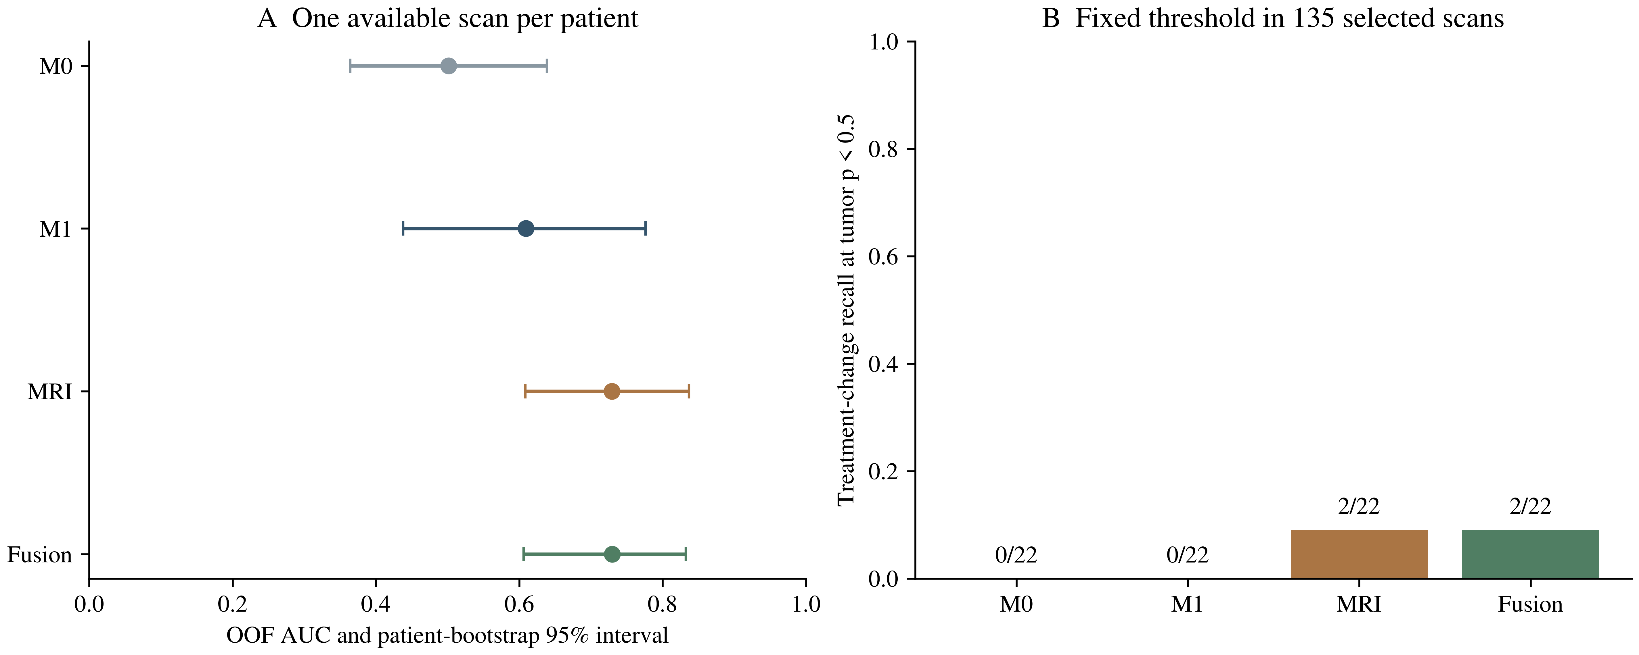
Figure S2. Sensitivity analysis using one available examination per patient, comprising 113 tumor and 22 treatment-related-change examinations. A, OOF AUCs and patient-bootstrap 95% percentile intervals conditional on fixed predictions. B, Treatment-change recognition at the fixed tumor-probability threshold of 0.5, with exact correct/total counts. Selection used the smallest available numeric session, followed by rebuilt patient-grouped folds.

Figure S3
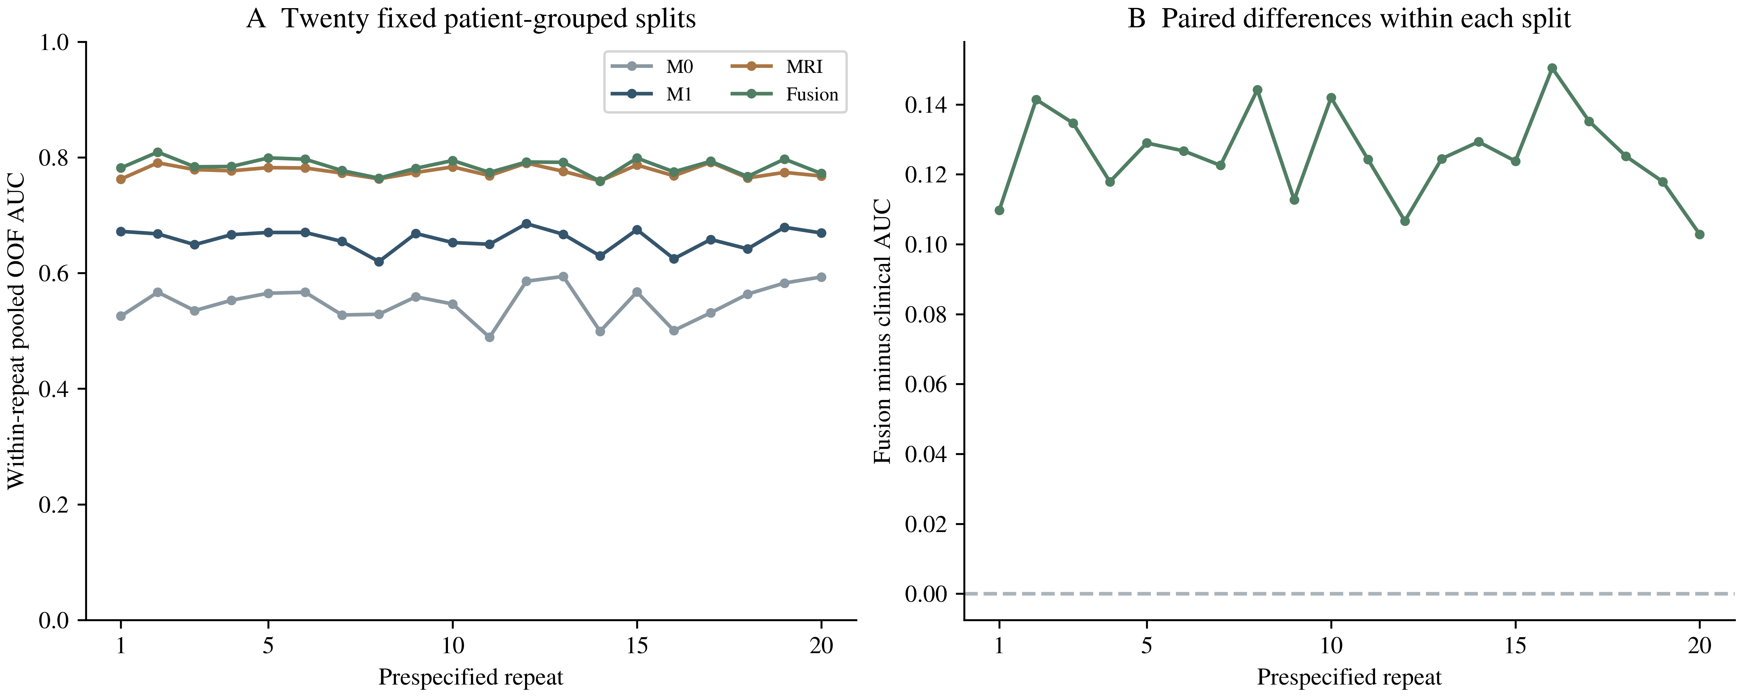
Figure S3. Performance across 20 patient-grouped five-fold partitions of the same 182 examinations from 135 patients. A, Pooled OOF AUC for each model within each partition. B, Paired Fusion-minus-M1 AUC differences, with zero marked by the dashed line. Partition 1 reproduces the primary analysis; the displayed variation describes split sensitivity within this cohort.

