Results

3.6 Boundary sensitivity
All 182 examinations retained complete MRI features after the prespecified erosion, allowing comparison on the original case set and fold assignments. The eroded MRI model had an OOF AUC of 0.765, compared with 0.762 for the original MRI model (Supplementary Table S4; Figure S1). Eroded Fusion had an AUC of 0.788 (95% patient-bootstrap percentile interval, 0.706 to 0.867), compared with 0.782 for original Fusion. The paired eroded-minus-original Fusion AUC difference was 0.0062, with an interval of -0.0051 to 0.0183 that included zero. Eroded Fusion had a Brier score of 0.141 and treatment-related-change AP of 0.529, and correctly recognized 14 of 41 treatment-related-change examinations at the fixed threshold. The corresponding original Fusion values were 0.144, 0.505 and 12 of 41. These findings described sensitivity to one boundary perturbation under fixed processing and did not establish superiority of erosion or segmentation accuracy. The original ROI remained the primary analysis.
预设腐蚀后，全部182次检查仍具备完整MRI特征，因此可以在原有病例集合与分折划分上进行比较。腐蚀后MRI模型的OOF AUC为0.765，原MRI模型为0.762（Supplementary Table S4；Figure S1）。腐蚀后Fusion的AUC为0.788（95%患者bootstrap百分位区间0.706至0.867），原Fusion为0.782。腐蚀后减去原Fusion的配对AUC差值为0.0062，区间为−0.0051至0.0183，包含零。腐蚀后Fusion的Brier评分为0.141，治疗相关改变AP为0.529，在固定阈值下正确识别41次治疗相关改变检查中的14次；原Fusion的相应数值为0.144、0.505和12/41。上述结果描述固定处理规则下对单次边界扰动的敏感性，不能据此认定腐蚀更优或证明分割准确性。原ROI分析仍保留为主分析。

Table S4. Original ROI and eroded-boundary sensitivity
Model | ROC AUC (95% interval) | Brier score | AP for treatment change | Treatment change correct, n/N
Original MRI | 0.762 [0.683, 0.838] | 0.151 | 0.444 | 12/41
Original Fusion | 0.782 [0.698, 0.859] | 0.144 | 0.505 | 12/41
Eroded MRI | 0.765 [0.684, 0.844] | 0.149 | 0.458 | 11/41
Eroded Fusion | 0.788 [0.706, 0.867] | 0.141 | 0.529 | 14/41
All models used the same 182 examinations, patient groups, folds and fixed model settings. Eroded models replaced the eight MRI features while retaining the image-specific normalization parameters and full-ROI discretization boundaries.
The paired eroded-minus-original Fusion AUC difference was 0.0062 (95% interval, -0.0051 to 0.0183). Intervals use 2000 patient-cluster bootstrap attempts with fixed OOF probabilities and no refitting; they do not include full retraining or partition variability.
AP denotes average precision for treatment-related change, using one minus the tumor probability. Lower Brier scores indicate smaller probability error. Treatment-change correct counts use tumor probability below 0.5. The original ROI remained primary. Performance values are displayed to three decimals; the small paired AUC difference and its interval are shown to four decimals.

Figure S1
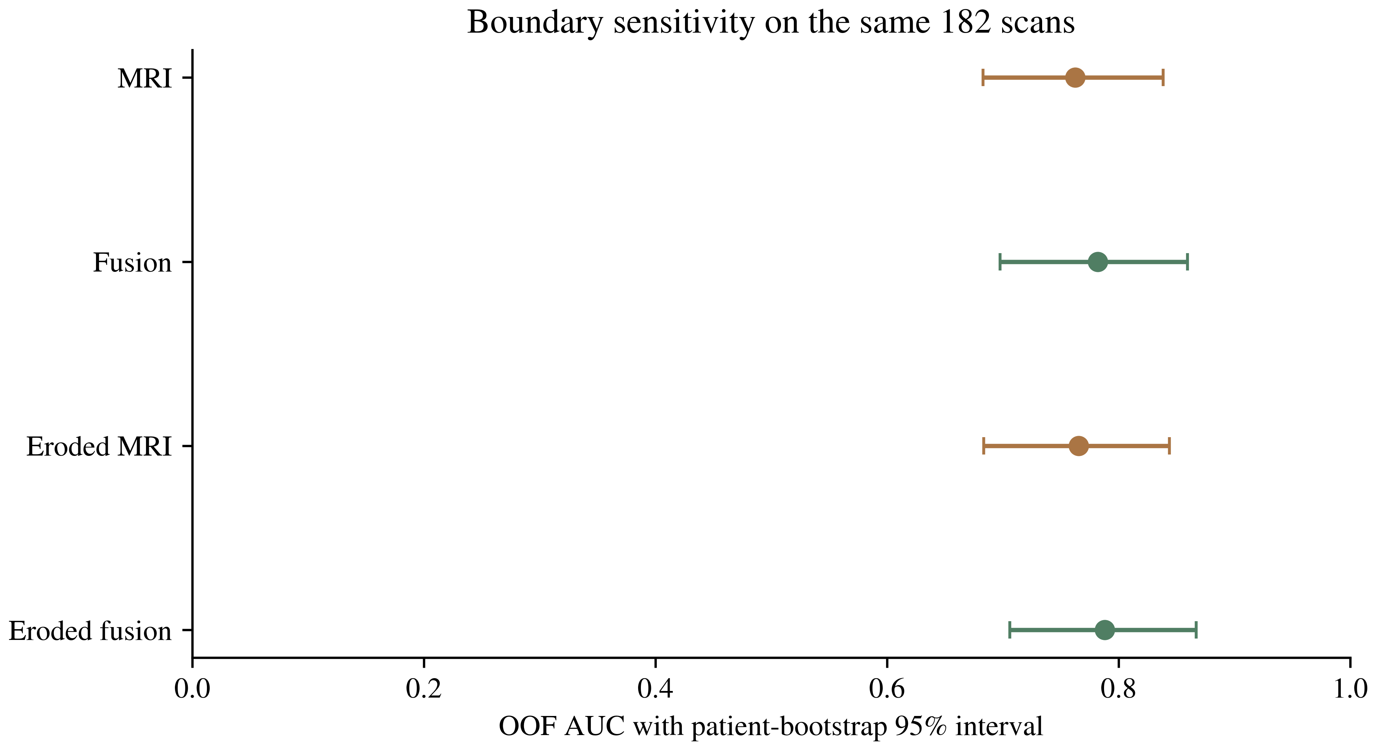
Figure S1. Boundary sensitivity in the same 182 examinations from 135 patients. Points show pooled OOF AUCs for the original and eroded MRI and Fusion models. Error bars are 95% patient-cluster bootstrap percentile intervals conditional on fixed OOF probabilities, without model refitting. The paired eroded-minus-original Fusion difference is reported in the text and Table S4 notes. Erosion used one iteration of the six-neighbor operation on the supplied voxel grid; this was not interpreted as a fixed millimeter distance. The original ROI analysis remained primary.

