Results

3.7 Split stability
All 20 prespecified repetitions completed the patient-grouped five-fold validation without failed fold-model fits. Across repetitions, median AUCs were 0.556 for M0, 0.667 for M1, 0.775 for MRI and 0.784 for Fusion (Supplementary Table S5A; Figure 3A). Fusion had first and third AUC quartiles of 0.775 and 0.795, with an observed range of 0.759 to 0.809. The median within-repetition Fusion-minus-M1 AUC difference was 0.125, with a range of 0.103 to 0.150; all 20 differences were positive (Supplementary Table S5B; Figure 3B). AP, Brier-score and logarithmic-loss differences also favored Fusion in all 20 repetitions. These sign counts described the observed partitions and did not replace the primary paired bootstrap intervals. Because the same patients were reused, the repetitions were not independent validation cohorts. Medians, quartiles and ranges summarized sensitivity to partitioning and were not confidence intervals. The first repetition reproduced the original partition and predictions, and its Fusion AUC of 0.782 remained the primary estimate rather than the maximum observed across repetitions.
20套预定重复均完成患者分组五折验证，没有折内模型拟合失败。跨重复的AUC中位数分别为M0的0.556、M1的0.667、MRI的0.775和Fusion的0.784（Supplementary Table S5A；Figure 3A）。Fusion AUC的第一和第三四分位数为0.775及0.795，实际范围为0.759至0.809。每套重复内部Fusion减去M1的AUC差值中位数为0.125，范围为0.103至0.150，20个差值均为正（Supplementary Table S5B；Figure 3B）。AP、Brier评分和对数损失差值也在全部20套重复中有利于Fusion。这些方向计数描述所观察的划分，不替代主要配对bootstrap区间。由于重复使用同一批患者，20套重复不是独立验证队列。中位数、四分位数及范围概括对划分的敏感性，不是置信区间。第一套重复复现原划分及预测，其Fusion AUC为0.782，仍作为主估计，不以全部重复中的最高值替代。

Table S5A. Performance across 20 fixed patient-grouped partitions
Model | Median ROC AUC [Q1, Q3] | ROC AUC range | Median Brier score
M0 | 0.556 [0.528, 0.567] | [0.489, 0.594] | 0.174
M1 | 0.667 [0.650, 0.670] | [0.620, 0.685] | 0.163
MRI | 0.775 [0.768, 0.783] | [0.759, 0.792] | 0.148
Fusion | 0.784 [0.775, 0.795] | [0.759, 0.809] | 0.143
All 20 repetitions were complete. Each repetition evaluated the same 182 examinations from 135 patients, using patient-grouped five-fold validation and the same fixed settings for M0, M1, MRI and Fusion.
Q1 and Q3 are the first and third quartiles across the 20 repetition-level estimates. Ranges are observed minima and maxima, not 95% confidence intervals. Repetitions reuse the same patients and are not independent studies. The primary Fusion AUC remains 0.782 from repetition 1.

Table S5B. Fusion-minus-M1 differences across the 20 partitions
Metric | Median difference [Q1, Q3] | Difference range | Favorable repetitions, n/N
ROC AUC | +0.125 [0.118, 0.135] | [0.103, 0.150] | 20/20
Treatment-related-change AP | +0.125 [0.108, 0.139] | [0.068, 0.176] | 20/20
Brier score | -0.019 [-0.023, -0.018] | [-0.027, -0.014] | 20/20
Logarithmic loss | -0.047 [-0.058, -0.038] | [-0.071, -0.022] | 20/20
Differences are calculated as Fusion minus M1 within each repetition, then summarized across repetitions. The median paired difference is not obtained by subtracting the two models’ separate medians.
Positive AUC or treatment-change AP differences and negative Brier-score or logarithmic-loss differences favor Fusion. AP denotes average precision for treatment-related change. Q1 and Q3 are quartiles, and ranges are observed minima and maxima.
Sign counts, including 20/20, are descriptive summaries of reused patients across fixed partitions. They are not independent replications or hypothesis tests and do not replace the primary paired patient-bootstrap intervals. Values are displayed to three decimals.

Figure 3
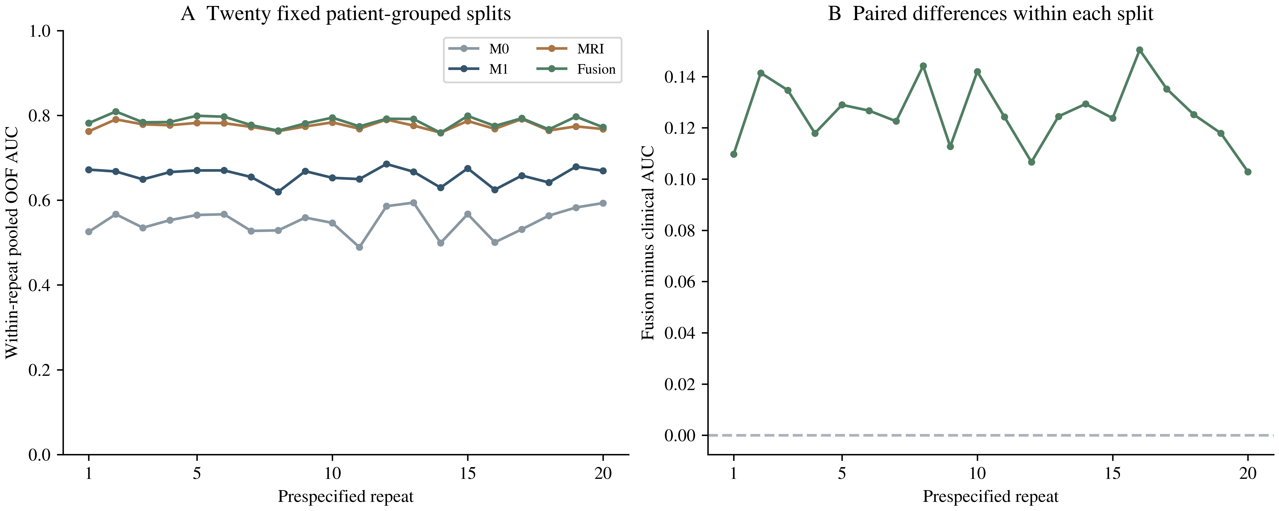
Figure 3. Sensitivity to 20 prespecified patient-grouped five-fold partitions. A, Pooled OOF AUC for each of the four fixed models within each repetition. B, Fusion-minus-M1 AUC differences calculated within the corresponding repetition; the dashed line marks zero. All repetitions reused the same 182 examinations from 135 patients. The repetitions are not independent validation cohorts, and their distribution does not define a confidence interval. Repetition 1 reproduces the primary partition. The highest AUC was not used to select a replacement analysis.

