Results

3.8 Single-scan sensitivity
Selecting the smallest available numeric session per patient retained 135 examinations from 135 patients, including 113 tumor and 22 treatment-related-change examinations. This selection did not establish the true first clinical visit. OOF AUCs were 0.501 for M0, 0.609 for M1, 0.729 for MRI and 0.730 for Fusion (95% patient-bootstrap percentile interval for Fusion, 0.606 to 0.833; Supplementary Table S6 and Figure S2A). The Fusion-minus-M1 AUC difference was 0.120, with a paired interval of -0.015 to 0.252 that included zero (Supplementary Table S7). The auxiliary AP, Brier-score and logarithmic-loss difference intervals also included zero. At the fixed threshold, Fusion recognized 109/113 tumor examinations (96.5%) and 2/22 treatment-related-change examinations (9.1%; Figure S2B). Its descriptive calibration slope was 0.539, without subsequent recalibration. The selected analysis differed from the primary 182-examination analysis in examination composition, class distribution and training data. Consequently, the difference between their AUC estimates could not be attributed solely to removing repeated scans. Incremental discrimination remained uncertain in the single-scan analysis, which was retained as a sensitivity analysis without replacing the primary comparison.
按每位患者最小可用数字会话编号选择后，保留135名患者的135次检查，包括113次肿瘤检查和22次治疗相关改变检查。该选择不能确定真实首次临床就诊。OOF AUC分别为M0的0.501、M1的0.609、MRI的0.729和Fusion的0.730；Fusion的95%患者bootstrap百分位区间为0.606至0.833（Supplementary Table S6和Figure S2A）。Fusion减去M1的AUC差值为0.120，配对区间为−0.015至0.252，包含零（Supplementary Table S7）。辅助AP、Brier评分与对数损失差值区间也均包含零。在固定阈值下，Fusion正确识别109/113次肿瘤检查（96.5%）和2/22次治疗相关改变检查（9.1%；Figure S2B）。其描述性校准斜率为0.539，未据此重新校准。所选分析与182次检查的主分析在检查构成、类别分布和训练数据方面不同。因此，两者AUC估计的差异不能仅归因于去除重复扫描。单扫描分析中的增量鉴别仍存在不确定性，该分析保留为敏感性分析，不替代主要比较。

Table S6. Performance in the one-examination-per-patient analysis
Model | ROC AUC (95% interval) | Brier score | AP for treatment change | Treatment change correct, n/N
M0 | 0.501 [0.364, 0.639] | 0.137 | 0.205 | 0/22
M1 | 0.609 [0.438, 0.776] | 0.132 | 0.283 | 0/22
MRI | 0.729 [0.609, 0.837] | 0.130 | 0.316 | 2/22
Fusion | 0.730 [0.606, 0.833] | 0.133 | 0.322 | 2/22
The selected cohort contains 135 examinations from 135 patients, including 113 tumor and 22 treatment-related-change examinations. Each patient contributes the smallest available numeric session in the imaging subset; this is not necessarily the first clinical examination.
Four models share the rebuilt patient-grouped five-fold partition. Intervals use 2000 patient-bootstrap attempts with fixed OOF probabilities and no model refitting. They do not capture full retraining or partition variability.
AP denotes average precision for treatment-related change, scored by one minus the tumor probability. Correct treatment-change counts use tumor probability below 0.5. Values are displayed to three decimals. The cohort has different examination composition, class distribution and training data from the primary analysis.

Table S7. Paired Fusion-minus-M1 differences in the single-scan analysis
Metric | Fusion minus M1 | 95% paired interval
ROC AUC | +0.1203 | [-0.0151, 0.2522]
Treatment-related-change AP | +0.0385 | [-0.0733, 0.1566]
Brier score | +0.0004 | [-0.0171, 0.0197]
Logarithmic loss | -0.0141 | [-0.0731, 0.0501]
Differences use the same 135 selected examinations and rebuilt grouped folds. Positive AUC or treatment-change AP differences favor Fusion; negative Brier-score or logarithmic-loss differences favor Fusion.
Intervals are the 2.5th and 97.5th percentiles of 2000 paired patient-bootstrap attempts with fixed OOF predictions and no refitting. All four intervals include zero. The result does not replace the primary comparison.
AP denotes average precision for treatment-related change. Differences are calculated from unrounded metrics and displayed to four decimals to preserve the small positive Brier difference. This is a sensitivity comparison within the selected cohort, not a paired contrast between the 135- and 182-examination analyses.

Figure S2
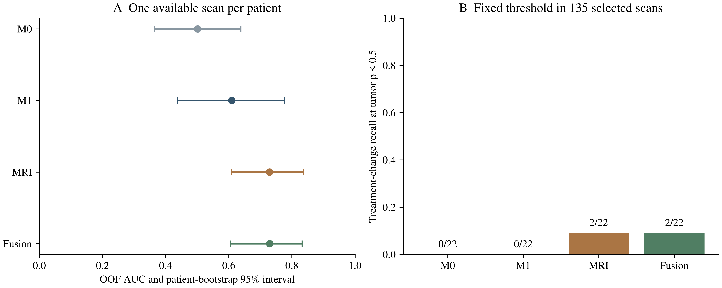
Figure S2. Sensitivity analysis using one available examination per patient. The selected cohort contains 135 examinations, including 113 tumor and 22 treatment-related-change examinations. A, Pooled OOF AUCs with patient-bootstrap 95% percentile intervals conditional on fixed predictions without refitting. B, Treatment-change recognition at the fixed tumor-probability threshold of 0.5, with exact correct/total counts. Selection used the smallest numeric session available in the imaging subset and does not establish the true first clinical visit. The analysis used rebuilt grouped folds and does not replace the primary 182-examination analysis.

