June 21, 2023

**DEPARTMENT OF MICROBIOLOGY AND IMMUNOLOGY**

1520A MEDICAL SCIENCE RESEARCH BUILDING I

ANN ARBOR, MICHIGAN 48109-0620

PHONE: (734) 763-3531

FAX: (734) 764-3562



Dear Editor,

My colleagues and I excited to submit for your consideration our manuscript, “**Machine learning classification by fitting amplicon sequences to existing OTUs**” with the hope that we can receive an expedited review with *mSphere*. This manuscript was previously reviewed twice at mBio (mBio00972-23 and mBio02491-22). Although the manuscript was not rejected, from the points raised in the two rounds of reviews we fear that that editors and reviewers and ourselves are talking past each other. Hopefully, you will find the current revisions and our response to the previous rounds compelling.

This manuscript is submitted as an Observation formatted paper. The results reported here are important because they demonstrate, for the first time, the ability to “lock down” a machine learning model trained using operational taxonomic unit (OTUs) relative abundance data and then classify new samples also clustered into OTUs. As indicated in the response to the last round of reviews, an earlier work of ours that described the OptiFit approach used in this study received this feedback (manuscript mSphere00916-21; DOI: 10.1128/msphere.00916-21):

*From my perspective, the development of OptiFit makes a perfect partner for OptiClust in a Train/Test (Train/Classify) splitting situation, where the users would split data, train using OptiClust and then classify the remaining reads using OptiFit. Of course, pursuing this would be well beyond the scope of this manuscript, but the authors may consider discussing such a possibility for future work.*

The current manuscript fulfills the vision that we shared with this vision.

We look forward to receiving your feedback on the latest version of the manuscript. We have deposited an update to this manuscript as a preprint in biorxiv (10.1101/2022.09.01.506299).

Sincerely,

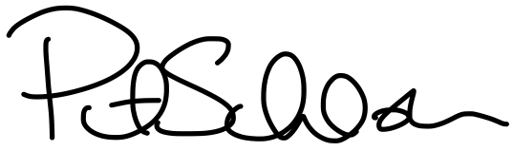

Patrick D. Schloss, PhD

Professor