<https://open5e.com/monsters/aatxe>

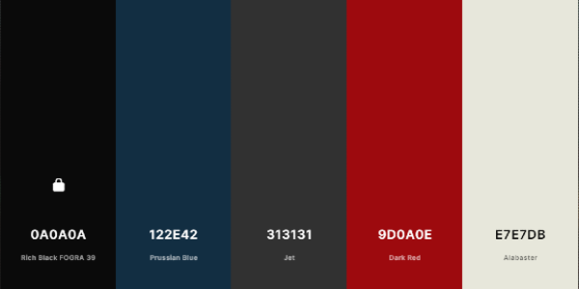

**ABCDEFGHIJKLMNOPQRSTUVWXYZ**

**Algerian**

Abcdefghijklmnopqrstuvwxyz

Constantia