**CS673S16 Software Engineering** 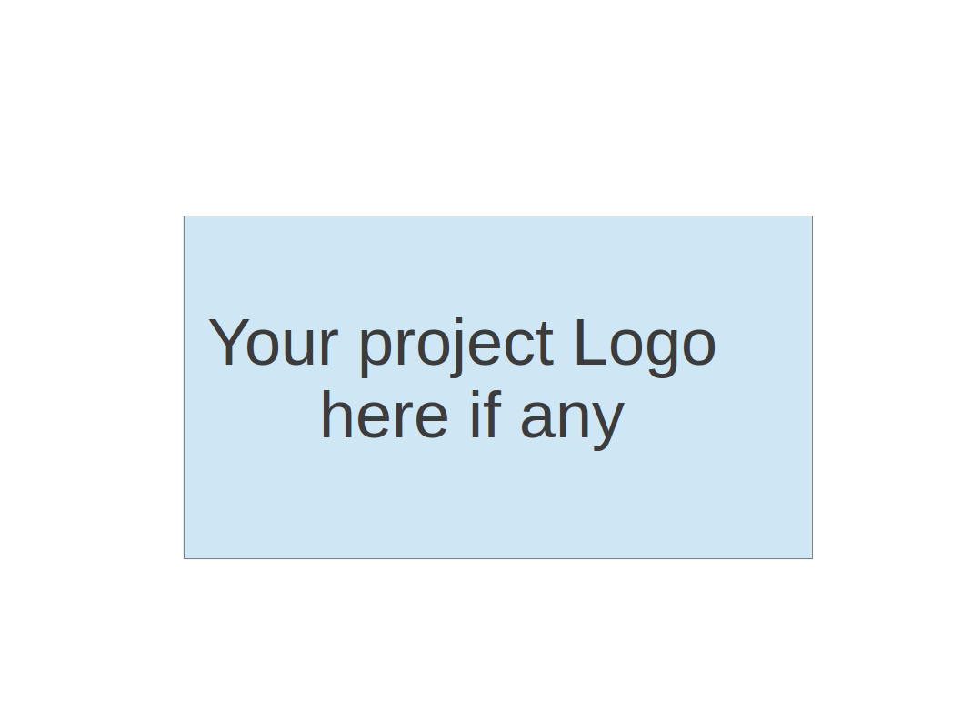

**Team 2 - What’s Eat**

**Tests Report**

|  |  |  |  |
| --- | --- | --- | --- |
| Team Member | Role(s) | Signature | Date |
| He Yu | QA leader; Document leader | *He Yu* | 5/2 |
|  |  |  |  |
|  |  |  |  |
|  |  |  |  |
|  |  |  |  |
|  |  |  |  |
|  |  |  |  |
|  |  |  |  |

**Revision history**

|  |  |  |  |
| --- | --- | --- | --- |
| **Version** | **Author** | **Date** | **Change** |
|  |  |  |  |
|  |  |  |  |

Introduction

Test Summary

Tests Reports

Testing Metrics

References

Glossary

# Introduction

In this section, give a summary of this tests report document.

**In the test iteration, our project mainly focus on integration test by Selenium framework. The IDE we used is Katalon Automation Record. Our project passed all the integration test designed. It means the modulars and system cooperates well and front end and back end connects in a good condition.**

**Also, while in the implementation process, we also did manual test for each achieve features. These features are tested with the acceptance test designed and posted on pivotal tracker. If passed, the corresponding user story will be marked as finished and deliver.**

# Test Summary

In this section, you will summarize what was tested and what happened, based on each test type.

* + Unit Tests

**Actually, we didn’t do much on unit test part. Because our project do not have much for the**

* + System Tests

**We mainly focus on 4 dimensions of test: sign up, log in, log out and food recommendation. The following graph shows how the system performs to test whether it is functional or not.**

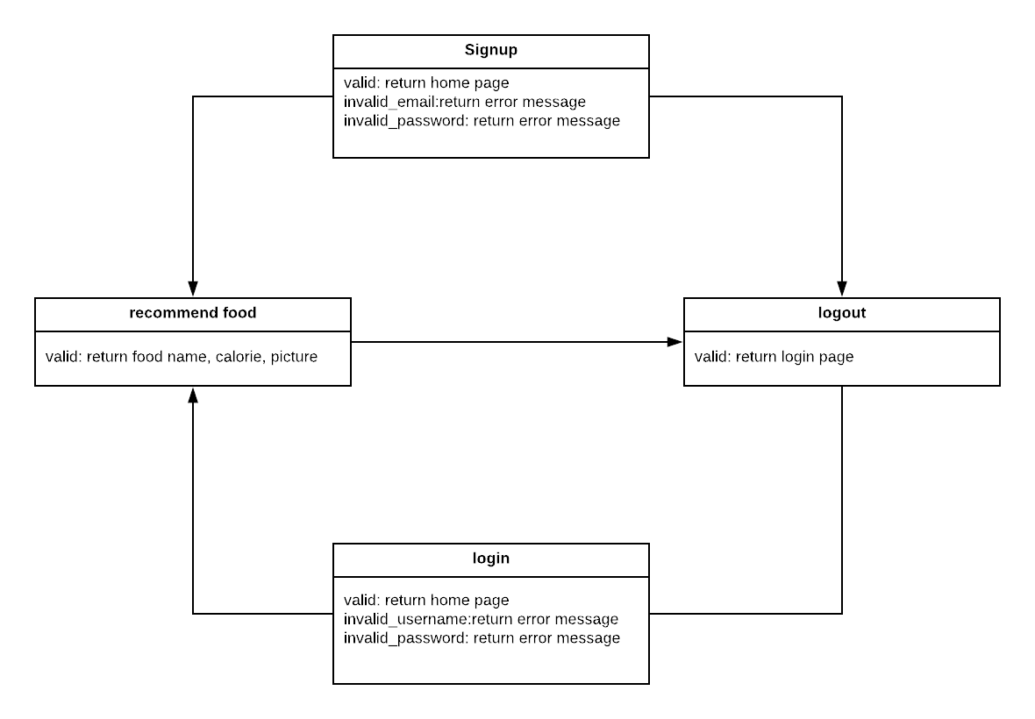

**As the graph shows above, we first test each function independently, and then group several functions together to do integration test. These groups are {(signup, logout), (login, logout), (signup, recommend food, logout), (login, recommend food, logout)}. For each type of test, the desired output is the return value for each cases as the diagram shows above. After performing all the tests, they all passed. Then we could conclude that our app is good to deliver.**

* + Acceptance Tests

**For each user story, we designed acceptance tests correspondingly. After the whole semester, we have achieved 11 user stories.**

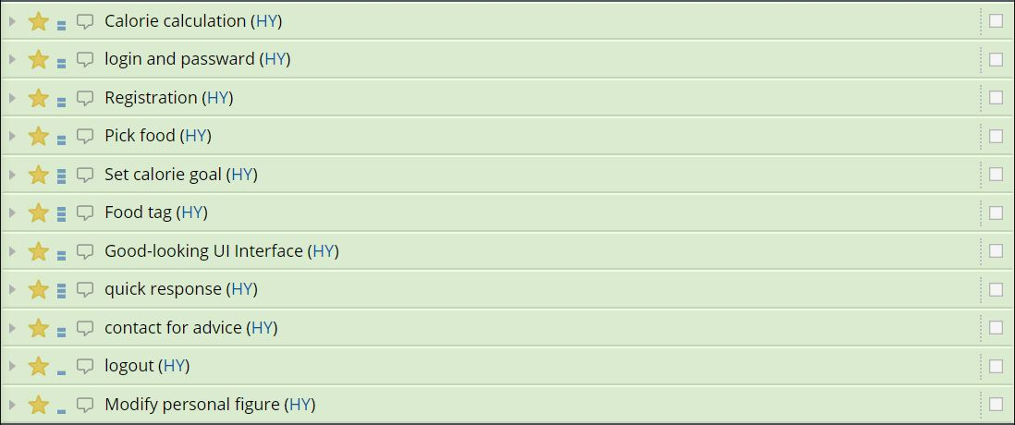

**Each story has corresponding acceptance tests. If these tests passed, then we will add comments for the story and mark it as finished. The following screenshot is an example logout. The bottom is the acceptance tests designed. And comments above shows these acceptance tests are passed and the user story is good to deliver.**

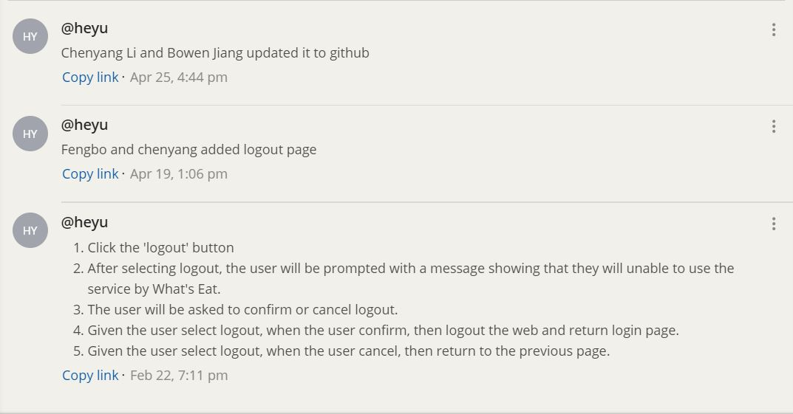

**For more details, please refer our pivotal tracker: https://www.pivotaltracker.com/n/projects/2149232**

# Tests Reports

# In this section, you will give a detailed description of each test case performed and the result. You shall list what are existing tests developed in the previous semester and what are new tests developed currently.

For each test case, you can use the following template (or something based on the following template)

* Test case ID, name
* New or old:
* Test items: (what do you test )
* Test priority (high/medium/low)
* Dependencies (to other test case/requirement if any):
* Preconditions: (if any)
* input data:
* Test steps:
* Postconditions:
* Expected output:
* Actual output:
* Pass or Fail:
* Bug id/link: (this should link to your github issue id)
* Additional notes:

(You can use an additional table or document for this section)

**There are 12 integration tests overall. For each test case, textual description are list below:**

|  |  |
| --- | --- |
| **Test ID, Name** | **1-Home** |
| **New or Old** | **New** |
| **Test Item** | **Home button** |
| **Test priority (high/medium/low)** | **Low** |
| **Dependencies (to other test case/requirement if any)** | **No** |
| **Preconditions (if any)** | **Server is connected correctly** |
| **input data** | **N/A** |
| **Test steps** | **Click Home button** |
| **Postconditions** | **N/A** |
| **Expected output** | **Home page** |
| **Actual output** | **Home page** |
| **Pass or Fail** | **Pass** |

|  |  |
| --- | --- |
| **Test ID, Name** | **2-Contact** |
| **New or Old** | **New** |
| **Test Item** | **Contact Button** |
| **Test priority (high/medium/low)** | **Low** |
| **Dependencies (to other test case/requirement if any)** | **N/A** |
| **Preconditions (if any)** | **Server is connected correctly** |
| **input data** | **N/A** |
| **Test steps** | **Click Contact Button** |
| **Postconditions** | **N/A** |
| **Expected output** | **Jump to contact page;**  **Display with contact info;** |
| **Actual output** | **Jump to contact page;**  **Display with contact info;** |
| **Pass or Fail** | **Pass** |

|  |  |
| --- | --- |
| **Test ID, Name** | **3- Home after contact** |
| **New or Old** | **New** |
| **Test Item** | **Home button function in contact page** |
| **Test priority (high/medium/low)** | **Medium** |
| **Dependencies (to other test case/requirement if any)** | **2-Contact pass;** |
| **Preconditions (if any)** | **Server is connected correctly;**  **Display contact page;** |
| **input data** | **N/A** |
| **Test steps** | **Click Home button** |
| **Postconditions** | **N/A** |
| **Expected output** | **Back to home page;** |
| **Actual output** | **Back to home page** |
| **Pass or Fail** | **Pass** |

|  |  |
| --- | --- |
| **Test ID, Name** | **4- Signup_valid** |
| **New or Old** | **New** |
| **Test Item** | **Sign up function** |
| **Test priority (high/medium/low)** | **high** |
| **Dependencies (to other test case/requirement if any)** | **N/A** |
| **Preconditions (if any)** | **Server is connected correctly** |
| **input data** | **Valid username, email and password** |
| **Test steps** | **Click signup button;**  **Input username=yuhe123;**  **Input email =** [**realyuhe@gmail.com**](mailto:realyuhe@gmail.com)**;**  **Input password = 123123;**  **Input repeat password = 123123;**  **Click gender;**  **Input height=6;**  **Input weight= 140;**  **Input age=28;**  **Click signup;** |
| **Postconditions** | **No error message;** |
| **Expected output** | **Jump to home page with welcome screen;** |
| **Actual output** | **Jump to home page with welcome screen;** |
| **Pass or Fail** | **pass** |

|  |  |
| --- | --- |
| **Test ID, Name** | **5-Signup_invalid_password** |
| **New or Old** | **New** |
| **Test Item** | **Signup function** |
| **Test priority (high/medium/low)** | **High** |
| **Dependencies (to other test case/requirement if any)** | **4-signup_valid pass** |
| **Preconditions (if any)** | **Server is connected correctly** |
| **input data** | **Invalid password;** |
| **Test steps** | **Click signup button;**  **Input username=yuhe123;**  **Input email = realyuhe@gmail.com;**  **Input password = real;**  **Input repeat password = real;**  **Click gender;**  **Input height=6;**  **Input weight= 150;**  **Input age=22;**  **Click signup;** |
| **Postconditions** | **Pop up error message** |
| **Expected output** | **AssertError: “password must be longer than 6”** |
| **Actual output** | **AssertError: “password must be longer than 6”** |
| **Pass or Fail** | **pass** |

|  |  |
| --- | --- |
| **Test ID, Name** | **6-Signup_invalid_email** |
| **New or Old** | **New** |
| **Test Item** | **Signup function** |
| **Test priority (high/medium/low)** | **High** |
| **Dependencies (to other test case/requirement if any)** | **4-signup_valid pass** |
| **Preconditions (if any)** | **Server is connected correctly** |
| **input data** | **Invalid email;** |
| **Test steps** | **Click signup button;**  **Input username=yuhe123;**  **Input email = 123123;**  **Input password = 123123;**  **Input repeat password = 123123;**  **Click gender;**  **Input height=6;**  **Input weight= 140;**  **Input age=28;**  **Click signup;** |
| **Postconditions** | **Pop up error message** |
| **Expected output** | **AssertError: “Invalid Email Address”** |
| **Actual output** | **AssertError: “Invalid Email Address”** |
| **Pass or Fail** | **pass** |

|  |  |
| --- | --- |
| **Test ID, Name** | **7-Signup_invalid_repeat_pwd** |
| **New or Old** | **New** |
| **Test Item** | **Signup function** |
| **Test priority (high/medium/low)** | **High** |
| **Dependencies (to other test case/requirement if any)** | **4-signup_valid pass** |
| **Preconditions (if any)** | **Server is connected correctly** |
| **input data** | **Different password and repeat password;** |
| **Test steps** | **Click signup button;**  **Input username=jiujiu;**  **Input email = jiujiu@gmail.com;**  **Input password = 123123;**  **Input repeat password = 1231234;**  **Click gender;**  **Input height=7;**  **Input weight= 150;**  **Input age=24;**  **Click signup;** |
| **Postconditions** | **Pop up error message** |
| **Expected output** | **AssertError: “password does not match”** |
| **Actual output** | **AssertError: “password does not match”** |
| **Pass or Fail** | **pass** |

|  |  |
| --- | --- |
| **Test ID, Name** | **8-Login_valid_ logout** |
| **New or Old** | **New** |
| **Test Item** | **Login function and logout** |
| **Test priority (high/medium/low)** | **High** |
| **Dependencies (to other test case/requirement if any)** | **N/A** |
| **Preconditions (if any)** | **Server is connected correctly; user has signed up;** |
| **input data** | **Valid username(email) with password;** |
| **Test steps** | **Click login button;**  **Input username = realyuhe@gmail.com;**  **Input password = 123123;**  **Click login;** |
| **Postconditions** | **No Error message** |
| **Expected output** | **Jump to home page with welcome screen;**  **Successfully return to home page with login;** |
| **Actual output** | **Jump to home page with welcome screen;**  **Successfully return to home page with login;** |
| **Pass or Fail** | **pass** |
| **Additional notes** | **N/A** |

|  |  |
| --- | --- |
| **Test ID, Name** | **9-Login_invalid_username** |
| **New or Old** | **New** |
| **Test Item** | **Login function** |
| **Test priority (high/medium/low)** | **High** |
| **Dependencies (to other test case/requirement if any)** | **8-Login test pass** |
| **Preconditions (if any)** | **Server is connected correctly; user has signed up;** |
| **input data** | **invalid username(email) with password;** |
| **Test steps** | **Click login button;**  **Input username = realyuhe@123.com;**  **Input password = 123123;**  **Click login;** |
| **Postconditions** | **Pop up error message** |
| **Expected output** | **AssertError: “Error”** |
| **Actual output** | **No error report** |
| **Pass or Fail** | **fail** |
| **Additional notes** | **The error message will not pop up with automatic test; but it does pop up with error message manually; we treat it as pass in the end** |

|  |  |
| --- | --- |
| **Test ID, Name** | **10-Login_invalid_username** |
| **New or Old** | **New** |
| **Test Item** | **Login function** |
| **Test priority (high/medium/low)** | **High** |
| **Dependencies (to other test case/requirement if any)** | **8-Login test pass** |
| **Preconditions (if any)** | **Server is connected correctly; user has signed up;** |
| **input data** | **Valid username(email) with invalid password;** |
| **Test steps** | **Click login button;**  **Input email = realyuhe@gmail.com;**  **Input password = 1231234;**  **Click login;** |
| **Postconditions** | **Pop up error message** |
| **Expected output** | **AssertError: “Error”** |
| **Actual output** | **No error report** |
| **Pass or Fail** | **fail** |
| **Additional notes** | **The error message will not pop up with automatic test; but it does pop up with error message manually; we treat it as pass in the end** |

|  |  |
| --- | --- |
| **Test ID, Name** | **11- Signup_recommend** |
| **New or Old** | **New** |
| **Test Item** | **Integrate test signup-recommend-logout** |
| **Test priority (high/medium/low)** | **high** |
| **Dependencies (to other test case/requirement if any)** | **4-Signup_valid pass;** |
| **Preconditions (if any)** | **Server is connected correctly** |
| **input data** | **Valid username, email and password** |
| **Test steps** | **Click signup button;**  **Input username=yuhe123;**  **Input email =** [**realyuhe@gmail.com**](mailto:realyuhe@gmail.com)**;**  **Input password = 123123;**  **Input repeat password = 123123;**  **Click gender;**  **Input height=6;**  **Input weight= 140;**  **Input age=28;**  **Click signup;**  **Click recommend;**  **Set calorie range;**  **Click recommend;** |
| **Postconditions** | **No error message;** |
| **Expected output** | **Pop up food with calorie and picture;** |
| **Actual output** | **Pop up food with calorie and picture;** |
| **Pass or Fail** | **pass** |

|  |  |
| --- | --- |
| **Test ID, Name** | **12-Login_recommend_logout** |
| **New or Old** | **New** |
| **Test Item** | **Integration test login-recommend-logout** |
| **Test priority (high/medium/low)** | **High** |
| **Dependencies (to other test case/requirement if any)** | **8-login_valid_logout pass;** |
| **Preconditions (if any)** | **Server is connected correctly; user has signed up;** |
| **input data** | **Valid username(email) with password;** |
| **Test steps** | **Click login button;**  **Input username = realyuhe@gmail.com;**  **Input password = 123123;**  **Click login;**  **Click recommend;**  **Set calorie range;**  **Click recommend;** |
| **Postconditions** | **No Error message** |
| **Expected output** | **Jump to home page with welcome screen;**  **Successfully return to home page with login;** |
| **Actual output** | **Jump to home page with welcome screen;**  **Successfully return to home page with login;** |
| **Pass or Fail** | **pass** |

# Testing Metrics

In this section, you shall report the any metrics used for the evaluation, e.g. coverage, defects rate, etc.

We use Katalon Automate test (an IDE designed to do web app integration test) to test all the test cases. 12 test was performed and 10 passed. The overall rate is 10/12 = 83.33%. It means that most of our web function properly.

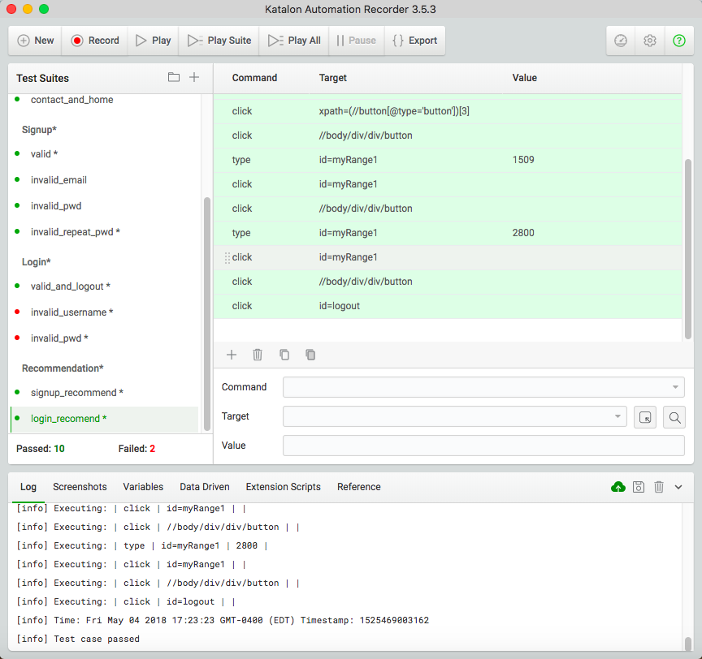

# References

# Glossary