Introduction

After some observation i have decided to choose some data that has visible effects in daily life. These four data are:

1. Total production (TP.SANAYREV4.Y1)
2. Consumer price index (TP.FG.J0)
3. Total export (TP.DT.GEN.IH.B)
4. Unemployment rate (TP.TIG07)

These are picked because some of them look as perfect fit for this kind of a study. And the others to analyze how they are getting affected by the first group.

To begin with since Turkey has a big variety of climates and gets affected by seasonal changes especially in tourism and farming way. There is even a term “mevsimlik işçi” to represent the workers who works season to season. This was the starting point for the study. Seasons affect employment, employment increases production, this takes us to an increase in export. Even though it needs further studies, consumer price index is also included to check whether this “system” has a direct effect on consumer or not.

Analysis Part 1

In the first part, the data is studied individually for each. To have a rough idea about them I’ve plotted their data of last five years. It is also the time period I’ve used for the following parts.

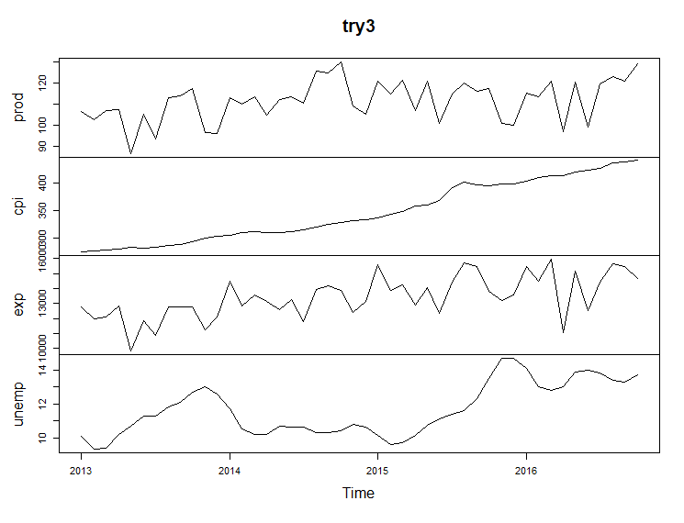

By observation, it is safe to say cpi is the only one following a linear-ish model. The others drew graphs having ups and downs. By using this we can reach to presence of autocorrelation.

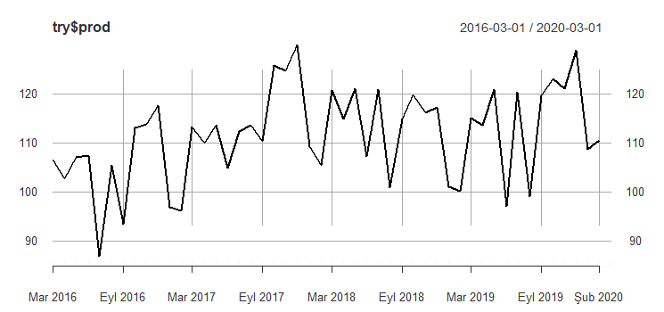

**Production in time**

When we calculate the autocorrelation for production we can’t see a direct seasonality nor a high rate of autocorrelation.

Autocorrelations of series ‘seasonalprod’, by lag

0 1 2 3 4 5 6 7 8 9 10 11 12

1.000 0.160 0.235 -0.088 0.061 0.259 0.090 0.257 -0.142 -0.109 -0.084 -0.015 0.330

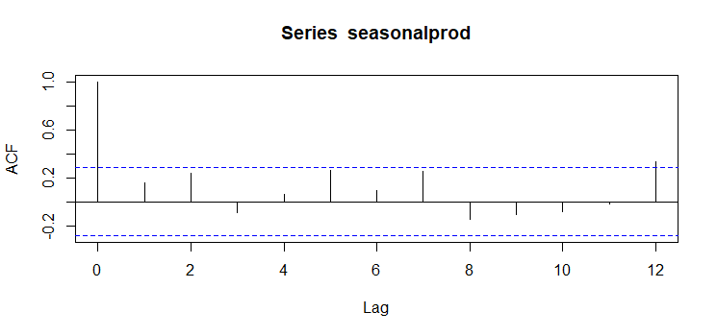

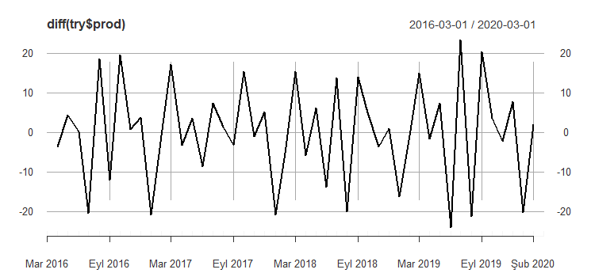Even though lag=12 has the biggest auto correlation it is not good enough to reach a conclusion. Also it doesn’t explain the “up and down” structure of production well. Hence it might be beneficial to take difference of this values month to month and work on that data.

Autocorrelations of series ‘seasonalprodd’, by lag

0 1 2 3 4 5 6 7 8 9 10 11 12

1.000 -0.554 0.246 -0.289 -0.028 0.206 -0.182 0.333 -0.253 0.011 -0.041 -0.152 0.462

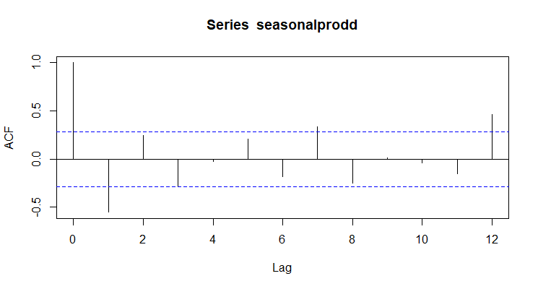

As we can see this time there is a visible pattern which changes the sign nearly every month. And the value of acf when lag=12 is higher than the last time. Hence the diff of this data gave us a better explanation for both zigzags and a healthier evidence for seasonality.

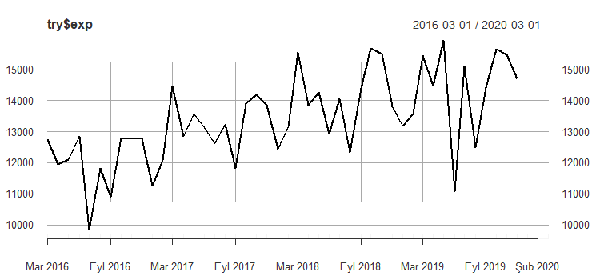

**Export in time**

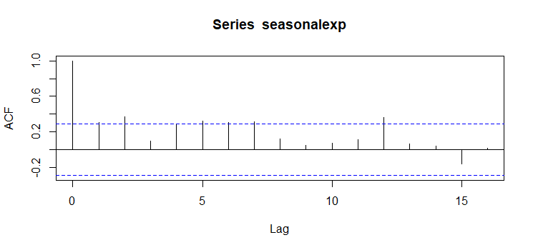

Autocorrelations of series ‘seasonalexp’, by lag

0 1 2 3 4 5 6 7 8 9 10 11 12 13 14 15 16

1.000 0.307 0.371 0.098 0.282 0.323 0.307 0.312 0.124 0.052 0.073 0.114 0.362 0.067 0.044 -0.156 0.018

It is safe to make comments on export data similar to production data. Unstable and nothing too clear with the acf either. There is only visibility of a peak at lag=12. And also diff of data is bit more helpful as seen below.

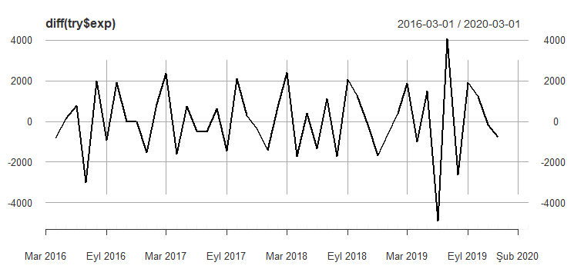

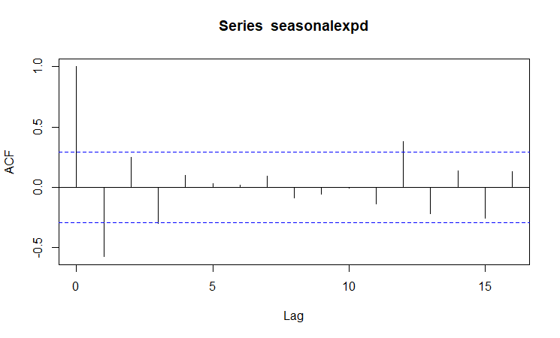

Autocorrelations of series ‘seasonalexpd’, by lag

0 1 2 3 4 5 6 7 8 9 10 11 12 13 14 15 16

1.000 -0.577 0.250 -0.302 0.096 0.029 0.019 0.096 -0.088 -0.056 -0.005 -0.138 0.382 -0.221 0.135 -0.258 0.128

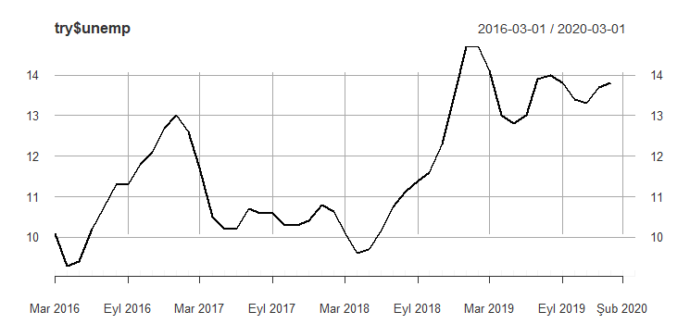

**Unemployment Rate**

And when we look into unemployment rates there are some things that is remarkable. The local maximums are mostly at 12th or 1st months of the year. And oppositely, local minimums fall onto the start of the summer like 5th or 6th months of the year. Also the graph is much smoother than the first two. There might be many reasons behind it.

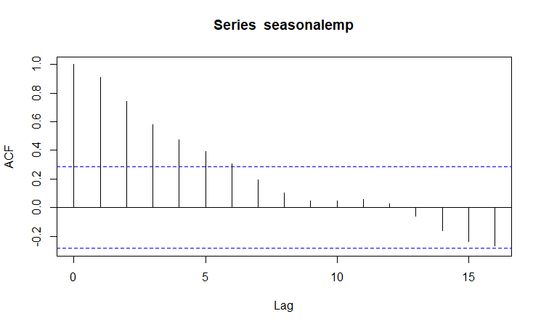

We can also see smoothness here. The effect of past is much stronger in employment rates than the previous two. And even though we observe local minimums and maximums fall onto the same period of year there is no significant presence of autocorrelation at lag=12. Its even much smaller than the previous two.

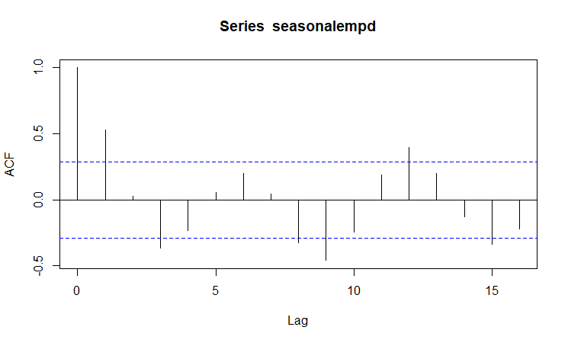

The same trend goes with differentiated version of it. By the graph we can see the move between positive and negative values are much slower. Apparently, employment is slower and harder to change than both production and export.

To have an idea, it’s beneficial to take a look how cpi looks like on this graphs.

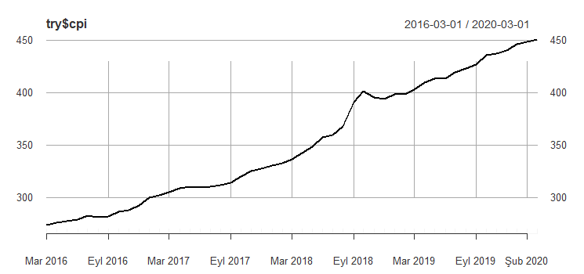

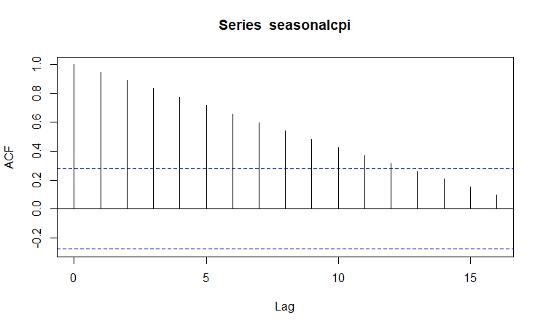

As we can see it’s very different from the others. It’s more like a linear graph. Hence the correlation graph has a decreasing trend as lag increases. We can’t quite talk about seasonality here. Yet it’s still should be kept for further correlation analysis.

Analysis Part 2

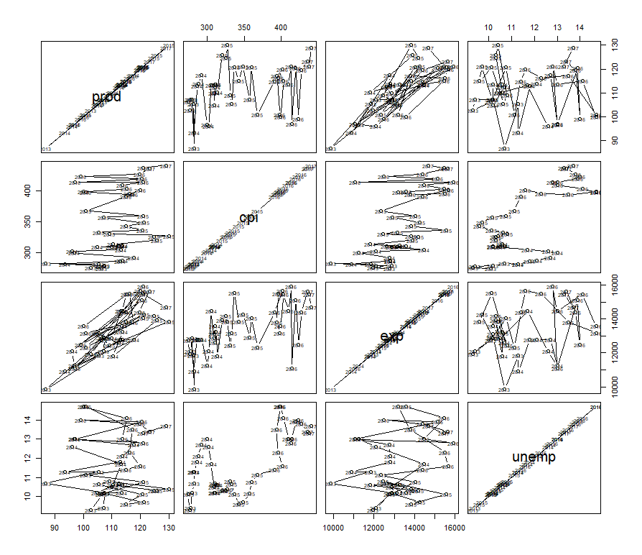

The first step was drawing a paired graph. But it was more of a mess than being helpful. Since cpi shows a linear trend, only the graphs that fall on its columns and rows look pretty. Other than that, there is a clear correlation between exp and prod worth mentioning. To have more solid information we can use cor() function.

prod cpi exp unemp

prod 1.000000000 0.3466641 0.7950566 -0.005467796

cpi 0.346664120 1.0000000 0.6238566 0.691540522

exp 0.795056595 0.6238566 1.0000000 0.266675529

unemp -0.005467796 0.6915405 0.2666755 1.000000000

As we can see the highest correlation value is between export and production which was observed in the first place and not surprising. And it’s logical. The second biggest value is between cpi and unemployment. This is probably because both are increasing over time. Even though there is seasonality in employment and not in cpi , the increasing trend makes them correlated. The unexpected part is the smallest value: the value between unemployment and production.

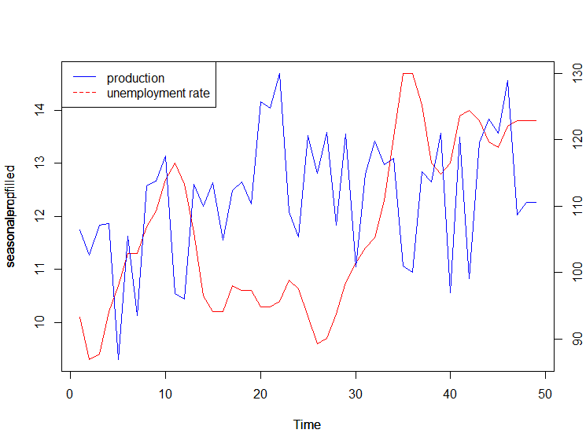

As we can see above there are some points that show significant negative correlation. The local minimums and maximums mostly have response in the opposite direction. But since they are both increasing in time, the correlation result is far from desired. And it fails the starting point of the study in a way.

Even though the first part isn’t proven. The second part which says “…*employment increases production, this takes us to an increase in export.*” Has more solid evidences.

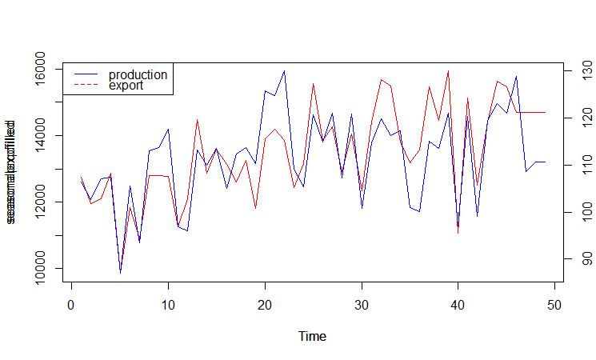

We can see what correlation says in the graph. The peaks and bottoms fit onto each other in a near perfect manner. They both have similar kind of autoregression. Follows the similar seasonal effects. Hence, they are strongly correlated.

Conclusion

As it’s shown above the selected data pieces (except cpi) are showing the indications of seasonality. We can also see some other signs to classify in a different way. While cpi shows the properties of a linear model, the others have some from both random walk model and moving average model.

The results show that initial thought of “unemployment and production is negatively correlated” isn’t strongly evident with this study. The correlation efficient is pretty small for approval. Yet the current state of the data shouldn’t be ignored either. The 4 data chosen, have shown increasing trend in the specified period. So it’s normal for the theory to fail. If it has studied on a more stable and maybe a smaller economy the results might be more satisfying.

Yet the second part of theory performed much better than the first. The numbers show that the production and export is directly correlated. They also follow the same seasonality properties.

The second strong correlation was the one between cpi and unemployment. To make further comments on this economical and political data is needed. And that can be a study for another homework.