How to submit your post-lab activity answer code to Gradescope.
- Create your R script file.

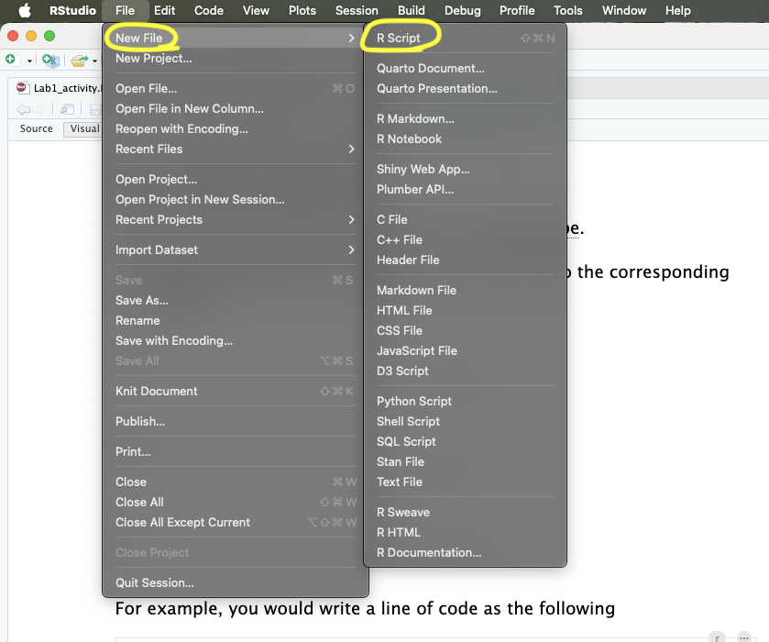

In Rstudio, create a new R script file by
going to “File” ⇨ “New File” ⇨ “R Script”

Shortcut : simply `Cmd`+`Shift`+`N` in mac, `Ctrl`+`Shift`+`N` in Windows & Linux

- Write your answer code
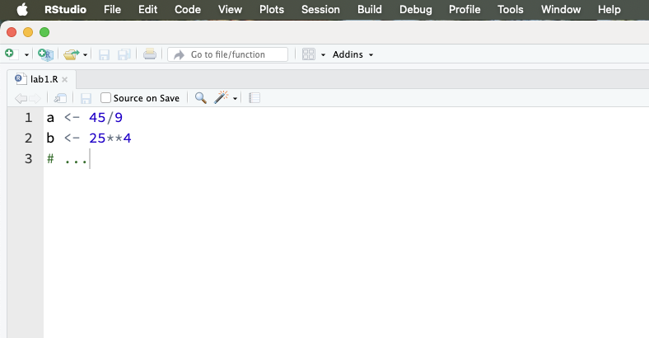
- Check if your R file (all the lines) can be executed.

How to run each line?
By highlight the line(s) you want to run and click ‘Run’.
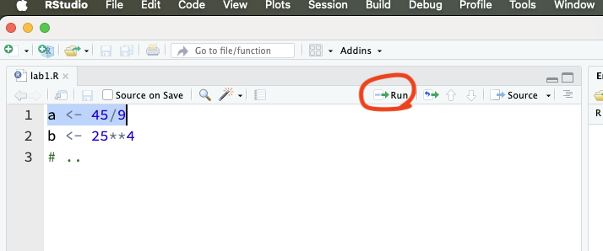
Or `cmd` + `return` in Mac, `ctrl`+`enter` in Windows

Note that if your R file cannot be executed (i.e., is not runnable), Gradescope will be unable to grade your submission.

For example,
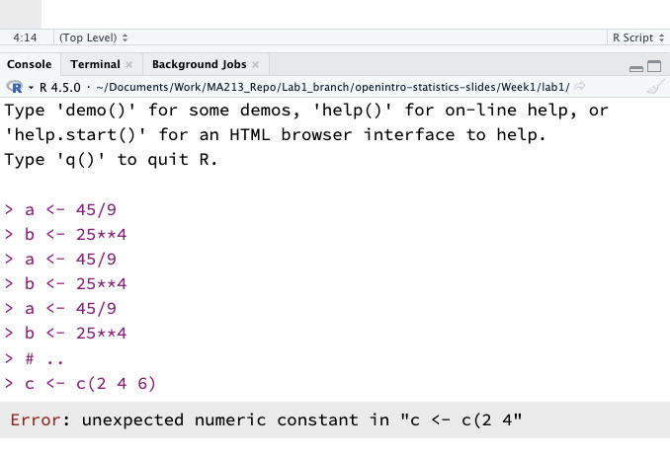
This case, Gradescope will not grade your file.
So, please check your R file before you submit to Gradescope.

- Save it.
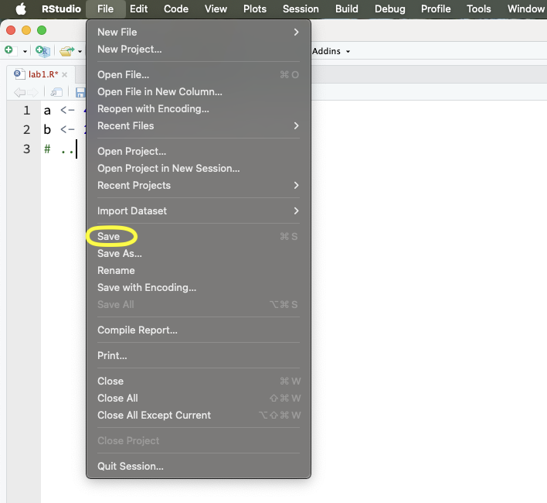
“File” ⇨ “Save” and name it “lab1.R”
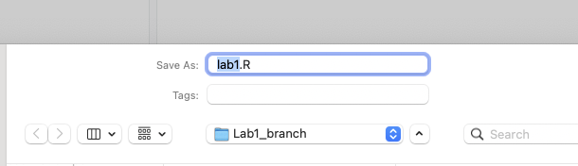
Please save the file name using all lowercase letters as "lab1". The extension must be ".R" with a capital letter "R". Note that R is case sensitive.

Note that ‘#’ in R is a comment symbol, and everything following it on the same line is not executed in R.

- Submit in Gradescope.
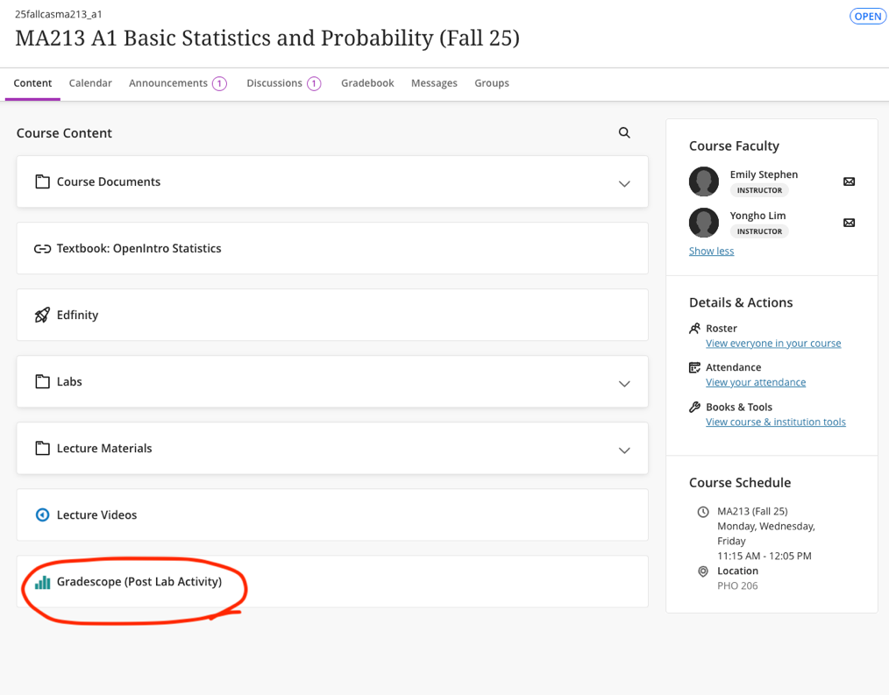
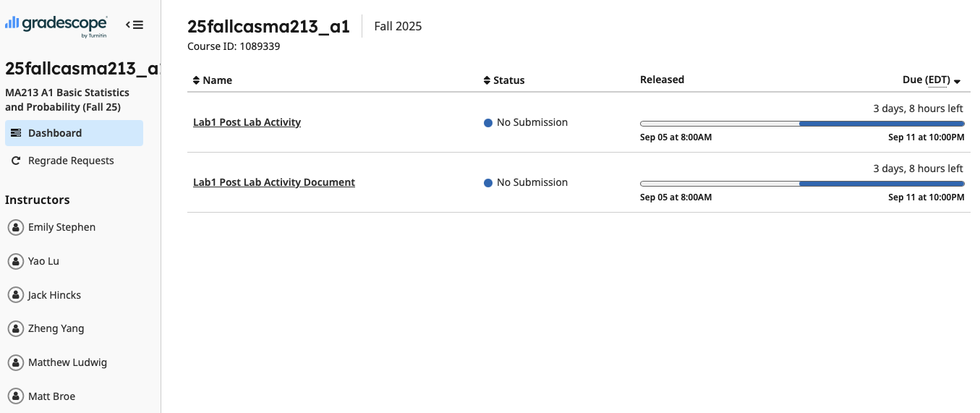

Submit your `lab1.R` file by uploading it through the ‘Lab1 Post Lab Activity’.
Please also complete the ‘Lab1 Post Lab Activity Document’. You may answer whether you used Generative AI (GenAI) in your work. If you did use GenAI, be sure to submit the corresponding documentation as well.

Also, see
https://guides.gradescope.com/hc/en-us/articles/21865616724749-Submitting-a-Code-assignment

