UML DIAGRAMS

1. Use Case Diagram

This diagram illustrates the interactions between the actors (User and Administrator) and the core functionalities of the system.

2. Activity Diagram: "Add a Transaction"

This diagram details the step-by-step process a user goes through to log in and add a new financial transaction.

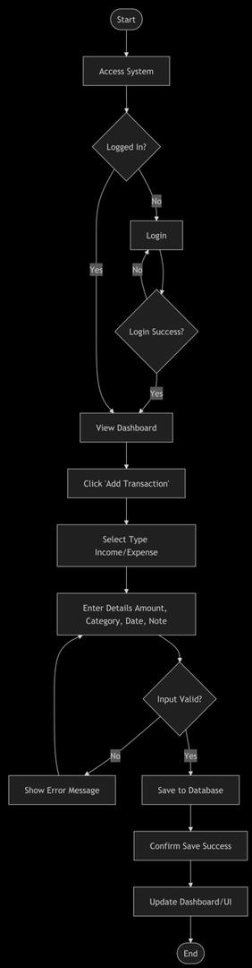

3. Class Diagram

This diagram shows the main classes (data models) of the system, their attributes, and the relationships between them.

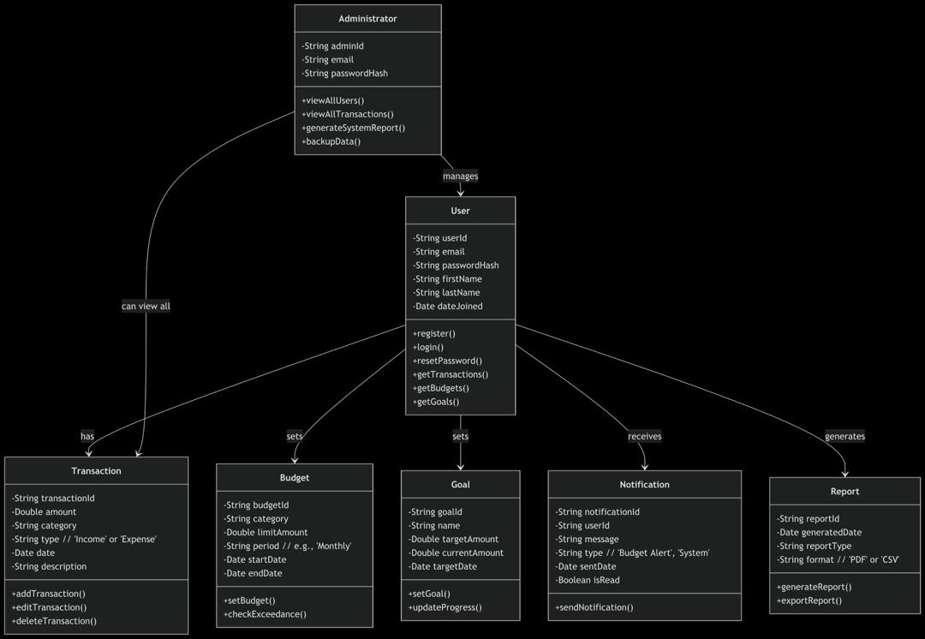

Diagram Explanations:

1. Use Case Diagram: This high-level diagram shows that:
· Users can perform all core financial activities like managing transactions, viewing reports, and setting budgets.
· Administrators have overarching system management duties, such as viewing all data, generating system-wide reports, and ensuring system health.
2. Activity Diagram (Add a Transaction): This diagram models the flow for a key user activity. It highlights:
· The prerequisite of being logged in.
· The loop for handling invalid login or form input.
· The core actions of filling out the transaction form and saving it.
· The final update of the user interface to reflect the new data.
3. Class Diagram: This shows the system's data structure:
· The User class is central, having one-to-many relationships with their Transactions, Budgets, Goals, and Reports.
· The Transaction, Budget, and Goal classes contain the attributes specified in the functional requirements (e.g., amount, category, date, limit).
· The Administrator class can interact with and manage all User and Transaction objects, reflecting their administrative privileges.
· Key methods like addTransaction(), setBudget(), and generateReport() are included, aligning with the system's functional requirements.

