*Wireless Sensor Node*  *Concept of Operations*



**Revision History**

|  |  |  |
| --- | --- | --- |
| **Person** | **Description** | **Date** |
| John McCullough  Daniel Vasilyonok | Initial Release (Adapted from previous ConOps document) | 06/03/2014 |
| John McCullough  Daniel Vasilyonok | Revisions | 06/04/2014 |
| John McCullough  Daniel Vasilyonok | Revisions to increase specificity | 06/24/2014 |
| Daniel Vasilyonok |  | 12/30/2014 |
| John McCullough  Daniel Vasilyonok | Revisions from Deep Dive | 04/10/2015 |
| Maria Kromis  John McCullough | Revisions for spring semester 2015 | 5/26/2015 |

**Table of Contents**

Revision History…………………………………………………………………...................................2

Table of Contents……………………………………………...….…..……………..….………………..3

Acronym List……………….……………….…………………………………………..…………………4

1.0 Overview……...……………………………………..……………………………..………………….5

2.0 Modes and Transitions……………..………………………………………………………………...5

2.1 Sensor Initialization Mode……………………………………………………………….….7

2.2 Science Mode…………………………………………………………………………….…..8

2.3 Data Transfer Mode………………………………………………………………………..10

2.4 Low Power Mode………………………………………………………………………...…11

3.0 WSN Deployment and Concept of Operations.……………...………………...………………...12

3.1 WSN Initialization and Deployment….…………………………………..……………….12

3.1.1 Initialization of WSN…..………………...……………………………..………..12

3.1.2 Deployment of WSN……………...……………………………………………..12

3.2 WSN Calibration.………..............………………………...………………..……………..12

3.2.1 WSN Data Test..….………………………………………………………….….12

3.3 Magnetic Field Experiment…………………………………….…...………..……….…...13

3.3.1 Magnetometer Data Retrieval and Storage…..…….………………………....13

3.3.2 Sending Magnetometer Data to RFM22B on Mule………………………......13

3.4 Extended Operations….….........................................................................................13

4.1. End of Life………………………………………………………………..………..13

**List of Acronyms**

**Acronym Definition**

ADCS Attitude Determination and Control System

ANDESITE Ad-hoc Network Demonstration for Extended Satellite Inquiries and other Team Endeavors

CDH Command and Data Handling

COM Communications

CSD Canisterized Satellite Deployer

EPS Electronic Power System

PCB Printed Circuit Board

WSN Wireless Sensor Node

**Document Notes**

**1.0 Overview**

The Command and Data Handling Subsystem of the Wireless Sensor Nodes includes the hardware and software responsible for creating the Wireless Network between the sensor nodes that can record, packetize, send, and receive scientific data. Each wireless sensor node deploys from the 6U aggregate satellite at the equator. The sensor nodes deploy in a manner that maximizes their cross-track separation of the mesh network, as the mesh penetrates the Birkeland current regions. Each sensor node contains an EPS, a Li-Po battery, one HopeRF’s RFM22B radio, a GPS, a 3-axis Gyroscope, a 1-axis HMC 1001 magnetometer and a 2-axis HMC 1002 that have the resolution needed to characterize the magnitude and direction of magnetic field over the polar region.

The software for the WSN is written in the Arduino language which is essentially an extension of C++. The program is stored and executed from an Atmega 2560 microcontroller. The software for the WSN is responsible for executing all of the operations that control the sensor nodes including one-time-only tasks, such as checkout after deployment, as well as repeated tasks including gathering mission data, sending data to Mule, and managing error cases. The CDH system is the only subsystem that can control the state of the sensor nodes and will constantly parse the states of the satellite and make pre-determined choices on how to proceed.

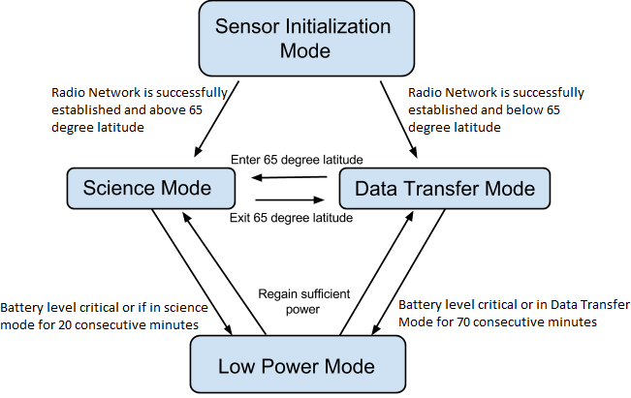

Figure 1. Modes and transitions

**2.0 Modes and Transitions**

The Wireless Sensor Node undergoes four different modes. These modes are Sensor Initialization Mode, Science Mode, Data Transfer Mode, and Low Power Mode. The modes described may be applied to each WSN. The transition from one mode to another is based on changing latitude and health status.

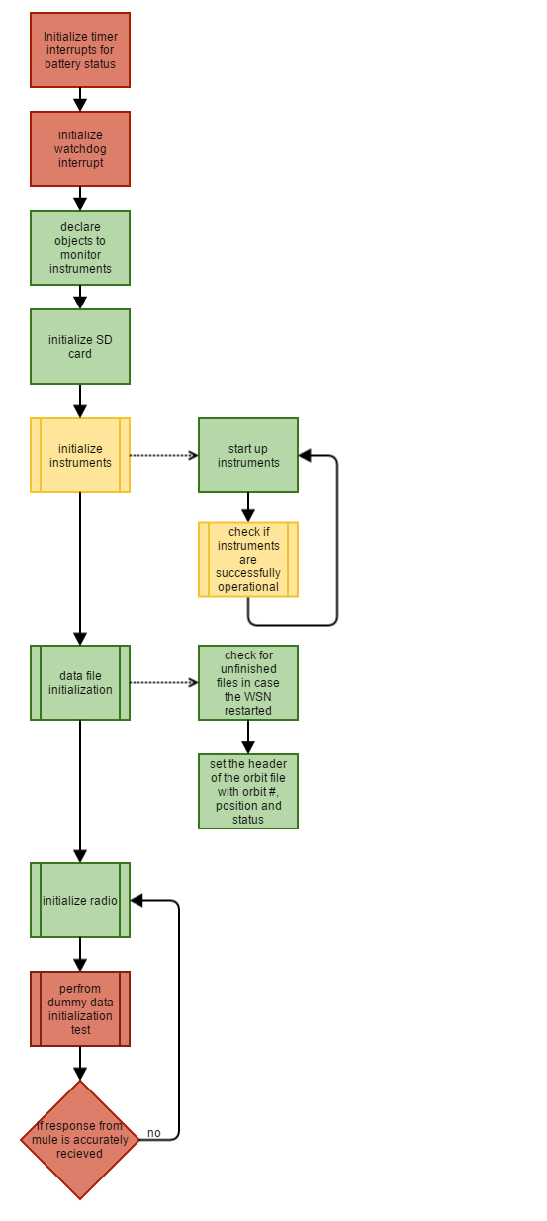

Figure 1. Sensor Initialization Mode

**2.1 Sensor Initialization Mode**

A Sensor Node is turned on once it has been ejected from the Mule satellite, and once turned on it will commence Sensor Initialization mode. First it will configure the timer interrupts so that it will regularly monitor its battery levels. Next it will configure its watchdog timer so that the WSN will have the capability to restart in the event that it gets stuck in a loop during operation. Once the interrupts are initialized the WSN will progress to initializing the other loads on the WSN, first the SD card is initialized and then the data collection instruments. Next the WSN will initialize their methods for saving data to the SD card. Finally the RFM22B radios will be initialized – this initialization involves both setting up the hardware for the radios (through software commands executed during initialization) and then checking the mesh network created by checking dummy data. To check the mesh network, the WSN will wait on a start command from the Mule and then transmit known dummy data to the mule and if the data was transmitted successfully the mule will send a “success” response to the WSN.

**Entrance Criteria:** This mode is automatically entered when the WSN is powered on.

**Exit Criteria:** When the radio mesh network has successfully been initiated.

1. The Mule charges WSN batteries and requests battery data from the WSN to determine if the WSN are fully charged.
2. Configures timer interrupts for regular health beacon checks
3. Configures the watchdog timer so that the WSN may restart in the event that it gets stuck in an infinite loop during operation
4. Initializes the SD card
5. Initialize the data collection instruments and check if the initialization was successful. In the event that it failed, they will be reinitialized. In the even that multiple initializations fail, the WSN will restart and the initialization process will commence. This initialization of the magnetometer is critical to the science mission – so the WSN won’t proceed without it.
6. In the event that the GPS could not be successfully initialized, we will have code ready to fabricate GPS data based on the rate of travel
7. Initializes the files on the SD card to store data collected based on the orbit and checks the current orbit file in the event that this is a reboot.
8. The WSN then waits on a request from the mule for a radio network test. The WSN will respond with known dummy data. If the Mule responds with a network success the WSN progresses to the next mode, and if it responds with a network fail, then it will attempt to reroute the mesh network and attempt the network test again.

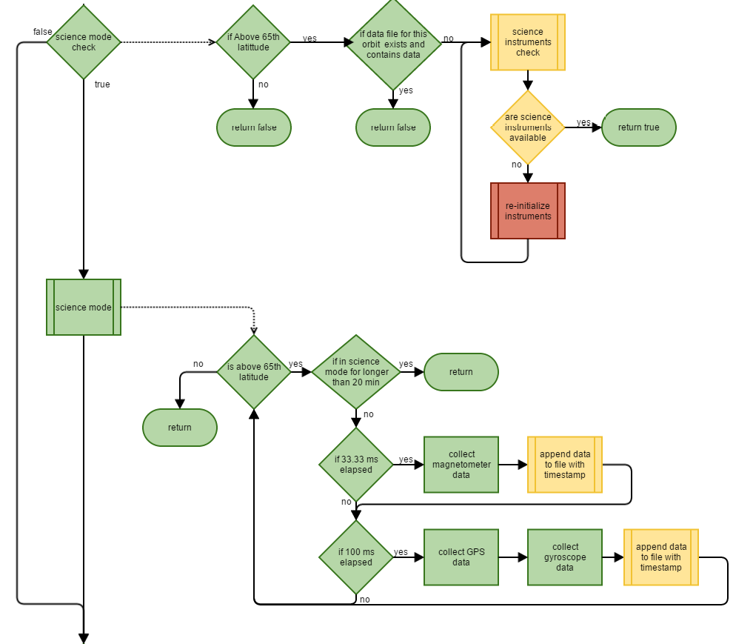

Figure 3. WSN Science Mode

**2.2 Science Mode**

Before the Science Mode begins the WSN must perform a science mode check to determine of the WSN is ready to enter science mode. This science mode check will verify that the WSN is ready to enter science mode by monitoring three things: the latitude of the WSN, the current working file on the SD card, and the availability of the science instruments. The latitude is checked because, the WSN must be within the Birkeland current regions – meaning, it is above the 65⁰N latitude – before it can enter science mode and begin collecting data. The working file of the SD card is checked, meaning we make sure that there is no file that already contains data for our current orbit (this could occur in the event of a reboot), we check this so that we do not write over existing data. The last check is that the science instruments are available to begin collecting data, if they are unavailable they are reinitialized so that we can commence collecting data.

In science mode the WSN will collect gyroscope, magnetometer, and GPS data and store it on a SD card file that corresponds to the current orbit.

**Entrance Criteria:** True return from science mode check – true if satellite is above 65⁰N latitude, if there is no file containing data already exists for this orbit number, and if science instruments are available.

**Exit Criteria:** WSN records latitude below 65˚N.

1. Perform Science Mode check to determine if the WSN is able to enter science mode
2. Update exact position, including latitude, longitude, and altitude above sea level. WSNs are on standby to transition into Data Transfer Mode once the GPS records latitude below 65˚N.
3. Log a start time the instant Science Mode is entered and continually check to make sure the node is not in Science Mode for more than 20 minutes.
4. Collect 3-axis magnetometer readings at 30 Hz and GPS and gyroscope readings at 10 Hz.
5. Store all raw magnetometer, GPS, and gyroscope data on a SD card in DATA.txt. The GPS will output a full NMEA type GGA sentence, however, only the UTC time, latitude, longitude, and altitude will be stored on the SD card in order to fix a time and position for the magnetometer readings.
6. Once the data is finished collecting, and the sensor node exits the 65˚N latitude, it will send a finished message to the mule.

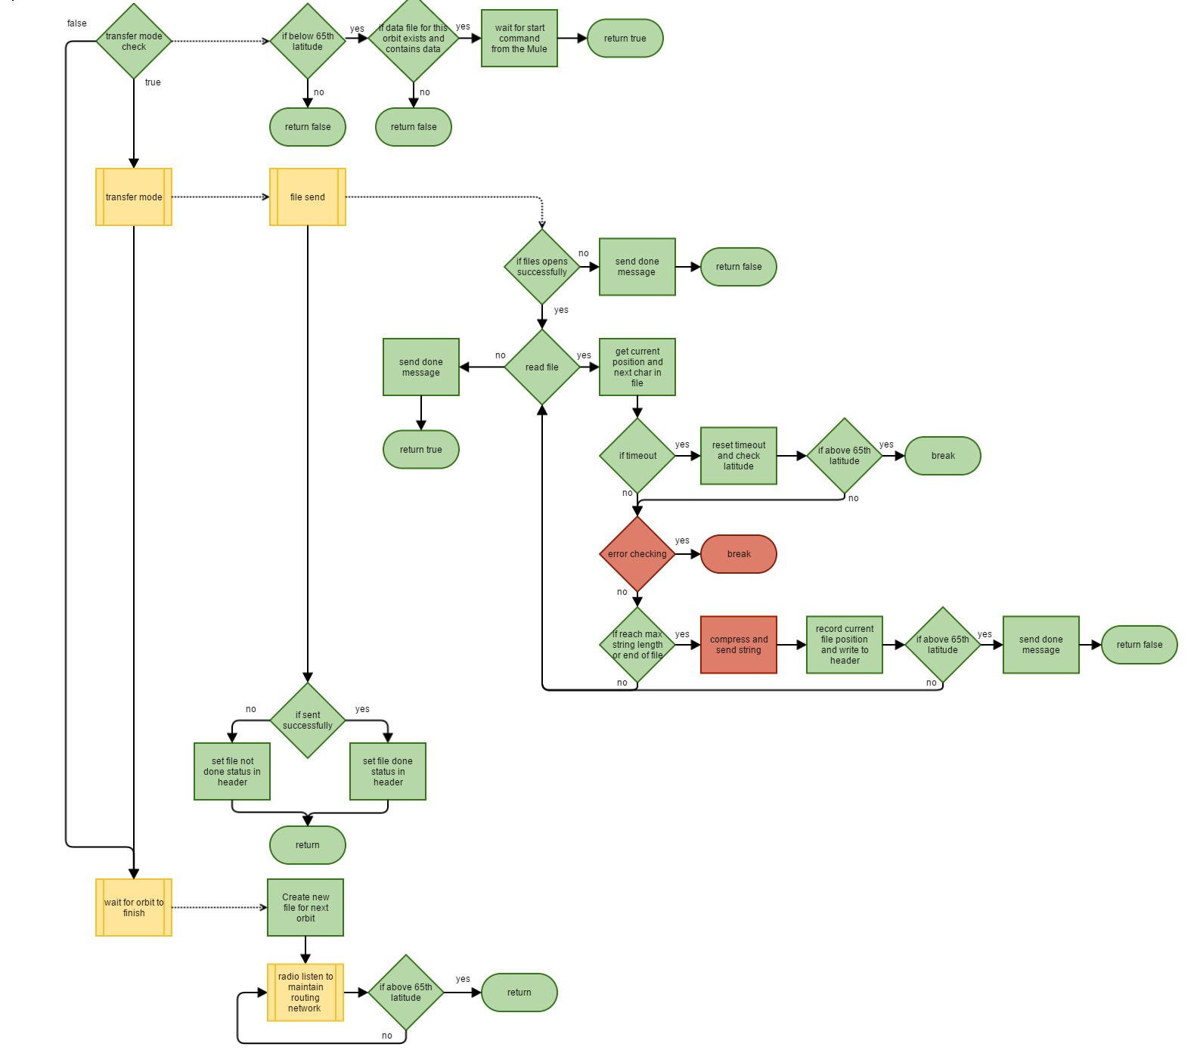

Figure 4. WSN Data Transfer Mode

**2.3 Data Transfer Mode**

Just as with science mode, before the WSN is able to enter data transfer mode, it must get a true return from data transfer mode check. This Data Transfer Mode Check will verify that the WSN is ready to enter Data Transfer Mode by monitoring three things: the latitude of the WSN, the current working file on the SD card, and commands from the Mule. The latitude is checked because, the WSN should only enter data transfer mode if it is outside the Birkeland current region – meaning, it’s below the 65⁰N latitude. The working file of the SD card is checked, meaning we make sure that the file for our current orbit contains data that needs to be relayed to the Mule. The last check is that the WSN has a received a “begin transfer mode” message from the Mule.

In Data Transfer mode, all data stored on the WSN's SD card will be compressed, packetized, and sent to the Mule where it will be sent to a ground station via GlobalStar systems.

**Entrance Criteria:** True return from data transfer mode check – true if satellite is below 65⁰N latitude, if there is a file containing data for this orbit number on the SD card, and if a data request message is received from the Mule.

**Exit Criteria:** WSN records latitude above 65˚N.

1. Update exact position, including latitude, longitude, and altitude above sea level. WSNs are on standby to transition into Science Mode once the GPS records a latitude above 65⁰N.
2. Log a start time the instant Data Transfer Mode is entered and continually check to make sure the node is not in Data Transfer Mode for more than 70 minutes.
3. Check battery voltage levels, to ensure we have enough power to execute data transfer mode. If not enough power, then enter Low Power Mode.
4. Sensor node receives data request message from the mule.
5. Read character by character from the data file and append to a string. Performing error checking as you read from the file.
6. Compress the string once it reaches the maximum buffer length of the radios
7. Send string and continue reading from file.
8. Send file finished message to the mule once the WSN has finished sending its message.
9. If above 65⁰N before end of file is reached, save position in file in hopes to finish transmitting in a later orbit, and exit Data Transfer mode.

**2.4 Low Power Mode**

Low Power Mode is entered if the WSN is in Science Mode for longer than 20 minutes, or in Data Transfer Mode for longer than 70 minutes, or if the battery levels are below thresholds required for data collection or data transmission. A WSN can transition out of Low Power Mode if power rises back up to adequate levels. Low Power Mode will transition into either Science Mode or Data Transfer mode based on its GPS location at the time of regaining power.

In Low Power Mode unnecessary loads are turned off so that the WSN may power up quicker and resume its duties.

**Entrance Criteria:** If the WSN has been in Science Mode for longer than 20, or if the WSN has been in Data Transfer Mode for longer than 70 minutes, or if battery levels drop below those required for data collection or data transmission.

**Exit Criteria:** WSN battery surpass required thresholds for data collection or transmission

1. Magnetometer, Gyroscope, and GPS are turned off.
2. WSN’s RF22B remains on.
3. WSN’s RF22B sends health status to mule.
4. Low Power Mode transitions back into Science Mode or Data Transfer Mode once adequate power levels are reached.

**3.0 WSN Deployment and Concept of Operations**

**3.1 WSN Initialization and Deployment**

At this time, the Mule has been deployed from the shuttle and has finished detumbling, and oriented to a sensor node deployment attitude using fine pointing.

**3.1.1 Initialization of WSN**

Once the ground station completes an uplink to the Mule, the avionics hub charges the sensor nodes to full capacity and the Mule powers on the WSN.

**Subsystems Powered On:** (Mule)Power, (Mule)CDH

**Software Mode:** Sensor Initialization Mode

**Bus Usage:** Power rail

**Success Criteria:** CDH commands Power to turn on Arduino microprocessor.

**Success Verification:** Automatic -- WSN directly connected to 3.3V rails.

**Critical Impact:** Critical for science mission.

**3.1.2 Deployment of WSN**

The Mule enters pointing state and deploys WSN in pairs at the equator.

**Subsystems Powered On:** (Mule)Power, (Mule)CDH, (Mule)ADCS

**Software Mode:** Sensor Initialization Mode

**Bus Usage:** Power rail

**Success Criteria:** All WSN deployed with correct velocity.

**Success Verification:** Future steps will prove accuracy.

**Critical Impact:** Critical for science mission.

**3.2 WSN Calibration**

At this time, a WSN has been deployed from the Mule. This node will continue to the next step before the other nodes.

**3.2.1 WSN Data Test**

Each WSN should be able to communicate with the RF22B on the mule so a network test is performed. Communication between the RF22B radios is possible within a range of 16 km.

**Subsystems Powered On:** CDH, COM

**Software Mode:** Sensor Initialization Mode

**Bus Usage:** SPI

**Success Criteria:** All nodes send/receive known data to and from the RF22B coordinator.

**Success Verification:** RF22B on mule receives packets with same known data.

**Critical Impact:** Critical for the transmission of data.

**3.3 Magnetic Field Experiment**

**3.3.1 Magnetometer Data Retrieval and Storage**

The magnetometer will sense the strength and direction of the magnetic field above 65⁰N latitude. The data will be stored on an SD card on the WSN. The data held on the SD card will be stored until Data Transfer Mode is entered.

**Subsystems Powered On:** Data collection instruments, CDH

**Software Mode:** Science Mode

**Bus Usage:** SPI

**Success Criteria:** Magnetometer data is collected and stored on SD card.

**Success Verification:** Data is read off the SD card during Data Transfer Mode.

**Critical Impact:** Critical for successful science mission.

**3.3.2 Sending Magnetometer Data to RF22B on Mule**

Once Data Transfer Mode is entered, a sensor node will send a “finished” message to the mule. The mule will send a “data” message back to the sensor node, and then that sensor node will transmit all of the data. Once all the data has been transmitted, the sensor node will send a final “finished” message to indicate that data transmission from that sensor node is complete. This process will occur for each of the seven sensor nodes.

**Subsystems Involved:** CDH, COM

**Software Mode:** Data Transfer Mode

**Bus Usage:** SPI

**Success Criteria:** RF22B on mule receives Magnetometer data and stores it on the SD card on the Beagle Bone.

**Success Verification:** Checksum in data indicates successful transfer.

**Critical Impact:** Critical for successful science mission.

**3.4 Extended Operations**

The following operations are only meant to be performed after the 2 week science mission is complete. Ensure that all the data collected has been relayed to the ground station.

**3.4.1 End of Life**

Check that all files on SD card have been relayed to ground. Transmit any files that have not yet been sent.

**Subsystems Involved:** CDH, COM

**Software Mode:** Data Transfer Mode

**Bus Usage:** SPI

**Success Criteria:** All data packets have been received by the RF22B on mule.

**Success Verification:** Mule’s RF22B confirms.

**Critical Impact:** Minimal. Make sure all data is received.