Week 4/6/21-4/13/21 Updates

George Padavick and Matt Gilgo

* Additional data collected.
  + Negative sentiment tweets up to 500 tweets
  + Negative sentiment tweets more scarce occurrences for even brutal pumps
* Using sentiment data to find most popular tweets for each sentiment score and inflection points

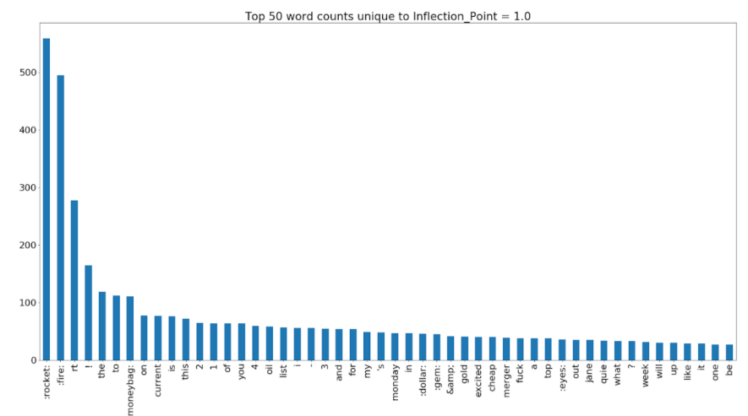

* + Stock Price vs Time, Colored by Tweet Sentiment

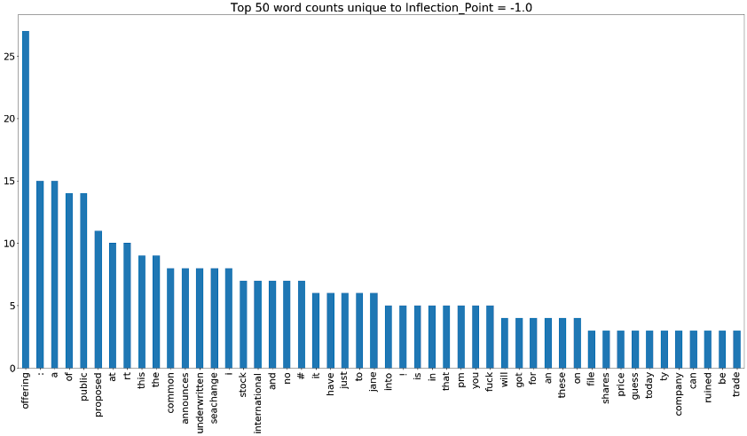

* Model performance:

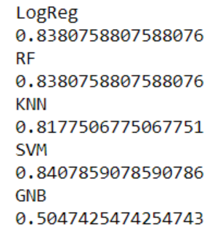

* **Next Steps:**
  + Run final tests to predict price with sentiment
  + Clean up data, prep final results for report and presentation,