Deliverable 1

**Q1: How many people participate in assistance programs?**

* SNAP- 1,062,883 people– 641,911 Households

The below graph shows the distribution of people and households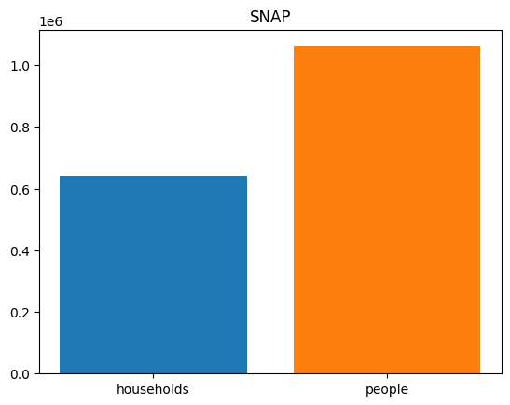

* TAFDC- 99,655 people– 37,713 Households

The below graph shows the distribution of people and households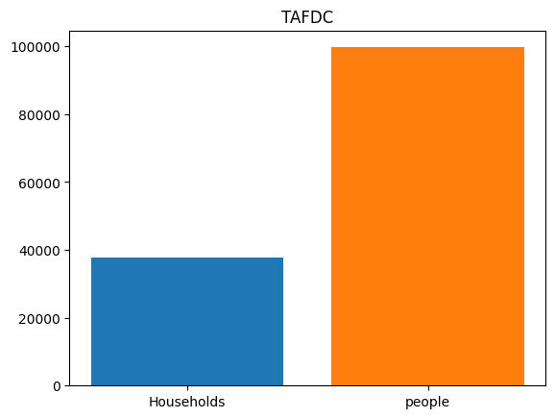

* EAEDC- 26,592 people– 26,405 Households

The below graph shows the distribution of people and households

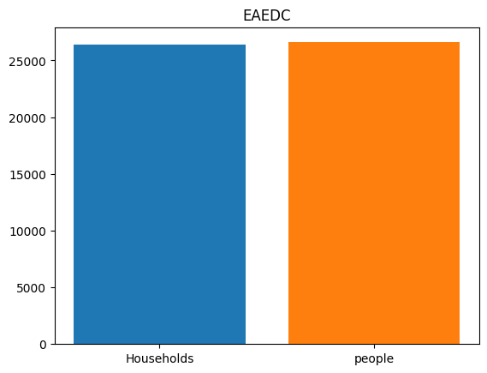

* TOTAL- 1,189,130 people– 706,029 Households

There is no proper dataset to calculate the total number of people benefited from Housing assistance, so we just did some research and found out that the total number of households under housing assistance in Massachusetts are around 200,000 and the same with the case of WIC where the total participation racks up to 115,590 in the state of Massachusetts.

**Q2: What is the income distribution for Boston residents living below the poverty line?**

From our analysis, the income distribution in Boston has the following characteristics:

* Distribution is normal with a peak at 42699
* Lower bound: 37595
* Mean: 42699
* Upper bound: 47803

The below graph shows the distribution of income range.

