Q2) : 2.What is the income distribution for Boston residents living below the poverty line

All families percentage: 13.7% with a margin of error of +- 1.8

All people percentage: 18.7 with a margin of error +- 1.3

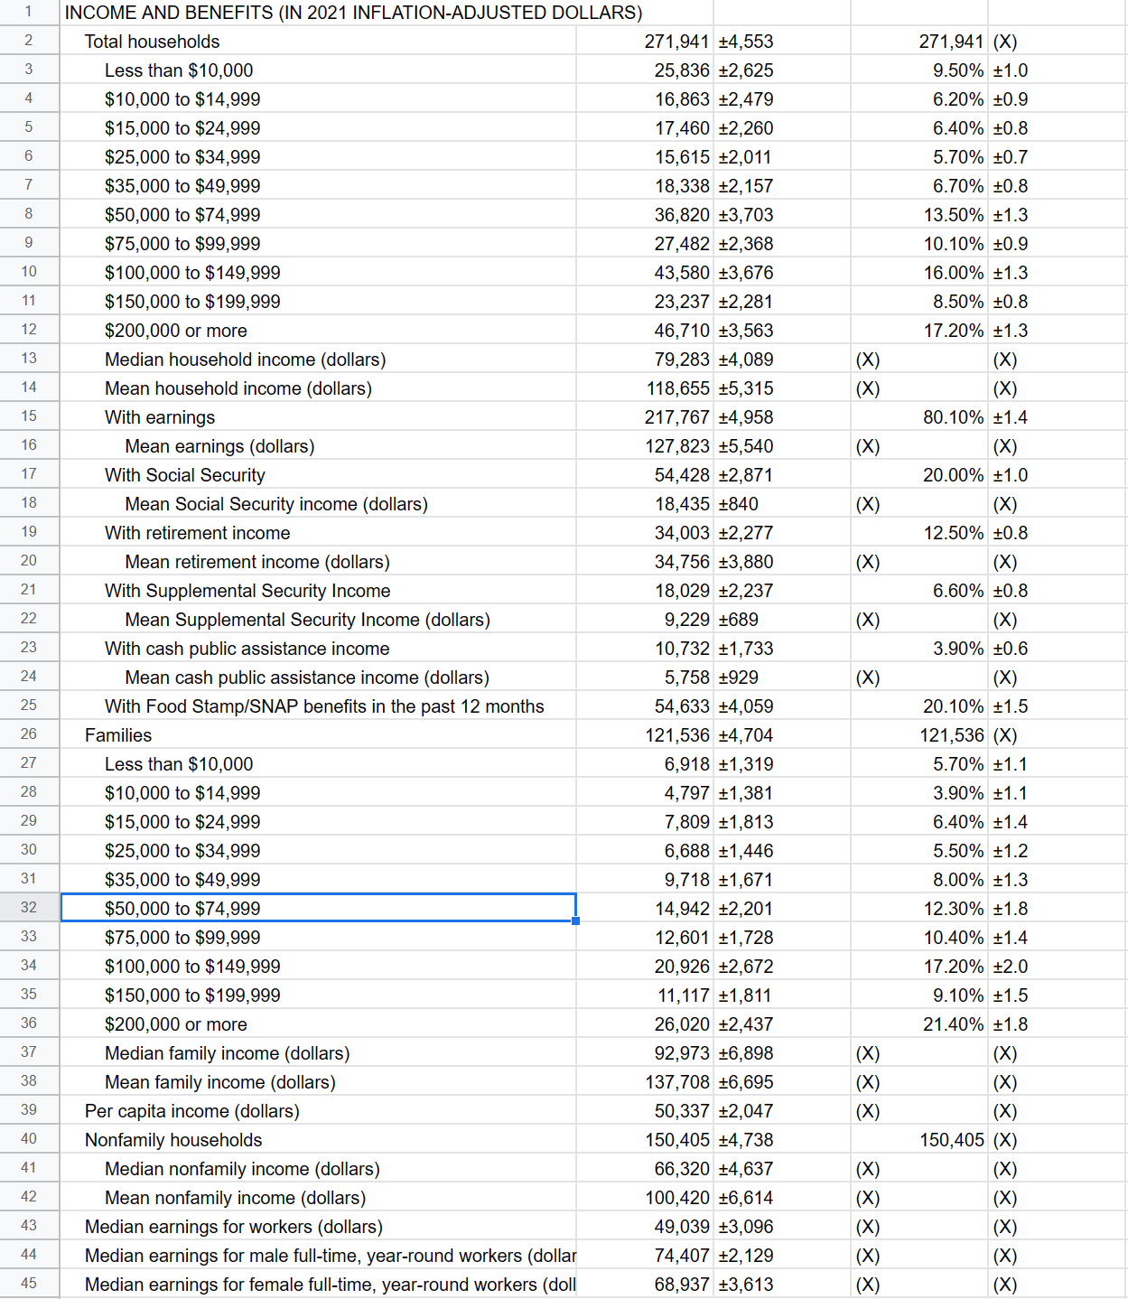

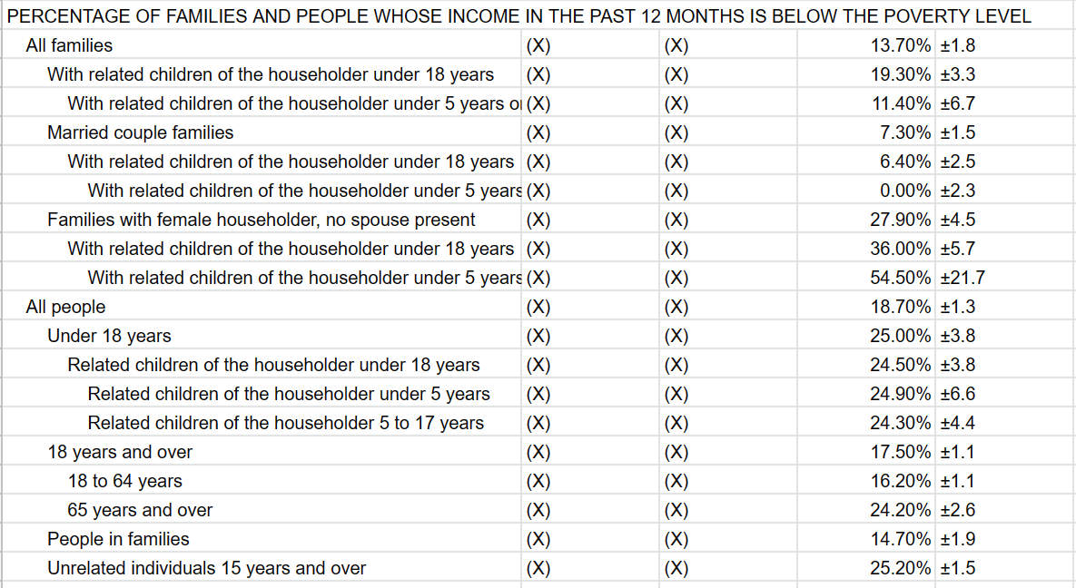

Summary:

All families are the income distribution for Boston residents living below the poverty line.

| Less than $10,000 | 6,918 | ±1,319 | 5.70% | ±1.1 |
| --- | --- | --- | --- | --- |
| $10,000 to $14,999 | 4,797 | ±1,381 | 3.90% | ±1.1 |
| $15,000 to $24,999 | 5,002 | ±1,813 | 3.40% | ±1.4 |