Q3: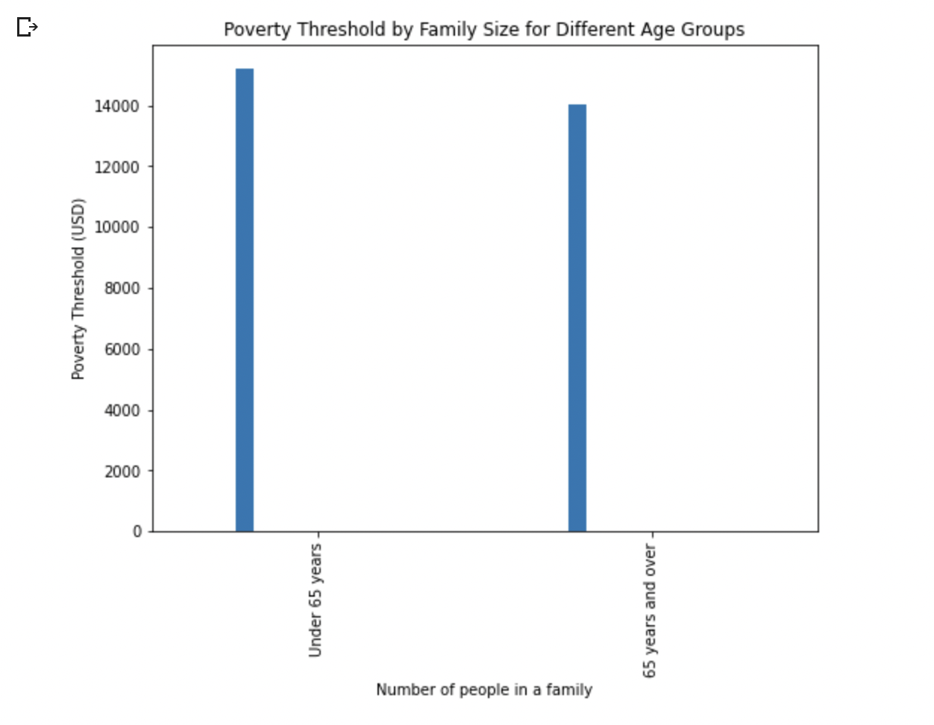

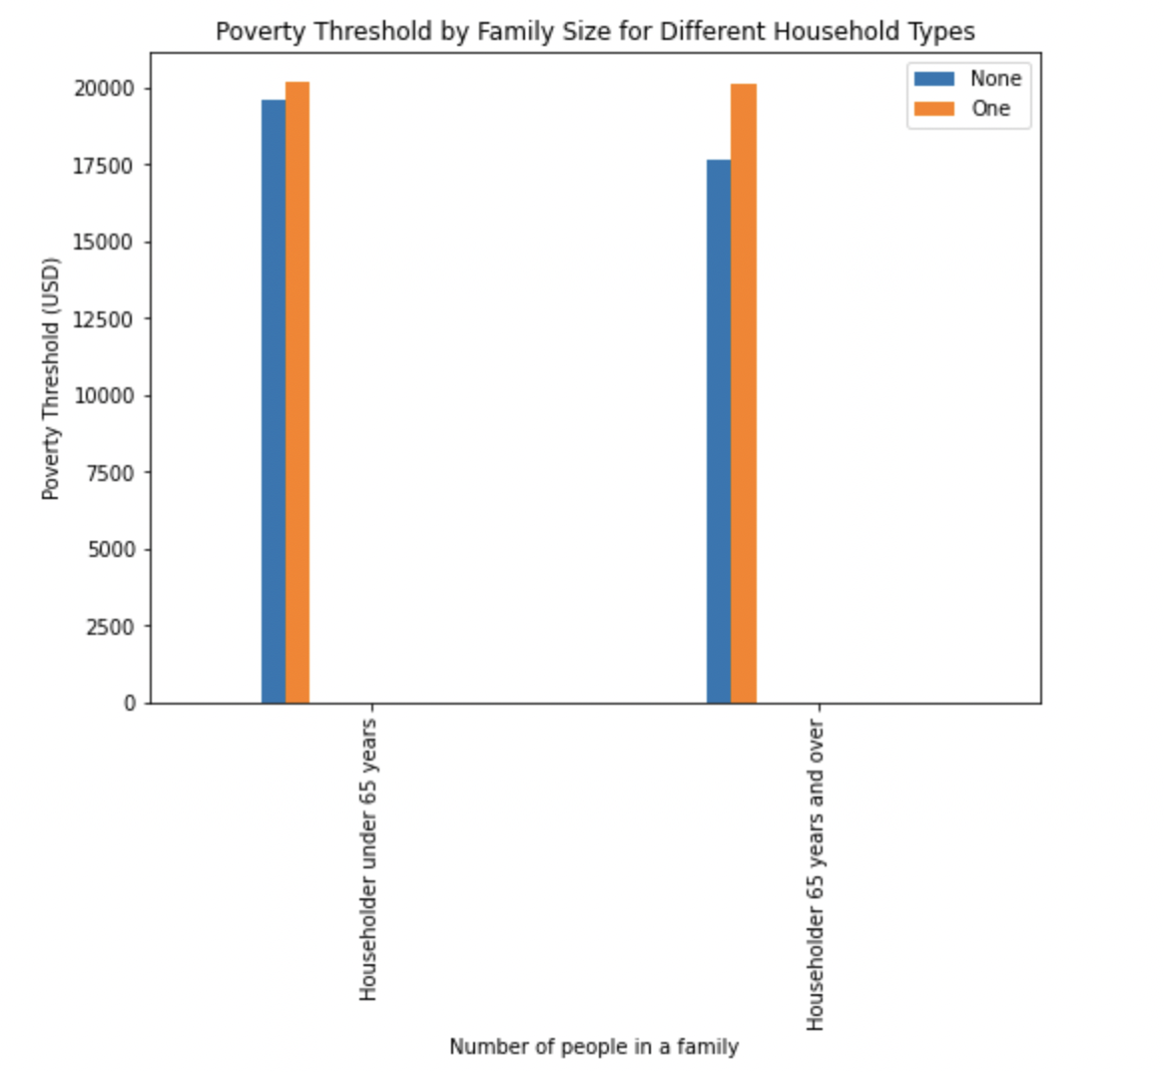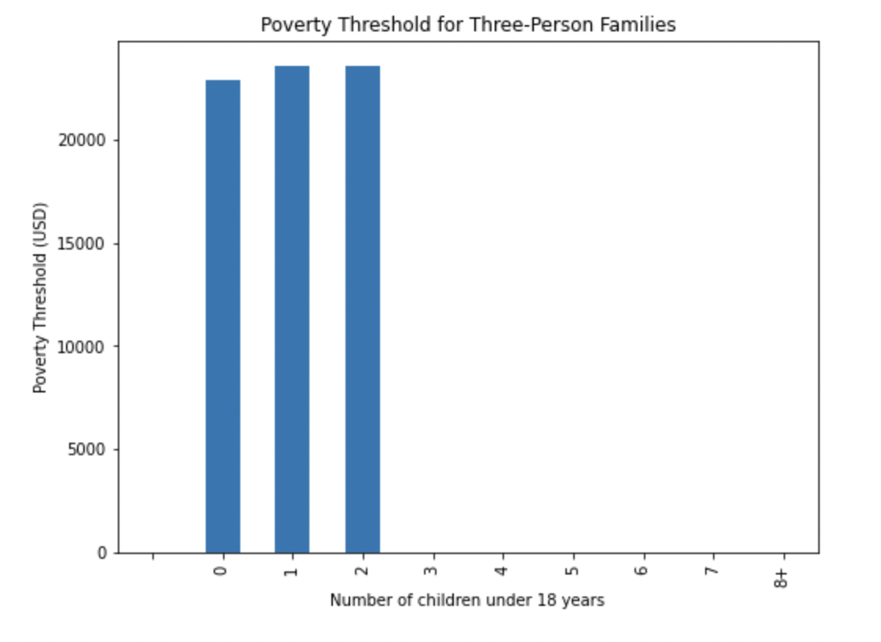

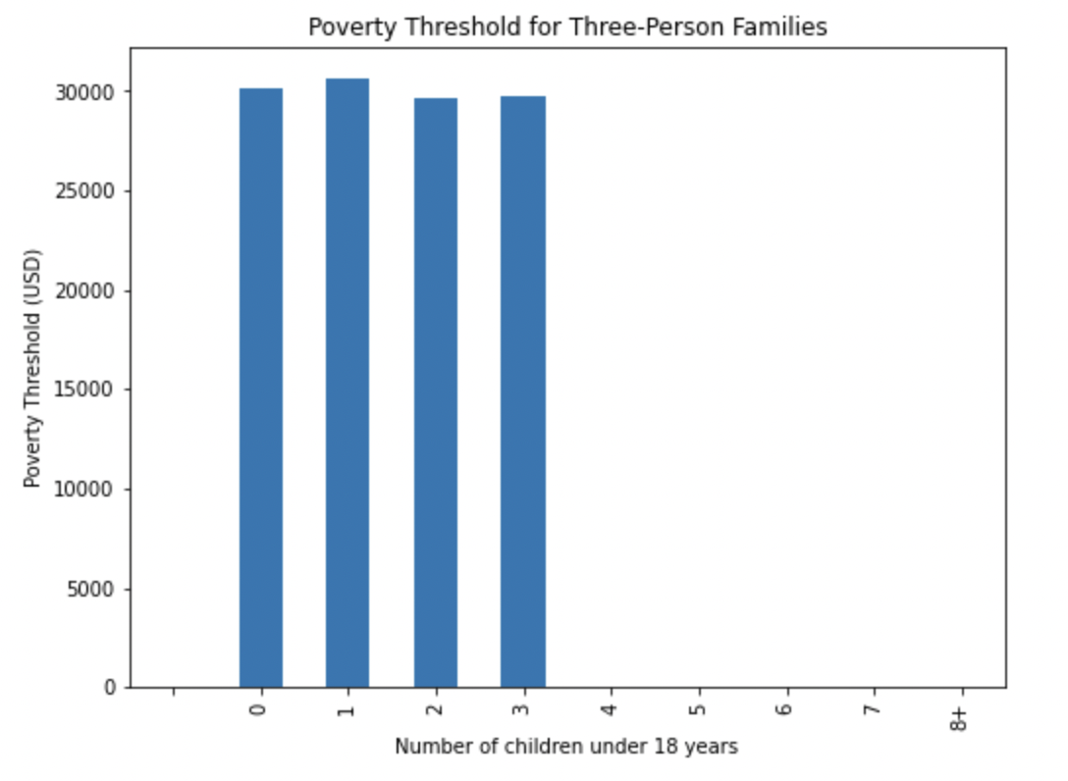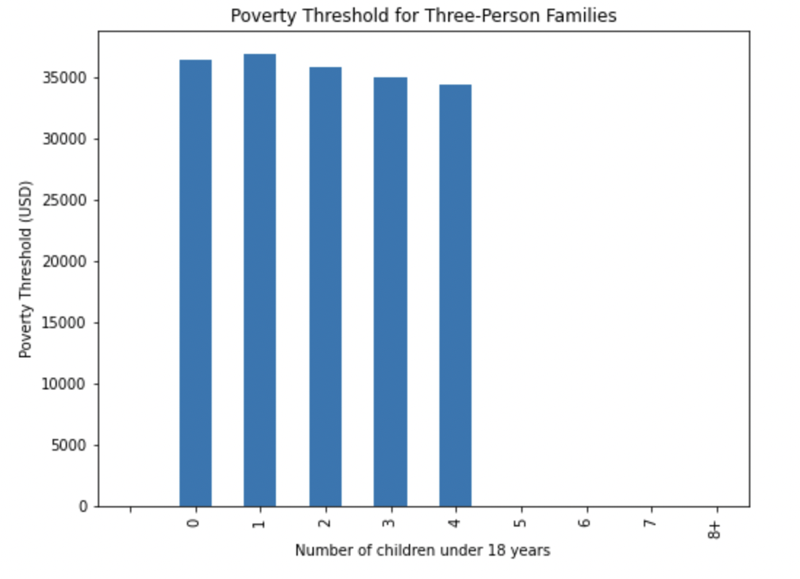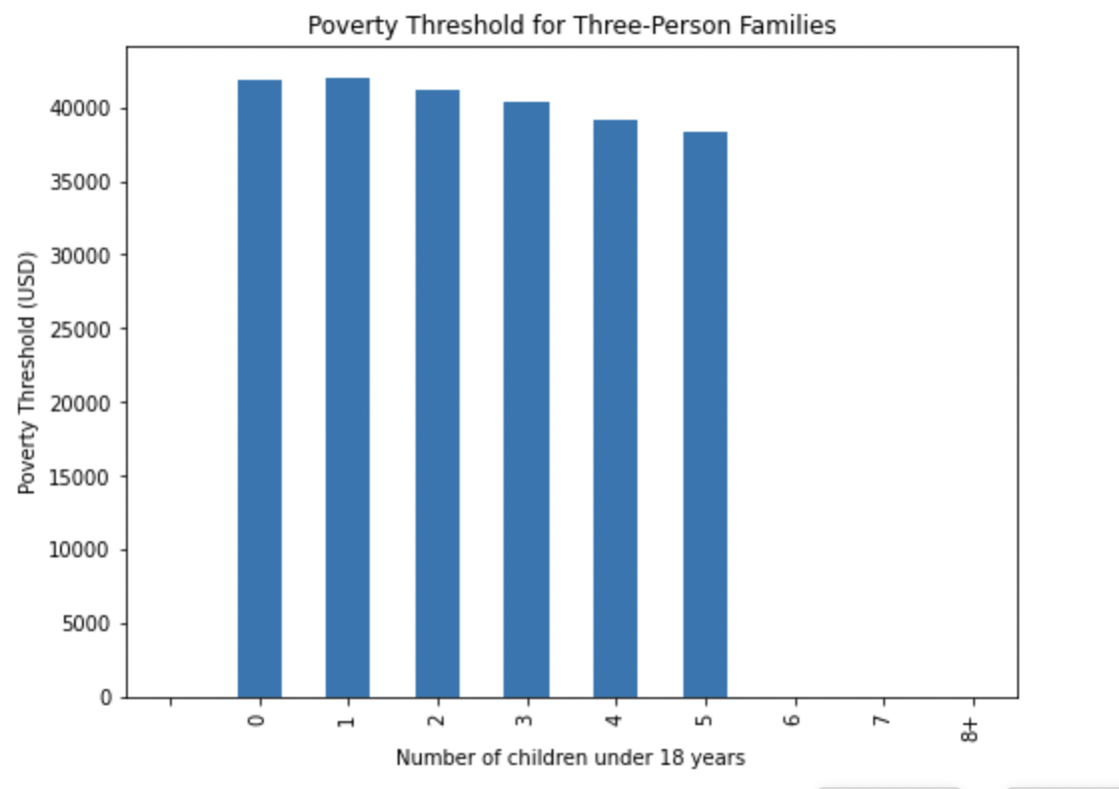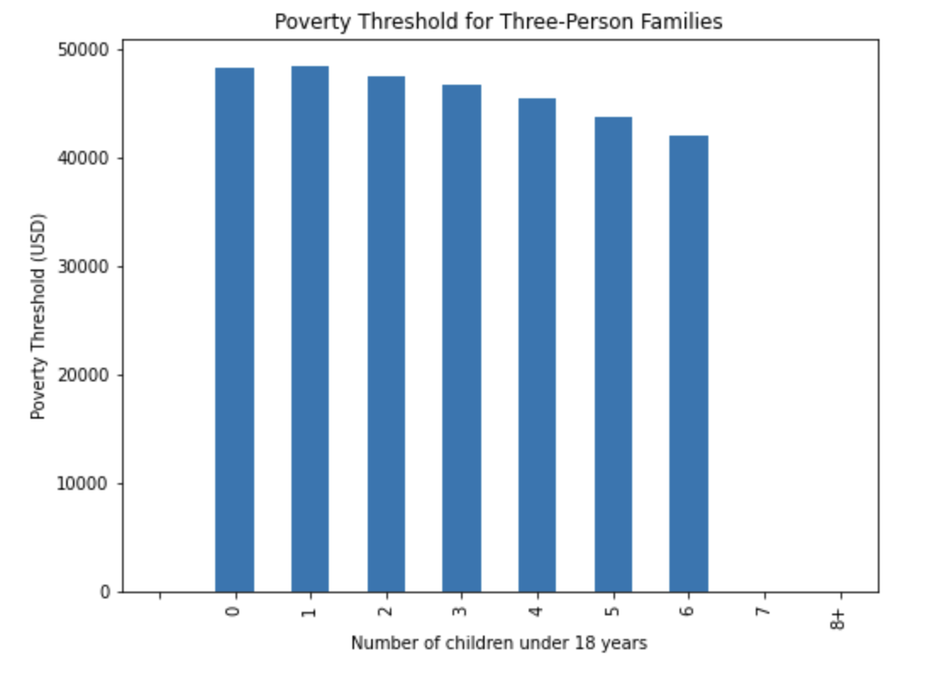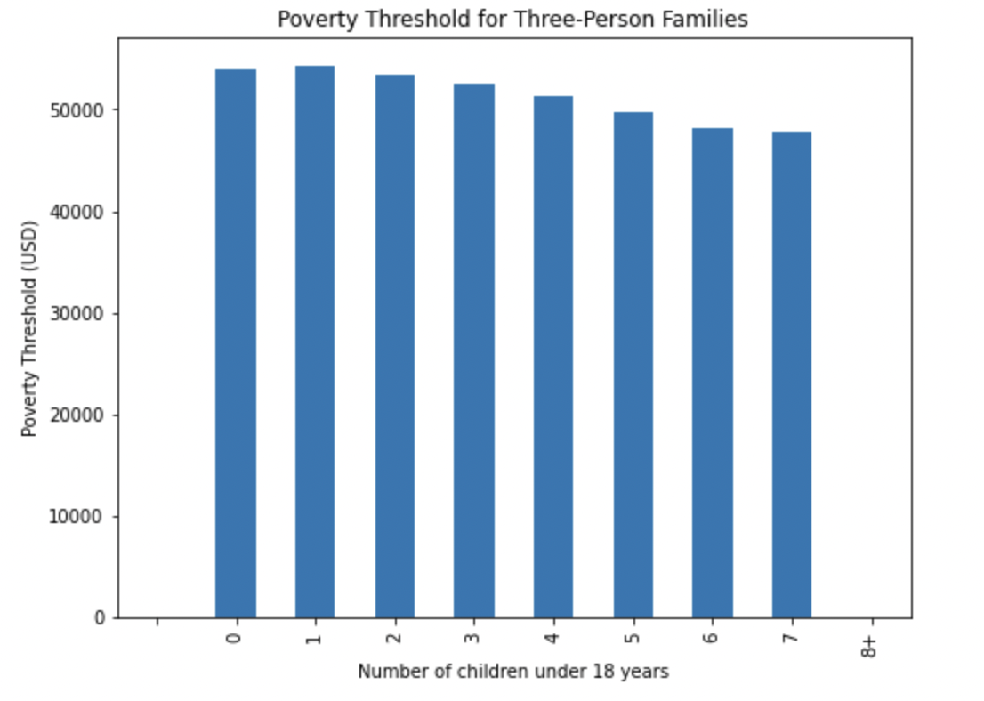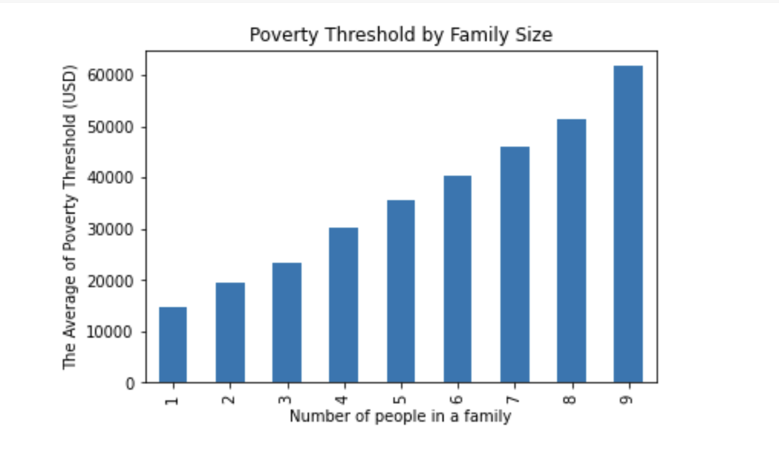

From the plot, we can see that there is a general trend of higher poverty levels for larger families. This makes sense since larger families have more mouths to feed and may have more difficulty making ends meet. And wen can also notice that the less children under 18, the higher poverty levels are. This make sense that the less children under 18, the more adults work to earn moeny, so that the poverty levels are higher. However, these trends are not perfectly linear, and there are some fluctuations in the data. It would be interesting to further investigate these fluctuations to see if there are any other factors that may be influencing the poverty levels for certain family sizes.