Universal Basic Income

Basil Alghamdi, haipeng Liu, Zeming Chen, Trived Katragadda, zhengxiong zouxu

2023

***Introduction***

In Boston, poverty is a persistent issue affecting a significant portion of the population. To address this, Boston City Councilor Kendra Lara has proposed a universal basic income program aimed at providing financial assistance to those in need. In support of this proposal, two projects have been initiated to analyze the economic status of families and households in Boston.

The first project's objective is to establish the selection criteria for participants in the universal basic income pilot program. This project will investigate the number of people living below the poverty line, the different levels of poverty, and the public assistance programs being used. It will also take into account the income of individuals who are not in poverty but still require monetary support. By analyzing the data, the project will provide insights into the optimal amount of money per household that can have the most significant positive impact. The primary output of this project will be a recommendation for Councilor Kendra Lara with the aim of reducing poverty levels in Boston.

The second project is focused on understanding the correlation between the population and poverty ratio in Boston over time, as well as the trend of mean and median income over the years. This project aims to examine how the population growth of Boston has affected the poverty levels in the city. The project will also analyze the mean and median income levels in Boston over the years to gain insight into how the income distribution has changed.

The analysis will be conducted by comparing the historical data of the city's population growth and poverty ratio with the trend of mean and median income levels. The project will provide valuable insights into the relationship between population growth, income distribution, and poverty levels in Boston over the years. The findings from this project will be used to inform policy recommendations to reduce poverty and increase income equality in the city. Overall, this project will contribute to a better understanding of the economic condition of Boston and provide data-driven solutions to address poverty and inequality.

The two interconnected projects focusing on the selection criteria for a universal basic income pilot program and the correlation between population growth, poverty ratio, and income levels in Boston will significantly enhance policymakers' understanding of the city's economic conditions. The comprehensive analysis of these projects will provide valuable insights into the most effective ways to tackle the persistent problem of poverty in the city. The primary goal of these projects is to have a sustained impact on lifting people out of poverty and promoting economic equity in Boston. Together, these projects will contribute to creating a more just and equitable society in the city.

***Base analysis***

**How many people participate in assistance programs?**

* SNAP- 1,062,883 people– 641,911 Households

The below graph shows the distribution of people and households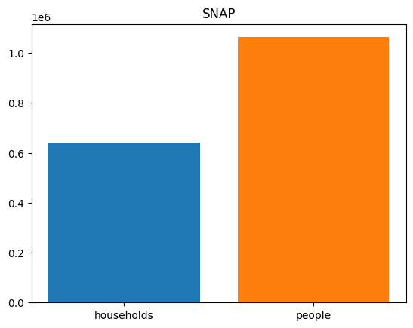

* TAFDC- 99,655 people– 37,713 Households

The below graph shows the distribution of people and households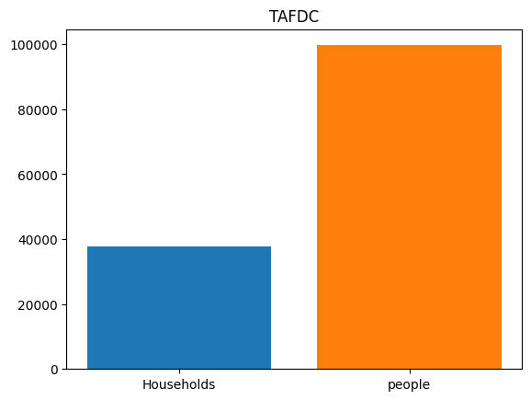

* EAEDC- 26,592 people– 26,405 Households

The below graph shows the distribution of people and households

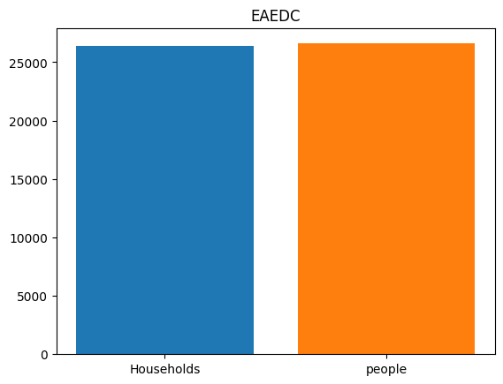

* TOTAL- 1,189,130 people– 706,029 Households

There is no proper dataset to calculate the total number of people benefited from Housing assistance, so we just did some research and found out that the total number of households under housing assistance in Massachusetts are around 200,000 and the same with the case of WIC where the total participation racks up to 115,590 in the state of Massachusetts.

**What is the income distribution for Boston residents living below the poverty line?**

From our analysis, the income distribution in Boston has the following characteristics:

* Distribution is normal with a peak at 42699
* Lower bound: 37595
* Mean: 42699
* Upper bound: 47803

The below graph shows the distribution of income range.

**What the distribution for the poverty ratio in boston?** 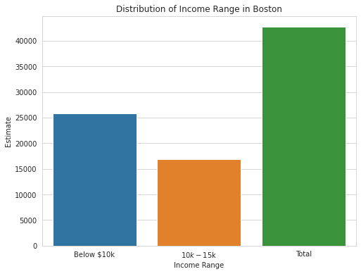

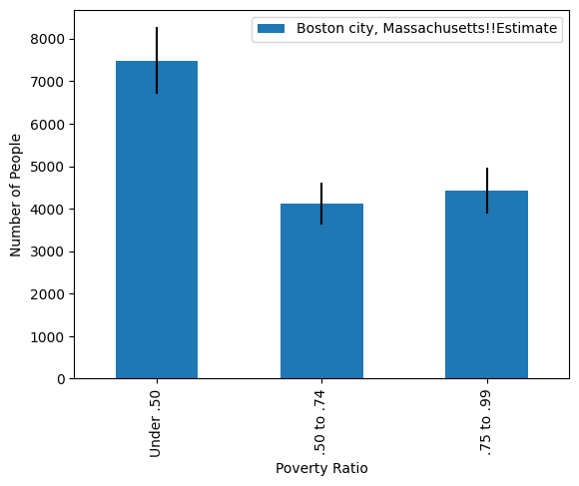

The data shows the poverty ratios in the city of Boston, Massachusetts, based on different income groups. The dataset contains information about the population estimates and margins of error for each income group.

According to the data, the highest poverty ratio is in the group of people earning under 0.50 of the median income, with an estimate of 7,488 people living in poverty. The next highest poverty ratio is in the group earning between 0.50 and 0.74 of the median income, with an estimate of 4,113 people living in poverty. Finally, the group earning between 0.75 and 0.99 of the median income has an estimated 4,421 people living in poverty.

Based on this data, it is clear that there is a significant population in Boston that is living below the poverty line. This information can be used by policymakers and community organizations to target resources and programs towards these vulnerable groups in order to alleviate poverty and promote economic development.

**Any interesting correlations with family size and the poverty threshold?**

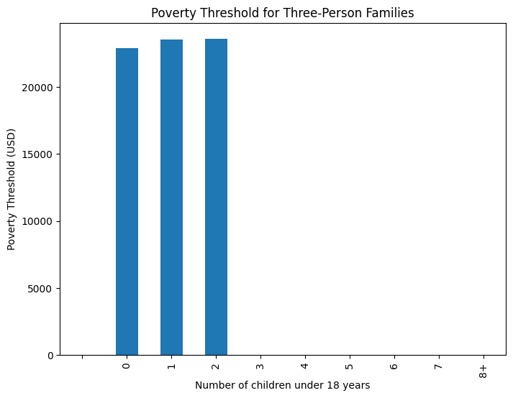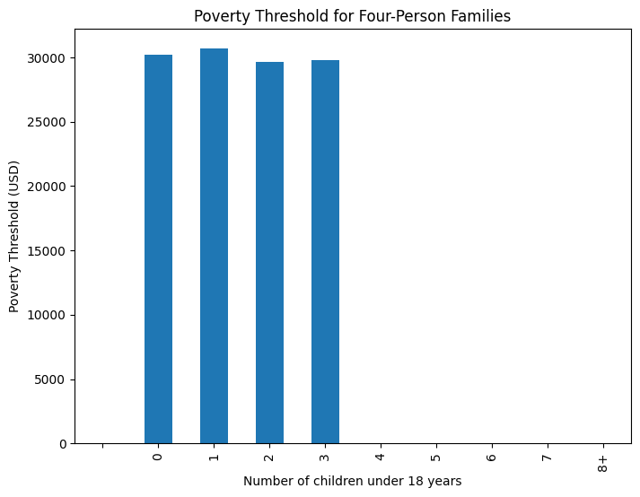

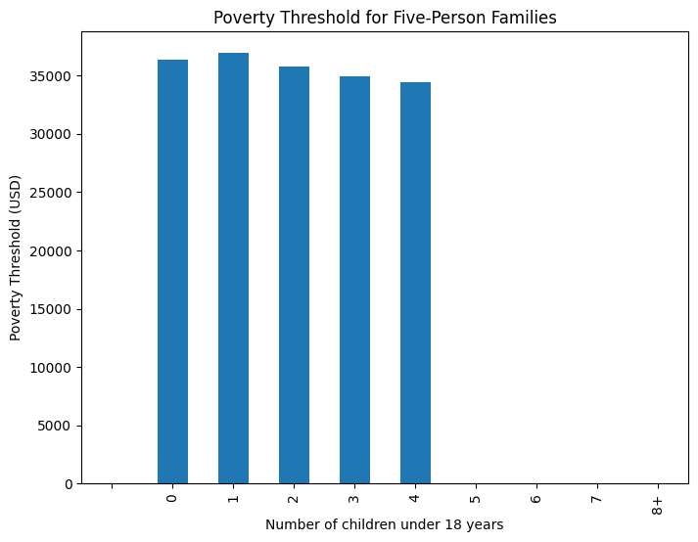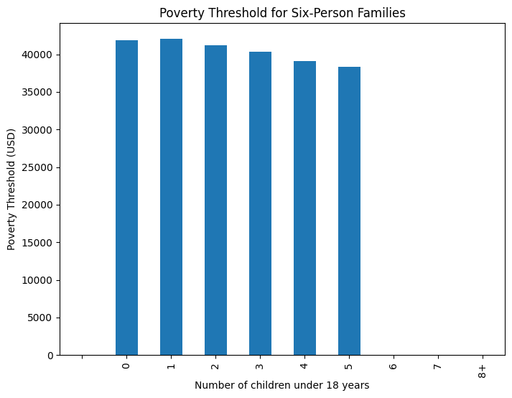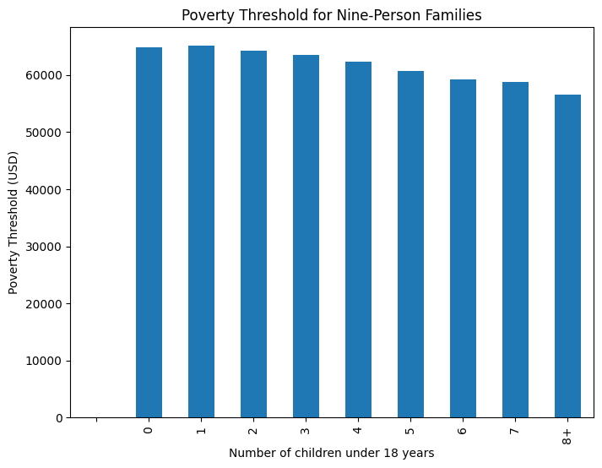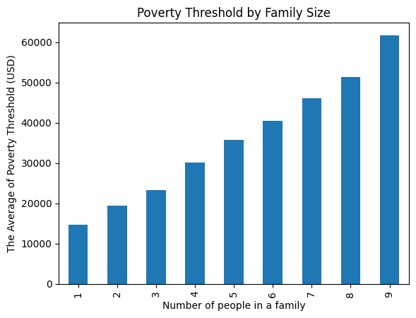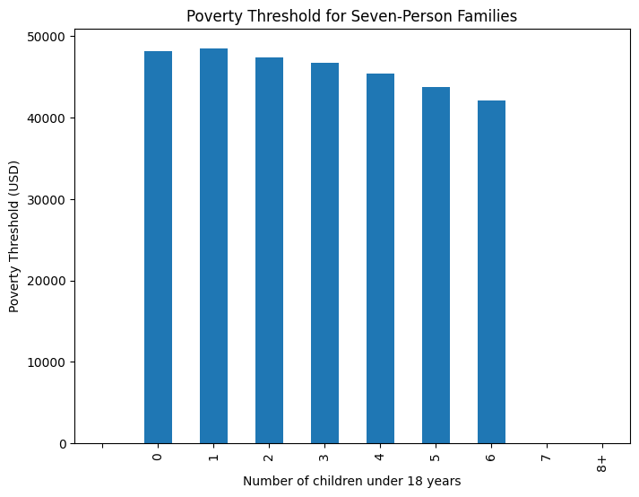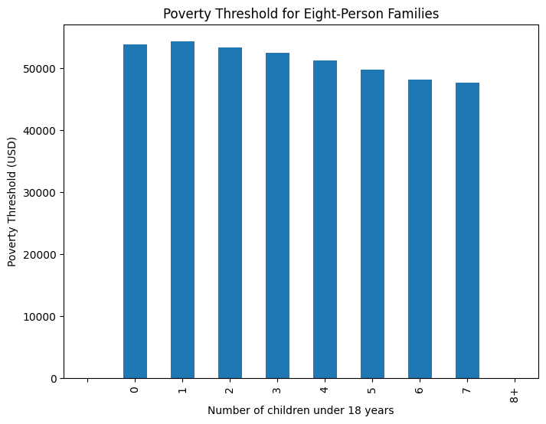

From the plot, we can see that there is a general trend of higher poverty levels for larger

families. This makes sense since larger families have more mouths to feed and may have more difficulty making ends meet. And wen can also notice that the less children under 18, the higher poverty levels are. This make sense that the less children under 18, the more adults work to earn moeny, so that the poverty levels are higher. However, these trends are not perfectly linear, and there are some fluctuations in the data. It would be interesting to further investigate these fluctuations to see if there are any other factors that may be influencing the poverty levels for certain family sizes.

**How many people/individuals/families are significantly below the poverty line**

**Statistical way: bottom 5%, 10%, 15% of families within the fams that are already under the poverty line?**

Here are some Stats:

------------------------------

Massachusetts:

Total families: 1,719,532

Poverty rate: 7.1%

Married-couple families: 1,268,347

Married-couple families poverty rate: 3.4%

Female householder, no spouse present families: 327,491

Female householder, no spouse present families poverty rate: 20.2%

Boston city, Massachusetts:

Total families: 121,536

Poverty rate: 13.7%

Married-couple families: 74,624

Married-couple families poverty rate: 7.3%

Female householder, no spouse present families: 36,475

Female householder, no spouse present families poverty rate: 27.9%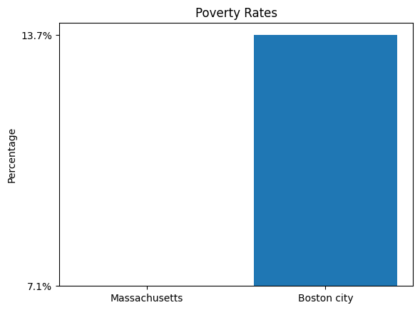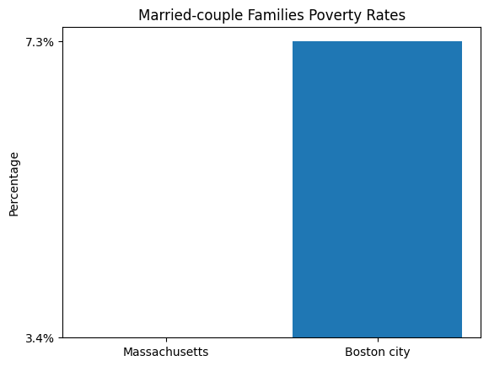

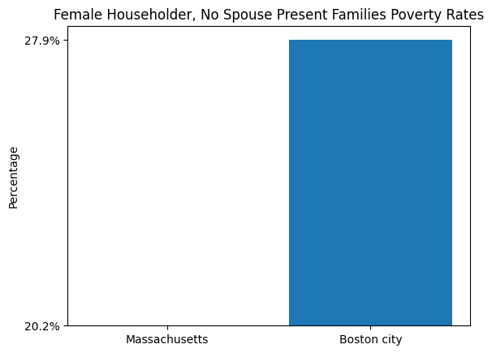

The graphs display three bar plots comparing:

- Poverty rates in Massachusetts and Boston city.

- Married-couple families poverty rates in Massachusetts and Boston city.

- Female householder, no spouse present families poverty rates in Massachusetts and Boston city.

To analyze how many families are significantly below the poverty line, we can define a threshold for "significantly below" as the bottom X% of families within the families already under the poverty line. In this case, we'll calculate the bottom 5%, 10%, and 15%.

However, since the given data doesn't provide income information for individual families, we cannot accurately determine the number of families falling within these percentages. In order to perform this analysis, we would need more detailed data, such as individual family incomes or income brackets.

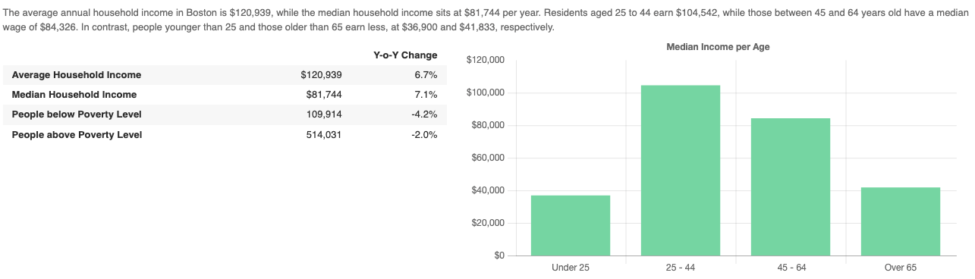

**What is the total population for different income groubs?**

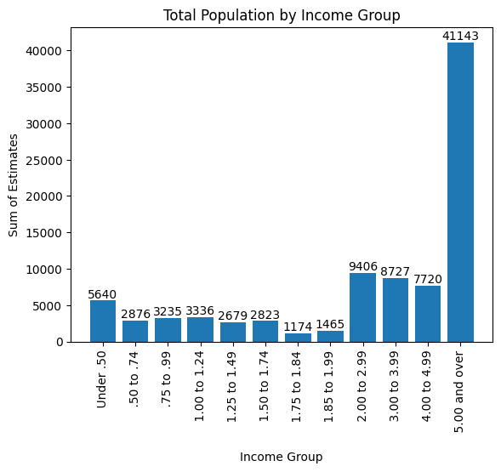

We can see that for the ratio of families under poverty line, we can see that the ratio under .50 contains 11280 families, while .50 to .74 only contains 5752, just nearly half of the ratio under .50. And the ratio .75 to .99 contains 6470 families.

***Extension analysis***

**What is the correlation between population and poverty ratio over the years?**

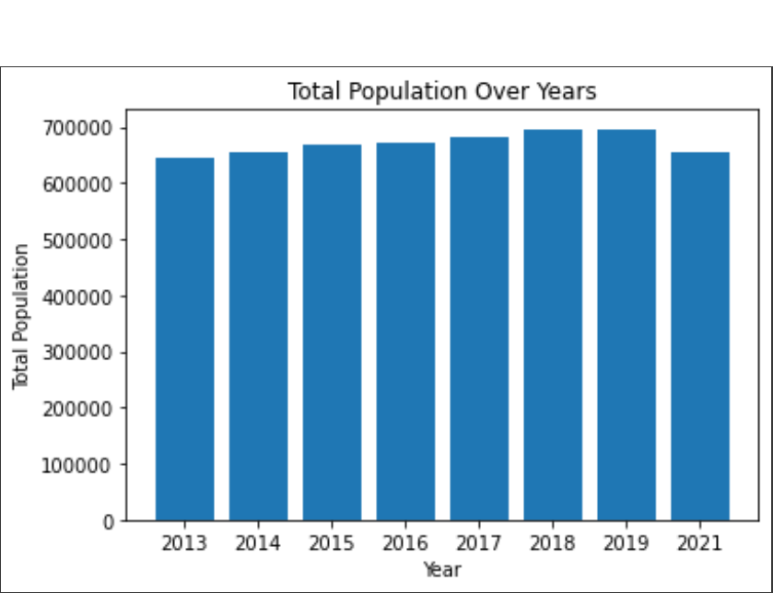

The graph above shows the total population of boston over the years.

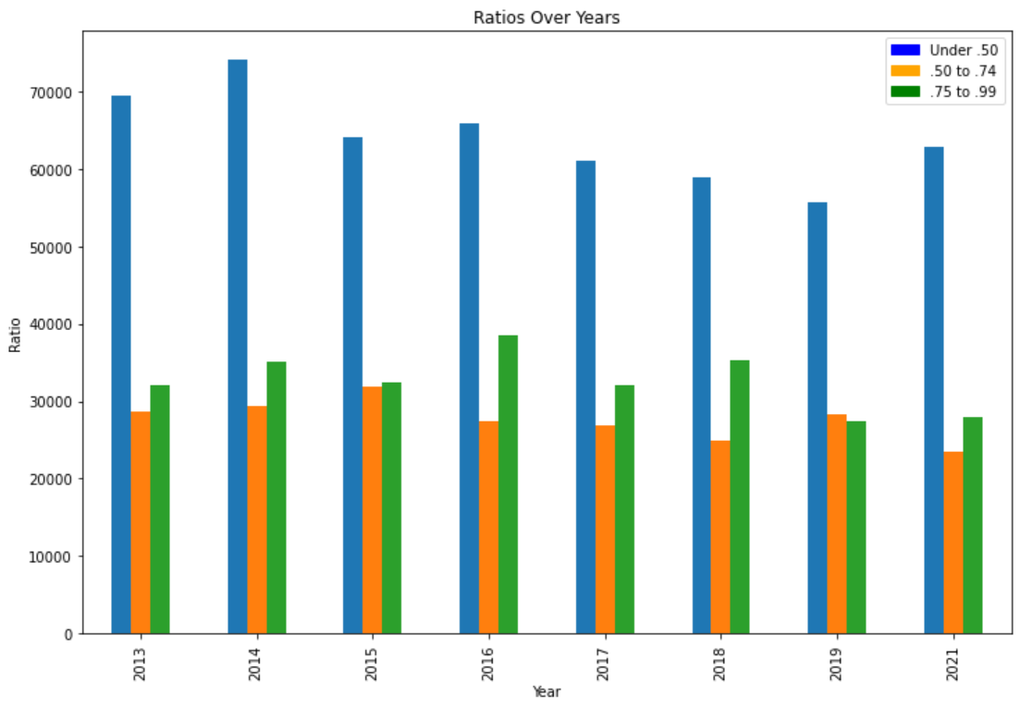

The graph above shows the number of people and their poverty ratios over the years.

**What is happening for the mean and median income over the years?**

Here are some statistics:

Year: 2013 Year: 2014

Median Earnings: 32,142 Median Earnings: 35,273

Mean Earnings: 70,418 Mean Earnings: 74,406

Year: 2015 Year: 2016

Median Earnings: 36,059 Median Earnings: 37,323

Mean Earnings: 73,968 Mean Earnings: 77,240

Year: 2017 Year: 2018

Median Earnings: 38,884 Median Earnings: 41,125

Mean Earnings: 79,642 Mean Earnings: 83,904

Year: 2019 Year: 2021

Median Earnings: 45,046 Median Earnings: 49,039

Mean Earnings: 87,885 Mean Earnings: 99,604

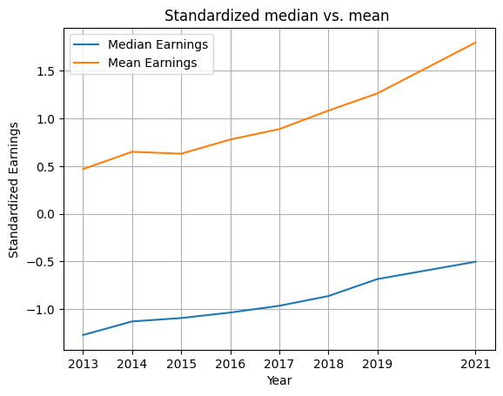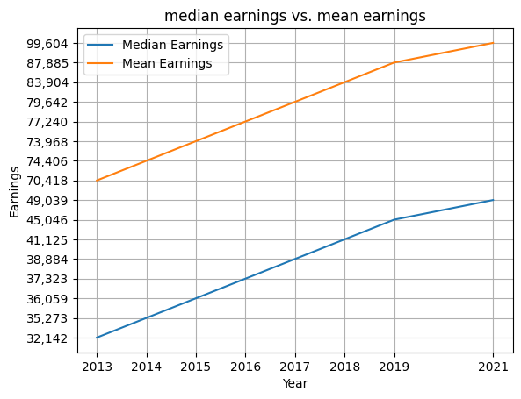

The standardized results are indeed different from the original results. Standardization is a preprocessing technique that adjusts the scale of a dataset so that each feature has a mean of 0 and a variance of 1. This method can help us more easily compare features of different scales and, in some cases, make machine learning algorithms work more effectively. However, this also means that the standardized data may no longer have the same original units and range.

In this example, we have standardized the earnings data, so the vertical axis (standardized earnings) now represents the number of standard deviations that the original earnings data is from the average earnings of the entire dataset. This is the reason why the standardized results are different from the original results. The purpose here is to help you more easily observe the relative changes in the data, rather than focusing on the absolute values of the original earnings.

***Contributions***

Basil Alghamdi: coded analysed two questions, wrote deliverable 1, wrote most or the mid presentation slides, presented the slides to the client, wrote the whole report.

haipeng Liu: (to be specified later)

Zeming Chen: (to be specified later)

Trived Katragadda: (to be specified later)

zhengxiong zouxu: (to be specified later)