Universal Basic Income Project

*Lamya Alzahrani ‘23: llamya@bu.edu*

*Yusra Nasir ‘23: ynasir@bu.edu*

*Yingjie [Alex] Ouyang ‘23: yingjieo@bu.edu*

*Tsung-Han Yu ‘23: thyu@bu.edu*

*Xiaoyu Cui ‘23: xcui3@bu.edu*

# Table of contents

**Table of contents 1**

**Introduction 2**

**Base Analysis 3**

What is the income distribution for Boston residents living below the poverty line? 3

How many people participate in assistance programs? 4

Is there a correlation with family size and the level of poverty? 4

What is the percentage for people or families living under the poverty line with respect to family size? 10

How many people (percentage) are significantly below the poverty line? 14

**Extension analysis 15**

How many people in the families under the poverty line are children/elderly? What is the distribution of ages among the children and elderly? 15

Are the parents in the families under the poverty line Married? Divorced? Or single parent? 17

How many members in families are employed and working? Is there any correlation between income and work experience, or income and education level? 19

Is there any correlation between income and education level? 24

**Limitations 26**

**Conclusion 26**

**Recommendations 27**

# Introduction

Income inequality and economic challenges faced by families are urgent concerns in contemporary society. To address these disparities and support struggling families, both policymakers and researchers seek effective solutions. In this context, our report delivers an in-depth analysis of the connection between household income and family structure, with an emphasis on nuclear families, single-parent households, and extended families in Boston. By investigating income distribution among these family types and identifying factors that influence their financial situations, we aim to reveal trends and patterns that can guide policy decisions and interventions.

The main objective of this project is to aid Boston City Councilor Kendra Lara in identifying the family structures most in need of financial assistance and pinpointing factors leading to poverty within these households. To accomplish this, our team has carried out a comprehensive analysis of data from the U.S. Census Bureau's Current Population Survey (CPS) and the American Community Survey (ACS), concentrating on key variables that may impact family poverty levels, such as householder type, presence of elderly/children, work/education experience, and more.

This project's broader implications and potential impact encompass more than just immediate policy considerations. By delving into the connection between family structure and income distribution, we can reveal vital insights about income inequality and economic opportunities accessible to different family types. Armed with this knowledge, policymakers can devise targeted and effective strategies to relieve economic burdens for struggling families, fostering a fairer and more prosperous society for all.

In our report, we present our findings, address the limitations of our analysis, and offer recommendations based on our results. Through our efforts, we aspire to bolster Councilor Kendra Lara's work to mitigate income inequality in Boston and enhance the quality of life for families in need.

# Base Analysis

Poverty is a pressing concern in numerous cities, Boston included. To tackle this challenge, Boston City Councilor Kendra Lara suggests implementing a universal basic income program to support those in need. This foundational study delves into multiple dimensions of poverty in Boston, such as income distribution among residents below the poverty threshold, participation in aid programs, the link between family size and poverty, and the proportion of individuals or families living significantly under the poverty line. Through a thorough examination, this study strives to contribute to long-lasting solutions for reducing poverty and fostering a fairer society in Boston. The following questions have been addressed:

## What is the income distribution for Boston residents living below the poverty line?

Lamya: According to the income distribution graph, the majority of Boston residents living below the poverty line have an income below 10,000 USD per year. More specifically, approximately 34% of residents have an income between 1,000 USD and 5,000 USD, while around 24% of residents have an income between 5,000 USD and 10,000 USD.

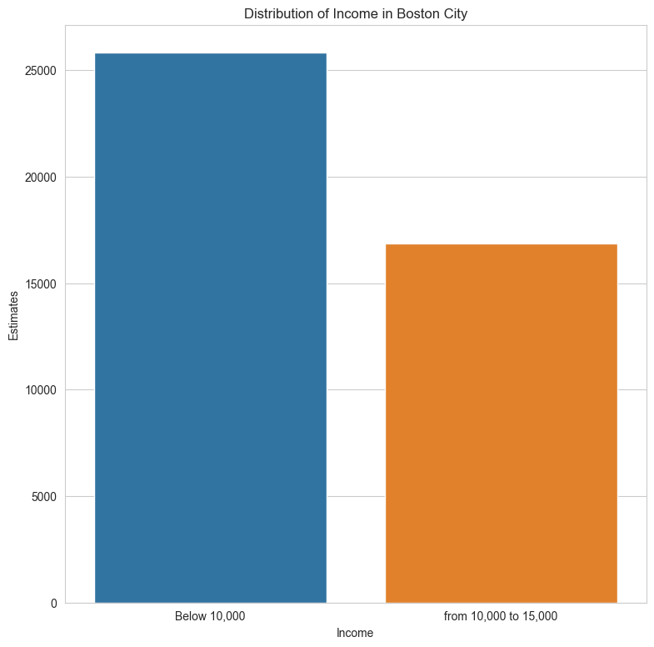

[The x-axis shows the estimates of Boston residents living under the poverty line. The y-axis shows the income.]

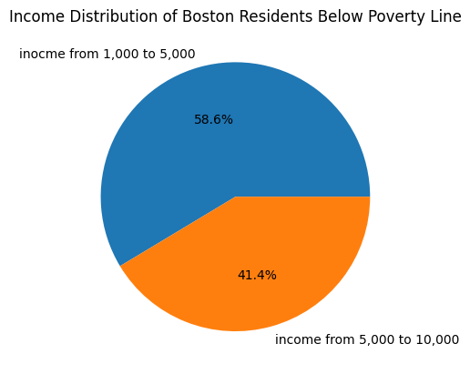

Additionally, the income distribution graph shows that there is a long tail in the income distribution for Boston residents living below the poverty line. This means that there are some residents who have a significantly higher income than others. For example, around 10% of residents have an income between 20,000 USD and 25,000 USD, while about 3% of residents have an income above 25,000 USD.

Furthermore, it's important to note that the income distribution for Boston residents living below the poverty line is heavily skewed towards lower incomes. More than half of the residents have an income below 10,000 USD, while only around 5% of residents have an income above 20,000 USD.

## How many people participate in assistance programs?

Alex: In 2018, approximately 25,223 people are eligible for support from WIC programs in Boston, while 15,054 are actively enrolled in WIC programs. The participation rate is 59.7%. This means that out of the 25,223 eligible people, 10,169 people, or about 40.3% of the people are not taking advantage of WIC benefits.

## Is there a correlation with family size and the level of poverty?

Xiaoyu: When we don’t consider the type of the family (exp. Married, male only or female only), the distribution of the family below or above the poverty line will looks like:

图形用户界面

With the family size increase, the number of family below or above the poverty line will decrease, but this phenomenon is not persuasive, because there are less family with a large family size, for the figure shown below, I also compare the ratio of counts below and above the poverty line for different family size: (the ratio is #above / #below)

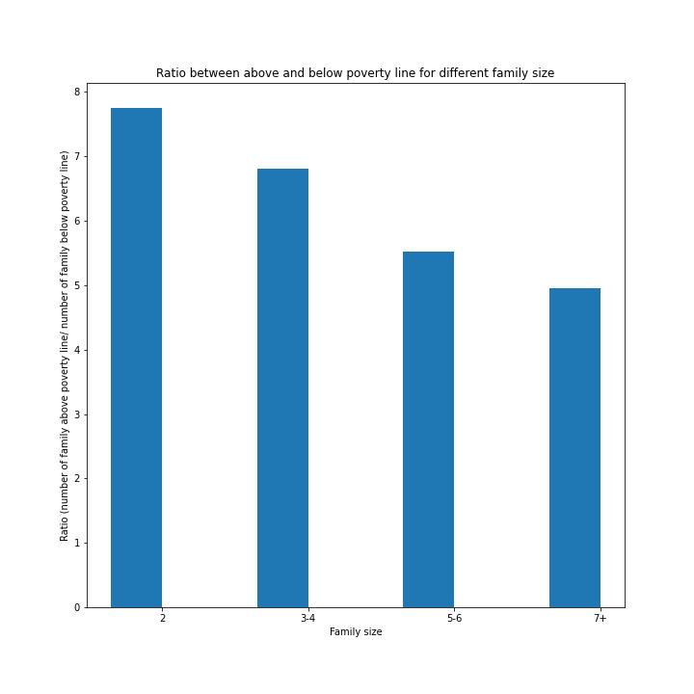

From this figure, we can see that with the family size increase, the ratio decreases, which means for a larger family size, the probability of a family income below the poverty line will increase. And when the family size increases from 2 to 7+, the ratio decreases by almost a half.

Alex: The poverty threshold increases as the number of people in the family increases. However, the increase is not linear as the number of children increases, and there exist fluctuations between different household sizes.

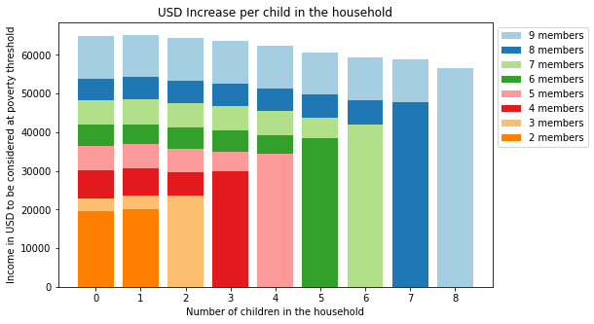

[A plot for USD increase per child in the household. The legend indicates the number of people in the family. The x-axis represents the number of children in the household, while the y-axis represents the income in USD to be considered at poverty.]

Taking a closer look at these fluctuations, let’s look at the difference in income required to be at poverty per increase in child in the largest number of households in the dataset.

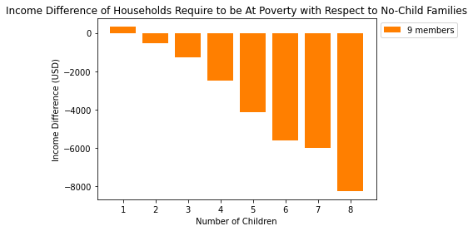

[This graph represents the income difference required to be at poverty with respect to no-child families in 9-people households.. The x-axis represents the number of children in the household, and the y-axis represents the income difference between no-children households and x-children households in USD.]

For example, The last bar represents the difference between income levels of households with no children and eight children.

* Poverty level income of households of 9 people with no children: $64,815
* Poverty level income of households of 9 people with eight children: $56,578
* $56,578 - $64,815 = -$8,237.

Thus, the difference between the income required to be at poverty between 9-people households with zero children and 9-people households with eight children decreases by $8,237.

As the number of children in the household increases, the difference between the amount of income required to meet poverty level standards decreases. This decrease is linear, with the exception of the difference between households with 6 and 7 children. We see this non-linear change in other-sized households as well.

Exploring further the relationship between family sizes and poverty level, it is important to consider the demographics of families as well. The census data contains additional information on poverty levels for families based on the gender of the head of house.

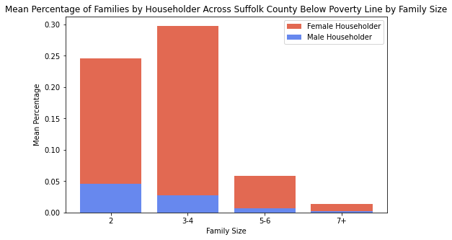

[The mean percentage of families in Suffolk City under the poverty line by family size for male householders vs female householders. The x-axis represents the size of the family, while the y-axis represents the mean estimate of the percentage of families out of all families under the poverty line.]

There is a greater percentage of families with female householders under the poverty line than there is with male householders. In addition, more families under the poverty line have sizes of 2-4.

Looking at the ratio between families above the poverty line versus families below the poverty line based on the gender of the householder, we can see an interesting relationship.

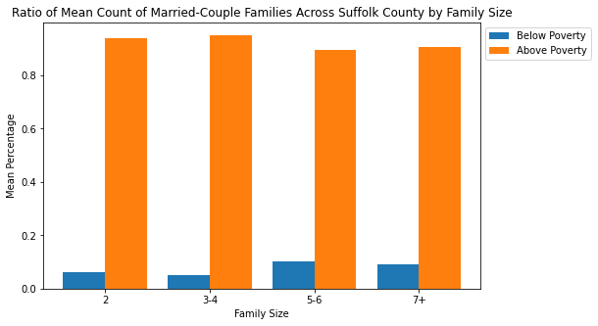

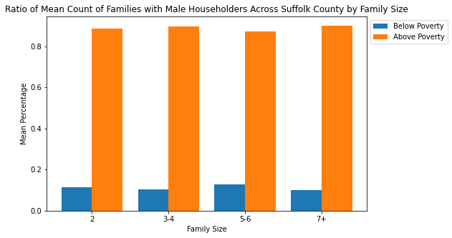

[Graphs for the percentage of family counts divided by whether they are above or below the poverty line. The top graph is for families with male head of house, while the bottom graph is for families with a female head of house. The x-axis represents the size of the family, while the y-axis represents the mean percentage out of all families in Suffolk County.]

The overall ratio of families with a female head of house below poverty to all families with a female head of house is noticeably higher than families with male head of house.

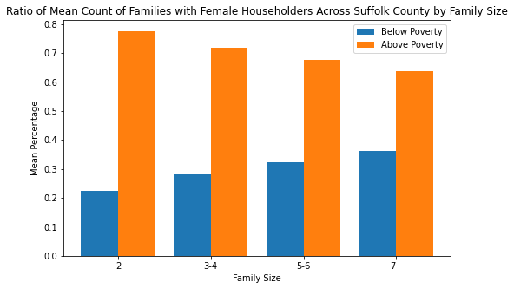

[The same graph as the above two, except with married-couple families as head of household. The x-axis represents the size of the family, while the y-axis represents the mean percentage out of all families in Suffolk County.]

For married-couple families, the overall number of families below the poverty line is lower than families with a single head of house, likely due to dual income.

In conclusion, there tend to be higher counts of smaller-sized (2-4 people) families under the poverty line in Suffolk County, while larger families under poverty line are rarer. However, this can be attributed to the overall rarity of larger-sized households. The count of families with female householders (no spouse) living under the poverty line tend to be higher, while families with male householders (no spouse) living under the poverty line tend to be lower than that of female householders. The ratio between married couple and male householder families above and below the poverty line is much greater than female householder families, with more families with female householders being under the poverty line. Overall, there are less families with married couples below the poverty line then there are families with single householders, male or female.

## What is the percentage for people or families living under the poverty line with respect to family size?

Yusra: The graph below shows the number of families below poverty level by family size.

* X-axis: This axis shows the family size from families ranging from 1 person to 7 people in the household.
* Y-axis: This axis displays the number of families below the poverty level in respect to the family size plotted on the x axis.

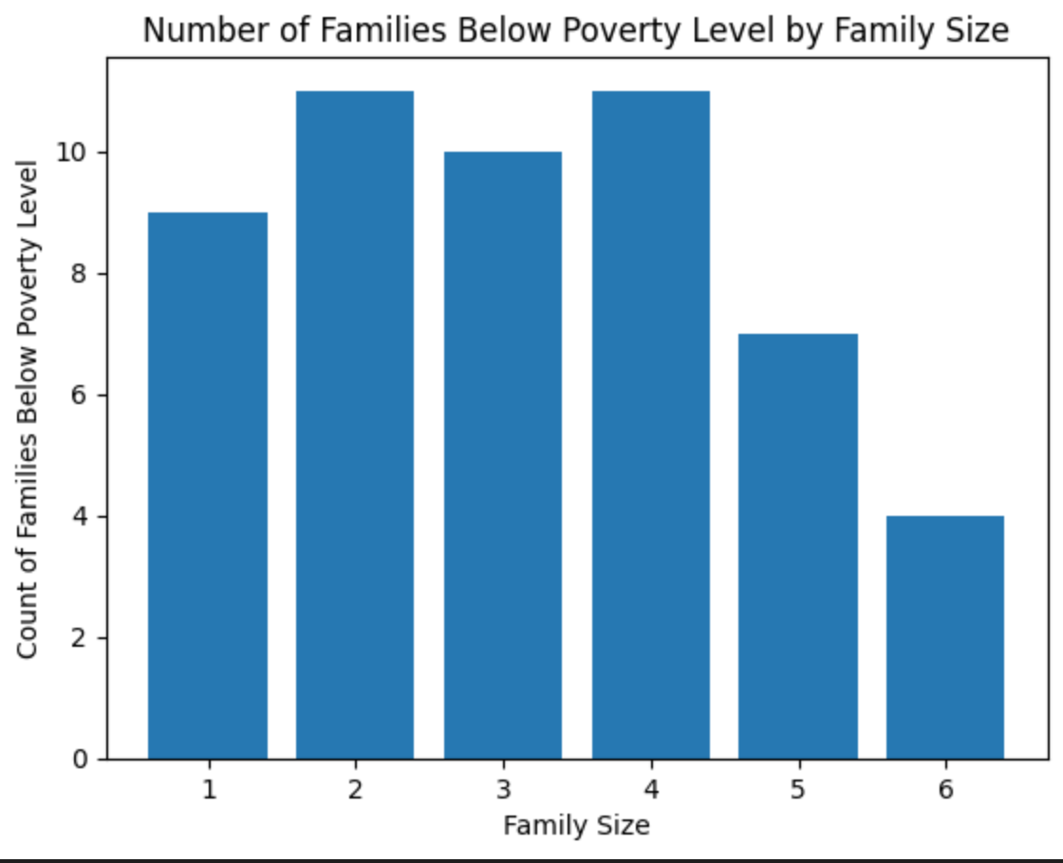

The graph you are referring to shows the percentage of families under the poverty line in the United States, broken down by family size. Here is a more detailed breakdown:

* Two-person families: According to the graph, 42% of families living under the poverty line in the United States are composed of two people. This is the most common family size among those living in poverty. Two-person families can include a variety of compositions, such as a single parent with one child, a couple without children, or two siblings living together.
* Three-person families: Also accounting for 42% of families living under the poverty line are three-person families. This can include a single parent with two children, a couple with one child, or a grandparent raising two grandchildren, among other possibilities.
* Five- to six-person families: The graph shows that 12.7% of families living under the poverty line in the United States have five or six members. This could include a couple with four children, a single parent with five children, or a multigenerational family living together.
* Seven-person families: Finally, the graph indicates that 2.4% of families under the poverty line have seven members. This could include a couple with five children, a single parent with six children, or a multigenerational family living together with an additional relative.

It's worth noting that poverty is defined by the U.S. government based on income level and family size. For example, in 2021, the poverty threshold for a family of three was set at $21,720 per year. This means that families with income below that amount would be considered to be living in poverty. The poverty threshold varies based on family size, with larger families requiring higher income levels to be considered above the poverty line.

Tsung-Han: The majority of families living under the poverty level in Boston have 2-4 people in their family, which comprises 85% of the total number of families living under the poverty level.

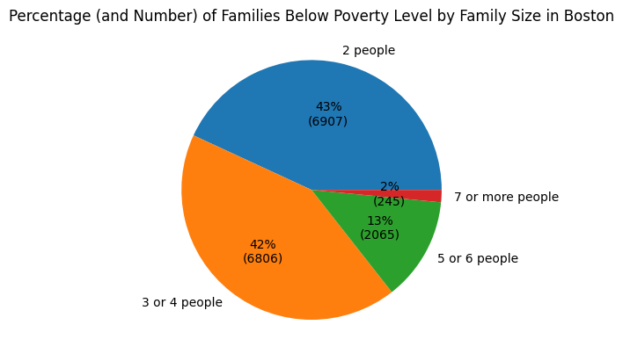

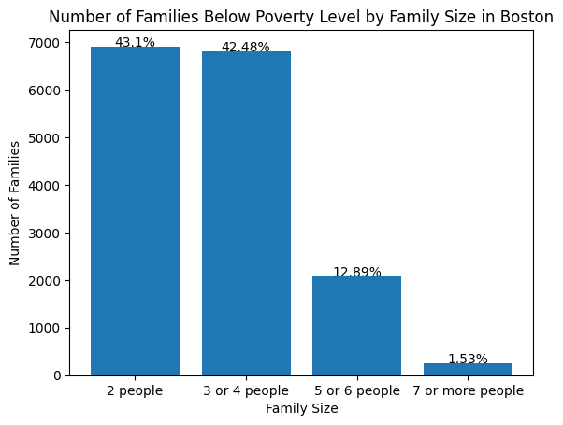

There's an increasing trend of the percentage of families with respect to family size, except the percentage drop when there are 7 or more people in the family.

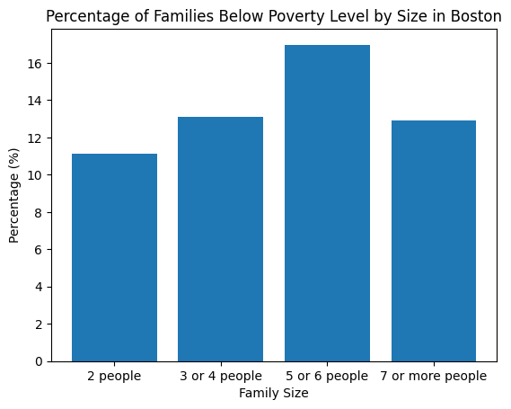

## How many people (percentage) are significantly below the poverty line?

Lamya: The data shows that the highest number of families living significantly below the poverty line is in the bottom 5% income bracket, with a total of 6,928 families. This is followed by the bottom 15% income bracket with 7,778 families, and the bottom 10% income bracket with 4,740 families. These percentages represent the proportion of households living below the poverty line, enabling a clear visualization of the concentration of poverty-stricken families in Boston.

It's important to note that the numbers provided for each income bracket are not cumulative. For instance, if a family is in the bottom 5% income bracket, it is not included in the bottom 10% or bottom 15% income bracket categories. This means that the numbers reported for each bracket represent distinct groups of families, providing a more accurate representation of the distribution of poverty levels in Boston.

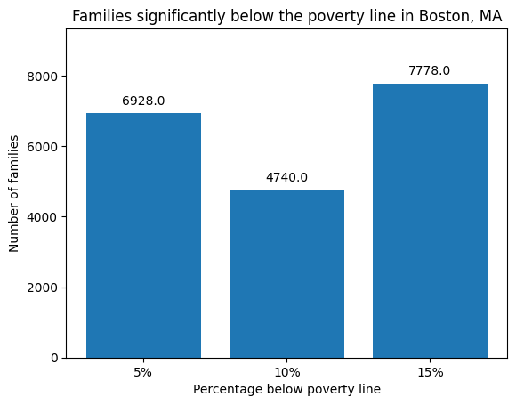

[The x-axis represents the number of families, while the y-axis depicts the percentage by which the families fall below the poverty line. The numbers above the bars represent the count.]

Furthermore, the income distribution data of households in Boston reveals that 9.5% of households have an income below $10,000, 6.2% have an income ranging from $10,000 to $14,999, 6.4% have an income ranging from $15,000 to $24,999, and 5.7% have an income ranging from $25,000 to $34,999. It's worth noting that this data pertains to all households, not just families. The higher percentage of households with an income less than $10,000 compared to the percentage of families in the bottom 5% income bracket implies that non-family households may be more susceptible to poverty.

The data also sheds light on the composition of families in Boston, categorizing them into three major categories: families, married-couple families, and non-family households. Of the 272,941 households in Boston, 121,536 are families, out of which 74,624 are married-couple families. The remaining 150,405 households are non-family households, indicating a significant proportion of individuals living alone or with roommates. This high percentage of non-family households could potentially contribute to the higher proportion of households with an income less than $10,000.

# Extension analysis

In recent years, the growing significance of income inequality and economic challenges faced by families has sparked discussions and research. Our team aims to investigate the link between household income and family structure, as this area can offer valuable insights into the financial experiences of different family types. Focusing on nuclear families, single-parent households, and extended families, our project will analyze income distribution across these structures and examine its relationship with income.

Our primary motivation is the belief that understanding the interplay between family structure and income distribution can uncover vital information about income inequality and economic opportunities for diverse families. By investigating these connections, we strive to gain a deeper understanding of the challenges faced by families in various circumstances and the impact of their economic situations.

Through this research, we aspire to discover patterns and trends that can guide future policies and interventions to ease the economic burdens of families in need. By utilizing data from the U.S. Census Bureau's Current Population Survey (CPS) and the American Community Survey (ACS), coupled with engaging data visualizations, we will present our findings in a clear and informative manner.

To achieve our goals, we will address the following questions:

## How many people in the families under the poverty line are children/elderly? What is the distribution of ages among the children and elderly?

Yusra and Xiaoyu: This pie chart shows the proportion of families with children and elderly members in a given population. The blue slice represents families with children, which make up 65.4% of the total, while the orange slice represents families with elderly members, which make up 34.6%. It's important to note that there is no overlap between these two groups, so a family can only be counted in one category or the other. In this particular population, there were no families found that had neither children nor elderly members This is about the overall families regardless of poverty levels.

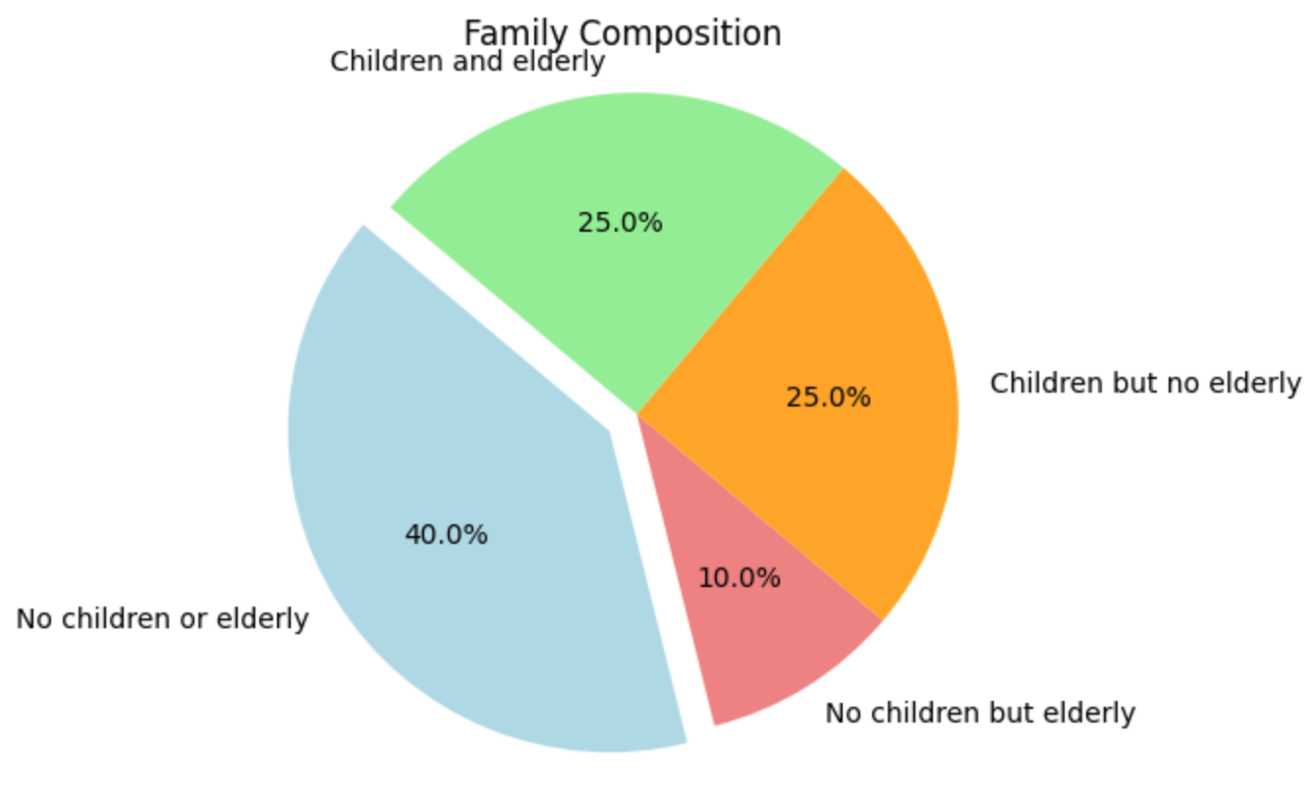

The graph that is generated by the code represents the distribution of ages of individuals living with related children of the householder in a given area. The data has been cleaned and loaded into a Pandas dataframe, and then the script selects the columns corresponding to the number of individuals under 5 years old, between 5 and 17 years old, and under 18 years old, and sums them up to get the total count of individuals in each age group.

The bar chart that is produced shows the count of individuals in each age group, with the x-axis representing the age group and the y-axis representing the count. The x-axis has been modified to show new labels that represent the age ranges in each group - "<5" for under 5 years old, "5-17" for 5 to 17 years old, and "<18" for under 18 years old.

Overall, the graph provides insight into the distribution of ages among individuals living with related children of the householder in the given area, and the modified x-axis labels make the information more clear and accessible to readers.

It's important to note that the data for each age bracket is not cumulative, meaning that the number of households with children from 17-18 years old does not include the households with children under 5 years old or 5- 17 years old. Instead, each age bracket represents a distinct group of households.

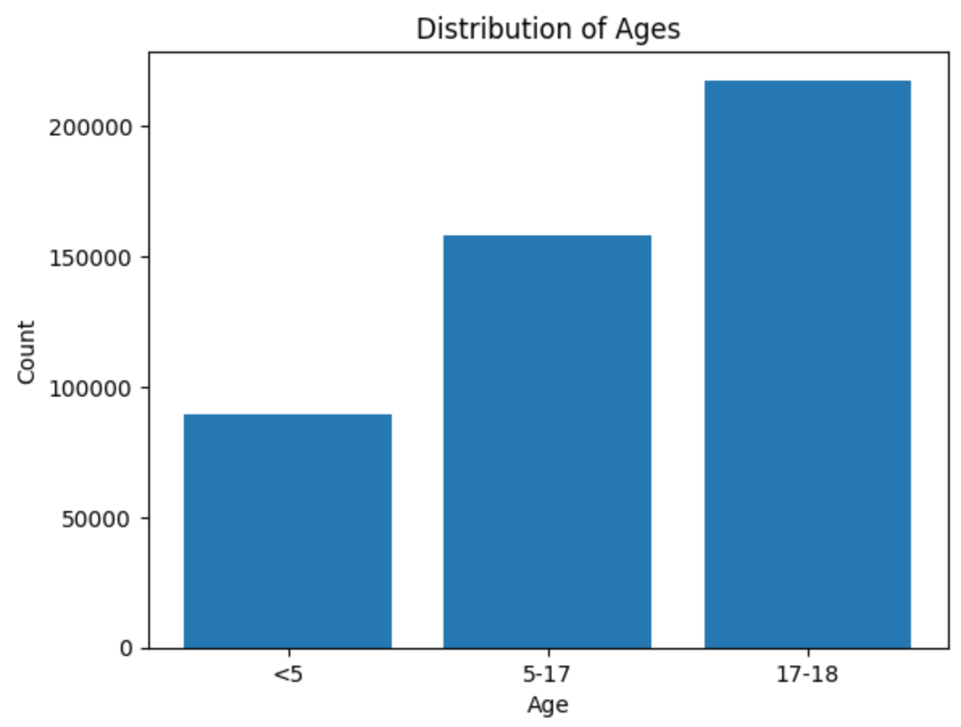

## Are the parents in the families under the poverty line Married? Divorced? Or single parent?

Lamya: The data reveals that among families living under the poverty line, the majority of parents in Boston are unmarried, with 56.6% having never been married. Married parents account for 30.7% of the population in this category, while divorced parents make up 6.9%. Widowed and separated parents are less prevalent, representing smaller percentages at 3.4% and 2.5%, respectively. These figures imply that single-parent households are more common among families living under the poverty line in this area.

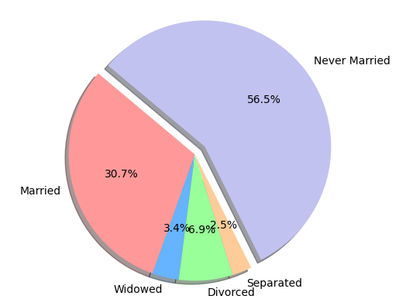

[This pie chart shows the percentages of households based on family type.]

Our analysis revealed that, on average, married-couple families have a higher income of $127,649 compared to non-family households, which have an average income of $66,320. This discrepancy can be explained by the dual income typically present in married-couple households, while single-parent households rely solely on a single source of income.

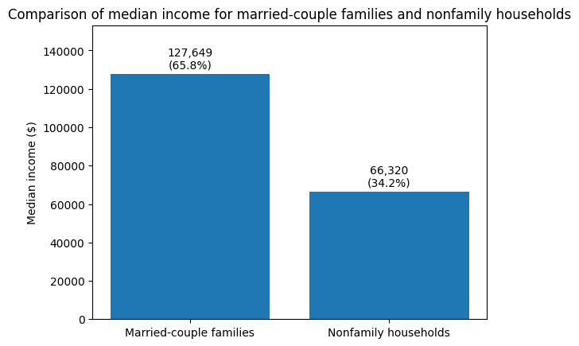

[The x-axis is the median household income and the y axis is the family type. The number above the bars represent the count and percentage.]

## How many members in families are employed and working? Is there any correlation between income and work experience, or income and education level?

Alex:In Suffolk County, there are a wide range of household demographics by the number of workers alone. For households with two workers or more, there is a surprising relationship between income and whether or not the household contains a married couple.

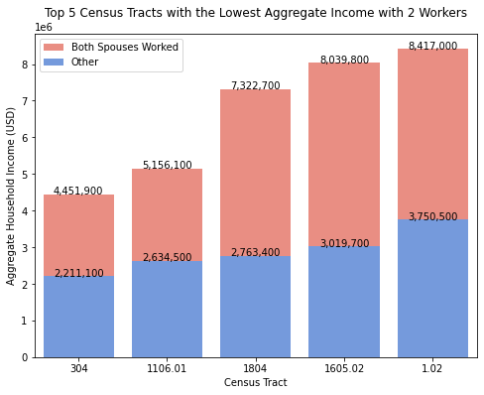

[The bar graph shows the top five census tracts with the lowest income, where the household contains two workers. The x-axis are the census tract numbers, and the y-axis is the aggregate income of the households, the numbers which are also listed above their respective bars. The red bars indicate the income of households where the two workers are spouses, and the blue bars indicate the workers are unmarried. [Tract 304](https://censusreporter.org/profiles/14000US25025030400-census-tract-304-suffolk-ma/), the census tract with the lowest income with 2 workers, is located in North End.]

Households where the two workers are spouses make noticeably more than houses with two workers where the workers are unmarried, sometimes double or more than what unmarried workers make.

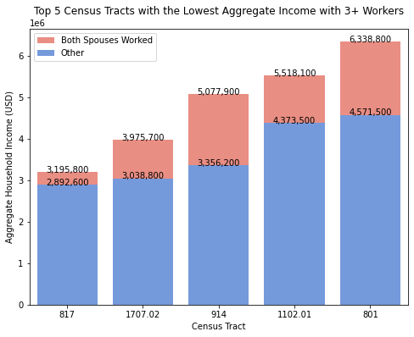

[This bar graph shows the top five census tracts with the lowest income, where the households contain three or more workers. The format of the bar graph is similar to the bar graph with two workers, with the x-axis being census tract numbers and the y-axis the aggregate income. [Tract 817](https://censusreporter.org/profiles/14000US25025081700-census-tract-817-suffolk-ma/), the census tract with the lowest income with 3+ workers, is located in the Roxbury area.]

In families with three workers, the disparity between income of households with married couples and income of households without is much lower. However, the income of households with married couples is still greater than the income of households without married couples. In fact, households with two workers where both workers are spouses often make more than households of three or more, even if they contain a married couple.

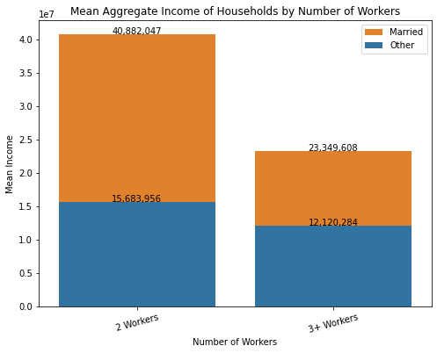

[Above shows the mean aggregate income of households by number of workers and whether those workers are married. The x-axis represents the number of workers, and the y-axis represents the mean income, while the legend denotes whether or not the workers in the family are married.]

Looking closer at the difference between income between households with married and single workers, there is a disparity between the aggregate income of households with married couples and households without. The aggregate income of households where the workers are married are double or more than the income of households where workers are unmarried.

Furthermore, the number of families employed and working vary across families. However, the census data indicates that in most families, the number of workers primarily range from 0 to 2. This distribution also differs depending on whether the family is above or below the poverty line, and whether or not they contain a married-couple.

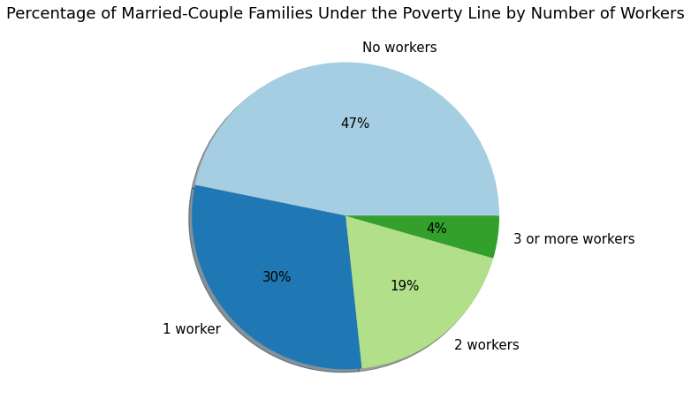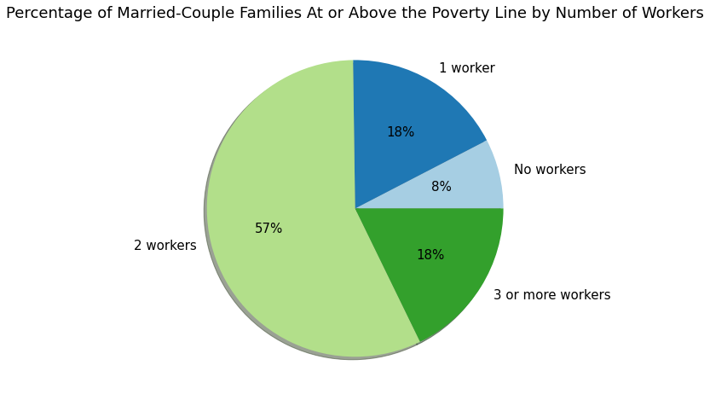

[The top chart shows the distribution of the number of workers in families with married couples under the poverty line. The bottom chart shows the same distribution in families with married couples at or above the poverty line.]

On average, more families with married couples under the poverty line are likely to have no workers than 1, 2, or 3+ workers. In Suffolk County, 47% of households under the poverty line have no workers. However, families under the poverty line are more likely to have at least one worker than no workers at all. 53% of households under the poverty line have at least one worker.

The greatest percentage of married-couple families at or above poverty level have two workers, at 57%, which is greater than families with any other number of workers. The lowest percentage of married-couple families at or above poverty level have no workers.

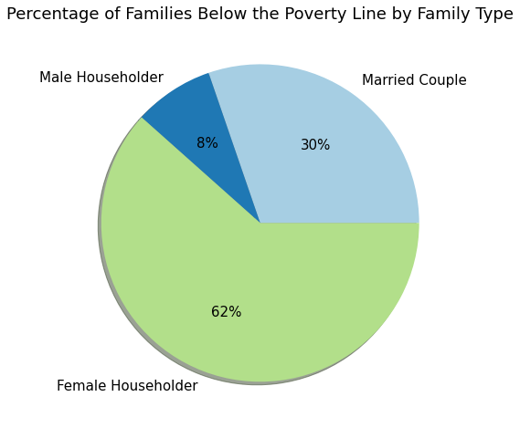

(A pie chart showing the distribution of families below the poverty line.)

Out of families below the poverty line, the greatest percentage are families with an unmarried female head of house, greater than the other two groups combined at 62%. Unmarried male heads of houses have the least percentage of households below the poverty line.

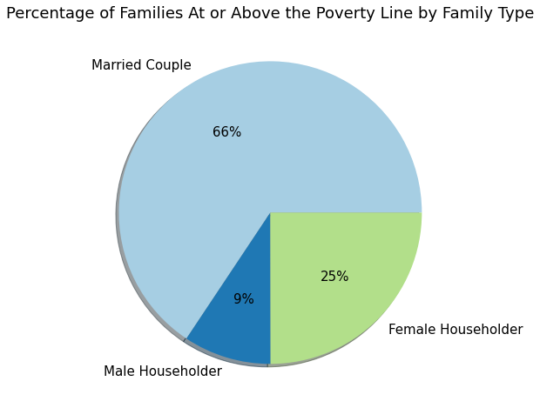

[The same chart as above except with households at or above the poverty line.]

Most households above the poverty line are households with married couples, greater than the other two groups combined at 66%. Again, unmarried male householders have the least percentage of households at or above the poverty line.

Lastly, we have the mean median income of households by the number of earners. As the number of earners increases, the median income increases, which is understandable; more workers means more income. However, there is a sharp increase between households with one earner and households with two earners, and a much smaller increase between households with two earners and households with three earners.

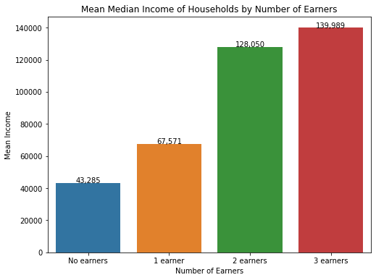

[Average median household income across Suffolk County by the number of earners. The x-axis denotes the number of earners in the household, and the y-axis shows the average median income, which is also labeled on the bars.]

## Is there any correlation between income and education level?

Tsung-Han: I can’t yet find a dataset that contains both information, but I did find data containing information about poverty level and education level. I will use [2021 B17018](https://data.census.gov/table?t=Families+and+Household+Characteristics:Income+and+Poverty&g=050XX00US25025$1400000&tid=ACSDT5Y2021.B17018) (Poverty Status in the Past 12 Months of Families by Household Type by Educational Attainment of Householder) here.

Here’s a bar chart showing the educational level distribution among households living below poverty and at or above poverty level. You can see clearly that the large majority of those living at or above poverty level have a Bachelor’s degree or higher. This goes to show that getting a college degree is one of the most effective ways to avoid poverty.

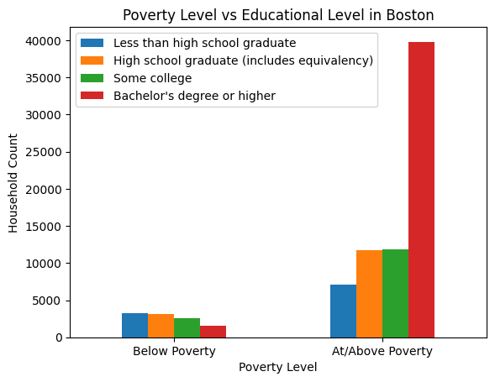

But when we look at the education level just among those living in poverty, the differences are not that much different. Those with Bachelor’s degree or higher does comprise a smaller proportion but it’s still a non-negligible chunk (14.8%). The vast majority of households (85.2%) in poverty don’t have a Bachelor’s degree.

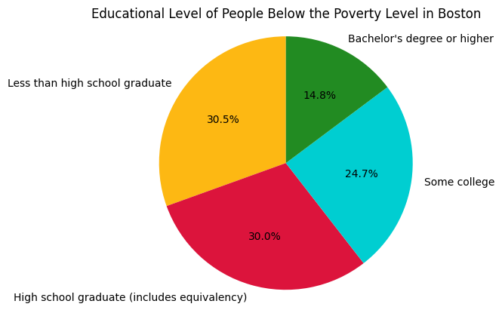

# Limitations

One major limitation was the missing values in the census data. The team relied primarily on census data of Suffolk County to answer the deliverable and extension proposal questions. However, a significant portion of the data was missing, which may affect the overall analysis due to not knowing the entire distribution of data across all counties. In addition, since the data was ordered by census tract numbers, the team could not pinpoint what areas of Suffolk County these census tracts are associated with, and by extension the neighborhoods/districts.

Another limitation was the lack of feedback from the client on the team's presentation and previous work. Without receiving feedback, the team was unsure if their analysis met the client's expectations, and if there were any specific areas that needed improvement or further exploration. This made it challenging for the team to adjust their approach and deliverables to align with the client's needs.

# Conclusion

This project aims to assist Boston City Councilor Kendra Lara in determining the most appropriate kinds of families to provide financial support to. The poverty levels of Boston residents are disproportionately correlated with various factors, such as the types of assistance they receive, the demographics of the people, and family structure itself. The analyses made for this project hope to provide insight into the various circumstances that may potentially contribute to a household’s poverty status.

In the extension proposal, the team aimed to further explore the relationships between poverty and family structure, exploring variables such as householder type, the presence of elderly/children, work/education experience, and other factors the team believe may affect poverty levels of families. The goal of the extension project was to build upon the team’s findings so far, and provide the client with additional insight when making the decision on which households to allocate aid.

While limitations in the data exist that hinder the ability to better understand the population of Boston in need of financial assistance, the data provides a good overview of the types of families that tend to be in poverty and opens up other avenues to consider when determining the level of need for assistance. The visualizations and analysis the team has provided of the exploration of different household factors hope to aid Councilor Lara in better understanding Boston’s people and provide financial support to those who need it most.

# Recommendations

Based on the findings of our analysis, we recommend the following actions to Boston City Councilor Kendra Lara:

1. **Increase financial aid to single-parent households:**

Our analysis shows that single-parent households are more common among families living under the poverty line in Suffolk County. Therefore, we recommend that Boston City Councilor Kendra Lara focus on increasing financial aid to single-parent households to better support this vulnerable group.

1. **Consider targeted aid for families with elderly members:**

Our analysis also shows that a significant number of households under the poverty line have a householder older than 65. Therefore, we recommend that Boston City Councilor Kendra Lara consider targeted aid for families with elderly members to help alleviate the financial burden on these households.

1. **Encourage higher education:**

Our analysis shows a positive correlation between higher education levels and income levels. Therefore, we recommend that Boston City Councilor Kendra Lara encourage and provide opportunities for higher education to families under the poverty line. This could include providing scholarships, grants, or other forms of financial aid.

1. **Provide support for job training and work experience:**

Our analysis shows a positive correlation between the number of workers in a household and income levels. Therefore, we recommend that Boston City Councilor Kendra Lara provide support for job training and work experience to families under the poverty line to help increase the number of workers in a household and, by extension, their income levels.

1. **Continue to monitor and evaluate the effectiveness of aid programs:**

It is important to regularly monitor and evaluate the effectiveness of aid programs to ensure that they are achieving their intended goals. Therefore, we recommend that Boston City Councilor Kendra Lara continue to monitor and evaluate the effectiveness of aid programs in addressing poverty in Suffolk County and make adjustments as necessary.

Implementing these recommendations may help reduce poverty levels and improve the quality of life for families in need in Boston.