Retail Customer Segmentation
& Sales Analysis
Who the customers of a UK online gift retailer actually are, what they are worth, and which of them are quietly leaving
Capstone Project Report
IBM SkillsBuild Data Analytics with AI Academic Internship Programme
Conducted by BharatCares in association with AICTE
Table 1. Submission details.
Field | Detail
Submitted by | Aryan Verma
Project title | Retail Customer Segmentation & Sales Analysis
Dataset | UCI Machine Learning Repository - Online Retail II (https://archive.ics.uci.edu/dataset/502/online+retail+ii)
Records analysed | 1,067,371 transaction lines, 1 December 2009 to 9 December 2011
Code file | AryanVerma_RetailCustomerSegmentationAnalysis.ipynb
Language / stack | Python 3 - pandas, NumPy, Matplotlib, scikit-learn
Methods | Data cleaning audit, EDA, RFM segmentation, K-Means clustering, CLV estimation, cohort retention
Report generated | 17 September 2026, by tools/build_report.py from outputs/facts.json

Every figure, table and result in this report is computed by the notebook and read from outputs/facts.json; the software versions are read from the run itself. The only hand-entered values are the wall-clock timings in section 16.

Contents
1. Executive summary
2. Introduction and business problem
3. The dataset
4. Tools and technologies
5. Methodology
6. Data cleaning and its audit trail
7. Exploratory analysis
8. Customer segmentation - RFM
9. Customer segmentation - K-Means
10. Customer lifetime value
11. Cohort retention
12. Key findings
13. Recommendations
14. Limitations
15. Conclusion
16. How to reproduce this project
17. References

1. Executive summary
This project analyses 1,067,371 transaction lines from a UK-based online gift retailer covering 1 December 2009 to 9 December 2011, and answers one question: which customers is this business actually built on, and which of them are leaving? After a documented cleaning pass that retains 96.4% of rows, the analysed base is £20,517,554 of revenue across 39,675 orders, 5,854 identified customers and 4,725 products in 43 countries.
The headline result is concentration. 1,170 customers - 20% of the base - produce 77.2% of identified revenue, and the top 1% (58 customers) produce 31.9%. The mean customer is worth £2,994 and the median £889 - a ratio of 3.4x - so any plan addressed to “the average customer” is addressed to nobody. That is the finding that justifies segmenting the base before doing anything else with it.
Rule-based RFM scoring splits the base into nine segments. 1,555 Champions (26.6% of customers) carry £12.54M, or 71.5% of identified revenue. A K-Means clustering run on the same log-scaled RFM features, given no rules at all, reproduces that structure: every one of the nine segments sends at least 60% of its members to a single cluster, and 80.5% of customers land in their own segment's modal cluster. Two methods that read the same features but draw their boundaries differently agreeing is evidence the structure is in the data rather than in the thresholds.
The actionable number is smaller and more specific. 683 customers who have already spent £1,689,620 (9.6% of identified revenue) have stopped ordering. They are not low-value customers who drifted off; they are proven buyers who went quiet, and they are the only group with a large, individually identified prize attached to contacting them.
Three further results change how the business should read its own reports. Returns total £738,952 - 3.60% of gross revenue - and the rate spikes to 13.30% in January 2011 rather than sitting flat. The single largest line in the file, £168,470 of one product, was cancelled 12 minutes after it was raised, which moves that product from gross rank 4 to net rank 4,711; 7 of the top ten products change position once cancellations are netted off. And customers acquired in the Christmas peak retain at 9.3% by month 3 against 22.3% for every other month - on 2 peak cohorts from a single season, so a lead to test rather than a settled fact.
Table 2. Headline metrics for the cleaned dataset. Computed in section 7 of the notebook.
Metric | Value
Total revenue | £20.5M
Orders (invoices) | 39,675
Identified customers | 5,854
Distinct products sold | 4,725
Countries served | 43
Average order value | £517
Median order value | £304
Average lines per order | 25.9
Units sold | 11,375,286
Trading window | 01 Dec 2009 to 09 Dec 2011

What this report does not do is equally deliberate. The dataset has no cost of goods, so every value here is revenue and not margin; it contains no campaign data, so nothing here shows that contacting a customer causes a return; and the timestamp records back-office keying rather than customer intent, so it cannot say when customers prefer to shop. Section 14 states all 11 limitations in full.

2. Introduction and business problem

2.1 Background
The subject of this analysis is a UK-registered online retailer selling all-occasion giftware, largely to wholesale buyers who resell the stock. Its transaction log for two full trading years is published by the UCI Machine Learning Repository as Online Retail II. Because the log is a real operational extract rather than a teaching file, it carries everything a real extract carries: cancelled invoices, bad-debt adjustments, postage lines mixed in with product lines, guest checkouts with no customer identifier, and duplicate writes.
A retailer in this position has a specific problem. It knows its total revenue and it knows which products sell, because both come straight off the invoice system. What it does not know is the shape of its customer base - how much of the business depends on how few accounts, which accounts have stopped buying, and whether the customers it acquires in its busiest season are worth the same as the ones it acquires in June.

2.2 The business problem
Marketing and account-management effort is finite, and it is currently being spread without evidence about where it pays back. The analytical problem is to convert a flat transaction log into a segmentation of the customer base that (a) is derived from behaviour rather than assumption, (b) attaches a revenue figure to each segment so effort can be prioritised, and (c) identifies the customers whose spending has stopped while they are still recoverable.

2.3 Objectives
1. Build a reproducible cleaning pipeline for a real transaction log, and record what each rule removes rather than dropping rows silently.
2. Establish the shape of the business through exploratory analysis: revenue over time, seasonality, products, geography, returns and order-value distribution.
3. Segment identified customers on Recency, Frequency and Monetary value using an explicit rule-based scheme, and quantify each segment's revenue contribution.
4. Cross-check that segmentation with unsupervised K-Means clustering on the same features, and report the agreement between the two.
5. Estimate customer lifetime value per segment, and test the estimate against actual revenue rather than presenting it unchallenged.
6. Measure retention with a monthly acquisition-cohort matrix, and correct it for the censoring at both ends of the observation window.
7. Turn the results into recommendations that name the finding and the number behind each one, and state plainly what the data cannot support.

2.4 Scope
In scope: the 1,067,371 transaction lines in the two source sheets, covering 1 December 2009 to 9 December 2011; descriptive and unsupervised analysis; revenue-based valuation.
Out of scope: profitability (no cost data exists in the file), demographic or firmographic profiling (no customer attributes exist), predictive churn modelling with a probabilistic survival model, and any causal claim about marketing effect. Section 14 explains why each exclusion is a property of the data rather than a shortcut.

3. The dataset

3.1 Source
Table 3. Dataset provenance. The notebook downloads this file on first run and caches it under data/raw/; the source workbook is never modified.
Attribute | Detail
Name | Online Retail II
Publisher | UCI Machine Learning Repository (dataset 502)
Link | https://archive.ics.uci.edu/dataset/502/online+retail+ii
Direct download | https://archive.ics.uci.edu/static/public/502/online+retail+ii.zip
Donated by | Dr Daqing Chen, London South Bank University
Licence | Creative Commons Attribution 4.0 International (CC BY 4.0)
Format | Single .xlsx workbook, two sheets: Year 2009-2010 and Year 2010-2011
Size | 45.6 MB download (a stored .zip holding one .xlsx of the same size)
Rows | 1,067,371 across both sheets
Period | 1 December 2009 to 9 December 2011
Granularity | One row per product line per invoice

3.2 Schema
Table 4. Schema of the combined dataset: eight source columns, plus SourceSheet and the engineered Revenue column.
Column | Type | Meaning and notes
Invoice | text | Invoice number. A C prefix marks a cancellation and an A prefix marks a bad-debt adjustment.
StockCode | text | Product code. Some codes are not products at all - POST, DOT, M, BANK CHARGES, AMAZONFEE, TEST001.
Description | text | Product name. Missing on 4,382 rows.
Quantity | integer | Units on the line. Negative on returns and write-offs.
InvoiceDate | datetime | When the line was keyed into the system - see section 7.4, this is not customer intent.
Price | float | Unit price in GBP. Zero or negative on non-sale lines.
Customer ID | float | Customer identifier. Missing on 243,007 rows (22.8%) - guest checkouts.
Country | text | Shipping country. 43 distinct values.
SourceSheet | text | Added by the notebook to record which sheet a row came from.
Revenue | float | Engineered by the notebook: Quantity x Price.

3.3 Data-quality issues found before any analysis
The profiling pass in the notebook found the following, all of which shape the cleaning rules in section 6:
- 243,007 rows (22.8%) have no customer ID. These are real sales with real revenue; they simply cannot be attributed to a customer.
- 12,133 rows are exact duplicates on every column including the timestamp - a double write, not two sales.
- 19,494 rows sit on C-prefixed cancellation invoices, and 22,950 rows carry a negative quantity. The two sets are not the same: the difference is stock write-offs on ordinary invoices.
- Six A-prefixed invoices carry £-147,614 of bad-debt adjustments. The common “drop invoices starting with C” recipe leaves every penny of that in the revenue line.
- 6,202 rows are priced at zero and 5 carry a negative price, the zero-priced set including every row with a blank description.
- Non-product stock codes are mixed into the product lines: postage (POST, DOT), carriage (C2, C3), manual corrections (M), bank charges, Amazon fees, samples, gift vouchers and test records.

4. Tools and technologies
Table 5. Software stack. Every version is the one that actually produced these results, read from the run itself; the lower bounds are in requirements.txt.
Tool | Version used | Role in this project
Python | 3.14.6 | Language for the entire analysis
Jupyter Notebook | 7.6.2 | Executable document holding code, charts and narrative
pandas | 3.0.5 | Loading, cleaning, joining, grouping, cohort pivots
NumPy | 2.5.3 | Vectorised arithmetic and the log1p transform before clustering
Matplotlib | 3.11.2 | All 14 figures, drawn on a single explicit chart theme
scikit-learn | 1.9.1 | StandardScaler, KMeans, silhouette_score
openpyxl | 3.1.5 | Reads the two sheets of the source .xlsx workbook
python-docx | 1.2.0 | Generates this report from outputs/facts.json
Git / GitHub | - | Version control and submission repository

Two deliberate choices are worth stating. Matplotlib rather than an interactive library: an interactive chart does not survive being committed to a notebook and read by someone else, so every figure here is a static image that renders identically on any machine. A hand-built chart theme rather than a default style: the notebook defines its own ink, grid and categorical colours once, assigns the four categorical hues in a fixed order, uses a single light-to-dark hue for every heatmap, prints a table alongside every chart, and never uses two y-axes on one plot.

Repository layout
- AryanVerma_RetailCustomerSegmentationAnalysis.ipynb - the complete analysis: 77 cells (47 code), all executed, no errors.
- requirements.txt - dependencies with verified versions.
- AryanVerma_ProjectReport.docx - this report.
- README.md - overview, dataset link, setup and run instructions.
- tools/build_report.py - the generator that produces this document.
- outputs/facts.json - every computed number, dumped by the notebook.
- outputs/figures/ - the 14 exported charts (regenerated by a notebook run).
- data/raw/ - the downloaded source workbook (not committed; downloaded on first run).

5. Methodology

5.1 Pipeline
The analysis runs top to bottom in one notebook, in this order: acquire and cache the workbook, profile it, clean it with a logged audit trail, engineer time and revenue fields, compute headline KPIs, run exploratory analysis, build RFM segments, cross-check them with K-Means, estimate CLV, build the cohort matrix, then write findings and dump every computed number to outputs/facts.json. No cell depends on a later cell, so a fresh kernel and Run All reproduces the whole report.

5.2 Two analysis bases, used deliberately
Restricting the whole analysis to identified customers would throw away £2,989,403 of real revenue; keeping guest orders in the customer models would be meaningless, because a guest row cannot be attributed to anyone. The notebook therefore carries two bases and states which is in use at every step:
- sales - all valid revenue lines including guest checkouts: 1,028,641 rows, £20,517,554. Used for revenue, products, geography, seasonality and returns.
- sales_id - the subset with a known customer ID: 792,828 rows, £17,528,150, which is 85.4% of clean revenue. Used for RFM, K-Means, CLV and cohorts, because all four need an identified customer, and therefore the base every customer-level share in this report is measured against.
Cancellations (19,433 rows - the 19,494 in the raw file less the exact duplicates step 2 removed) and stock write-offs (3,457 rows) are set aside rather than deleted, so section 7.7 can analyse them instead of losing them.

5.3 RFM segmentation
Recency, frequency and monetary value are computed per customer as of the day after the last transaction in the file (9 December 2011), so “recency” is measured against a fixed reference point rather than today's date. Each measure is scored 1-5 by quintile.
The scoring is rank-based, and that detail matters. Frequency is heavily tied - thousands of customers have exactly one or two orders - and quintile cutting on raw values fails on ties. The notebook therefore ranks first (pd.qcut(x.rank(method="first"), 5, ...)), which guarantees five populated bands. Recency is scored in reverse: a small number of days since the last order is a high score.
The R score and the average of the F and M scores are then mapped onto nine named segments - Champions, Loyal, Cannot lose them, At risk, Needs attention, Promising, New, Hibernating, Lost - through an exhaustive rule ladder, so every one of the 25 (R, FM) combinations lands in exactly one segment and no customer falls through.

5.4 K-Means clustering
The same three features are clustered without any rules, as a check on whether the segment boundaries are a property of the data or of the chosen thresholds. Because recency, frequency and monetary value are all heavily right-skewed, each is log1p-transformed and then standardised with StandardScaler; skipping either step lets the single largest customer dominate the Euclidean distance. k is scanned from 2 to 8 with inertia and silhouette recorded at every value, and the chosen k is justified against that scan in section 9 - including where the metric disagrees with the choice.

5.5 Customer lifetime value
CLV is reported two ways. Historical CLV is simply the revenue a customer has already produced - a fact, not a model. Projected 12-month value takes each customer's observed spend rate over their own active lifespan and extends it twelve months. Section 10 then tests that projection against actual second-year revenue and reports the bias instead of hiding it.

5.6 Cohort retention
Every identified customer is assigned to the month of their first purchase. The matrix records, for each cohort and each month since acquisition, the share of that cohort transacting. Two censoring effects are then corrected: late cohorts have not lived long enough to fill the right of the matrix (blank means not yet observable, never zero), and the first cohort is left-censored because customers who had been buying before the log opens appear as newly acquired. Section 11 reports both the raw and the corrected averages so the size of the correction is visible.

6. Data cleaning and its audit trail
Cleaning is where an analysis is most easily and most invisibly wrong, so every step in the notebook logs the rows and revenue it removed and why. The table below is that log, printed directly from the pipeline.
Table 6. The cleaning audit trail. Revenue rises at step 3 because removing cancellations removes negative revenue.
Step | Rows | Rows removed | Revenue (GBP) | Revenue removed
0. Raw combined (both sheets) | 1,067,371 | 0 | 19,287,251 | 0
1. Normalise text, types; engineer Revenue | 1,067,371 | 0 | 19,287,251 | 0
2. Drop exact duplicate rows | 1,055,238 | 12,133 | 19,231,800 | 55,450
3. Set aside cancellation invoices | 1,035,805 | 19,433 | 20,755,215 | -1,523,415
4. Set aside stock write-offs | 1,032,348 | 3,457 | 20,755,215 | 0
5. Drop non-positive Price | 1,029,609 | 2,739 | 20,913,891 | -158,676
6. Drop non-positive Quantity | 1,029,609 | 0 | 20,913,891 | 0
7. Drop administrative stock codes | 1,028,641 | 968 | 20,517,554 | 396,338
8. Flag product vs carriage/voucher lines | 1,028,641 | 0 | 20,517,554 | 0
9. Restrict to known CustomerID (customer analytics base) | 792,828 | 235,813 | 17,528,150 | 2,989,403

6.1 Why each rule is defensible
- Duplicates are dropped only on an exact match of every column, timestamp included. Two identical lines a minute apart are two sales; two identical lines with the same timestamp are one sale written twice.
- Cancellations and write-offs are separated, not merged. A C-prefixed invoice is a customer return. A negative quantity on an ordinary zero-priced invoice is a stock adjustment. Treating both as “returns” would overstate the customer return rate.
- Non-positive prices go, and that also removes every blank-description row - which is why description is never imputed. There is no product to name.
- Administrative stock codes are removed by an explicit list, built from the profiling output rather than from a guess: bank charges, Amazon fees, manual adjustments, bad debt, samples and test records.
- Postage and carriage lines are flagged, not deleted. They are real revenue (£465,687, 2.3% of the total) but they are not merchandise, so the product analysis excludes them while the revenue total keeps them.
The pipeline retains 96.4% of the raw rows (38,730 lines removed) and produces the £20,517,554 base that every later section uses.

7. Exploratory analysis

7.1 Revenue over time
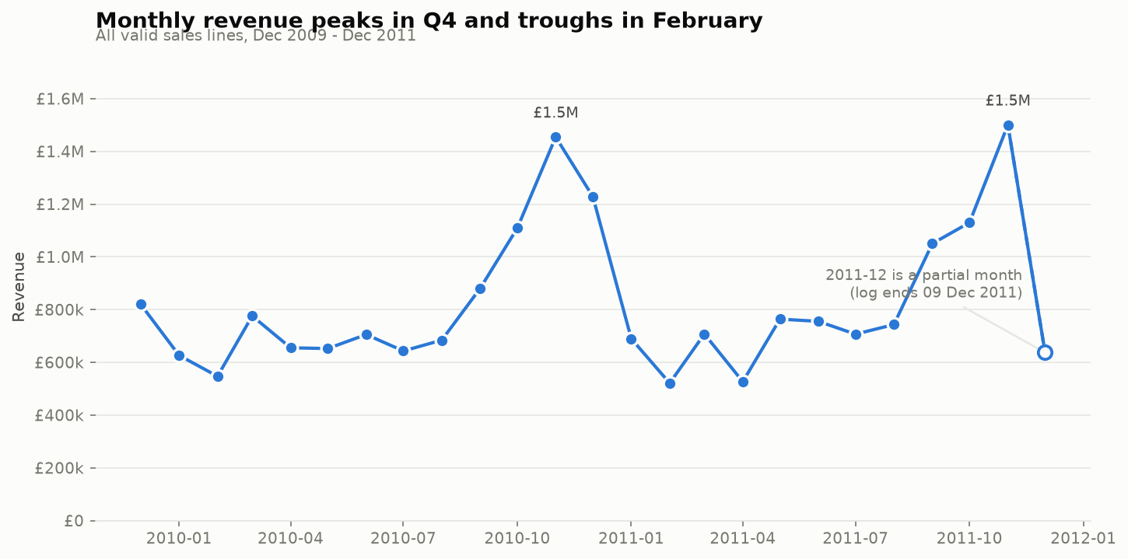
Figure 1. Monthly revenue across the 25-month window, with the September-November peak marked.
Revenue is strongly seasonal. September to November averages £1,187,527 a month against £708,613 for every other month - a 67.6% uplift. The peak month is November 2011 at £1,500,524; the trough is February 2011 at £521,308, which is 34.7% of the peak. Comparing the two like-for-like trading years, revenue grew 8.1%, from £9,555,256 to £10,324,943.
The final month in the file, December 2011, is truncated - the log stops on 9 December 2011 - so its £637,355 is a partial month and is never compared with a full one.

7.2 Where the growth came from
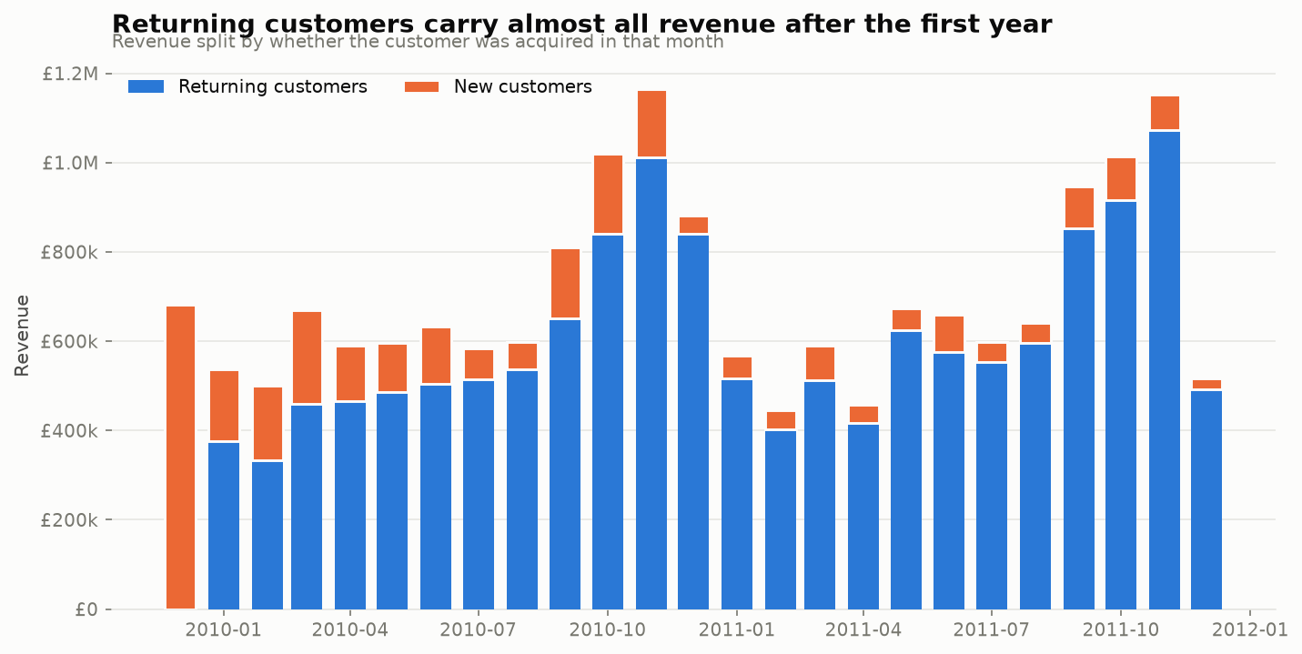
Figure 2. Monthly revenue split by whether the customer had bought before.
Repeat buying dominates the revenue level. In the second year - the twelve full months from December 2010 to November 2011, the truncated final month excluded - 91.3% of identified revenue came from customers who had already ordered in an earlier month; only 8.7% came from customers in their very first month.
That figure is a month-level flag, not a cohort split: a customer counts as returning in every month after the one they first appear in, including later months of the same year they were acquired. Read as "the second year was carried by the customers we already had" it would be wrong, so the same window is also split by acquisition cohort. Customers acquired before the second year began supplied 82.7% of its revenue and customers first acquired during it supplied 17.3%.
The direction of the growth is the opposite of what the first figure suggests. Identified revenue rose from £8,384,041 to £8,627,354 - £243,313, 2.9% - and that net movement is £1,491,334 added by customers acquired during the year, against a £1,248,022 decline in the base that already existed. New acquisition did not top up a growing base; it covered a shrinking one. The existing base is still where the money is - more than four fifths of it - which is what makes the at-risk pool in section 8 expensive, but the case for defending it is that it is leaking, not that it is compounding.

7.3 When orders are processed
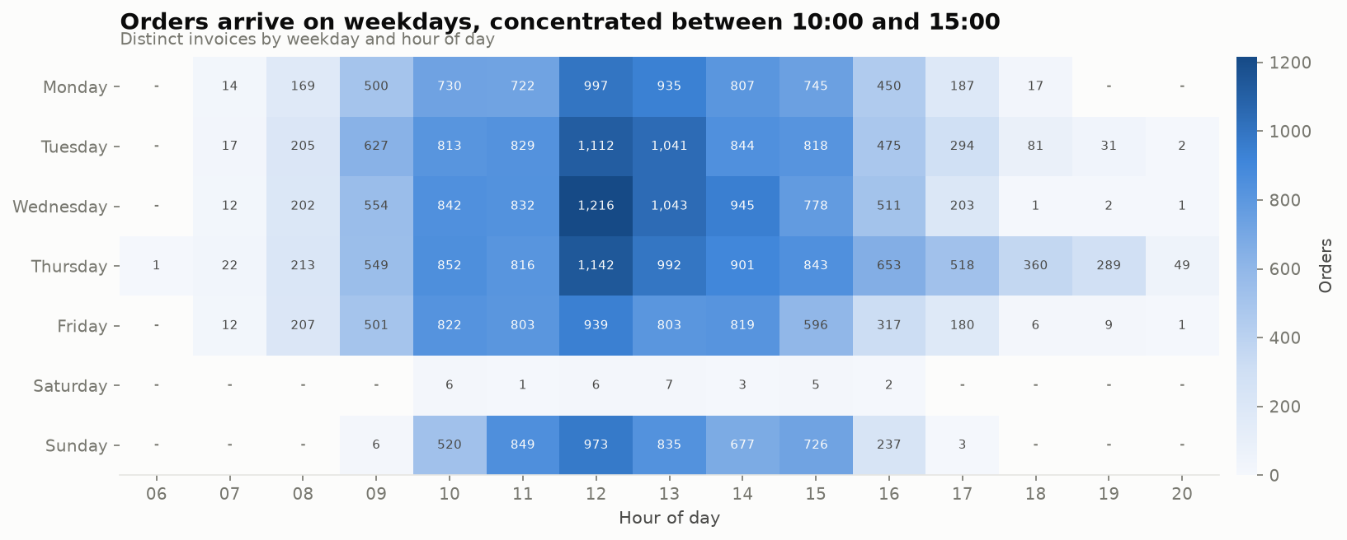
Figure 3. Distinct invoices by weekday and hour. Saturday is effectively empty; Sunday is not.
All 30 Saturday orders in 25 months fall on a single date, 5 December 2009, leaving 104 of the 105 Saturdays in the window at zero - while Sunday processes 4,826 orders at weekday-like volumes. No customer base trades every Sunday and one Saturday in two years.
The conclusion is that InvoiceDate records when staff keyed the order in, not when the customer decided to buy. That makes the column worthless for any “best day to advertise” question and genuinely useful for staffing: 78.1% of all orders are processed between 10:00 and 15:59, peaking at 12:00, and the busiest day is Thursday with 8,200 orders.

7.4 Products
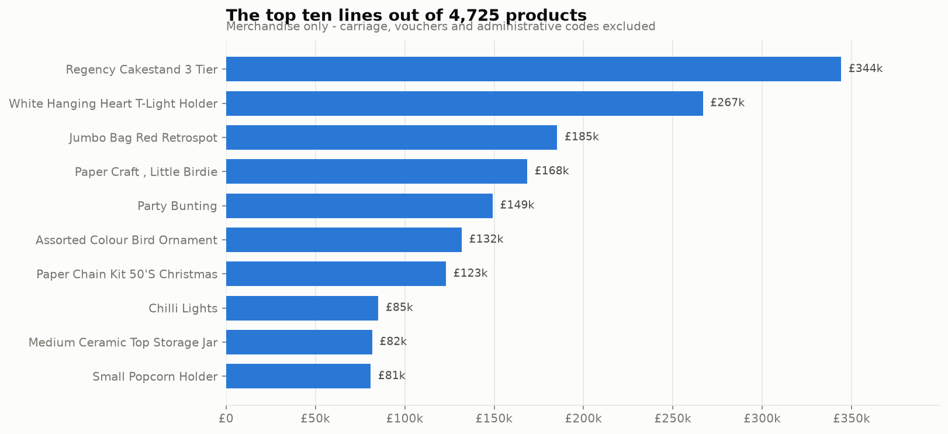
Figure 4. The ten highest-revenue products, net of nothing - see section 7.7 for what changes when returns are netted off.
Table 7. Top ten products by merchandise revenue, out of 4,725 stock codes.
Product | Revenue | Units | Orders | % of revenue
Regency Cakestand 3 Tier | £344,069 | 27,536 | 3,918 | 1.72%
White Hanging Heart T-Light Holder | £266,761 | 96,624 | 5,464 | 1.33%
Jumbo Bag Red Retrospot | £185,248 | 98,594 | 4,013 | 0.92%
Paper Craft , Little Birdie | £168,470 | 80,995 | 1 | 0.84%
Party Bunting | £149,109 | 28,362 | 2,674 | 0.74%
Assorted Colour Bird Ornament | £131,818 | 81,590 | 2,807 | 0.66%
Paper Chain Kit 50'S Christmas | £123,003 | 36,534 | 2,018 | 0.61%
Chilli Lights | £85,158 | 16,763 | 1,135 | 0.42%
Medium Ceramic Top Storage Jar | £81,701 | 78,033 | 247 | 0.41%
Small Popcorn Holder | £80,888 | 89,860 | 2,322 | 0.40%

The best-selling line is Regency Cakestand 3 Tier at £344,069. The ten largest products together are 8.06% of merchandise revenue, which sounds small until it is compared with a uniform expectation: ten products out of 4,725 is 0.21% of the catalogue, so those ten are over-represented by 38.1x.
Products are aggregated on StockCode, not on Description. The 4,725 merchandise codes carry 5,336 distinct descriptions, so the same physical product is spelled more than one way; grouping on the text splits one product's revenue across its spellings and, in this file, moves a genuine top-three line down to fourth place. Every rank in this section and in section 7.7 is therefore a rank among 4,725 codes.
Revenue and volume are also not the same ranking. Only 6 of the top ten products by revenue also appear in the top ten by units sold - the rest are either cheap products sold in enormous quantity or expensive products sold steadily. A buying team optimising on units and a finance team optimising on revenue would pick different winners.

7.5 Geography
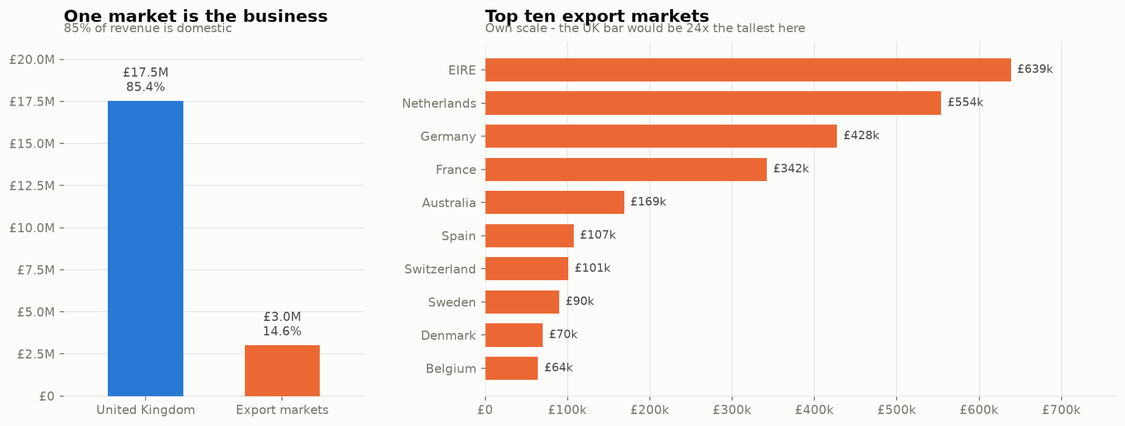
Figure 5. Revenue by country, with the UK share called out.
Table 8. The twelve largest markets by revenue.
Country | Revenue | Orders | Customers | AOV | % of revenue
United Kingdom | £17,514,781 | 36,242 | 5,334 | £483 | 85.36%
EIRE | £638,552 | 585 | 3 | £1,092 | 3.11%
Netherlands | £554,034 | 223 | 22 | £2,484 | 2.70%
Germany | £427,502 | 777 | 107 | £550 | 2.08%
France | £342,177 | 614 | 94 | £557 | 1.67%
Australia | £168,767 | 90 | 15 | £1,875 | 0.82%
Spain | £107,488 | 149 | 38 | £721 | 0.52%
Switzerland | £100,989 | 93 | 22 | £1,086 | 0.49%
Sweden | £90,090 | 103 | 19 | £875 | 0.44%
Denmark | £69,862 | 43 | 12 | £1,625 | 0.34%
Belgium | £64,225 | 148 | 29 | £434 | 0.31%
Portugal | £53,606 | 88 | 23 | £609 | 0.26%

The United Kingdom is 85.36% of revenue (£17,514,781). All 42 other markets together produce £3,002,772, led by EIRE at £638,552. That is a concentration risk stated plainly.
The revenue ranking hides the more interesting number. Netherlands averages £2,484.46 per order against the UK's £483.27 - 5.1x - on a small number of orders. The export business is low-volume and high-value, which is a different business from the domestic one. On a base this small it is a hypothesis worth testing, not a conclusion to act on.

7.6 Order value
Average order value is £517.14 against a median of £303.85 - the mean is 1.70x the median, so a minority of very large baskets is pulling the average away from the typical order. Orders average 25.9 product lines and 11,375,286 units were sold in total, both consistent with wholesale buying rather than consumer shopping.

7.7 Returns and cancellations
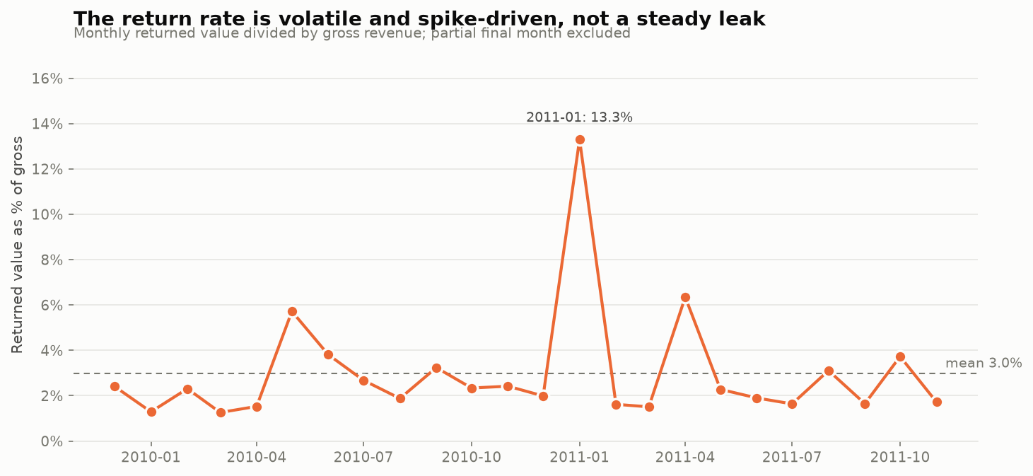
Figure 6. Monthly return rate against the overall average.
Customer returns total £738,952 across 18,467 lines - 3.60% of gross revenue, taking £20.52M down to a net £19.78M. 2,465 customers returned something at least once.
A return rate is a ratio, so both sides of it have to count the same population, and getting that wrong here roughly doubles the answer. The credit notes set aside in cleaning step 3 come to £1,523,788 across 19,432 lines, but £784,837 of that - 965 lines - is administrative rather than a customer sending goods back: MANUAL adjustments, AMAZONFEE, bank charges, discounts, charity lines and samples. Cleaning step 7 removes exactly those stock codes from the revenue base, so counting them in the numerator while the denominator excludes them would divide one population by another. Including them would report 7.43% rather than 3.60%. They are real money and are itemised in the notebook, but they are not returns.
The aggregate rate hides the pattern. The monthly rate averages 3.0% but spikes to 13.30% in January 2011, immediately after the Christmas peak. Returns are a post-seasonal event, so a single annual return-rate assumption under-provisions January and over-provisions the rest of the year.
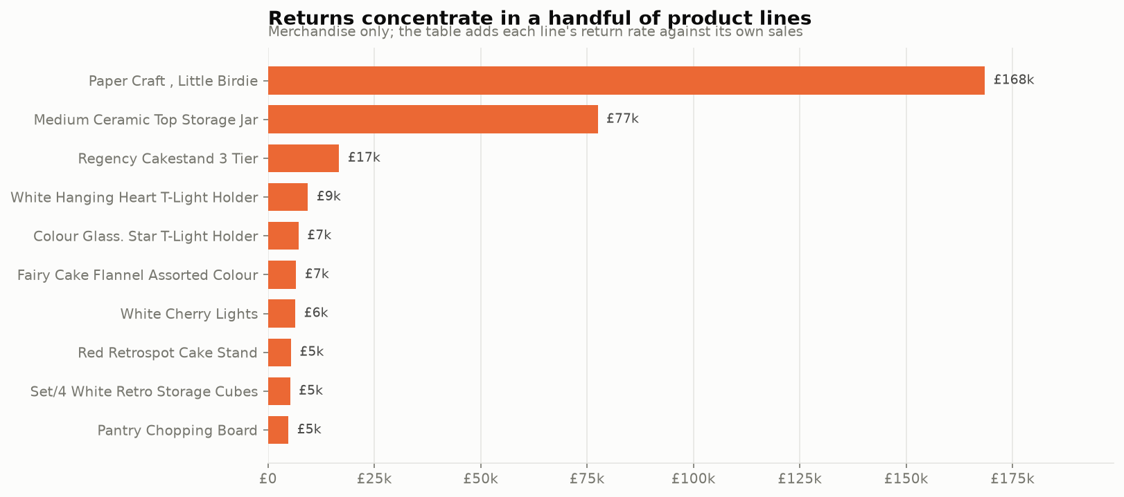
Figure 7. The ten products with the largest returned value, with each product's return rate.
Table 9. Most-returned products by value. A 100% rate on a single line is a cancelled order, not a quality problem.
Product | Returned | Sold | Return rate | Lines
Paper Craft , Little Birdie | £168,470 | £168,470 | 100.0% | 1
Medium Ceramic Top Storage Jar | £77,480 | £81,701 | 94.8% | 10
Regency Cakestand 3 Tier | £16,724 | £344,069 | 4.9% | 346
White Hanging Heart T-Light Holder | £9,390 | £266,761 | 3.5% | 135
Colour Glass. Star T-Light Holder | £7,174 | £46,519 | 15.4% | 70
Fairy Cake Flannel Assorted Colour | £6,614 | £25,859 | 25.6% | 4
White Cherry Lights | £6,421 | £18,049 | 35.6% | 126
Red Retrospot Cake Stand | £5,402 | £66,349 | 8.1% | 159
Set/4 White Retro Storage Cubes | £5,188 | £43,922 | 11.8% | 20
Pantry Chopping Board | £4,803 | £5,868 | 81.8% | 6

Tracing the largest of those lines produces the most consequential single finding in the project. 80,995 units of Paper Craft , Little Birdie, worth £168,469.60, were cancelled 12 minutes after the invoice was raised - net contribution £0.00. The second-largest line in the file is the same story: 74,215 units of Medium Ceramic Top Storage Jar, worth £77,183.60, also cancelled. The two largest sales in the dataset were never sales.
The consequence is not academic. Ranked on gross revenue Paper Craft , Little Birdie is the retailer's 4th best seller; ranked net of cancellations it is 4,711th. Medium Ceramic Top Storage Jar moves from 9th to 1,032nd. 7 of the top ten products change position once returns are netted off. Any product report built on gross sales is materially wrong at the top of the table. The most-returned table above shows the other half of the same event: medium ceramic top storage jar carries £77,479.64 returned against £81,700.92 sold, a 94.8% return rate over 10 lines.

7.8 How concentrated the customer base is
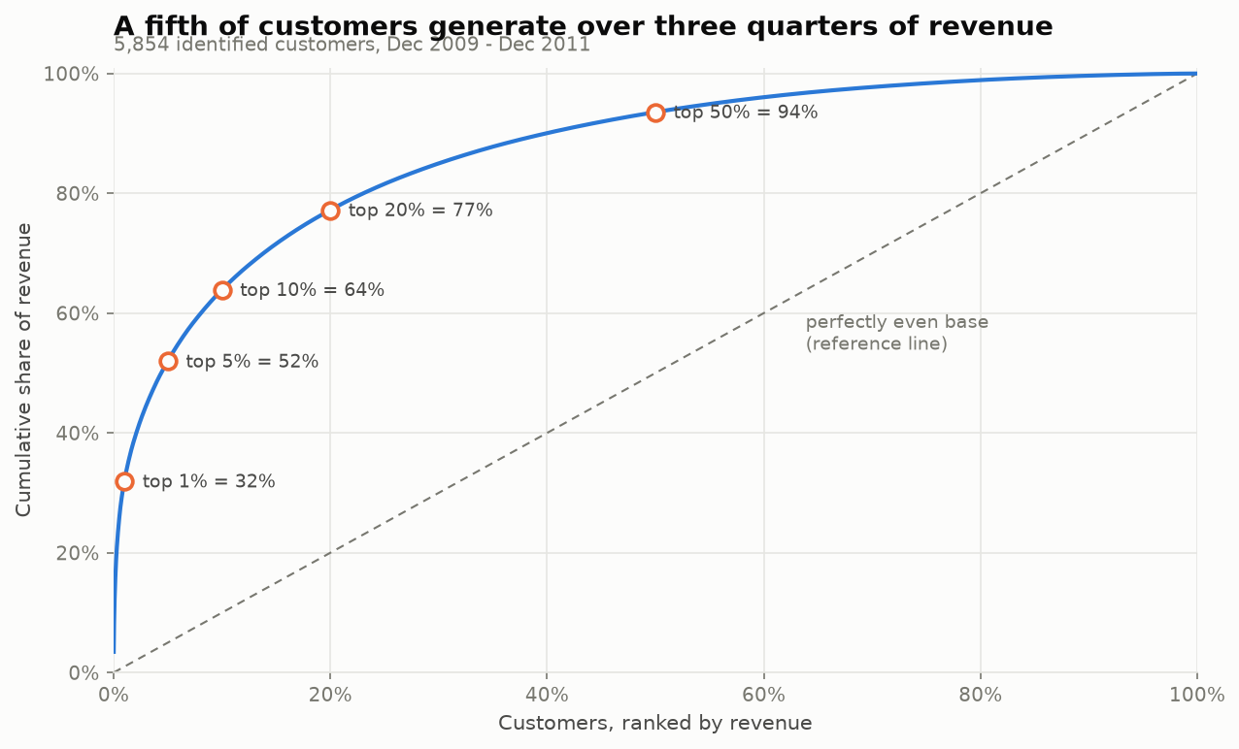
Figure 8. Cumulative share of revenue against cumulative share of customers, ranked by spend.
Table 10. Revenue concentration among identified customers.
Customer group | Customers | Share of identified revenue
Top 1% | 58 | 31.9%
Top 5% | 292 | 52.0%
Top 10% | 585 | 63.9%
Top 20% | 1,170 | 77.2%
Top 50% | 2,927 | 93.6%

1,170 customers produce 77.2% of identified revenue, and 58 produce 31.9%. Both shares are measured against the £17,528,150 carried by identified customers, not the £20,517,554 total - as is every other customer-level share in this report. The distribution behind that is extreme: the median customer is worth £889.31, the mean £2,994.22 (3.4x the median), and the largest single customer £608,821.65.
This is the finding that licenses everything after it. Treating this base uniformly is guaranteed to be wrong, because a uniform plan is calibrated to a customer who does not exist.

8. Customer segmentation - RFM
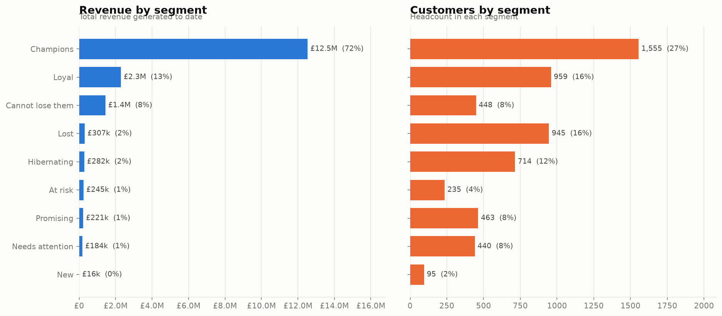
Figure 9. The nine RFM segments: share of customers against share of revenue.
Table 11. The nine RFM segments, ordered by revenue contribution.
Segment | Customers | % of base | Revenue | % of identified revenue | Avg recency (days) | Avg orders | Avg spend
Champions | 1,555 | 26.6% | £12.54M | 71.5% | 20.3 | 14.9 | £8,062
Loyal | 959 | 16.4% | £2.29M | 13.1% | 85.9 | 6.0 | £2,391
Cannot lose them | 448 | 7.7% | £1.45M | 8.2% | 350.9 | 6.7 | £3,226
At risk | 235 | 4.0% | £245k | 1.4% | 385.7 | 3.1 | £1,040
Needs attention | 440 | 7.5% | £184k | 1.1% | 108.5 | 1.6 | £419
Promising | 463 | 7.9% | £221k | 1.3% | 27.0 | 1.9 | £477
New | 95 | 1.6% | £16k | 0.1% | 29.5 | 1.0 | £167
Hibernating | 714 | 12.2% | £282k | 1.6% | 314.6 | 1.5 | £394
Lost | 945 | 16.1% | £307k | 1.8% | 553.6 | 1.3 | £325

1,555 Champions - 26.6% of the base - account for £12,536,030, or 71.5% of all identified revenue. They order roughly 15 times, last bought 20 days before the reference date, and spend £8,062 each.
At the other end, 945 Lost and 714 Hibernating customers - 28.3% of the base between them - contribute 3.4% of identified revenue. They are numerous and nearly worthless, which is exactly why a base-wide campaign wastes most of its budget.
The urgent group is neither. 448 customers in Cannot lose them and 235 in At risk - 683 accounts - have already spent £1,689,620, which is 9.6% of identified revenue, and have stopped ordering. Cannot lose them last bought an average of 351 days ago having ordered 6.7 times and spent £3,226 each: proven buyers who went quiet, not casual browsers who never came back.
The remaining segments matter for pipeline rather than revenue. Promising (463), New (95) and Needs attention (440) hold 2.5% of identified revenue between them - they are where the next cohort of Champions has to come from, and they are cheap to nurture precisely because they are small.

9. Customer segmentation - K-Means

9.1 Choosing k honestly
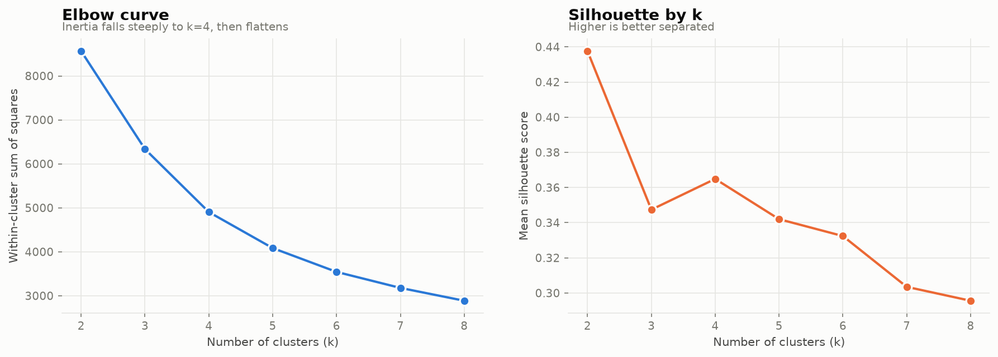
Figure 10. Inertia and silhouette score for k = 2 to 8.
Table 12. Cluster-count scan on log-scaled, standardised RFM features.
k | Inertia | Silhouette
2 | 8,564.8 | 0.4376
3 | 6,335.6 | 0.3474
4 | 4,904.2 | 0.3649
5 | 4,084.8 | 0.3420
6 | 3,543.2 | 0.3324
7 | 3,179.0 | 0.3035
8 | 2,887.0 | 0.2956

The silhouette score is highest at k = 2 (0.4376), and the value adopted here is k = 4 (0.3649). That is a deliberate disagreement with the metric, for a stated reason: two clusters cannot be marketed to differently, so the split would be statistically neater and operationally useless. The elbow in inertia is also around the adopted k. The cost of the choice is reported rather than hidden.

9.2 What the 4 clusters are
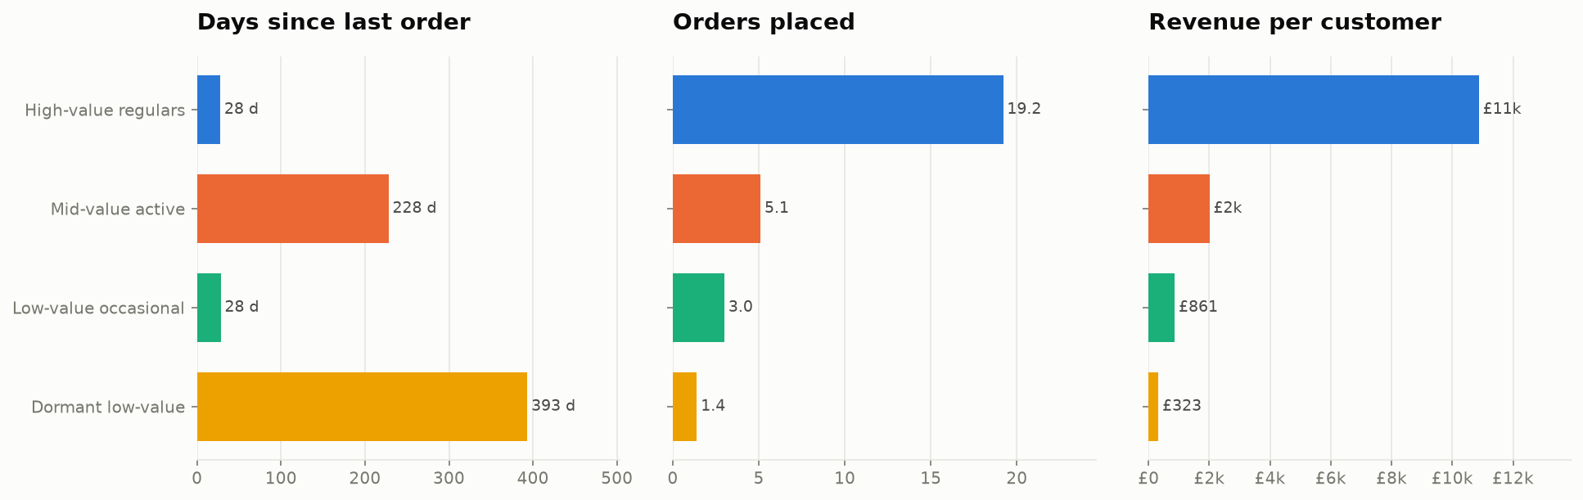
Figure 11. Average recency, frequency and monetary value per cluster, shown as separate panels rather than on one shared axis.
Table 13. Cluster profiles. Labels are assigned from the profile, after fitting.
Cluster | Label | Customers | Avg recency (days) | Avg orders | Avg spend | Revenue | % of identified revenue
0 | Mid-value active | 1,458 | 228.0 | 5.1 | £2,004 | £2.92M | 16.7%
1 | Low-value occasional | 1,247 | 28.2 | 3.0 | £861 | £1.07M | 6.1%
2 | Dormant low-value | 1,963 | 393.3 | 1.4 | £323 | £634k | 3.6%
3 | High-value regulars | 1,186 | 27.7 | 19.2 | £10,875 | £12.90M | 73.6%

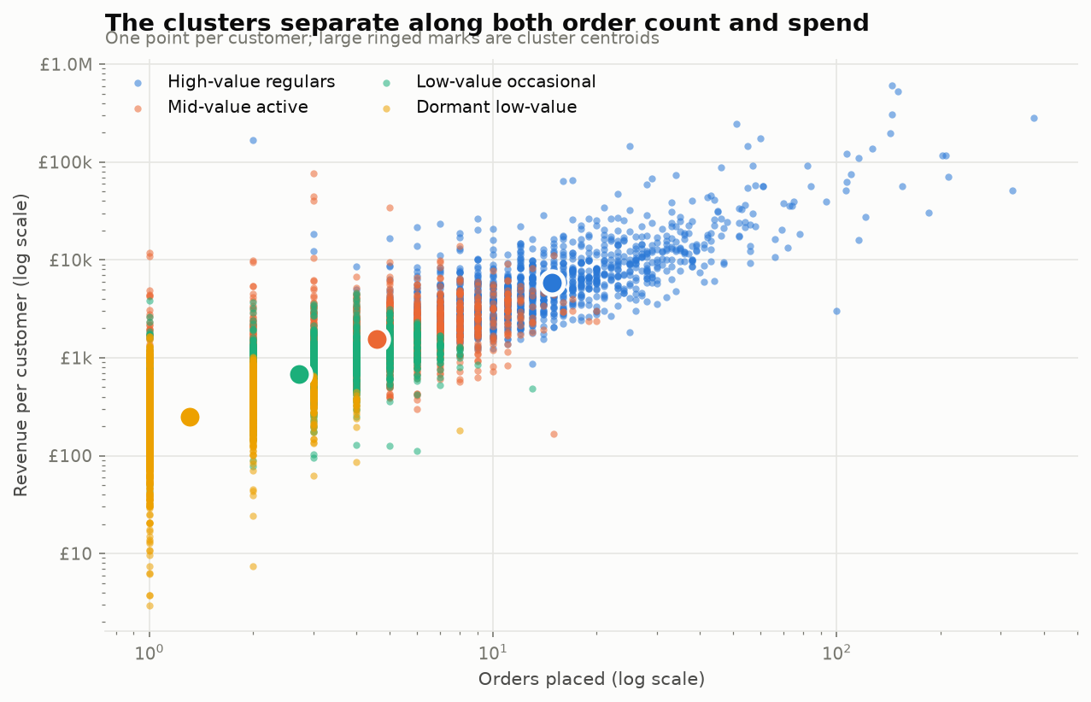
Figure 12. Customers in frequency-monetary space, coloured by cluster, both axes log-scaled.
The clusters separate cleanly on value and activity. 1,186 “High-value regulars” carry 73.6% of identified revenue on an average of 19.2 orders and £10,875 of spend, while the largest cluster by headcount - 1,963 “Dormant low-value” - carries 3.6%. The clustering finds the same imbalance the RFM rules found, from a completely different starting point.

9.3 Do the two methods agree?
This is the point of running both. K-Means was given no rules, no segment names and no thresholds, and every one of the nine rule-based segments sends at least 60% of its members to a single cluster (100% of segments clear that bar). Cannot lose them maps 96.7% onto one cluster and Lost maps 98.4% onto another; the weakest agreement, Loyal, is still 60.9%.
Read carefully, this is agreement between two methods rather than corroboration by two independent bodies of evidence: both read the same three R/F/M features off the same rows, so they cannot disagree about the underlying facts. What they disagree about is where to draw the boundaries - fixed quintile thresholds against distances in a standardised log space - and the fact that 80.5% of customers (4,710 of 5,854) land in their own segment's modal cluster says the group structure survives that change of rule. That is weaker than independent confirmation and still enough for the practical consequence: the transparent, explainable RFM rules can be used to run the business, with the clustering standing behind them as a robustness check.

10. Customer lifetime value
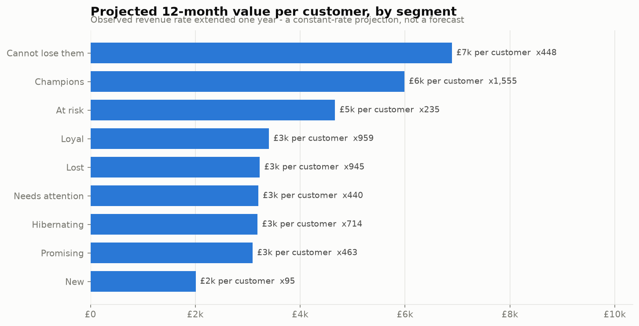
Figure 13. Historical value already realised against projected 12-month value, by segment.
Table 14. Historical and projected value per segment.
Segment | Customers | Historical CLV | Projected 12M | Pool projected | % of pool
Champions | 1,555 | £8,062 | £5,989 | £9.31M | 37.1%
Loyal | 959 | £2,391 | £3,405 | £3.27M | 13.0%
Cannot lose them | 448 | £3,226 | £6,895 | £3.09M | 12.3%
At risk | 235 | £1,041 | £4,665 | £1.10M | 4.4%
Needs attention | 440 | £419 | £3,203 | £1.41M | 5.6%
Promising | 463 | £477 | £3,096 | £1.43M | 5.7%
New | 95 | £167 | £2,007 | £191k | 0.8%
Hibernating | 714 | £394 | £3,188 | £2.28M | 9.1%
Lost | 945 | £325 | £3,230 | £3.05M | 12.1%

Historical CLV - revenue already banked - averages £2,994.22 with a median of £889.31. The 12-month projection averages £4,292.02 per customer and £25,125,493 across the base.

10.1 Testing the projection instead of publishing it
That total is not credible, and the notebook says so with a number. £25,125,493 is 2.91x the £8,627,354 these same identified customers actually produced in the most recent full year. The comparison is deliberately like-for-like: the projection is built on the identified base, so measuring it against the £10,324,943 that includes guest checkouts would credit the model with revenue it never saw and understate the gap to 2.43x. The projection assumes every customer keeps buying at their observed rate for a further twelve months, and it carries no churn probability, so a customer who has not ordered for a year is projected forward exactly as confidently as one who ordered last week.
The failure is visible in the ranking as well as the total. The projection puts Cannot lose them at £6,894.77 per customer, above Champions at £5,988.81 - because a dormant customer who bought heavily in a short window shows a high rate over a short lifespan. That ordering is an artefact of the constant-rate assumption, not a real ranking.
Two conclusions follow, and both are carried into section 13. The projection is reported as an upper bound in aggregate, and for the dormant accounts that inflate it, never as a forecast - for a genuinely accelerating customer the same assumption is conservative, which is why it is not a per-account ceiling. And every prioritisation decision in this report rests on historical value, which is measured, rather than on the projection, which is modelled. The correct fix - a BG/NBD model for purchase frequency with a Gamma-Gamma model for spend - is named in the limitations and is not attempted here.

11. Cohort retention
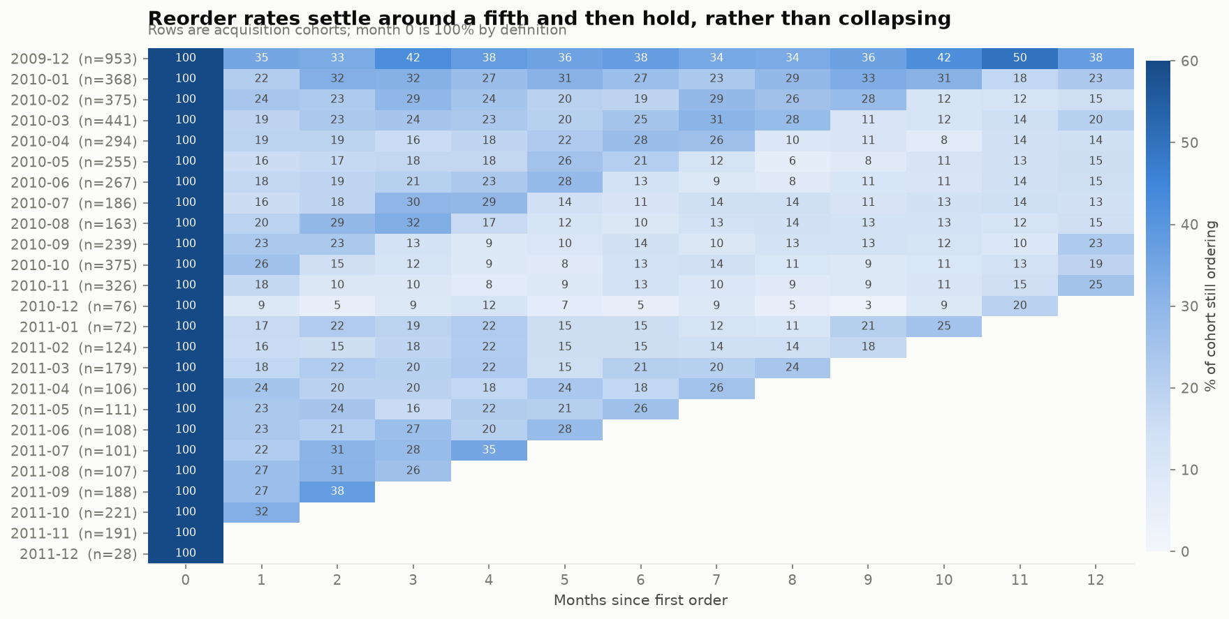
Figure 14. Monthly acquisition cohorts against months since acquisition. Blank cells are not yet observable, or fall in the truncated final month.
Table 15. Cohort size, early retention and lifetime revenue per acquisition month.
Cohort | Customers | Month 1 | Month 3 | Month 6 | Revenue | Revenue per customer
2009-12 | 953 | 34.9% | 42.4% | 37.6% | £8.55M | £8,974
2010-01 | 368 | 21.5% | 31.5% | 26.9% | £1.31M | £3,561
2010-02 | 375 | 24.0% | 29.3% | 19.2% | £999k | £2,664
2010-03 | 441 | 19.0% | 24.3% | 24.7% | £1.31M | £2,981
2010-04 | 294 | 19.4% | 16.0% | 27.6% | £548k | £1,863
2010-05 | 255 | 15.7% | 17.6% | 21.2% | £391k | £1,533
2010-06 | 267 | 17.6% | 20.6% | 12.7% | £600k | £2,247
2010-07 | 186 | 15.6% | 29.6% | 11.3% | £312k | £1,675
2010-08 | 163 | 19.6% | 32.5% | 9.8% | £250k | £1,537
2010-09 | 239 | 23.4% | 13.0% | 13.8% | £598k | £2,502
2010-10 | 375 | 25.9% | 12.5% | 13.1% | £529k | £1,411
2010-11 | 326 | 17.5% | 9.5% | 12.9% | £364k | £1,117
2010-12 | 76 | 9.2% | 9.2% | 5.3% | £75k | £990
2011-01 | 72 | 16.7% | 19.4% | 15.3% | £141k | £1,960
2011-02 | 124 | 16.1% | 18.5% | 15.3% | £136k | £1,099
2011-03 | 179 | 17.9% | 20.1% | 20.7% | £219k | £1,223
2011-04 | 106 | 24.5% | 19.8% | 17.9% | £107k | £1,008
2011-05 | 111 | 23.4% | 16.2% | 26.1% | £283k | £2,546
2011-06 | 108 | 23.1% | 26.9% | — | £139k | £1,288
2011-07 | 101 | 21.8% | 27.7% | — | £94k | £930
2011-08 | 107 | 27.1% | 26.2% | — | £149k | £1,396
2011-09 | 188 | 27.1% | — | — | £156k | £827
2011-10 | 221 | 32.1% | — | — | £144k | £649
2011-11 | 191 | — | — | — | £93k | £489
2011-12 | 28 | — | — | — | £24k | £851

Retention settles at roughly a fifth and then holds: 20.8% at month 1, 21.0% at month 3, 17.3% at month 6 and 18.0% at month 12, excluding the left-censored first cohort. A curve that flattens rather than decaying is the signature of a wholesale reorder cycle: the customers who stay, stay for years.
Two exclusions are applied before those averages are taken, for the same reason the revenue chart drops the final month. 24 cells of the matrix land in December 2011, which holds 9 December 2011 and therefore nine days rather than a month; a nine-day window measures less reordering than a full one for arithmetic reasons alone, so those cells are treated as not comparable and left blank. Cells to the right of each cohort's own history are absent rather than zero.

11.1 Correcting the first cohort
The December 2009 cohort is the largest in the file (953 customers) and it retains far better than any other - because it is not really a cohort. Customers who had been buying before the log opens are recorded as newly acquired in the first month, so an established base is being counted as new. Excluding it moves month-1 retention from 21.4% to 20.8% and month-12 from 19.6% to 18.0%.
The same artefact distorts a conclusion an analyst might otherwise draw. The correlation between cohort size and month-6 retention is +0.668 with the first cohort included and +0.372 without it - so “bigger cohorts retain better” is mostly one censored row doing the work.

11.2 What the Christmas peak actually delivers
Splitting cohorts by acquisition month exposes a sharp difference. Customers acquired in November or December retain at 9.3% by month 3, against 22.3% for customers acquired in any other month - a gap of 2.4x. The season that produces the revenue spike appears to produce the retailer's worst customers, and a target that counts peak-season acquisitions as equivalent new relationships is measuring the wrong thing.
How much weight that carries is a separate question, and the answer is: less than the size of the gap suggests. Section 11.1 excludes the left-censored December 2009 row, and that row is the only other December in the file, so the peak side of this comparison is 2 cohorts - 2010-11, 2010-12 - holding 402 customers between them, 38 of whom ordered again at month 3 - against 18 off-peak cohorts. Every peak customer in it was acquired in a single trading season, so nothing here separates this Christmas from Christmas in general.
There is also a calendar confound. Month 3 for those cohorts falls in 2011-02, 2011-03 - the trough identified in section 7.1, where monthly revenue is 34.7% of the peak. A cohort acquired in November is being asked to reorder in the retailer's quietest weeks, while a cohort acquired in June is asked to reorder in September. Part of the gap is therefore weak seasonal demand rather than weak customers, and this dataset cannot separate the two. The finding is a lead worth testing on the next season, which is how recommendation 5 is written; it is not an established seasonal law.

12. Key findings
Every figure below is computed in the notebook and stored in outputs/facts.json. Nothing here is estimated or rounded from memory.

Finding 1. Revenue is extremely concentrated, so segmentation is justified before it is built
1,170 customers (20%) generate 77.2% of identified revenue. The top 58 customers (1%) generate 31.9%. The median customer is worth £889 and the mean £2,994 - 3.4x - so “the average customer” is a fiction. Order value tells the same story: a £517.14 mean against a £303.85 median.
Uniform treatment of this base is guaranteed to be wrong, because it is calibrated to a customer who does not exist.

Finding 2. One segment holds most of the revenue, and a different one holds the risk
Champions - 1,555 customers, 26.6% of the base - account for £12.54M, or 71.5% of identified revenue. At the other end, 945 Lost and 714 Hibernating customers (28.3% of the base) contribute 3.4% between them.
The urgent group is neither: 683 customers in Cannot lose them and At risk have already spent £1,689,620 (9.6% of identified revenue) and have stopped ordering. These are proven buyers who went quiet - the only group where an intervention has a large, identified prize attached.

Finding 3. The two largest sales in the dataset were never sales
The single biggest line in 1,067,371 rows - 80,995 units of Paper Craft , Little Birdie, £168,469.60 - was cancelled 12 minutes after it was raised, on the final day of the log. Net contribution: £0.00. The second-biggest line - 74,215 units of Medium Ceramic Top Storage Jar, £77,183.60 - was cancelled too. Neither of the two largest sales in the dataset was a sale.
Ranked on gross revenue Paper Craft , Little Birdie is the retailer's 4th best seller. Ranked net of cancellations it is 4,711th; Medium Ceramic Top Storage Jar falls from 9th to 1,032nd. 7 of the top ten products change position once returns are netted off. Any product report built on gross sales - the default in most published work on this dataset - is materially wrong at the top of the table.

Finding 4. Returns cost £0.74M, and the aggregate rate hides the problem
Returns total £738,952 across 18,467 lines - 3.60% of gross revenue, taking £20.52M down to a net £19.78M. The monthly rate averages 3.0% but is not stable: it spikes to 13.30% in January 2011, immediately after the Christmas peak.
Returns are a post-seasonal event, not a constant leak, so a single annual return-rate assumption will under-provision January and over-provision the rest of the year.

Finding 5. The business is one country and one quarter
The UK is 85.36% of revenue (£17.51M); all 42 other markets together make £3.00M. September to November averages £1.19M per month against £708,613 for every other month - a 67.6% seasonal uplift, peaking at £1.50M in November 2011 against a £521,308 trough in February 2011.
Both concentrations are risks, but the export data also holds an opportunity the revenue ranking hides: Netherlands averages £2,484.46 per order against the UK's £483.27 - 5.1x - on a small number of orders. The export markets are low-volume and high-value, which is a different business from the domestic one.

Finding 6. The existing base carries the revenue but shrank; new customers covered the gap
On all revenue, like-for-like years grew 8.1% (£9.56M to £10.32M). Underneath that, two questions get confused, so both are answered on the identified base. Repeat buying dominates the level: in the second year 91.3% of identified revenue came from customers who had already ordered in an earlier month, and only 8.7% from customers in their first month.
Acquisition, not retention, produced the growth. Split by acquisition cohort, identified revenue went from £8,384,041 to £8,627,354 - a rise of just £243,313 (2.9%) - made up of £1,491,334 from customers first acquired during year 2, against a £1,248,022 decline in the year-1 base. Customers acquired before year 2 still supplied 82.7% of its revenue, but less of it than the year before.
So the existing base is where the money is, and it is leaking. That is a stronger reason to act on finding 2's at-risk pool than "growth came from retention" would have been: the decline is already in the totals.

Finding 7. Christmas buys volume, not loyalty
Retention settles at roughly a fifth and then holds: 20.8% at month 1, 21.0% at month 3, 17.3% at month 6, 18.0% at month 12 (excluding the left-censored first cohort). The curve flattens rather than decaying, which is the signature of a wholesale reorder cycle rather than one-off consumer buying.
Splitting cohorts by acquisition month exposes a sharp difference: customers acquired in November or December retain at 9.3% by month 3, against 22.3% for customers acquired in any other month - less than half. The peak season that produces the revenue spike appears to produce the retailer's worst customers.
How thin this one is. Excluding the left-censored December 2009 row also excludes the only other December in the file, so the peak side is 2 cohorts (2010-11, 2010-12), 402 customers, 38 of whom reordered at month 3 - against 18 off-peak cohorts, and all from one Christmas. Their month 3 falls in 2011-02, 2011-03, the calendar trough, so weak seasonal demand and weak customers are confounded. It is a hypothesis worth a controlled test, not an established seasonal law.

Finding 8. The rules and the algorithm agree, which is the point of running both
K-Means on log-scaled RFM was given no rules, and every one of the nine rule-based segments sends at least 60% of its members to a single cluster. Cannot lose them maps 96.7% onto one cluster and Lost maps 98.4% onto another; the weakest is Loyal at 60.9%. At customer level 80.5% of accounts (4,710) sit in their own segment's modal cluster.
What that does and does not prove: the two methods are not independent evidence in the strong sense, because both read the same three R/F/M features off the same rows. What differs is how the boundaries are drawn - fixed quintile thresholds against distances in a standardised space - so the agreement shows the structure does not depend on the thresholds chosen, which is the specific thing worth knowing about a hand-built segmentation.
The honest caveat: the silhouette score preferred k = 2 (0.4376) over the k = 4 (0.3649) adopted here. Two clusters cannot be marketed to differently, so interpretability was chosen over the metric, and the cost is stated rather than hidden.

Finding 9. Two data artefacts that would have produced wrong answers
InvoiceDate is not customer intent. All 30 Saturday orders in 25 months fall on one date, 5 December 2009 (0.076% of orders), while Sunday processes 4,826 orders at weekday-like volumes. No customer base trades every Sunday and one Saturday in two years. The timestamp records back-office keying, which makes it valid for staffing (78.1% of orders are processed between 10:00 and 15:59, peaking at 12:00) and worthless for deciding when to advertise.
Cancellations are not the only reversal. 6 A-prefixed invoices carry £-147,614 of bad-debt write-offs. The standard “drop invoices starting with C” recipe leaves all of it in the revenue line.

13. Recommendations
Each recommendation names the finding it rests on and the number that sizes it. Where the data cannot support a decision, that is stated instead of guessed.

Recommendation 1. Run a win-back on the 683 quiet high-value accounts - and measure it properly
From finding 2. These customers have already spent £1,689,620 and have stopped ordering. Prioritise by historical value, not by the projected figure: section 10.1 shows the projection ranks this group above Champions, which is an artefact of the constant-rate assumption rather than a real ordering.
Because these are wholesale accounts, the intervention is a phone call from a named account manager, not a discount email - and a discount is the wrong lever anyway, since nothing in this dataset says price caused them to leave.
Hold back a random 20% as an untreated control group. Without one, any subsequent recovery is indistinguishable from customers who would have reordered regardless - and given the flat 18.0% month-12 reorder rate in finding 7, a meaningful fraction would have.

Recommendation 2. Protect the 1,555 Champions before chasing anyone new
From findings 2 and 6. Champions produce 71.5% of identified revenue, and 82.7% of second-year revenue came from customers acquired before that year began. The concentration cuts both ways: losing 58 customers (the top 1%) would remove 31.9% of identified revenue.
Concretely: guaranteed stock availability on their repeat lines through the September-November peak, and a named contact. The defensive case is not that the existing base is growing - finding 6 shows it fell by £1,248,022 in year 2 - it is that the base still carries more than four fifths of the revenue while it declines. Retention work here defends a larger number than acquisition work adds, and the at-risk pool in finding 2 is where that decline is already visible.

Recommendation 3. Stop reporting product performance on gross revenue
From finding 3. 7 of the top ten products change rank once cancellations are netted off, and the gross-rank-4 product is genuinely 4,711th. Every product report should net cancellations against the original sale.
This is a reporting fix, not a strategy: it costs nothing, and it stops the buying team restocking a line that sold nothing.

Recommendation 4. Treat January as a returns event, and investigate the top returned lines
From finding 4. The return rate hits 13.30% in January 2011 against a 3.0% average. Two actions follow: provision warehouse and refund capacity for a post-Christmas spike rather than an even monthly rate, and inspect the concentrated returned lines in section 7.7 for a cause.
The data shows which products come back but never why, so the second action is a question to take to the warehouse, not one to answer from the file.

Recommendation 5. Change what the Christmas peak is expected to deliver
From finding 7. Customers acquired in November and December retain at 9.3% by month 3 versus 22.3% otherwise - on 2 peak cohorts totalling 402 customers from a single Christmas, whose month 3 falls in the calendar trough.
That evidence supports a test, not a reallocation of budget. Tag peak-acquired customers on arrival and measure their month-3 reorder rate against an off-peak control over the coming season; if the gap survives a second Christmas with the seasonal effect controlled for, then move acquisition spend out of the peak.
The half of this that is safe now costs nothing: stop counting peak-acquired customers as new relationships in any target that assumes they behave like the rest of the base, and run the peak as a volume and cash-generation event.

Recommendation 6. Test the export markets deliberately
From finding 5. Netherlands averages £2,484.46 per order - 5.1x the UK's £483.27. That is a striking ratio on a small base, and a small base is exactly why it must be tested rather than acted on: with £3.00M of export revenue against £17.51M domestic, a handful of large wholesale accounts could produce the entire effect.
The recommendation is a bounded test on the highest-AOV markets with a defined budget, not a market-entry decision. The data supports the hypothesis; it does not support the investment.

Recommendation 7. Fix the 14.6% attribution gap at source
From the limitations. £2,989,403 of clean revenue - 14.6% of the total, spread over 22.9% of all sales lines - has no customer ID, so it is invisible to every model here. No amount of analysis recovers it: it is a checkout-and-CRM change, and it raises the ceiling on all future customer work.

What this analysis does not support
- Any pricing or product-mix decision. The dataset has no cost of goods, so every figure here is revenue, not margin.
- Any claim that a campaign causes a customer to return. There is no campaign data and no experiment in this file. That is why recommendation 1 specifies a control group.
- Any conclusion about when customers prefer to shop - see finding 9.
- Using the 12-month CLV projection as a forecast. It sums to 2.91x actual second-year revenue (section 10.1). Summed across the base it is an upper bound, nothing more; for one accelerating account it can equally be too low.

14. Limitations
Stating what this analysis cannot support is part of the analysis.
1. Attribution gap. 22.9% of clean sales lines (235,813), carrying 14.6% of clean revenue (£2,989,403), have no customer ID - both shares measured on the same cleaned base. Every customer-level result is computed on the identified 85.4% of revenue only. If guest orders are disproportionately one-off purchases, the true repeat rate is lower than reported here; if they are unrecognised repeat buyers, several segments are undercounted. The data cannot distinguish the two cases.
2. Revenue, not profit. The dataset has no cost of goods. A low-margin bestseller and a high-margin niche line are indistinguishable in this analysis, so no pricing or product-mix decision should rest on it alone.
3. The CLV projection is demonstrably biased upward, and section 10.1 shows by how much. Summed across the base it is 2.91x actual second-year revenue, and it ranks a dormant segment above Champions. It carries no churn probability, so it should be read as an aggregate upper bound - the constant-rate assumption is optimistic for a dormant account and conservative for an accelerating one, so it is not a ceiling on any single customer. BG/NBD plus a Gamma-Gamma spend model is the correct fix and is not done here; prioritisation in section 13 therefore rests on historical value.
4. Censoring at both ends of the cohort matrix. Cohorts acquired late in the window have not had time to show a retention curve, so blank cells on the right mean not yet observable, not zero. At the other end, the first cohort is left-censored: customers who predate the log appear as newly acquired in December 2009. Section 11.1 quantifies that bias and reports corrected figures.
5. InvoiceDate records processing, not intent. All 30 Saturday orders in the 25-month window fall on one date, so the timestamp reflects back-office keying rather than customer behaviour. No conclusion about when customers want to shop can be drawn from the hour and weekday columns.
6. Quintile scoring is relative. An RFM score of 5 means “top fifth of this base”, not “good” in absolute terms. Scores are not comparable across a different customer base or a different time window.
7. k = 4 is a judgement call. The silhouette metric preferred k = 2. Four clusters were chosen for operational interpretability, and the metric cost of that choice is reported in section 9.1 rather than hidden.
8. One retailer, one category, 2009-2011. A UK giftware wholesaler in the post-financial-crisis period. The method transfers; these coefficients do not.
9. Segments are descriptive, not causal. Nothing here establishes that a campaign causes a customer to return. A holdout test would be needed to claim that, and this dataset contains no campaign data.
10. The Christmas retention gap rests on one season. Excluding the left-censored December 2009 row also removes the only other December in the file, so the peak side of the 9.3%-versus-22.3% comparison is 2 cohorts (2010-11, 2010-12), 402 customers, 38 of whom reordered at month 3. Their month 3 falls in 2011-02, 2011-03, the February-March trough, so seasonal demand and customer quality are confounded and this data cannot separate them. Finding 7 is a hypothesis to test; recommendation 5 is written as a test rather than a decision.
11. The return rate depends on which credit notes count as returns. The 3.60% figure counts customer returns of products and carriage only, so that its numerator and the gross-revenue denominator describe the same population. Including the administrative reversals - manual adjustments, Amazon fees, bank charges, discounts, samples - would give 7.43% on £1,523,788, but those stock codes are removed from the revenue base by cleaning step 7 and are not customers sending goods back. Both numbers appear in section 7.7; neither is the single true rate without saying which question is being asked.

15. Conclusion
The project set out to turn a flat transaction log into a picture of a customer base, and the picture is sharper than the aggregate figures suggest. £20,517,554 of revenue and 5,854 identified customers resolve into a business that depends on a few hundred accounts: 1,170 customers carry 77.2% of identified revenue, 1,555 Champions carry 71.5%, and 82.7% of second-year revenue came from customers who were already there - a base that nonetheless spent £1,248,022 less than it had the year before.
That structure was recovered twice: by an explicit RFM rule ladder and by an unsupervised K-Means clustering that was given no rules at all. The two are not independent in the strong sense - both read the same three features off the same rows - but they draw their boundaries in completely different ways, so their agreement (80.5% of customers in their own segment's modal cluster, every segment above 60%) is good evidence that the segmentation follows the data rather than the thresholds the analyst picked.
The most useful output is not the segmentation itself but the list it produces: 683 named accounts, worth £1,689,620 of proven historical spend, that have stopped ordering. That is a finite, addressable list rather than a strategy slide, and it comes with a measurement design attached - a 20% untreated control group - because without one the result would be unreadable.
Three of the results in this report contradict what a first pass at this dataset would have produced. The largest sale in the file was a cancellation, so gross product rankings are wrong at the top. The Christmas peak generates the retailer's worst-retaining customers, so peak acquisition should not be counted like any other. And the invoice timestamp records office hours rather than customer behaviour, so an entire class of “when to advertise” conclusions is unavailable. Each was found by checking a claim against the data rather than accepting a plausible number - which, more than any individual figure here, is what the project was for.

16. How to reproduce this project
From a clone of the repository. The analysis was developed and run on Python 3.14.6 under Windows 11; the bounds in requirements.txt are the oldest releases whose APIs the code uses, but no other version was exercised:
- python -m venv .venv and activate it, then pip install -r requirements.txt
- jupyter notebook AryanVerma_RetailCustomerSegmentationAnalysis.ipynb
- Kernel > Restart Kernel and Run All Cells. The first run downloads the 45.6 MB source workbook from UCI into data/raw/ and caches both sheets as a CSV; later runs read the cache. Measured on the development machine, the first run takes 1 min 28 s and later runs 33 s, excluding the download - UCI's throughput varies from about 30 seconds to several minutes.
- python tools/build_report.py regenerates this document from the notebook's outputs.
The notebook writes 14 PNG figures to outputs/figures/ and every computed number to outputs/facts.json (236 facts plus the segment, cluster, cohort and product tables). This report reads only those two locations, so the document and the analysis cannot disagree.
The source workbook is never modified, and it is not committed to the repository: it is a large binary that the notebook can fetch reproducibly from the publisher.

17. References
- Chen, D. (2019). Online Retail II [Data set]. UCI Machine Learning Repository. https://archive.ics.uci.edu/dataset/502/online+retail+ii (CC BY 4.0).
- Hughes, A. M. (1994). Strategic Database Marketing. Probus Publishing - the origin of RFM scoring.
- Fader, P. S., Hardie, B. G. S., & Lee, K. L. (2005). “RFM and CLV: Using iso-value curves for customer base analysis.” Journal of Marketing Research, 42(4), 415-430.
- Rousseeuw, P. J. (1987). “Silhouettes: a graphical aid to the interpretation and validation of cluster analysis.” Journal of Computational and Applied Mathematics, 20, 53-65.
- Pedregosa, F. et al. (2011). “Scikit-learn: Machine learning in Python.” Journal of Machine Learning Research, 12, 2825-2830.
- Project repository: https://github.com/BU1lDR/IBM-BharatCares---Internship-CAPSTONE-PROJECT-

