大学英语A1\B1模拟卷

出卷时间：2021年1月

参考试卷：2020秋考试卷

**出卷人 limelight**

1. 听力（注意：正式卷中所有提示语将全部以英文形式给出，如果你甚至连提示语都看不懂，那么别想及格了）
2. 了



SectionD

三个讲座，每个讲座读两遍

***Lecture 1: Philosophy***

1. What is the main purpose of the lecture?
2. To illustrate the importance of extrinsic values
3. To explain Aristotle’s views about the importance of teaching
4. To explain why people change what they value
5. To discuss Aristotle’s views about human happiness
6. Why is happiness central to Aristotle’s theory?
7. Because it is so difficult for people to attain
8. Because it is valued for its own sake by all the people
9. Because it is a means to a productive life
10. Because most people agree about what happiness is
11. According to the professor, why does Aristotle think that fame cannot provide true happiness?
12. Fame cannot be obtained without help from other people
13. Fame cannot be obtained by all people
14. Fame does not last forever
15. People cannot share their fame with other people

***Lecture 2: Astronomy***

1. What is Bode’s law?
2. A law of gravitation
3. An estimate of the distance between Mars and Jupiter
4. A prediction of how many asteroids there are
5. A pattern in the spacing of planets
6. Why does the professor explain Bode’s Law to the class?
7. To describe the size of the asteroids
8. To explain how the asteroids belt was discovered
9. To explain how gravitational forces influence the planets
10. To describe the impact of telescope on astronomy
11. How does the professor introduce Bode’s Law?
12. By demonstrating how it is derived mathematically
13. By describing the discovery of Uranus
14. By drawing attention to the inaccuracy of a certain pattern
15. By telling the names of several of the asteroids

***Lecture 4: Botany***

1. What aspect of Manila hemp fibers does the professor mainly describe in the lecture?
2. Similarities between cotton fibers and Manila hemp fibers
3. Various types of Manila hemp fibers
4. The economic importance of Minila hemp fibers
5. A use of Manila hemp fibers
6. What does the professor imply about the name “Manila hemp?”
7. It is a commercial brand name
8. Part of the name is inappropriate
9. The name has recently changed
10. The name was first used in the 1940s
11. Why does the professor mention the Golden Gate Bridge?
12. To demonstrate a disadvantage of steel cables
13. To give an example of the creative use of color
14. To show the steel cables are able to resist salt water
15. To give an example of a use of Manila hemp
16. According to the professor, what was the main reason that many ships used Manila hemp ropes instead of steel cables?
17. Manila hemp was cheaper
18. Manila hemp was easier to produce
19. Manila hemp is more resistant to salt water
20. Manila hemp is lighter in weight

二、词汇考查

（1）词语替换（注：此题难度大大低于实际考试难度，仅作为题型参考）

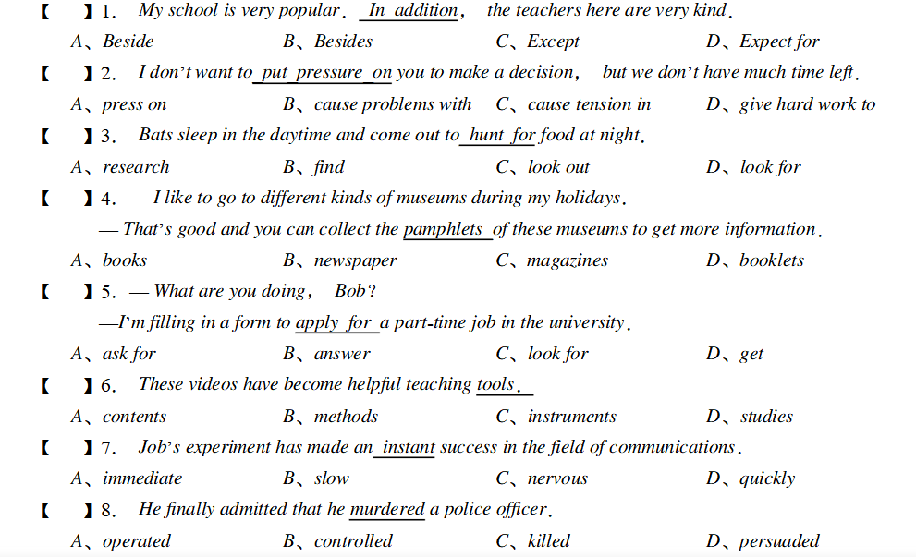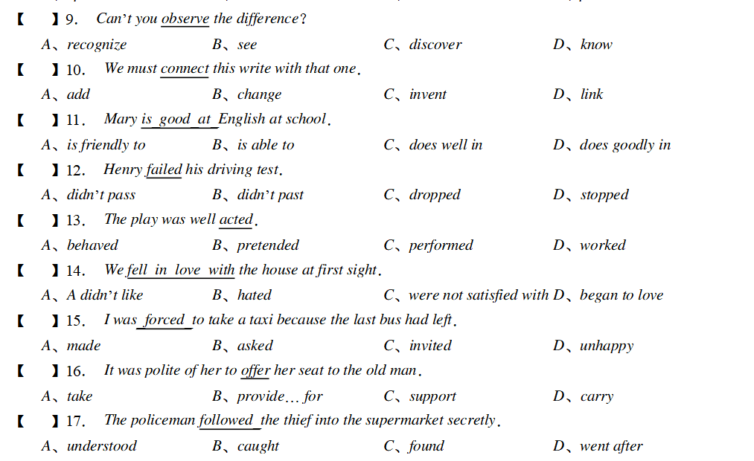

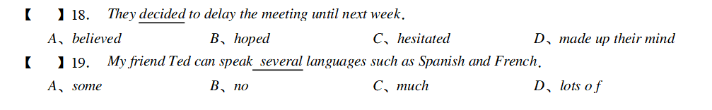4

（2）词语填空

1. The French pianist who had been praised very highly ________________ to be a great disappointment.
2. turned up B. turned in C. turned out D. turned down

57. The girl was________ a shop assistant; sho is now a manager in a large department store.

A. preliminary B. presumably C. formally D. formerly

58. The film Titanic tells about a very _______ love story which touches every spectator.

A. romantic B. ridiculous C. unpractical D. absurd

59. The man to whom we handed the forms pointed out that they had not been_________ filled in.

A. consequently B. regularly C. comprehensively D. properly

60. The government ___________ regulations that put this archeological site

under protection.

1. published B. issued C. discharged D. released
2. I would have gone to visit him in the hospital had it been at all possible, but I ______________________ fully occupied the whole of last week.
3. were B. had been C. have been D. was
4. The carnival, which will_________ the streets of London____________more than 1. 5 million people this weekend, was started in 1959 as a direct response to the riots.
5. crowd; of B. pour; for C. fill; with D), emerge; in
6. No one would have time to read or listen to an account of everything___________ going on in the world.
7. it is B. as is C. there is D)what is
8. The professor could hardly find sufficient grounds _______________________ his arguments in favor of the new theory.
9. on which to base B. which to base on C. to base on D, to be based on
10. It takes a _ time for me to prepare for the dinner, but the results are so good that it’ s worth the_______ .

A. short; force B. long; effort C. many; labor D. much; pains





1. 阅读

**Doctoring Sales**

Pharmaceuticals is one of the most profitable industries in North America. But do the drugs industry’s sales and marketing strategies go too far?

1. A few months ago Kim Schaefer, sales representative of a major global pharmaceutical company, walked into a medical center in New York to bring information and free samples of her company’s latest products. That day she was lucky --- a doctor was available to see her. ‘The last rep offered me a trip to Florida. What do you have?’ the physician asked. He was only half joking.

2. What was on offer that day was a pair of tickets for a New York musical. But on any given day, what Schaefer can offer is typical for today’s drugs rep--- a car trunk full of promotional gifts and gadgets, a *budget* that could buy lunches and dinners for a small country, hundreds of free drug samples and the freedom to give a physician $200 to prescribe her new product to the next six patients who fit the drug’s profile. And she also has a few $ 1,000 honoraria to offer in exchange for doctors’ attendance at her company’s next educational lecture.

3. Selling pharmaceuticals is a daily exercise in ethical judgment. Salespeople like Schaefer walk the line between the common practice of buying a prospect’s time with a free meal, and bribing doctors to prescribe their drugs. They work in an industry highly criticized for its sales and marketing practices, but find themselves in the middle of the age-old-chicken-or-egg question---businesses won’t use strategies that don’t work, so are doctors to blame for the escalating extravagance of pharmaceutical marketing? Or is it the industry’s responsibility to decide the boundaries?

4. The explosion in the sheer number of salespeople in the field --- and the amount of funding used to promote their causes --- forces close examination of the pressures, influences and relationships between drug reps and doctors. Salespeople provide much-needed information and education to physicians. In many cases the glossy brochures, article reprints and prescriptions they deliver are primary sources of drug education for healthcare givers. With the huge investment the industry has placed in face-to-face selling, salespeople have essentially become specialists in one drug or group of drugs--- a tremendous advantage in getting the attention of busy doctors in need of quick information.

5. But the sales push rarely stops in the office. The flashy brochures and pamphlets left by the sales reps are often followed up with meals at expensive restaurants, meeting in warm and sunny places, and an inundation of promotional gadgets. Rarely do patients watch a doctor write with a pen that isn’t emblazoned with a drug’s name, or see a nurse use a tablet not bearing a pharmaceutical company’s logo. Millions of dollars are spent by pharmaceutical companies on promotional products like coffee mugs, shirts, umbrellas, and golf balls. Money well spent? It’s hard to tell. ‘I’ve been the recipient of golf balls from one company and I use them, but it doesn’t make me prescribe their medicine,’ says one doctor. ‘I tend to think I’m not influenced by what they give me.’

6. Free samples of new and expensive drugs might be the single most effective way of getting doctors and patients to become loyal to a product. Salespeople hand out hundreds of dollars’ worth of samples each week --- 7.2 billion worth of them in one year. Though few comprehensive studies have been conducted, one by the University of Washington investigated how drug sample availability affected what physicians prescribe. A total of 131 doctors self-reported their prescribing patterns---the conclusion was that the availability of samples led them to dispense and prescribe drugs that differed from their preferred drug choice.

7. The bottom line is that pharmaceutical companies as a whole invest more in marketing than they do in research and development. And patients are the ones who pay--- in the form of sky-rocketing prescription prices --- for every pen that’s handed out, every free theatre ticket, and every steak dinner eaten. In the end the fact remains that pharmaceutical companies have every right to make a profit and will continue to find new ways to increase sales. But as the medical world continues to grapple with what’s acceptable and what’s not, it is clear that companies must continue to be heavily scrutinized for their sales and marketing strategies.

**Questions:**

1. **Do the following statements agree with the views of the writer in the passage? Write**

Yes if the statement agrees with the views of the writer

No if the statement disagrees with the views of the writer

Not Given if it is impossible to say what the writer thinks about this

1. Sales representatives like Kin Schaefer work to a very limited budget.
2. Kim Schaefer’s marketing techniques may be open to criticism on moral grounds.
3. The information provided by drug companies is of little use to doctors.
4. Evidence of drug promotion is clearly visible in the healthcare environment
5. The drug companies may give free drug samples to patients without doctors’ prescriptions.

**II. Detailed understanding of the passage**

**Paragraph 1:**

1. What purpose does paragraph 1 plays in the introductory part of the passage?

○To argue that sales reps are having a difficult time.

○To argue that sales reps have to bribe the doctors.

○To introduce the topic of pharmaceutical sales and marketing strategies by an example of a sales rep.

○To introduce the topic of effectiveness of pharmaceutical sales and marketing strategies.

**Paragraph 2:**

2. The word budget in the passage is closest in meaning to

○ plan for a tour

○ plan for research

○ arrangement of activities

○ money planned to be spent

**Paragraph 4:**

3. According to paragraph 4，what role may a sales rep play to doctors?

○ The role of an information provider.

○ The role of a salesperson.

○ The role of a researcher．

○ The role of a physician.

**Paragraph 5:**

4. The money on promotional products is spent ______ according to Para. 5.

○ well

○ wisely

○ with expected outcomes

○ with outcomes hard to tell

**Paragraph 6:**

5. The word dispense in the passage is closest in meaning to

○ prepare and give out

○ do away with

○ deal with

○ give special attention to

**Lost for Words**

**1.** In the Native American Navajo nation, which sprawls across four states in the American south-west, the native language is dying. Most of its speakers are middle-aged or elderly. Although many students take classes in Navajo, the schools are run in English. Street signs, supermarket goods and even their own newspaper are all in English. Not surprisingly, linguists doubt that any native speakers of Navajo will remain in a hundred years’ time.

**2.** Navajo is far from alone. Half of the world’s 6,800 languages are likely to vanish within two generations --- that’s one language lost every ten days. Never before has the planet’s linguistic diversity shrunk at such a pace. ‘At the moment, we are heading for about three or four languages dominating the world,’ says Mark Pagel, an evolutionary biologist at the University of Reading. ‘It’s a mass extinction, and whether we will ever rebound from the loss is difficult to know.’

**3.** Isolation breeds linguistic diversity: as a result, the world is peppered with languages spoken by only a few people. Only 250 languages have more than a million speakers, and at least 3,000 have fewer than 2,500. It is not necessarily these small languages that are about to disappear. Navajo is considered endangered despite having 150,000 speakers. What makes a language endangered is not just the number of speakers, but how old they are. If it is spoken by children it is relatively safe. The critically endangered languages are those that are only spoken by the elderly, according to Michael Krauss, director of the Alassk Native language Center, in Fairbanks.

**4.** Why do people reject the language of their parents? It begins with a crisis of confidence, when a small community finds itself alongside a larger, wealthier society, says Nicholas Ostler, of Britain’s Foundation for endangered Languages, in Bath. ‘People lose faith in their culture,’ he says. When the next generation reaches their teens, they might not want to be induced into the old traditions.

**5.** The change is not always voluntary. Quite often, governments try to kill off a minority language by banning its use in public or discouraging its use in schools, all to promote national unity. The former US policy of running Indian reservation schools in English, for example, effectively put language such as Navajo on the danger list. But Salikoko Mufwene, who chairs the Linguistics department at the University of Chicago, argues that the deadliest weapon is not government policy but economic globalization. ‘Native Americans have not lost pride in their language, but they have had to adapt to socio-economic pressures,’ he says. ‘They cannot refuse to speak English if most commercial activity is in /English.’ But are languages worth saving? At the very least, there is a loss of data for the study of languages and their evolution, which relies on comparisons between languages, both living and dead. When an unwritten and unrecorded language disappears, it is lost to science.

**6.** Language is also intimately bound up with culture, so it may be difficult to preserve one without the other. ‘If a person shifts from Navajo to English, they lose something,’ Mufwene says. ‘Moreover, the loss of diversity may also deprive us of different ways of looking at the world,’ says Pagel. There is mounting evidence that learning a language produces physiological changes in the brain. ‘Your brain and mine are different from the brain of someone who speaks French, for instance,’ Pagel says, and this could affect our thoughts and perceptions. ‘The patterns and connections we make among various concepts may be structured by the linguistic habits of our community.’

**7.** So despite linguists’ best efforts, many languages will disappear over the next century. But a growing interest in cultural identity may prevent the direst predications from coming true. ‘The key to fostering diversity is for people to learn their ancestral tongue, as well as the dominant language, says Doug Whalen, founder and president of the Endangered Language Fund in New Haven, Connecticut. ‘Most of these languages will not survive without a large degree of bilingualism,’ he says. In New Zealand, classes for children have slowed the erosion of Maori and rekindled interest in the language. A similar approach in Hawaii has produced about 8,000 new speakers of Polynesian languages in the past few years. In California, ‘apprentice’ programs have provided life support to several indigenous languages. Volunteer ‘apprentices’ pair up with one of the last living speakers of a Native American tongue to learn a traditional skill such as basket weaving, with instruction exclusively in the endangered language. After about 300 hours of training they are generally sufficiently fluent to transmit the langue to the next generation. But Mufwene says that preventing a language dying out is not the same as giving it new life by using it every day. ‘Preserving a language is more like preserving fruits in a jar,’ he says.

**8.** However, preservation can bring a language back from the dead. There are examples of languages that have survived in written form and then been revived by later generations. But a written form is essential for this, so the mere possibility of revival has led to many speakers of endangered languages to develop systems of writing where none existed before.

**Questions:**

1. **Do the following statements agree with the views of the writer in the passage? Write**

Yes if the statement agrees with the views of the writer

No if the statement disagrees with the views of the writer

Not Given if it is impossible to say what the writer thinks about this

○The purpose paragraph 1 serving in the introductory part of the passage to introduce the topic by presenting a concrete example.

○Most children of Navajo do not speak their native language．

○Young people dislike their own culture because they have no choice but to reject their own language.

○.According to Paragraph 6，preserving a language is closely related to preserving its culture.

○having speakers of endangered languages to learn a traditional skill in their ancestral language is not a solution adopted in order to preserve endangered languages

**II. Detailed understanding of the passage**

**Paragraph 1:**

2. The word sprawl in the passage is closest in meaning to

○enlarge ○extend ○locate ○situate．

**Paragraph 3:**

6.According to paragraph 3，which of the following statements is a sign for a language to become endangered?

○ Only children speak the language. ○ Only a small number of people speak the language.

○ People speak the language are isolated from the world. ○ No children speak the language.

**Paragraph 5:**

9. All of the following are the external factors that put some languages to death EXCEPT_____?

○ Official orders from the government. ○ Economic globalization ○ government policy ○ Poor education

**Paragraph 7:** 11. The word “direst” in the passage is closest in meaning to

○ most dreadful ○ most important ○ most reliable ○ most unbelievable

12. The word “fostering” in the passage is closest in meaning to

○ preventing the development of ○ increasing the number of

○ reducing the strength of ○ promoting the growth of

14. Which of the following is NOT a solution adopted in order to preserve endangered languages?

○ bilingual teaching in school ○ ‘apprentices’ programs

○ providing modern education to speakers of endangered languages

○ having speakers of endangered languages to learn a traditional skill in their ancestral language