大学英语A1\B1模拟卷

参考答案

出卷时间：2021年1月

参考试卷：2020秋考试卷

**出卷人 limelight**

一、

SectionA-C

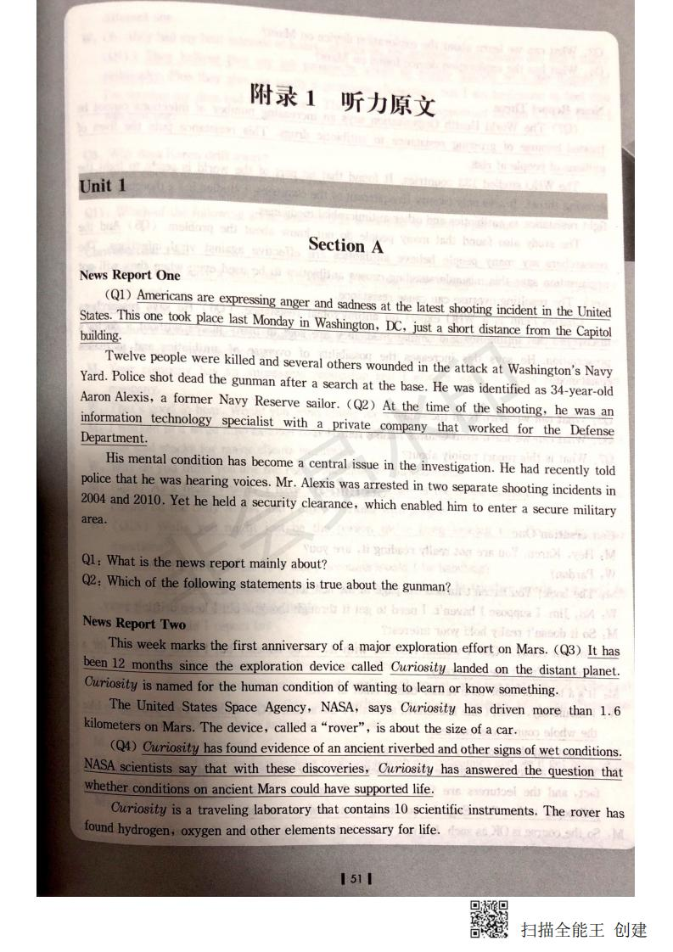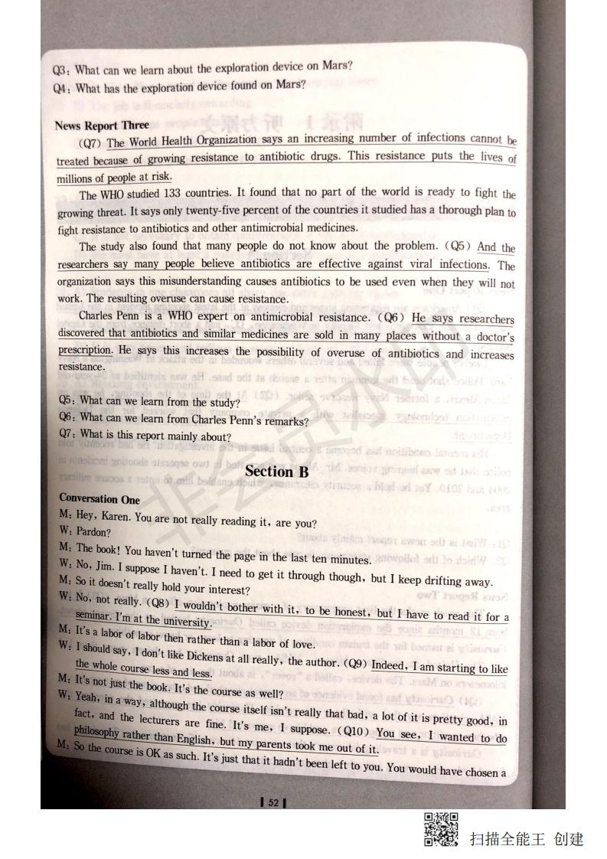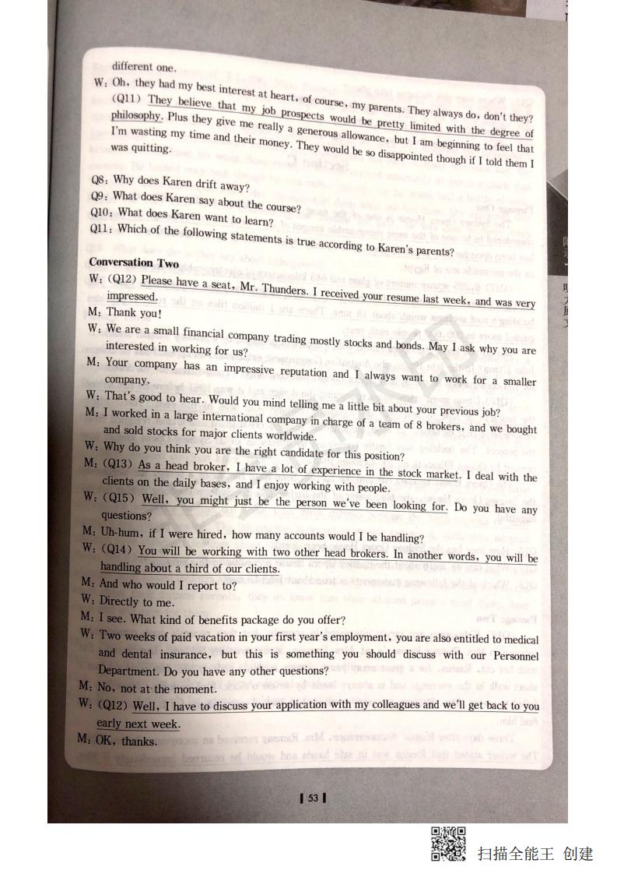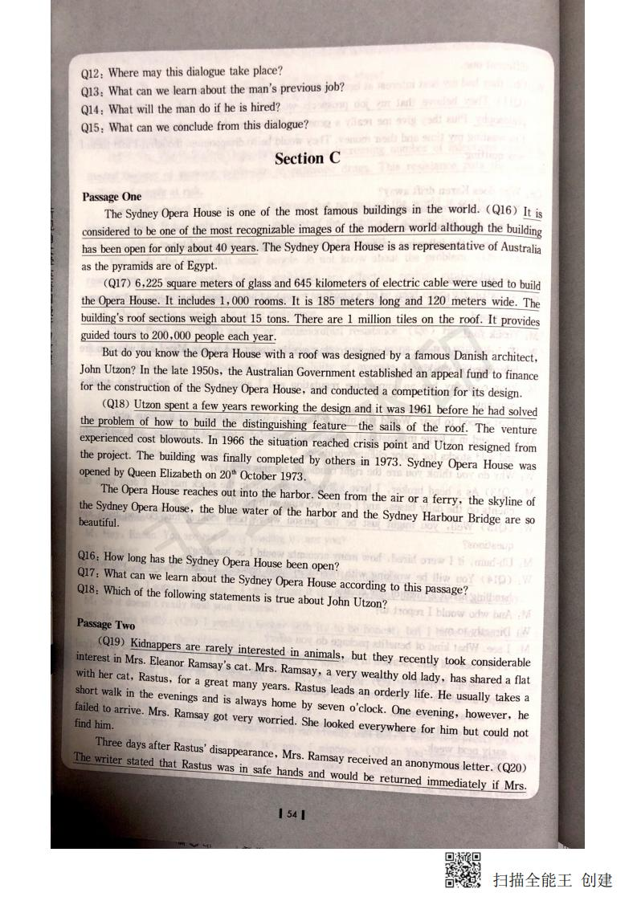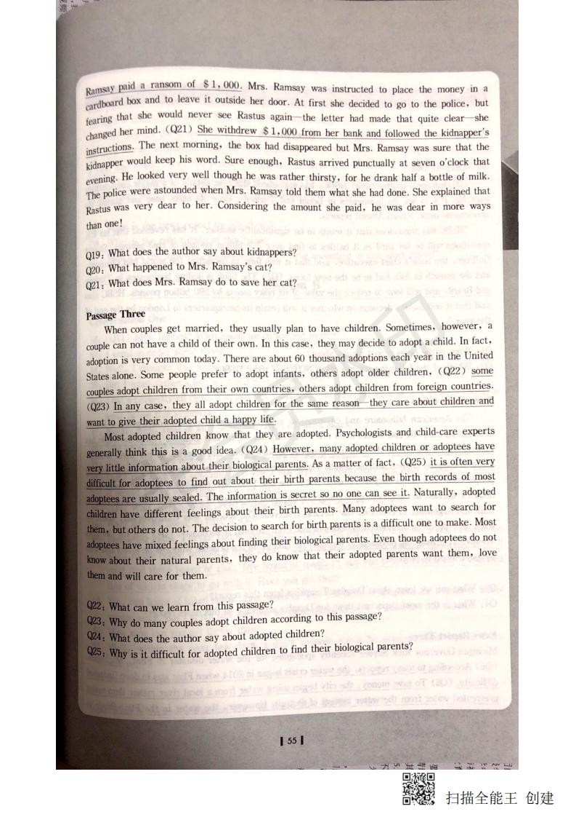

SectionD

DBA DBA DBAC

Lecture1 Script

OK. Another ancient Greek philosopher we need to discuss is Aristotle-Aristotle's ethical theory. What Aristotle's ethical theory is all about is this: he's trying to show you how to be happy-what true happiness is.

Now, why is he interested in human happiness? It's not just because it's something that all people want or aim for. It's more than that. But to get there, we need to first make a very important distinction. Let me introduce a couple of technical terms: extrinsic value and intrinsic value.

To understand Aristotle's interest in happiness, you need to understand this distinction. Some things we aim for and value, not for themselves, but for what they bring about in addition to themselves. If I value something as a means to something else, then it has what we will call "extrinsic value." Other things we desire and hold to be valuable for themselves alone. If we value something not as a means to something else, but for its own sake, let us say that it has "intrinsic value."

Exercise. There may be some people who value exercise for itself, but I don't. I value exercise because if I exercise, I tend to stay healthier than I would if I didn't. So I desire to engage in exercise, and I value ·exercise extrinsically ... not for its own sake, but as a means to something beyond it. It brings me good health.

Health. Why do I value good health? Well, here it gets a little more complicated for me. Um, health is important for me because I can't ... do other things I wanna doplay music, teach philosophy-if I'm ill. So health is important to me-has value to me-as a means to a productive life. But health is also important to me because I just kind of like to be healthy-it feels good. It's pleasant to be healthy, unpleasant not to be. So to some degree I value health both for itself and as a means to something else: productivity. It's got extrinsic and intrinsic value for me.

Then there's some things that are just valued for themselves. I'm a musician, not a professional musician; I just play a musical instrument for fun. Why do I value playing music? Well, like most amateur musicians, I only play because, well, I just enjoy it. It's something that's an end in itself.

Now, something else I value is teaching. Why? Well, it brings in a modest income, but I could make more money doing other things. I'd do it even if they didn't pay me. I just enjoy teaching. In that sense it's an end to itself.

But teaching's not something that has intrinsic value for all people-and that's true generally. Most things that are enjoyed in and of themselves vary from person to person. Some people value teaching intrinsically, but others don't.

So how does all this relate to human happiness? Well, Aristotle asks: is there something that all human beings value ... and value only intrinsically, for its own sake and only for its own sake? If you could find such a thing, that would be the universal final good, or truly the ultimate purpose or goal for all human beings. Aristotle thought the answer was yes. What is it? Happiness. Everyone will agree, he argues, that happiness is the ultimate end to be valued for itself and really only for itself. For what other purpose is there in being happy? What does it yield? The attainment of happiness becomes the ultimate or highest good for Aristotle. The next question that Aristotle raises is: what is happiness? We all want it; we all desire it; we all seek it. It's the goal we have in life. But what is it? How do we find it?

Here he notes, with some frustration, people disagree. But he does give us a couple of criteria, or features, to keep in mind as we look for what true human happiness is. True human happiness should be, as he puts it, complete. Complete in that it's all we require. Well, true human happiness ... if you had that, what else do you need? Nothing.

And, second, true happiness should be something that I can obtain on my own. I shouldn't have to rely on other people for it. Many people value fame and seek fame. Fame for them becomes the goal. But, according to Aristotle, this won't work either, because fame depends altogether too much on other people. I can't get it on my own, without help from other people.

In the end, Aristotle says that true happiness is the exercise of reason-a life of intellectual contemplation ... of thinking. So let's see how he comes to that.

Lecture2 Script

OK. Let's get going. Today I'm going to talk about how the asteroid belt was discovered. And ... I'm going to start by writing some numbers on the board. Here they are: we'll start with zero, then 3, ... 6, ... 12. Uh, tell me what I'm doing.

Female Student: Multiplying by 2?

Professor: Right. I'm doubling the numbers, so 2 times 12 is 24, and the next one I'm going to

write after 24 would be ...

Female Student: 48.

Professor: 48. Then 96. We'll stop there for now. Uh, now I'll write another row of numbers under

that. Tell me what I'm doing: 4, 7, 10 ... How am I getting this second row?

Male Student: Adding 4 to the numbers in the first row.

Professor: I'm adding 4 to each number in the first row to give you a second row. So the last two

will be 52, 100, and now tell me what I'm doing.

Female Student: Putting in a decimal?

Professor: Yes, I divided all those numbers by 10 by putting in a decimal point. Now I'm going to write the names of the planets under the numbers. Mercury ... Venus ... Earth ... Mars. So, what do the numbers mean? Do you remember from the reading?

Male Student: Is it the distance of the planets from the Sun?

Professor: Right. In astronomical units-not perfect, but tantalizingly close. The value for Mars is off by ... 6 or 7 percent or so. It's ... but it's within 10 percent of the average distance to Mars from the Sun. But I kind of have to skip the one after Mars for now. Then Jupiter's right there at 5-point something, and then Saturn is about 10 astronomical units from the Sun. Um, well, this pattern is known as Bode's Law.

Um, it isn't really a scientific law, not in the sense of predicting gravitation mathematically or something, but it's attempting a pattern in the spacing of the planets, and it was noticed by Bode hundreds of years ago. Well, you can imagine that there was some interest in why the 2.8 spot in the pattern was skipped, and um ... but there wasn't anything obvious there, in the early telescopes. Then what happened in the late 1700s? The discovery of ... ?

Female Student: Another planet?

Professor: The next planet out, Uranus-after Saturn.

And look, Uranus fits in the next spot in the pattern pretty nicely, um, not perfectly, but close. And so then people got really excited about the validity of this thing and finding the missing object between Mars and Jupiter. And telescopes, remember, were getting better. So people went to work on finding objects that would be at that missing distance from the Sun, and then in 1 801, the object Ceres was discovered.

And Ceres was in the right place-the missing spot. Uh, but it was way too faint to be a planet. It looked like a little star. Uh, and because of its starlike appearance, um, it was called an ''asteroid." OK? Aster is Greek for "star," as in astronomy. Um, and so, Ceres was the first and is the largest of what became many objects discovered at that same distance. Not just one thing, but all the objects found at that distance form the asteroid belt. So the asteroid belt is the most famous success of this Bode's Law. That's how the asteroid belt was discovered.

Lecture3 Script

Hi, everyone. Good to see you all today. Actually, I expected the population to be a lot lower today. It typically runs between 50 and 60 percent on the day the research paper is due. Um, I was hoping to have your exams back today, but, uh, the situation was that I went away for the weekend, and I was supposed to get in yesterday at five, and I expected to fully complete all the exams by midnight or so, which is the time that I usually go to bed, but my flight was delayed, and I ended up not getting in until one o'clock in the morning. Anyway, I'll do my best to have them finished by the next time we meet.

OK. In the last class, we started talking about useful plant fibers. In particular, we talked about cotton fibers, which we said were very useful, not only in the textile industry, but also in the chemical industry, and in the production of many products, such as plastics, paper, explosives, and so on. Today we'll continue talking about useful fibers, and we'll begin with a fiber that's commonly known as "Manila hemp."

Now, for some strange reason, many people believe that Manila hemp is a hemp plant. But Manila hemp is not really hemp. It's actually a member of the banana family- it even bears little banana-shaped fruits. The "Manila" part of the name makes sense, because Manila hemp is produced (chiefly in the Philippine Islands, and, of course, the capital city of the Philippines is Manila.

Now, as fibers go, Manila hemp fibers are very long. They can easily be several feet in length, and they're also very strong, very flexible. They have one more characteristic that's very important, and that is that they are exceptionally resistant to salt water. And this combination of characteristics-long, strong, flexible, resistant to salt water-makes Manila hemp a great material for ropes, especially for ropes that are gonna be used on oceangoing ships. In fact, by the early 1940s, even though steel cables were available, most ships in the United States Navy were not moored with steel cables; they were moored with Manila hemp ropes.

Now, why was that? Well, the main reason was that steel cables degrade very, very quickly in contact with salt water. If you've ever been to San Francisco, you know that the Golden Gate Bridge is red. And it's red because of the zinc paint that goes on those stainless steel cables. That, if they start at one end of the bridge and they work to the other end, by the time they finish, it's already time to go back and start painting the beginning of the bridge again, because the bridge was built with steel cables, and steel cables can't take the salt air unless they're treated repeatedly with a zinc-based paint.

On the other hand, plant products like Manila hemp, you can drag through the ocean for weeks on end. If you wanna tie your anchor to it and drop it right into the ocean, that's no problem, because plant fibers can stand up for months, even years, in direct contact with salt water. OK. So how do you take plant fibers that individually you could break with your hands and turn them into a rope that's strong enough to moor a ship that weighs thousands of tons? Well, what you do is extract these long fibers from the Manila hemp plant, and then you take several of these fibers, and you group them into a bundle, because by grouping the fibers, you greatly increase their breaking strength-that bundle of fibers is much stronger than any of the individual fibers that compose it. And then you take that bundle of fibers and you twist it a little bit, because by twisting it, you increase its breaking strength even more. And then you take several of these little bundles, and you group and twist them into bigger bundles, which you then group and twist into even bigger bundles, and so on, until eventually, you end up with a very, very strong rope.

二、

1-20 BADDD CACBD CACDA BDDAC（仅供参考）

56-65 CDADB BABDC

d044992fc6d5f175bbcc925c1922f5f

三、

1、

I、(1) No (2) Yes (3) no (4) Yes (5) Not Given (6) Yes

II、CDADA

2、

I、（1）Yes （2）No （3）No （4）Yes （5）No

II、BDABD