# 3. PWM控制输出

## 3.1利用 LED_PWM

(1) PWM0 PWM1 说明

原始功能没有复用

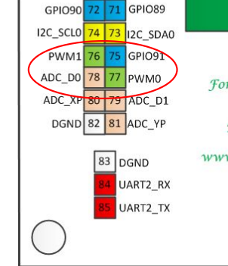

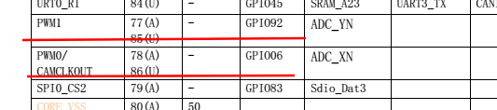

LS1X_PWM0_BASE 0x1fe5c000 此处是物理地址0xbfefc0000 为核心虚地址空间的程序空间地址

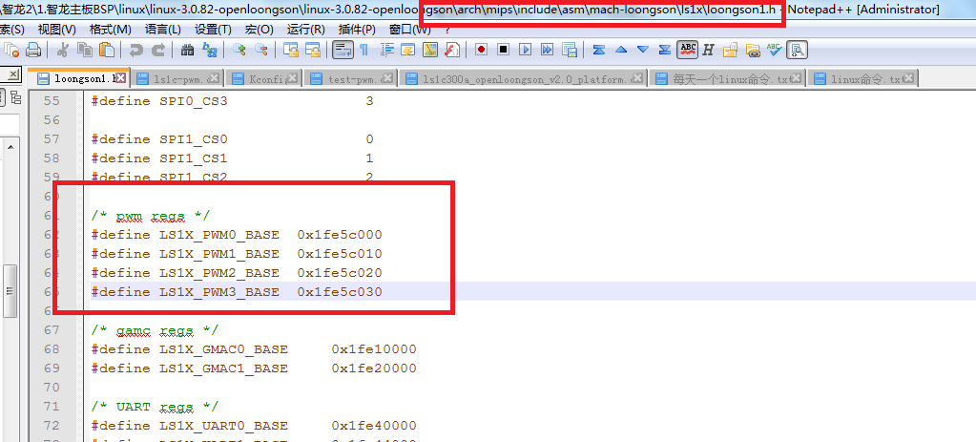

使用的平台文件 pwm.c 中

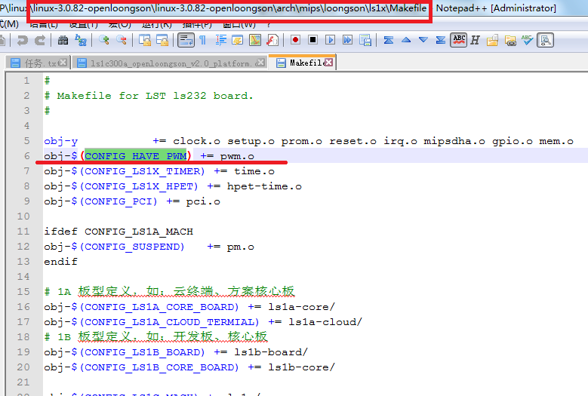

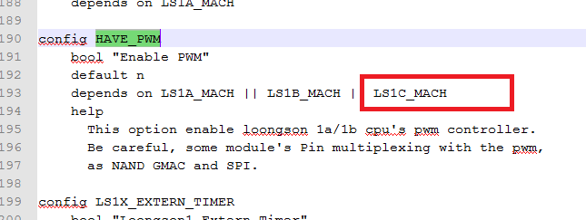

这就需要在内核配置时，添加以下选项：

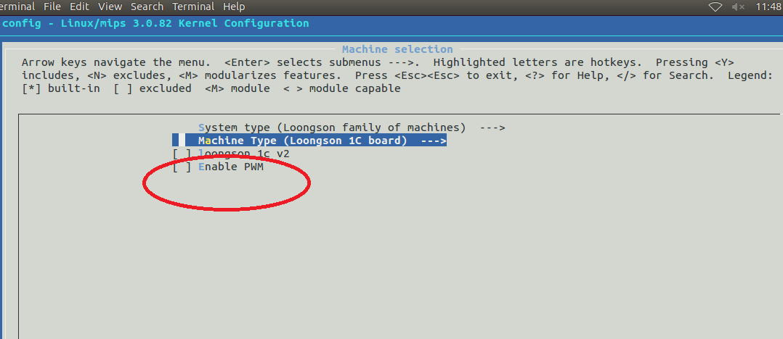

添加了HAVE_PWM后，就有了 平台设备pwm_device的定义 ls1x_pwm_list

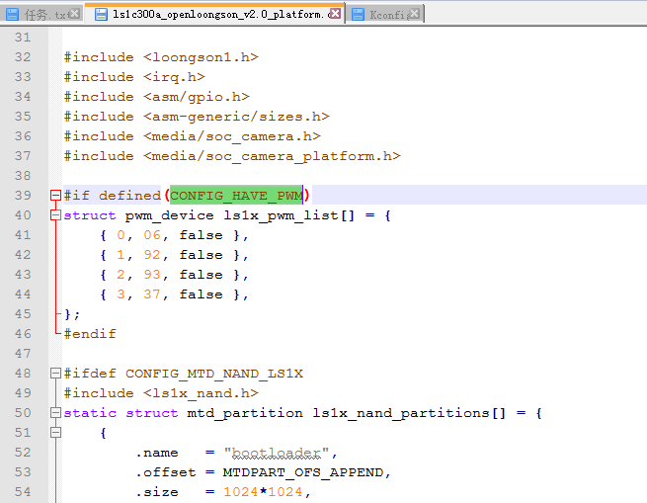

(2)内核中选择Loongson 1C board的CPU

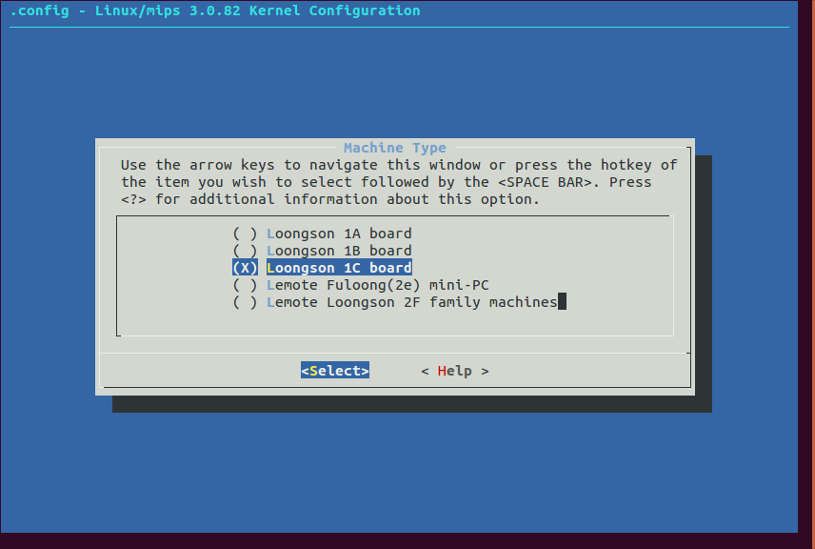

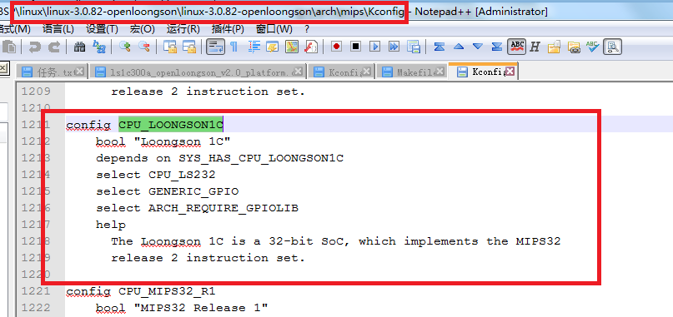

则在pwm.c中定义了外部的ls1x_pwm_list，分析驱动pwm.c

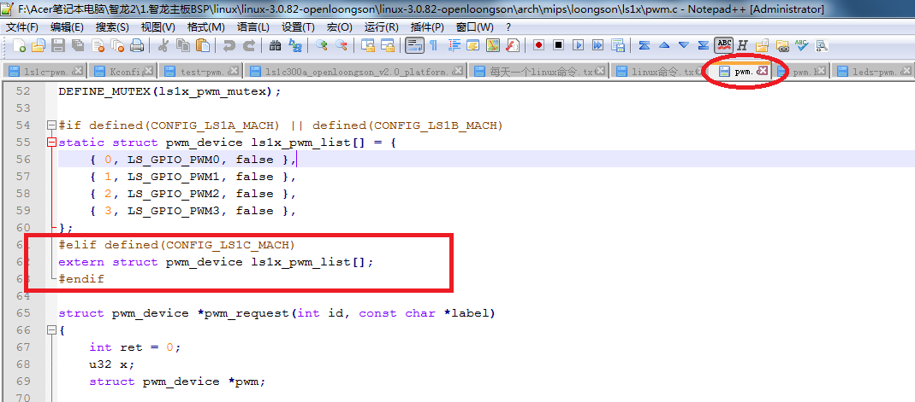

这个变量在 平台文件中定义，分析ls1c300a_openloongson_v2.0_platform.c

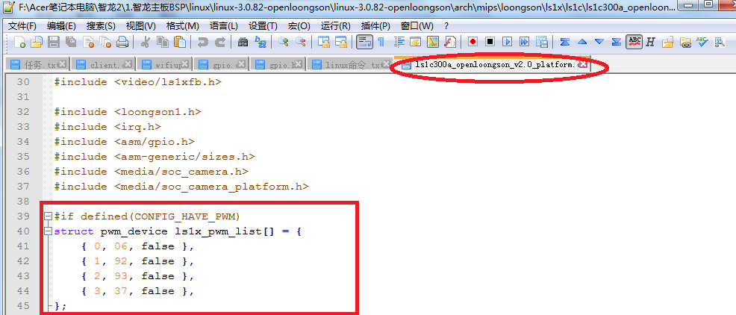

下面看leds_pwm：

在drivers/leds/ 下的makefile, leds_pwm的编译依赖于 CONFIG_LEDS_PWM.

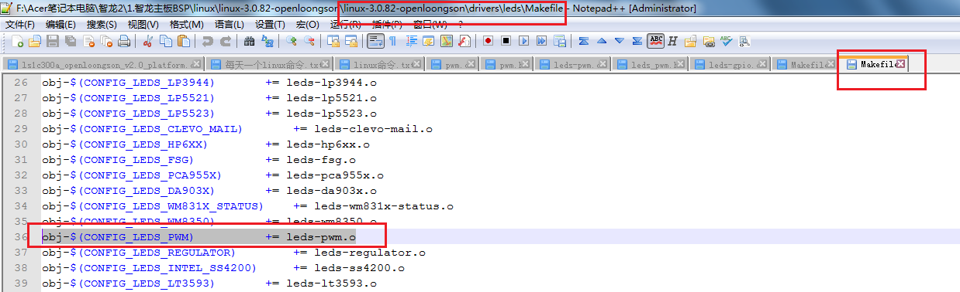

CONFIG_LEDS_PWM 在内核配置中如下配置

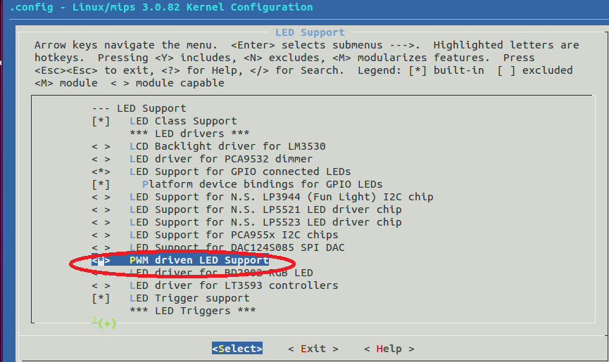

该配置选项的出现依赖于 前图中的 HAVE_PWM配置项

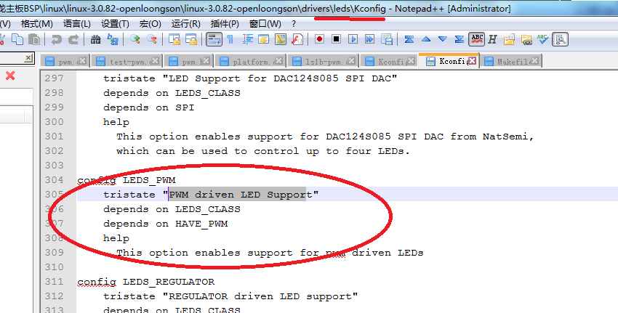

其中， struct pwm_device 在文件

linux-3.0.82-openloongson\linux-3.0.82-openloongson\arch\mips\include\asm\mach-loongson\ls1x\ls1x_pwm.h

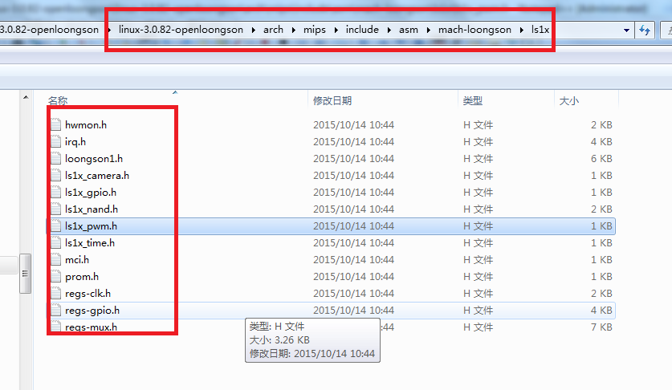

#ifndef __ASM_ARCH_LS1X_PWM_H

#define __ASM_ARCH_LS1X_PWM_H

struct pwm_device {

unsigned int id;

unsigned int gpio;

bool used;

};

#endif /* __ASM_ARCH_LS1X_PWM_H */

（3）Linux内核配置选中pwm驱动

Machine selection --->

System type(Loongson family of machines) --->

Macine Type(Loongson 1C board) --->

[ ] loongson 1c v2

[*] Enable PWM

在LED类中配置PWM

Device Drivers --->

[*] LED Support --->

<*> PWM driven LED Support

在平台文件ls1c300a_openloongson_v2.0_platform.c 中添加：

#ifdef CONFIG_LEDS_PWM

static struct led_pwm ls1x_pwm_leds[] = {

{

.name = "ls1x_pwm_led1",

.pwm_id = 0,

.max_brightness = 255,

.pwm_period_ns = 7812500,

},

{

.name = "ls1x_pwm_led2",

.pwm_id = 1,

.max_brightness = 255,

.pwm_period_ns = 7812500,

},

};

static struct led_pwm_platform_data ls1x_pwm_data = {

.num_leds = ARRAY_SIZE(ls1x_pwm_leds),

.leds = ls1x_pwm_leds,

};

static struct platform_device ls1x_leds_pwm = {

.name = "leds_pwm",

.id = -1,

.dev = {

.platform_data = &ls1x_pwm_data,

},

};

#endif //#ifdef CONFIG_LEDS_PWM

上一个平台文件中，函数 static struct platform_device *ls1b_platform_devices[] __initdata 中添加：

#ifdef CONFIG_LEDS_PWM

&ls1x_leds_pwm,

#endif

平台文件增加成功：leds_pwm

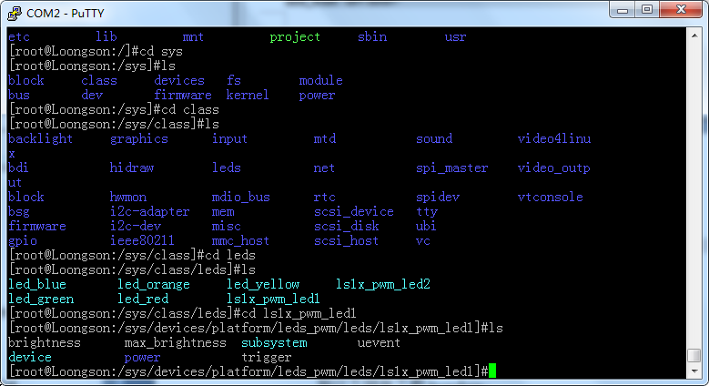

将 PWM0 占比调到最大(高电平占100%)

echo 255 > brightness

将 PWM0 占比调到最小(低电平占100%)

echo 0 > brightness

## 3.2自己编写驱动文件

首先在平台文件中添加资源：

平台文件\arch\mips\loongson\ls1x\ls1c\ls1c300a_openloongson_v2.0_platform.c添加：

#ifdef CONFIG_LS1C_PWM_DRIVER

static struct resource ls1c_pwm0_resource[] = {

[0]={

.start = LS1X_PWM0_BASE,

.end = (LS1X_PWM0_BASE + 0x0f),

.flags = IORESOURCE_MEM,

},

[1]={

.start = LS1X_PWM1_BASE,

.end = (LS1X_PWM1_BASE + 0x0f),

.flags = IORESOURCE_MEM,

},

[2]={

.start = LS1X_PWM2_BASE,

.end = (LS1X_PWM2_BASE + 0x0f),

.flags = IORESOURCE_MEM,

},

[3]={

.start = LS1X_PWM3_BASE,

.end = (LS1X_PWM3_BASE + 0x0f),

.flags = IORESOURCE_MEM,

},

};

static struct platform_device ls1c_pwm_device = {

.name = "ls1c-pwm",

.id = -1,

.num_resources = ARRAY_SIZE(ls1c_pwm0_resource),

.resource = ls1c_pwm0_resource,

};

#endif //#ifdef CONFIG_LS1C_PWM_DRIVER

上一个文件中，函数 static struct platform_device *ls1b_platform_devices[] __initdata 中添加：

#ifdef CONFIG_LS1C_PWM_DRIVER

&ls1c_pwm_device,

#endif

在 \drivers\char\Kconfig中添加：

config LS1C_PWM_DRIVER

bool "ls1c pwm driver"

default n

help

pwm.

在 char 下的Makefile文件中添加语句：

obj-$(CONFIG_LS1C_PWM_DRIVER) += ls1c-pwm.o

平台设备增加成功：ls1c-pwm

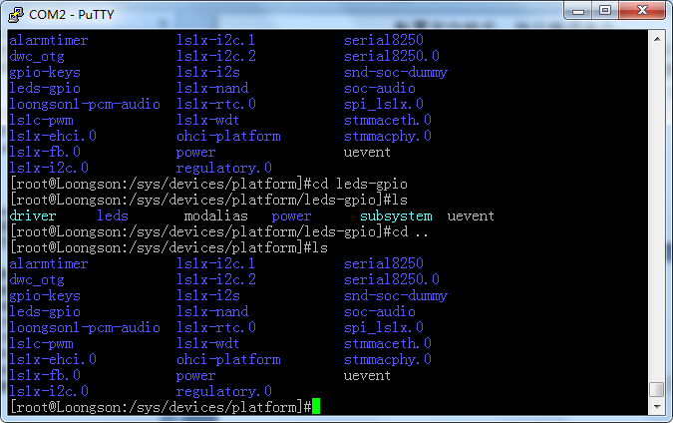

编写驱动文件 ls1c_pwm.c（根据1B中的资料修改）， 放到内核代码driver/char下，

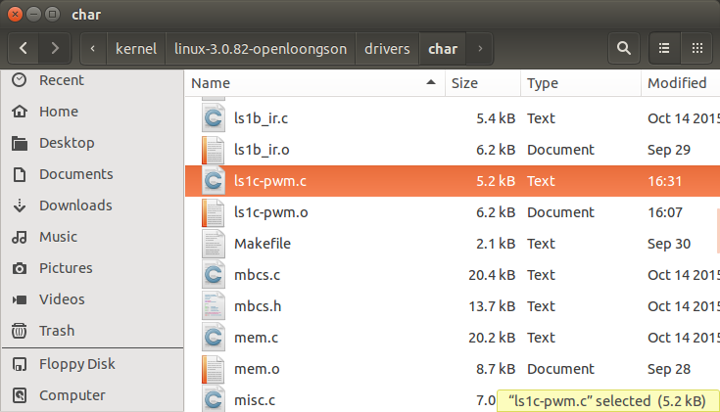

修改Makefile文件，添加语句：obj-$(CONFIG_LS1C_PWM_DRIVER) += ls1c-pwm.o

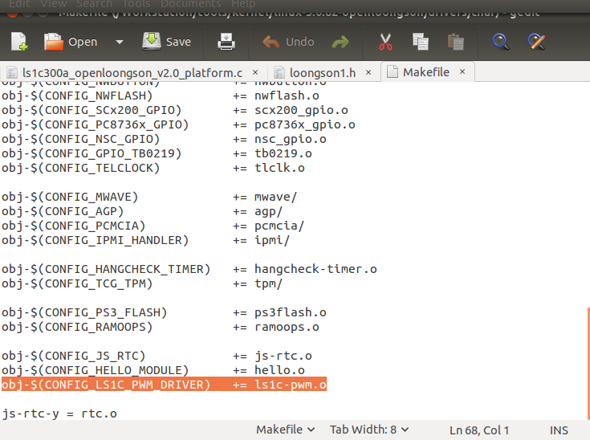

以下 设备驱动ls1c_pwm.c 代码：

/*ls1c_pwm.c*/

#include <linux/miscdevice.h>

#include <linux/errno.h>

#include <linux/fs.h>

#include <asm/io.h>

#include <asm/uaccess.h>

#include <asm/ioctl.h>

#include <linux/platform_device.h>

#include <linux/timer.h>

#define CMD_PWM_GET _IO('c',0x01)

#define CMD_PWM_START _IO('c',0x02)

#define CMD_PWM_STOP _IO('c',0x03)

#define REG_PWM_CNTR 0x00 // 0xBFE5C010

#define REG_PWM_HRC 0x04 // 0xBFE5C014

#define REG_PWM_LRC 0x08 // 0xBFE5C018

#define REG_PWM_CTRL 0x0c // 0xBFE5C01C

#define REG_GPIO_CFG0 0xbfd010c0//GPIO GPIO[31:0] 配置寄存器 1 表示配置为GPIO， 0 表示无效

#define REG_GPIO_CFG2 0xbfd010c8//GPIO[95:64] 配置寄存器 1 表示配置为GPIO， 0 表示无效

#define SB2F_GPIO_MUX_CTRL1 0xbfd00424//功能复用寄存器

static unsigned char __iomem *pwm_base = NULL;

struct resource *res;

static int ls1f_pwm_probe(struct platform_device *pdev);

struct platform_device *pwm_dev;

struct resource *res1 = NULL;

static int ls1f_pwm_getResourse(struct platform_device *pdev, unsigned int index);

static struct platform_driver ls1f_pwm_driver = {

.probe = ls1f_pwm_probe,

.driver = {

.name = "ls1c-pwm",

},

};

static int ls1f_pwm_open(struct inode *inode, struct file *file)

{

//配置PWM0 PWM1 原始功能没有复用

//long val = readl(SB2F_GPIO_MUX_CTRL1);

//val &= 0xfffffffc;

//writel(val, SB2F_GPIO_MUX_CTRL1);

long val = readl(REG_GPIO_CFG0);

//配置GPIO6引脚为普通功能，而非GPIO功能

val &= 0xffffffbf;

writel(val, REG_GPIO_CFG0);

val = readl(REG_GPIO_CFG0);

//配置GPIO92引脚为普通功能，而非GPIO功能

val &= 0xefffffff;

writel(val, REG_GPIO_CFG2);

return 0;

}

static int ls1f_pwm_close(struct inode *inode, struct file *file)

{

writel(0x0, pwm_base + REG_PWM_CTRL);

return 0;

}

static ssize_t ls1f_pwm_read(struct file *file, char __user *buf, size_t count, loff_t *ptr)

{

unsigned int pwm_val;

pwm_val = readl(pwm_base);

if (copy_to_user(buf, &pwm_val, sizeof(unsigned int)))

return -EFAULT;

return 4;

}

static ssize_t ls1f_pwm_write(struct file *file, const char __user *buf, size_t count, loff_t *ptr)

{

unsigned int hrc_val, lrc_val;

unsigned int data[2] = {0x0};

if (copy_from_user(data, buf, sizeof(data)))

{

printk("Write error!\n");

return -EIO;

}

hrc_val = data[1] - 1;

lrc_val = data[0] + data[1] -1;

//设置占空比

writel(hrc_val, pwm_base + REG_PWM_HRC);

writel(lrc_val, pwm_base + REG_PWM_LRC);

printk("hrc:%i ; lrc:%i\n",hrc_val,lrc_val);

return 0;

}

static int pwm_start_stop(unsigned int cmd, unsigned long arg)

{

printk("into: %s\n", __FUNCTION__);

printk("arg: %ld\n", arg);

if (arg > 3)

return -1;

//从platform中获取指定PWM的寄存器基址 pwm_base

//通过改变arg，实现在pwm0、pwm1、pwm2、pwm3之间切换

ls1f_pwm_getResourse(pwm_dev, arg);

switch (cmd) {

//启动PWM

case CMD_PWM_START:

printk("CMD_PWM_START\n");

writel(0x0, pwm_base + REG_PWM_CNTR);

writel(0x01, pwm_base + REG_PWM_CTRL);

break;

//停止PWM

case CMD_PWM_STOP:

printk("CMD_PWM_STOP\n");

writel(0x0, pwm_base + REG_PWM_CTRL);

break;

default:

break;

}

return 0;

}

static long ls1f_pwm_ioctl(struct file *file, unsigned int cmd, unsigned long arg)

{

printk("into %s\n", __FUNCTION__);

printk("cmd: %d\n", cmd);

printk("arg: %ld\n", arg);

if (arg > 3)

return -1;

switch (cmd) {

case CMD_PWM_GET:

ls1f_pwm_getResourse(pwm_dev, arg);

break;

case CMD_PWM_START:

case CMD_PWM_STOP:

return pwm_start_stop(cmd, arg);

default:

break;

}

return 0;

}

static const struct file_operations ls1f_pwm_ops = {

.owner = THIS_MODULE,

.open = ls1f_pwm_open,

.release = ls1f_pwm_close,

.read = ls1f_pwm_read,

.write = ls1f_pwm_write,

.unlocked_ioctl = ls1f_pwm_ioctl,

};

static struct miscdevice ls1f_pwm_miscdev = {

MISC_DYNAMIC_MINOR,

"ls1f-pwm",

&ls1f_pwm_ops,

};

static int ls1f_pwm_getResourse(struct platform_device *pdev, unsigned int index)

{

res = platform_get_resource(pdev, IORESOURCE_MEM, index);

if (res == NULL)

{

printk("Fail to get ls1f_pwm_resource!\n");

return -ENOENT;

}

printk("Resource start=0x%x, end = 0x%x\n", res->start, res->end);

if (res1 != NULL)

{

release_mem_region(res->start, 0x0f);

}

res1 = request_mem_region(res->start, 0x0f, "ls1f-pwm");

if (res1 == NULL)

{

printk("Fail to request ls1f_pwm region!\n");

return -ENOENT;

}

pwm_base = ioremap(res->start, res->end - res->start + 1);

if (pwm_base == NULL)

{

printk("Fail to ioremap ls1f_pwm resource!\n");

return -EINVAL;

}

return 0;

}

static int __devinit ls1f_pwm_probe(struct platform_device *pdev)

{

pwm_dev = pdev;

return ls1f_pwm_getResourse(pdev, 1);

}

static int __init ls1f_pwm_init(void) {

if (misc_register(&ls1f_pwm_miscdev))

{

printk(KERN_WARNING "pwm: Couldn't register device 10, %d.\n", 255);

return -EBUSY;

}

return platform_driver_register(&ls1f_pwm_driver);

}

static void __exit ls1f_pwm_exit(void)

{

misc_deregister(&ls1f_pwm_miscdev);

release_mem_region(res->start, 0x20);

platform_driver_unregister(&ls1f_pwm_driver);

}

module_init(ls1f_pwm_init);

module_exit(ls1f_pwm_exit);

MODULE_AUTHOR("sundm");

MODULE_DESCRIPTION("loongson 1C PWM driver");

MODULE_LICENSE("GPL");

编译成功后，编写测试代码：

#include <stdio.h>

#include <unistd.h>

#include <fcntl.h>

#include <sys/ioctl.h>

#define CMD_PWM_GET _IO('c',0x01)

#define CMD_PWM_START _IO('c',0x02)

#define CMD_PWM_STOP _IO('c',0x03)

//sel为选择PWM通道(0或者1);value为占空比(0-100); freq为频率().

int pwmset(unsigned int sel, unsigned int value, unsigned int freq) {

int fd;

//data[0]的值代表的是高电平脉冲所占的时钟数，data[1]的值代表的是低电平脉冲所占的时钟数

unsigned int data[2] = {0x7ffffff,0x7ffffff};

if(value>100)

value = 100;

data[0] = freq / 100 * value;

data[1] = freq / 100 * (100-value);

printf("cys: ready to open!\n");

fd = open("/dev/ls1f-pwm",O_RDWR);

sleep(2);

if (fd != -1)

{

printf("open ok!\n");

//共有四路pwm(pwm0...pwm3)，四路pwm可同时工作，也可选择使用其中任何一路

if (sel <0 || sel > 3)

return -1;

switch(sel) {

case 0:

//在驱动中没有用到ioctl的第三个参数，故直接赋予0就可以啦

ioctl(fd, CMD_PWM_START , 0);

write(fd, data, sizeof(data) );

break;

case 1:

ioctl(fd, CMD_PWM_START , 1);

write(fd, data, sizeof(data) );

break;

case 2:

ioctl(fd, CMD_PWM_START , 2);

write(fd, data, sizeof(data) );

break;

case 3:

ioctl(fd, CMD_PWM_START , 3);

write(fd, data, sizeof(data) );

break;

default:

break;

}

}

else

{

printf("Device open failure\n");

}

sleep(10);

close(fd);

return 0;

}

调用函数 pwmset(0,50,10000) 意思是在PWM0引脚产生占空比 50%, 周期10000时钟周期的波形。

GPIO92与其中一个KEY冲突，在平台文件中注释掉一个KEY 92

