# 7. LCD

http://www.openloongson.org/forum.php?mod=viewthread&tid=141&extra=page%3D1

## 7.1 硬件接口

开发板的底板上电路如下图示。



## 7.2 GPIO口操作函数

LCD模块操作实际上是GPIO口的操作。以前在单片机中，可以简单置位、复位，在linux系统中，操作GPIO的方法有很多，可采用中级篇中的《GPIO硬件编程方法》节，但最直接的方法是寄存器操作。

操作寄存器主要是对GPIO的相关寄存器操作，如图所示。在应用编程中，需要使用mmap系统调用。使用mmap映射文件到进程后,就可以直接操作这段虚拟地址进行文件的读写等操作,不必再调用read,write等系统调用。相关操作参考《9. 内核访问外设I/O资源》。

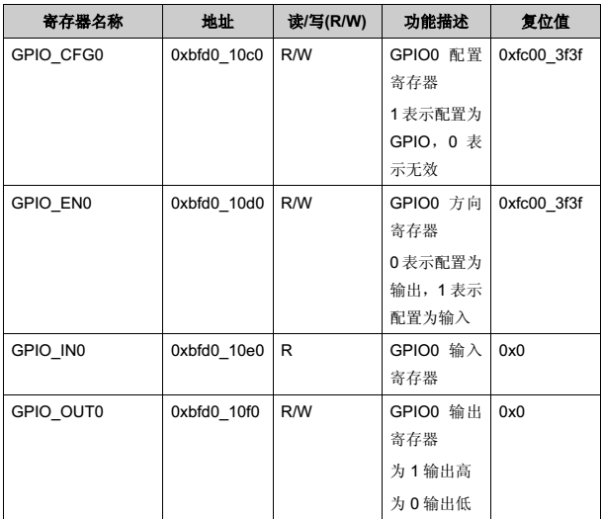

/*gpio_fun.c*/

#include<stdio.h>

#include<stdlib.h>

#include<stdint.h>

#include<string.h>

#include<unistd.h>

#include<sys/mman.h>

#include<sys/types.h>

#include<sys/stat.h>

#include<fcntl.h>

#define GPIO_CFG0 0xC0

#define GPIO_EN0 0xD0

#define GPIO_IN0 0xE0

#define GPIO_OUT0 0xF0

#define CBUS_FIRST0 0x1C0

unsigned char * map_base;

int fd;

int gpio_open(void)

{

fd = open("/dev/mem", O_RDWR|O_SYNC);

if (fd == -1) {

return (-1);

}

/* °Ñ 0x1fd01000 ¿ªÊŒ0x1000×ÖœÚ£¬Ó³Éäµœmap_base */

map_base = mmap(NULL, 0x1000, PROT_READ|PROT_WRITE, MAP_SHARED, fd, 0x1fd01000);

if (map_base == 0) {

printf("NULL pointer!\n");

}

return 0;

}

void gpio_close(void)

{

close(fd);

munmap(map_base, 0x1000);

}

void gpio_cfg_init(int gpio_number, int function)

{

uint16_t addr_offset;

uint16_t bit_offset;

int index;

uint32_t data_temp;

index = gpio_number / 32;

bit_offset = gpio_number % 32;

addr_offset = GPIO_CFG0 + index*4;

data_temp = *(volatile unsigned long *)(map_base+addr_offset);

if(function == 0)

{

data_temp = data_temp & (~(1<<bit_offset));//clr

}

else

{

data_temp = data_temp | ((1<<bit_offset));//set

}

*(volatile unsigned long *)(map_base+addr_offset)=data_temp;

}

void gpio_en_init(int gpio_number, int function)

{

uint16_t addr_offset;

uint16_t bit_offset;

int index;

uint32_t data_temp;

index = gpio_number / 32;

bit_offset = gpio_number % 32;

addr_offset = GPIO_EN0 + index*4;

data_temp = *(volatile unsigned long *)(map_base+addr_offset);

if(function == 0)

{

data_temp = data_temp & (~(1<<bit_offset));//clr

}

else

{

data_temp = data_temp | ((1<<bit_offset));//set

}

*(volatile unsigned long *)(map_base+addr_offset)=data_temp;

}

void gpio_func_init(int gpio_number, int function)

{

uint16_t addr_offset;

uint16_t bit_offset;

int index,i;

uint32_t data_temp;

index = gpio_number / 32;

bit_offset = gpio_number % 32;

addr_offset = CBUS_FIRST0 + index*4;

data_temp = *(volatile unsigned long *)(map_base+addr_offset);

for(i=1;i<6;i++)

{

data_temp = *(volatile unsigned long *)(map_base+addr_offset+(i-1)*0x10);

if(i == function)//set

{

data_temp = data_temp | ((1<<bit_offset));//set

}

else//clr

{

data_temp = data_temp & (~(1<<bit_offset));//clr

}

*(volatile unsigned long *)(map_base+addr_offset)=data_temp;

}

}

void gpio_set(int gpio_number)

{

uint16_t addr_offset;

uint16_t bit_offset;

int index;

uint32_t data_temp;

index = gpio_number / 32;

bit_offset = gpio_number % 32;

addr_offset = GPIO_OUT0 + index*4;

data_temp = *(volatile unsigned long *)(map_base+addr_offset);

{

data_temp = data_temp | ((1<<bit_offset));//set

}

*(volatile unsigned long *)(map_base+addr_offset)=data_temp;

}

uint32_t gpio_get(int gpio_number)

{

uint16_t addr_offset;

uint16_t bit_offset;

int index;

uint32_t data_temp;

index = gpio_number / 32;

bit_offset = gpio_number % 32;

addr_offset = GPIO_IN0 + index*4;

data_temp = *(volatile unsigned long *)(map_base+addr_offset);

return (data_temp >> bit_offset)&0x01;

}

void gpio_clr(int gpio_number)

{

uint16_t addr_offset;

uint16_t bit_offset;

int index;

uint32_t data_temp;

index = gpio_number / 32;

bit_offset = gpio_number % 32;

addr_offset = GPIO_OUT0 + index*4;

data_temp = *(volatile unsigned long *)(map_base+addr_offset);

{

data_temp = data_temp & (~(1<<bit_offset));//clr

}

*(volatile unsigned long *)(map_base+addr_offset)=data_temp;

}

uint32_t data_get(int gpio_start_number, int len)

{

uint16_t addr_offset;

uint16_t bit_offset;

int index,i;

uint32_t data_temp;

index = gpio_start_number / 32;

bit_offset = gpio_start_number % 32;

addr_offset = GPIO_IN0 + index*4;

if((bit_offset+len)>32)

{

len = 32 - bit_offset;

}

data_temp = *(volatile unsigned long *)(map_base+addr_offset);

for( i=bit_offset+len;i<32;i++)

{

data_temp = data_temp & (~(1<<i));//clr

}

return data_temp>>bit_offset;

}

void data_write(int gpio_start_number, int len ,uint32_t data)

{

uint16_t addr_offset;

uint16_t bit_offset;

int index,i;

uint32_t data_temp;

index = gpio_start_number / 32;

bit_offset = gpio_start_number % 32;

addr_offset = GPIO_OUT0 + index*4;

if((bit_offset+len)>32)

{

len = 32 - bit_offset;

}

data_temp = *(volatile unsigned long *)(map_base+addr_offset);

{

for( i=0;i<len;i++)

{

if(0x00 == (0x01&(data>>i))){

data_temp = data_temp & (~(1<<(bit_offset+i)));//clr

}

else{

data_temp = data_temp | (1<<(bit_offset+i)) ;//set

}

}

}

*(volatile unsigned long *)(map_base+addr_offset)=data_temp;

}

void gpio_cfg_data(int gpio_start_number, int len ,uint32_t data)

{

uint16_t addr_offset;

uint16_t bit_offset;

int index,i;

uint32_t data_temp;

index = gpio_start_number / 32;

bit_offset = gpio_start_number % 32;

addr_offset = GPIO_CFG0 + index*4;

if((bit_offset+len)>32)

{

len = 32 - bit_offset;

}

data_temp = *(volatile unsigned long *)(map_base+addr_offset);

{

for( i=0;i<len;i++)

{

if(0x00 == data){

data_temp = data_temp & (~(1<<(bit_offset+i)));//clr

}

else if(0x01 == data){

data_temp = data_temp | (1<<(bit_offset+i)) ;//set

}

}

}

*(volatile unsigned long *)(map_base+addr_offset)=data_temp;

}

void gpio_en_data(int gpio_start_number, int len ,uint32_t data)

{

uint16_t addr_offset;

uint16_t bit_offset;

int index,i;

uint32_t data_temp;

index = gpio_start_number / 32;

bit_offset = gpio_start_number % 32;

addr_offset = GPIO_EN0 + index*4;

if((bit_offset+len)>32)

{

len = 32 - bit_offset;

}

data_temp = *(volatile unsigned long *)(map_base+addr_offset);

{

for( i=0;i<len;i++)

{

if(0x00 == data){

data_temp = data_temp & (~(1<<(bit_offset+i)));//clr

}

else if(0x01 == data){

data_temp = data_temp | (1<<(bit_offset+i)) ;//set

}

}

}

*(volatile unsigned long *)(map_base+addr_offset)=data_temp;

}

/* Usage:

* ./gpio_fun cfg [gpio_num] [0] // 用法

* ./gpio_fun en [gpio_num] [0]

* ./gpio_fun out [gpio_num] [0]

* ./gpio_fun in [gpio_num] [0]

* ./gpio_fun dataout [gpio_num] [len] data//len bit

* ./gpio_fun datain [gpio_num] [len] data// len bit

* ./gpio_fun cfgdata [gpio_num] [len] 0/1// 8 bit

* ./gpio_fun endata [gpio_num] [len] 0/1// 8 bit

* ./gpio_fun function [gpio_num] functionnum

*/

int main(int argc, char *argv[])

{

unsigned int buf[3];

if(argc<3) {

printf("gpio_fun cfg/en/out/in 50 0\r\n");

printf("gpio_fun dataout 58 6 85\r\n");

printf("gpio_fun datain 58 6\r\n");

printf("gpio_fun cfgdata 58 6 0/1 \r\n");

printf("gpio_fun endata 58 6 0/1 \r\n");

printf("gpio_fun function 4 85 ;set gpio85 to function 4 \r\n");

return (-2);

}

if(gpio_open()<0)

return (-1);

/* gpio_num */

buf[0] = strtoul(argv[2], NULL, 0);

/* function */

if(argc>=4)

{

buf[1] = strtoul(argv[3], NULL, 0);

}

/* data */

if(argc==5)

{

buf[2] = strtoul(argv[4], NULL, 0);

}

if (strcmp(argv[1], "cfg") == 0)

{

gpio_cfg_init(buf[0], buf[1]);

}

else if (strcmp(argv[1], "en") == 0)

{

gpio_en_init(buf[0], buf[1]);

}

else if (strcmp(argv[1], "out") == 0)

{

if(1 == buf[1]){

gpio_set(buf[0]);

}

else if(0 == buf[1]){

gpio_clr(buf[0]);

}

}

else if (strcmp(argv[1], "in") == 0)

{

printf("gpio%d = %d\r\n",buf[0], gpio_get(buf[0]) );

}

else if (strcmp(argv[1], "dataout") == 0)

{

if(argc>=5)

{

data_write(buf[0],buf[1],buf[2]);

}

else

{

printf("gpio_fun argc<5 !\r\n" );

}

}

else if (strcmp(argv[1], "datain") == 0)

{

printf("gpio%d read %d bit= 0x%02x\r\n",buf[0], buf[1], data_get(buf[0],buf[1]));

}

else if (strcmp(argv[1], "cfgdata") == 0)

{

if(argc>=5)

{

gpio_cfg_data(buf[0],buf[1],buf[2]);

}

else

{

printf("gpio_fun argc<5 !\r\n" );

}

}

else if (strcmp(argv[1], "endata") == 0)

{

if(argc>=5)

{

gpio_en_data(buf[0],buf[1],buf[2]);

}

else

{

printf("gpio_fun argc<5 !\r\n" );

}

}

else if (strcmp(argv[1], "function") == 0)

{

if(argc>=4)

{

gpio_func_init(buf[0],buf[1]);

}

else

{

printf("gpio_fun argc<4 !\r\n" );

}

}

gpio_close();

return (0);

}

代码中，main函数测试用，测试成功后，将main改成其它名字。

## 7.3 LCD操作

这里使用LCD是来自于

<https://item.taobao.com/item.htm?spm=a1z10.5-c.w4002-1891666121.32.hqEYu4&id=25142720480>

使用控制器NT35310 ，屏幕大小为480*320。

直接在驱动例程上进行修改，将GPIO口的操作换成7.3节的GPIO口操作的函数，还延时函数的替换。代码太长，这里不再列出。这里只说明初始化过程。

首先从0x00处读取ID，如果读不到，再从0xD3处读判断是否9341, 如果不是再从0xBF读判断是否6804，如果不是再从0xD4判断是否35310，如果不是再从0XDA00读判断是否NT35510，如果不是再从0XA1读判断是否SSD1963。

lcddev.id = LCD_ReadReg(0x0000);

if(lcddev.id<0XFF||lcddev.id==0XFFFF||lcddev.id==0X9300)//读到ID不正确,新增lcddev.id==0X9300判断，因为9341在未被复位的情况下会被读成9300

{

//尝试9341 ID的读取

LCD_WR_REG(0XD3);

LCD_RD_DATA(); //dummy read

LCD_RD_DATA(); //读到0X00

lcddev.id=LCD_RD_DATA(); //读取93

lcddev.id<<=8;

lcddev.id|=LCD_RD_DATA(); //读取41

if(lcddev.id!=0X9341) //非9341,尝试是不是6804

{

LCD_WR_REG(0XBF);

LCD_RD_DATA(); //dummy read

LCD_RD_DATA(); //读回0X01

LCD_RD_DATA(); //读回0XD0

lcddev.id=LCD_RD_DATA();//这里读回0X68

lcddev.id<<=8;

lcddev.id|=LCD_RD_DATA();//这里读回0X04

if(lcddev.id!=0X6804) //也不是6804,尝试看看是不是NT35310

{

LCD_WR_REG(0XD4);

LCD_RD_DATA(); //dummy read

LCD_RD_DATA(); //读回0X01

lcddev.id=LCD_RD_DATA(); //读回0X53

lcddev.id<<=8;

lcddev.id|=LCD_RD_DATA(); //这里读回0X10

if(lcddev.id!=0X5310) //也不是NT35310,尝试看看是不是NT35510

{

LCD_WR_REG(0XDA00);

LCD_RD_DATA(); //读回0X00

LCD_WR_REG(0XDB00);

lcddev.id=LCD_RD_DATA();//读回0X80

lcddev.id<<=8;

LCD_WR_REG(0XDC00);

lcddev.id|=LCD_RD_DATA();//读回0X00

if(lcddev.id==0x8000)lcddev.id=0x5510;//NT35510读回的ID是8000H,为方便区分,我们强制设置为5510

if(lcddev.id!=0X5510) //也不是NT5510,尝试看看是不是SSD1963

{

LCD_WR_REG(0XA1);

lcddev.id=LCD_RD_DATA();

lcddev.id=LCD_RD_DATA(); //读回0X57

lcddev.id<<=8;

lcddev.id|=LCD_RD_DATA(); //读回0X61

if(lcddev.id==0X5761)lcddev.id=0X1963;//SSD1963读回的ID是5761H,为方便区分,我们强制设置为1963

}

}

}

}

}

printf(" LCD ID:%x\r\n",lcddev.id); //打印LCD ID

最终运行结果为：LCD控制器为NT35310。

[root@Loongson:/app]#./testlcd

Init LCD

LCD ID:5310

DRIVER GET LCD ID:0x5310

ili9341.c-Init_ili9341():ILI9341 init Successful!

## 7.4 编写Makefile

本应用程序中使用的文件结构如下图示。

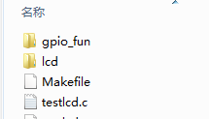

其中gpio_fun中为GPIO口的操作函数。Lcd中为LCD的驱动。

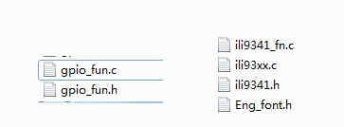

下面编写通用的Makefile，指明了头文件的位置，目标文件，并指定输出文件testlcd。

# 指令编译器和选项

CC=mipsel-linux-gcc

CFLAGS=-Wall -std=gnu99 -Wstrict-prototypes

# 目标文件

TARGET=testlcd

SRCS = testlcd.c \

./gpio_fun/gpio_fun.c \

./lcd/ili9341_fn.c\

./lcd/ili93xx.c

INC = -I./gpio_fun -I./lcd

OBJS = $(SRCS:.c=.o)

$(TARGET):$(OBJS)

@echo TARGET:$@

@echo OBJECTS:$^

$(CC) -o $@ $^

clean:

rm -rf $(TARGET) $(OBJS)

%.o:%.c

$(CC) $(CFLAGS) $(INC) -o $@ -c $<

## 7.5 代码及运行结果

### 1)显示字符

LCD_Clear(BLUE); //设置背景色

LCD_ShowString(30,40,400,24,24,"OPEN LOONGSON Smart Loong V2.0^_^");

LCD_ShowString(30,70,200,16,16,"TFTLCD TEST ");

LCD_ShowString(30,90,200,16,16,"sundm75");

LCD_ShowString(30,110,200,16,16,lcd_id); //显示LCD ID

LCD_ShowString(30,130,200,12,12,"2017/5/24");

### 2）显示图片

用Image2Lcd转换图片。

（1）设置输出数据格式 C语言数组

（2）设置输出灰度 16位真彩色

（3）设置最大宽度高度不得大于LCD的宽、高（320、480）。

（4）最后数据头文件picture.h。

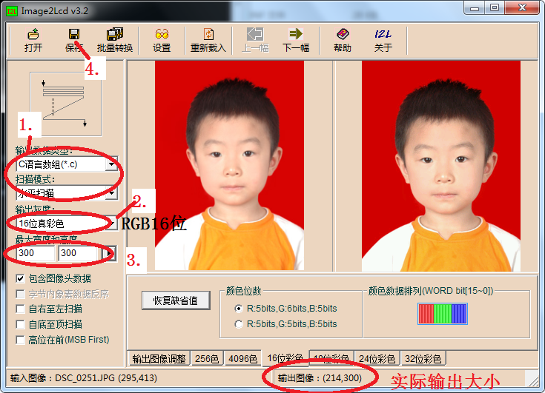

代码如下：

/* 画 picture */

/****************************************************************************

* 名 称：void lcd_draw_picture(u16 StartX,u16 StartY,u16 EndX,u16 EndY,u16 *picture)

* 功 能：在指定座标范围显示一副图片

* 入口参数：StartX 行起始座标

* StartY 列起始座标

* EndX 行结束座标

* EndY 列结束座标

picture 图片头指针

* 出口参数：无

* 说 明：图片取模格式为水平扫描，16位颜色模式 (RGB565)

* 调用方法：lcd_draw_picture(0,0,100,100,(u16*)demo);

****************************************************************************/

void lcd_draw_picture(u16 start_x, u16 start_y, u16 end_x, u16 end_y, u16 *picture)

{

u32 length;

u32 i;

u16 x, y;

x = start_x;

y = start_y;

length = (end_x - start_x + 1) * (end_y - start_y + 1) ;

for (i = 0; i < length; i++)

{

LCD_Fast_DrawPoint(x, y, *picture++);

y++;

if(y > end_y)

{

x++;

y = start_y;

}

}

}

/*-------------测试LCD函数，在当前LCD屏幕中心画出PictureAddr图片-------------*/

void DrawPicture_Center(u16 *PictureAddr)

{

u16 PictureWidth;

u16 PictureHeight;

u16 * picuturepoint;

picuturepoint=PictureAddr;

PictureHeight = picuturepoint[1];

PictureWidth = picuturepoint[2];

lcd_draw_picture((480-PictureWidth+1)/2, (320-PictureHeight+1)/2, ((480+PictureWidth+1)/2)-1,

((320+PictureHeight+1)/2)-1, (u16 *)(PictureAddr + 3));

}

### 3）显示汉字

用 字模III增强版 ,生成字模的汉字库。

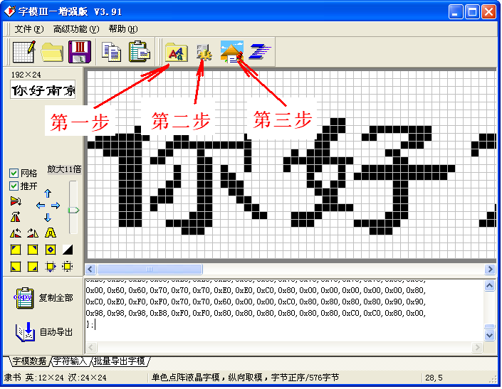

第一步

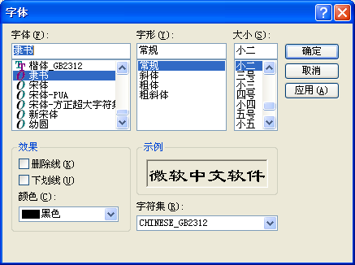

第二步

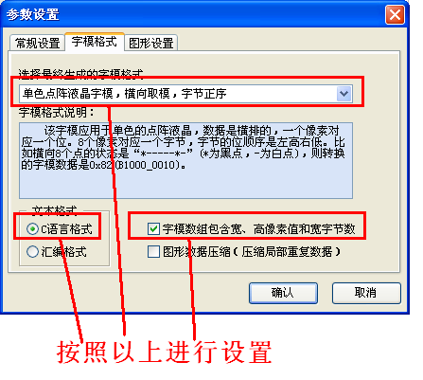

汉字显示软件操作：

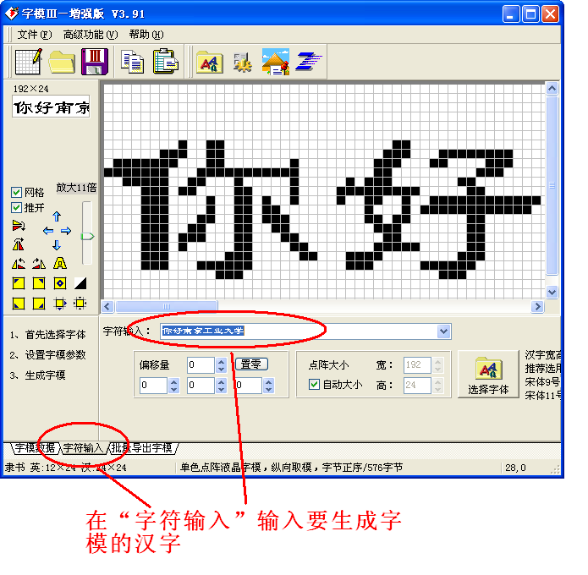

第三步，生成字模数据

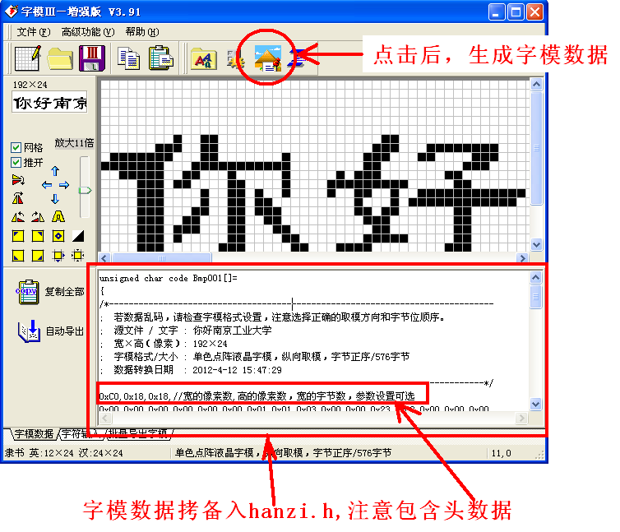

代码如下：

/****************************************************************************

* 名 称：void lcd_draw_hanzi(u16 x,u16 y,u8 *hanziaddr,u16 charColor,u16 bkColor)

* 功 能：在指定座标显示一个由字模软件生成的汉字字符

* 入口参数：x 行座标

* y 列座标

hanziaddr 汉字头指针

* charColor 字符的颜色

* bkColor 字符背景颜色

* 出口参数：无

* 说 明：显示范围限定为汉字头文件中，用横向取模的单色点阵液晶字模，横向取模，字节正序

* 调用方法：lcd_draw_hanzi(10,10,(u8*)Str_table1,White, HYALINE);

****************************************************************************/

void lcd_draw_hanzi(u16 x,u16 y,u8 *hanziaddr,u16 charColor,u16 bkColor) //

{

u16 i=0;

u16 j=0;

u16 m=0;

u8 width,high, wbyte;

u8 *hanzipoint = hanziaddr;

u8 tmp_char = 0;

width = *hanzipoint++;

high = *hanzipoint++;

wbyte = *hanzipoint++;

if(HYALINE == bkColor)

{

for (i=0;i<(high);i++)

{

for (j=0;j<wbyte;j++)

{

tmp_char=*hanzipoint++;

for(m=0;m<8;m++)

{

if ( (tmp_char >>7-m) & 0x01 == 0x01)

{

POINT_COLOR = charColor;// 字符颜色

LCD_DrawPoint(x+j*8+m,y+i);

}

else

{

// do nothing // 透明背景

}

}

}

}

}

else

{

for (i=0;i<(high);i++)

{

for (j=0;j<wbyte;j++)

{

tmp_char=*hanzipoint++;

for(m=0;m<8;m++)

{

if ( (tmp_char >>7-m) & 0x01 == 0x01)

{

POINT_COLOR = charColor;// 字符颜色

LCD_DrawPoint(x+j*8+m,y+i);

}

else

{

POINT_COLOR = bkColor;// 背景颜色

LCD_DrawPoint(x+i,y+i-8);

}

}

}

}

}

}

### 4）画线、圆圈

LCD_DrawLine(20,20, 20,300); //画线

LCD_DrawLine(410,30, 410,290); //画线

LCD_DrawRectangle(3,15,450,310); //画矩形

LCD_ShowString(30,40,400,24,24,"Picture 214 X 300");//写字符

主程序testlcd.c：

int main(int argc,char * argv[])

{

u8 x=0;

u8 lcd_id[64]; //存放LCD ID字符串

gpio_open();

Init_ili9341();

POINT_COLOR=RED;

sprintf((char*)lcd_id,"LCD ID:%04X",lcddev.id);//将LCD ID打印到lcd_id数组。

while(1)

{

switch(x)

{

case 0:LCD_Clear(WHITE);

LCD_Display_Dir(1); //横屏

POINT_COLOR = BLACK;

BACK_COLOR = WHITE;

LCD_ShowString(30,40,400,24,24,"OPEN LOONGSON Smart Loong V2.0^_^");

LCD_ShowString(30,70,200,16,16,"TFTLCD TEST ");

LCD_ShowString(30,90,200,16,16,"sundm75");

LCD_ShowString(30,110,200,16,16,lcd_id); //显示LCD ID

LCD_ShowString(30,130,200,12,12,"2017/5/24");

break;

case 1://LCD_Clear(BLACK);

POINT_COLOR = WHITE;

BACK_COLOR = BLACK;

LCD_ShowString(30,40,400,24,24,"OPEN LOONGSON Smart Loong V2.0^_^");

LCD_ShowString(30,70,200,16,16,"TFTLCD TEST ");

LCD_ShowString(30,90,200,16,16,"sundm75");

LCD_ShowString(30,110,200,16,16,lcd_id); //显示LCD ID

LCD_ShowString(30,130,200,12,12,"2017/5/24");

break;

case 2://LCD_Clear(BLUE);

POINT_COLOR = RED;

BACK_COLOR = BLUE;

LCD_ShowString(30,40,400,24,24,"OPEN LOONGSON Smart Loong V2.0^_^");

LCD_ShowString(30,70,200,16,16,"TFTLCD TEST ");

LCD_ShowString(30,90,200,16,16,"sundm75");

LCD_ShowString(30,110,200,16,16,lcd_id); //显示LCD ID

LCD_ShowString(30,130,200,12,12,"2017/5/24");

break;

case 3://LCD_Clear(RED);

POINT_COLOR = BLUE;

BACK_COLOR = RED;

LCD_ShowString(30,40,400,24,24,"OPEN LOONGSON Smart Loong V2.0^_^");

LCD_ShowString(30,70,200,16,16,"TFTLCD TEST ");

LCD_ShowString(30,90,200,16,16,"sundm75");

LCD_ShowString(30,110,200,16,16,lcd_id); //显示LCD ID

LCD_ShowString(30,130,200,12,12,"2017/5/24");

break;

case 4:

LCD_Display_Dir(0); //竖屏

LCD_Clear(BLUE);

lcd_draw_hanzi(5,420,(u8*)Hanzi, WHITE, HYALINE);

LCD_Display_Dir(1); //横屏

DrawPicture_Center(gImage_picture);

msleep(500);

break;

case 5:

LCD_Display_Dir(1); //横屏

POINT_COLOR = RED;

BACK_COLOR = BLUE;

LCD_DrawLine(20,20, 20,300);

POINT_COLOR = GREEN;

LCD_DrawLine(405,30, 405,290);

LCD_DrawRectangle(3,15,450,310);

LCD_Display_Dir(0); //竖屏

LCD_ShowString(30,45,400,29,24,"Smart Loong V2.0");

LCD_ShowString(100,20,400,4,24,"Loongson");

POINT_COLOR = RED;

LCD_Draw_Circle(30,15,10);

LCD_Draw_Circle(50,15,10);

LCD_Draw_Circle(70,15,10);

LCD_Draw_Circle(90,15,10);

LCD_Draw_Circle(110,15,10);

LCD_Draw_Circle(130,15,10);

LCD_Draw_Circle(150,15,10);

LCD_Draw_Circle(180,15,10);

LCD_Draw_Circle(200,15,10);

LCD_Draw_Circle(220,15,10);

LCD_Draw_Circle(240,15,10);

LCD_Draw_Circle(260,15,10);

LCD_Draw_Circle(280,15,10);

LCD_Draw_Circle(300,15,10);

msleep(800);

break;

}

x++;

if(x==6)x=0;

msleep(300);

}

gpio_close();

return 0;

}

程序运行结果：

