# 8.ADC

## 8.1 配置ADC驱动

Devices Drivers --->

<*> Hardware Monitoring support --->

<*> loongson1 built-in ADC

配置如下选项。

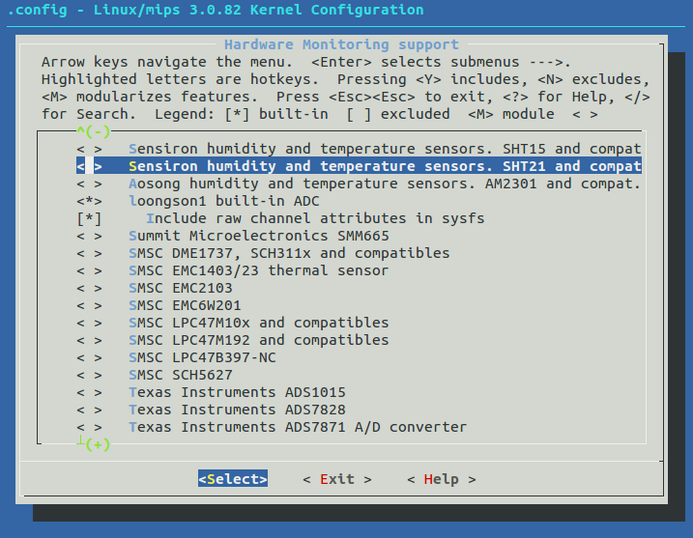

## 8.2硬件管脚分配

使用管脚GPIO85，86，87，88

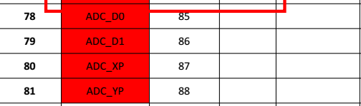

## 8.3应用测试

重启系统后，进入ADC目录。一共有4个adcN_raw（N=0~3），分别对应ADC_D0,ADC_D1, ADC_XP,ADC_YP

[root@Loongson:/]#cd /sys/class/hwmon/hwmon0/device/ [root@Loongson:/sys/devices/platform/ls1x-hwmon]#ls

adc0_raw adc2_raw driver in0_input modalias subsystem

adc1_raw adc3_raw hwmon in0_label power uevent

读取ADC_D0(GPIO85)输入的值，D0悬空。

[root@Loongson:/sys/devices/platform/ls1x-hwmon]#cat adc0_raw

977

将开发板上D0脚接入GND，再执行命令

[root@Loongson:/sys/devices/platform/ls1x-hwmon]#cat adc0_raw //D0管脚接GND

0

将开发板上D0脚接入3V3，再执行命令

[root@Loongson:/sys/devices/platform/ls1x-hwmon]#cat adc0_raw //D0管脚接GND3V3

1023

其它ADCN 可同样操作。

## 8.4应用层编程

应用层使用系统调用即可以控制。

/**************************************************************************

Loongson1s1c hwmon-adc driver test

device node is "/sys/class/hwmon/hwmon0/device/adcN_raw"

***************************************************************************/

/*testadc.c*/

#include <stdio.h>

#include <stdlib.h>

#include <unistd.h>

#include <sys/fcntl.h>

int main(int argc, char *argv[])

{

int fd = -1, ret;

int adc_ch, value;

char buffer[5];

char dev_name[50];

if ( argc < 2 )

{

printf("usage adc_test chanel(0~7)\n");

exit(1);

}

else

{

adc_ch = atoi(argv[1]);

}

if ( (adc_ch >= 0) && (adc_ch <= 7) )

{

sprintf(dev_name, "/sys/class/hwmon/hwmon0/device/adc%d_raw\0", adc_ch);

printf("dev name %s\n", dev_name);

if ((fd = open(dev_name, O_RDONLY)) < 0)

{

perror("open error");

exit(1);

}

}

else

{

printf("adc_ch is (0~7)\n");

exit(1);

}

ret = read(fd, buffer, 4);

if (ret < 0)

{

perror("read error");

exit(1);

}

value = atoi(buffer);

printf("ADC %d current value is %d\n", adc_ch, value);

close(fd);

return 0;

}

编译后，下载到开发板，运行命令：./testadc 0， 后面0表示使用ADC_D0。

[root@Loongson:/]#./testadc 0

dev name /sys/class/hwmon/hwmon0/device/adc0_raw

ADC 0 current value is 0 //D0管脚接GND

[root@Loongson:/]#./testadc 0

dev name /sys/class/hwmon/hwmon0/device/adc0_raw

ADC 0 current value is 1023　　//D0管脚接3V3