表5.2.3 不同温度/特征温度下干空气密度ρ、粘度μ、定压热容Cp与热导率λ数据汇总表
序 | 参考 | 参考 | 参考 | 参考 | 参考 | 空气 | 空气 | 流体 | 定性 | 流体 | 定压 | 流体
号 | 温度 | 密度 | 粘度 | 热容 | 热导率 | 入口温度 | 出口温度 | 密度 | 温度 | 粘度 | 热容 | 热导率
 | t₀ | ρ₀ | μ₀ | Cp₀ | λ₀ | t₁ | t₂ | ρ | t | μ | Cp | λ
 | (℃) | (kg/m³) | (10⁻⁶Pa·s) | (kJ/kg·K) | (W/m·K) | (℃) | (℃) | (kg/m³) | (℃) | (10⁻⁶Pa·s) | (kJ/kg·K) | (W/m·K)
1 | 0 | 1.293 | 13.28 | 1.005 | 0.0244 | 37.70 | 67.40 | 1.137 | 52.55 | 19.75 | 1.005 | 0.0285
2 | 10 | 1.247 | 14.16 | 1.005 | 0.0251 | 37.20 | 68.40 | 1.138 | 52.80 | 19.85 | 1.005 | 0.0285
3 | 20 | 1.205 | 15.06 | 1.005 | 0.0259 | 36.00 | 68.60 | 1.143 | 52.30 | 19.87 | 1.005 | 0.0285
4 | 30 | 1.165 | 16.00 | 1.005 | 0.0267 | 34.80 | 68.80 | 1.147 | 51.80 | 19.89 | 1.005 | 0.0284
5 | 40 | 1.128 | 16.96 | 1.005 | 0.0276 | 33.30 | 69.10 | 1.153 | 51.20 | 19.93 | 1.005 | 0.0284
6 | 50 | 1.093 | 17.95 | 1.005 | 0.0283 | 32.40 | 69.70 | 1.156 | 51.05 | 19.99 | 1.005 | 0.0284
7 | 60 | 1.060 | 18.97 | 1.005 | 0.0290 | 31.40 | 70.05 | 1.160 | 50.73 | 20.03 | 1.005 | 0.0284
8 | 70 | 1.029 | 20.02 | 1.009 | 0.0297 | 30.60 | 70.70 | 1.163 | 50.65 | 20.09 | 1.005 | 0.0284
9 | 80 | 1.000 | 21.09 | 1.009 | 0.0305 | 30.20 | 71.20 | 1.164 | 50.70 | 20.15 | 1.005 | 0.0284
10 | 90 | 0.972 | 22.10 | 1.009 | 0.0313 | 29.70 | 71.70 | 1.166 | 50.70 | 20.20 | 1.005 | 0.0284
11 | 100 | 0.946 | 23.13 | 1.009 | 0.0321 | 37.30 | 76.10 | 1.138 | 56.70 | 20.67 | 1.005 | 0.0288
12 |  |  |  |  |  | 38.10 | 77.00 | 1.135 | 57.55 | 20.77 | 1.005 | 0.0288
13 |  |  |  |  |  | 38.20 | 78.20 | 1.135 | 58.20 | 20.90 | 1.005 | 0.0289
14 |  |  |  |  |  | 37.70 | 78.80 | 1.137 | 58.25 | 20.96 | 1.005 | 0.0289
15 |  |  |  |  |  | 36.90 | 79.00 | 1.139 | 57.95 | 20.98 | 1.005 | 0.0289
16 |  |  |  |  |  | 36.20 | 79.10 | 1.142 | 57.65 | 20.99 | 1.005 | 0.0288
17 |  |  |  |  |  | 35.40 | 78.80 | 1.145 | 57.10 | 20.96 | 1.005 | 0.0288
18 |  |  |  |  |  | 34.60 | 79.30 | 1.148 | 56.95 | 21.02 | 1.005 | 0.0288
19 |  |  |  |  |  | 34.00 | 79.40 | 1.150 | 56.70 | 21.03 | 1.005 | 0.0288
20 |  |  |  |  |  | 33.30 | 79.60 | 1.153 | 56.45 | 21.05 | 1.005 | 0.0288
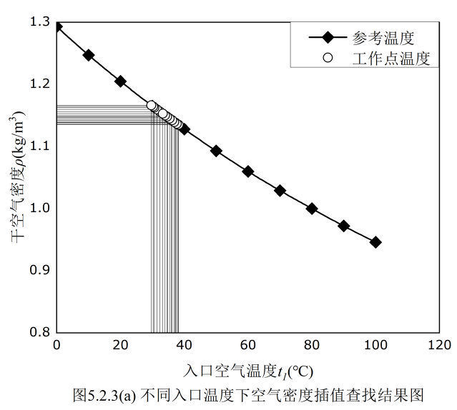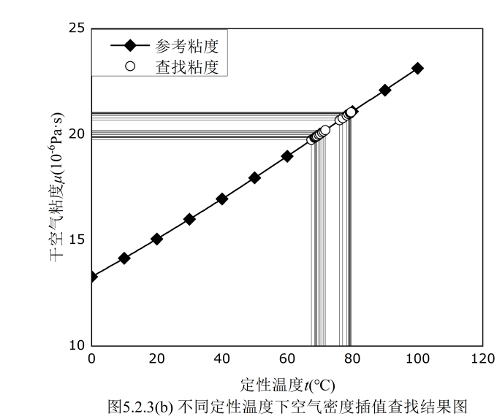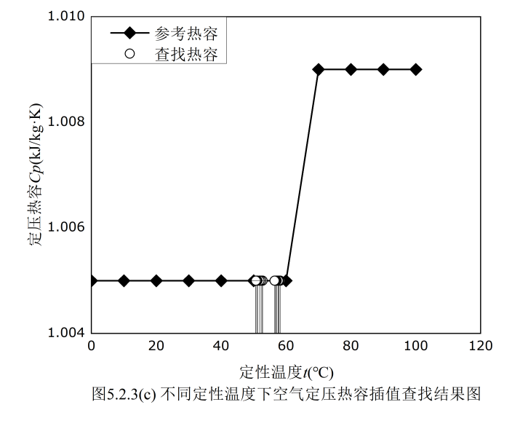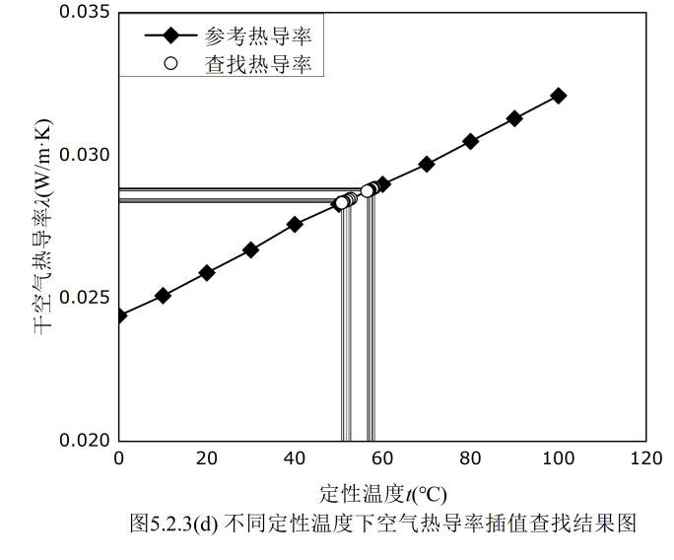

表6.1 加装静态混合器前后管内空气流动雷诺数Re
与拟合变量Nu/Pr^{0.4}关系拟合结果汇总表
实验 | 斜率 | 截距 | 系数 | 拟合结果关系式
装置 | m | lgA | A | Nu=ARe^{m}Pr^{0.4}
无相变强制对流经验公式理论值 | 0.800 | -1.638 | 0.023 | Nu=0.023Re^{0.800}Pr^{0.4}
无静态混合器 | 0.801 | -1.642 | 0.023 | Nu=0.023Re^{0.801}Pr^{0.4}
有静态混合器 | 0.846 | -1.702 | 0.020 | Nu=0.020Re^{0.846}Pr^{0.4}


