

**SECD2523-DATABASE**

**20242025 – SEMESTER 1**

**PHASE 3**

**Conceptual Design**

**FACULTY OF MJIIT**

|  |  |
| --- | --- |
| **NAME** | **MATRIC ID** |
| **Liu Ruoyang** | **A23MJ4022** |
| **Pranto Anik Islam** | **A23MJ4024** |
| **Kahlan Sultan** | **A23MJ4021** |
| **Bu Guoshun** | **A23MJ4019** |
| **Saumik Hasan** | **A23MJ3009** |

1. **ERD Design**

The conceptual Entity-Relationship Diagram is designed to model the hospital management system by capturing entities, attributes, relationships, and their cardinalities. The design adheres to the system requirements outlined in Phase 2.

**Explanation of Relationships**

1. **Staff - Subclasses (Doctor, Nurse)**:

**Constraint**: Optional, Disjoint (OR)

**Explanation**: Every Staff member can be a Doctor, a Nurse, etc. (Optional) A Staff member cannot be both Doctor and Nurse(OR).

1. **Patient - Appointment**:

**Relationship Name**: Has

**Multiplicity**: 0..1 (Patient) to 1..* (Appointment)

**Explanation**: A Patient can have multiple Appointments or none, but each Appointment must be linked to one Patient.

1. **Doctor - Appointment**:

**Relationship Name**: Schedules

**Multiplicity**: 0..1 (Doctor) to 1..* (Appointment)

**Explanation**: A Doctor can schedule multiple Appointments or none, but each Appointment is managed by one Doctor.

1. **Patient - Treatment**:

**Relationship Name**: Receives

**Multiplicity**: 1..1 (Patient) to 1..* (Treatment)

**Explanation**: A Patient can undergo one or multiple Treatments, but each Treatment is associated with one Patient.

1. **Doctor - Treatment**:

**Relationship Name**: Provides

**Multiplicity**: 1..1 (Doctor) to 1..* (Treatment)

**Explanation**: A Doctor can administer one or multiple Treatments, but each Treatment is conducted by one Doctor.

1. **Patient - Bill**:

**Relationship Name**: Pays

**Multiplicity**: 1..1 (Patient) to 1..* (Bill)

**Explanation**: Each Patient can generate one or multiple Bills, but each bill belongs to one patient.

1. **Patient - LabTest**:

**Relationship Name**: Undergoes

**Multiplicity**: 0..1 (Patient) to 1..* (LabTest)

**Explanation**: A Patient can undergo multiple LabTests or none, but each LabTest must be associated with one Patient.

1. **LabTest - Department**:

**Relationship Name**: ConductedIn

**Multiplicity**: 1..* (LabTest) to 0..1 (Department)

**Explanation**: Each LabTest is performed in one Department, but a Department may conduct many or may not conduct LabTests.

1. **Patient - Visitor**:

**Relationship Name**: VisitedBy

**Multiplicity**: 0..1 (Patient) to 1..* (Visitor)

**Explanation**: A Patient can have multiple Visitors or none, but each Visitor is associated with one Patient.

1. **Treatment - Medication**:

**Relationship Name**: Prescribes

**Multiplicity**: 0..* (Treatment) to 1..* (Medication)

**Explanation**: A Treatment may require multiple Medications or none, and each Medication can be prescribed for multiple Treatments.

1. **Staff - Department**:

**Relationship Name**: AssignedTo

**Multiplicity**: 1..* (Staff) to 1..1 (Department)

**Explanation**: A Staff must be assigned to one Department, but a department can have one or multiple Staffs.

The ERD is shown below. 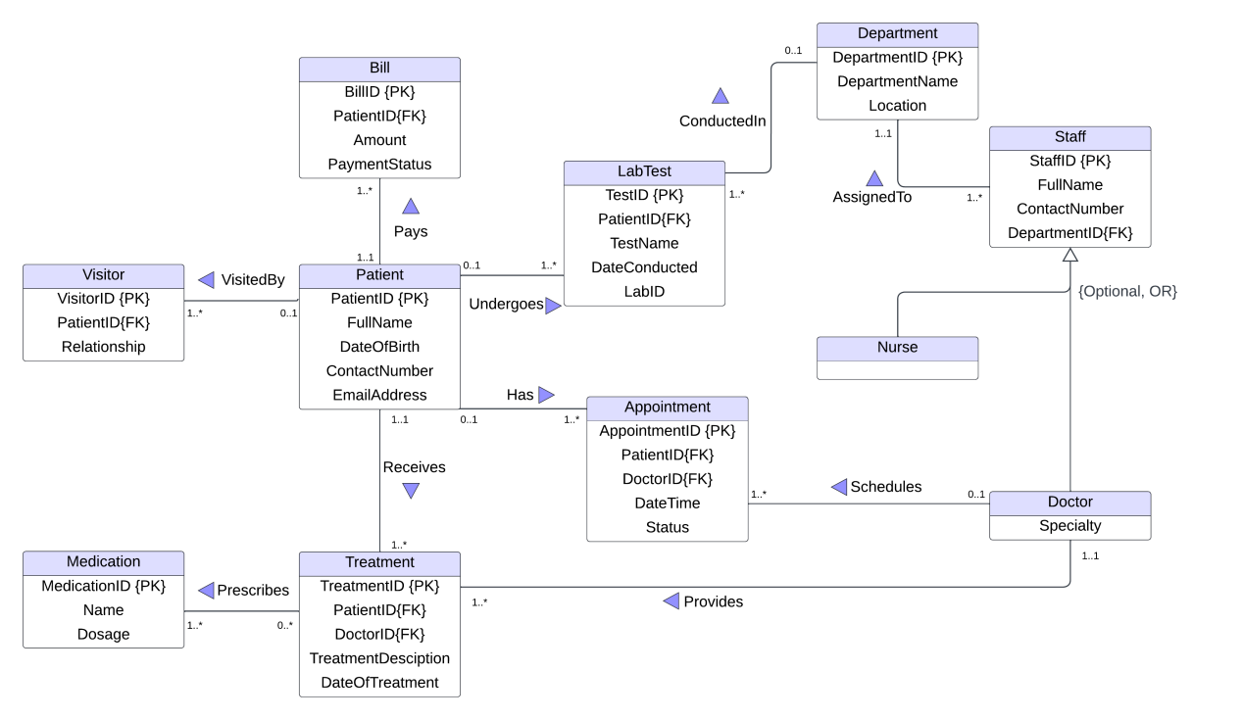

**Data Dictionary**

**Overview**

The Data Dictionary provides a detailed description of the entities, attributes, primary keys (PK), foreign keys (FK), and their roles in the database schema for the hospital management system.

**Entities and Attributes:**

**Patient:**

1. **PatientID (PK): Unique identifier for each patient.**
2. **Name: Full name of the patient.**
3. **DOB: Date of birth of the patient.**
4. **ContactNumber:Phone number of patient**
5. **EmailAddress:Patient’s email**

**Visitor:**

1. **VisitorID(PK):Unique identifier for each visitor**
2. **PatientID(FK):Unique identifier for each patient**
3. **Relationship:Visitor-patient relationship**

**Appointment:**

1. **AppointmentID (PK): Unique identifier for each appointment.**
2. **PatientID (FK): Links to PatientID in the Patient entity.**
3. **DoctorID (FK): Links to DoctorID in the Doctor entity.**
4. **Date Time: Date of the appointment.**
5. **Status:The specific location of the reservation**

**Doctor:**

1. **DoctorID (PK): Unique identifier for each doctor.**
2. **Name: Full name of the doctor.**
3. **Specialization: Area of expertise of the doctor.**

**Treatment:**

* 1. **TreatmentID (PK): Unique identifier for each treatment.**
  2. **PatientID (FK): Links to PatientID in the Patient entity.**
  3. **DoctorID (FK): Links to DoctorID in the Doctor entity**
  4. **Details: Description of the treatment provided**
  5. **DOB: Date of birth of the patient**

**Bill:**

1. **BillID (PK): Unique identifier for each bill.**
2. **PatientID (FK): Links to PatientID in the Patient entity.**
3. **Amount: Total amount charged.**
4. **PaymentStatus:Pay specific location**

**LabTest:**

1. **LabTestID (PK): Unique identifier for each lab test.**
2. **PatientID (FK): Links to PatientID in the Patient entity.**
3. **TestName:Name of test**
4. **DateConducted:date for lab test**
5. **LabID:Unique identifier for each lab**

**Department:**

1. **DepartmentID (PK): Unique identifier for each department.**
2. **Name: Name of the department.**
3. **Location:Department location**

**Medication:**

1. **MedicationID (PK): Unique identifier for each medication.**
2. **Name: Name of the medication.**
3. **Details: Description of the medication.**

**Staff:**

1. **StaffID (PK): Unique identifier for each staff.**
2. **DepartmentID (FK): Links to DepartmentID in the Department entity.**
3. **FullName: Full name of the staff.**
4. **ContactNumber：Phone number of staff**

| ****Entity**** | ****Attribute**** | ****Key (PK/FK)**** | ****Description**** | ****Data Type**** |
| --- | --- | --- | --- | --- |
| **Patient** | PatientID | PK | Unique identifier for each patient | INTEGER |
|  | Name |  | Full name of the patient | VARCHAR(100) |
|  | DOB |  | Date of birth of the patient | DATE |
|  | Gender |  | Gender of the patient | CHAR(1) |
|  | ContactNumber |  | Phone number of the patient | VARCHAR(15) |
|  | EmailAddress |  | Patient's email address | VARCHAR(100) |
|  |  |  |  |  |
| **Visitor** | VisitorID | PK | Unique identifier for each visitor | INTEGER |
|  | PatientID | FK | Foreign key referencing PatientID | INTEGER |
|  | Relationship |  | Relationship of the visitor to the patient | VARCHAR(50) |
|  |  |  |  |  |
| **Appointment** | AppointmentID | PK | Unique identifier for each appointment | INTEGER |
|  | PatientID | FK | Foreign key referencing PatientID | INTEGER |
|  | DoctorID | FK | Foreign key referencing DoctorID | INTEGER |
|  | DateTime |  | Date and time of the appointment | TIMESTAMP |
|  | Status |  | Status of the appointment | VARCHAR(20) |
| **Doctor** | DoctorID | PK | Unique identifier for each doctor | INTEGER |
|  | Name |  | Full name of the doctor | VARCHAR(100) |
|  | Specialization |  | Area of expertise | VARCHAR(100) |
|  |  |  |  |  |
| **Treatment** | TreatmentID | PK | Unique identifier for each treatment | INTEGER |
|  | PatientID | FK | Foreign key referencing PatientID | INTEGER |
|  | DoctorID | FK | Foreign key referencing DoctorID | INTEGER |
|  | Details |  | Description of the treatment provided | TEXT |
|  |  |  |  |  |
| **Bill** | BillID | PK | Unique identifier for each bill | INTEGER |
|  | PatientID | FK | Foreign key referencing PatientID | INTEGER |
|  | Amount |  | Total amount charged | DECIMAL(10,2) |
|  | PaymentStatus |  | Payment status (e.g., Paid, Pending) | VARCHAR(20) |
|  |  |  |  |  |
| **LabTest** | LabTestID | PK | Unique identifier for each lab test | INTEGER |
|  | PatientID | FK | Foreign key referencing PatientID | INTEGER |
|  | DepartmentID | FK | Foreign key referencing DepartmentID | INTEGER |
|  | TestName |  | Name of the lab test | VARCHAR(100) |
|  | DateConducted |  | Date of the lab test | DATE |
| **Department** | DepartmentID | PK | Unique identifier for each department | INTEGER |
|  | Name |  | Name of the department | VARCHAR(100) |
|  | Location |  | Department location | VARCHAR(100) |
|  |  |  |  |  |
| **Medication** | MedicationID | PK | Unique identifier for each medication | INTEGER |
|  | Name |  | Name of the medication | VARCHAR(100) |
|  | Details |  | Description of the medication | TEXT |
|  |  |  |  |  |
| **Staff** | StaffID | PK | Unique identifier for each staff | INTEGER |
|  | DepartmentID | FK | Foreign key referencing DepartmentID | INTEGER |
|  | FullName |  | Full name of the staff | VARCHAR(100) |
|  | ContactNumber |  | Phone number of the staff | VARCHAR(15) |
|  |  |  |  |  |
| **Nurse** | NurseID | PK | Unique identifier for each nurse | INTEGER |
|  | DepartmentID | FK | Foreign key referencing DepartmentID | INTEGER |
|  | Name |  | Full name of the nurse | VARCHAR(100) |