SMART WALKING STICK

A Final Project Presented to the Faculty of the College of Engineering
Laguna State Polytechnic University
Siniloan, Laguna

In Partial Fulfillment of the Requirements for the Subject
CPE16 Embedded System
Bachelor of Science in Computer Engineering

By:
Cordonato, Jhudiel F.
Valera, Ezekiel Vancleo I.
December 2025
Chapter 1: INTRODUCTION
Problem Statement
Visually impaired individuals encounter significant difficulty in navigating their surroundings due to the inability to visually detect obstacles such as walls, posts, and objects along walkways. Traditional white canes rely on physical contact, which may result in delayed hazard awareness and possible accidents. Affordable assistive technologies remain limited, especially for low-income users.

Objectives
The main objective of this project is to design and develop a low-budget smart walking stick that assists visually impaired users in obstacle detection. Specifically, the project aims to
- Provide immediate alerts through sound and vibration;
- Utilize low-cost, locally available components; and
- Improve user safety and mobility.

Proposed Solution
The proposed solution is a smart walking stick constructed using a PVC pipe body integrated with an Arduino Uno, ultrasonic sensor, piezoelectric buzzer, and vibration motor. When an obstacle is detected within a preset distance, the system alerts the user through audio and tactile feedback.

Project Scope
The system is limited to forward obstacle detection only. It provides alerts using sound and vibration but does not include GPS navigation, object recognition, mobile application connectivity, or camera-based detection.

Chapter 2: SYSTEM DESIGN AND METHODOLOGY
Block Diagram
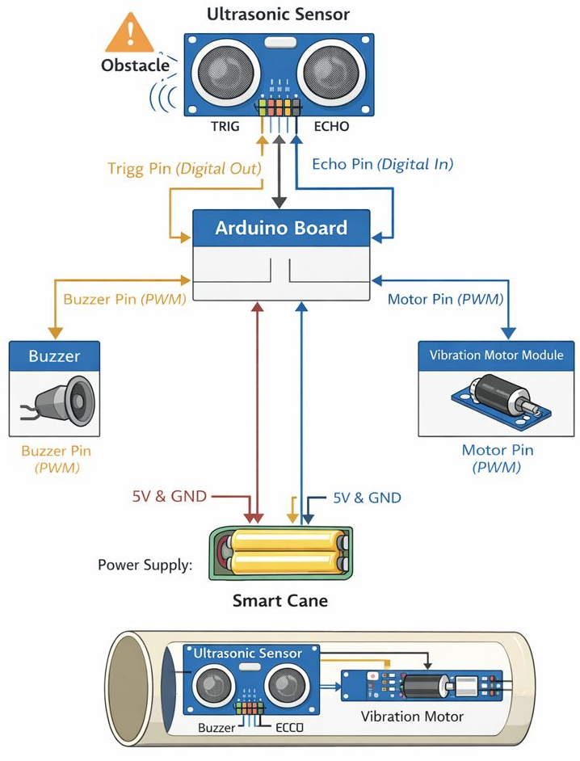

- Component Selection & Justification
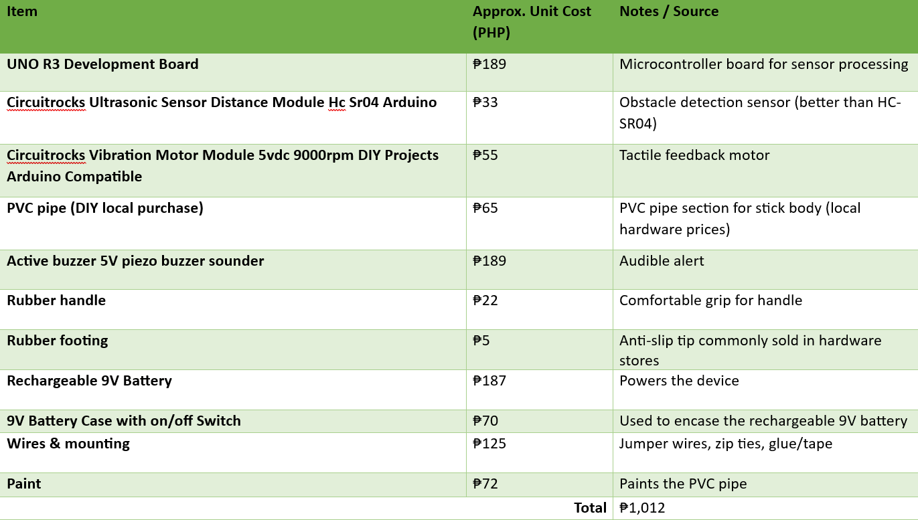
- Circuit Schematic:
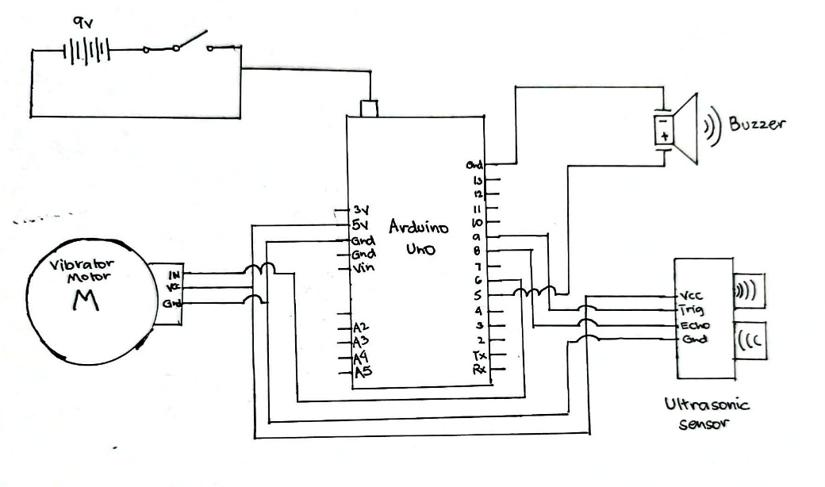

Chapter 3: HARDWARE IMPLEMENTATION
- Hardware Setup
The PVC pipe was cut to the appropriate length to function as the walking stick body. The ultrasonic sensor was mounted at the front-facing section to detect obstacles ahead. The Arduino Uno, battery, and wiring were installed inside the pipe. Wiring issues such as loose connections were addressed using secure soldering and insulation. The rubber handle grip and footing were attached to enhance comfort and stability.

- Pin Configuration Table
Pin Name | Arduino Pin | Type | Component Connected | Function / Description
trigPin | D9 | Digital Output | Ultrasonic Sensor (TRIG) | Sends trigger pulse to start distance measurement
echoPin | D8 | Digital Input | Ultrasonic Sensor (ECHO) | Receives echo pulse to calculate distance
buzzer | D5 (PWM) | PWM Output | Buzzer | Generates sound alert with variable intensity
motorIN | D6 (PWM) | PWM Output | Vibration Motor Module | Controls vibration intensity using PWM
VCC | 5V | Power | Ultrasonic Sensor, Buzzer, Motor Module | Supplies power to components
GND | GND | Ground | All Components | Common ground reference

Chapter 4: SOFTWATE IMPLEMENTATION
- Software Flowchart: Include a flowchart illustrating the main program logic

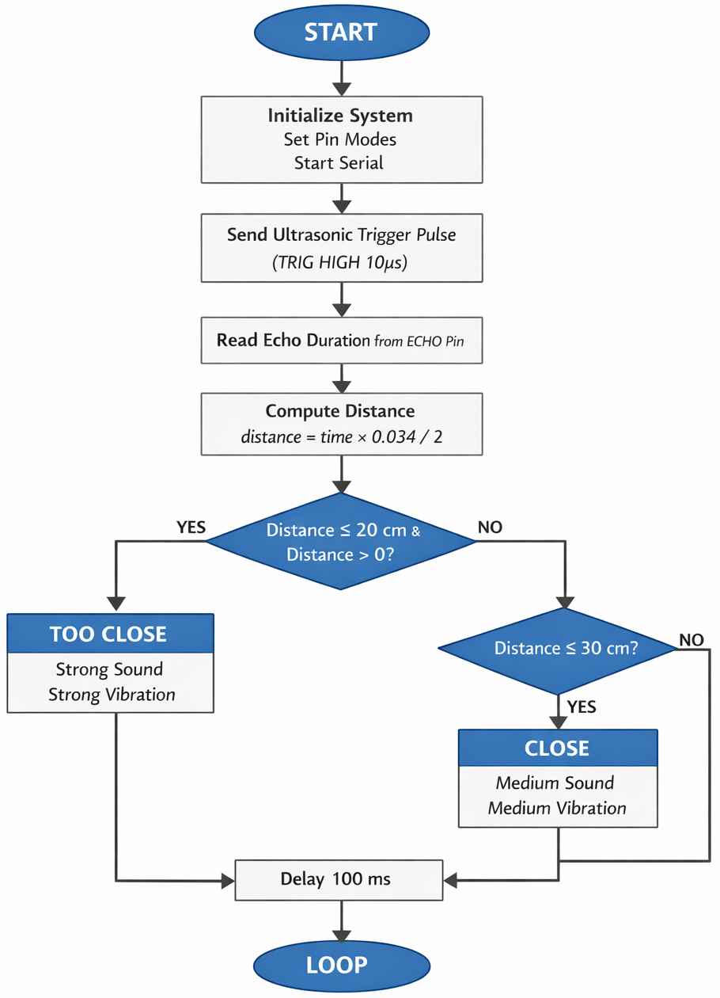
- Algorithm & Logic: Explain the control logic.
The Arduino continuously sends trigger pulses to the ultrasonic sensor and measures the echo time to compute distance. If the detected distance is below the defined threshold, the buzzer and vibration motor are activated. Otherwise, the system remains idle.

- Key Code Snippets:
#define trigPin 9
#define echoPin 8
#define buzzer 5
#define motorIN 6

long duration;
int distance;

void setup() {
pinMode(trigPin, OUTPUT);
pinMode(echoPin, INPUT);
pinMode(buzzer, OUTPUT);
pinMode(motorIN, OUTPUT);
Serial.begin(9600);
}

// --- Stronger vibration functions ---
void vibrateMedium() {
analogWrite(motorIN, 200);
}

void vibrateStrong() {
analogWrite(motorIN, 255); // kick-start
delay(25);
analogWrite(motorIN, 230); // sustain strong vibration
}

void loop() {
// Send ultrasonic pulse
digitalWrite(trigPin, LOW);
delayMicroseconds(2);
digitalWrite(trigPin, HIGH);
delayMicroseconds(10);
digitalWrite(trigPin, LOW);

duration = pulseIn(echoPin, HIGH);
distance = duration * 0.034 / 2;

Serial.print("Distance: ");
Serial.println(distance);

if (distance <= 20 && distance > 0) {
// TOO CLOSE
analogWrite(buzzer, 200); // stronger sound
vibrateStrong(); // stronger vibration
}
else if (distance > 20 && distance <= 30) {
// CLOSE
analogWrite(buzzer, 120); // medium sound
vibrateMedium(); // stronger medium vibration
}
else {
// SAFE → OFF
analogWrite(buzzer, 0);
analogWrite(motorIN, 0);
}

delay(100);
}

- Libraries Used: List all external libraries
Arduino Core Library
Chapter 5: TESTING AND RESULT
- Functional Testing
Each component was tested individually prior to system integration. The ultrasonic sensor was tested at various distances, while the buzzer and vibration motor were tested for responsiveness.

- Results & System Performance
The system successfully detected obstacles within the defined range and produced immediate alerts. The alerts stopped once obstacles were no longer detected.

- Discussion
The system performed as expected under normal conditions. Minor inaccuracies occurred with soft or angled surfaces, which is a known limitation of ultrasonic sensors.

Chapter 6: CONCLUSION AND FUTURE WORK
- Conclusion
The project successfully developed a low-cost smart walking stick that enhances the safety and mobility of visually impaired users. All project objectives were met.

- Challenges Faced
Key challenges included space limitations inside the PVC pipe, cable management, and power optimization.

- Future Enhancements
Future improvements may include adjustable alert intensity, additional sensors for wider coverage, rechargeable lithium batteries, and wireless connectivity features.

FINAL PROJECT RUBRICS
Subject: ___________________________
Criteria | Excellent | Good | Fair | Poor | Final Rating
1. Hardware Design & Implementation (25%) | Hardware fully functional, optimized, safe, and well-documented  (21-25%) | Minor issues but meets objectives.  (16%-20%) | Partially functional, design flaws present.  (11%-15%) | Major errors, unsafe or incomplete. (0%-10%)
2. Software Development & Integration (25%) | Software runs flawlessly, well-structured, integrates smoothly.  (21-25%) | Minor bugs, integration mostly successful.  (16%-20%) | Frequent errors, weak integration.  (11%-15%) | Non-functional or incomplete.  (0%-10%)
3. Innovation & Problem-Solving (15%) | Highly innovative, unique solution.  (13-15%) | Some originality, practical approach.  (10%-12%) | Limited creativity, conventional solution.  (7%-9%) | No innovation, copied design.  (0%-6%)
4. Documentation & Reporting (15%) | Clear, detailed, professional documentation.  (13-15%) | Mostly complete, minor gaps.  (10%-12%) | Incomplete or unclear.  (7%-9%) | Minimal or missing documentation.  (0%-6%)
5. Presentation & Demonstration (10%) | Clear, engaging, confident, demo successful.  (8-10%) | Understandable, minor issues in demo.  (6-7%) | Weak delivery, demo partially works.  (4-5%) | Unclear, demo fails. (0-3%)
6. Teamwork & Project Management  (10%) | Strong collaboration, well-managed timeline.  (8-10%) | Minor coordination issues.  (6-7%) | Unequal contributions, weak management.  (4-5%) | Poor teamwork, disorganized.  (0-3%)

Total : _______
Performance Levels:
Total: 100%
- 90–100 (Outstanding) Project exceeds expectations, highly professional.
- 75–89 (Proficient) Meets most objectives with minor issues.
- 60–74 (Developing) Partial success, significant improvements needed.
- <60 (Needs Improvement) Project incomplete or fails to meet objectives.

