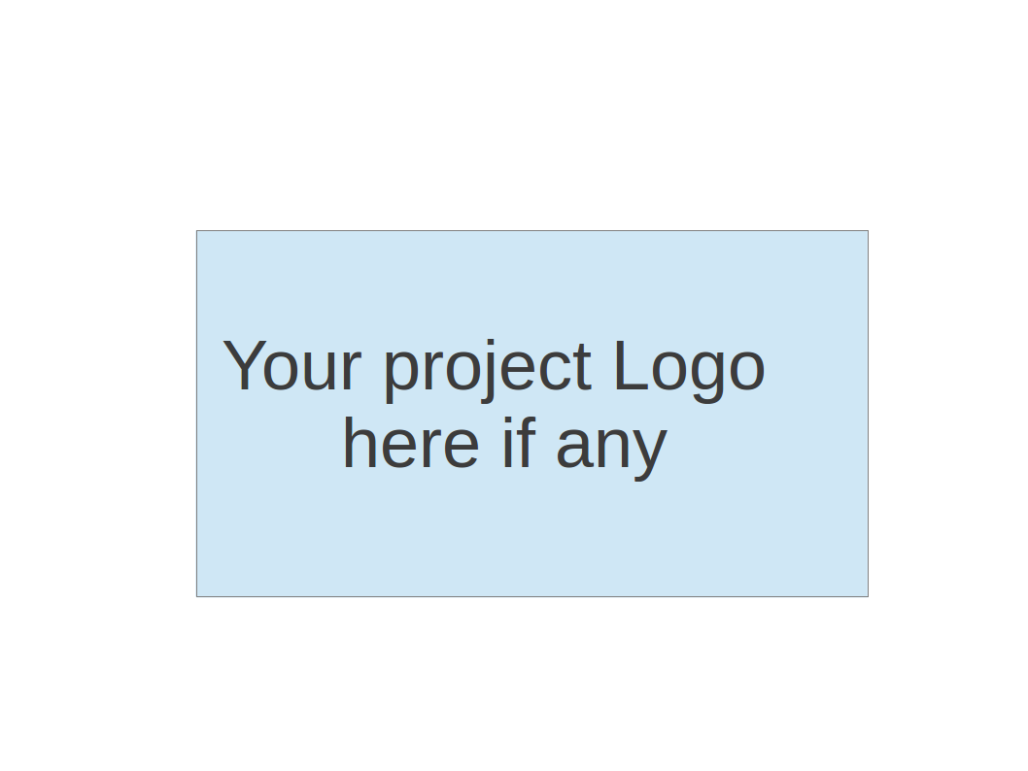
CS673 Software Engineering
Team 2 - Massachusetts Bay Transportation Authority (MBTA) tracker
Project Proposal and Planning

Team Member | Role(s) | Signature | Date
Wenbo Fan | Team Leader  Security Leader | Wenbo Fan | 2026/09/27
Yuexian Feng (Luna) | Requirement Leader | Yuexian Feng | 09/27/2026
The Anh Tran (Bill) | Design and Implementation Leader | The Anh Tran | 09/27/2026
Yuchen Bao | Configuration leader | Yuchen Bao | 2026/09/27
Zhiao Chu | QA Leader | Zhiao Chu | 2026/09/27

Revision history
Version | Author | Date | Change
0 | Wenbo Fan  Yuchen Bao | 09/27/2026 | Initial project proposal and planning document
1 | Wenbo Fan | 10/25 | Detailing the Function for Iteration 1

1. Overview
2. Related Work
3. Proposed High level Requirements
4. Management Plan
a. Objectives and Priorities
b. Risk Management (need to be updated constantly)
c. Timeline (this section should be filled in iteration 0 and updated at the end of each later iteration)
5. Configuration Management Plan
a. Tools
c. CI/CD Plan
6. Quality Assurance Plan
a. Metrics
c. Code Review Process
d. Testing
e. Defect Management
7. AI usage Log
8. Project Links
9. References
10. Glossary

Overview
We are building a responsive web application for students, commuters and visitors who need to choose stations, check upcoming trains and understand disruptions. A Boston University student can select an origin and BU Central as the destination, inspect the next available Green Line B departures and review alerts affecting the journey. The application runs in a desktop or mobile browser; native Android, iOS and desktop applications are outside the current scope.
The current code uses Next.js 16.3.8 with its App Router, React and React DOM 19.2.8, JavaScript modules, global CSS and CSS Modules. Node.js 22 is the Docker runtime, npm installs the committed package-lock.json, and ESLint 9 with eslint-config-next provides static lint checks. React components render the interface and an SVG subway map. Next.js route handlers provide the server-side API layer within the same application.
MBTA V3 is the source for live predictions, vehicles, alerts, schedules and route topology. The repository also contains a generated subway-network JSON file for the map. Our code matches trips and station sequences, filters results, orders departures and calculates countdowns. It does not train an arrival-prediction model or independently predict train movement. Schedule fallback is explicitly labeled as timetable information, and retained predictions during an outage are identified as approximate or stale.
The current journey workflow is specific to Green Line B. A wider network drawn on the map and generic Green Line API helpers do not establish complete journey support for every MBTA line. Broader route support requires additional implementation and acceptance tests.
The running application has no AI capabilities integration for now. A calendar or natural-language journey planner remains a desirable extension to investigate after essential features pass acceptance tests. If approved, a arrive time Reliability Engine will also be added here to show the reliability of each prediction arrive time.

Related Work
Transit is the comparison product identified in the original proposal. Our project focuses on a smaller MBTA browser workflow and explicit handling of missing or stale data. The distinction is scope and implementation learning; we will add prediction accuracy in later iterations. The team will review comparable departure and alert workflows when evaluating usability, while using MBTA data as the transit authority for this application.

Proposed High level Requirements
  - Functional Requirements
    - Essential Features (the core features that you definitely need to finish):
      - Route and stop discovery. As a rider, I want to select an origin and destination on a supported route so that I can check the correct service. The current B-branch workflow derives direction from the selected station order. Acceptance requires valid station identifiers, a destination later in the chosen pattern, a readable direction label and useful handling of identical or unsupported stations. Free-text search and broader route selection remain planned extensions.
      - Upcoming arrivals. As a rider, I want the next available arrivals at my selected stop, so that I can decide when to leave. Show up to three predictions in time order, destination, time/countdown and source label. Handle absent predictions, canceled/unavailable service and time-zone boundaries using fixtures; never invent an arrival.
      - Relevant service alerts. As a rider, I want alerts affecting my selected route or stop, so that I can adjust my travel. Show applicable active alert text and available effective periods, distinguish no alerts from an alert-fetch failure, and test unrelated/expired alert filtering.
      - Refresh and failure transparency. As a rider, I want visible refresh and stale-data status, so that I know whether arrivals are current. Propose a 30-second foreground refresh, manual refresh and a stale label after 90 seconds without a successful fetch. Show last successful fetch time, pause background polling and offer retry after errors. Fetch time does not guarantee upstream observation freshness.
      - Favorites. As a returning rider, I want to save and remove route/stop/direction choices locally(stored on browser cookies), so that I can reopen frequent trips.
    - Desirable Features (the nice features that you really want to have too):
      - Vehicle map. As a rider, I want available vehicle locations for my route, so that I can view service movement. Accept route filtering, timestamp/stale labels and an equivalent text view; unavailable positions must not appear live. Map provider, attribution and quota suitability are [TBD].
      - Planner. As a rider I can input my calendar or schedule to different addresses. And the application can automatically give me the plan for which train to take at which station. We could potentially add an AI API to help us give the plan.
    - Optional Features (additional cool features that you want to have if there is time):
      - Nearby stops. As a rider, I want nearby stops with optional location permission, so that I can find service around me. Accept denial handling and manual search fallback; do not retain precise location.
      - Shareable stop view. As a rider, I want a link to a route/stop/direction selection, so that another person can open the same view. Validate link parameters and handle unavailable routes gracefully.
  - Nonfunctional Requirements
    - Security requirements
      - The MBTA API key shall remain server-side and shall not appear in browser JavaScript, API responses, or committed files.
    - Reliability requirements
      - If an MBTA request fails, the application shall display an error or stale-data message and shall not label previously saved data as fresh.
    - Privacy requirements
      - When favorites are implemented, they shall store only route, station, and direction selections in browser storage, without collecting personal identity or precise location.
    - Compatibility requirements
      - Core journey selection, departure display, and refresh functions shall work in Chrome, Edge, Firefox, and mobile Safari.

Management Plan

Objectives and Priorities
(Please describe your project objectives with highest priority first. Project Goals can include but not limited to complete all proposed (essential) features, deploy the software successfully, the software has no known bugs, maintain high quality, etc )
- Complete the software with all essential features and as many desirable features as possible.
- Fix all known bugs along the development.
- Maintain a clean github repository.

Risk Management (need to be updated constantly)
Risk Management Sheet Link:
https://docs.google.com/spreadsheets/d/19Ud8ZKOAHr60J9ZxlKItetXT4bnNECfi/edit?gid=1939224981#gid=1939224981

Timeline
Iteration | Functional Requirements(Essential/Desirable/Optional) | Tasks (Cross requirements tasks) | Estimated/real total person hours
1 | Essential feature 1-3 finished, the application can be fully functional with the basic features. | Set up dev environment for everyone, set up the basic user interface, connect the MBTA API and clean the input into into usable data and set up a generally functional basic application | 60hrs/100hr
2 | Essential feature 4-5 with some chosen desirable features. | Adding more features to the application. Adjust the UI to a mobile usable size. | 60hrs
3 | Complete more desirable features. Testing and refine the application | Testing all parts of the application. Security review, debug, and improvement. And final deployment | 60hrs

Configuration Management Plan

Tools
- IDE tools: Visual Studio Code
- CI/CD tools: Github
- SAST or DAST tools:
- DevOps tools & AI tools: GitHub Copilot, ChatGPT, Google Gemini

  - Code Commit Guideline and Git Branching Strategy
Proposed guideline: use Git and GitHub to manage source code. Keep the main branch stable and create separate branches for features, bug fixes and documentation changes. Make small, focused commits with clear messages that explain the change, and reference related issues when applicable.
Before submitting a pull request, check that the code builds, follows the coding standard and passes relevant tests. Include a brief description of the changes and any necessary documentation updates. Merge into main only after peer review, resolution of blocking feedback and successful automated checks. Avoid direct changes to main and remove branches after merging.
Keep source code, tests, dependency files and project documentation under version control. Do not commit passwords, API keys, local environment files or generated build output. Use release tags to identify stable versions, and review and test AI-assisted contributions before including them.

CI/CD Plan
Proposed plan: use an automated CI/CD workflow, such as GitHub Actions, to check changes consistently and support reliable releases. On pull requests, run code-quality checks, automated tests, security scans and an application build. Address failed required checks before merging.
After changes are merged, deploy the tested build to a staging environment and verify that the main application functions work as expected. Use controlled test data for repeatable tests and check live MBTA integration separately. Release to the demo environment after team review and confirmation that the agreed quality criteria are met.
Store deployment credentials securely and keep environment settings separate from source code. Record release versions and deployment results, verify the application after deployment, and retain a previous stable version for rollback if problems occur. Hosting and deployment details remain [TBD].

Quality Assurance Plan

Metrics

The team plans to use several measurable metrics to monitor software quality and project progress. The specific metrics may be adjusted as the project develops.
Metric Name | Description
Number of Test Cases | Number of unit, integration, or other test cases created for the project.
Test Pass Rate | Percentage of executed test cases that pass successfully.
Defect Count | Number of defects identified and resolved during each iteration.
Code Coverage | Percentage of the code covered by automated tests, where applicable.
User Stories Completed | Number of planned user stories completed during each iteration.

  - Coding Standard
Use JavaScript ES modules, React function components and Hooks, Next.js App Router route handlers, and CSS Modules for component styles. Keep pure journey and schedule logic in lib, server-only MBTA access in server, and route adapters under app/api. Use camelCase for functions and variables, PascalCase for React components, descriptive identifiers and consistent existing formatting. Use the @/ alias consistently, avoid embedded secrets and hard-coded fabricated arrival data, and preserve accessibility labels and error states.
Run npm run lint with the committed ESLint configuration. Resolve newly introduced lint findings and document any pre-existing baseline issues rather than claiming the repository is lint-clean without results. Add regression tests for fixed defects and document significant AI assistance according to the repository convention. Prefer explicit error handling, validated timestamps and small functions over duplicated data transformation code.

Code Review Process
Every change entering dev or main must be reviewed through a pull request, including fixes and documentation. Individual work-in-progress commits on a feature branch do not each require separate approval; the reviewer assesses the complete pull request and rechecks material changes after feedback. At least one non-author reviewer must approve before merge.
Bill, the Design and Implementation Leader, assigns the primary reviewer for application changes. If Bill is the author, Wenbo assigns another qualified non-author reviewer. Yuchen reviews Docker, dependency and CI changes; Wenbo reviews security-sensitive changes; Zhiao checks test evidence and acceptance coverage. Luna reviews changes to requirement meaning or scope. All members review documents before course submission.
The review checklist covers requirement correctness, route/direction and time matching, freshness semantics, secret handling, input validation, readable code, accessible controls, tests and deployment impact. Reviewers label feedback as blocking or advisory and explain the expected correction. The author responds and updates the branch; the reviewer verifies blocking fixes. The designated maintainer merges only after approvals and required checks pass.

Testing

Automated unit and integration tests
The current tests/*.test.mjs suite uses node:test and node:assert/strict. Run node --test tests/*.test.mjs from the app directory. Existing files cover journey selection, train and schedule matching, map geometry and labels, automatic refresh, snapshot reuse, freshness and shared cache backoff. Developers add or update focused tests with each behavior change; Zhiao reviews coverage of acceptance criteria.
Use controlled MBTA fixtures and clocks for duplicates, canceled/skipped stops, missing destination predictions, invalid timestamps, empty data, stale retained snapshots, tab visibility, HTTP 429 and retry delays. Integration tests should verify the route-handler-to-adapter contract, status codes, partial failures and timestamp preservation. Separate deterministic checks from live MBTA smoke tests so an upstream outage does not produce a misleading code regression result.

Automated browser testing
The repository already includes manual-refresh.browser.cjs and map-labels.browser.cjs. Despite the first filename, these are scripted browser checks using the Chrome DevTools Protocol and an existing debug browser at port 9333. They exercise browser behavior with fixtures; they are not Selenium, Cypress or Playwright tests and are not currently a self-contained CI browser suite.
To address repeatable end-to-end testing, the plan is to add Playwright with a committed configuration, an application webServer command and network interception for MBTA-dependent routes. Zhiao owns the browser suite and Yuchen integrates it into CI. Cover choosing two B-branch stops, direction and three departure cards, scheduled fallback labels, relevant alerts, manual refresh, hidden-tab polling, network failure/recovery and mobile keyboard interaction. Run Chromium on pull requests and add Firefox/WebKit checks for release validation. Capture traces and screenshots on failure. This Playwright work remains planned.

Manual checks and release evidence
Developers run relevant unit checks before requesting review. The QA Leader runs integration and browser regression checks on release candidates. Each iteration also includes manual keyboard navigation, map readability, small-screen layout, loading/error messages and a live MBTA smoke test. The Requirement Leader verifies user-story acceptance. Record executed results, environment, known failures and screenshots in the iteration report; do not infer a pass from the existence of test files.

Defect Management
Use GitHub Issues for defects and link the affected Jira story when available. Record a concise summary, reproduction steps, expected and actual behavior, commit, browser/viewport, severity and sanitized evidence. Never attach API keys or private environment files. Include functional, API/data, freshness, UI/accessibility, security and deployment defects.
Zhiao triages new reports and assigns a developer with Bill. Critical defects include exposed credentials or unusable core service; high defects include misleading journey information or a broken essential workflow; medium and low defects cover limited impact or cosmetic problems. Wenbo prioritizes security incidents. Track Open, In progress, Ready for retest and Closed states through labels or the issue board. The fix author links a pull request and regression test; QA retests the original steps and closes only after verification. Reopen failures and report accepted residual risks before release.

AI usage Log
(This table summarizes AI contribution in this document)
Section | Who | AI contribution (%) | Description | Verified by
Configuration Management Plan | Wenbo Fan | 80% | Ask Chatgpt to make up a proper guideline for commit and CI/CD plan | Yuchen Bao
Quality Assurance Plan | Yuchen Bao | 60% | Based on the MBTA Tracker and the basic features needed, ask ChatGPT the proper way to make a clear testing plan specifically for the project. | Wenbo Fan

Project Links
Github link: https://github.com/BUMETCS673/CS673A1F26P2
Project management tool link (e.g. Jira): None

References
(Any references/citations that you have used)

Open API Provided by Massachusetts Bay Transportation Authority:
Website: https://www.mbta.com/developers/v3-api
Documentation: https://api-v3.mbta.com/docs/swagger/index.html

Glossary
(Any acronym used in the document should be explained here)
MBTA: Massachusetts Bay Transportation Authority

