CS673 Software Engineering
Team 2 - MBTA
Software Test Document

Team Member | Role(s) | Signature | Date
The Anh Tran | Design & Implementation Leader | The Anh Tran | 10/25/2026
Wenbo Fan | Team Leader  Security Leader | Wenbo Fan | 10/25/2026
Yuexian Feng | Requirement Leader | Yuexian Feng | 10/25/2026
Yuchen Bao | Configuration leader | Yuchen Bao | 10/25/2026
Zhiao Chu | QA Leader | Zhiao Chu | 10/25/2026

Revision history
Version | Author | Date | Change
0 | The Anh Tran | 10/25/2026 | Initial Documentation
1 | Yuexian Feng | 10/26/2026 | Performed manual and automated testing, recorded results, and updated the STD.

Testing Summary
Manual Tests Reports
Automated Testing Report
Testing Metrics
AI usage Log
References
Glossary

Testing Summary

The purpose of testing is to make sure the MBTA Green Line B Tracker works correctly and meets the project requirements.

Our team tested the main features of the application, including homepage loading, subway map display, station selection, journey planning, arrival predictions, and service alerts.

Manual testing was used to check the user interface and application functions. Automated testing was used to verify the existing code and API-related functions.

During Iteration 1, we completed 6 manual tests and 37 automated tests. All 43 tests passed, with no failures found during this testing session. However, some scenarios, such as displaying active service alerts, were not tested.

Manual Testing Report
Test Case ID: TC-01
Test Name: Homepage Loading
New or Old: New
Test Type: System Testing (Manual)
Test Item: MBTA Tracker Homepage
Priority: High
Dependencies: None
Preconditions: The application is running locally.
Test Input: http://localhost:3000
Test Steps:
- Start the application using npm run dev.
- Open Chrome.
- Navigate to the homepage.
- Check whether the subway map and journey planner are displayed.
Expected Result: The homepage loads successfully and displays the subway map and journey planner.
Actual Result: The homepage loaded successfully. The subway map and journey planner were displayed correctly.
Postconditions: The homepage remains open and ready for user interaction.
Status: PASS
Bug ID: N/A
Notes: No visible errors were found during the test.
Evidence: TC-01_Homepage_PASS.png
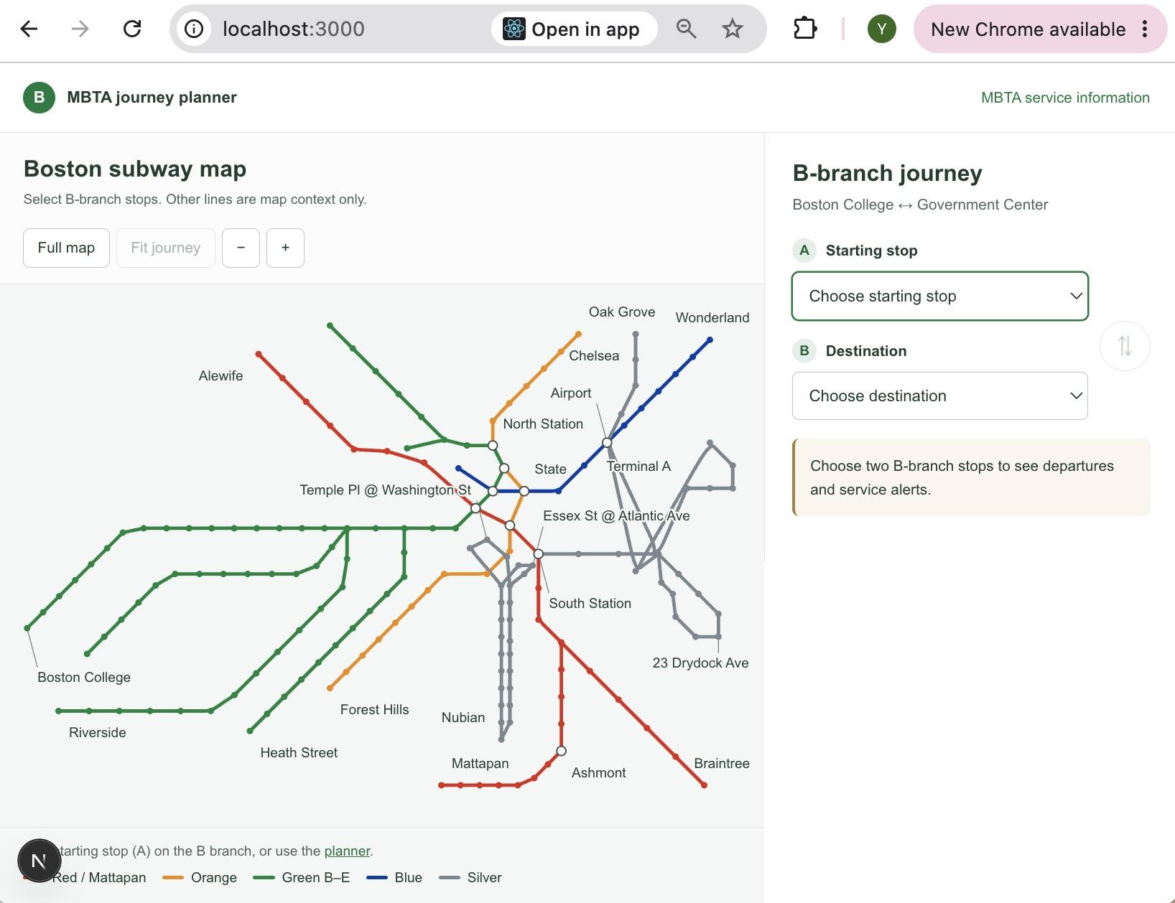
Test Case ID: TC-02
Test Name: Subway Map Display and Interaction
New or Old: New
Test Items: Subway map display, zoom in, zoom out, and map dragging.
Test Priority: High
Dependencies: TC-01 Homepage Loading
Preconditions: The MBTA Tracker application is running locally.
Input Data: Mouse clicks and dragging actions.
Test Steps:
- Open the MBTA Tracker homepage.
- Check whether the subway map is displayed.
- Click the "+" button to zoom in.
- Click the "−" button to zoom out.
- Drag the map using the mouse.
Postconditions: The map remains displayed and interactive.
Expected Output: The subway map loads correctly and supports zooming and dragging.
Actual Output: The map displayed correctly. Zoom in, zoom out, and dragging worked as expected.
Pass or Fail: PASS
Bug ID/Link: N/A
Additional Notes: No issues were found during testing. Screenshots were captured as evidence.

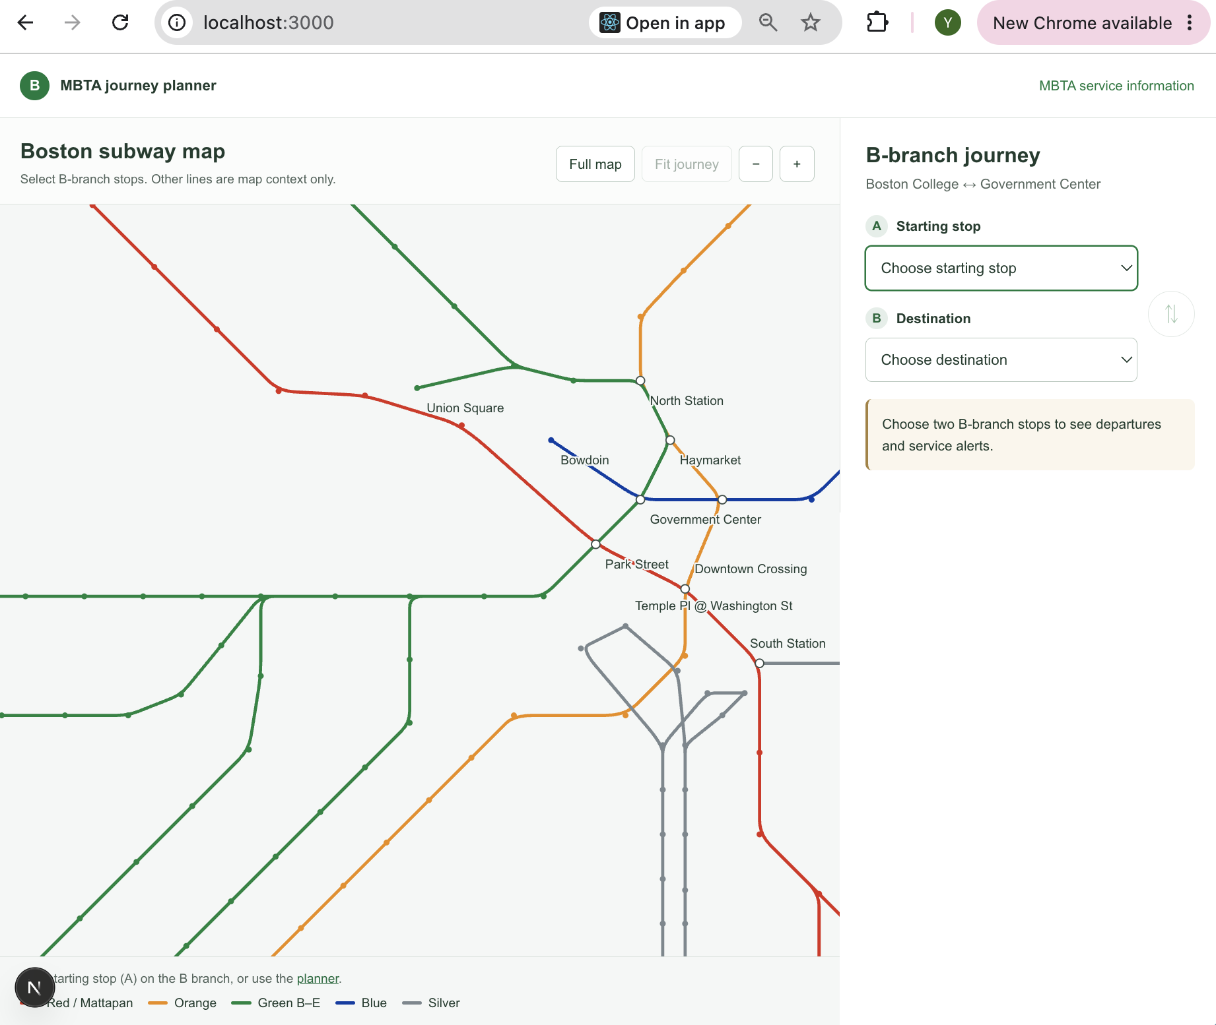
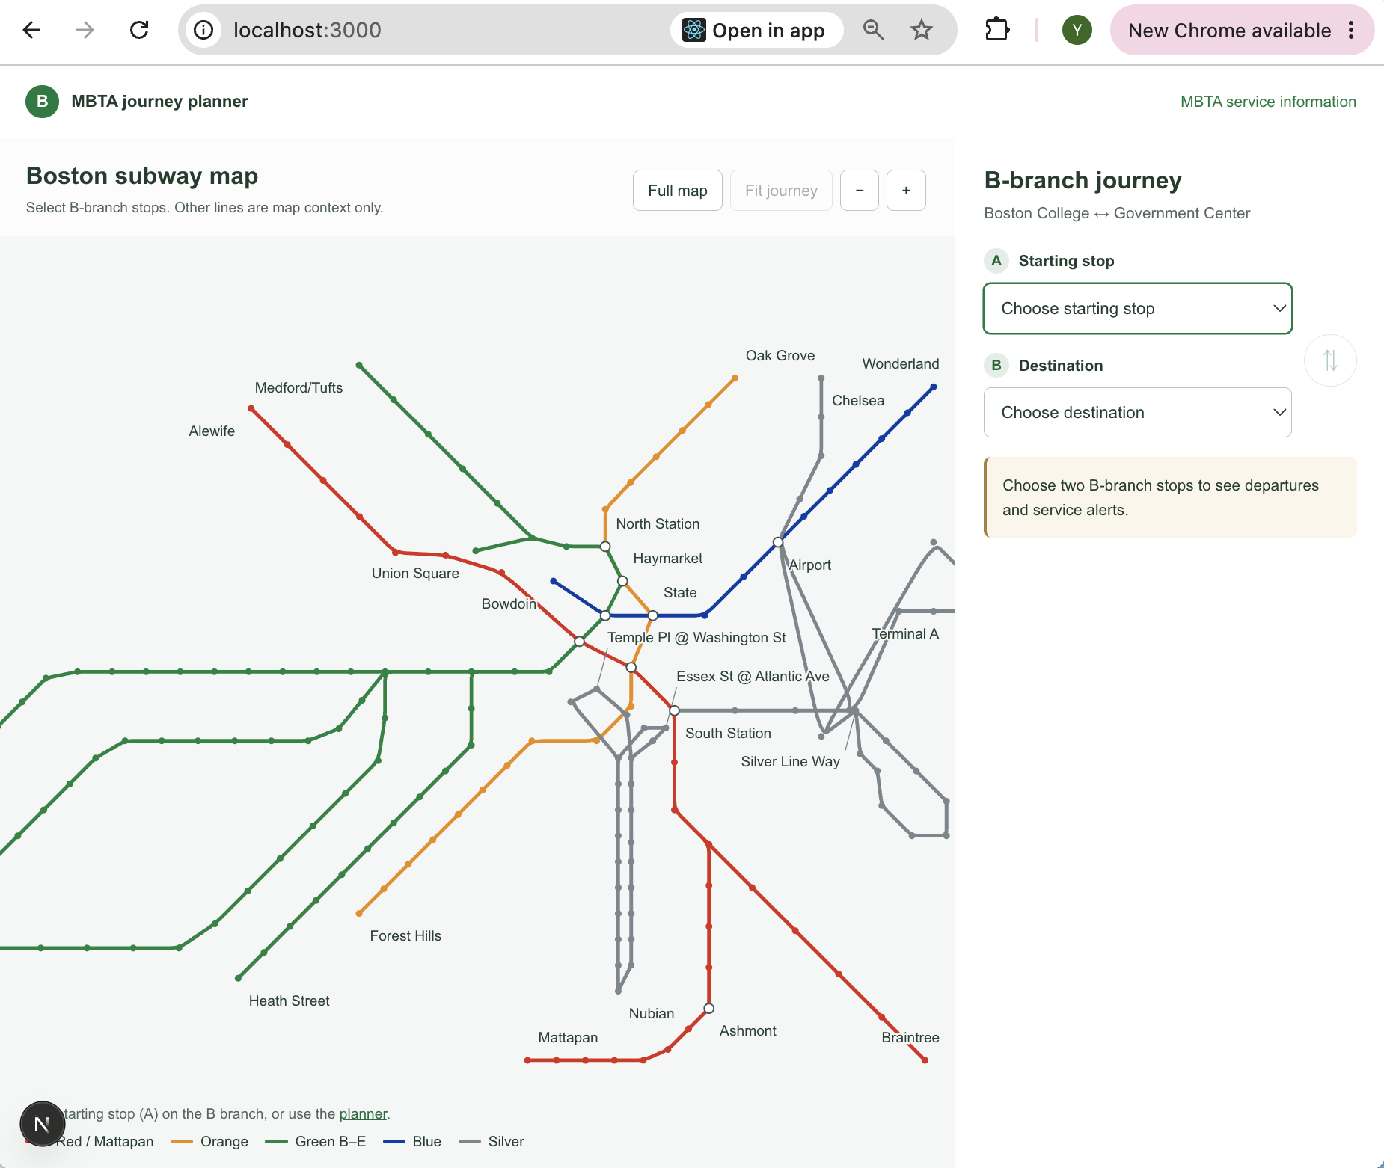
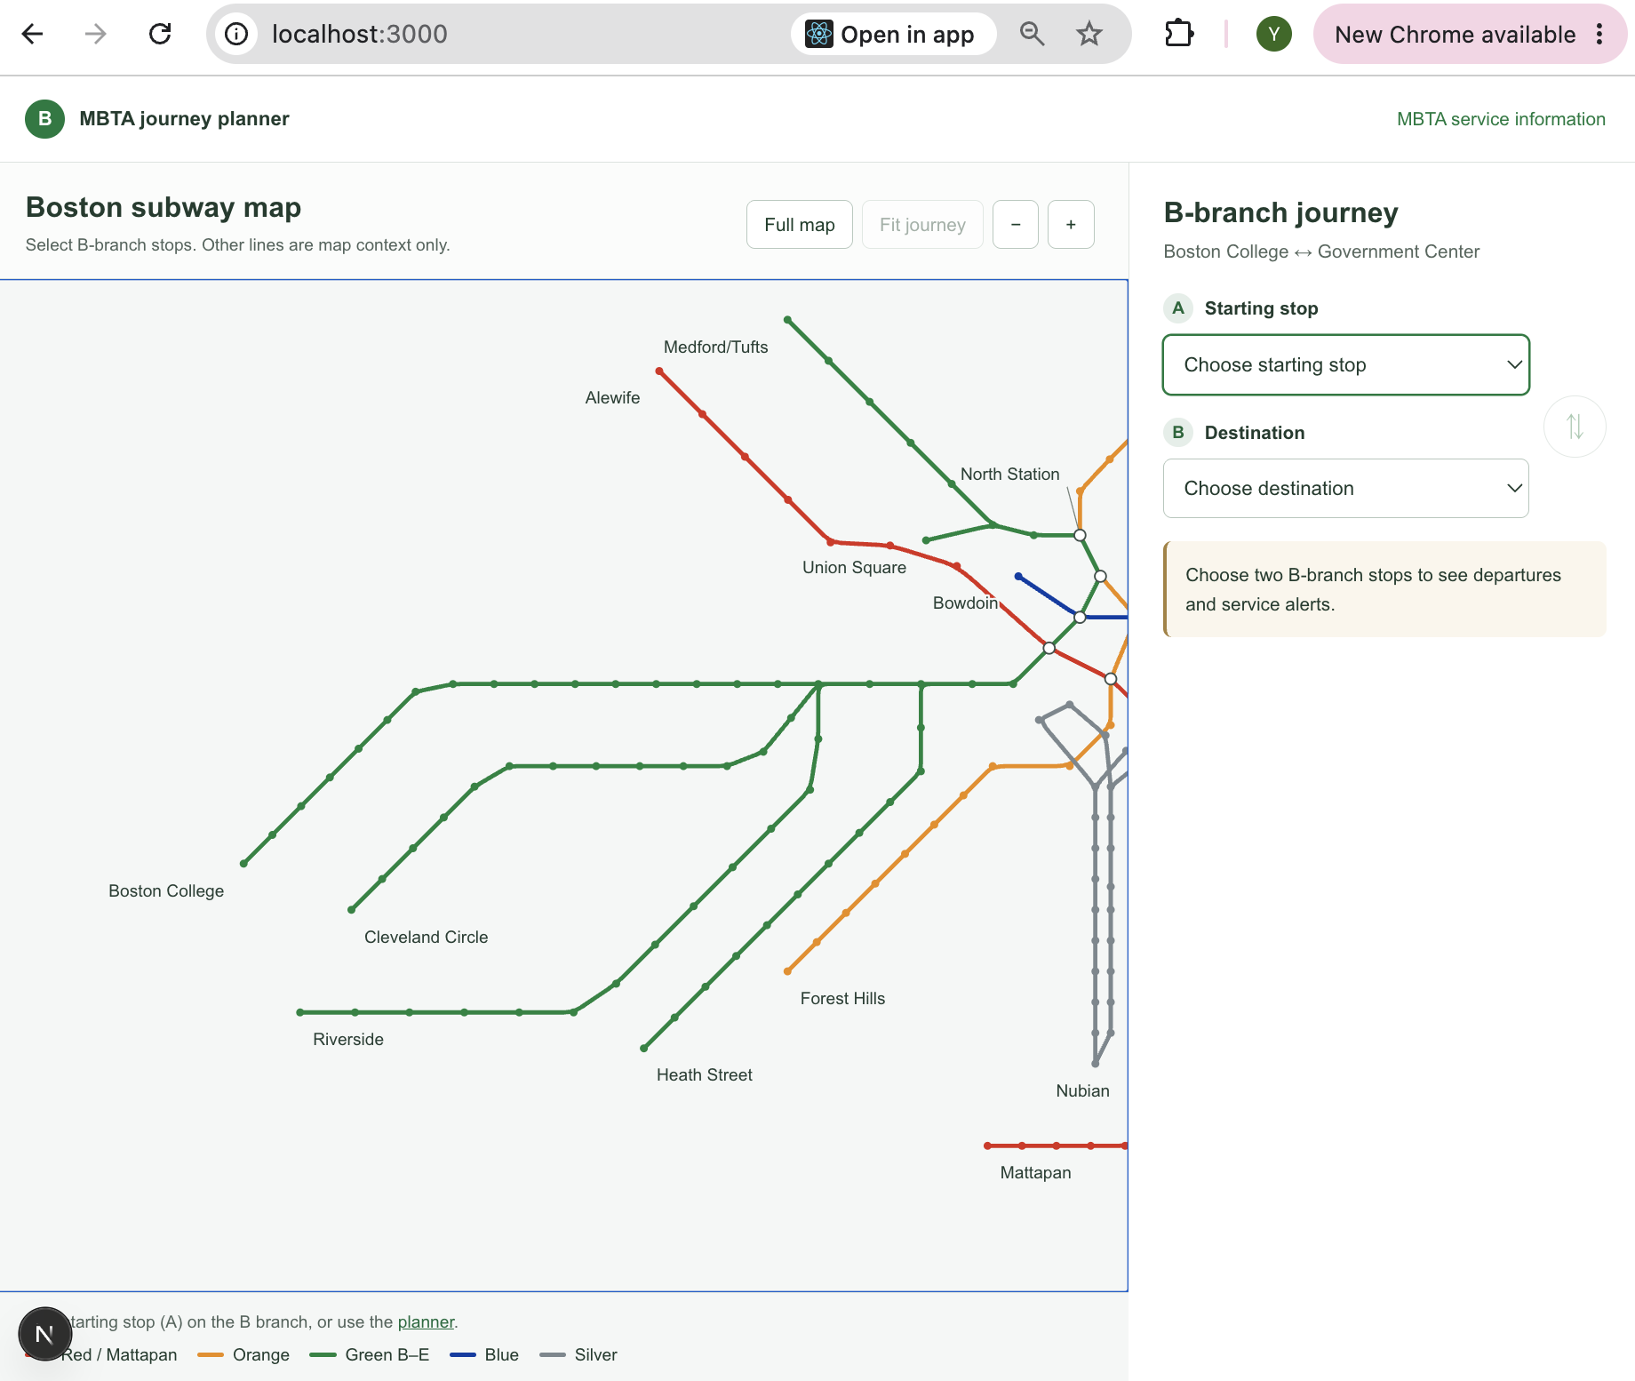

Test Case ID: TC-03
Test Name: Station Selection
New or Old: New
Test Items: Starting stop and destination selection.
Test Priority: High
Dependencies: TC-01 Homepage Loading
Preconditions: The MBTA Tracker application is running locally.
Input Data: Boston College (starting stop) and Government Center (destination).
Test Steps:
- Open the MBTA Tracker homepage.
- Click "Choose starting stop".
- Select "Boston College".
- Click "Choose destination".
- Select "Government Center".
- Check whether the selected stations appear correctly.
Postconditions: Both selected stations remain displayed in the journey planner.
Expected Output: The application displays the selected starting stop and destination correctly.
Actual Output: Boston College and Government Center were selected successfully. The map updated to show the selected route.
Pass or Fail: PASS
Bug ID/Link: N/A
Additional Notes: No visible errors were found during station selection.
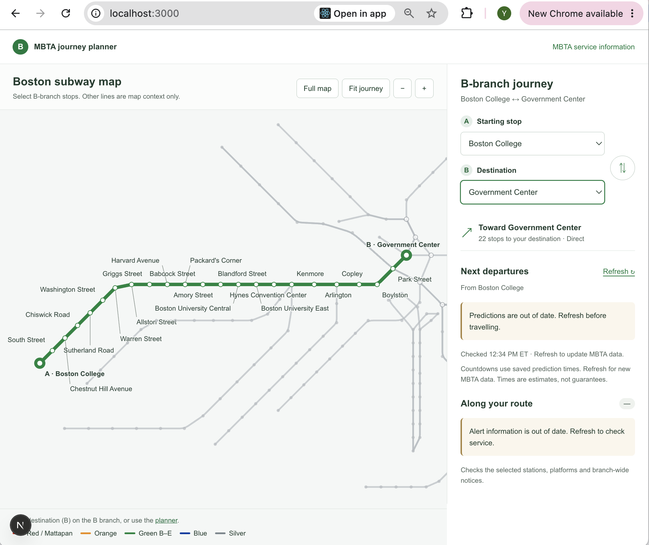

Test Case ID: TC-04
Test Name: Journey Planning
New or Old: New
Test Items: Route planning and map view controls.
Test Priority: High
Dependencies: TC-03 Station Selection
Preconditions: The application is running, and two B-branch stations are selected.
Input Data: Boston College (starting stop) and Government Center (destination).
Test Steps:
- Open the MBTA Tracker homepage.
- Select Boston College as the starting stop.
- Select Government Center as the destination.
- Check the displayed route and journey information.
- Click "Full map" to display the complete subway map.
- Click "Fit journey" to focus on the selected route.
Postconditions: The selected route remains displayed in the journey planner.
Expected Output: The application displays the selected route, starting and destination markers, journey direction, and stop count. The map view controls work correctly.
Actual Output: The application displayed the route from Boston College to Government Center with 22 stops and a direct journey. The map view changed correctly using "Full map" and "Fit journey".
Pass or Fail: PASS
Bug ID/Link: N/A
Additional Notes: No visible errors were found during route planning and map view testing.

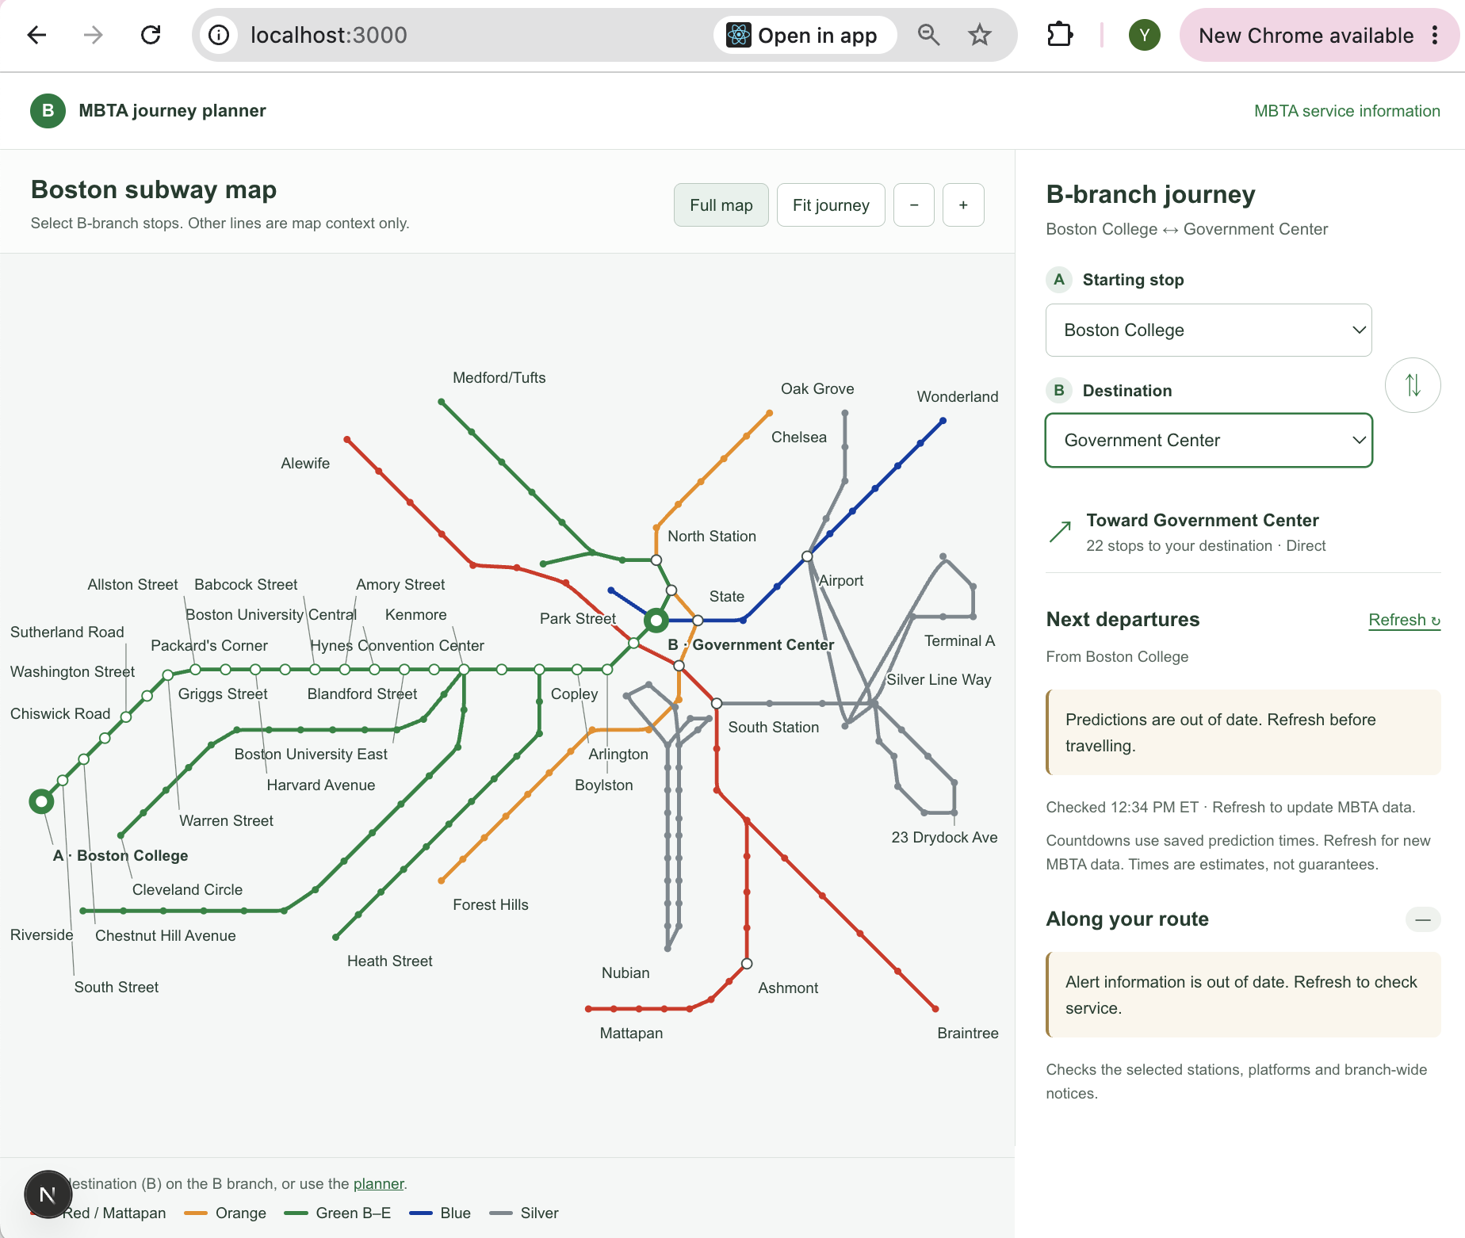

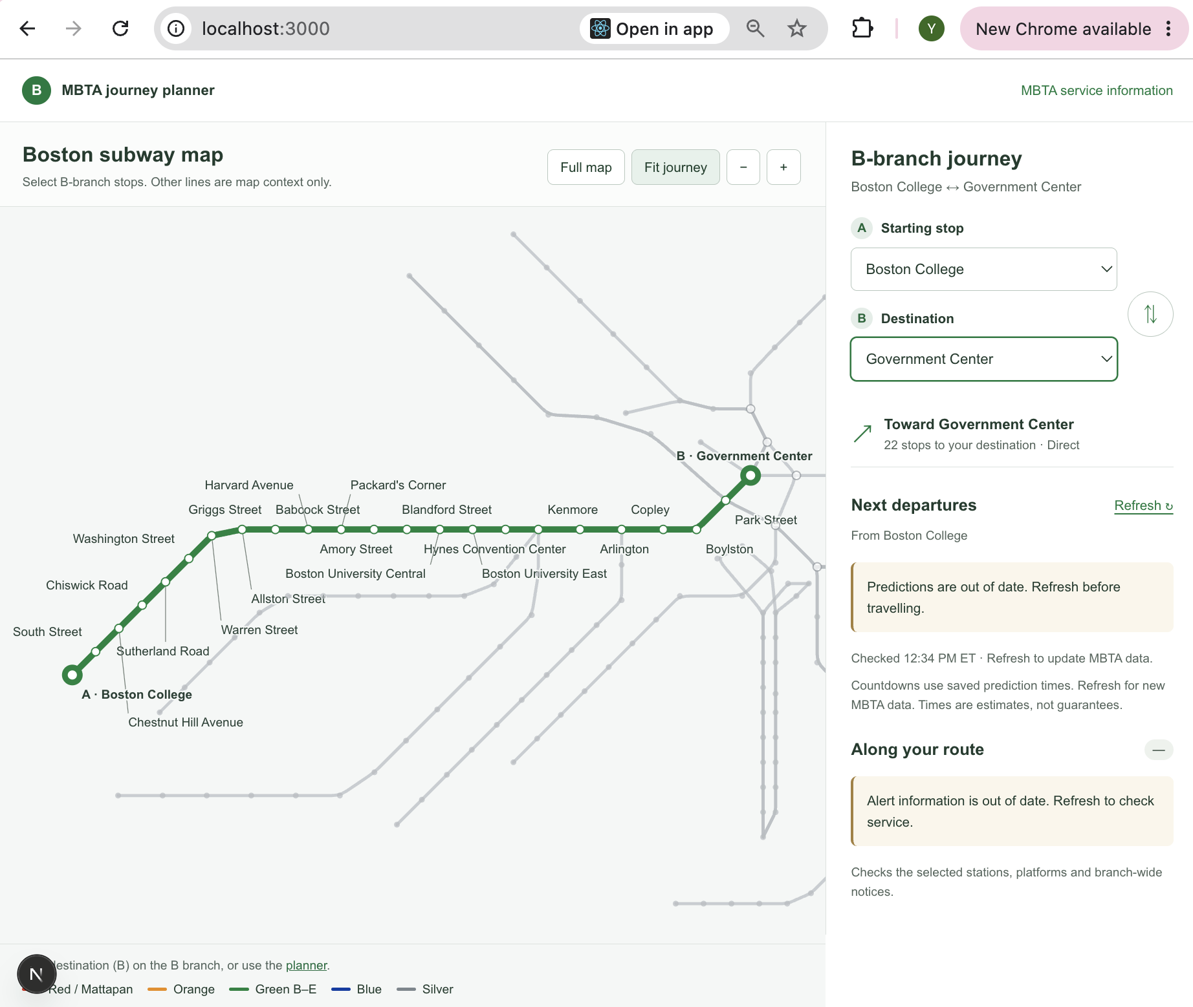
Test Case ID: TC-05
Test Name: Arrival Predictions
New or Old: New
Test Items: Real-time train arrival predictions and data refresh.
Test Priority: High
Dependencies: TC-03 Station Selection
Preconditions: The application is running, and two B-branch stations are selected.
Input Data: Kenmore (starting stop) and Babcock Street (destination).
Test Steps:
- Open the MBTA Tracker homepage.
- Select Kenmore as the starting stop.
- Select Babcock Street as the destination.
- Click "Refresh" under "Next departures".
- Check the displayed train predictions.
Postconditions: Updated train predictions remain displayed.
Expected Output: The application refreshes MBTA data and displays available train predictions and estimated arrival times.
Actual Output: The application displayed "MBTA data updated" and showed three train predictions (11, 22, and 30 minutes), including estimated arrival times.
Pass or Fail: PASS
Bug ID/Link: N/A
Additional Notes: No visible errors were found. Prediction accuracy was not independently verified against the MBTA API.
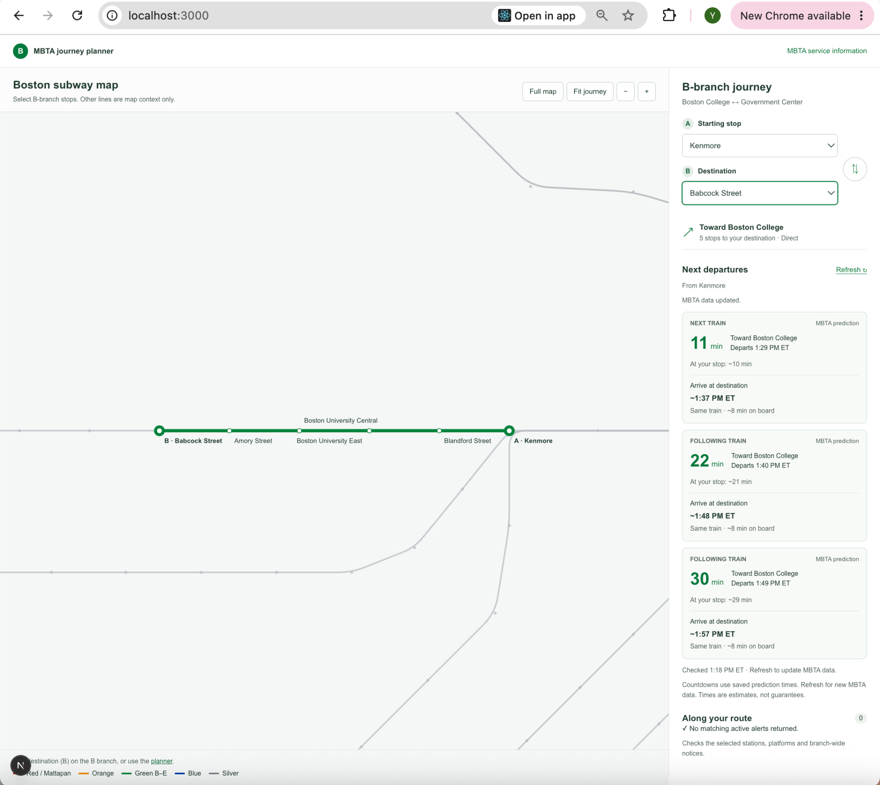

Test Case ID: TC-06
Test Name: Service Alerts
New or Old: New
Test Items: Service alert display for the selected route.
Test Priority: High
Dependencies: TC-03 Station Selection
Preconditions: The MBTA Tracker application is running, and two B-branch stations are selected.
Input Data: Allston Street (starting stop) and Kenmore (destination).
Test Steps:
- Open the MBTA Tracker homepage.
- Select Allston Street as the starting stop.
- Select Kenmore as the destination.
- Click "Refresh" under "Next departures".
- Check the "Along your route" section.
Postconditions: The selected route and service alert status remain displayed.
Expected Output: The application displays relevant service alerts or an appropriate message when no active alerts are available.
Actual Output: The application displayed "No matching active alerts returned" with an alert count of 0. No visible errors occurred.
Pass or Fail: PASS (No-alert scenario)
Bug ID/Link: N/A
Additional Notes: The no-alert scenario passed. Display of active service alerts was not tested because no matching alerts were returned.
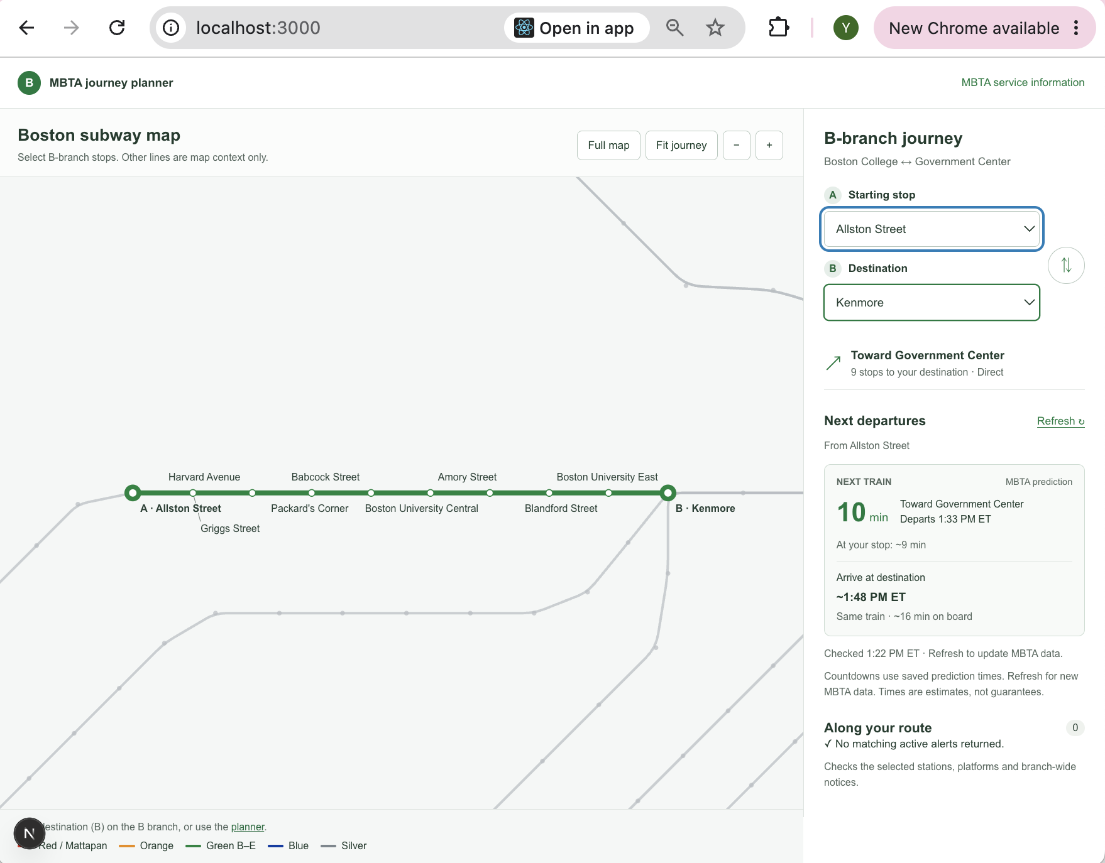

Automated Testing Report
Automated testing was performed using the Node.js built-in test runner.
The test files are located in the tests/ folder of the MBTA Tracker GitHub repository.
The tests cover journey planning, train predictions, API data handling, map geometry, map labels, data freshness, and caching.
Test Command: node --test tests/*.test.mjs
Testing Results:
- Total Tests: 37
- Passed: 37
- Failed: 0
- Skipped: 0
- Pass Rate: 100%
All 37 automated tests passed successfully. No failures were found during this test run.
Test Evidence: Screenshot of the terminal test results.
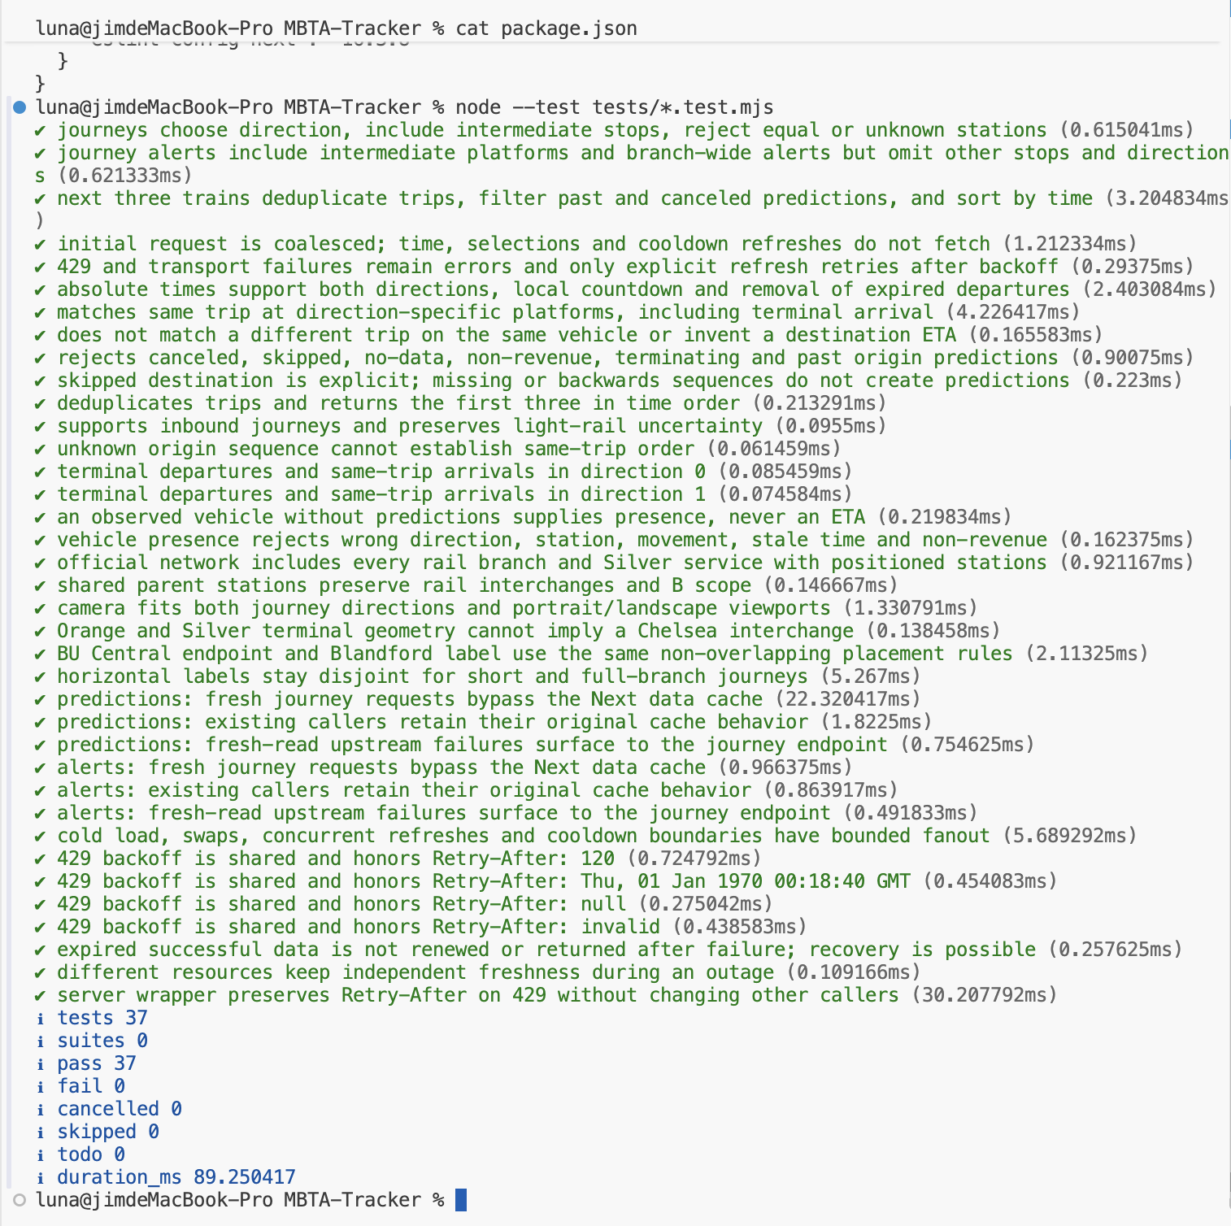

Testing Metrics
During Iteration 1, we completed 6 manual test cases and 37 automated tests.
Manual Testing:
- Total Test Cases: 6
- Passed: 6
- Failed: 0
- Pass Rate: 100%
Automated Testing:
- Total Tests: 37
- Passed: 37
- Failed: 0
- Pass Rate: 100%
Overall Testing Results:
- Total Tests: 43
- Passed: 43
- Failed: 0
- Overall Pass Rate: 100%
No test failures were found during this testing session. However, some scenarios, such as displaying active service alerts, were not tested.

AI usage Log

Section | Who | AI contribution (%) | Description | Verified by
Manual Testing Report | Yuexian Feng | 40% | AI assisted with test planning, test steps, and troubleshooting. | Yuexian Feng
Automated Testing Report & Testing Metrics | Yuexian Feng | 30% | AI assisted with test commands and result analysis. | Yuexian Feng

References

MBTA V3 API Documentation
MBTA Tracker GitHub Repository
CS673 Software Test Document Template

Glossary

MBTA: Massachusetts Bay Transportation Authority.
API: Application Programming Interface.
STD: Software Test Document.
Manual Testing: Testing performed by a person.
Automated Testing: Testing performed using automated scripts.
Test Case: A set of steps used to verify a specific function.

